CHCECE002
Ensure the health and safety of children
Learner Workbook



Table of Contents

Table of Contents 2
Candidate Details 3
Assessment – CHCECE002 Ensure the health and safety of children 3
Competency Record to be completed by Assessor 4
Activities 7
Activity 1A 7
Activity 1B 8
Activity 1C 9
Activity 1D 10
Activity 2A 11
Activity 2B 12
Activity 2C 13
Activity 3A 14
Activity 3B 16
Activity 3C 17
Activity 3D 18
Activity 3E 19
Activity 4A 20
Activity 5A 21
Activity 5B 22
Activity 5C 23
Activity 5D 24
Activity 5E 25
Activity 5F 26
Activity 6A 27
Activity 6B 28
Activity 7A 29
Activity 7B 30
Skills and Knowledge Activity 31
Major Activity 35

Candidate Details

Assessment – CHCECE002 Ensure the health and safety of children
Please complete the following activities and hand in to your trainer for marking. This forms part of your assessment for CHCECE002 Ensure the health and safety of children.
Name: _____________________________________________________________
Address: _____________________________________________________________
_____________________________________________________________
Email: _____________________________________________________________
Employer: _____________________________________________________________
Declaration
I declare that no part of this assessment has been copied from another person’s work with the exception of where I have listed or referenced documents or work and that no part of this assessment has been written for me by another person.
Signed: ____________________________________________________________
Date: ____________________________________________________________
If activities have been completed as part of a small group or in pairs, details of the learners involved should be provided below:
This activity workbook has been completed by the following persons and we acknowledge that it was a fair team effort where everyone contributed equally to the work completed. We declare that no part of this assessment has been copied from another person’s work with the exception of where we have listed or referenced documents or work and that no part of this assessment has been written for us by another person.
Learner 1: ____________________________________________________________
Signed: ____________________________________________________________
Learner 2: ____________________________________________________________
Signed: ____________________________________________________________
Learner 3: ____________________________________________________________
Signed: ____________________________________________________________

Competency Record to be completed by Assessor
Learner Name: _______________________________________________________
Date of Assessment: _______________________________________________________
The learner has been assessed as competent in the elements and performance criteria and the evidence has been presented as:
Assessor Initials
Authentic
Valid
Reliable
Current
Sufficient

Learner is deemed: COMPETENT NOT YET COMPETENT (Please circle)

If not yet competent, date for re-assessment: ____________________________________

Comments from Trainer / Assessor:
__________________________________________________________________________________________________________________________________________________________________________________________________________________________________________________________________________________________________________________________________________________________________________________________________________________________
Assessor Signature: ________________________________________________________
Observation/Demonstration

Throughout this unit, you will be expected to show your competency of the elements through observations or demonstrations. Your instructor will have a list of demonstrations you must complete or tasks to be observed. The observations and demonstrations will be completed as well as the activities found in this workbook. An explanation of demonstrations and observations:
Demonstration is off-the-job
A demonstration will require:
- Performing a skill or task that is asked of you
- Undertaking a simulation exercise
Observation is on-the-job
The observation will usually require:
- Performing a work based skill or task
- Interaction with colleagues and/or customers
Your instructor will inform you of which one of the above they would like you to do. The demonstration/observation will cover one of the unit’s elements.
The observation/demonstration will take place either in the workplace or the training environment, depending on the task to be undertaken and whether it is an observation or demonstration. Your instructor will ensure you are provided with the correct equipment and/or materials to complete the task. They will also inform you of how long you have to complete the task.
You should be able to demonstrate you can:
- Support each child’s health needs
- Provide opportunities to meet each child’s need for sleep, rest and relaxation
- Implement effective hygiene and health practices
- Supervise children to ensure safety
- Minimise risks
- Contribute to the ongoing management of allergies
- Contribute to the ongoing management of asthma

You will also need to show:
- Reading skills
- Numeracy skills
- That they consistently supported the health needs of the children in the service, including the following activities:
  - Contributing to the provision of a clean and safe environment
  - Recognising and responding to signs of illness of children, including signs and symptoms of asthma and anaphylaxis
  - Reading and interpreting authorisation forms, medication labels, medical management plans and other relevant medical information
  - Developing children’s awareness of safety

Activities

Activity 1A
Estimated Time | 20 Minutes
Objective | To provide you with an opportunity to communicate with families about children’s health needs.
Activity | Individually, in pairs or in groups, complete the following:  Provide a list of health needs/concerns you will need to communicate to the families of the children at your centre.  - Illnesses – chronic and occasional  - Nutrition – including general guidelines, detailed information on what the child ate at the centre and ideas for dealing with picky eating or other eating problems at home  - Healthy sleep – toddlers and children in early childhood need 10-12 hours in a 24 hour period, split between night time and naps  - Allergies and food intolerances  - Hydration  - Hygiene  - Doctor visits when children are exhibiting signs of illness.  Outline the appropriate ways to communicate this information according to your policies and procedures.  - Share daily reports/logs, written or verbal, that include what the child ate, when they slept, and their toileting (when appropriate).  - Informal conversations at pick-up or drop-off times (“She was not sleepy during naptime today and stayed awake, so she may need to get some extra sleep tonight to meet that 10-12 hours guideline,” or “He really enjoyed carrots at lunch, so there’s a vegetable he might be willing to eat at home!”).  - Share articles on health topics, either with individual families as they need arises, or with all the parents in the group.  - Scheduled, one-on-one conferences.  - An email or phone call if there’s something you need to share and you won’t get a chance to talk to the parent in person.  Attach the form you would use to document or share the information with families (if applicable)

Activity 1B
Estimated Time | 30 Minutes
Objective | To provide you with an opportunity to maintain confidentiality in relation to children’s individual health needs.
Activity | Individually, in pairs or in groups, complete the following:  Research mandatory reporting in your state/territory. Summarise your findings as it relates to your work role.  In accordance with the Child Protection Act 1999, section 188, any person receiving information under the Child Protection Act 1999, chapter 5A, must keep it confidential. Further, once information has been released from one agency or person to another, there are restrictions on the use and disclosure of the information by that agency or person (Child Protection Act 1999, section 187 and 188).  Read your centre’s policies and procedures surrounding confidentiality and summarise your findings.  Confidentiality around all children’s individual needs is expected of early childhood educators. It safeguards their privacy and promotes trust between families and the centre. When parents trust that sensitive information will be kept private, they are more likely to share it with you, and you are more likely to be able to help.  Things to keep confidential:  - Names of specific children with a diagnosis of a communicable disease. Sometimes you may need to let parents know that their children have been exposed to an illness, but you should not share who has come down with it, or who had it first, or even whether it was a student or staff member.  - Diagnoses of non-communicable diseases or other health issues of any kind.  - Types of medications or dietary restrictions a child has.

Activity 1C
Estimated Time | 20 Minutes
Objective | To provide you with an opportunity to assist others to implement appropriate practices when administering medication and check the written authorisation form to administer medication from the parent or guardian.
Activity | Individually, in pairs or in groups, complete the following:  Create a summary of the process you are expected to follow when assisting the administration of medication. Include the following information:  - Where medication is stored  - The process for insuring all medications have not expired  - Where Medical Authorisation Forms are located  - Who typically is expected to administer medications in each room  - The process for checking medications by two people prior to administering  - Early childhood education educators are responsible for correctly administering medications. Medication can be dangerous if administered incorrectly. Administering medication to children is a task that requires attention to detail, meticulous record keeping, teamwork and common sense.  List the information included on the medical authorisation form at your centre.  Parents must complete a Medication Authorisation Form (or similar) for every medicine to be administered to their child. This applies to long and short-term medicines. Your centre will have a form, and you must become familiar with its location, use and storage. When parents fill out the authorisation form, they expect that the directions will be followed.  Medication authorisation forms typically include:  - Child’s full name  - Medication  - Reason for medication  - Dosage amount  - Time to be given  - Date/s to be given  - Side effects and/or anticipated reactions  - GP/Chemist contact  - Special instructions  - Storage requirements  - Parent signature and date  - Area for educators to record how and when the medicine was administered

Activity 1D
Estimated Time | 20 Minutes
Objective | To provide you with an opportunity to check the medication does not exceed the use-by date, is supplied in its original packaging and displays the child’s name and store medication appropriately.
Activity | Individually, in pairs or in groups, complete the following:  Create a summary of the process you are expected to follow to ensure medications do not exceed the use-by date, are supplied in their original packaging, display the child’s name and are stored appropriately. Be sure to include who is able to access medication at your centre.  - Medications that are stored at the centre can expire before they are used. Check them frequently to make sure they are not expired when you need them. Review the authorisation forms regularly and ensure that parents complete an updated form for long-term medication every three-months.  - Ingesting the wrong or expired medication or the wrong amount of a medication can have serious health risks. You should only administer medication if it is in its original packaging with the pharmacy label attached. The child’s name must be listed as the prescribed person, along with the dosage to be given. This applies to all medications, regardless of whether they are non-prescribed (such as teething gels, nappy creams, cough medicines etc.) or prescribed (antibiotics etc.).

Activity 2A
Estimated Time | 30 Minutes
Objective | To provide you with an opportunity to ensure sleep and rest practices are consistent with approved standards and meet children’s individual needs and provide appropriate quiet play activities for children who do not sleep or rest.
Activity | Individually, in pairs or in groups, complete the following:  What are the important things to consider when providing appropriate sleep and rest? Include information about:  - Individual sleep preferences/requirements  Physiological needs have to be met in order for children to thrive. One of the most essential needs of early childhood is adequate sleep and rest. You must provide appropriate sleep areas and times in order for children to get the rest they need while in your care.  General sleep standards for children:  - Infants up to one year are able to sleep at-will, throughout the day.  - Infants must be put to sleep on their backs.  - Toddlers transition to one afternoon nap, usually right after lunch.  - The sleeping area should be darkened and white noise or soft music should be playing.  - Mats or cots should be covered with a blanket or sheet and only used for one child in between washes.  - Mats or cots should be adequately spaced (at least 30CM)  - Children should sleep head-to-toe when they are less than a metre apart, to avoid the spread of germs.  - Record the time that children spend sleeping on the daily log.  - Children who are not sleeping  - Children who do not sleep should be offered a quiet activity, or if they are still awake more than a half-hour after lying down. It is not appropriate to expect a child to stay quietly on a mat or cot for a long period of time if they are awake.  Summarise your centre’s policies regarding techniques used to promote healthy sleep and rest that follow strict safety standards.  - Make sure babies are sleeping on their backs not on their tummies or side, placing them on their backs means that they have better airway open and easier for them to breathe  - Make sure nothing is wrapped near their faces such a blankets  - Don’t sleep on pillows or beanbags

Activity 2B
Estimated Time | 30 Minutes
Objective | To provide you with an opportunity to respect children’s needs for privacy during any toileting and dressing and undressing times and ensure children’s and families’ individual clothing needs and preferences are met, to promote children’s comfort, safety and protection within the scope of the service requirements for children’s health and safety.
Activity | Individually, in pairs or in groups, complete the following:  What procedures must you follow to ensure children’s privacy during toileting and dressing and undressing times?  The clothing policy will include items such as:  - Appropriate clothing for learning and play  - Dirty and soiled clothing  - Clothing for weather  - Cleanliness  - Spare clothing.  All policies must be current and in line with the following guidelines:  - Sun safety  - Hygiene practices  - Children’s health and safety  - Safe sleeping  - Children’s health and development.  Summarise your centre’s clothing policy.  Encourage dressing for health, safety, comfort and wellbeing.  • Comply with Sun Protection Policy safe measures, broad brim hats, and appropriate clothing to prevent exposure of skin to sun.  • Dressing for extreme cold weather protection includes warm clothing, winter jacket, water proof coat and winter hat. Gloves and scarves are optional.  • Wearing safe comfortable shoes.  • Using smocks for art & water play.  How do you ensure families are informed about appropriate clothing for childcare?  There are many reasons why children come to care in unsuitable clothing. They may be adjusting to a new climate, have cultural or religious traditions that determine clothing choices or families may simply have different views of appropriate clothing for childcare. Some families may not have the means to provide their children with a variety of appropriate clothing for childcare, or they may not be able to regularly launder their children’s clothing. Be sensitive to this and provide assistance where possible.

Activity 2C
Estimated Time | 20 Minutes
Objective | To provide you with an opportunity to share information about individual children’s rest and sleep with families as appropriate.
Activity | Individually, in pairs or in groups, complete the following:  Compose an email to a family member regarding a child’s complicated sleep situation. Write it below:  Hello Mrs Miller,  I am sending out an email regarding Richard’s sleep patterns within the centre. he is a very playful kid and always loves playing with other kids but he struggles with de-compressing to go to sleep. When he tries to sleep he is very active and have a difficult time shutting his mind off so when he finally falls asleep it’s out of routine when the other kids have their nap. We have a plan to get Richard to slow down with his activity closer to the time when we put him down for a rest. I thought I would let you know to let him go to bed earlier tonight.  Kind Regards  Gemma Hoskingy

Activity 3A
Estimated Time | 30 Minutes
Objective | To provide you with an opportunity to consistently implement hygiene practices that reflect advice from relevant health authorities, support children to learn personal hygiene practices and implement the service health and hygiene policy and procedures consistently.
Activity | Individually, in pairs or in groups, complete the following:  Locate your state’s childcare regulations. What does it say about the following areas as listed relevant to early childhood education and care centre’s:  - Health and hygiene practices  - Supporting adults to use thorough handwashing and drying  - Encouraging children to follow simple rules of hygiene such as handwashing and basic dental care  - Ensuring equipment and toys are regularly cleaned/washed and are well maintained  - Keeping facilities such as bathrooms, kitchens, sleep and rest areas, and play areas clean  - Using hygienic toileting and nappy change methods  - Having hygienic procedures for wiping children’s nose  - Cleaning  - floors are not fully dry and can be accessed  - spills and contaminants are left unattended  - a build-up of cleaning product residues (reduces slip resistance)  - cleaning equipment and cords left across walkways  - cleaning is ad hoc, unplanned and reactive  - poor, inappropriate or dirty cleaning equipment used  - incorrect cleaning products and procedures  - General maintenance  - Maintenance must be viewed in the overall  - Context of the ability of the building asset  - Physical condition, functionality, capacity  - Environmental performance and alignment with service demand  Describe a regular routine you can use to ensure the hygiene practices below are followed:  - Children wash hands after using the toilet  - Make sure that parents are aware of the expectation that they and their child wash hands as they enter the centre/room.  - For older children, make sure that the hand washing area is set up so that they can do each of the steps of the process independently when they are individually able (for example, have an easy-to-operate soap pump, make sure paper towels are reachable).  - Post simple visuals of the steps of the hand washing process for children to refer to, and teach them how to use them.  - Make hand washing a consistent part of the routine, and children will begin to do it at appropriate times without needing reminders.  - Bedding and clothing are not shared  - Give children a dedicated space for their belongings (basket, cubby).  - Encourage parents to label their child’s items.  - Work with children to learn the expectations.  Create an activity that helps children learn to wash hands appropriately.  Hand Wash Song  Help your child make up his or her own words to a popular song that lasts about twenty seconds. You could try the tune of “ABC,” “Yankee Doodle,” “Happy Birthday” (sung twice), or “Twinkle, Twinkle, Little Star.” Teach your child how to properly wash his or her hands and explain that washing is finished when they have finished singing the song.

Activity 3B
Estimated Time | 15 Minutes
Objective | To provide you with an opportunity to ensure that service cleanliness is consistently maintained.
Activity | Individually, in pairs or in groups, complete the following:  Outline the daily and weekly cleaning routine in your room. Include the details of who will clean/disinfect and how it is to be done.  Bathrooms and toilets should be cleaned every day, and accidents must be cleaned up immediately according to the centres procedures. Nappy change areas must be thoroughly cleaned with detergent and water after each nappy change. Dispose of cleaning cloths or paper towels. Waterproof sheets or changing mats should be laundered at the end of each day and when they are soiled during a change  Cleaning equipment must be well maintained, cleaned and stored appropriately so it can dry between uses. It is recommended that you use different coloured cleaning cloths for different areas, e.g., green in the classroom, yellow in food preparation areas and blue in the bathroom.

Activity 3C
Estimated Time | 20 Minutes
Objective | To provide you with an opportunity to observe and respond to signs of illness and injury in children and systematically record and share this information with families.
Activity | Individually, in pairs or in groups, complete the following:  Outline how you respond to the following situations:  Two-year-old Declan wakes up from a nap feeling quite warm.  Check temperature  - Take off clothes  - Lay them under a fan  - Put on a damp cloth  - Call parents and inform tem  - Call an ambulance if it’s over 40 degrees  Four-year-old Samantha is running around playing chase when she trips and falls, hitting her head on a stump.  - Do not move her in case there is a neck injury  - Check to see if she is okay and shows any signs of concussion  - If there is cracked head or sign of nausea or concussion call and ambulance immediately

Activity 3D
Estimated Time | 15 Minutes
Objective | To provide you with an opportunity to consistently implement the service policies for the exclusion of ill children.
Activity | Individually, in pairs or in groups, complete the following:  The lead educator in your room called Andrew’s mother to pick him up yesterday at noon because he had a fever. This morning, Andrew’s mother brings Andrew to the centre for drop off. What do you do? Be sure to review your centre’s exclusion policy.  Children cannot learn or benefit from being at the centre school when they are ill; they need individual care, which educators in the group care setting cannot properly give. When children and adults come to the centre when they are sick, they spread germs, which results in others also getting sick. Early childhood education and care centres must consistently exclude children who show signs of illness.  An exclusion policy helps to reduce the spread of infectious illnesses. Excluding ill children, educators and other staff is an effective way to limit the spread of infection. The more consistent you are about the exclusion of ill children, the easier it becomes to convince parents to keep their child home or come in to pick them up when they demonstrate symptoms of illness.

Activity 3E
Estimated Time | 30 Minutes
Objective | To provide you with an opportunity to discuss health and hygiene issues with children.
Activity | Individually, in pairs or in groups, complete the following:  Design a poster [A4] encouraging important hygiene habits, including oral care, aimed at 4 year olds. Use bright and colourful illustrations. Make sure it is clear and easy to read.  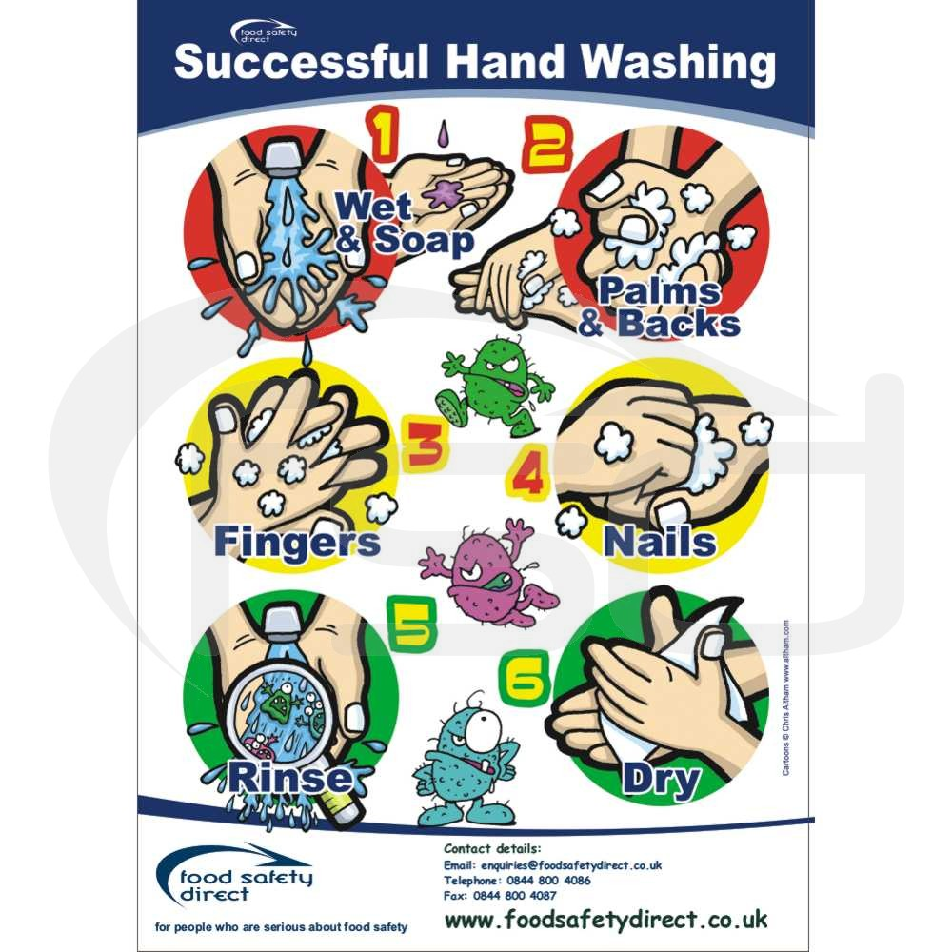

Activity 4A
Estimated Time | 30 Minutes
Objective | To provide you with an opportunity to supervise children by ensuring all are in sight or hearing distance at all times, adjust levels of supervision depending upon the area of the service and the skill, age mix, dynamics and size of the group of children, and the level of risk involved in activities and exchange information about supervision with colleagues to ensure adequate supervision at all times.
Activity | Individually, in pairs or in groups, complete the following:  Discuss the following scenario with your supervisor and then answer the questions.  You are in your room with five 2-year-olds, your maximum ratio. Another educator comes rushing in with a 4-year-old. The educator’s mother is in the emergency room and has to leave immediately.  What do the centre’s policies and procedures say about this situation?  Early childhood education regulations govern the ratio of children to educators in both home-based and centre-based services. You must learn these ratios, as they are vital in maintaining the safety of the children in care. Centres will have their own procedures and guidelines for discussion and modelling, however basic safety areas will apply to all children in all settings.  What would you do?  If I was in this position I would get another staff to cover the person who has to leave and ensure that the kids are okay.  What are the safety issues?  If a child runs off without supervision and runs into the car parks on peak hour.

Activity 5A
Estimated Time | 30 Minutes
Objective | To provide you with an opportunity to assist in the implementation of safety checks and the monitoring of buildings, equipment and the general environment.
Activity | Individually, in pairs or in groups, complete the following:  Create a detailed schedule for safety checks for your room. Design it so you can post it clearly in your room.  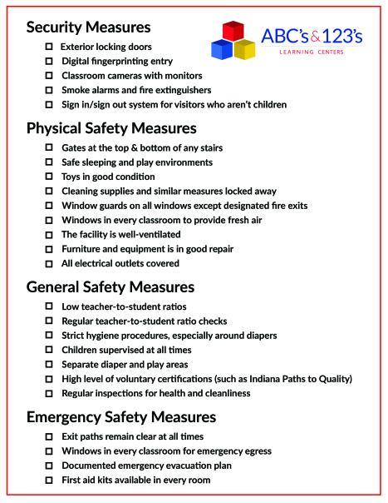  Come up with a protocol for the times that require more intensive monitoring  - Double checks on the important things on the checklist to make sure or get another staff member to help you with looking over all the needed.

Activity 5B
Estimated Time | 30 Minutes
Objective | To provide you with an opportunity to consistently implement policy and procedures regarding the use and storage and labelling of dangerous products.
Activity | Individually, in pairs or in groups, complete the following;  Find and familiarise yourself with your centre’s policies and procedures regarding use, storage and labelling of dangerous products. Summarise your findings.  - Cleaning products, like bleach, glass cleaner, or washing detergent  - Used nappies and wipes  - Tools and toolboxes  - Ladders  - Toxic office supplies, like permanent markers or printer ink cartridges  - Scissors and knives  - Staplers  - Medications, lotions and sunscreen  - Fertiliser for planting projects  - Items that pose a choking hazard to children, especially rubber gloves used for changing nappies.

Activity 5C
Estimated Time | 20 Minutes
Objective | To provide you with an opportunity to follow service procedures for the safe collection of each child, ensuring they are released to authorised people.
Activity | Individually, in pairs or in groups, complete the following;  Three-year-old Heather has been excited all day for her Aunt Margret to pick her up. She tells you that they are going to see a puppet show. Heather’s mother did not mention that Aunt Margret was picking Heather up today. You have tried unsuccessfully to get in touch with her. Aunt Margret arrives and you tell her you are unable to release Heather to her care without confirmation from her mother. Both Heather and Aunt Margret are very upset, saying the puppet show starts in 15 minutes. Aunt Margret says to you, “Well, we are not waiting any longer. We are leaving.”  What do you do?  Tell her that you’re sorry this has happened and that it’s by law that you can’t take a child without their parent’s permission first and if she takes off with her she will have to contact the police and get them involved. Remind her that she can pick her up any other day but she will need permission from her parents.

Activity 5D
Estimated Time | 20 Minutes
Objective | To provide you with an opportunity to assist in the supervision of every person who enters the service premises where children are present.
Activity | Individually, in pairs or in groups, complete the following;  Your supervisor asks you to evaluate the centre’s procedures for visitors. Review the current procedures and propose three changes that will make the centre safer as well as ensure visitors feel welcome.  - Find and familiarise yourself with your centre’s policies and procedures regarding use, storage and labelling of dangerous products.  - Label cleaning products accurately and only use them for their intended purpose.  - Keep medications and chemicals in their original packaging to limit confusion about how and why to use each product.  - Store cleaning supplies, tools, office supplies, medications and other potentially hazardous items in locked storage areas out of the reach of children.  - Follow your centre’s procedures for the storage and administering of children’s medications and lotions, both prescription and over-the-counter.  - Keep bathroom and nappy changing areas clean and neat, ensuring that children do not have access to gloves or soiled items.  - Use ladders and other tools appropriately and return them to storage immediately after use.  - Keep your personal items out of the reach of children.  3 CHANGES  - Plan ahead when possible so that you are using hazardous products when children are not present, and cleaning up before children arrive/return.  - Watch for expiration dates on cleaning products and medicines.  - Ask parents to be mindful of bringing in hazardous items during drop-off and pick-up, like hot drinks, sharp objects, etc.

Activity 5E
Estimated Time | 30 Minutes
Objective | To provide you with an opportunity to discuss sun safety with children and implement appropriate measures to protect children from over-exposure to ultraviolet radiation.
Activity | Individually, in pairs or in groups, complete the following;  Design a lesson to encourage a discussion about sun safety with children.  Ask children what they can do to practice sun safety (wears a hat, wear sunglasses, play in the shade, wear sunscreen, etc.).  Help them make up words for a sun safety song that can be sung to a familiar tune (If I Had a Hammer; Mary Wore a Red Dress; BINGO, Old MacDonald Had A Farm, etc.).  Continue to add words or verses to the class song that describe sun-safe practices.  Example: (sung to “Old MacDonald Had a Farm”)  I am sun-safe all day long, Ee ii ee ii oo  I wear a hat to shade my face. Ee ii ee ii oo  With a floppy hat here, and a floppy hat there,  here a hat, there a hat, everywhere a floppy hat,  I am sun-safe all day long, Ee ii ee ii oo  Design a room procedure for getting ready for outdoor playtime. Include a timeline and details for when a relief educator is in your room, s/he will know exactly what to do.

Activity 5F
Estimated Time | 30 Minutes
Objective | To provide you with an opportunity to check toys and equipment are safe for children and safe to use in their proposed area and remove any hazards immediately or secure the area to prevent children accessing the hazard.
Activity | Individually, in pairs or in groups, complete the following;  Review the play areas, toys and equipment in your room. Complete the toy safety checklist:  List any areas, toys or equipment that did not meet safety requirements and list the risk reduction strategies you would implement to address the situation.
  Play area, toys and equipment | Tick
  Toys are age-appropriate and suited to the abilities of the children playing with them
  Toys for different age groups are stored separately
  No toy small enough to fit inside an empty toilet roll is accessible to babies and toddlers
  Toy labels with age-related and small parts warnings and instructions for safe use are known and adhered to
  Toy labels or instructions are intact and legible
  Age-appropriate, non-toxic, non-edible arts and crafts materials are stored in labelled containers out of the reach of children
  No toy has a pull cord or string longer than 20 cm
  Toys do not have peeling paint or broken pieces
  Indoor play structures are safely positioned, away from windows and other furniture, with a proper fall zone, and sufficient surfacing to cushion a fall.
  Ride-on toys are appropriate for the age and stage of children using them
  Rise-on toys have all their working parts (wheels, handles, nuts and bolts, etc.)
  Height, age and weight specifications are known and adhered to
  Children wear a certified helmet when using wheeled toys
  Play equipment does not have any rusting, pinch- or catch-points or and other signs of wear and tear
  Gates and stairs have working locks
  Outdoor playground equipment does not have broken pieces, lost screws, or missing attachments.

Activity 6A
Estimated Time | 20 Minutes
Objective | To provide you with an opportunity to identify and recognise signs, symptoms and key characteristics of allergies and anaphylaxis.
Activity | Individually, in pairs or in groups, complete the following;  Brody is 2 years old and is going to start at your centre in two weeks. Brody is highly allergic and cannot tolerate any nut products or any food containing eggs. Brody has an EpiPen® in case he experiences anaphylactic shock. An EpiPen® will be stored at the centre and must be administered within one minute of any reaction.  - What strategies/policies can be put in place to reduce risks to Brody?  Making sure that there are checks on all of the food in the facility to make sure that it hasn’t come in contact with anything that could bring on allergic reaction  - How will this information be communicated to staff?  - Mention it in meetings  - Put up signs in the room, staffroom and kitchen

Activity 6B
Estimated Time | 30 Minutes
Objective | To provide you with an opportunity to apply organisational risk-management strategies for children with severe allergies and follow organisational policies and legislative requirements in relation to medication for anaphylaxis.
Activity | Individually, in pairs or in groups, complete the following;  Look over an anaphylaxis action plan at your centre. If one does not exist, create a mock plan with your supervisor. Summarise your findings and answer the following questions:  Who is expected to carry out this plan?  - Any staff member that is present should be able to perform anaphylaxis epi pen when the moment happens.  - They should have been trained how to  Do you need special training to carry out this plan?  - Yes, you need your first aid  Who at your centre is authorised to carry out this plan?  - Centre director or Room director

Activity 7A
Estimated Time | 20 Minutes
Objective | To provide you with an opportunity to identify signs, symptoms and triggers of asthma.
Activity | Individually, in pairs or in groups, complete the following;  Summarise the symptoms of asthma:  - Coughing, especially at night, during exercise or when laughing.  - Difficulty breathing.  - Chest tightness.  - Shortness of breath.  - Wheezing (a whistling or squeaky sound in your chest when breathing, especially when exhaling)  Describe three different situations when an asthma attack is more likely to occur.  - animal dander  - smites in house dust  - fungi (molds) that grow indoors  - mold spores that grow outdoors  - cockroach allergens  - tree, grass, and weed pollen  - occupational exposure to chemicals, fumes, or particles of industrial materials in the air  - strong odors, such as from perfume  - wood smoke

Activity 7B
Estimated Time | 30 Minutes
Objective | To provide you with an opportunity to identify children who have an asthma management plan and follow that plan and follow organisational policies and legislative requirements in relation to medication for asthma.
Activity | Individually, in pairs or in groups, complete the following;  Consult with your supervisor about completing this activity. Identify all the children at your centre who have an asthma management plan. Review one of these plans (with permission from your supervisor).  Outline all of the ways you can assist in the implementing the plan.  - Information regarding how to reduce the risk of asthma attacks, signs and symptoms of an attack, and protocols to follow if symptoms are occurring.  - Detailed instructions on when and how to administer any asthma medications (rescue inhalers, etc.) Similar to other types of medicine, asthma medications can be harmful or can become less effective when administered improperly.  - Information regarding when to limit physical activity.  - Information regarding dietary restrictions  - Special sleep instructions (put to sleep on sides, propped up with a towel or blanket, etc.)  - Instructions regarding breathing exercises that the child may need to do every day. You must provide opportunity and space for them to do these exercises with respect to their privacy.  - Up-to-date phone numbers that would be needed in case of an emergency.  What medication is indicated in the plan? How are you required to administer it, following all policy and legislative requirements?  Inhalers, Nebulizers, and Pills as Asthma Medicine. There are a few ways to take asthma medications. Some are inhaled, using a metered dose inhaler, dry powderinhaler, or a nebulizer (which changes medication from a liquid to a mist). Others are taken by mouth, either in pill or liquid form.

Skills and Knowledge Activity
Estimated Time | 45 Minutes
Objective | To provide you with an opportunity to demonstrate your knowledge of the required skills, knowledge and critical aspects of assessment.
Activity | Complete the following individually and attach your completed work to your workbook.  The answers to the following questions will enable you to demonstrate your knowledge of:  - How to access:  - The National Quality Framework  - The National Quality Standards  - The relevant approved learning framework  - How to navigate through framework and standards documents to find areas relevant to this unit of competency  - How to undertake a risk analysis of toys and equipment  - Potential hazards to children, including medical conditions  - Children’s requirements for sleep and rest  - Environments that promote rest and sleep including light, noise, temperature and ventilation requirements  - Signs, symptoms and key characteristics of allergy/anaphylaxis  - Signs, symptoms and key characteristics of asthma  - How to use an adrenalin auto injector for anaphylaxis  - How children’s oral health impacts on their general health and well-being, including signs of tooth decay  - Safety issues and risk management strategies for children’s health and safety in a variety of contexts  - Basic home fire safety including high-risk groups, behaviour that contributes to fire injury and fatalities, and smoke alarm placement, installation and maintenance  - Organisational standards, policies and procedures  - Reading-in order to accurately read and interpret medication packaging and dosage instructions  - Numeracy-in order to correctly calculate medication dosages for common measurements including milligrams (mg) and millilitres (ml)  - Consistently supported the health needs of the children in the service, including the following activities:  - contributing to the provision of a clean and safe environment  - recognising and responding to signs of illness of children, including signs and symptoms of asthma and anaphylaxis  - reading and interpreting authorisation forms, medication labels, medical management plans and other relevant medical information  - developing children’s awareness of safety  Answer each question in as much detail as possible, considering your organisational requirements for each one.  - National Framework and Standards  Locate and use the following documents:  - National Quality Framework  - National Quality Standards  - Or the relevant approved learning framework used in the service if different from those above  - Your organisation’s standards, policies, procedures and guidelines  Outline what each of these standards/documents specifically say about ensuring educators:  - Support each child’s health needs  - Provide opportunities to meet each child’s need for sleep, rest and relaxation  - Implement effective hygiene and health practices  - Supervise children to ensure safety  - Minimise risks  - Contribute to the ongoing management of allergies  - Contribute to the ongoing management of asthma  - Research and summarise the following:  - How to undertake a risk analysis of toys and equipment  - Potential hazards to children, including medical conditions  - Children’s requirements for sleep and rest, including environments that promote rest and sleep including light, noise, temperature and ventilation requirements  - Signs, symptoms and key characteristics of allergy/anaphylaxis  - Signs, symptoms and key characteristics of asthma  - How to use an adrenalin auto injector for anaphylaxis  - How children’s oral health impacts on their general health and well-being, including signs of tooth decay  - Basic home fire safety including high-risk groups, behaviour that contributes to fire injury and fatalities, and smoke alarm placement, installation and maintenance  - Workplace observation – Your assessor will observe you ensuring the health and safety of children in your care at your centre. Be sure to demonstrate to your assessor your ability to correctly calculate medication dosages for common measurements including milligrams (mg) and millilitres (ml).

Major Activity
Estimated Time | 1 Hour
Objective | To provide you with an opportunity to demonstrate your knowledge of the entire unit.
Activity | This is a major activity – your instructor will let you know whether you will complete it during class or in your own time.  You must individually, answer the following questions in full to show your competency of each element:  - Support each child’s health needs  - Provide opportunities to meet each child’s need for sleep, rest and relaxation  - Implement effective hygiene and health practices  - Supervise children to ensure safety  - Minimise risks  - Contribute to the ongoing management of allergies  - Contribute to the ongoing management of asthma  - Create a detailed safety plan for your room. Outline exactly how you will consistently support the health needs of the children in the service, including the following activities:  - Contributing to the provision of a clean and safe environment  - Recognising and responding to signs of illness of children, including signs and symptoms of asthma and anaphylaxis  - Reading and interpreting authorisation forms, medication labels, medical management plans and other relevant medical information  - Developing children’s awareness of safety  - Supervising children to ensure safety  - Communicating with families and other educators about children’s safety

