Practical Assessment Part 1- Residential construction.

Footing Systems

Footing systems are an integral part of the building process as they transfer the load of the building to the foundation. As Pictured Below there is a 450mm wide by 300 deep footing around the perimeter of the slab as per footing detail F1 shown on the plan. As Per the engineered footing plan 4 Bar 8mm Trench mesh is placed in the bottom of each footing 65mm off the ground. During the process of pouring the concrete Slab N12 Starter Bars are then placed into the footing and hooked underneath the bottom of the trench mesh which helps to connect the external block walls through to the footings providing strength and helping to transfer the load down into the footing. The size and layout of the footings required may vary depending on the Type of Soil in the foundation. The Picture below is from a Job at jacamunda circuit where the soil classification is class P.
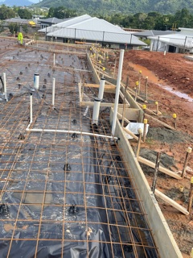
Floor System
The most common form of flooring system used in North Queensland is concrete slab on ground. This is popular as it is cost effective and provides a strong base for construction in a Cyclone prone area. The Slab must be a minimum 100mm think N20 Grade concrete reinforced with 1-layer of RF72 Mesh. You must provide 25mm Top cover over your mesh to all areas other then external areas which require 40mm top cover. When pouring your slab, you must set all your starter bars into the slab. On each set of building plans there is usually a starter bar layout plan which shows you were the starter bars are required. All concrete work shall be in accordance with AS 1379. The following photo is from Jacamunda circuit and is a concrete slab on ground.
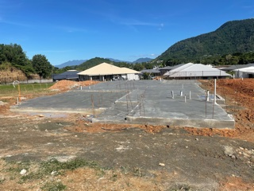
External Walls
Masonry Block external walls are the most used in North Queensland as they are cost effective and provide great strength and resistance to cyclonic winds. These walls are then rendered to provide weatherproofing on the outside and can be easily lined with plasterboard on the inside. Block Walls also provide support for the roof structure and help to transfer the load of the roof down to the foundation. As per engineered plans the bond beam is filled with concrete around the perimeter of the house along with each pot that has a N12 dropper which ties into the N12 starter bars which are set in when the Slab is poured. Each of these droppers will hook over the N16 perimeter steel which helps tie the roof system down the walls into the stater bars and into the footings. Each corner and besides each opening also require a dropper and to be filled with concrete. Any openings greater then 1800mm require 2 pots to be filled as per engineer’s specifications. The Engineered plans also provide a lintel detail which show how much N16 steel must be placed over each opening. Other then the openings shown on the lintel detail one N16 bar is placed around the top course of the bond beam and through the bottom hole of the truss cleats which ties the roof trusses down to the wall. The following Photos are from Jacamunda Circuit and show a standard 2.6m high masonry block wall along with a view of the bond beam steel set up ready to pour.
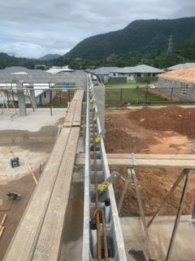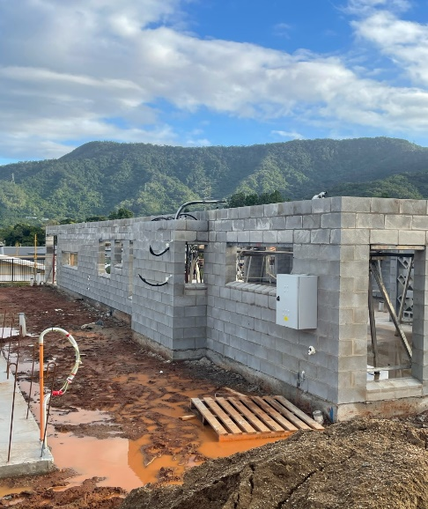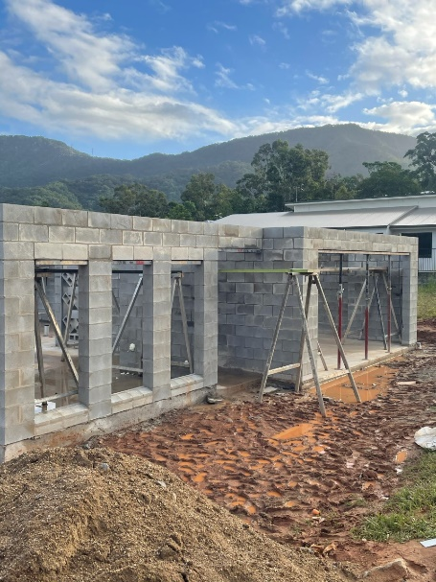
Internal Walls
When building a masonry block home majority of the internal walls are non-load bearing timber stud walls. As per engineered plans the timber must comply with AS 1684. 70x35 and 90x35 MGP 10 is the most used timber. Bracing walls are sometimes required if specified on the engineered plans and must be tied down to the slab using N12 Threaded rods that have been drilled and anchored in using a polyester adhesive. Racking blocks must also be installed above the bracing wall between each truss to provide additional strength and help resist horizontal forces from High winds. Ply Bracing is then nailed to one side of the wall in accordance with manufacturing specifications and AS1684.3 for 6.4kN/m racking resistance. Shown below is a set of non-load bearing wall frames from 49 Banner st with a plywood brace wall.
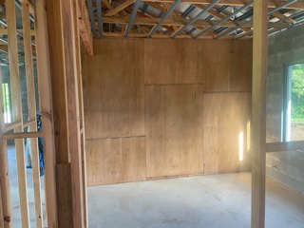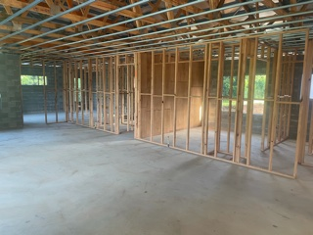
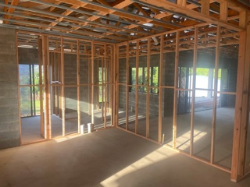

Roof System
Majority of roof trusses are prefabricated today as they are cost effective and time efficient. Prefabricated Pine trusses should be checked over for any damage or imperfections prior to being lifted onto the roof. You can find the wind classification on your engineered plans. All prefabricated trusses should be installed as per the manufacturer’s requirements. The Truss tie-down detail plan will provide the information required to let you know what size bolts and how many cleats are required for each truss. Any truss with an uplift less then 16 KN requires one 16mm Bolt and one cleat. It is also important that you strap, batten screw and nail speedy brace on where required. The following set of roof trusses at Jacamunda circuit follow the wind classification of Class C1

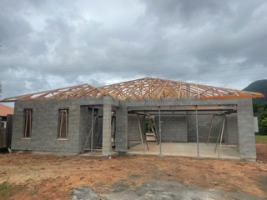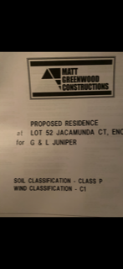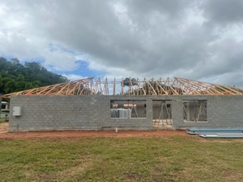

External Wall Cladding

There are many types of external wall cladding and depending on what style of housing is being constructed will determine which product is used. When constructing a masonry block home, the most common cladding used is render as it is durable, cost efficient and weather resistant. Other types of common wall cladding mainly used in timber frame housing is fibre cement products or timber cladding. This must be installed to the manufacturer’s instructions including the use of sarking, flashings above openings, damp coarse behind joins and nailed at the required centres. The following photos show two different types of cladding. The photos are from a job in Mareeba and shows three different types of fibre cement products. In the first photo the cladding on the left is a prefinished fibre cement product which once installed is the final product meaning no painting is required and also no fixings are seen. The other type of cladding is Matrix cladding and is fixed through the face of the board meaning must be patched and painted. The Blue cladding in the 2nd photo is called Blueboard cladding and once installed is rendered over to give a textured finish.

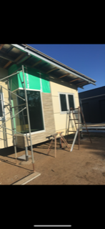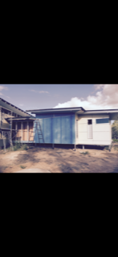

Practical Assessment Part 2 – Commercial

Footings

Depending on the soil classification and size of the project will determine which footings are to be used in commercial construction. For smaller scale commercial jobs, the footing layouts can be quite similar to that of residential builds. Any fill used building area should be uniformly compacted in layers of not more then 200mm final thickness, under level 3 supervision (AS 3798-1990) to the max dry density ratio of 98% SRDD. The Footings are crucial to the structural integrity of any building and failure to comply to the Australian standards and engineered plans could create disaster. The Photos shown on the next page are the footing detail and footing plan for a School library extension in Atherton. These two pages provide the necessary information required to complete the footings.
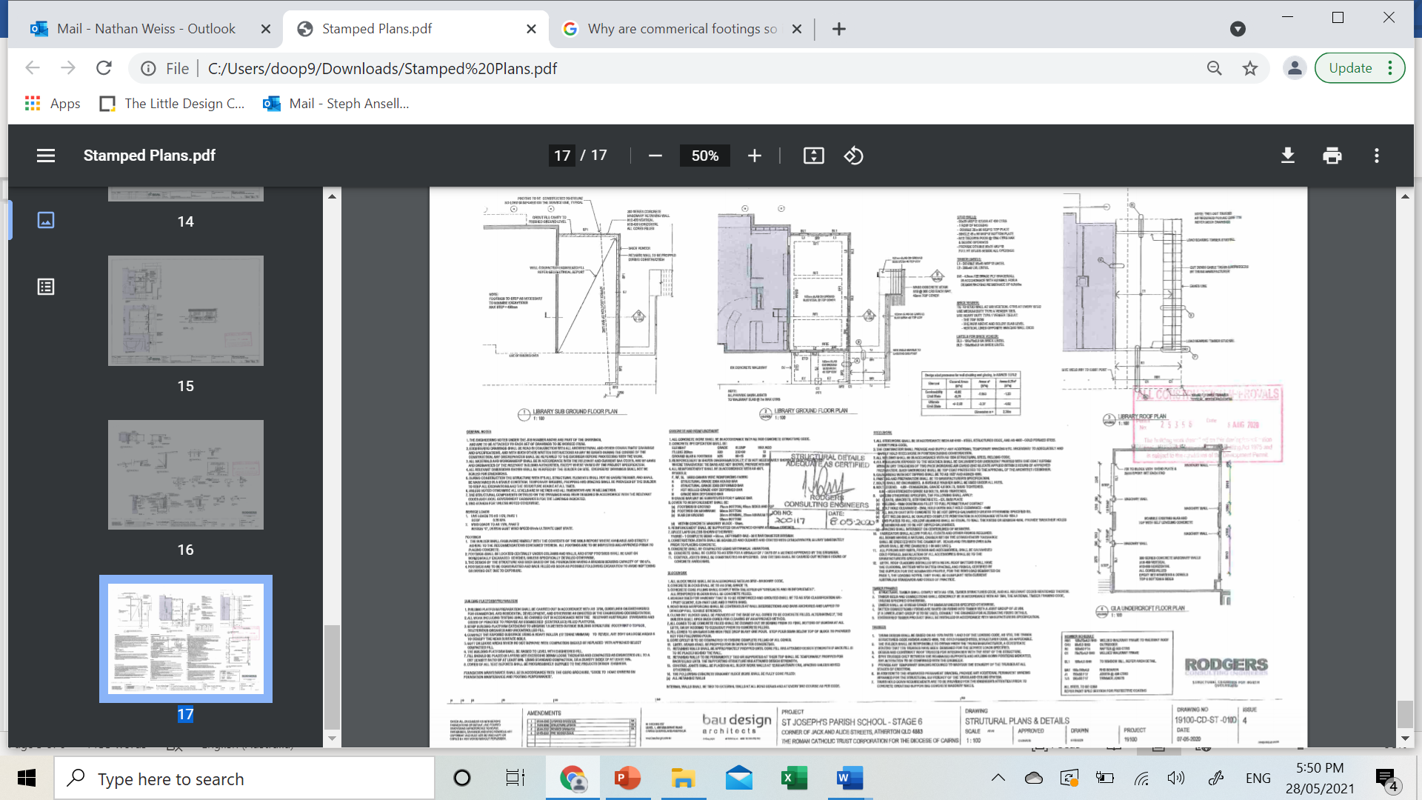
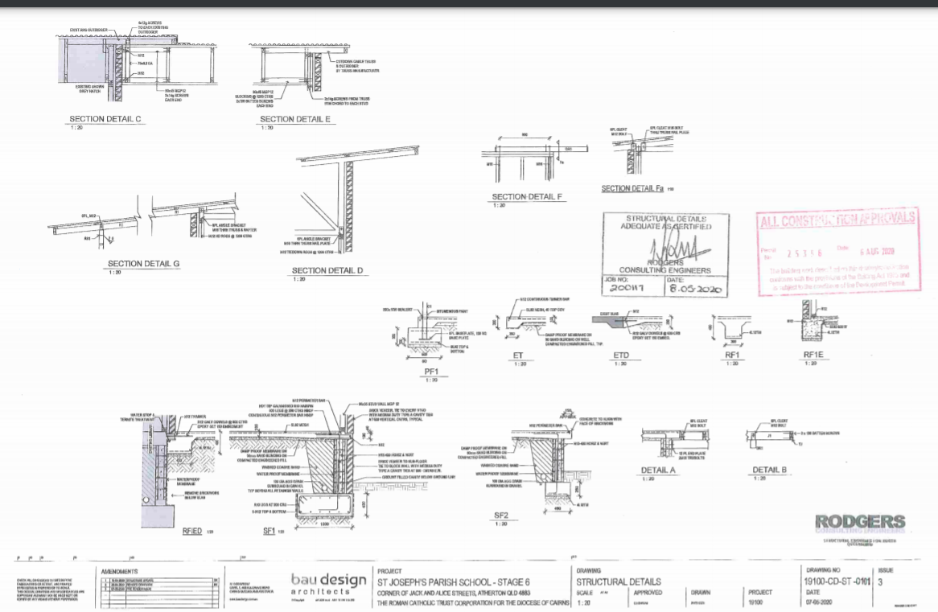

Floor System

Concrete Slab on ground is the most common floor system used in commercial construction. When setting up and pouring your concrete slab its important that you follow the plans and specifications. The footings must support the floor system and then provide the structural support for the walls and roof system. The photos above show the details and specifications for the concrete slab on ground for the library extension. All concrete work should be in accordance with AS 3600 concrete structure code. All reinforcement work should be in accordance with AS 4671. All this information can be found in the notes section of Concrete and reinforcement in the first photo. As this is an extension the concrete slab must be Dowed into the existing structure with R12 Galvanized dowels at 600 centres using an epoxy with 150mm embedment. This is shown is footing detail RFIED.

Structural Wall and Cladding Systems

Structural wall and cladding systems are another vital component of commercial buildings. Types of wall systems can vary between Concrete tilt panels, Masonry block walls, brick veneer and timber frame construction. The wall helps to transfer the load of the roof structure down to the foundations. The photos below show the section detail for the external brick veneer wall. You can also find the Notes for the timber frame wall on the last page of the plans shown below. As it states in the framing notes all structural timber must comply with AS 1720. The bricks act as the cladding in this project and must be tied back to the Timber frame.

Structural Roof Systems

Roof Frames in commercial projects are usually made up of timber prefabricated pine trusses or Steel Purlins depending on the size and scope of the project. Its important to know the wind classification to ensure the roof structure is sufficient to withstanding high winds. Timber trusses are tied down to the wall with a 16mm Cuphead bolt through a truss cleat which Is connected down to the wall. Metal battens are then screwed down into the timber trusses at spacings specified in the engineered approved plans. Sarking or insulation is then laid out over the battens before the roof cladding is fixed. The most common roof cladding used is colorbond steel roofing. The roof sheets must be screwed in accordance with AS 1562.1.

Whilst working on the Cairns Base Hospital in 2013 i worked as a formwork carpenter and got to see the structural principles applied in a complex high rise commercial project. The work I performed included Tilt panel construction, suspended concrete slabs with beams and lift cores.

