Practical Task 1 (2X)
Description of task:
On two (2) occasions, a suitable observer is to verify the participant’s ability to produce schedules of resource requirements so that orders can be placed for materials and labour for projects, and costs can be recorded and tracked as they are incurred.
- Occasion 1: Residential project
- Occasion 2: Commercial project

The participant is to gather evidence of how they have completed each component of the Practical Task, which is to be submitted with this Practical Assessment sheet. Evidence to be submitted may include:
- A copy of a material/labour schedule or supplier list for a project
- A copy of a purchase order for purchasing materials or other resources
- A cost report
- Site condition reports or dilapidation reports
- Contract documents
- Call forward sheets
- Variations

The observer is to provide detailed comments on the tasks completed by the participant. The assessor is to verify the observer’s comments in the Assessor Comments section, and provide the Practical Assessment outcome on the front cover of this document.

See below for take down order
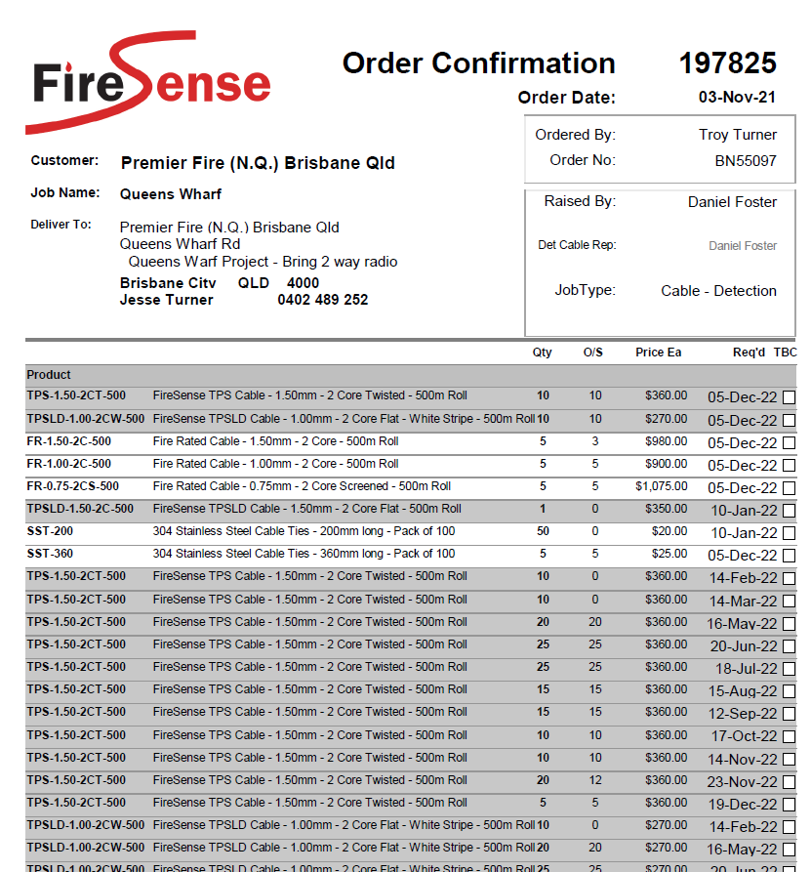

See below for price list
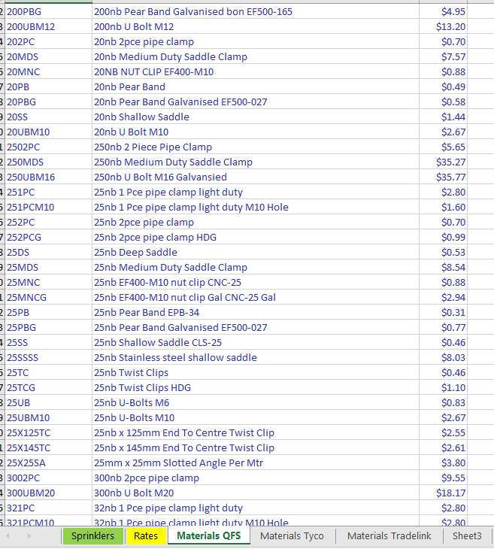

See below for variation


