Health & Safety
Management Plan
Yurika as Principal Contractor

DOCUMENT DETAILS
CLIENT | CleanCo Queensland Limited
PROJECT | CleanCo Swanbank BESS
WORK REQUEST | WR1853038
DOCUMENT TITLE | Swanbank BESS Health & Safety Management Plan
CLIENT DOCUMENT NUMBER | SBK-F-175-2000-005
YUR DOCUMENT NUMBER | SBK-F-YUR-WHS-PLN-0001
CURRENT REVISION | C

ENDORSEMENT AND APPROVAL
At Rev C | Authored By | Endorsed By | Approved By
Name | Sooty Phomsouvanh | Brendon Watts | Rolf Collett
Title | Project HSE Specialist | Project Manager | Project Director
Date | 29/10/2024 | 29/10/2024 | 29/10/2024
Health & Safety Management Plan - Document Control Record

DOCUMENT CONTROL
Rev | Date | Status | Author(s)
A | 30/05/2024 | Issued for Use | Brendon Watts & Sooty Phomsouvanh
B | 31/07/2024 | Issued for Use. Insert updated HS Policy | Sooty Phomsouvanh
C | 29/10/2024 | Issued for Use. Added Heat Stress, Lightning and Formwork. Updated new code of practice for mobile crane and referencing other Code of Practices. | Sooty Phomsouvanh

TABLE OF CONTENTS
1 Introduction 7
1.1 Purpose 7
1.2 Distribution, Update and Review 7
1.3 Project Scope and Delivery Overview 8
1.4 HSE Management System Overview 9
2 Policy and Accountabilities 11
2.1 Policy and Commitment 11
2.2 Accountabilities and Responsibilities 11
3 Project Objectives and Targets 12
4 Hazard and Risk Management 14
4.1 General Requirements 14
4.2 Project Specific Risk Outputs 15
4.3 High Risk Construction Work 17
4.4 Contractors performing High Risk Work 17
5 Legislative and External Obligations 17
6 Design and Change Management 18
7 Induction, Training and Competencies 19
7.1 Induction 19
7.1.1 General Construction Induction 19
7.1.2 Project Induction 19
7.1.3 Visitor Induction 19
7.1.4 Delivery Driver Induction 19
7.1.5 Short Service Worker Induction 19
7.2 Competency, Qualifications and Licencing 19
8 Communication, Consultation and Reporting 20
8.1 General Requirements 20
8.2 Project Specific Mechanisms 20
8.3 Issue Resolution 22
9 Control of Work 23
9.1 Safe Systems of Work 23
9.2 CleanCo Safe System Core Principals 23
9.3 Activity RACI 24
10 Audit and Assurance 24
10.1 Non-Conformance and Corrective Actions 25
11 Incident Management and Learning 26
12 Emergency Preparedness 27
13 Operational Protocols and Controls 27
13.1 Drugs and Alcohol 27
13.2 Fatigue Management 27
13.3 Health Hazards and Hazardous Chemicals Management 27
13.4 Work Environment and Facilities 28
13.5 Personal Protective Equipment (PPE) 29
13.6 Barricades and Signage 29
13.7 Powered Mobile Plant 30
13.8 Excavations 31
13.9 Work at Heights and Ladders 31
13.10 Electrical Safety 32
13.11 Cranes and Lifting Operations 33
13.12 Fire Prevention and Hot Work 34
13.13 Noise Management 35
13.14 Asbestos Management 35
13.15 Crystalline Silica Management 36
13.16 Manual Tasks 36
13.17 Work Environment Issues 37
13.18 Permit to Work System 38
13.19 Site Security 38
13.20 Heavy Vehicle Chain of Responsibility 38
13.21 Confined Space 39
13.22 Subcontractor Management 39
13.23 Heat Stress Management 39
13.24 Lightning Management 40
13.25 Formwork 40
14 Appendices 41
14.1 Appendix 1 - EQL Health & Safety Policy 41
14.2 Appendix 2 – Roles and Responsibility Summary 42
14.3 Appendix 3 – High Risk Construction Work Appraisal 45
14.4 Appendix 4 – Activity RACI 46
14.5 Appendix 5 – Fatigue Management Requirements 47

TABLE OF TABLES
Table 1: Scope and Delivery Overview 8
Table 2: Project Objective and Targets 13
Table 3: Project Specific Risk Outputs 16
Table 4: Project Specific Mechanisms – Communication, Consultation and Reporting 21
Table 5: Safe Systems of Work 23
Table 6: Audit and Assurance 25
Table 7: Roles and Responsibility Summary 44
Table 8: High Risk Construction Work Appraisal 45
Table 9: Activity RACI 46
Table 10: Work Thresholds, Actions to Extend and Maximum Limits 47
Table 11: Minimum Rest Breaks 48

TABLE OF FIGURES
Figure 1 – HSE Management System Framework 9
Figure 2 – Yurika HSE Management System Elements 10
Figure 3 – Project Organisational Chart 11
Figure 4 – Five Step Hazard Risk Management Process 14
Figure 5 – Hierarchy of Control Options 15

Introduction

Purpose
This Project Health and Safety Management Plan (the Plan) and supporting documents has been developed to:
- Describe the Health and Safety processes and measures which will be implemented by Yurika during the CleanCo Swanbank BESS project.
- Comply with the QLD WHS legislative requirements for implementing a Principal Contractor Work Health and Safety Management Plan for a construction project.
- Meet the relevant health, safety, environmental and project plan requirements of CleanCo Queensland Limited and the CleanCo Queensland Limited Engineering, Swanbank BESS Project BOP EPC Contract (7 December 2023) EXECUTION VERSION contract.
- Conform with Yurika Health, Safety and Environment Management System Manual requirements as outlined in Section 1.4.

Distribution, Update and Review
The latest approved version of this Plan will be available in hardcopy format at the project site office, available to all persons in the workplace undertaking construction work or associated with the construction works.
All persons at the project will be made aware of this Plan and its hardcopy location via the Project Induction, prior to commencing construction work.
Yurika’s Project Manager will electronically distribute updated versions of this Plan to the following list of key stakeholders:
- CleanCo Queensland Limited Project Delivery Manager.
- Yurika General Manager.
- Yurika HSE Manager.
- Relevant Subcontractor Supervisors / Managers engaged by Yurika on this project.
The endorsement and version control section of this Plan will be used to track the approval of this Plan, clearly state the most up to date version of the Plan and to summarise key change information relevant to any update of the Plan.
When a new version of this Plan is developed and approved, Yurika will formally communicate the update to workers on the project via a daily Pre-Start briefing or a dedicated Toolbox Meeting.
The Project Manager is to maintain, review and update this Plan on a 3-monthly basis as a minimum, or where deemed relevant as a result of:
- Incident actions or learnings.
- Deficiencies or actions derived from audits or assurance (internal, external or client).
- HSE legislative change.
- Changes to project scope, design or on-site activities.
- Consultation with workers on the project.

Project Scope and Delivery Overview
Entity |  | Key Details |  | Key Contact
Client: |  | CleanCo Queensland Limited  Level 18, 140 Creek Street, Brisbane QLD 4000. |  | Rhys Parsons Project Delivery Manager  0419 773 430
Principal Contractor: |  | Yurika Pty Ltd (ABN 19 100 214 131)  4/26 Reddacliff St, Newstead QLD 4006 |  | Brendon Watts  0436 124 934
Project Details
Project Name: |  |  | CleanCo Swanbank BESS
Project Address: |  |  | Swanbank Power Station (Access via Memorial Drive)  - 305-311 Swanbank Road, Swanbank QLD 4306
Anticipated Start Date: |  |  | 8 January 2024
Project Duration: |  |  | 1 years and 8 months
Brief Project Description: |  |  | The scope includes the design, supply, installation and commissioning of 275kV Battery Energy Storage Systems (BESS) and Switchyard
Project Type: |  |  | ☒Design, Construct & Commissioning
Accountability and Works Delivery Summary
Yurika | Project Engineering Design – Design of Substation & Secondary Systems, and BESS.  Civil – Detailed Earthworks below ground conduits and services, and BESS foundations.  Electrical – Install electrical components associated with BESS Works, construction of Switchyard, Secondary Systems, Switch Room, Control Room, and Overhead Lines.  Commissioning – Testing and commissioning of BESS and Switchyard. Final commissioning in readiness for commercial operation handover.
Specialist Subcontractors | Asbestos: Remediation of asbestos contaminated materials. Using Heavy Vehicle for transporting regulated waste material  Demolition: Demolish of existing concrete foundation, and recycling of steel in foundation and stockpiling. Using Heavy Vehicle for transporting of construction waste.  Earthworks: Excavating, filling and compacting of soil. Using Heavy Vehicle and Earthmoving Equipment for movement or transporting of materials  Drainage and Capping: Construct drainage, place gravel from stockpiles with gravel top layer, level and compact for construction.  Fencing: Construct fencing as per design.  Fire System: Construction of Fire Safety Systems and relevant infrastructure.  Services & Structures: Below ground services, earth grid construction and foundation construction.
Table 1: Scope and Delivery Overview
Supporting the scope and delivery, hazards have been identified in Section 13 Operational Protocols and Controls.

HSE Management System Overview
The following diagram summarises Yurika’s overarching HSE management system framework:
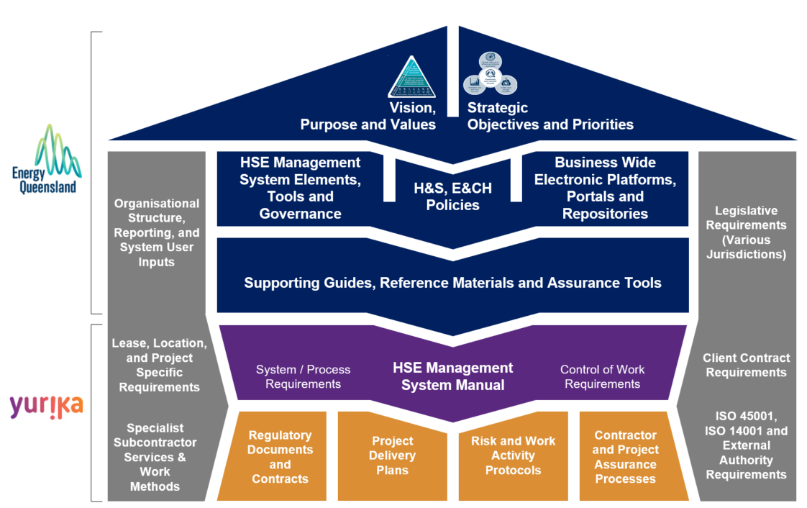
Figure 1 – HSE Management System Framework
This diagram illustrates how:
Colour | Definition
Dark-Blue | Group-wide and whole of Energy Queensland Limited (EQL) requirements provide the overarching principles, direction, system requirements and expectations of Yurika, inclusive of the HSE Policy.
Purple | The HSE Management System Manual sets the HSE standard across Yurika’s operations and projects and these are influenced by internal and external requirements (inclusive of clients, OFSC, ISO45001, ISO 14001, legislation across various jurisdictions; and Yurika personnel).
Orange | Project and work activity specific outputs are developed as a cascade of the Yurika HSEMS Manual requirements and as influenced by client, specialist subcontractors, legislative requirements (unique to that location / activity scope) and management system (OFSC, ISO45001, ISO 14001) output requirements.
Yurika, as a business / subsidiary company within the EQL Group leverage from and align to group / corporate wide processes and requirements where relevant to Yurika activities. As such, Yurika documents and/or outputs may at times be EQL branded, Ergon Energy branded, Energex branded, or Yurika branded if specific to the business.
EQL and its subsidiary companies are currently accredited to operate the HSE IMS which complies with ISO45001:2018 Occupational health and safety management systems and ISO14001:2015 Environment management systems.
The scope of accreditation involves the provision of planning, design, construction, installation, operation, maintenance and asset management of an electricity transmission and distribution network (Distribution Network Service Provider) and ancillary services including training, metering, generation, laboratory testing and calibration.
The following diagram summarises in greater detail the key elements and protocols (not exhaustive) that constitute the Yurika Health, Safety and Environmental Management System.

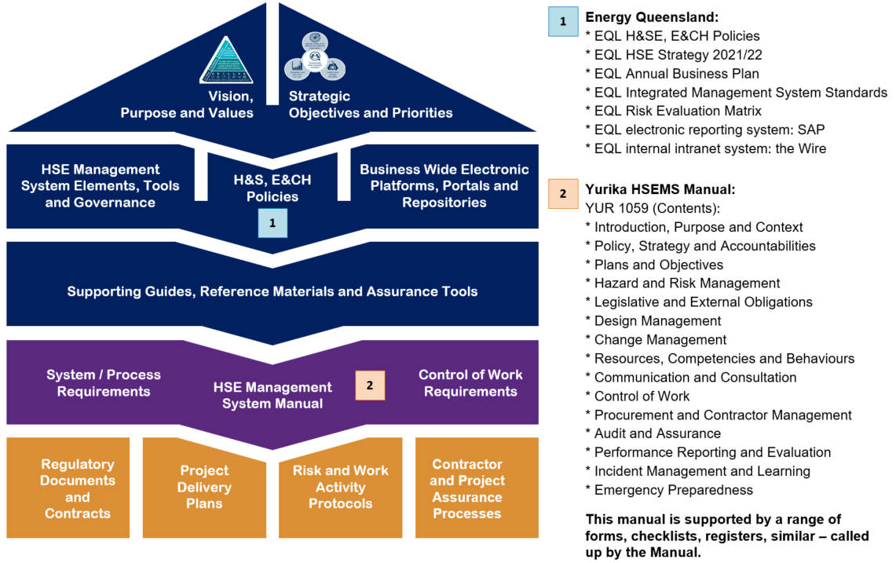
Figure 2 – Yurika HSE Management System Elements

This Plan does not include a duplication of content from the HSEMS Manual elements as listed above. Instead, this plan summarises key requirements and outputs that are relevant to the scope of activities for this project.
Where further information is sought or required, the Project Manager should be contacted so that additional HSE Management System Manual information can be provided.

Policy and Accountabilities

Policy and Commitment
Yurika’s leadership team is committed to maintaining a healthy and safe workplace.
Yurika fosters a culture where all personnel are empowered to implement effective controls, innovate for improved outcomes, and to stop the job if an activity or decision may compromise HSE.
The EQL Health and Safety Policy statements (refer to Appendix 1) apply across Yurika works. This policy describes our focus areas, outline our SKILLED values (Safety, Knowledge, Innovation, Listening, Leading, Engaged, Diversity) and will be communicated as part of the Project Induction.

Accountabilities and Responsibilities
Yurika’s Executive General Manager – Belinda Watton will have overall accountability for the successful execution of the CleanCo Swanbank BESS , including conformance with this HSE Management Plan and positive health, safety and environmental performance outcomes.
The summarised organisational structure for this project is shown below:

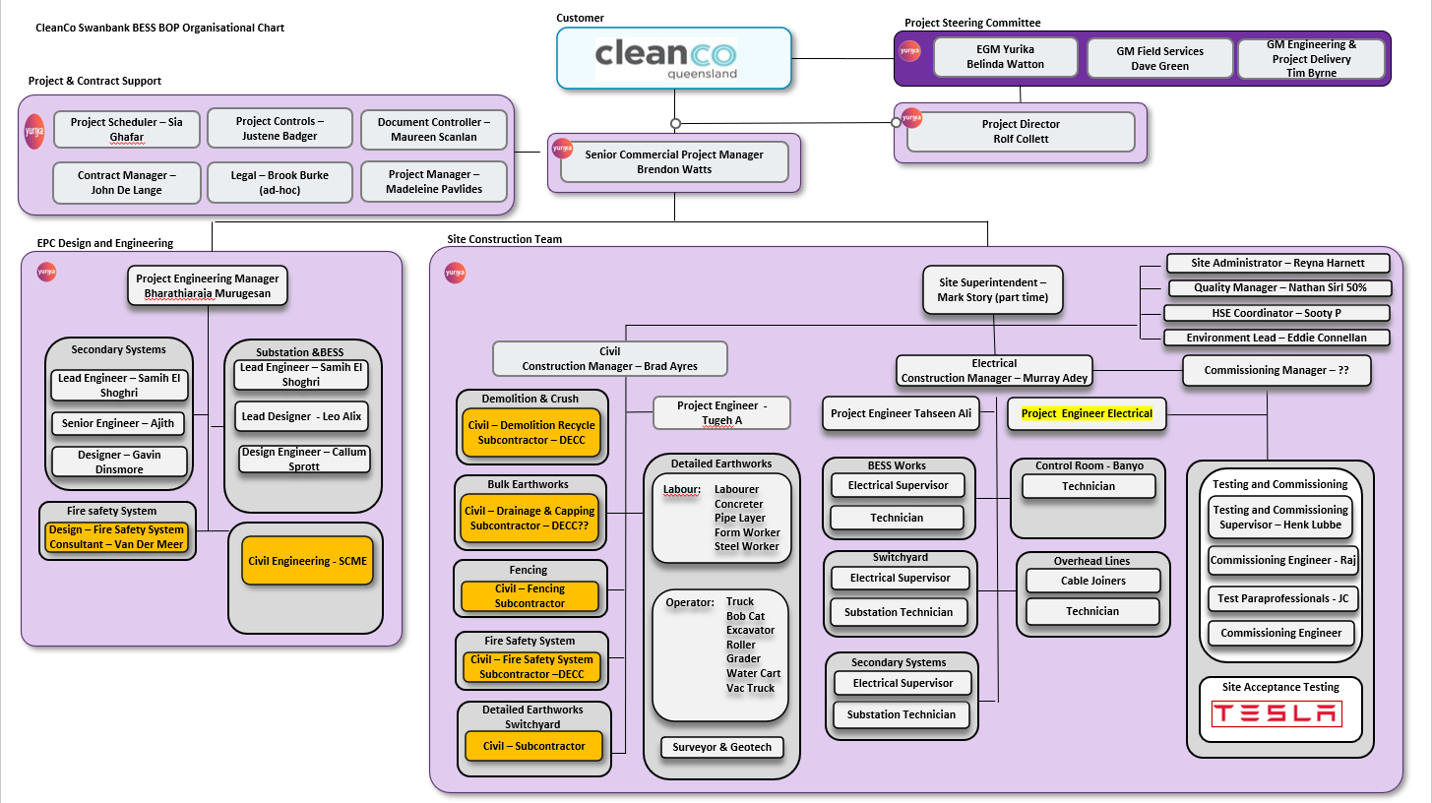

Figure 3 – Project Organisational Chart
Project personnel at all levels and functions will have clear and achievable health and safety (HS) responsibilities, which they will commit to complying with.
Appendix 2 to this plan defines the HS responsibilities for the following project delivery roles:
- Project Director/Project Manager
- Project Engineering Manager
- Site Superintendent
- Civil Construction Manager
- Electrical Construction Manager
- Commissioning Manager
- Project Engineer
- Workers (including EQL shared service personnel and subcontractors).
For emergency-related roles and responsibilities, refer to the project Emergency Response Management Plan (ERMP).
Responsibilities will be communicated to all relevant project personnel via a manner deemed appropriate. This may include:
- During the onboarding / project / program induction process
- During awareness sessions and training courses
- During the Subcontractor selection and engagement process
- Within employment and subcontractor agreements, contracts and/or health and information packs.
Yurika will monitor worker and subcontractor compliance via supervision and observation generally and also via site inspections, safe work method statement (SWMS) observations, leadership site visits and task/behavioural conversations. Refer also to Section 10 – Audit and Assurance.

Project Objectives and Targets
These HSE objectives and performance targets align with Yurika’s company-wide HSE objectives and performance targets, incorporate both lead and lag indicators of performance where relevant, and have been developed to incorporate CleanCo Queensland Limited’s objectives and targets for the project.

Theme | Measure | Target
Positive Choices | Task/Behavior Conversations | >95% safe behaviors identified
Positive Choices | Daily Pre-Start quality | >95% attendance and positive input by work crew
Effort | Monthly Reports and Project Meetings | 100% reports developed and forums held
Effort | Actions from Assurance and Incidents | >95% closed out on time
Effort | Reviewed and Monitored High-Risk Work | 100% of SWMSs reviewed (prior to work)
Prevent Harm | Fatalities, serious incidents, lost time injuries, medical treatment injuries | 0
Prevent Harm | Notifiable WHS or Environmental incidents, including dangerous occurrences / near misses | 0
Prevent Harm | Minor incidents (report only, first aid, minor spill, similar) | < 4
Table 2: Project Objective and Targets
Measurement and reporting against these performance targets will be formally undertaken monthly as part of the Project Monthly Report.
Monitoring and analysing trends, positive performance and areas of improvement will form part of monthly project management meetings.
If deemed appropriate as part of performance monitoring, additional project management actions or improvement plan development may also be undertaken by Yurika to specifically improve an element of HSE performance.

Hazard and Risk Management

General Requirements
All Yurika personnel involved at the project will take the necessary precautions and diligence to:
- Identify hazards.
- Assess the risks associated with those hazards (using the EQL Risk Evaluation Matrix).
- Choose and implement adequate control measures in accordance with the hierarchy of control options to ensure risks are managed So Far As Is Reasonably Practicable (SFAIRP).
- Obtain acceptance of control measures prior to the commencement of work on site.
- Review and monitor control adequacy during work.
The five-step risk assessment process adopted by Yurika and the hierarchy of control options is summarised in Figures 4 and 5.
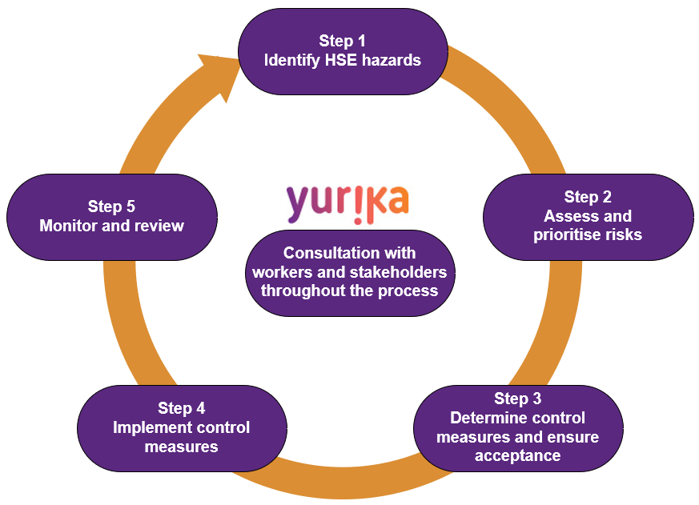
Figure 4 – Five Step Hazard Risk Management Process

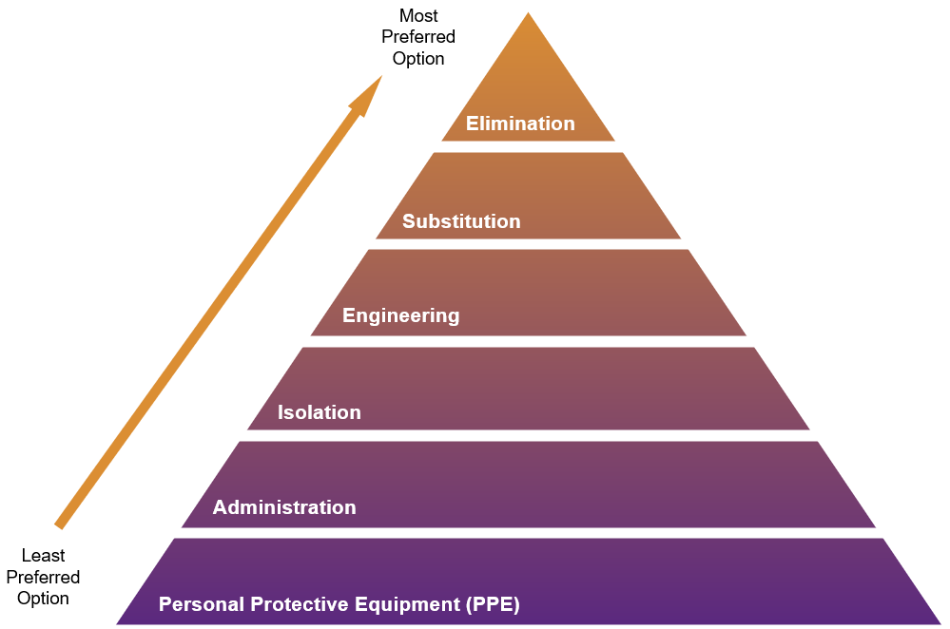
Figure 5 – Hierarchy of Control Options
Refer also to the YUR1303 Risk and Opportunity Management Procedure for further detail regarding hazard identification, risk assessment and control methodology.
All project personnel will be encouraged to identify, eliminate or control hazards within their work areas in accordance with the hierarchy of controls and HSE Legislation. Hazards which workers are unable to immediately eliminate or control are to be communicated to supervisors / leads so that alternative work methods, and/or adoption of additional controls can be determined and documented via one of the following means:
- HazChat form.
- Amended Safe Work Method Statement (SWMS).
- Revised Project Risk Register.

Project Specific Risk Outputs
As per YUR1303 Risk and Opportunity Management Procedure requirements, Yurika will develop, maintain and monitor the following project specific risk management deliverables.
Deliverable | Description | Purpose
Safety in Design (SiD) Risk Register  (Yurika developed for D&C scopes, or client / designer developed for Construct only scopes) | Yurika to develop for D&C scopes, or Yurika will request and review for Construction only scopes  May be developed and refined as relevant over the relevant project delivery phases | To summarise HSE risks inherent in the design and residual risks that apply in the construction phase (and/or maintenance / operation / decommissioning phases)  To assist the Principal Contractor to adequately plan the construction phase
Project HSE Risk Register  (Typically, this is a subset of a multi-disciplined whole of project risk register) | A project specific risk register that addresses HSE risks relevant to the scope of the project, including constructability risks residual to the design.  High level / whole of project in nature | To provide a central register of key HSE risks for the project.  To summarise key Yurika controls.  To clarify key interface risks and protocols to manage these interfaces.
Safe Work Method Statements (SWMS) | Mandatory for high-risk construction work activities at the project.  Developed and endorsed by the teams and personnel doing the work.  Reviewed by Yurika prior to work commencing and updated at least 6-monthly by teams using the SWMSs. | To provide a documented and typically sequenced work method for how the activity will be undertaken.  To identify key HSE hazards and control measures to manage associated risks.  To clarify and communicate HSE requirements for personnel.
HazCHAT Form  (Or equivalent EQL shared service team form, or subcontractor personal task assessment) | Used as part of a daily / pre-task hazard assessment when working per established SWMSs.  Recommended for use when about to undertake a new / non-standard task.  Developed by those doing the work. | To provide a brief prompt and means for personnel to stop, plan and assess their proposed daily work actions.  To enable minor changes, work environment, weather or similar work influences to be considered each day.
Plant Risk Assessments (PRA) | Mandatory for mobile plant used at a Yurika controlled construction project.  Developed and/or reviewed by plant operators. | To summarise the key mobile plant hazards and related in-situ / inbuilt controls that minimise risk for operators.
Hazardous Chemicals Risk Assessment  (May be stand-alone within ChemAlert, a subcontractor format, or contained within SWMS to adequately address chemical use) | Mandatory for hazardous chemicals stored and used at a Yurika controlled construction project.  Developed and endorsed by those doing the work.  Shared and/or made available to client representatives to ensure transparency. | To summarise hazardous chemical use hazards and controls to minimise risk for users.
Table 3: Project Specific Risk Outputs
The Project HSE Risk Register and project specific SWMS will be maintained on site and form part of this Plan.
Utilising the SWMS Review Checklist, Yurika will review and accept or otherwise request further information of EQL shared services team and subcontractor SWMS (submitted via their own processes and templates).
Control measures will be informally monitored by personnel supervising and/or undertaking work activities (those on the job) to ensure the controls remain effective in managing the hazards and risks identified.
At a task and project activity level, formal processes for monitoring the project risk outputs and related control measures will be undertaken via protocols defined in Section 10 of this plan, the Project HSE Risk Register and as prescribed by activity-specific SWMS.
The Project HSE Risk Register and SWMSs will be reviewed periodically. The interval between reviews will not exceed six months.
A review may also be conducted in the following circumstances:
- When control measures are insufficient or cease to be effective in controlling the risk.
- When a notifiable incident occurs.
- Before a change at the project that is likely to give rise to a new or different HSE risk that the current control measures may not effectively control.
- If a new hazard or risk is identified.
- If the results of consultation indicate that a review is necessary.
- If a Health and Safety Representative (HSR) requests a review.
- Following changes to legislation, code or standard requirements.
- Where a safer method of doing the work is identified.

High Risk Construction Work
High risk construction work activities have been identified for this project scope. Refer to Appendix 3 for a listing of relevant activities.

Contractors performing High Risk Work
Specialist contractors used to deliver defined scopes of high-risk work (e.g. confined space entry, work from personal fall protection systems, high voltage switching work, low voltage electrical work), will:
- Provide the necessary resources and capability to establish their own specific rescue / retrieval plans, as prescribed by relevant legislation, codes of practice and Australian Standards.
- Include rescue / retrieval plans as part of, or attach a copy of it to, the applicable activity specific Safe Work Method Statement.
- Provide copies of rescue / retrieval plans to Yurika, as required.
- Be responsible for facility / equipment inspection, monitoring and maintenance, as prescribed by relevant legislation, codes of practice and Australian Standards.
- Be responsible for ensuring worker competency (experience, training, qualifications, licences) with respect to rescue / retrieval.

Legislative and External Obligations
This HSE Management Plan has been developed in accordance with Yurika’s HSE Management System Manual to comply with client specified requirements and relevant QLD HSE legislative requirements.
As per the HSE Management System Manual, a Project Legal and Other Requirements Register has been developed (from the Yurika Legal and Other Requirements Register) and is included as an attachment to this HSE Management Plan.
Yurika as Principal Contractor for this project, will comply with its Principal Contractor obligations and provide a safe place of work at the construction workplace.
Project workers can access items from the above Project Legal and Other Requirements Register via request from a Yurika project team member who will facilitate and enable access (via the internet, internal servers and subscription to on-line databases). This protocol will be communicated during the Project Induction.
Yurika’s Project HSE Risk Register and on-site work activity documentation such as Safe Work Method Statements (SWMSs) have also been developed in accordance with the Project Legal and Other Requirements Register.
Where a legislative change is identified that affects this plan or project specific documentation, a review, update and communication of this change will be coordinated by the Project Manager in accordance with Yurika’s HSE Management System Manual.

Design and Change Management
Yurika has accountability for the following design aspects of this project scope:
- All design aspects to meet client specifications / project scope.
Where practicable, Yurika has undertaken reasonable endeavours to:
- Act as early as possible in the planning stages of this project to influence the design positively from a health and safety perspective.
- Eliminate and/or minimise health and safety risk for personnel involved in the construction phase of the project and its entire lifecycle.
- Confirm, detail and/or finalise design specifications (whether internally developed or otherwise) as early as practicable during the project planning stages; and
- Comply with client specifications and legislative requirements.
A listing of relevant design related specifications, drawings, safety in design risk assessment outputs, similar, are located E&I Swanbank BESS WR1853038 CLEANCO - Project Files – “06 HSE” and “08 Design”.
From a project perspective:
- Yurika’s safety in design protocols will be implemented as per the YUR 1305 Project Establishment and Design Safety Procedure.
- Yurika has used its Project Mobilisation assessment process to aid in the identification and management of scope and design specific issues; and
- Residual design risks of a constructability / buildability nature have specifically been reviewed by Yurika as part of developing the Project HSE Risk Register.
Where a design or technical change is identified during the construction phase of this project, Yurika will manage this change in accordance with the Design Change Documentation section within the Project Establishment and Design Safety Procedure, inclusive of maintaining a Construction RFI Register.

Induction, Training and Competencies

Induction

General Construction Induction
All personnel who will be accessing or working on site will have undertaken a ‘CPCCWHS1001 Work Safely in the Construction Industry training course, commonly referred to as a ‘White Card’. This will be validated as part of Yurika’s project induction process.

Project Induction
All personnel working on this project must completed the online Project Induction and Site Familiarisation Induction prior to being granted access to site.

Visitor Induction
Personnel identified as a Visitor, will need complete the Visitor Induction. Visitor will be supervised, escorted and/or directed at all times when on site by a fully inducted worker.

Delivery Driver Induction
All delivery drivers will undergo a Delivery Driver Induction by a fully inducted worker.
Delivery drivers will be always under the direction of a fully inducted worker. This may include escorting of the delivery vehicle to and from the delivery location.

Short Service Worker Induction
A Short Service Worker (SSW) Induction will be implemented on the Project for works of limited duration up to 2 days. This Induction is for short term trades, consultants, specialists and Emergency works such as machine maintenance or repairs.
The SSW Induction will focus on applicable elements within the Site Induction to focus solely on the essential elements of the Short-Term Works exposures and applicable requirements under this Management Plan.

Competency, Qualifications and Licencing
No worker will undertake activities on site that they are not qualified, licensed or competent to perform. Minimum Yurika requirements are detailed within its Training Needs Analysis.
Yurika will confirm competency of all workers as part of the induction process and prior to starting work on site.
The following can be used as evidence of competency to confirm minimum training, competency, qualification and licensing requirements are verified (in line with requirements identified within Yurika’s Training Needs Analysis):
- A High-Risk Work Licence issued by a state or territory under the National Certification System as per applicable WHS regulatory requirements.
- Where a High-Risk Work Licence is not required by legislation:
    - Licence or Certificate of Competency issued under previous state or territory legislation for which there is no longer a High-Risk Work Licence required (e.g. load shifting equipment).
    - Statement of Attainment or Certificate issued by a registered training organisation (RTO) for the successful completion of the appropriate unit of competency in the nationally recognised training (NRT) package (this includes certificates for qualifications or degrees under the Australian Qualifications Framework).
    - Evidence of formal verification of competency (VOC) assessment against defined competency standards, which:
      - Is to be completed, or confirmed as having been completed, by the accredited company to an acceptable level, such as the relevant NRT package.
      - Includes a detailed and documented assessment standard.
      - Is completed by a person or persons who meets the documented competency as defined by the company conducting the VOC assessment.
      - Is evidenced by a signed and completed VOC assessment.
Evidence sighted (inductions, licences, statements of attainment, certifications, similar) will be maintained on site via photocopies, scans, electronic files (i.e. within Lucidity) or in hard-copy form.

Communication, Consultation and Reporting

General Requirements
Yurika will proactively consult and communicate with personnel (including subcontractors, suppliers, client representatives and external stakeholders as relevant) when:
- Identifying hazards and assessing risks
- Making decisions about ways to eliminate or minimise those risks.
- Making decisions about the adequacy of facilities or the welfare of workers.
- Proposing changes that may affect the health and safety of workers.
- Developing and reviewing SWMSs or HSE procedures relevant to their work.
- Making decisions about procedures for consulting with workers, issue resolution, monitoring workers’ health, monitoring project conditions and providing information and training to workers.
In addition, Yurika will:
- Provide ready access to its HSE Management System Manual, this Plan and related documents as appropriate.
- Facilitate health and safety representative elections and/or establish a health and safety committee where requested by workers on the project in accordance with legislative requirements.
- Share information on its HSE performance to workers and other interested parties as part of established formal meeting/discussion forums.
- Share good practices, HSE/incident alerts, lessons learnt and opportunities for improvement.
Further requirements are outlined in the EQL Standard 7 Communication and Consultation and Work health and safety consultation, cooperation and coordination Code of Practice 2021.

Project Specific Mechanisms
On this project, Yurika will communicate, consult and report via the following methods.
Method | Frequency / Description | Output / Record
Pre-start Briefings | Daily (attended by all on the project).  To confirm work activities, controls and interfaces for the shift about to commence.  To reflect on previous work / progress/ hazards / incidents / what’s working well.  Client representative to have standing invite. | Pre-start Briefing Form and/or HazChat Form.
Toolbox Meetings | Monthly (attended by all on the project)  To run a focused HSE discussion relating to a particular topic / incident / industry communication / site-specific hazard / similar.  To share information and raise awareness.  Client representative to have standing invite. | Toolbox Meeting Form.
Project Management Meeting | Monthly (attended by Yurika Project Manager and supervisor personnel).  To discuss HSE performance / project progress / action management / upcoming works / subcontractor issues / client satisfaction / other stakeholder issues / similar.  This meeting will be supported by a Project Performance Report that includes summary HSE performance information inclusive of information relating to HSE Objectives and Targets.  Client representative to have standing invite. | Project Management Team Meeting Minutes.  Project Performance Report.
Client / Project Control Meetings | Monthly / As specified by the Client (attended by Yurika Project management representatives and Client representatives).  To discuss HSE performance / project process / performance against the contract / Interface with Client’s subcontractor/ specific agenda items required by the Client.  This meeting will be supported by a Client Performance Report that includes summary HSE performance information inclusive of information relating to HSE Objectives and Targets.  Site Supervisor to attend all site meetings. | Client / Project Control Meeting Minutes.
Noticeboard Information | Ongoing (displayed in prominent on-site location/s).  To provide HSE information and promote transparency of HSE communications with all personnel on site.  To share industry / incident / general HSE information. | Displayed information on Noticeboard/s on site.
Table 4: Project Specific Mechanisms – Communication, Consultation and Reporting
Where a worker asks for the election of a Health and Safety Representative (HSR) to represent them on work health and safety matters, Yurika will facilitate an election at the project and comply with legislative requirements relating to the election process; training of the HSR/s communicating HSRs; regulator notification; and ongoing HSR consultation and support.
Similarly, Yurika will establish a WHS Committee in accordance with legislative requirements, upon request by a Health and Safety Representative, or upon request by workers in accordance with legislative requirements.
As relevant, Yurika will also consult and communicate with the following external stakeholders about the project, HSE matters and effective hazard identification, risk assessment and control:
- Local council or state government representatives.
- Relevant government authority or regulatory bodies.
- Asset owners or service providers (e.g. gas, electricity, telecommunications, water and drainage) – particularly where these service providers may have assets on site and the assets require relocation, testing, monitoring, maintenance, repair or new assets installed.
- Adjacent residents, building or structure owners, businesses and community groups.
Records of formal consultation and HSE performance reporting will be maintained and readily accessible at the project.

Issue Resolution
Yurika will implement an issue resolution process for HSE matters or areas of worker health and safety concerns. This process will be communicated with workers on this project via the Project Induction. The issue resolution process involves attempting to raise and resolve issues progressively through Yurika’s structure and ultimately externally via the relevant Government Authority until the issue is resolved as shown in the figure following.
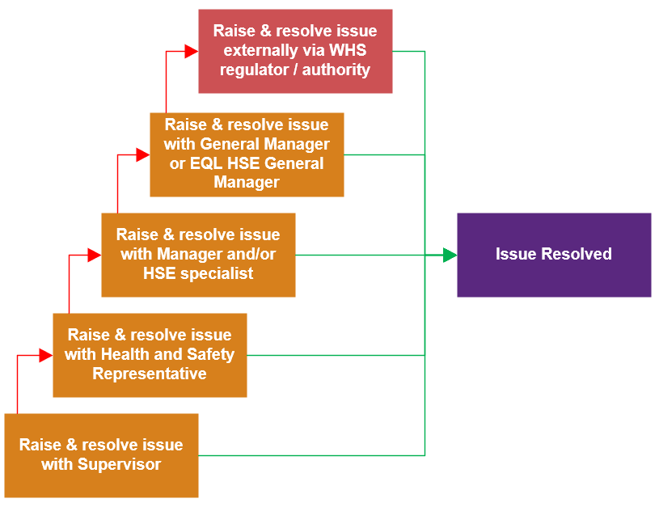

Control of Work

Safe Systems of Work
The table following summarises project specific entities involved with the work scope and relevant safe systems of work (SSoW) that will apply or be interfaced with by Yurika.
Entity | SSoW Type | Description
Client – CleanCo | Online Induction  Safe Work Authorisations (Permit)  Safe Work Authorisation (Permit)  IC – Isolation Certificate  SIC – Switching Isolation Certificate  CSEC – Confined Space Entry Certificate  Area Handover  CleanCo’s Fatigue Management Procedure  Vehicle Parking, Isolation and Maintenance Business Procedure OHS-PROC140  CleanCo-Site-Conditions-200914 | Cleanco ePas Safe System of Work – Refer to section 9.2.  Where CleanCo’s asset has been identified, Yurika will seek permission to undertake the works on the asset. Yurika to follow CleanCo’s SSoW when undertaking works on CleanCo Asset.
Principal Contractor - Yurika | YUR 0002 Project Risk Register  Yurika Online Induction  YUR 1055 Emergency Response Plan  YUR 1056 Health & Safety Management Plan  Yurika Permit to Work System  Traffic Management Plan  Safety in Design | Yurika Principal Contractor SSoW
Asset Owner / Network Operator | ADHOC services if required | Not required at time of development
Internal Shared Services Work Team | ADHOC specialist services as required | -
Specialist Contractor | Health & Safety Management Plan | Specialist Contractor SSoW
Table 5: Safe Systems of Work

CleanCo Safe System Core Principals
CleanCo’s safe work system is designed and executed to ensure adherence to the following core principles:
- Actively contributes to CleanCo’s HSE Fundamentals, HSE Policy commitments and overarching Values by providing a mechanism for the protection of people, plant and the environment.
- Achieves compliance with relevant legislation and standards, inclusive of the Queensland Electricity Generators Permit to Work (PTW) Code of Practice.
- Is a whole-of-work system linking safe and environmentally responsible work practices with maintenance management and authorisation protocols to deliver an integrated approach to hazard management and work completion.
- Ensures protection against the inadvertent restoration of hazardous energies. This includes the use of an isolation point locking system and includes a personal locking system. Only authorised personnel are permitted to adjust safe work system tags and locks in accordance with detailed planning, placement, adjustment and removal protocols.
- Ensures consolidated business processes / requirements and is operationalised by an Information Communications Technology (ICT) process which is regarded as intuitive. The defined process is consistently applicable to each of the organisation’s generation sites.
- Ensures that the defined and documented process for relevant work activities is followed in a sequential, well-ordered manner and independent checking / verification hold points are included at all necessary stages.
- Is adequately supported at all levels of the organisation from both an operations and information technology viewpoint.

Activity RACI
Further to the above, Yurika has prepared an activity RACI that clarifies a range of activities required at the project and an indication of Responsible / Accountable / Consulted / Informed status in relation to these activities or the control of work. Refer to Appendix 4.

Audit and Assurance
Audit and assurance activities will be undertaken on the project with the objective of improving performance across the project. This will primarily be achieved by personnel undertaking assurance processes in an open and transparent manner, and by identifying both positive findings as well as deficiencies or areas for improvement or action. More specifically, these assurance activities aim to:
- Monitor and review the adequacy of work activity controls.
- Confirm high risk construction work practices align to documented SWMSs requirements and prescribed legislative requirements.
- Monitor work behaviours / practices, physical work environment and equipment issues.
- Conform to audit and assurance requirements specified by CleanCo.
The table following summarises the various activities that will be applied on this project in line with the HSE Management System Manual YUR 1059 and Auditing and Management Review Procedure YUR 1308.
Assurance Type | Applicability / Situation | Method / Tool and Frequency
Informal / on-the-job hazard identification and control | - Undertaken by workers and contractors during all work  - Undertaken by managers and supervisors as part of ongoing supervision | Informal / Undocumented  Ongoing
Leadership site visits | - Undertaken by Yurika Senior Managers  - To facilitate senior leadership on-site discussions | Leadership Site Visit Form  When Senior Leader attends the project – monthly
Task / Behavioural conversations | - Undertaken by Managers and Supervisors.  - To facilitate on-site HSE conversations and behavioural focused interactions. | Task / Behavioural Conversation Form  Frequency: Monthly
SWMS observations | - Undertaken by Supervisors and Managers.  - To facilitate on-site observation of high-risk construction work methods and verify SWMS implementation of Yurika and Subcontractor | SWMS Observation Form  Frequency: Monthly
General Site inspections | - Undertaken by Supervisors and Managers.  - To facilitate in-field inspections of work areas and check the adequacy of controls for on-site hazards of Yurika and subcontractors. | General Site Inspection Form  Frequency: Monthly
Mobile plant inspections | - Undertaken by Supervisors.  - To facilitate in-field inspections of powered mobile plant activities and associated documentation of Yurika and Subcontractors. | Plant Inspection Form  Frequency: Monthly
Process HSE audit | - Undertaken by Yurika HSE Specialist.  - To review the implementation of Yurika’s HSE Management System. | Process HSE Audit  Frequency: Monthly
Table 6: Audit and Assurance
These assurance processes are additional to other reviews and scheduled activities detailed elsewhere in this Plan or the Project HSE Risk Register, such as:
- Periodic Project HSE Risk Register reviews and updates.
- SWMS reviews and updates.
- Subcontractor documentation reviews as part of pre-mobilisation (SWMS Reviews).
- Emergency drills.
- Inspection, testing and tagging of fire response and protection equipment.
- Inspection of powered mobile plant, equipment and tools used at the project.
- Inspection, testing and tagging of electrical equipment.
- Inspection and tagging of rigging, lifting and personal fall protection equipment.
- Inspection, testing and calibration of specialist devices (e.g., for survey, measurement, testing, medical response; atmospheric monitoring, drug and alcohol testing, occupational hygiene monitoring and similar).
All engaged Subcontractors must participate in inspections and investigations relative to their scope of work and activities.

Non-Conformance and Corrective Actions
Any Non-conformances arising during the course of the project will be dealt with promptly with appropriate consultation to be made with the client or Regulator, to correct the non-conformances.
Non-conformances and/or Corrective Actions issued by Yurika from an inspections, observations or audits will be recorded in Lucidity INFORM Module and tracked until closure. The person conducting the inspection, observation or audit to enter the corrective actions it into the Lucidity INFORM Module and assign it to appropriate person to action (Actionee). The Actionee must take the required measures to address the action and close the action in Lucidity.

Incident Management and Learning
All HSE related incidents are to be reported immediately to an on-site supervisor and escalated to the Yurika Project Manager. This includes incidents involving impact or potential impact to workers, the environment or cultural heritage, service delivery, network asset, fleet, property and equipment or other personnel including members of the public.
Yurika will subsequently report all incidents to CleanCo as soon as practicable and as per Swanbank BESS Project BOP EPC Contract (7 December 2023) EXECUTION VERSION requirements.
Incident response, reporting, external regulator notification, investigation and subsequent action management and communication will be managed in accordance with:
- Yurika’s HSE Management System Manual YUR 1059.
- EQL’s R073 HSE and Asset Management Incident Management Framework.
- the EQL Incident Classification Table R025 Incident Classification Table.
Contractors shall report all incidents to their Yurika supervisor immediately through the Lucidity platform using the incident notification process. Incidents shall then be transferred from the Lucidity platform and into SAP by Yurika personnel and managed through the EQL SAP system.
The Yurika work supervisor / incident manager is responsible for ensuring that all incidents under their area of control are reported and recorded within required timeframes. Incidents will be recorded and classified in EQL’s SAP electronic system as soon as practicable and within one business day of the incident occurring.
Yurika also has legal obligations to notify regulatory bodies of prescribed incidents contained within the respective HSE legislation for incidents which arise from the conduct of the organisation as a PCBU, and where it possesses a duty to notify.
HSE incidents will be investigated to:
- Ensure that suitable investigation methods, interviews of personnel and recording of witness statements is undertaken.
- Determine the root causes / causal factors and contributing factors that led to the incident.
- Identify and manage corrective actions aimed at eliminating or minimising the opportunity for recurrence.
- Ensure that Yurika supervisors / managers are involved in reviewing investigations and corrective actions agreed to.
- Facilitate a review of relevant Yurika and/or contractor processes / procedures where identified / recommended as part of investigations.
Refer to the HSE Management System Manual YUR 1059 for detail requirements relating to reporting; recording and external notification; investigation; improvement actions and learning.

Emergency Preparedness
Yurika has developed an Emergency Response Management Plan (ERMP) for this project. The ERMP takes into account:
- The project location, proximity to emergency services support and client and neighbouring stakeholder factors.
- Credible emergency scenarios applicable to the project scope and specific high-risk activities.
- Consideration of external factors such as weather and seasonal issues.
Refer to the ERMP for specific information not limited to key emergency contact information; response protocols; first aid and emergency response resources.

Operational Protocols and Controls

Drugs and Alcohol
The possession or consumption of illicit drugs (including synthetic drugs) or unauthorised use of alcohol is prohibited on the Project.
Although Yurika has no contractual requirement to conduct alcohol and drug testing, where requested and formally managed by the client, Yurika and its subcontractors will participate in client testing requirements. Yurika will confirm that the client testing is undertaken by trained personnel, in accordance with the client’s procedure or standard.

Fatigue Management
Yurika shall manage risk associated with fatigue in accordance with Energy Queensland’s Standard for Fatigue Management, covering the minimum requirements for working hours, work schedules, rest periods, fatigue assessment and other fatigue-related responsibilities of workers, supervisors and managers to support the effective management of fatigue risk.
Refer to Appendix 5 Fatigue Management Requirements for further requirements.

Health Hazards and Hazardous Chemicals Management
Yurika shall manage risks associated with Hazardous Chemicals in accordance with the YUR 1301 Hazardous Chemicals and Health Management Procedure, Managing risk of hazardous chemicals in the workplace Code of Practice 2021, Preparation of safety data sheets for hazardous chemicals Code of Practice 2021 and Labelling of workplace hazardous chemicals Code of Practice 2021.
Potential health hazards relating to the project construction activities have been identified and assessed within the Project HSE Risk Register and also within activity specific SWMS.
Consideration has been given to hazards of a biological, physical, and chemical/atmospheric contaminant nature. As a non-exhaustive guide, the following hazards have been considered:
- Biological hazards: drinking water, wastewater, communicable diseases, blood borne biological agents.
- Physical hazards: occupational noise, vibration, ionising and non-ionising radiation sources.
- Chemical/atmospheric contaminants: inhalation, ingestion, skin and eye exposure to hazardous chemicals in solid, liquid or gaseous forms; exposure to unsafe confined space atmosphere; inhalation of asbestos; synthetic mineral fibres, crystalline silica or other harmful dusts.
Yurika will review substances hazardous to health, hazardous chemicals or dangerous goods prior to their use on this Project. Yurika will ensure controls are implementation and maintained, not limited to:
- Hazardous chemicals will be registered within Yurika’s ChemAlert system or subcontractor specific hazardous chemical registers reviewed by Yurika.
- Copies of SDSs will be readily available to workers.
- Risk assessments have been conducted for hazardous chemical use (via ChemAlert risk assessments; stand-alone risk assessments; or SWMSs that address work involving the use of the hazardous chemicals).
- Labelling, storage, segregation and PPE controls are implemented as per SDS and risk assessment outcomes.
- CleanCo require all chemicals and hydrocarbons be stored in a bund large enough to contain 110% capacity of the chemicals it contains.

Work Environment and Facilities
Yurika shall manage risks associated with the work environment and facilities in accordance with Managing the work environment and facilities Code of Practice 2021.
Housekeeping must be effectively managed to maintain a clean and tidy work site.
All main access ways, emergency routes and passageways must be clearly lit, marked and kept free from obstructions and debris to reduce the risk of trips and slips.
All materials must be safely stacked (i.e. stack is on solid ground, is stable and not over-stacked), away from fences and hoardings, and located to minimise re-handling and transport distances. Materials must be stacked in a manner that does not require work at height to manage the stack (e.g. to attach lifting equipment).
Risks of cuts and punctures from sharp objects must be assessed and controlled (e.g. needle handing, safety knives, gloves, removal of protruding nails, protection or curving of reinforcement bars, use of safety glass, etc).
Signs must be posted where necessary to provide clear instructions – e.g. “No Smoking”, “No Entry”, “Personal Protective Equipment (PPE)” etc.
All waste must be disposed of appropriately, ensuring that all recyclable materials are disposed of correctly and not into general waste.
All site offices and amenities are to be maintained to Yurika requirements and must include:
- First aid facilities in place that meet the legislative requirements.
- All amenities are maintained clean and tidy.
- Rubbish is regularly removed.
- Facility maintenance and general hygiene is maintained.
- Identification, storage and management of hazardous substances is conducted.
- Facilities are inspected as part of general site inspections.
Smoking is prohibited onsite at Swanbank Power Station. There is a designated smoking area located outside the main entrance.

Personal Protective Equipment (PPE)
Any worker or visitor accessing the project will adhere to the minimum PPE requirements, as listed below unless accessing a designated PPE-free area, which includes car parks, site offices and crib facilities, vehicles and mobile plant cabs.
- Safety boots.
- Long trousers.
- High visibility long sleeved shirt or long-sleeved shirt with a High Visibility Vest.
- Safety glasses.
- Hard hat.
Further requirements on the PPE Standards refer to Energy Queensland’s Standard of Personal Protective Equipment.
Where any work activity requires additional PPE requirements (e.g. gloves; face protection for hot work activities), these requirements will be stipulated within the work activity SWMS.
PPE will be supplied by each workers’ respective employer, in accordance with the requirements of this section.
Any PPE that is damaged or outdated will not be used on site.
Workers will be provided with instructions in the equipment’s safe use, inspection, cleaning, maintenance and storage, as relevant, prior to its use on site. This is to enable the equipment to be used as intended and for risks to be controlled as intended.

Barricades and Signage
Barricades will be erected and maintained by the workers initiating the work activity, with barricade positioning such that the barricade:
- Effectively controls the hazard SFAIRP.
- Does not impede on other workers or work areas.
- Does not block clear access to emergency equipment, facilities or exits.
- Barricades selected for use on site will be suited to the risk or risks they are positioned for.
All signage installed/used on site will be in accordance with AS 1319:1994 – Safety signs for the occupational environment.
Establishment of an exclusion zone around operating plant is mandatory. The control measures that are used to identify the exclusion zone and control the risks associated with operating plant, may vary depending on the practicality and effectiveness of the control measures. Such control measures are defined in specific SWMS for the activity that may include, but not limited to, one or more of the following:
- Spotters.
- Hard barricading including ATF fencing or barriers.
- Medium barricading including crowd control barricades and webbing.
- Soft barricading including cones (i.e. witches’ hats) and flagging.

Powered Mobile Plant
Yurika shall manage risks associated with Powered Mobile Plant in accordance with the YUR 1306 Vehicles, Plant and Equipment Procedure and Managing the risk of plant in the workplace Code of Practice 2021.
As a minimum, all plant is to meet the relevant Australian Standards and is to be maintained in alignment with manufacturer’s specifications.
Operators of powered mobile plant will undertake Yurika’s Project Induction, inclusive of competency validation protocols.
Operators will only operate powered mobile plant that they are licensed/competent to operate, and in accordance with a SWMS suitable for the use of that plant item.
A Mobile Plant Pre-Commencement Checklist will be undertaken prior to plant commencing work on site. This inspection will verify items not limited to:
- Currency of plant registration and/or conditional road registration certificates (where relevant).
- Currency of servicing/maintenance records.
- Presence of a plant risk assessment that is suitable to the specific item of plant.
- Presence of pre-start inspection process that is suitable / aligned to the specific item of plant.
Maintenance works must be planned, scheduled and undertaken by a competent person. Plant maintenance records are to be readily available for all items of plant used on site.
Powered mobile plant pre-start inspections will be completed using in-cab hardcopy forms, an electronic inspection application (e.g. Plant Assessor) or equivalent subcontractor inspection process.
Plant must be secured when unattended or not in use to avoid unauthorised use. This includes shutting machine down and removing ignition keys.
Separation / complete exclusion of worker on foot access to powered mobile plant areas is to be implemented SFAIRP.
Note additional site-specific plant requirements:
- No brass fittings or Utilux (worm drive) clamps for air hoses are permitted on sites.
- All Elevated Work Platforms operated at CleanCo sites are to be fitted with a pressure sensing secondary guarding device.
Powered mobile plant and Vehicle belonging to Contractor’s may be driven on to Construction Site with the prior approval of Yurika and where applicable a relevant weed hygiene declaration certificate may be required.
Speed limit on site is 10 kilometres per hour unless signed otherwise.
Parking on site:
- Vehicles must be parked only in designated car parks outlined within Yurika construction area or other authorised areas.
- Vehicles shall be parked to allow the first movement to be in a forward direction (reverse parked);
- Vehicles are parked in a safe location wherever possible; this includes parking on a level surface and parking away from any traffic flows.
- The vehicle transmission is placed in gear (or “park” for automatic transmissions) with the engine switched off.
- The park brake shall be applied before leaving the vehicle; and
- The operator shall lower all ground engaging devices such as blades or tines, if applicable.

Excavations
Yurika shall manage risks associated with earthworks and excavation in accordance with the YUR 1310 Excavation Procedure and Excavation work Code of Practice 2021.
All excavation work is to be conducted in accordance with prescriptive legislative requirements, inclusive of ensuring mandatory excavation collapse controls for excavations greater than 1.5m deep that require entry.
Where there is a potential to contact underground services, (e.g. gas, electricity, sewer, water mains, fibre optic, etc) it is the responsibility of Yurika to ensure current underground essential services information (i.e. Dial Before You Dig and project utilities drawings) are made available to relevant parties undertaking ground disturbance, before works commence.
Where there is doubt of service location, then a suitable detection device must be used to locate and mark underground services (electricity, gas, etc) before works commence. Where any uncertainty exists regarding the location of underground services hand digging or potholing must be used to identify and sight the services.
Asset / utility owner requirements must also be complied with and detailed/referenced within activity specific SWMSs. All works involving excavations must be planned and communicated to those undertaking the works. Detailed SWMS are to be developed for all excavation works and for work requiring entry in excavations, at least one of the following control measures must be in place:
- Battering
- Benching
- Shoring
- Certification by a geotechnical engineer (inclusive of constraints and ongoing inspection requirements).
Barricading will be positioned well clear from excavation edges to exclude worker access into a location where there is a risk that they may fall into an open trench, excavation or non-trafficable embankment.
Removal of all water, excavated materials and other waste is to be disposed of to a place directed by the CleanCo Representative and in an environmentally friendly manner in accordance with any relevant law or government consent and/or via a suitably qualified and fit for purpose specialist subcontractor.

Work at Heights and Ladders
Yurika shall manage risks associated with Working at Heights in accordance with the YUR 1309 Safe Work at Heights Procedure and Managing the risk of falls at workplace Code of Practice 2021.
Controls to prevent falls from one level to another are to be implemented SFAIRP across the site.
Fall prevention controls will be implemented wherever practicable (e.g. construction at ground and lift into position; elevating work platforms, scaffolding, guard railing, or similar where a person has a form of edge protection).
Fall protection controls (reliance on fall protection or catch equipment as the sole means of fall protection) will be used as a last resort and only when primary control options have been exhausted.
An activity specific SWMSs will be used for all tasks where reliance on fall protection or catch equipment as the sole means of fall protection is used and for work involving an EWP.
An activity specific emergency rescue/retrieval plan referenced in the SWMSs will be established for the rescue of a suspended worker. Retrieval plans will:
- Detail the emergency equipment required to be immediately accessible to affect the retrieval (e.g. elevating work platform, crane and rescue/work box, rope rescue and retrieval equipment).
- List the competencies/qualifications of personnel required to be immediately on hand to affect the retrieval.
- Summarise the method/actions to be taken to affect the retrieval.
100% hook up will be required at all times while a worker is using personal fall protection equipment (in fall restraint or fall arrest scenarios).
Fall arrest anchor points will be installed and certified by a competent person and will be designed and used as per relevant Australian Standards.
Scaffolding will be erected and dismantled by licenced scaffolders only using a sequential method so that scaffolders have primary fall protection available during their activities.
A Scafftag system will be implemented for all scaffolding structures and fall arrest anchor-lines. Scafftags will be placed at each entry point to the scaffold or anchor-line.
Formal inspections will be completed and recorded on the Scafftag by a competent scaffolder at first use, every 30-days and where a change to the scaffold system occurs.
Relevant falling object prevention and protection controls to eliminate or minimise risk will be detailed within SWMS where there is potential for objects (equipment, materials, tools, debris, similar) to fall.
Ladders are only to be used for access activities where other methods of higher control are not practical. In such instances, ladders are to extend at least 1 metre past the landing and be secured in place.
Platform ladders can be used for works of short duration. Mobile scaffolds and scissor lifts are to be used as the first preference.

Electrical Safety
Yurika shall manage electrical risks in accordance with YUR 1307 Electrical Work and Activities Involving Services and Managing electrical risks in the workplace Code of Practice 2021.
Electrical work will only be undertaken by licenced electrical workers.
Installation of temporary electrical installations and management of electrical hazards on site will be done in accordance with:
- AS/NZS 3012:2010 Electrical installations—Construction and demolition sites requirements
- AS/NZS 3000:2018 Electrical Installations
- State / territory specific regulatory and code of practice requirements.
Electrical work on energised electrical equipment is prohibited on the project unless the tasks involve fault finding or testing of energised electrical equipment.
Where a work scope requires isolation of incoming and stored energy, the isolation will:
- Be planned in a documented list / isolation sheet / similar.
- Be completed before work commences.
- Use lockout, tagout and testing to prove de-energised protocols.
- CleanCo will issue all relevant Contractor’s Personnel with a unique personal isolation lock and key for use as part of the isolation point locking system (Personal Locking). This CleanCo issued lock is the only lock that may be used by the Contractor and Contractor’s Personnel as part of the CleanCo isolation point locking system. Personal locks or locks from other organisations are not permitted for use on the Site. It is a requirement that all Contractor’s Personnel return the CleanCo issued lock and key when required / requested. If the lock and key is not able to be returned, or is returned in a non-serviceable condition, CleanCo may seek to recover costs from the Contractor.
Established EQL protocols for working on / adjacent to overhead electrical lines must be adhered to at all times.
Installation of any temporary electrical switchboard, construction wiring, or electrical installation will be supported by a completed certificate relevant to the jurisdiction (e.g. certificate of testing and compliance; certificate of compliance for electrical work; equivalent).
Testing, inspection and tagging of electrical equipment will be undertaken based on the environment the equipment is used in, as guided by AS/NZS 3760: 2010 In-service Safety Inspection and Testing of Electrical Equipment. This will involve three-monthly inspection, testing and tagging of the equipment involved with construction activities and equipment used in office, crib, similar environments on the project.
Electrical leads will be protected from damage, not joined together and clear of access/egress points.
Construction wiring will be adequately supported, insulated and marked as construction wiring in accordance with AS/NZS 3012.
Residual current devices (RCD) will be fitted to all temporary electrical switchboards and protect all construction sub-circuits, including portable generators. RCDs will be inspected, tested and tagged per AS/NZS 3012 and AS/NZS 3760 requirements with records maintained and readily available.
An out of service tag will be fitted to any damaged or out of currency electrical equipment until the equipment is inspected, tested and tagged, or discarded of.
Prior to undertaking any works on energised plant, equipment or maintenance on equipment, effective isolation procedures must be implemented and must include physical lock out and tag out. Lock out and tag out controls must be documented in the associated SWMS for that activity.

Cranes and Lifting Operations
Yurika shall manage risks associated with Cranes and lifting operations in accordance with the YUR 1306 Vehicles, Plant and Equipment Procedure and Mobile Crane Code of Practice 2024.
All lifting and slinging works undertaken on site must be documented and approved by a competent (licenced) person. As a minimum the following applies to all crane and lifting works:
- Equipment must be authorised by Yurika for use on site.
- Workers undertaking the works must be licenced.
- Detailed SWMS developed, approved, implemented and monitored.
- Exclusion zones appropriate to the task are to be established and maintained.
- All equipment must be inspected prior to use and documented.
- All cranes are to be inspected when arriving on site with daily operator pre-starts as per manufacturer guidelines.
- Lifting gear must be inspected, tagged in date, and maintained.
- Annual crane inspections undertaken by a competent person and verifiable.
In all cases where a delivery is made using a truck mounted crane (e.g. HIAB), it is the responsibility of the Supervisor who is receiving the goods/materials to ensure that the following apply:
- A dedicated laydown area must be provided or a laydown area clearly demarcated away from any work activity.
- Outriggers must be established without any “short legging”.
- The wheels of the truck must be braked or chocked before any loading or unloading occurs.
- Access to the tray of the truck must only be obtained via work platform or dedicated stairway with a handrail. No work or access can be undertaken from the tray of the truck unless adequate fall protection is in place.
- All loading and unloading must be done on the opposite side of the truck mounted cranes controls being used to load or unload.
- Operators of truck mounted cranes must be trained and assessed as competent in the operation of the crane and also hold a basic dogging certificate.
- Work area is to be barricaded.
Where lifting operations are undertaken via the use of excavators, loaders, telehandlers or similar:
- SWMS specific to the lifting activities must be implemented by competent plant operators.
- Manufacturer-specified lifting points, attachments and controls such as anti-hose burst protection must be fitted/used as part of all lifts.
- The plant must contain manufacturer load charts displayed or readily available in the cab.
- Safe Working Limits (SWLs) or Working Load Limits (WLLs) must not be exceeded under any lifting configuration.
- Personnel involved with slinging loads must be a licensed dogger, or only undertake lifts not requiring a dogging licence as outlined in the Safe Work Australia High Risk Work Licensing for Dogging Information Sheet.
Lifting and rigging equipment must be inspected, tested and tagged as fit for safe use in accordance with frequencies defined in the Australian Standards applicable to the item (e.g. AS 4991:2004 Lifting devices, AS 4497.1:2018 Round slings - Synthetic Fibre, AS 1353.1:1997 Flat synthetic-webbing slings, and AS 3775.1:2014 Chain slings for lifting purposes - Grade T(80) and V(100)).
Records of periodic inspections (typically three-monthly – soft slings, 12-monthly – all other devices, or based on usage for alloy chain slings) will be maintained and readily available by Yurika or the relevant subcontractor via lifting and rigging equipment registers, inspection reports or proof load testing certificates.
Refer to YUR 1304 Vehicles, Plant and Equipment Procedure for detailed cranage and lifting requirements.

Fire Prevention and Hot Work
Suitable waste containers and bins will be provided and regularly emptied to ensure combustible waste does not accumulate on the project.
All powered mobile plant used on the project will be fitted with a fire extinguisher.
Flash back arrestors must be in place on the regulator end of supply hoses for oxy acetylene welding and cutting sets.
Fire detection and response provisions will be identified, implemented and maintained throughout the duration of the project, in line with fire risks identified within the project ERMP.
Hot work activities (activities involving welding, open flames or sparks) will be undertaken within a designated workshop area wherever practicable, where purpose-built fire detection and response controls are readily available and flammable/combustible materials are not in the vicinity of the works.
A Permit to Work is required to perform hot works activities in accordance with the YUR 1079 Permit to Work Procedure.
Where hot work activities are undertaken outside of designated workshop areas, the activity will be documented via an activity specific SWMSs. The SWMS will address aspects not limited to:
- Hot work task details.
- Controls required to remove combustible or flammable materials.
- Controls required to protect, shield or cover sensitive equipment or areas into which sparks could fall.
- Fire response and emergency equipment required to be ready at the work location.
- Designated fire watch requirements.

Noise Management
Yurika shall manage risks associated with noisy activities in accordance with Managing noise and preventing hearing loss at work Code of Practice 2021.
Where practicable, Yurika and our subcontractors will implement controls on site to minimise exposure to noise, to levels that do not exceed 85dB(A) over an eight-hour period, or a peak exposure of 140dB(C) or more. Yurika does recognise however that certain tasks will present increased noise exposure risk for personnel.
Controls to manage noise on the project will be addressed within the Project HSE Risk Register and activity-specific SWMS.
Controls that will be implemented wherever practicable include:
- Exclusion of worker on-foot access from high-noise emission areas.
- Fully enclosed airconditioned cabs on powered mobile plant, wherever practicable.
- Regular servicing and maintenance of powered mobile plant and noise emitting tools and equipment.
- Placement of generators, air compressors, and similar, clear of common work access areas, where practicable.
- Provision and use of personal hearing protection, such as earmuffs or plugs, inclusive of instructions regarding their safe use/fitting and noise exposure information for at risk workers.
- Provision of audiometric testing for workers who are frequently required to use personal protective equipment to protect them from the risk of hearing loss associated with noise that exceeds regulatory exposure standards.

Asbestos Management
Yurika shall manage risks associated with Asbestos in accordance with YUR 1301 Hazardous Chemicals and Health Management Procedure, How to manage and control asbestos in the workplace Code of Practice 2021 and How to safely remove asbestos Code of Practice 2021.
A suitably licensed subcontractor will be engaged for any asbestos assessment or removal activities undertaken on site. Controls not limited to the following, will be implemented:
- The isolation and securing of areas identified as containing asbestos (e.g. via exclusion zones, temporary barricades and signage).
- The wetting down and/or placement of asbestos-affected soil in designated onsite containment cell/asbestos waste fill stockpile (if necessary).
- Development and implementation of an Asbestos Management Plan via the licensed asbestos subcontractor, which includes the content listed within the regulatory and code of practice requirements for the safe removal of asbestos.
- Yurika verification of specialist asbestos subcontractor worker health surveillance/monitoring currency.
- Independent atmospheric monitoring during prescribed removal activities and clearance inspections.
- Only authorised persons are to undertake work that involves disturbing asbestos materials. Each site has an asbestos register which contains the location of known asbestos. Contractor’s must consult with CleanCo if they are planning to disturb materials such as wall sheeting, gaskets and brake shoes which may contain asbestos.

Crystalline Silica Management
Yurika shall manage risks associated with Crystalline Silica in accordance with YUR 1301 Hazardous Chemicals and Health Management Procedure and Managing respirable crystalline silica dust exposure in construction and manufacturing of construction elements Code of Practice 2022.
Yurika and our subcontractors will implement controls on site to minimise respirable crystalline silica.
Where identified as a relevant risk, controls to manage crystalline silica on the project will be addressed within the Project HSE Risk Register and activity-specific SWMS.
Controls that will be implemented wherever practicable include:
- Exclusion of worker access to activities involving natural materials containing quartz (e.g. during rock breaking, drilling, bulk earthworks).
- Dust suppression controls (e.g. watering of bulk earthworks areas).
- Use of local exhaust ventilation systems to remove dust at the source when cutting, grinding or drilling into products containing quartz (e.g. rock, asphalt, brick, cement).
- Use of respiratory personal protective equipment, inclusive of instructions regarding their safe use/fitting.
- Engagement of a specialist occupational hygiene consultant to undertake atmospheric monitoring during onsite high crystalline-silica producing tasks and provide subsequent reports and recommendations regarding control adequacy.

Manual Tasks
Yurika shall manage risks associated with hazardous manual tasks in accordance with Hazardous manual tasks Code of Practice 2021.
Yurika and our subcontractors will implement controls on site to minimise the potential for injury resulting from hazardous manual tasks.
In particular, a focus on eliminating or minimising one or more of the following risk factors will be undertaken wherever practicable:
- Repetitive or sustained force.
- High or sudden force.
- Repetitive movement.
- Sustained or awkward postures.
- Vibration.
Controls to manage manual task risks will be addressed within activity-specific SWMS. Wherever practicable manual task control strategies are to include:
- Use of automation to eliminate the task.
- Delivery of goods directly to the point of use to eliminate multiple handling.
- Replacement or ordering materials in lighter/easier to handle sizes/volumes.
- Use of power tools rather than hand tools to reduce the level of force required of workers.
- Isolation of vibrating machinery from the operator (e.g. use of fully independent seating on powered mobile plant).
- Use of mechanical lifting aids (e.g. cranes, vehicle mounted hoists, lifting platforms and winches, use of loaders and telehandlers, wheelbarrows, similar).
- Use of height-adjustable workstations, platforms, and seating configurations.
- Rotation of workers across different tasks.
- Team lifting/handling of large, heavy or awkward items.
- Instruction/training on safe handling, lifting and postural practices.

Work Environment Issues
Sufficient lighting will be provided, whether it is from a natural or artificial source, to allow safe movement around the workplace and to allow workers to perform their job without having to adopt awkward postures or strain their eyes to see.
Lighting which protects workers from the risks of electric shock, burns and glare must be provided to supplement natural light as required to ensure works can be conducted safely.
Subcontractors must provide suitable task lighting to ensure a safe area of work.
Emergency lighting must be provided to any areas where work is required after a power/lighting failure. Access lighting must be provided in all access ways, amenities and emergency exits.
Wherever a construction activity is taking place, SFAIRP a suitable physical barrier will be established to prevent members of the public gaining access. All hoardings, fencing and signage must be of solid construction and regularly maintained to prevent risk to the public and workers.
All workers using hand tools and small electrical/pneumatic tools must be trained and competent to carry out their works. All hand tools and small plant and equipment must be inspected and maintained in accordance with the relevant manufacturer’s specifications, warnings and labels.
Workers must be protected from injury that may be sustained from any pulley, chain drive, coupling, conveyor, conveyor belt or other moving mechanical device by providing a guard on all access and nip points of the device.

Permit to Work System
A Permit to Work is required to perform nominated high-risk work activities in accordance with the YUR 1079 Permit to Work Procedure. These include:
- Any work on live electrical equipment.
- Excavations (deeper than 500mm) on a brownfields site (CleanCo SWSis 150mm – Consider and engage with CleanCo contact prior to commencement).
- Working at height.
- Hot work performed in restricted areas (refer to Section 6.2.2 of the YUR 1079 procedure).
- Confined Space Entry.
- Any operations which require the removal of critical safety systems (e.g. fire alarms, emergency shutdown).
- Work on process, mechanical or electrical equipment where the potential exists for the equipment to be activated or engaged remotely or without the knowledge of the person working on the equipment.
- Any critical lifting activity.
- Any activity that the Permit Authority deems necessary.
The YUR 1080 Permit to Work form will be used for all permitted activities.

Site Security
Any person entering CleanCo’s site must comply with CleanCo’s relevant security procedure. Without limitation, this includes complying with the rules and regulations laid down from time to time by CleanCo in relation to such matters as security, entry, exit, parking and traffic control at the Site and allowing CleanCo to search vehicles, mobile plant and personal luggage prior to entry to, or exit from, site as requested.
Security identification / access cards must be worn at all times while on site and all persons must swipe in on entry and swipe out when leaving. Access cards must be maintained at all times on your person.
Contractor’s Personnel must not remove from Site any item that is the property of CleanCo, or any third party, without the written consent of the person in control of the relevant item.
You must not take any photographs, digital images or video footage of the Site or areas within the Site unless you have prior approval from Site.
Areas of the site may be monitored by cameras. You must not interfere with any cameras or other recording equipment used at the Site.
Unless specifically authorised by CleanCo, you must not bring any firearm or explosive device onto the Site.
The main gas yard at Swanbank Power Station is restricted to authorised workers only. So, any person conducting any activity involving the gas system or a gas device must be trained and authorised.
Site security and access controls will be implemented to ensure that access to the site is effectively controlled (including during shutdown periods) to prevent unauthorised access.

Heavy Vehicle Chain of Responsibility
Yurika shall manage risks associated with chain of responsibility in accordance with the YUR 1306 Vehicles, Plant and Equipment Procedure and the Heavy Vehicle National Law (HVNL).
The Heavy Vehicle National Law (HVNL) effects all heavy vehicles over 4.5 tonne (gross vehicle mass). The law recognises that there is a chain of responsibility in regard to heavy vehicles and every party in that supply chain has a duty to ensure, so far as is reasonably practicable, the safety of their transport activities relating to the vehicle.
Under these laws, if you undertake specified functions that exercise, or have the capability to exercise, control or influence over any transport task, you are part of the chain of responsibility and have an obligation to ensure compliance with the 4-key chain of responsibility obligations:
1. Mass, dimension and load of vehicles.
2. Speed compliance.
3. Fatigue management; and
4. Vehicles standards and maintenance.
Regardless of the role we play in the chain, all parties must ensure they do not directly or indirectly cause or encourage the driver or another party in the supply chain to breach the HVNL.
Yurika will ensure that contractors do not introduce unacceptable risks to the workplace and preference will be given to contractors with superior management systems and performance, this includes compliance with the requirements of chain of responsibility in relation to the Heavy Vehicle National Law.

Confined Space
Yurika shall undertake confined space works in accordance with YUR 1079 Permit to Work Procedure and Confined Spaces Code of Practice 2021. A risk assessment will be undertaken to identify the hazards and assess the risks of each confined space identified. Each confined space identified shall be recorded on a register.
A confined space entry will not be undertaken without an approved permit to work approved by an authorised person. All personnel engaged in any confined space works are to provide documented evidence of training and competency. Records of confined space entry permits, and associated documents will be maintained.

Subcontractor Management
Yurika shall undertake subcontractor engagement in accordance with YUR 1302 Subcontractor Management and Procurement Procedure.
Subcontractor management at Yurika occurs across the following stages:
  - Sourcing and Engagement
  - Preparation and Mobilisation
  - Delivery/Construction, Monitoring, Close-Out and Review.

Heat Stress Management
Yurika shall manage heat-related stress in accordance with EQL Standard for Heat Stress Management (S048) covering the minimum requirements for workers, supervisors and managers to support the effective management of heat risk.
EQL Standard for Heat Stress Management (S048) also covers the management response to heat related illnesses.

Lightning Management
Yurika subscribes to the Weather zone service (Weather guard App) which will automatically send out alerts when lightning activity occurs within proximity of the project site. Yurika Representative will communicate the alert level to workers and what response to take to minimise the exposure to lightning strike in accordance with YUR 1311 Lightning Response Procedure.

Formwork
Formwork is a temporary structure that supports part or the whole of a permanent structure until it is self-supporting. Individual components of formwork, for example frames, safety props are plant. Once assembled the components form the temporary structure.
Generally work carried out to design, construct, erect, alter, maintain, dismantle or remove formwork will be defined as construction work.
Yurika shall manage formwork activities in accordance with Formwork Code of Practice 2016.
A safe work method statement (SWMS) must be prepared for the erection and stripping of formwork.

Appendices

Appendix 1 - EQL Health & Safety Policy
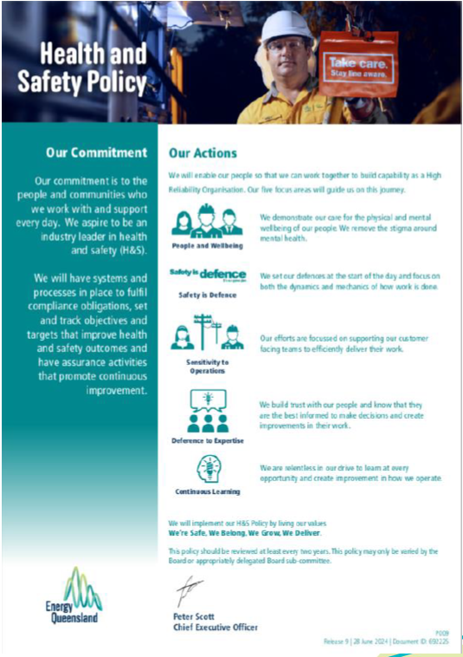

Appendix 2 – Roles and Responsibility Summary
Role | Responsibilities
Project Director / Project Manager | – Overall responsibility for the successful execution of the project, including positive HSE performance outcomes, and conformance to this HSE Management Plan and applicable legal and other requirements  – Review and approve/endorse this HSE Management Plan and the Project HSE Risk Register  – Demonstrate visible leadership, commitment and proactive behaviours by personal example  – Provide adequate resources and budget to enable HSE obligations and the requirements of this HSE Management Plan to be fulfilled  – Ensure program milestones do not compromise HSE or project personnel  – Clearly define HSE expectations and establish and implement appropriate recognition and disciplinary processes  – Ensure project HSE consultative arrangements are working formally and effectively  – Endorse project-specific HSE objectives and performance targets and ensure they are measured and reported against monthly  – Ensure development and implementation of adequate project induction information  – Ensure adequate systems for storing and maintaining records are implemented and applicable project personnel have been instructed/trained in their use  – Ensure suitable site facilities have been installed and are maintained  – Conduct task/behavioural conversations, inspections, and similar, and participate in relevant assurance activities  – Regularly meet with the client to coordinate activities, discuss priorities and determine direction  – Ensure emergency scenarios are identified, suitable first aid and medical services are provided; an Emergency Response Plan is developed and maintained, and emergency drills and exercises are conducted and reviewed  – Nonconformities are actioned and closed out on time  – Injured/ill workers are supported and actively rehabilitated
Site Superintendent / Construction Manager / Commissioning Manager / Project Engineer | – Work with Project Manager to ensure set HSE objectives and performance targets are met and positive HSE performance outcomes are achieved  – Plan, implement, organise, monitor, supervise and perform work to ensure compliance with this HSE Management Plan, SWMS and similar  – Demonstrate visible leadership, commitment and proactive behaviours by personal example  – Review and manage controls for interfacing work parties  – Provide adequate levels of supervision to ensure HSE compliance  – Hold workers/subcontractors accountable for their HSE behaviour, performance, and responsibilities  – Identify hazards, implement effective controls, innovate for safer outcomes, and stop the job if an activity or decision may compromise HSE  – Ensure risk to workers is at an acceptable level  – Facilitate pre-start briefings and toolbox meetings, as required  – Promote HSE initiatives and share and discuss lessons learnt  – Report to the management level above, any identified hazards that cannot be rectified in the normal course of work  – Report incidents and near misses and actively complete and/or assist with investigation of incidents, as appropriate  – Actively participate in monitoring and assurance activities, as required  – Ensure workers and subcontractors are suitably competent to undertake work tasks and have completed the required project induction
Project Engineering Manager (Design) | – Ensuring construction HSE Risks and Safety in Design principles have been addressed and verified for design compliance against legislative requirements  – Utilising the Risk and Opportunity Management process in all design activities to minimize HSE risk  – Coordinating interaction with Construction Manager, for the risk and opportunity management process and constructability review of design  – Participate in assurance activities
HSE Specialist/ Coordinator/ Advisor | – Have a comprehensive understanding of the HSE Management Plan  – Ensuring the HSE Management Plan remains current and compliant to legislation, codes of practices and Standards  – Ensuring compliant to Yurika’s safety system and contractual requirements  – Assisting the Project team with safety advice, information and support where requested  – Participate in inspection, observation and audits with the project team  – Ensuring that incidents are reported, recorded and investigated  – Monitor the implementation of the HSE procedures, forms and checklist
Workers (including subcontractors and EQL shared service personnel) | – Know and work in accordance with this HSE Management Plan and any relevant SWMS  – Undertake work tasks in a planned and safe manner  – As required, complete SWMSs; Pre-start briefings; HazChats; plant risk assessments; hazardous chemical risk assessments; plant pre-starts and similar, prior to commencement of work  – Follow reasonable instructions and rules of Yurika’s project management team / supervisory personnel  – Immediately notify site supervisor of any unsafe situation, and to not work in any way that could endanger themselves, their fellow workers, or others  – Report all incidents, near misses, injuries/illnesses and suggest ways of eliminating hazards and improving HSE on site  – Create and retain HSE records, as required  – Do not undertake any work or work practice that is unsafe or that you are not competent to perform  – Be fit for work  – Attend and contribute within consultative forums (pre-start briefings, toolboxes)  – Attend/complete the project induction and be appropriately competent for work tasks  – Use appropriate PPE as and where required, and report any breakages and failures that need replacement or rectification  – Keep work areas in a clean and tidy state  – Only use known hazardous chemicals that you are familiar with  – Do not tamper, modify or remove any item, sign, barrier, guard, equipment, safety feature or similar, provided to ensure health and safety of project personnel and protection of the environment
Table 7: Roles and Responsibility Summary

Appendix 3 – High Risk Construction Work Appraisal

Work that: | Applicable |  | Scope Description
Work that: | Yes | No | Scope Description
Involves a risk of a person falling more than 2m | ☒ | ☐ | During scaffold erection and dismantling  While using harness systems on the roof  While using elevating work platforms
Is carried out on a telecommunication tower | ☐ | ☒ | Nil
Involves demolition of an element of a structure that is load-bearing or otherwise related to the physical integrity of the structure | ☐ | ☒ | Nil
Involves, or is likely to involve, the disturbance of asbestos | ☒ | ☐ | While removing old services  While modifying roof sheeting, flooring or wall sheeting
Involves structural alterations or repairs that require temporary support to prevent collapse | ☐ | ☒ | Nil
Is carried out in or near a confined space | ☒ | ☐ | Storm water construction and service works
Is carried out in or near a shaft or trench with an excavated depth greater than 1.5m or a tunnel | ☒ | ☐ | While excavating to install new services
Involves the use of explosives | ☐ | ☒ | Nil
Is carried out on or near pressurised gas distribution mains or piping | ☐ | ☒ | Nil
Is carried out on or near chemical, fuel or refrigerant lines | ☐ | ☒ | Nil
Is carried out on or near energised electrical installations or services | ☒ | ☐ | While working near buried, in-situ or overhead lines  While constructing and commissioning new electrical installations  While accessing existing switchboards / rooms
Is carried out in an area that may have a contaminated or flammable atmosphere | ☒ | ☐ | Generation of Respirable Crystalline Silica Dust from disturbing silica containing material
Involves tilt-up or precast concrete | ☐ | ☒ | Nil
Is carried out on, in or adjacent to a road, railway, shipping lane or other traffic corridor that is in use by traffic other than pedestrians | ☒ | ☐ | Heavy Vehicle entering and exiting between Construction site to traffic road
Is carried out in an area at a workplace in which there is any movement of powered mobile plant | ☒ | ☐ | While using earthmoving plant; mobile cranes; elevating work platforms or similar
Is carried out in an area in which there are artificial extremes of temperature | ☐ | ☒ | Nil
Is carried out in or near water or other liquid that involves a risk of drowning | ☐ | ☒ | Not identified within construction boundary, However Site ponds/lakes outside the construction boundary
Involves diving work | ☐ | ☒ | Nil
Table 8: High Risk Construction Work Appraisal

Appendix 4 – Activity RACI
Guide: | A: Accountable (Ultimately accountable for the task / action. May delegate the work, however is accountable to review / endorse / approve the deliverable prior to completion).
Guide: | R: Responsible (Undertakes / does the work to complete the task / action).
Guide: | C: Consulted (Provides input / is consulted on the task or action being undertaken due to their expertise or a contractual or legislative requirement that mandates the consultation).
Guide: | I: Informed (Is informed about the task or action, its progress or when the action is complete. Informed parties often need to know a task / action is complete so they can commence a subsequent task / action).

Activity / Deliverable | Yurika | EQL Shared Service Team | Specialist Principal / Subcontractor | Client | Other Stakeholders
Develop initial design (options; concept; product/s) for the project scope | A / R | C | C | C / I
Negotiate, review and clarify contract and client specific requirements | A / R | I | I | C / I
Request and review detailed services drawings, electrical schematics, existing installations and metering; structural capabilities, similar | A / R | I | I | C
Undertake / coordinate the detailed engineering and site specific design for the project, inclusive of safety in design assessments | A / R
Select and engage specialist subcontractors and/or EQL shared services team/s | A / R | C | C
Develop and refined project specific HSE Management Plan and HSE Risk Register | A / R | C | C
Confirm / arrange site office, crib, toilet, drinking water and other construction amenities relevant to the project | A / R |  |  | C / I
Deliver, set-up, anchor / tie-down and commission site construction amenities at the project | A |  | R | C
Set-up of Principal Contractor signage, delineation, fencing and site access controls | A |  | R | C
Develop project specific induction, deliver to all workers on the project and record induction and worker competency verifications | A / R | I | I | I | I
Make services information, drawings, schematics, similar, available to works delivery supervisors / workers | A / R | C / I | C / R
Review subcontractor and/or EQL shared services team SWMSs | A / R | C | C
Undertake energy isolation, testing to prove de-energised and lock-out tag-out protocols | A | R | R | C / I
Coordinate, monitor and supervise works, and ongoing consultative arrangements at the project | A / R | C | C |  | C
Undertake work in accordance with HSE Management Plan; SWMS; and legislative requirements | A / R | R | R |  | R
Undertake HSE assurance during the project | A / R | C | C | C / I
Energise and commission new installations | A | R | R | C / I
Provide building certification; structural / other engineering certification and electrical installation certifications for work completed | A | R | R | C / I
Provide as-built drawings, schematics, equipment operational manuals, similar post construction | A | R | R | C / I
Table 9: Activity RACI

Appendix 5 – Fatigue Management Requirements
The below extracts are from the Energy Queensland Standard for Fatigue Management (Standard S009). This standard should be referred to for any additional clarification or for requirements relating to more complex shift arrangements, emergency event and natural disaster response requirements or similar.
The minimum mandatory requirements for working extended hours including overtime, or unplanned emergency call out and standby situations are outlined in the tables following. All work hours are inclusive of paid and unpaid breaks within periods of work e.g. meal, crib, rest breaks. Fatigue Assessment is required to identify appropriate controls to allow work to continue safely past 12 hours in any one day and for any night hours worked.
Work Thresholds, Actions to Extend and Maximum Limits
Time Period | Planned Work Threshold | Action to Extend Work | Maximum Limit
1 day (24-hour period) | 12 hours | Fatigue Assessment | 16 hours
Night work (over 7 days) | 0 hours | Fatigue Assessment | 24 hours
3 days | Up to 36 hours |  | 42 hours
7 days | Up to 60 hours |  | 84 hours
Consecutive days | 7 days |  | 14 days
Table 10: Work Thresholds, Actions to Extend and Maximum Limits
Table Notes:
1. All work hours are cumulative for the period.
2. A 24-hour period commences at the start of work following the completion of at least a minimum 9-hour break (or another longer break).
3. All time periods are rolling periods – i.e. rolling 3 and 7-day periods for thresholds and limits.
4. Night work hours is any work between the hours of 23:00h and 05:00h.
5. Fatigue assessment is required on each day as indicated - not just the first day.
6. A calendar day (00:00 – 23:59h) where no work is conducted breaks the consecutive day count.
7. Planned Work Threshold values in italics are included for guidance and may be exceeded for planned work. See Standard, Section 5.5 Planned Overtime for more detail.

Minimum Rest Breaks
 | Rest Breaks | Description
Breaks Between Work Periods | Minimum 9-hour break | Minimum 9-hour break plus reasonable travel. Must be commenced within every 24-hour period (incl. Sat, Sun, Public Holidays) and then be continued until completed.
Breaks Between Work Periods | 14-hour Overnight Rest | Minimum 14-hour rest including period from 11pm to 5am is required whenever there are three consecutive nights with total of 12 hours (or more) night work hours. The fourth night is 14-hour rest.
Breaks Between Work Periods | 30-hour Reset | Minimum 30-hours and should include two (2) consecutive nights. Required following 14 consecutive days work. Can be used to ‘reset’ fatigue hours to zero to plan for operational needs.
Breaks Within Work Periods | Heavy Vehicle 15-minute break | Any driver of a Fatigue Regulated Heavy Vehicle (FRHV) must break for 15 mins (or more) after 5 hours and 30 mins of work. NB. EQL requirements are that at least a 15-minute break is required after 2 hours of driving – any vehicle.
Breaks Within Work Periods | Union Collective Agreements (UCA) Breaks | All rest breaks, crib breaks, pauses within periods of work should be taken as they are key fatigue controls.
Table 11: Minimum Rest Breaks
Table Notes:
1. 14-hour overnight rest example: Night 1 - 11pm to 3am, Night 2 - 1am to 4am, Night 3 - 11 pm to 5am = 13hrs total night work hours over 3 consecutive nights. A 14-hour rest break applies including the period 11pm to 5am on Night 4.
2. 14-hour overnight rest applies to emergency work, stand-by or other generally unplanned arrangements. Does not apply to night shift work or planned overtime where the fatigue risk must be managed in the creation of the work schedule and predetermined rosters.

Fatigue Assessment
Fatigue assessment is required before work can continue:
- Whenever 12 hours (continuous or cumulative) is worked in 1 day.
- Where any work is performed between the hours of 23:00 and 05:00 (night work hours); or
- Where a worker advises they are not fit for work due to sleep and/or fatigue issues.

1. Start with a conversation – talk to your work mates, check in with each other, how do you feel?
2. If available, use the Fatigue Calculator app on the work phone to find your Fatigue Score.
3. If available. refer to the Fatigue Action Table in the app and note relevant actions.
4. Talk about the job, think about the task, how can work proceed safely with fatigue present? Does it need to be delayed, reallocated, rotated?
5. Come up with controls relevant to the job, your fatigue score and how you feel. You may need to discuss this with your supervisor before proceeding.
6. Note it down on the HazChat and put your agreed actions into play.

