1D

Polka Dot

Telephone: 707707

Miss Smith
12 Parrot Parade
Tree Lane
The Forest

19th March 2018
Dear Miss Smith
It was great to speak to you earlier at Polka Dot. I would like to take this opportunity to welcome you on behalf of everyone at Polka Dot insurance. Here at Polka Dot, we know how important it is to have a friendly, helpful voice at the end of the phone.
To show you how much we value your custom, we are giving you $100 when you refer a friend.
See you soon,
Claire Bird

2B

Meeting Minutes
Date: [Space for text]

Attendees:
[Space for text]

Agenda:
- [Space for text]
- [Space for text]
- [Space for text]
- [Space for text]
- [Space for text]
Action Items | Owner | Deadline
- [Space for text] | - [Space for text] | - [Space for text]
- [Space for text] | - [Space for text] | - [Space for text]
- [Space for text] | - [Space for text] | - [Space for text]

Staff Name | Department | Start Date
Sharon Wise
Daniel Parker
Graham Pat
Tyler Rust
2D

2D
2E


3A

Mail merge
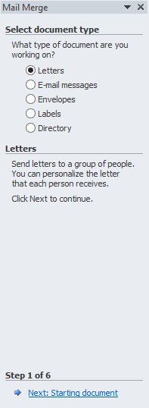
To create a Mail Merge, follow these steps:
- Click the ‘Mailings’ tab
- Click ‘Start Mail Merge’
- Click ‘Step by Mail Merge Wizard’
- In the task pane, click ‘Letters’
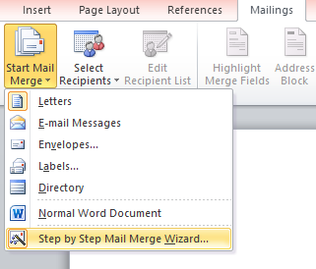
- Click ‘Next: Starting document’
- Select the starting document
- Select your recipients
- Write your letter
- Complete the merge.

Newspaper columns
Follow these steps:
- Highlight the text that you wish to put into columns
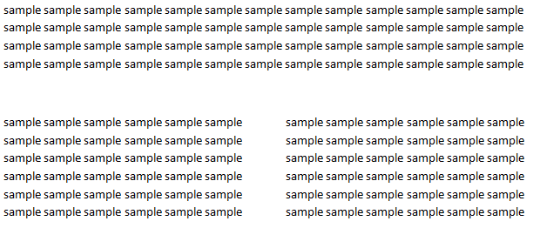
- Click the ‘Page Layout’ tab
- Click the ‘Columns’ button
- Select how many columns you wish to apply
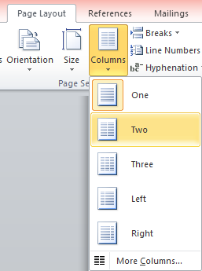
- Extra options can be found in ‘More Columns’

Dear Staff Members,

We have double-checked the staff members that have been in accidents due to the faulty soldering equipment in the last year.

There have been five accidents in the last year, resulting from the use of faulty soldering equipment. Accidents have resulted in minor injuries to five staff members.

As a result, all soldering task have been suspended. New soldering equipment have been ordered. Extensive learning on how to safely use the equipment will be given before soldering task resume.

The management would like to thank the staff for their patience and apologies for the delay of projects.

Sincerely yours,
Kyla Avila

State Cashmere Men’s 100% Pure Cashmere Jumper Long Sleeve Pullover Crew Neck Sweater

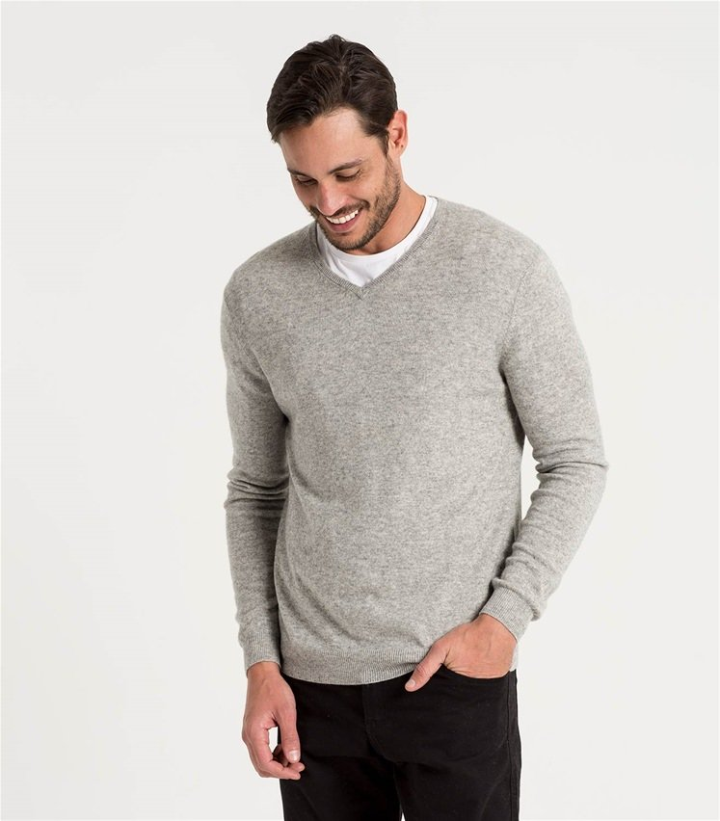
- 100% Genuine 2-ply inner Mongolian Cashmere
- Ribbed Crew Neck, cuffs and hem. Superior softness with easy fit comfort
- 100% Mongolian Cashmere
- Dry clean or Hand wash cold dry flat
- ST3612
- Super versatile: Light weight, Relax fit, Classical design, Wearing with shirt shows formal for working, and wearing with jeans shows leisure at home and party.
- Densely knitted with the finest and long staple cashmere which provides best anti-pilling performance
- Model Measurements: height: 6”2”7 waist: 37”. Model is wearing size: Large.

Brave Soul Men’s Tame Casual Shirt

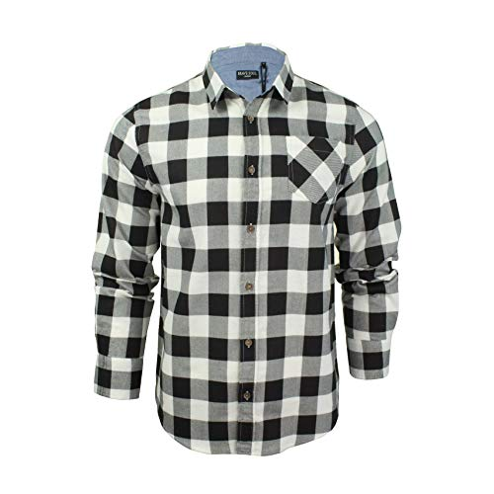
- Heavy brushed checked shirt
- 100% Cotton
- Machine wash – Cold (30º max)
- Fastening: Buttoned
- Collar Style: Classic
- Regular Fit
- Regular Fit
- Long Sleeve
- MSH-69TAME

ORCHENTA Men’s Casual Slim-Tapered Flat-Front Trousers Khaki Label 33

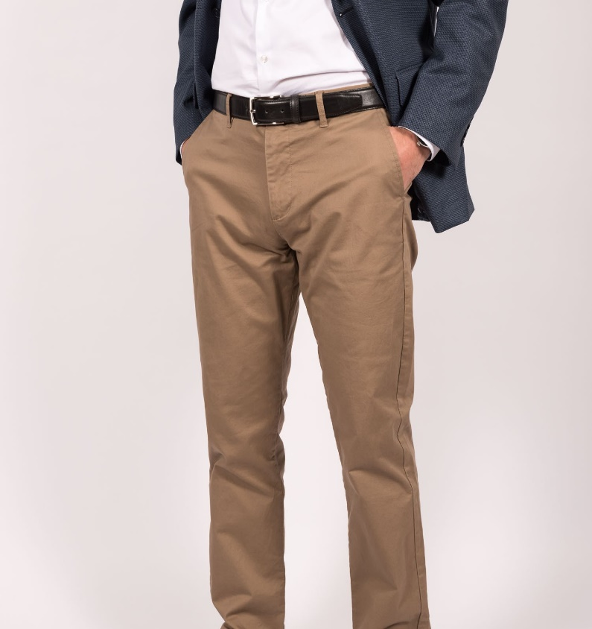
- Breathable chino pants, as they are slim fit trousers may slight tight when first time wear, please choose one size larger than you usually wear if prefer more room.
- Fleece lined are now available for cold weather, Ideal for casual and formal wear
- 100% Cotton
- Fastening: Zip
- Casual
- Slim
- R8-01-Khaki-33
- 2 front slash pockets, 2 back pockets
- Slim fit style/Hand/Machine cold wash separately
- Kind Notice: belt not included, shipping time: 1-3 days fulfilled by Amazon, 5-12 fulfilled by Seller.

