Date 22/03/2024.

Rebecca Henderson
MG Group
2172 Gold Coast Highway
Miami QLD 4220

Dear Rebecca

RE: Tender Submission for River Park Lifestyle Village Display Villa – Unit 32 – Construct Only Lump Sum

Alder Constructions are pleased to submit our Lump Sum tender proposal for the above-mentioned project, aligning with the provided documentation and clarifications outlined within our offer. Alder Constructions is a reputable construction company with 20 years of experience in delivering high-quality projects on time and within budget. We are confident in our ability to execute the River Park Over 50’s project requirements to the highest standards, aiming to meet your expectations.

Tender Sum (excluding GST) $249,175.40
GST 10% $ 24,917.54
Tender Sum (including GST $274,092.94

Two Hundred and Forty Nine Thousand, One Hundred and Seventy Five Dollars and Thirty Nine Cents – Excluding GST.

1 ASSUMPTIONS

In the development of our offer, we have made the following assumptions in our Lump Sum price.

  - This offer is based on the documentation provided during the tender period received up to the 01st March 2024.

  - All necessary approvals will be obtained by the Principal.

  - Rock in earthworks is not anticipated and consequently prohibited. However, there is a possibility of encountering rock in trenches. In such an event, a rate of $195 per cubic meter plus GST will be applied for the actual quantity excavated. Additionally, additional bedding may be necessary, which will incur a charge of $91 per cubic meter plus GST.

  - We have factored in the acid sulphate treatment for this project based on the initial information provided.

  - At present, we have not included Boulder retaining walls in out estimation due to the limited information provided in the preliminary design documentation. However, we are prepared to furnish a price once detailed design specifications are made available.

  - Clear and unimpeded access to the site will be provided at all times. Any modifications to this arrangement may impact our delivery schedule and/or incur additional costs.

  - We have incorporated an estimate for the connection fees to GCCC assets into our Lump Sum amount, which may be adjusted based on the final charges determined by GCCC. We highly recommend initiating these works promptly, considering the potential delays often experienced in council processes due to their substantial workload.

  - It is anticipated that a final approved set of ‘for construction’ drawings will be provided before site establishment, allowing us the opportunity to review and identify any changes that may impact the overall pricing covered by this initial offer.

  - Our pricing is inclusive of all the work outlined in this tender document. Should specific elements be chosen and excluded from our scope of work, we retain the right to reassess our pricing, methodology and sequencing accordingly.

  - All power and water connections for our temporary site facility will be provided at no cost. The expenses, if any, associated with installing and disconnecting the temporary services will be covered by Alder. However, the client will be responsible for the consumption charges incurred during the construction period.

  - We have assumed that all services are adequately capacitated and readily available directly outside the site boundary. Our offer does not include provisions for service upgrades, and only those services indicated on the preliminary design drawings have been considered.

2 ALLOWANCES

In the development of our offer, we have made the following allowances in our Lump Sum price.

2.1 We have evaluated the programme and can achieve practical Completion within a construction period of 26 weeks on site.

2.2 No allowance has been made for wet weather or its effects in this assessment.

2.3 Our Tender is valid for a period of 30 days from the aforementioned date.

2.5 Allowance has been made for white goods (Oven, cooktop, rangehood and dishwasher) and Landscaping.

3 EXCLUSIONS

We have excluded the following items from our Lump Sum price.

3.1 Telstra, NBN & Pay TV connections and fees are excluded. Lead ins will be provided.

3.2 The removal and treatment of hazardous or contaminated materials.

3.3 Road dedication by the client, encompassing the design, plans, titles, plan sealing, and associated fees.

3.4 Facilitate easements as required for water supply and sewer, encompassing the preparation of designs, plans, titles, and associated fees.

3.5 Allowance for any soft spots and these will only be charged if encountered.

3.6 For WH&S fees, Home Owners insurance and Portable Long Service Levy / Qleave.

3.7 The provision and/or installation of any furniture, fixtures, and equipment (FFE), including loose furniture, window coverings, ornamental items, and features, etc.

3.8 We have not included designer fees for overseeing the design of the works or design management, as we understand this responsibility lies with the client. Nevertheless, we are prepared to offer guidance on Building and Civil methodologies, as well as suggest alternative materials and designs that could potentially yield cost savings, should this be desired.

4 CLIENT PROVISIONAL SUMS

The Client nominated Provisional Sum Items listed below have been included in our offer.

No. | Description | Value (ex GST)
 | N/A

5 ADDENDA

Addendum No and Description | Date Received
RFI 1 - Clarifications | 13/02/2024
Extension of Time | 20/02/2024
RFI 2 – Finishes Schedule | 23/02/2024
RFI 3 – DA Issue | 28/02/2024
RFI 4 – Clarifications + Attachments | 12/03/2024
Extension of Time | 14/03/2024
RFI 5 - Clarifications | 16/03/2024

Should our offer be of interest, we would be pleased to engage in discussions concerning the following matters:

- Contract Conditions
- Programme
- Clarifications

If you have any queries or wish to discuss any aspect of our offer, please do not hesitate to contact me using the provided details below.

Yours sincerely,
Alder Constructions

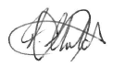

Tyanna Childs
Contract Administrator
M: 0434575242 Email: Tyanna.childa@aldercon.com.au
Table of Contents

ATTACHMENTS………………………………………………………………………………………….………………… 05

APPENDIX 1 – CONTRACTOR DETAILS……………………………………………………………………. 06 APPENDIX 2 – OFFER BREAKUP……………………………………………………………………………. 07
APPENDIX 3 – PRELIMINARY PROGRAM…………………………………………………………………. 09
APPENDIX 4 – CONSTRUCTION METHODOLOGY…………………………………………………….. 10
APPENDIX 5 – INSURANCE CERTIFICATE………………………………………………………………… 12

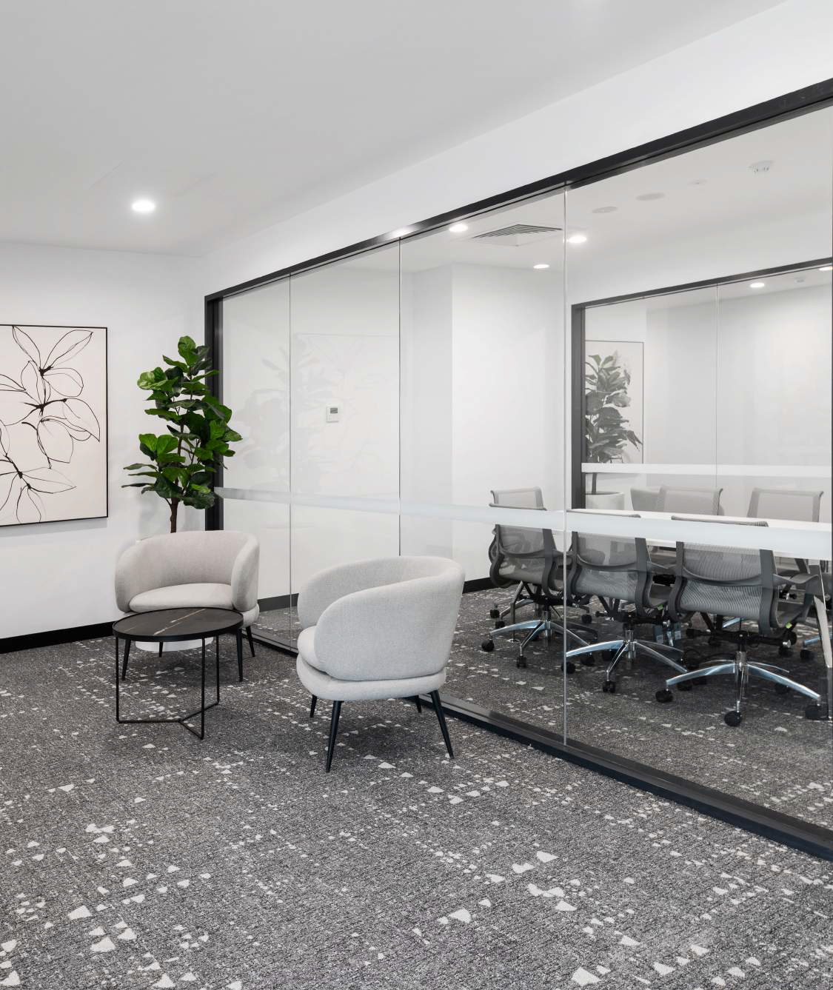
Attachments

Appendix 1
Contractor Details

Alder Constructions has solidified its reputation as a leader in civil and infrastructure development, leveraging over 20 years of industry experience. Our growth trajectory has been marked by the evolution of a distinctive business mode, encompassing both civil engineering and construction divisions. This integrated approach equips us with the versatility and expertise needed to successfully deliver a wide range of complex and high-quality projects.

Our capabilities span the spectrum of civil and infrastructure endeavours, encompassing everything from earthworks, road construction, and bridge development to marine infrastructure, treatment plants, and specialised remediation projects. Additionally, we have garnered recognition for our excellence in constructing architecturally sophisticated commercial buildings across various sectors, a testament to our commitment to delivering exceptional quality and attention to detail.

Company Name: | Alder Constructions Pty Ltd
ABN: | 31 106 657 470
Address: | 116 Siganto Drive, Helensvale QLD 4212
Authorised representative: | Tyanna Childs  0434 575 242 | Tyanna.childs@aldercon.com.au
Phone Number: | 07-5514 4900
Email: | mail@aldercon.com.au
QBCC Licence No: | 1066 730
QBCC Licence Details:

Appendix 2
Offer Breakup

PROJECT: RIVER PARK LIFESTYLE VILLAGE DISPLAY UNIT – UNIT 32
TENDER: ALDER CONSTRUCTIONS PTY LTD
DATE: 22/03/2024

 |  | TOTAL
 | OFFER BREAKUP | Ecl GST
1 | CIVIL WORKS | $ 1,192.80
2 | DETAILED EXCAVATIONS | $ 602.80
3 | TERMITE TREATMENT | $ 1,716.00
4 | BORED PIERS | $ 10,157.31
5 | CONCRETE TESTING | $ 91.49
6 | CONCRETE SUPPLY | $ 1,386.44
7 | CONCRETE PLACE | $ 3,353.01
8 | COMCRETE PUMPING | $ 484.35
9 | REINFORCEMENT SUPPLY | $ 1,185.25
10 | REINFORCEMENT FIX | $ 1,049.68
11 | MASONRY | $ 5,867.60
12 | METALWORK | $ 2,016.00
13 | HANDRAILS & BALUSTRADES | $ 4,130.00
14 | FIRE DOORS & METAL FRAMES | $ 462.00
15 | ROLLER SHUTTERS | $ 1,065.00
16 | LETTER BOXES | $ 235.00
17 | WINDOWS & GLAZING | $ 11,749.00
18 | SHOWER SCREENS | $ 2,380.00
19 | SUN SCREENS | $ 4,670.00
20 | CEILINGS & PARTITIONS | $ 34,134.50
21 | CARPENTRY LABOUR | $ 32,897.36
22 | TIMBER SUPPLY | $ 23,793.41
23 | TIMBER TRUSS SUPPLY | $ 5,616.00
24 | TIMBER WALL FRAMING SUPPLY | $ 9,448.40
25 | CABINET WORK | $ 10,270.00
26 | TIMBER DOORS & FRAMES SUPPLY | $ 497.90
27 | HARDWARE SUPPLY | $ 1,250.00
28 | SIGNS | $ 130.00
29 | ROOF PLUMBING | $ 15,043.00
30 | HYDRAULICS AND DRAINAGE | $ 17,940.00
31 | TILING | $ 6,411.48
32 | VINYL & CARPET | $ 3,482.00
33 | PAINTING | $ 9,346.29
34 | LANDSCAPING | $ 3,521.75
35 | ELECTRICAL | $ 13,579.58
36 | WHITE GOODS | $ 2,430.00
37 | MECHANICAL | $ 5,590.00
Total (Excl GST) |  | $ 249,175.40
Goods and Service Tax (GST) |  | $ 24,917.54
TOTAL (Including GST) |  | $ 274,092.94

Appendix 3
Preliminary Program

(To be attached when compiling documents in Adobe)

Appendix 4
Construction Methodology

(To be attached when compiling documents in Adobe)

ATTACHMENTS

Appendix 3
Preliminary Program

MG Group
22 March 2024
RIVER PARK LIFESTYLE VILLAGE DISPLAY UNIT – UNIT 32
TENDER SUBMISSION

