CPCCBC4012B
Read and interpret plans and specifications

THEORY EXAM INSTRUCTIONS

- This exam will occur under standard assessment conditions.
  - An oral examination may be allowed under certain circumstances.
Answers will be documented and FT003 (Oral examination declaration form) must be completed.
- Participants must provide enough detail in their responses to demonstrate their knowledge and skills.
- Please fill in the details below, providing your name, signature and date of assessment.
  - Your signature acknowledges that this is your own work.
- If a participant initially answers a question incorrectly but modifies their response, they must follow the instructions below:
  - If a participant changes their response in writing, they must put their initials next to the written change.
  - If a participant changes their response verbally, this must be noted on the exam paper by the assessor.

Participant name | Emma Carew
Participant signature | 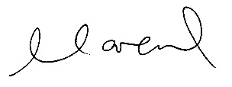

Assessor name
Assessor signature | 

Date | 18/04/2018

Number of questions | Number of questions answered correctly | Satisfactory?
77 |  | Yes | No
Assessor Comments
- What does the term ‘plan’ mean when referencing plans and drawings for construction purposes?

Answer | All of the drawings for a proposed house are knowns as plans.  A plan is a view which shows the layout or arrangement of rooms and other parts of the interior of a house.

- Name the people and organisations who will have an interest in plans and drawings for a construction project.

Answer | - The client and lending body  - Local council  - Estimators  - Supply authorities – water, sewerage, drainage  - Electrical, gas and NBN supply companies  - Engineers – Structural, Electrical, Mechanical, Hydraulic  - Subcontractors – carpenters, concreters, plasterers, bricklayers, painters, joinery, stone, stairs, etc.  - Project Team – Project Manager, Contract Administrator, Site Manager  - Neighbours  - Real estate agents  - Landscapers  - Various Suppliers for materials or products  - Environmental agencies  - Energy efficiency, Geotech, Acoustic  - Mechanical service installers – air conditioning, fire

- What will plans show to the interested parties?

Answer | Plans show all people interested in the proposed structure what is will look like when completed and how it will be constructed.  This includes:  - Location of site features and details about the building  - Height, position and bulk of building so council can determine compliance to its codes  - Allowing builders and trades to prepare written quotes – for approved plans  - Provides surveyor with set out  - Illustrates to trades the structure to be built  I

- What types of plans is it necessary to be familiar with for building and construction projects?

Answer | Types of Plans include:  - Block plans  - Site plans  - Floor Plans – Basic & General  - Elevations  - Estate road layout

- All plans and drawings give a compass direction.
Which compass direction is always shown and on which drawings is it likely to be found?

Answer | The compass direction shown is North.  Shown on the following plans:  - Key Plans  - Site Plans  - Block Plans  - Floor Plans

- What does a location plan contain?

Answer | A location plan details the:  - Lot number/s  - Deposit plan numbers  - North Point  - Scale  Location plans are required to correctly identify the building site.

- What does a site or block plan contain?

Answer | A Site of Block plan contains critical adjoining parts of the surrounding properties and locality.  It provides the reference height to other site levels (Datum) and the building orientation to north point.  It also gives the following information:  - Outline of site boundaries showing location of proposed building and existing dwellings  - Information including: plan page number, client name, project address, scale, reference numbers and dates  - Major geological and topographical features  - Contours and slopes – 500mm intervals and depths where they may occur  - Distance from boundaries to building foot print  - Driveways, stormwater drainage, easements and right of carriage  - Soil and surface water drains, pipe sizes  - Service runs from the house to the mains  - Sewer, water, gas, electricity locations  - New levels on the site in connection with the new house  - Paving and retaining walls

- What features would you expect to look for and find on plans and drawings for a construction project?

Answer | The key features to be found on construction plans and drawings are:  - Ceiling heights and variations  - Doors  - Light fittings and power supplies  - Services – Hydraulic, Electrical, Mechanical, Fire  - Elevations – showing finish to external walls, size of windows, doors & balconies  - Sections – showing height of building, position of piers, beams, opening, floor to ceiling heights, distance between finished floor and existing floor and existing or proposed ground levels  - Floor plans  - Penetrations

- What do floor plans identify?

Answer | Floor plans show the layout of the house from a perspective above the floor.  Floor plans identify walls, doors, floors, stairs, windows, fittings & fixtures.

- What are elevation views? What do they provide to the plan reader?

Answer | Elevation views face squarely and look at the four sides of a proposed development. The view is indication by north, south, east or west.  Elevations show the plan reader the finished appearance of a given side and vertical height dimensions. For example size of windows, doors and balconies and the finish to external walls..

- What is a section?

Answer | A section is a vertical view through the building. The direction of the section lines help interpret the sectional view.

- What are detailed drawings?

Answer | Detailed drawings provide further detail of roads, pathways, parking areas, boundaries and landscaping.

- What are specifications?

Answer | Specifications set the building codes or minimum standards that are necessary to obtain relevant sizes for all structural components and they provide details of building materials and fittings.  Specifications are read along with the plans, Contract documents, engineering details, building permits and forms part of the contact.

- What information will you find in a title block to a drawing?

Answer | - Drawing Number  - Current Revision  - Scale  - Clients Name  - Project / Job Number  - Drawn By Initials  - Project / Site Address  - Builder Name  - Date Drawn  - Amendments / Revision Block  - Project / Job Name  - Plan Title

- What is the significance of the Australian Architectural Standards?

Answer | The significance of the Australian Standards is to ensure that products, services and systems are safe, reliable and consistently perform the way they were intended to. They establish a common language which defines quality and safety criteria.

- What will you find in the Waste Management Plans & Site Management plans?

Answer | The Waste Management & Site Management Plans contain the processes of how each task onsite is addressed and monitored, for example:  - Waste removal and management  - Personnel  - Proximity to service providers  - Exit and entry locations for heavy duty vehicles  The Waste Management Plan – Key Objectives:  - Minimise the amount of waste generated as part of the project.  - Maximise the amount of materials which are sent for reuse, recycling or reprocessing  - Minimise the amount of material sent to landfill.  A Site Management Plan ensures construction sites, including demolition and excavation do no adversely affect the health, safety, amenity, traffic or the environment in the surrounding area. It addresses recycling, waste management and environmental initiatives. It considers each stage of construction, including demotion, excavation and construction.  The Site Management Plan – Key Objectives:  Plan ahead for each phase of construction minimising impact on  - Neighbours and residents  - Businesses and public venues  - Users of public footpaths, roads, bike paths, reserves  - Traffic flow  - Public parking  - Environment and local waterways

- What is a landscape plan?

Answer | A Landscape plan is a scaled drawing showing the extent, function, context and attributes of areas to be landscaped.  They should be prepared by qualified landscape architect or professional.  Depending on the development and /or council requirements generally the plan will show some of more of the following:  - Planting Schedule and placement  - Driveway materials and colour  - Proposed soft and hard landscaping  - Details of planting procedures and maintenance  - Irrigation plan

- What is the purpose of a shadow diagram? Who primarily would seek one?

Answer | A shadow diagram calculates the amount of shadow cast by the proposed building or development.  The shadow diagram is required to ensure neighbouring properties will not be impacted significantly by the new building.  Council planning would seek the shadow diagram for the Development Approval process.

- What is a bracing schedule?

Answer | A bracing schedule identifies elements of the building that are required to be structurally braced. Bracing is required to withstand the wind pressure on the timber structure.

- What must we do with plans and drawings in our on-site environments? How often should plans and drawings be viewed on site?

Answer | Plans, drawings and specifications should all be kept up to date on site.  They need to be available for all trades to view for any questions or queries that may arise during construction.  A drawings transmittal should be kept up to date with all dates and revisions recorded, along with the distribution list noting which trades received drawings and when they received these.  All plans, drawings and specifications should all be constantly referred to in conjunction with each other, ensuring that all areas of construction are covered, from architectural, structural, civil, mechanical, electrical, etc  Whenever there is a change, the plans should be updated and current revision emailed or posted to the trades affected by the change and drawing register updated accordingly.  Changes can be minor or considerable which may result in a variation from the subcontractor and also to the client.

- Explain the meaning of the abbreviations in the table below.

Answer | Abbreviation | Meaning
 | ACRYL | Acrylic
 | AS | Australian Standard
 | ASSD | Assumed Datum
 | B | Basin
 | BN | Bull Nose
 | BTH | Bath
 | BWK | Brickwork
 | CB | Concrete Block
 | CF | Concrete Floor
 | CG | Clear Glass
 | CJ | Ceiling Joist
 | CORR | Corrugated
 | CWT | Cold Water Tank
 | DG | Double Glazing
 | DH | Double Hung
 | DPC | Damp Proof Course
 | DSB | Distribution Switch Board
 | DW | Dishwasher
 | EJ | Expansion Joint
 | FPBD | Fibrous Plaster Board
 | FFL | Finished Floor Level
 | FHR | Fire Hose Reel
 | GPO | General Purpose Outlet
 | HBD | Hardboard
 | HTR | Heater
 | HWD | Hardwood

- Why and when would you use presentation drawings?

Answer | Presentation drawings convey basic design concepts from a design team to the client or others. They are more creative and aesthetical and also more realistic. The drawings can include people, trees and vehicles and they would be used for marketing the project.

- Service drawings provide information about a variety of different components and equipment. In order to identify individual items, it is usual to give them a reference number on drawings such as services layout drawings and location plans.
What details might we expect to see from service drawings?

Answer | - Hot and Cold Water supplies, above and below ground drainage  - Sanitary appliances  - Refuse disposal  - Heating  - Ventilation  - Air Conditioning  - Electrical installations – Lighting, NBN  - Gas  - Fire Protection  - Mechanical and Security systems

- What are working drawings? What do they record?

Answer | They are used as preliminary construction plans to clarify on site details not made clear by other drawings.  Working drawings record or explain the appearance and construction of an existing building or sketch.

- What is an isometric view?

Answer | A method of showing three faces of an object in one drawing.  Isometric means equal measure. The three lines defining the three faces produce three equal angles using vertical lines and horizontal lines at 30 degrees to the horizontal.

- Sketch a concrete block in isometric view.

Answer

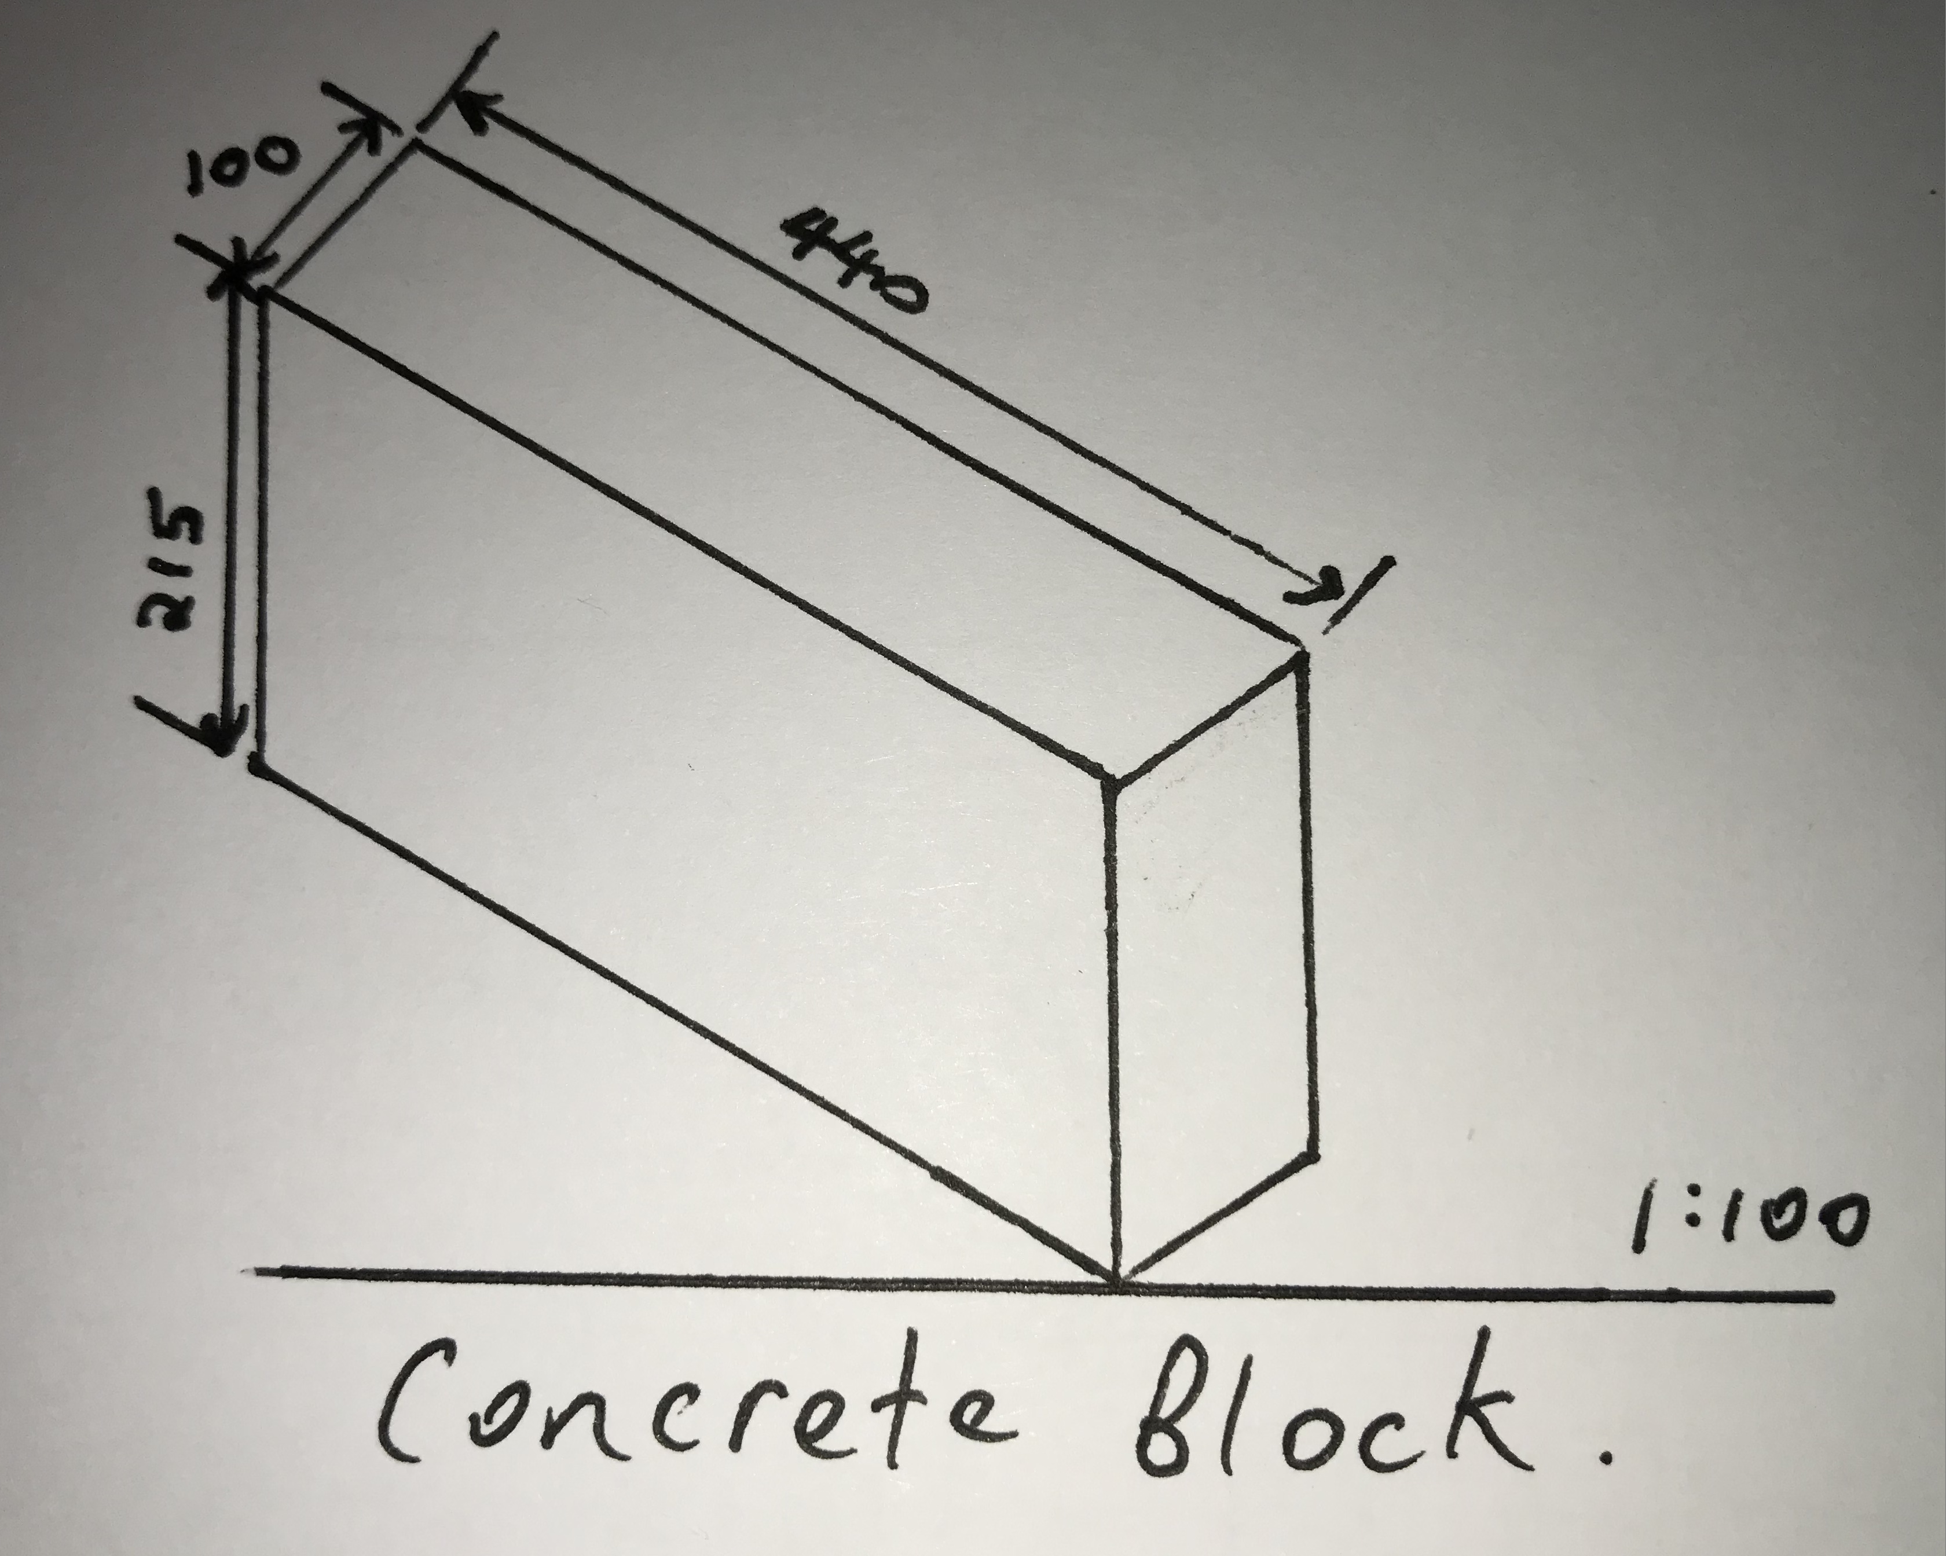

- What is the purpose of perspective projection and representation in drawing of architectural buildings and edifices?

Answer | The purpose of perspective projection is to show more complex details of a drawing and at difference projections.  In perspective projection all lines of sight start at a single point.  Perspective projection is a view normally seen by the eye or camera and is the most realise form of pictorial. There are three basic types of perspectives:  - One-Point (One vanishing point)  - Two-Point (Two vanishing points)  - Three-Point (Three vanishing points)

- What is a topographical survey?

Answer | A topographical survey gathers data about the natural and man-made features of the land as well as its elevations and presents them as contour lines on a plot.  They set out the exact position of a proposed structure ensuring the construction is done within the legal boundary preventing any future disputes.  A topographic survey shows the location, size, and height of these types of improvements, as well as gradual changes or contours in elevation. Unlike boundary or residential land surveys, a topographic land survey focuses more on elevation than on horizontal measurements.

- What is an ecological survey?

Answer | Ecological surveys identify the habitats and/or species that exist within an area at the time of the survey. Early identification of any ecological constraints ensures development proposals are not delayed and appropriate mitigation or compensation is incorporated into the design phase

- What is significant to keep in mind when developing the Schedule of Quantities (also known as a Bill of Quantities)?

Answer | If the BOQ does not form part of the lump sum contract then this will disentitle the contractor for claiming for additional payment for increased in quantities.  If the BOQ has been incorporated into the lump sum contract to define the works, then the contractor will ordinarily be entitled to be paid for increases in the quantities as extra work.

- What should be applied in consideration of stress, load and bearing calculations in the design, the drawings and the building of a structure?

Answer | All Building Code requirements and calculations for stress and load bearing need to be identified and complied with.

- What is a prime cost (PC) item? Give an example.

Answer | Prime cost items include tiles, taps, doors and bathroom fittings.  An amount for these items is included in the contract sum. This is an agreed estimated amount as the specific products are not selected until a later stage. The estimate for the PC items must be above or at what they could reasonably cost.

- What is a provisional sum (PS) item? Give an example.

Answer | A provisional sum is an amount included in the contract to cover work and/or materials note detailed when entering the contact. For example Site works, removal of trees. The builder legally needs to take steps to ensure an accurate cost estimate but if unforeseen event occur and the provisional sum is exceeded, the additional costs can be added to the contract sum.

- Suggest when you would need to provide ‘additional’ plans.
Give some examples of such plans.

Answer | Additional plans may need to be provided if there are variations to the contract. For example an extra room added or services added or removed, for example space for a microwave in a kitchen.  For an extra room to be added the architectural and structural plans would need to be amended.  For removal of a microwave space, the architectural plans including joinery and also possibly the electrical would need to be amended as you will not need the power point for the microwave.

- How do you identify and record customer variations?

Answer | A customer variation is any change to the scope of work to be done under a contract which may involve an increase, decrease or substitution in the contracted work.  A customer variation is recorded in writing to the client and also listed in a register so that you can refer to one location if necessary to review all variations for the project.

- When reading and interpreting (or amending) variations project specifications, what documentation should you also refer to?

Answer | Refer to building plans, schedule of finishes, scopes of work.  Also refer to our company project processes to ensure one variation does no create another, this assists with eliminating causes of non-conformities.

- So you don’t end up in a dispute what strategies can you employ with your customer/client/home owners?

Answer | - Remind the client that it is their responsibility to put variations in writing to the builder as early as possible.  - Always put variations in writing on paper or by email.  - Any changes in terms, including cost must be dated, and signed by all parties to the contract  - Extension of time should be submitted for any significant change or delay caused by owner increasing the scope of works  - Variation payments should be made in accordance with the time stated in the variation document.

- Name each of the drawing symbol images shown in the table below.

Answer | Name | Image
 | Wall - cavity brick | 
 | Wall – brick veneer | 
 | Wall – timber stud | 
 | Window – in cavity wall | 
 | Window – in single wall | 
 | Door – single swing – opening 90 degrees | 
 | Door - double swing  Each opening 90 degrees | 
 | Door - pocket / cavity door | 
 | 02Door – sliding exposed on wall | 
 | Power Socket outlet | 

- Draw symbols for the following items.

Answer | Item | Drawing
 | Basin | 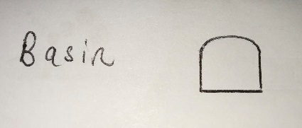
 | Bidet | 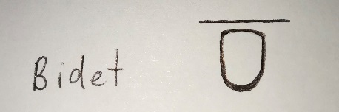
 | Bath | 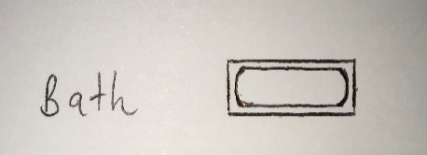
 | Drinking fountain | 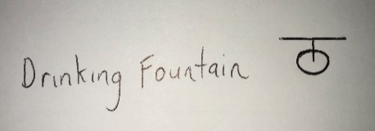
 | Sink: Single bowl | 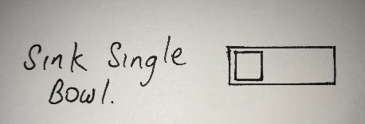
 | Sink: Double bowl | 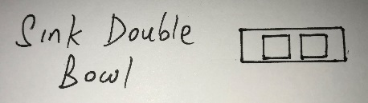
 | Tub: Double | 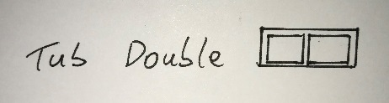
 | Tub: Single | 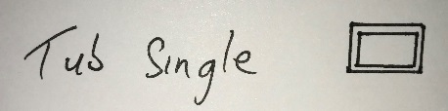
 | Drinking trough | 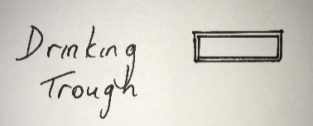
 | Hotplates | 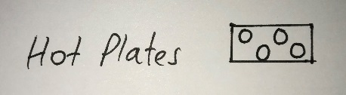
 | Shower | 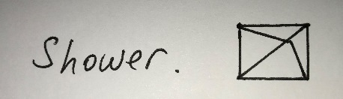
 | Shower bath | 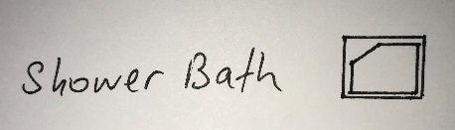
 | Urinal stall | 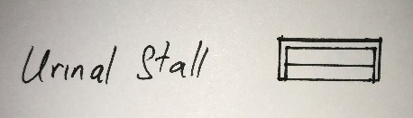
 | Vanity basin | 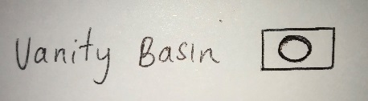
 | Water Closet (Toilet) | 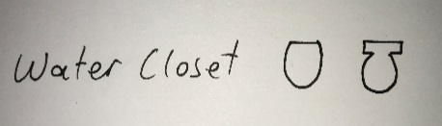

- Draw the following window symbols in elevation.

Answer | Item | Drawing
 | Hinged at side | 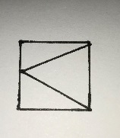
 | Hinged at top | 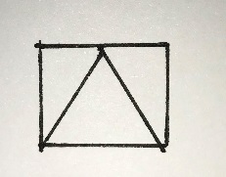
 | Sliding horizontally | 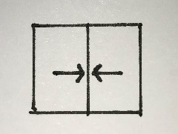
 | Fixed | 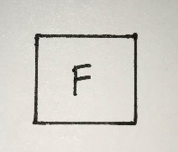

- Draw symbols for the following items.

Answer | Item | Drawing
 | Brickwork | 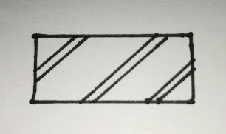
 | Blockwork | 
 | Concrete | 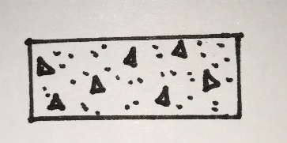
 | Plaster/Render | 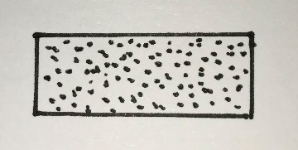

- Provide a description of the residence shown in the plan drawing below.

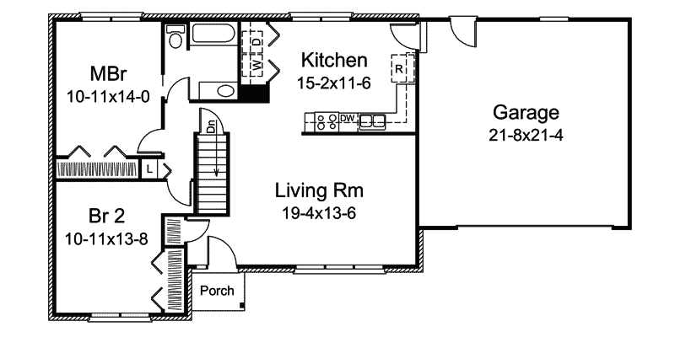

Answer | This plan shows the ground floor of a brick veneer residence  Containing:  Porch at front entry door  Storage Cupboard at entry with door  Timber Staircase  Internal Walls are Timber stud  External Walls are Brick veneer  Living Room with triple sash window in single wall  Kitchen with hot plate, dishwasher, double bowl sink, range hood and internal access door to garage. Also contains cupboard for washing machine and dryer with concertina doors  Garage with single roller door, fixed window and rear access door, plus internal access door to kitchen  Master Bedroom with cavity slider available to dual access bathroom that contains bath, vanity and toilet and door access from hallway  Wardrobe with concertina doors and a double sash window in single wall  Hallway between bedrooms has a linen cupboard and concertina door.  Bedroom 2 has a wardrobe with concertina doors and double sash window in single wall.

Refer to the sectional drawing below to respond to Q43. to Q63.


- Give a brief description about the building from the detail available in the sectional drawing.

Answer | - Full timber frame construction house  - Slab on ground  - Ground floor brick veneer  - Upper level light weight timber weather board  - Scissor truss roof  - Colorbond metal roof  - Perimeter verandah with Colorbond metal roof  - Ground floor family room  - Upper level Bed 3, Bed 4 and bathroom

- Who is the client?

Answer | H&M Smith

- Where is this project to be built?

Answer | Lot 16 Glenvalley Road Richmond

- What are the contact details for the draftsman?

Answer | Joe Foreman  Ph: 03 9514 2311  Mobile: 0413 113 113  18 Faireview road, Richmond 3216

- What sheet number is this drawing?

Answer | 5 of 7

- What timber is required for loading and non-load bearing walls?

Answer | Load bearing = F5 – 45x90  Non-load bearing = F5 – 35x90

- What spacing is recommended for common studs?

Answer | 600mm max spacing

- What type of roof truss is to be installed?

Answer
Scissor trusses

- What centres are the trusses positioned at?

Answer | 900 max spacing

- What size are the veranda posts?

Answer | 90 x90

- What timber species are the veranda posts to come from?

Answer | DAR Oregon

- What pitch is the roof?

Answer | 30 degrees

- What size are the noggings and at what spacing?

Answer | 35 x 70 – 1350 max spacing

- What size are the ceiling joists?

Answer | HJ 240 joists at 450 spacing

- What timber is used for roof battens and what spacing?

Answer | Pine at 900 spacing

- What thickness is the plasterboard sheeting?

Answer | 10mm

- What type of flooring is to be installed?

Answer | 15mm plywood

- What is the roof cladding material?

Answer | Colorbond corrugated metal roofing

- Where will you find information about the footings?

Answer | Engineers drawing

- What do the letters DAR refer when timber ordering?

Answer | Dressed All Round – the timber has been planed smooth on all surfaces.

- Explain 240 x 63 LVL. What does it refer to on the section?

Answer | The section refers to the flooring joists: Laminated Veneer Lumber – 240mm width x 63mm thickness

Refer to the drawing overleaf to respond to Q64. to Q75.

- What is the number of the drawing?

Answer | 2

- What is the Job Number?

Answer | 00R-112

- What is the scale of the drawing?

Answer | 1:100

- What does the drawing show?

Answer | House Elevations – East, West, North, South and Section

- Which view shows the front of the house?

Answer | East Elevation

- How many motor vehicles can be parked in the garage?

Answer | Two

- What are the window and doors made from?

Answer | Aluminium Frames Sliding Doors & Windows and also a Timber Entrance Door

- What is the size of the eaves?

Answer | 450

- What are the eaves lined with?

Answer | Hardiflex

- What type of roof structure is the roof built from?

Answer | Timber framed roof trusses

- What is the roof cladding materials made from?

Answer | Concrete roof tiles

- What is the roof pitch?

Answer | 22.5 degree slope



- You have spoken with a client on the phone and they are seeking to make amendments to some plans. They wish to add two more bedrooms to extend their home from the current four bedrooms to six bedrooms.
The two new bedrooms are to both have ensuites (including single shower in each, double bowl vanity unit and under cupboard and toilet) with walk in robes, including the extension of the existing hallway with built-ins for the existing Bed 1 and Bed 2. The Family Room is to be extended to the rear wall in line with kitchen rear wall.
The client has faxed through the image below. Re-sketch and redesign the drawing and add the two new bedrooms along with extended hallway, ensuites, walk-in robes and the Family Room extension for consideration by the client.
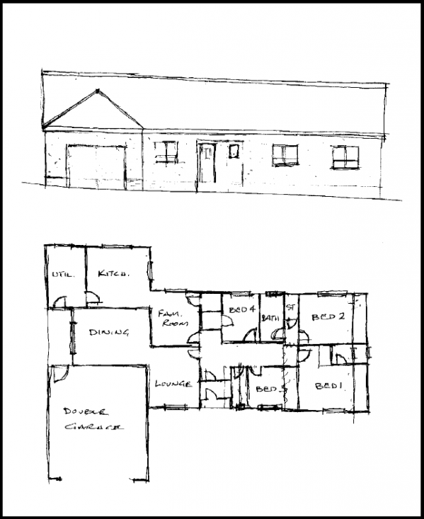
SKETCH
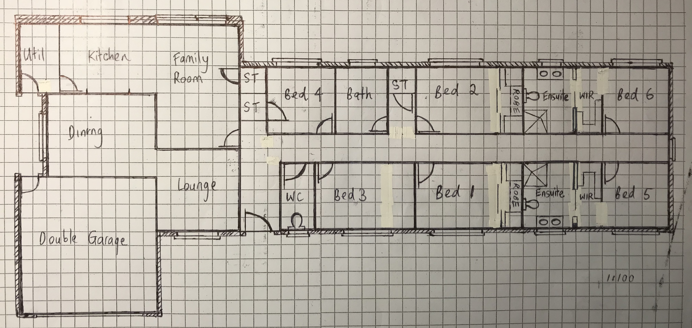

Answer

- Referring to Q76. compose an email to the client, providing an estimate of the additional labour hours/costs and material quantities/costs that have resulted from the their request.

Answer | Dear Client,  PRELIMINARY QUOTE: HOUSE RENOVATION  We are pleased to submit our preliminary quote for your house renovation for the figure of $51,050.97.  The full breakdown and details of this quote are attached in a separate document.  The following items have been included in the above quotation price:  - This quote is valid for 30 days from date of issue  - All supervision, site allowances and insurances  - Private certification & plumbing & inspections fees  - Surveying & site set out  - Levelling of areas for extension  - Detailed excavation to footings  - Concrete & reinforcement to ground slabs  - Termite control  - Final clean  The following items have been excluded from the above quotation:  - Building services fees  - Council fees other than mentioned in inclusions  - Allowance for Telstra / NBN  - Removal of rock in which a 20 ton excavator or greater is required  - Light fittings to be supplied by owner  - Plumbing tapware and accessories to be supplied by owner  - PC Allowances for Tiles and Carpet.  Please contact me should you require any further assistance.  Yours faithfully  RCQ Construction QLD Pty Ltd  Emma Carew

