Reports where legal advice is required and/or legal proceedings are reasonably anticipated shall be completed using the T041. Incident Investigation Report (Template).
Incident Summary: | Damaged to sedimentation dam’s pipe and valve block resulting in dam water released
Date of incident: | 24/09/2024 | Date reported: |  | 24/09/2024
Business Unit: | Energy & Infrastructure | Incident Owner: |  | Brendon Watts
Location of incident: | Swanbank BESS Project: 2 Memorial Drive, Swanbank QLD 4306 - UX01 BESS Area
SAP ID: | 75727
Investigation Team
Lead Investigator | Sooty Phomsouvanh (Yurika)
Team Member | Murray Adey (Yurika)
Person’s interviewed (including third parties)
Name | Position |  | Role in the incident
Jake Ducane | Trade Assistant |  | Building temporary structure
Anaru Nicholas | Trade Assistant |  | Building temporary structure
Beau Rasmussen | Employee in Charge |  | Allocating tasks to crew member
Injury Details
Name of injured person: | Jake Ducane | Company: |  | Yurika
Injuries sustained: | Sustained injury to lower back resulting in Lost Time Injuries
Treatment: | Medication
Damage / Impact
Equipment/Assets | -
Fleet/Plant | -
Environmental/Cultural Heritage | -
Property | -
Community | -
Service Delivery | -

PEEPO Investigation questions for identification of contributing factors
PEOPLE | Yes | No | N/A | ENVIRONMENT | Yes | No | N/A
PE1 - Was person experienced in the task? | Y |  |  | EN1 - Was the weather suitable for the tasks performed? | Y
PE2 - Had they been adequately trained? | Y |  |  | EN2 - Was housekeeping acceptable? | Y
PE3 - Did the person understand the task? | Y |  |  | EN3 - Was the physical work location suitable or managed for the tasks performed? E.g. access/egress, lighting, noise, traffic, people, wildlife, surface gradients/conditions, hazardous substances, vegetation. | Y
PE4 – Could person physically do the work? | Y |  |  | EN4 - Did the location of the work area contributed? |  | N
PE5 – Was person under stress (work or personal)? |  | N |  | EN5 - Was visibility an issue? |  | N
PE6 – Was fatigue a factor? |  | N |  | EN6 - List any other contributing factor |  |  | NA
PE7 - Was the person wearing required PPE for the task? | Y
PE8 - Was person aware of the hazard(s) associated with task? | Y
PE9 - If hazards identified, was HazChat / Take5 /Start Card report completed? | Y
PE10 - Were controls put in place to rectify the hazards? |  | N
PE11 - Was there effective communication in the work team or with other people involved in the task? | Y
PE12 - List any other contributing factor |  |  | NA

EQUIPMENT | Yes | No | N/A | PROCEDURES | Yes | No | N/A
EQ1 - Was the equipment in, and performing in good working order and operating correctly? | Y |  |  | PR1 - Were procedures/SWIs available for the task? | Y
EQ2 - Were interlocks or other equipment controls of reasonable quality and /or correctly designed? |  |  | NA | PR2 – Were current version used? | Y
EQ3 - Were the appropriate equipment/tools available for the task? | Y |  |  | PR3 – Were contributory hazards identified prior? | Y
EQ4 - Was the equipment working within its limitations? | Y |  |  | PR4 – Are required competencies documented? | Y
EQ5 - Was equipment maintained according to schedule? |  |  | NA | PR5 - Was a risk assessment conducted prior to the task being performed or when conditions changed? Eg, SWMS |  | N
EQ6 - Were regular inspections/pre-start checks conducted on the equipment? |  |  | NA | PR6 - If a permit was required, was one used for the task? |  |  | NA
EQ7 - Has a documented risk assessment been conducted on the equipment? |  |  | NA | PR7 - If required were change management procedures completed and communicated (stakeholder/contractor interface)? |  |  | NA
EQ8 – Other contributing factor? |  |  | NA | PR8 - If required was there an environment and cultural heritage assessment done on the project prior to works commencing? |  |  | NA
 |  |  |  | PR9 - If there was E&CH permit conditions in place were they complied with? |  |  | NA
 |  |  |  | PR10 – Other contributing factor? |  |  | NA

ORGANISATION | Yes | No | N/A | ORGANISATION | Yes | No | N/A
O1 - Was an adequate level of training provided to personnel? | Y |  |  | O6 - Is there behavioural observation information available for the task? |  | N
O2 - Was management leadership or commitment to safety sufficient? |  |  | NA | O7 - Was contractor management effective? |  |  | NA
O3 - Were priorities managed effectively (production/service vs. safety)? |  |  | NA | O8 – Was there communication on the safety systems? |  | N
O4 - Was resourcing (human or equipment) sufficient? | Y |  |  | O9 – Was there adequate and effective supervision available | Y
O5 - Was contractor management effective? |  |  | NA

Description of Incident: (Who, What, How, When)
On Tuesday, 24th September 2024, Trade Assistants was tasked to gather the tools and materials to set up the rectangular-shaped jigs (A jig is a steel temporary structure installed on ground for concrete to be poured into a particular shape) at UX01 BESS Area (also known Western BESS Area) in preparation for the Concrete pour planned for Friday 27th September 2024.
After smoko, (10:30hrs), two (2) Trade Assistants returned to UX01 BESS Area and continued to set up of the jigs at Bay 6. Trade Assistant Two (TA2) was tasked to remove the screws to release the width section of the rectangular-shaped jig, so the timbers can be installed at each end (Photo 1). Trade Assistant One (TA1) was using the Crowbar (Photo 2) to lift the length section of the rectangular-shaped jig up to put more timbers underneath to secure and level the jig so TA2 can fasten the jig into the timbers.
After the timbers were fasten in, TA1 finished using the crowbar and went to pick the timbers, ready for the next jig set up. When TA1, went to pick up the timbers, he sudden felt pain to the back after straightening back up at approximately 12:15hrs.
TA1 notified the Employee In Charge, approximately 12:30hrs of the back pain. TA1 went to rest and was taken to the Hospital by the Supervisor for medical assessment.

Investigation Findings
PEEPO Code | Findings
PR5 | Hazardous Manual Handling SWMS signed by TA1.  However SWMS is absent on the task/activity of setting up the jig.
PE10 | HazChat completed by on 24/09/2024. TA1 have signed onto the Hazchat.  HazChat noted Manual Handling SWMS. HazChat noted task was to install battery jigs with Franna. Identified manual handling as a hazard however controls absent on the manual handling task.
O6 | No Task / Behavioural Conversation or SWMS observations completed for manual handling task
O8 | On the Work Capacity Certificate on 24/09/2024,  TA1 declared to the Medical Practitioner he had pre-existing factors or condition aggravated for chronic back pain since 20 years of age.
- | Prestart completed for on 24/09/2024. Group Discussion point noted Manual Handling SWMS. TA1 attended the Daily Prestart Meeting.
- | EQL Hazardous Manual Task Online completed by TA1
- | Online Project Induction completed by TA1. The induction covers Manual Handling requirements.
Basic cause of the incident (where was control lost?)
Muscle strain from repeated heavy lifting task

Supporting Evidence
- Pre-Start - Daily Shift and Onsite Attendance Log
- YUR 0003 HazChat
- YUR 1415 WR1853038 Hazardous Manual Handling SWMS
- Witness Statements of Trade Assistants and Employee in Charge
- EQL Hazardous Manual Task Online Training
- Swanbank BESS Online Induction
- Photos of the work area where incident occurred
- Work Capacity Certificates (Confidential Record)
- Incident Notification to WHSQ

Photo 1
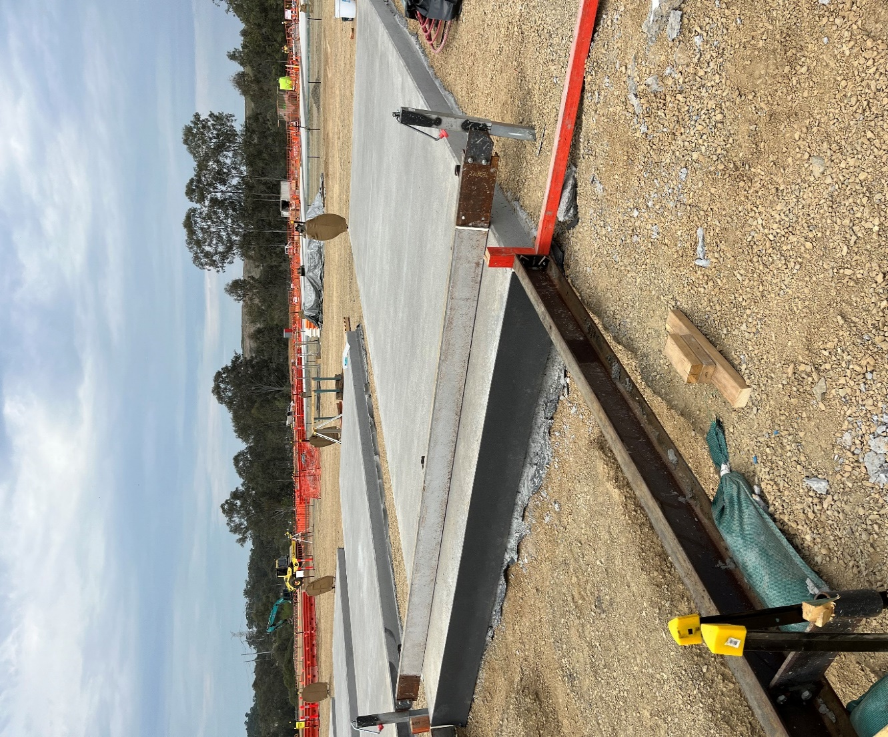
Post-event Photo - Jig section lifted with crowbar, to screw into red-coloured timber

Photo 2
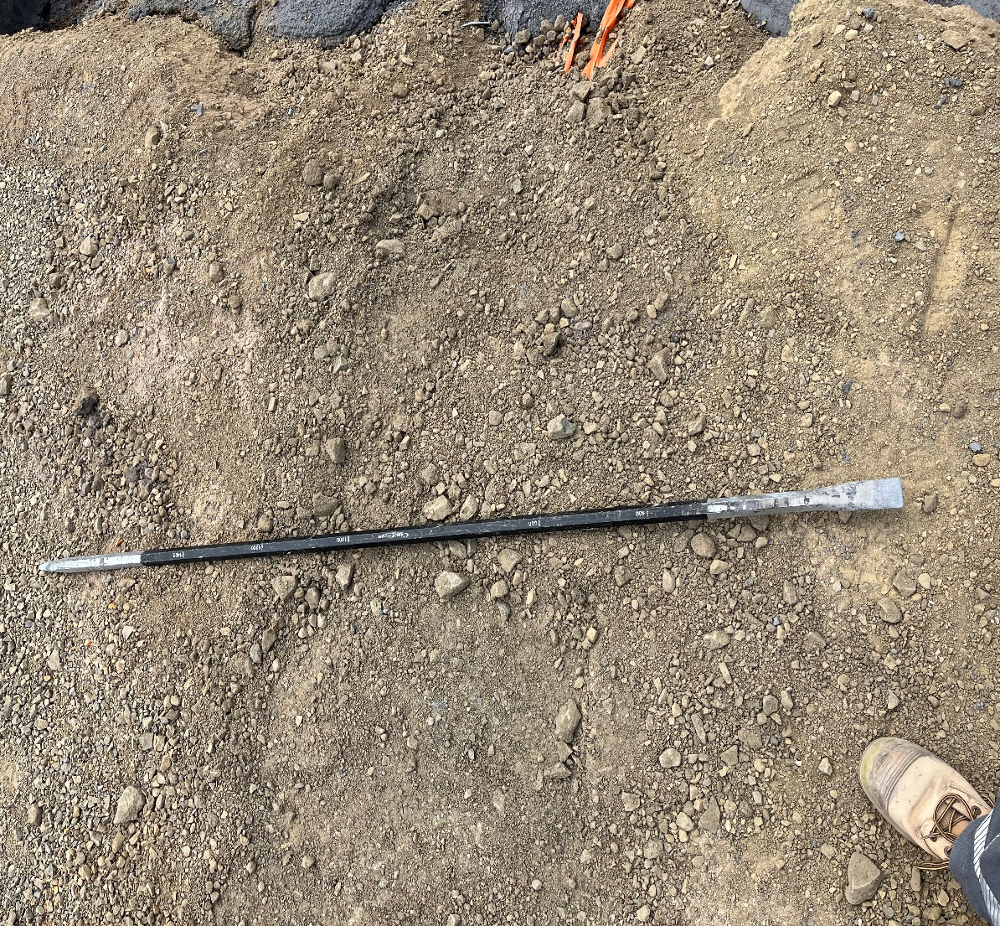
Post-event Photo - Crowbar used for lifting of jig section

Key Learnings / Incident Findings: (detail learnings from investigation)
- It is a reminder, that personnel should practice safe manual handling techniques when planning to perform a hazardous manual task for setting up the jigs. Technique is to bend at the knees (not your back) and tighten your core muscles to lift straight up, without bending and/or twisting your back. Use high level hierarchy of controls to perform lifting task to eliminate manual lifting.
- If known worker’s pre-existing injuries and/or health condition, the project can determine and allocate suitable tasks to minimise aggravation to the pre-existing or health conditions.
Recommendations & Corrective Actions
PEEPO Code | Proposed Corrective Actions | Responsible Person | Completion  Date | Hierarchy of Control
PR5 | Review and update Hazardous Manual Task SWMS to include setting up the jigs task and Toolbox the updated SWMS | Site Manager/ Construction Manager | 31/10/2024 | Admin
PE10 | Perform inspection on completed HazChat to confirm control measures for hazardous manual task are communicated and recorded | Site Manager/ Construction Manager | 31/10/2024 | Admin
O6 | Conduct SWMS Observation and Task / Behavioural Conversation to verify manual handling techniques are performed as trained. | Site Manager/ Construction Manager | 31/10/2024 | Admin
O8 | Consult with Corporate HSE to improve Safety System, for onboarding new workers to declare any pre-existing and/or medical condition | Project HSE Specialist | 31/10/2024 | Admin

Report authorisation and sign off
The Investigation Team’s responsibilities have been completed with respect to this investigation.
All investigation processes were performed in accordance with applicable Energy Queensland incident investigation procedures.
Upon signing this final Incident Investigation Report I am indicating that Corrective Actions will be entered into SAP in accordance with R073. HSE & Asset Incident Management Framework (Reference) for appropriate actioning to reduce the likelihood of recurrence of this type of incident.

Signature: |  |  | Date: | 23/10/2024
Incident Owner Name and Title: |  | Brendon Watts  Project Manager

