BSBPMG516
Manage project information and communication

PRACTICAL ASSESSMENT INSTRUCTIONS

- The following practical assessment will require the participant to complete work related activities.
- Observations will be conducted of the participant’s work to determine whether they display sufficient practical skills and knowledge.
- Please fill in the details below, providing your name, signature and date of assessment.
  - Your signature acknowledges that the assessor provided clear instructions and the participant understood what was required to complete this assessment.
- The assessor may substitute a Practical Task with another task of equal value.
  - Alternate tasks must be fully documented by the assessor.

Participant name | Seremaia Veramu
Participant signature | 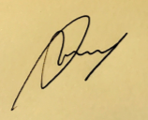

Assessor name | Santiago Jimenez
Assessor signature | 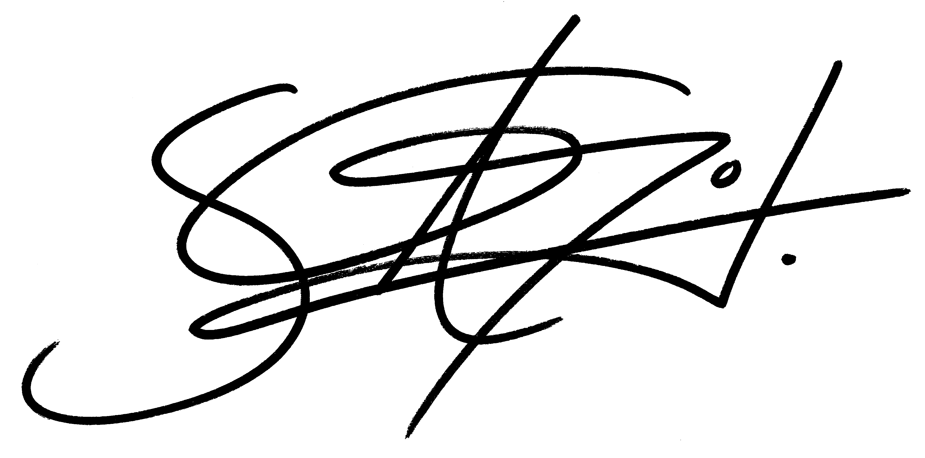

Date | 11/10/2020

Number of tasks | Number of tasks completed | Satisfactory?
1 | 1 | Yes | No

Assessor Comments
BSBPMG516
Manage project information and communication

Practical Task 1
Description of task:
A suitable observer is to verify the participant’s ability to plan, implement, maintain and review information and communication management systems and processes. The participant is required to link people, ideas and information at all stages in the project life cycle, ensuring timely and appropriate generation, collection, dissemination, storage and disposal of project information through formal structures and processes.

These tasks may be simulated or real. The participant is to gather evidence of how they have completed each component of the Practical Task, which is to be submitted with this Practical Assessment sheet. The observer is to provide detailed comments on the tasks completed by the participant. The assessor is to verify the observer’s comments in the Assessor Comments section, and provide the Practical Assessment outcome on the front cover of this document.
Resources required:
Project documentation, Computer.
Assessment of task
Name of participant: | Seremaia Veramu
Name of observer: | Santiago Jimenez
Role of observer  (Confirm suitability to sign) | Electrical Engineer
Email address of observer | sjimenez@protechpas.com
Signature of observer:
Date: | 11/10/2020
When completing the task, did the participant: |  | Tick if satisfactorily completed.  Provide comments if left unticked.
1 Plan information and communication processes
- Using input from stakeholders, identify, analyse and document information requirements – ensuring:
- Consideration of alternative communication methods, media and systems, and their application on various projects
- Use of clear language in verbal and written interactions with stakeholders
- Consideration of non-verbal communication
- Use of active listening and questioning to confirm understanding and agreement
- Within delegated authority, develop an agreed communication management plan to support achievement of project objectives.
- Establish and maintain a designated project-management information system to ensure quality, validity, timeliness and integrity of information and communication.
2 Implement project information and communication processes
- Manage generation, gathering, storage, retrieval, analysis and dissemination of information by project staff and stakeholders.
- Implement, modify, monitor and control designated information-validation processes to optimise quality and accuracy of data.
- Implement and maintain appropriate communication networks.
- Identify and resolve communication and information-management system issues.
3 Assess information and communication outcomes
- Finalise and archive records according to agreed project information ownership and control requirements.
- Review project outcomes to determine effectiveness of management of information and communication processes and procedures.
- Identify and document lessons learned and recommended improvements for application in future projects.
The participant’s performance was: Satisfactory Not Satisfactory

observer Comments
It is important to have meeting minutes after every weekly meeting, all parties should be informed and accept discussed agendas and resolutions.

