Early Contractor Involvement (ECI) with McNab

Introduction
McNab’s expertise lies in providing buildability, cost estimating/planning, identification of practical and robust design detailing, value management, innovation, programming/staging and design management. We work with our clients, project teams and operational teams in a collaborative, open and transparent manner. We take a cooperative approach to managing design development with a strong emphasis on stakeholder involvement and signoff.
At McNab, we embrace the Early Contractor Involvement (ECI) process to ensure all objectives and deliverables are successfully achieved. Our approach includes a series of key elements, many of which overlap or are addressed concurrently throughout the process. Our ECI process demonstrates how we intend to achieve a full understanding of the Principals Project Requirements (PPR) and early positive engagement, and be the effective lead collaborator to the subsequent design and procurement processes.
Through the ECI phase, McNab as the Building Consultant, will update the Target Construction Cost based on documentation and stakeholder input along with market based pricing information as it becomes available.
We are experienced in obtaining trade pricing and adopt ownership of the scope and cost, providing real time advice to the team and are proactive in reviewing design documentation and responding to opportunities and risk items as they arise. In addition to progressively updating the Indicative Target Construction Cost, McNab will provide design cost checks on specific design details as presented.
During the Phase 2 Design Development Stage, McNab will go to significant efforts and obtain subcontractor trade coverage and engage with the market to ensure the Contractor Lump Sum is the best pricing for the project.
In order to gain a head start on the overall project program McNab will assist in identifying strategic works packages that could be done as early works. Additional earlier works in advance of the main works de-risk the project for both the Client and contractor.
The description of our approach includes a series of key stages, many of which overlap or are addressed concurrently through the process:
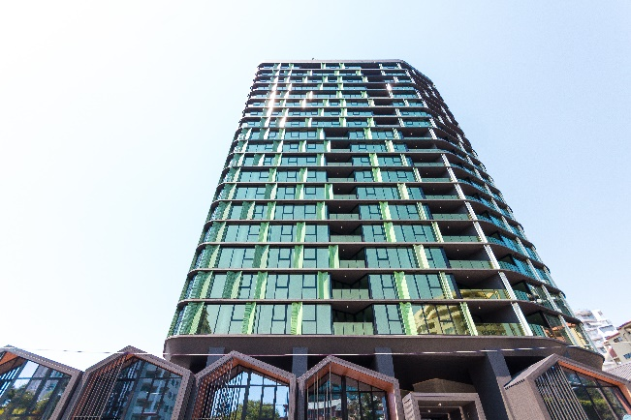
Lotus Towers, Kangaroo Point $77m
- Engagement and Understanding – Note this phase has commenced.
- Design Development and Sales Display works
- ECI Verification
- Design Development under a D&C Contract
- Construction

McNab ECI Process
STAGE 1
ENGAGEMENT & UNDERSTANDING
& COST PLANNING

STAGE 3
CONTRACT NEGOTIATIONS
GMP AGREED
DESIGN DEVELOPMENT 50%

STAGE 2
DESIGN DEVELOPMENT 30%
ECI & DA MINOR CHANGE

STAGE 5
DESIGN & CONSTRUCT DELIVERY

STAGE 4
DESIGN DEVELOPMENT
AUTHORITY APPROVALS

Commenced – Jun 21
Nov ‘21-Dec’21
Client
Apartment & Tenancy Matrix
Sales agent feedback
Design Review
Town Planning
Marketing & Sales Feedback
McNab
Perform Sales Display Works
Design Management
Consultant Engagement
Site Investigations
Geotechnical Investigations
Structural Schematic Design
Services Schematic Design
Reverse Brief
Design Rationalistion
Authority Engagement
Client
Design Approval
Apartment & Tenancy Matrix
Marketing & Sales Feedback
Client
Presales feedback
Head contract Administration
Client
Prepare D & C Contract
Contract Execution
Design Approval
Apartment & Tenancy Matrix
Marketing & Sales Feedback
Client
Briefing
Feasibility
Sales agent engagement
Submit DA – Minor Change
Authority Applications – Energex etc.

Timeline
McNab
Project Understanding
Cost Planning
Concept Design
Design Rationalisation
Stakeholder Engagement
Programme Targets
Team Introduction
Initial Value Management
Construction Budget agreed.

McNab
D&C Pricing /
Cost Plan Validation / Market testing.
Programme review & Validation
Buildability Review
Early Subcontract Engagement
Contract Negotiation & Agreement
Site infrastructure applications (OPW)
Fulfilment of ECI agreement obligations
Execute D&C Contract
McNab
Design Development and Finalisation
Authority Approvals
Safety in Design
Building Approvals
Commence Construction
McNab
Project Delivery
Safety Management
Contract Administration
Project Reporting
Jul - Aug ‘21
Sep – Oct ‘21
Aug ’21 -
Stage 1: Engagement & Understanding
The first important step is to clarify our understanding of all requirements and objectives for the Stanhill Drive Apartments Project. This is an informative period of project engagement to understand our client’s requirements for the development including content, cost and time. Our approach thereafter will be to make proactive proposals to manage the process for which we are responsible, and to contribute positively in the areas that remain of ongoing concern to Bivcorp. When the ECI commences, we will be familiar with the demands of the project and will move forward into the ECI period with the required background to address these demands and de-risk the project for all parties.
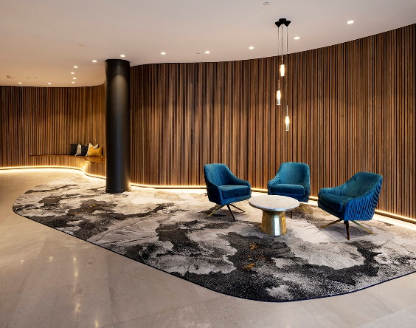
The Banc , Brisbane $38m
Upon completion of this stage of the project, McNab enter into a period of ECI Engagement (Stage 2) with a sound understanding of the project and its specific design requirements, a baseline cost plan and programme.
Stage 2: ECI and DA Submission
OVERVIEW
The second stage of the project delivery will be to advance the design to create the following outcomes:
- Review current DA proposal and assist with commentary through Minor change submission.
- Source and evaluate Consultant Fee Proposals. On board consultants and execute under McNab consultancy agreement.
- Commence design development through schematic design. Confirm floor plates, service spatials including riser coordination and building performance requirements. Develop documents to 30%DD (Concept Design)
- Perform Sales Display works on a cost plus 10% model.
- Manage and coordinate additional Geotechnical investigation.
- Support design development decisions in line with the cost plan.

PROGRAMME
Stage two will run for approximately 6-8 weeks from the receipt of the ECI agreement.
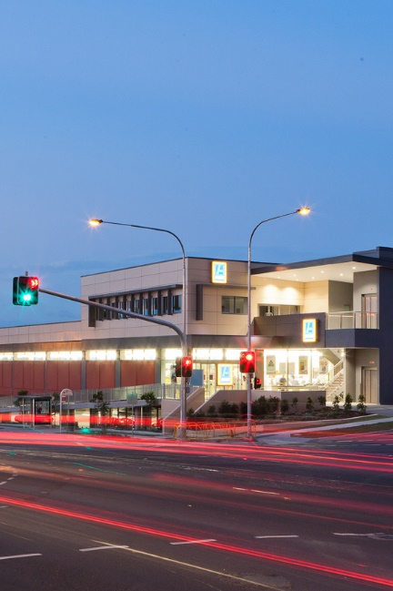
SCOPE
The Stage will require the Design development of consultant drawings to a stage of approximately 30% completion (Or 100% Concept Design) which will include:
- Design development of Point Architects Design
- Preliminary Structural
- Preliminary Hydraulic
- Preliminary Electrical
- Preliminary Mechanical
- Preliminary Fire feedback
ALDI, Kelvin Grove $7m
- Preliminary Cerifiation feedback
In order to accurately cost the works, engagement with civil, structural and service engineers will be required as well as certification and sundry consultants.
The civil, hydraulic and electrical consultant engineers will address and resolve in conjunction with GCCC, Energex & GCCC Water, key infrastructure issues including the interface of the proposed development with existing hydraulic infrastructure services, power reticulation and traffic arrangements. This process will involve an elements of site survey to identify and locate existing services.
Structure will be required to produce a preliminary structural design from which rates and quantities can be developed. In order to de risk the structure and refine the design further geotechnical investigations including ground water modelling will be undertaken. We will undertake breakout meeting to overlay and coordinate the architectural and structural designs.
Service consultants will be required to develop D&C tender packages that can be used to obtain market pricing in Stage 3 of the ECI delivery model.
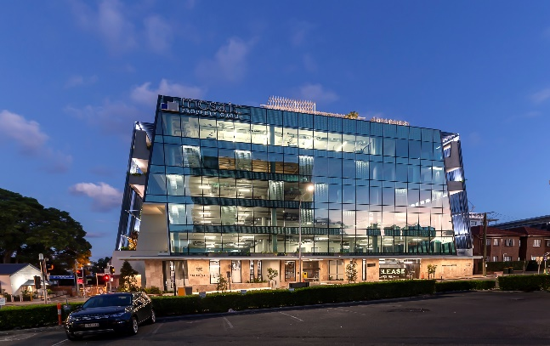
Eminence Commercial Building, $18m
In order to complete this phase of the works McNab will engage, contract and drive the design team to the required outcomes under the management of the McNab Design Manager and McNab ECI Manager. Regular design meetings will be conducted to maintain focus and identify key action items. Client meetings will be scheduled as required to maintain project momentum.
Running parallel with the design development McNab will undertake a number of steps to define and de-risk the project including:
- Review of the Pincipals brief in the form of a Principle Project Requirements (PPR) that will capture all finishes, fitments and service requirements for all spaces throughout the development. This document will require our client to define all sales requirements to be included in this publication.
- Review design decisions & directions against the cost plan and monitor change as the design develops.
- Implement value engineering initiatives.
- Undertake site appraisal and survey as required to de-risk the design.
- Undertake risk analysis.
- Review the programme and assess/implement buildability in the developing design.
Following completion of the schematic design deliverables we will enter Stage 3 of the ECI.

COST
In order to complete this phase of the works McNab and external parties’ fees will be as per the attached schedule of fees as described in Annexure 3 of the ECI Agreement.

Stage 3: D&C Contract Negotiations & Design Development
OVERVIEW
The intent of Stage 3 of the project delivery is to sufficiently develop the design to which all parties can agree upon a Design and Construct Contract including conditions of contract, cost and programme.
PROGRAMME
Stage 3 will run concurrently with the Council DA approval, Energex & GCCC water approvals and the phase is expected to run for a period of approximately four + four weeks (Design + Market testing respectively).
SCOPE
McNab will undertake a full revised estimate for the project including market testing of trades, in particular services to provide a comprehensive Design and Construct Offer. The offer will be based on all Design Documentation developed to that date, PPR, available sales agreements, available authority conditions and agreed conditions of contract.
At this stage the definition of the project will have gained clarity, all key risks identified and quantified ready to continue detailed design in stage 4.

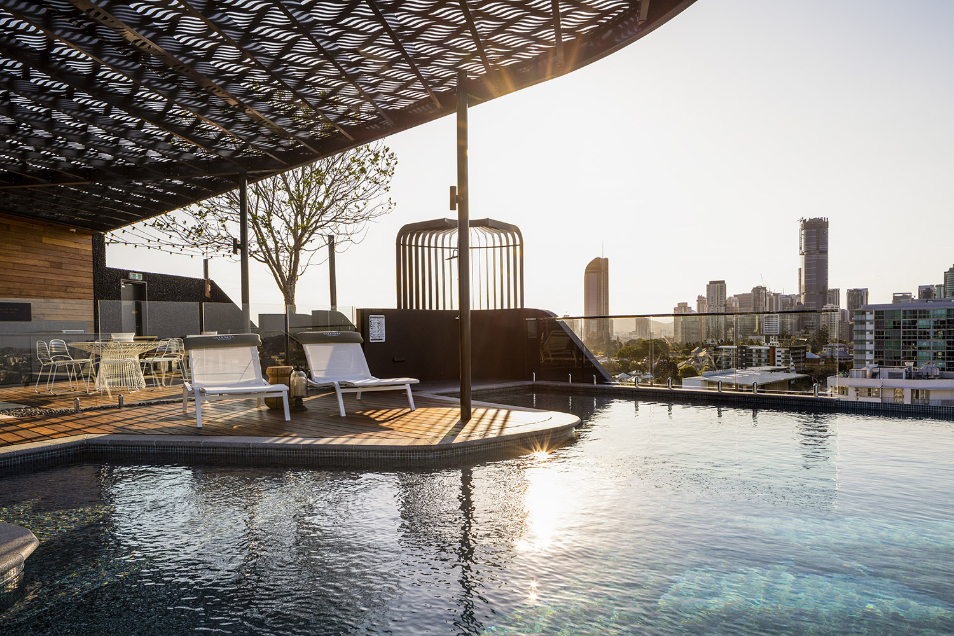
Aria Valencia Residences, $42m
Stage 4: D&C Contract Design
OVERVIEW
Following an agreement of Head Contract terms and receipt of the approved DA (Code Assessable), detailed design will progress. The detail design phase of the works will progress the design from the 50% Design Development (DD) used for pricing and DA onto For Construction Documentation.
PROGRAMME
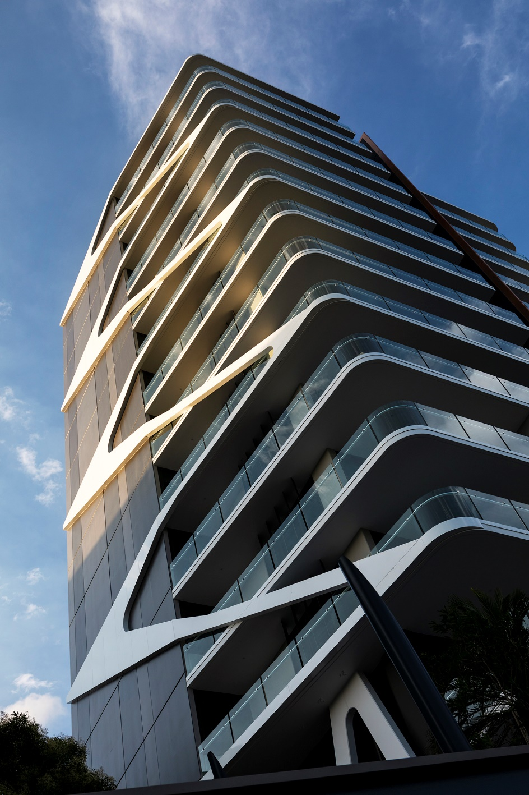
BANC, Toowong, $40m
It is expected that a period of 12 -16 weeks of Design Development will be required to progress design sufficiently to satisfy the requirements of Authorities and the Building Certifier to issue a staged Building Approval. The design phase will run on throughout the initial construction phase of the project.
SCOPE
The key to Design Development is progressing key documentation to a point that Building Approval and Operational works submissions can be granted. These works are not limited to design, submissions and approvals will be sought from authorities and collated with other project documentation to form Building Approval Packages.
McNab understands that the design of the development will continue to evolve as sales progresses and new stakeholders with particular requirements are introduced to the project. This too will require a specific design coordination to ensure changes are appropriately captured and documented.
Design Development will be managed by the McNab Design Manager who will be supported by the ECI Manager and Operational Project Manager who will stay on to deliver the construction phase right through to project handover and beyond.

Stage 5: Construction
The final stage of the delivery model is the on-site delivery of the development. Delivery will follow the path of the agreed construction programme and will include key milestones for testing and commissioning, as well as detailed purchaser handovers to satisfy the terms of sales agreements.
As with design, construction at McNab is a collaborative process involving the efforts of multiple stake holders (our client, purchasers, consultants, subcontractors and the McNab team) to create a successful outcome.
The McNab Construction team will be headed by a Project Manager who will be fully supported by a Contract Administrator, Site Manager, Site Team and HSEQ team who will continue to coordinate all stake holders to deliver the successful outcome.

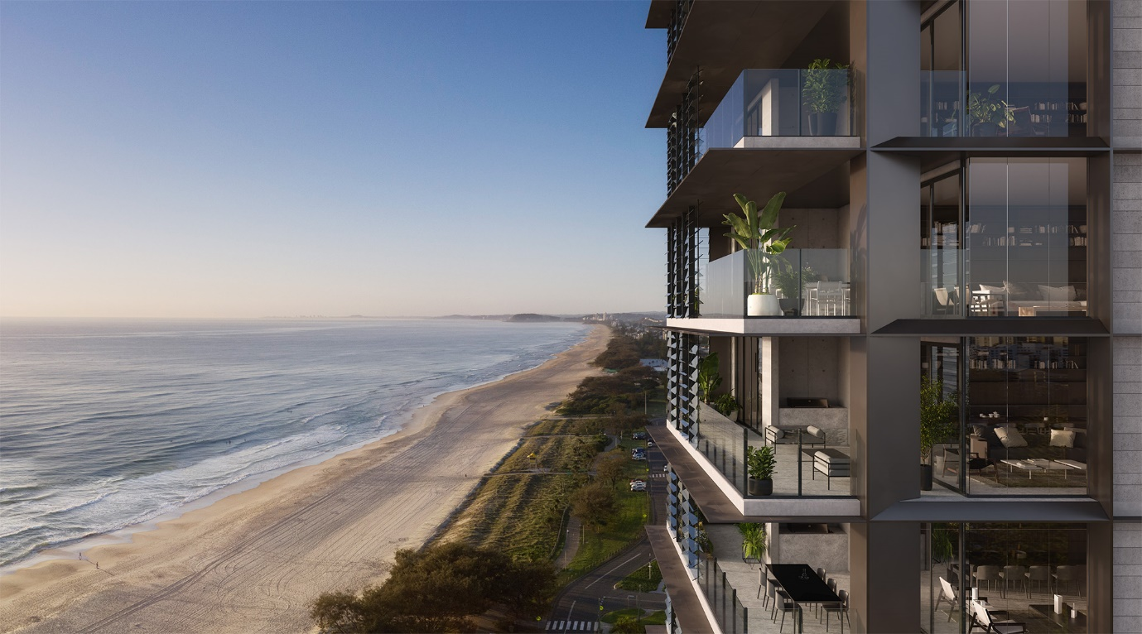
31BB Apartments Broadbeach, $32m

Clarifications

- Our ECI proposal is based on obtaining the DA for the code assessable scheme of the development to allow OPW submissions to be issued and construction of the project to commence.
- Our ECI proposal is based on the Client receiving a Minor change for the Impact Assessable scheme in a timely manner as not to delay construction.
- Our ECI proposal is based on developing the Joe Adsett Design drawings (November Impact Scheme) through the ECI phase.
- We have made no allowance for preparing a hazardous material report for the existing site nor the removal of any hazardous materials.
- Our offer excludes all town planning associated with the development.
- Our ECI Proposal excludes Architectural Design Fees. Architect retained by Client.
- Our ECI proposal for design development scope and costs to include Foundation, Structure, Architectural and Interior design coordination to 50% DD documentation.
- The Contractor has provided separate pricing for the management and construction of the sales display on a cost plus 10% basis. Costs to date can be seen in annexure 4.
- The Contractor have provided separate pricing for the management and facilitation of the ECI design process including all consultant costs as per annexure 2.
- Review design decisions & directions against the cost plan and monitor change as the design develops.

