Callous clothing

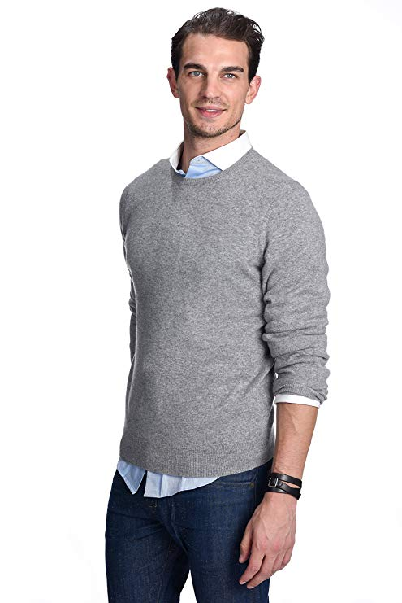
State Cashmere Men's 100% Pure Cashmere Jumper Long Sleeve Pullover Crew Neck Sweater
The care label may read “dry clean only,” but hand washing a cashmere sweater will actually make it softer over time. Be sure to: wash it Inside out in cold water; use baby or Wool and Cashmere shampoo; press out the excess water, but do not wring the sweater; lay it flat on a towel and reshape it as it dries. Fold to store. Never hang.
• Heimlich weich, warm und leicht
• Super versatile; Light weight; Relax fit. Classical design. Wearing with shirt shows formal for working, and wearing with jeans shows leisure at home and party.
• Densely knitted with the finest and long staple cashmere which provides best anti-pilling performance
• Model Measurements: height: 6'2"/ waist: 32". Model is wearing size: Large.

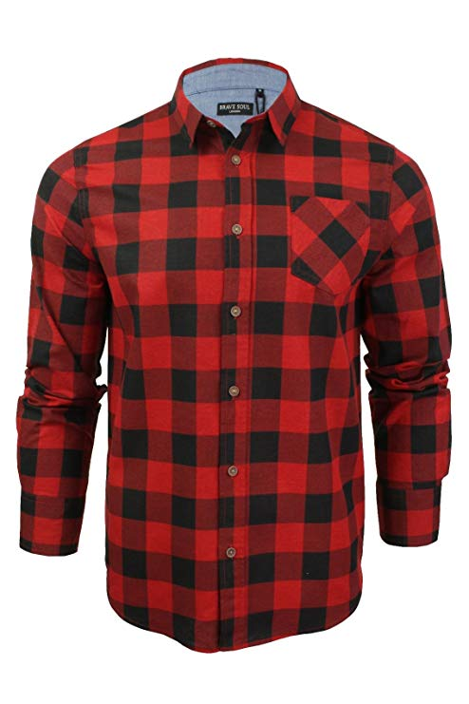
Brave Soul Men's Tame Casual Shirt
Heavy brushed checked shirt
• 100% Cotton
• Machine wash - Cold (30° max)
• Fastening: Buttoned
• Collar Style: Classic
• Regular Fit
• Regular Fit
•Long Sleeve
•MSH-69TAME

OCHENTA men´s trousers chino slim made of cotton business casual cargo leisure suit trousers
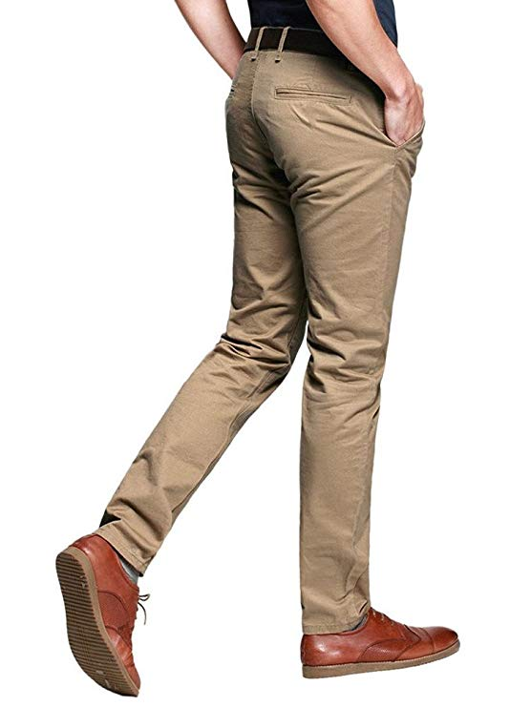
Breathable, because they are slim fit chino trousers, perhaps slightly tight in the wear and tear of first time, please select a larger size than you normally wear if you prefer more room
• Fleece-lined are now available for the coldest weather, ideal for casual and formal wear
• 100% Cotton
• Fastening: Zip
• Cargo
• Slim Fit
• R8-01-Khaki-33
•2 front slash pockets, 2 back pockets

