Internal Dispute Resolution

Purpose
The purpose of this procedure is to outline a fair process for the resolution of internal complaints/ grievances raised by staff regarding employment related matters within T&T Corporation Pty Ltd (T&T CORP).

Scope
This procedure details who to go to when a staff member has a problem or concern, in relation to something affecting his or her employment within T&T CORP and how it will be managed.

Principles

In managing and resolving disputes and grievances the following principles will be appropriately applied, taking into account the nature of the complaints/ grievances:

- Complaints/grievances will be treated seriously by T&T CORP
- Appropriate communication should occur throughout the process
- Confidentiality must be maintained
- Neither party should be subject to victimization
- Support should be available to all parties to the complaint/grievance, including the opportunity to nominate a Representative to accompany and support the complainant/s and/or the respondent/s
- Principles of Natural Justice will guide the application of this procedure. This includes:
  - The Right to be Heard
  - Absence of Bias
  - Procedural Fairness

Procedure
Step 4 – Final Review - Staff member provides a copy of written cmpliant to General Manager
General Manager compile a repot for the executive and provides a copy to staff member

NO
Executive approves decision and grievane process is finalised.

5 working days

If the matter is not resolved either party has the right to discuss the matter with the Fair Work Commission
Resolution: Townsend Building Services aims for dispute resolution via a negotiated outcome, where involved parties reconcile the issue through discussion and reach an agreement on resolution. If a negotiated outcome is unattainable, TBS will endeavour to reach a mediated outcome by involving an independent mediator to assist with reaching an agreement. The dispute will be escalated to an arbitration or adjudication process only where a negotiated or mediated outcome is unachievable.

COO or People & Culture Coordinator listens to the employee’s concerns and attempts to resolves the dispute. If it is not resolved, the dispute will be escalated to the CEO.

The manager listens to the employee’s grievance and together they try to resolve the dispute.

If the manager and employee are unable to resolve the dispute or it is not appropriate that the manager deal with it, the matter should be referred to the Chief Operating Officer (COO) or the People & Culture Coordinator.
The CEO listens to the employee and attempts to resolve the dispute. It is either resolved or referred to an independent body.
An independent mediator (for example, the Fair Work Commission) will be engaged to determine the outcome.
Employee meets with the employee’s direct manager to discuss a problem.

This flow chart should be read in conjunction with the Internal Dispute Resolution Procedure which provides guidance with matters such as reporting to the manager when the issue may be with the manager.

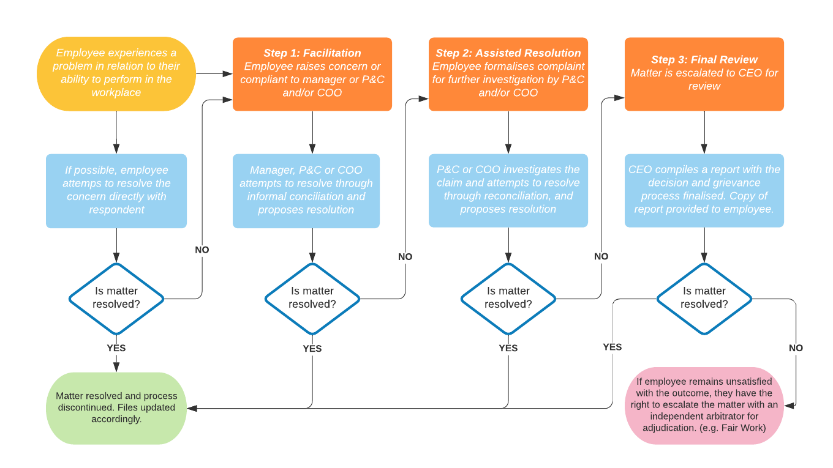

Additional information
Further information can be sourced from:
- T&T CORP policies and procedures - can be referenced on the T&T CORP intranet
- Dispute Resolution - can be referenced on the Fair Work Commision Website - https://www.fwc.gov.au/

Document control information

Document history
The history of changes made to this document is shown below. The most recent changes are listed first.

Date | Summary of Changes
18/01/2017 | Initial Release
29/10/2020 | Update of titles and resolution process
08/12/2020 | Update to procedural workflow

Document status
The current status of this document is shown below.

Issue Date | 08/12/2020 | Owner | Kate Schafer

Approval
This document has been reviewed and approved for publishing by:

 |  | Date
Reviewed by | Kate Schafer | 08/12/2020
Authorised by | Glenn Seaton | 08/12/2020

Documentation and filing
Time Retained (Years) | Responsible Manager | Location
1 | Systems Manager | Gold Coast

