
AHCLSC305
Construct stone structures and features

Copyright © 2021 CSTC Pty Ltd

All rights reserved. No part of the contents of this publication may be reproduced or used in any form or by any means – graphic, electronic, or mechanical including photocopying, digitising, recording, or information storage-and-retrieval systems – without the written permission of CSTC Pty Ltd.
ASSESSMENT FOR AHCLSC305

Student name | Nick Hollowood
Date of assessment submission | Click here to enter a date.

Trainer/Assessor’s name
Date of assessment marking | Click here to enter a date.
Outcome for unit | ☐ Competent  ☐ Not Yet Competent

TASK INSTRUCTIONS

- As part of the assessment for this unit of competency, you are required to complete a series of activities.
  - Some of these activities will require you to provide a response within this document, others will require you to gather evidence to demonstrate your knowledge and skills.
- At all times, the responses in your assessment must reference Australian (Queensland or Federal) documentation, including legislation, regulations, codes of practice, standards and guidance publications.

ACTIVITIES

Draw a simple concept plan for a proposed landscape design which includes stone structures/features.

Response
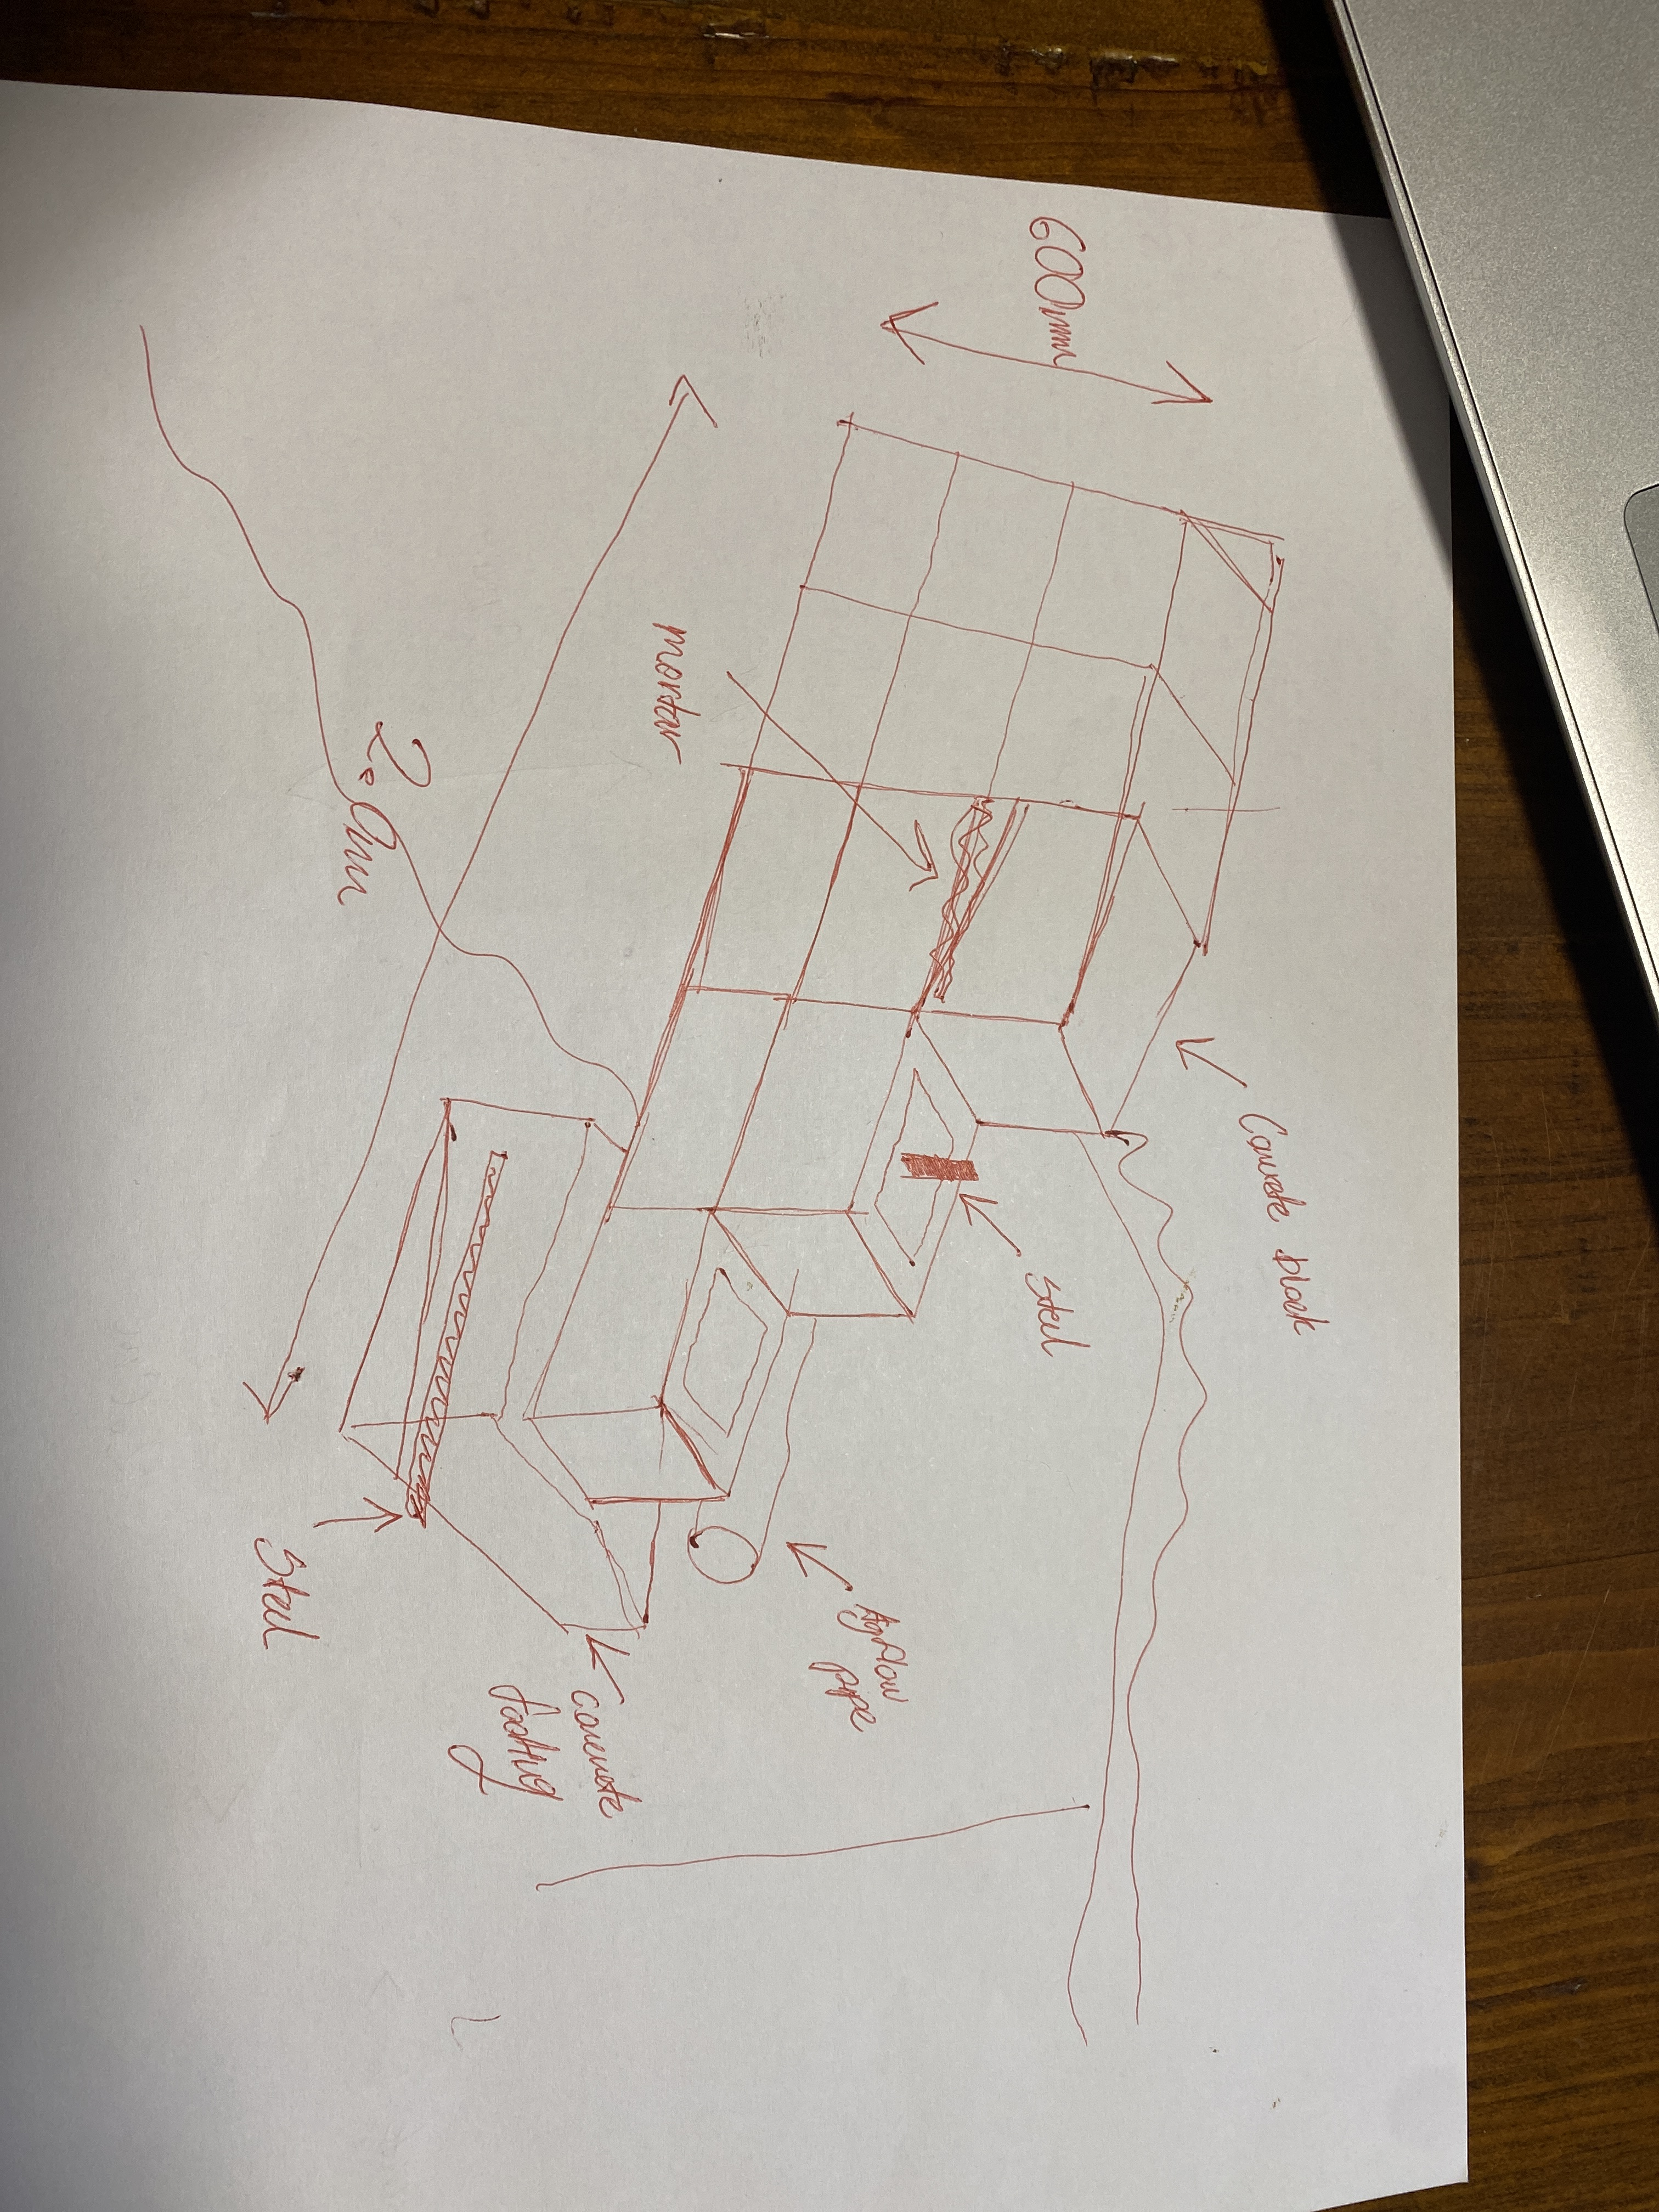

Outcome for Activity 1 | ☐ Satisfactory  ☐ Not satisfactory
Trainer/Assessor comments

Identify/list the detail on the landscape plan shown.

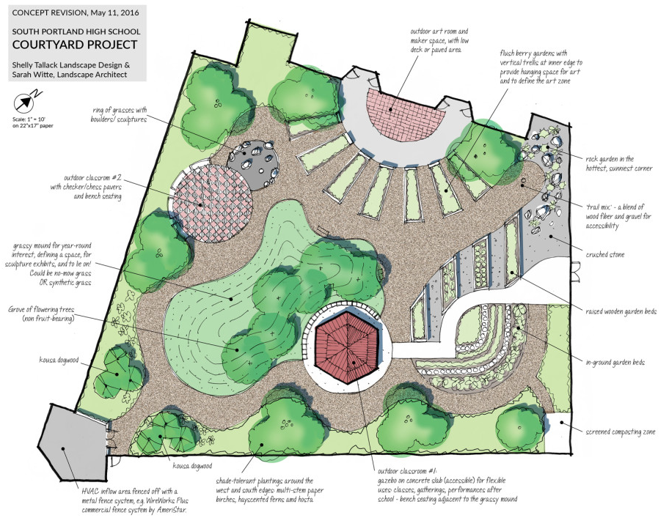

Response
Plants, gravel, paved areas, arbour, raised timber gardens, compose area, rock garden, turf area

Outcome for Activity 2 | ☐ Satisfactory  ☐ Not satisfactory
Trainer/Assessor comments

List the materials required to complete the water feature, by using the wall and water feature construction plan shown.

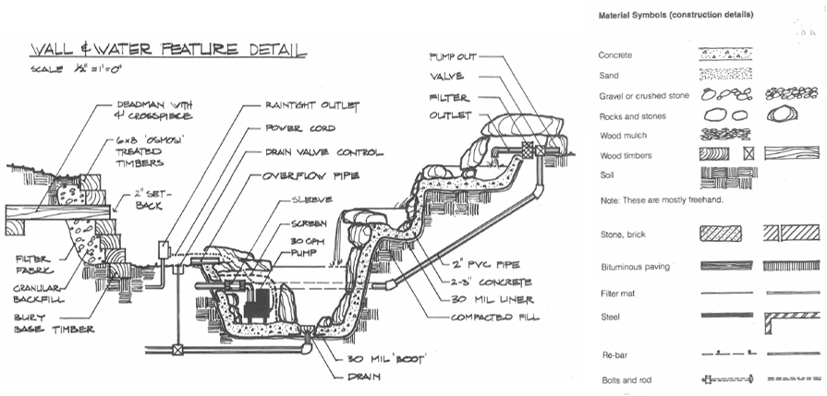

Response
Concrete, sand, gravel, rocks, wood mulch, wood timber, soil, stone brick, bituminous paving, filter mat, steel, rebar, bolts and rods

Outcome for Activity 3 | ☐ Satisfactory  ☐ Not satisfactory
Trainer/Assessor comments

Identify formal and informal stone structures and describe their features.

 | Features
- Formal stone structures | Tidy usual used in formal gardens, clean lines, symmetrical usually a pattern being repeated, straight lines or exact circles.
- Informal stone structures | More natural look, crazy pavers or stone cladding, want randomness but still tidy no straight lines.

Outcome for Activity 4 | ☐ Satisfactory  ☐ Not satisfactory
Trainer/Assessor comments

List the components for four (4) common surface drainage systems used in landscape construction.

System | Components
- Spoon | Usually just concrete
- Channel and grate | Drainage grate, agflow pipe or PVC.
- Pit | Gravel, agflowpipe
- Contour | Earth hill made by machine to reduce waterflow

Outcome for Activity 5 | ☐ Satisfactory  ☐ Not satisfactory
Trainer/Assessor comments

List the advantages and disadvantages of drainage behind and through the stone wall (as shown).

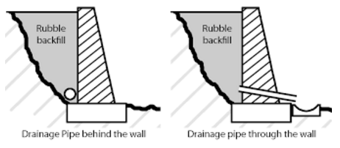

Drainage pipe behind the wall
Advantages
Hidden and tidy, doesn’t reduce strength of structure, water doesn’t run out the front of the wall when raining
Disadvantages
If not working much harder to access, not as reliable as weep hole, may clog up and easier.

Drainage pipe through the wall
Advantages
Easier access, more reliable, not affected by dew or mold.
Disadvantages
Visible from front of wall, could affect strength of wall slightly, if lots of water coming out may pool infront of wall.

Outcome for Activity 6 | ☐ Satisfactory  ☐ Not satisfactory
Trainer/Assessor comments

Research and list a variety of admixes.

Admix | Description
- Set accelerator | Set accelerating admixtures are best defined as those which, when added to concrete, mortar or paste, increase the rate of hydration of hydraulic cement, shorten the time of setting and increase the rate of early strength development
- Shrinking reducing | Shrinkage-reducing admixtures are used to reduce the shrinkage of concrete, whether from drying or self-desiccation. In contrast to other concrete admixtures, they are used in rather large amounts. It directly follows that less energy is available for deformation and shrinkage is reduced.
- Water Reducing | Water-reducing admixtures usually reduce the required water content for a concrete mixture by about 5 to 10 percent. Consequently, concrete containing a water-reducing admixture needs less water to reach a required slump than untreated concrete. The treated concrete can have a lower water-cement ratio
- Set retarder | Retarding admixtures are frequently required in hot weather conditions to facilitate delaying the setting time. They are also used to delay set in more difficult jobs or for special finishing operations such as exposing aggregate.

Outcome for Activity 7 | ☐ Satisfactory  ☐ Not satisfactory
Trainer/Assessor comments

Research other methods of damp proofing (excluding DPC and base course) and identify the materials used.

Damp proofing method | Materials
- Plastic | Poly damp course plastic
- Water proofing | Mastic Asphalt
- Mortar | Mortar, damp proofing admixes
- Pressure grouting | Cracks and joints in grouting

Outcome for Activity 8 | ☐ Satisfactory  ☐ Not satisfactory
Trainer/Assessor comments

Research and describe suitability of various patterns for stone work projects.

Pattern | Suitability
- French Pattern | Formal tile areas
- English bond | Formal or basic structural design
- Stack pattern | Basic informal garden
- Common bond | Informal garden

Outcome for Activity 9 | ☐ Satisfactory  ☐ Not satisfactory
Trainer/Assessor comments

List the advantages and disadvantages of mortared and dry stone features.

Mortared stone features
Advantages
More structural integrity, easier to make all blocks or brick same height, holds blocks together.
Disadvantages
More work, more mess, mortar could stain blocks if not cleaned properly.

Dry stone features
Advantages
If built correctly allows for movement in the ground (has more flexibility)
Disadvantages
Made be harder to construct as each block must fit correctly, if not built properly wall will collapse.

Outcome for Activity 10 | ☐ Satisfactory  ☐ Not satisfactory
Trainer/Assessor comments

Research the different types of stone work finishes.

Response
Natural Cleft Stone.
Polished Stone
Honed Stone.
Brush Hammered Stone.

Outcome for Activity 11 | ☐ Satisfactory  ☐ Not satisfactory
Trainer/Assessor comments

List environmentally safe products for cleaning.

Response
Greenwork cleaning products

Outcome for Activity 12 | ☐ Satisfactory  ☐ Not satisfactory
Trainer/Assessor comments

Have team members take photos and videos of your involvement with stone features.

Identify each photo / video with a letter label and describe each photo / video in the table below. Submit the photo / video files along with this workbook.

Advantages
A
B
C
D
E
F
G
H
I
J
K
L
M
N
O
P
Q
R
S
T
U
V
W
X
Y
Z

Outcome for Activity 13 | ☐ Satisfactory  ☐ Not satisfactory
Trainer/Assessor comments

