Hotel WHS Policies and Procedures
Learner tip: this is a lengthy document! Click on the ‘View’ tab above then check the ‘Navigation Pane’ box. This gives you a menu to go straight to the area you need.
Delete this box when you no longer need it.
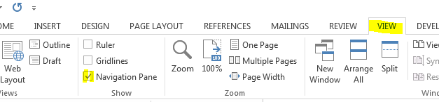
CA City Hotel recognises its responsibility to provide a healthy and safe working environment for employees, contractors, clients and visitors. CA City Hotel is committed to the continued wellbeing of its employees and to ensuring that all employees are safe from injury and health risks whilst undertaking work-related duties, including home-based work.
In order to ensure a healthy and safe working environment, CA City Hotel will:
- provide written procedures and instructions for safe working practices
- ensure compliance with all relevant legislation
- maintain safe systems of work including the work premises and environment
- provide appropriate support, instruction, training and supervision to employees to ensure safe working practices.
The CA City Hotel WHS Policy, procedures and all related documentation can be accessed in the following locations:
- Soft copy – CA City Intranet or request a copy from the assigned WHS representative.
- Hard copy – all documentation is available in the WHS Committee meeting room or request a copy from the assigned WHS representative.

Scope
This Policy applies to decision making through all levels of the Hotel and in relation to any function or activity likely to have any significant impact on the Hotel's operations, irrespective of the level of financial exposure. This policy is applicable to all areas of the Hotel.
All staff members of the Hotel and its controlled entities must comply with this policy in planning and when decisions are made including, but not limited to, the following:
- contracting (whether for goods or services) for an amount requiring executive approval
- capital procurement including strategic IT initiatives
- outsourcing, partnering or shared service arrangements of functions
- community events held on Hotel property or those sponsored by the Hotel
- major fundraising activities
- when developing new strategies, rules, policies and procedures
- when reviewing existing strategies, rules, policies and procedures
- when managing products
- when introducing significant change
- in the management of sensitive issues.

Responsibilities
The Work Health and Safety Act (2011) states that while at work, a worker must cooperate with any reasonable policy or procedure of the person conducting the business or undertaking (PCBU) relating to health or safety at the workplace that has been notified to workers.
In addition, under the Work, Health and Safety Regulations (2011) there are specific work health and safety policy obligations for safety management systems of major hazard facilities.
Responsibilities of WHS roles are described below, as per requirements of health and safety legislation.
PCBU  (owner, manager)  (Section 20-26 WHS Act 2011) | - Primary duty of care to ensure health and safety of workers while at work in the business  - Make sure work does not carry risk to health and safety of others  - Provide and maintain safe work environment, plant and structures, systems of work  - Ensure safe use handling and storage of plant, structures and substances  - Provide adequate facilities, instruction, training, information, supervision  - Monitor health of workers and conditions in the workplace
Officers  (person within the business, Director or secretary of a company)  (Section 27 WHS Act 2011) | - Officers are responsible to make sure the PCBU meets their obligations They need to take reasonable steps to:  - Gain and update knowledge of WHS  - Understand the type of business and hazards/ risks involved  - Make sure PCBU has resources to reduce/ remove risks and hazards  - Processes exist to manage incidents, hazards, risks  - Make sure PCBU is involved in consultation, providing training and instruction and reports notifiable incidents
Workers  (all employees)  (Section 28 WHS Act 2011) | - Take reasonable care for your own safety  - Take care your actions do not harm others  - Comply with instructions from PCBU or their officers to help comply with WHS obligations  - Cooperate with policies or procedures which relate to WHS
Visitors (Contractors, volunteers, others)  (Section 29 WHS Act 2011) | - Take reasonable care for your own safety  - Take care your actions do not harm others  - Comply with instructions from PCBU or officers to help comply with WHS obligations
Health and safety committees (Work groups)  (Section 77 WHS Act 2011) | - Group of persons in the workplace who maintain and improve WHS  - Establishing a workgroup or committee depends on the number of employees and the size of the business  - At least half of the members must not be nominated by the PCBU
Health and safety representative  (Section 68 WHS Act 2011) | - The person elected by members of a workgroup to represent them during consultation on WHS issues  - They monitor actions taken by the PCBU to comply with WHS Act

WHS consultation procedures
Health and safety legislation requires PCBUs must consult with all workers, including contractors, subcontractors, labour hire workers, apprentices, work experience staff and volunteers on health and safety issues. They must also consult with other PCBUs, so far as is reasonably practicable, if their duty of care overlaps with theirs.
Consultation can be encouraged through the establishment of health and safety committees (HSCs) and/or the appointment of health and safety representatives (HSRs). Active contribution from workers or their representatives should be sought and incorporated into operations.
A PCBU must consult with workers when:
- identifying hazards and assessing risks arising from work
- proposing changes that may affect the health and safety of workers
- carrying out activities prescribed by the Work Health and Safety Regulation 2011 (PDF, 2.53 MB) (the WHS Regulation).
A PCBU must also consult with workers and take their views into account when making decisions about:
- ways to eliminate or minimise risks
- the adequacy of facilities for workers' welfare
- procedures for consulting workers
- resolving health and safety issues
- monitoring the health and safety of workers or workplace conditions
- how to provide health and safety information and training to workers.
The WHS consultation process can involve the steps below.
- Understand individual and organisational WHS role
- Communicate and share WHS information with work team, via:
  - CA city intranet, noticeboards or other internal communication channels
  - scheduled formal meetings, e.g. strategic safety group or operational WHS committees
  - scheduling informal team meetings, toolbox talks or prestart meetings
  - special interest working groups, formed to address specific WHS issues
- give workers opportunity to express issues, raise concerns and contribute to decision-making
- Review ideas and concerns prior to decision-making and advise workers of consultation outcomes.
All WHS goals and objectives at CA City Hotel need to fit with, and support overall CA City goals. PCBUs need to ensure WHS processes are subject to regular monitoring, evaluation and review.
Consultation on health and safety is a two-way process and this provides an opportunity to add value when making decisions. To support health and safety procedures effectively in the workplace, information must be accessible, clearly understood and shared between all Hotel staff.

Risk management program
The Hotel will manage risks and hazards continuously using the analysis, treatment, recording, monitoring and review of risks and hazards as outlined in this Policy and the following procedures.
Risk will be assessed and managed by all employees, through supervisors and managers, appropriate to the level, and impact, of the risk.
This Policy seeks to embed a risk management philosophy as part of the Hotel's everyday working environment, by:
- implementing the Risk Management approach and general methodology specified in the Australia/New Zealand Standard for Risk Management AS/NZS ISO 31000:2009 (‘the Standard’)
- establishing a consistent approach to Risk Management in which Risks related to the objects and functions of the Hotel will be identified, evaluated, managed, reviewed and addressed in approval, review and control processes
- ensuring the Hotel's compliance with relevant legislation
- establishing authorities and accountabilities of staff in relation to Risk Management activities
- providing an agreed and structured basis for strategic planning
- requiring proactive rather than reactive Risk Management
- achieving improved Hotel outcomes and outputs based on informed decision making
- assisting in safeguarding the Hotel's assets, staff, guests, finances, property and reputation
- improving the quality of decision making throughout the Hotel
- reducing costs through better targeted and more effective controls.

Responsibilities
Every staff member of the Hotel is responsible for effective management of risk including the identification of potential risks. Risk management processes should be integrated with other planning processes and management activities. All staff should actively participate in identifying potential risks in their area of responsibility and operations and contribute to the implementation of appropriate treatment actions. This policy is not to relieve the hotel's responsibility to comply with other legislation and/or regulations.
Risks might include, but not be limited to:
- failure to attract and retain guests;
- guest, staff or client dissatisfaction;
- a threat to the environment of the institution or elsewhere;
- a threat to the physical safety of persons within the Hotel;
- breaches of security;
- criminal, fraudulent or corrupt activities;
- poor management practices;
- damage to property;
- failure of essential services or business/administrative systems;
- currency fluctuations;
- market competition, trade practices implications;
- legal risk, breach of contract;
- joint ventures, partnerships;
- employment practices (e.g. tenure, casual employment etc.).

Risk and hazard management procedure
CCRG Hotel has a legal obligation:
- to eliminate risks to health and safety, so far as is reasonably practicable; and
- if it is not reasonably practicable to eliminate risks to health and safety, to minimise those risks so far as is reasonably practicable.
All individuals have an obligation to guard against or protect others from any hazards or incidents as soon as they are recognised. If the hazards or incidents cannot be rectified immediately, the person must report the hazards or incidents to the appropriate person.
Step 1  Preliminary risk analysis | This first stage of risk management involves identifying and reporting hazards. The range of potential consequences and how likely those consequences are to occur in the absence of any treatment plans or controls must be estimated and assessed. Staff may use the Risk Register for this purpose.  An Inherent Risk Rating must be assigned to each identified risk by multiplying the Risk Likelihood by the Risk Consequences (refer the Risk Likelihood Descriptors, Risk Consequence Descriptors and Risk Rating Matrix and compare against the criteria established at the outset of this process). At this stage, do not account for any treatment plan or controls. Where multiple Risk Consequences are identified, the highest Risk Consequence score must be used when determining the Risk Rating.
Step 2  Risk control | The most appropriate Risk Control will be that which balances the costs and efforts of implementation against the benefits to be derived from an activity.  Depending on the Risk Rating, treatment options may be applied individually or in combination. Risk control is documented in the Risk Register, in the Risk Control section. This documents the control strategy, the owner of the risk and the status and occurrence of the risk.  The hierarchy of control is used as a benchmark for controlling identified risks. Under the WHS Regulations, Hierarchy of control measures are as follows.  (1) This regulation applies if it is not reasonably practicable for a duty holder to eliminate risks to health and safety.  (2) A duty holder, in minimising risks to health and safety, must implement risk control measures in accordance with this regulation.  (3) The duty holder must minimise risks, so far as is reasonably practicable, by doing one or more of the following:  (a) substituting (wholly or partly) the hazard giving rise to the risk with something that gives rise to a lesser risk;  (b) isolating the hazard from any person exposed to it;  (c) implementing engineering controls.  (4) If a risk then remains, the duty holder must minimise the remaining risk, so far as is reasonably practicable, by implementing administrative controls.  (5) If a risk then remains, the duty holder must minimise the remaining risk, so far as is reasonably practicable, by ensuring the provision and use of suitable personal protective equipment.  Note: A combination of the controls set out in this regulation may be used to minimise risks, so far as is reasonably practicable, if a single control is not sufficient for the purpose.  The hierarchy of control measures are applied in the following order.  - Elimination – physically remove the hazard  - Substitution – replace the hazard  - Engineering controls – Isolate people from the hazard  - Administrative controls – change the way people work  - PPE – protect the worker with Personal Protective Equipment  Each hazard should be assessed against the hierarchy of control in order of most to least effective. Refer to the hierarchy of control below.  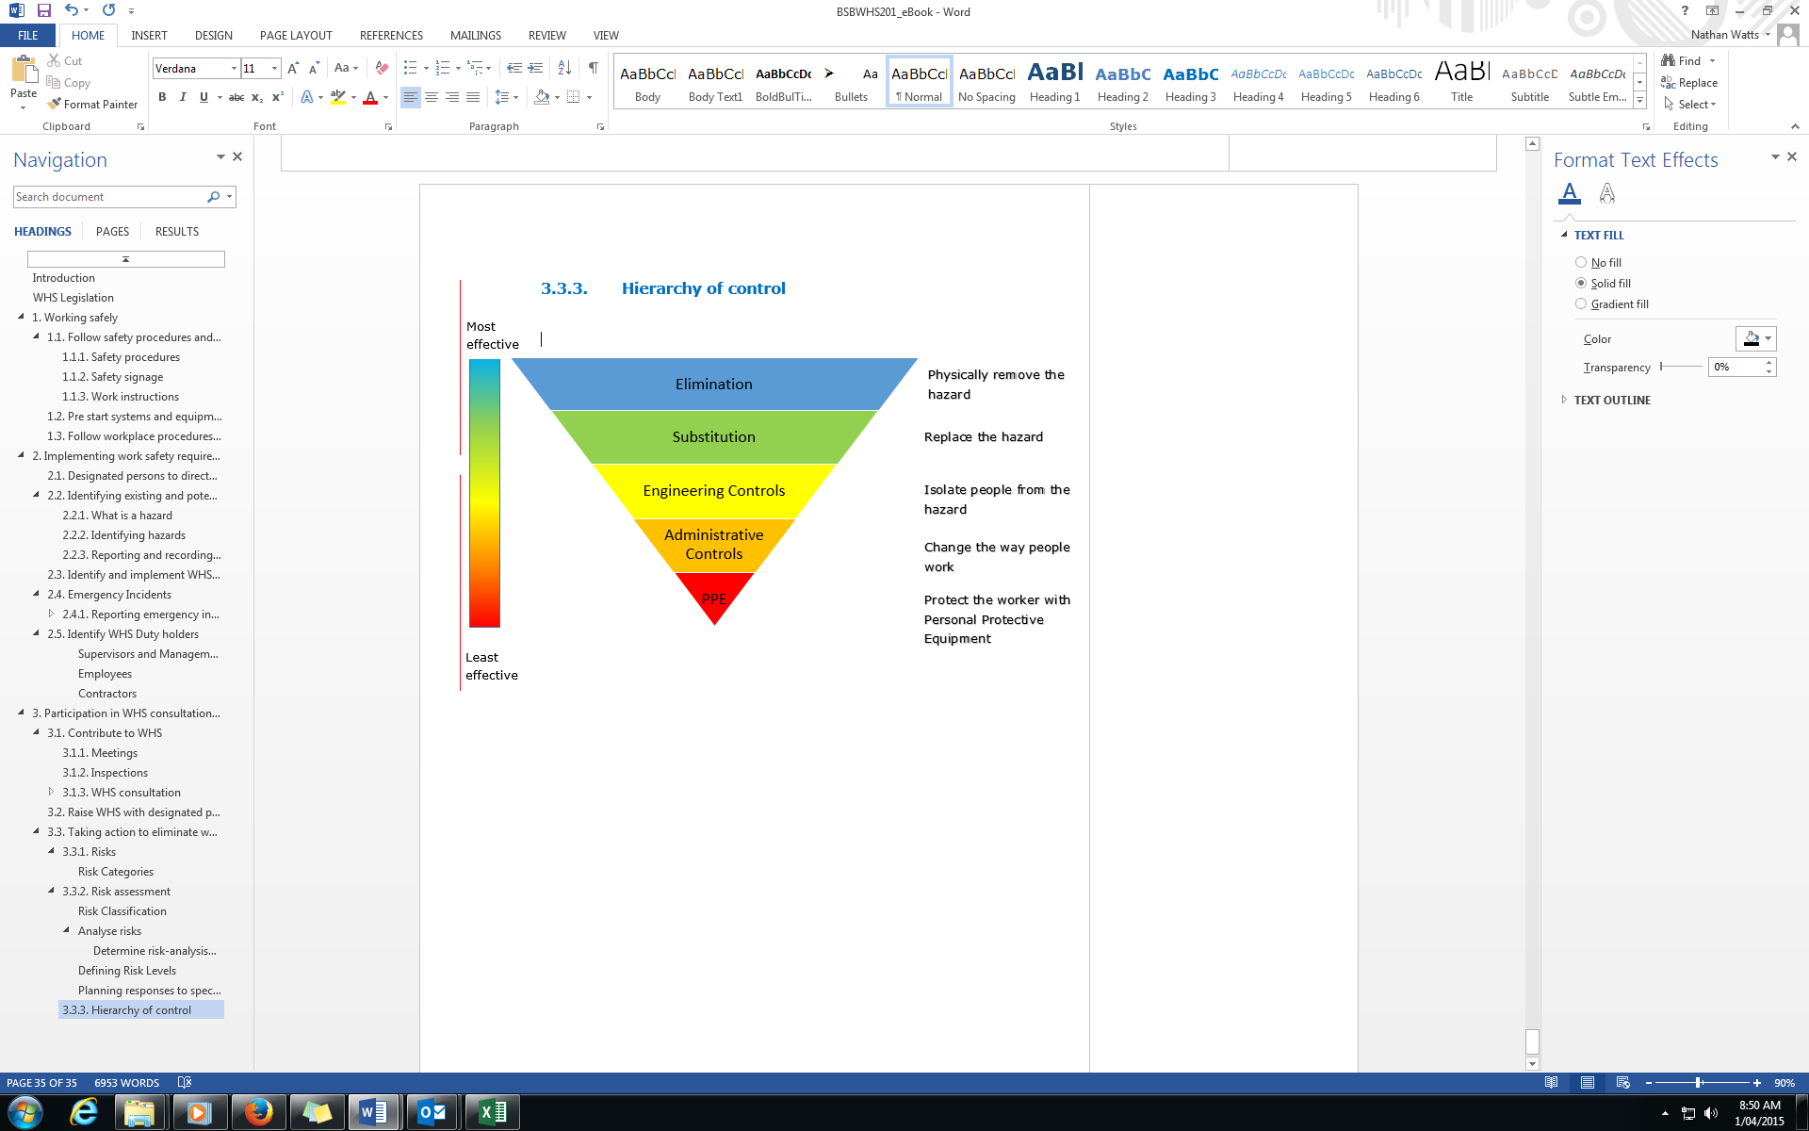
Final risk analysis | The range of potential consequences and how likely those consequences are to occur when treatment plans or controls are applied must be estimated and assessed using the Risk Register.  Using the Risk Register, a Risk Rating must be assigned to each identified risk by multiplying the Risk Likelihood score by the Risk Consequences score (accounting for any treatment plan or controls)  - Where multiple Risk Consequences are identified, the highest Risk Consequence score must be used when determining the Risk Rating.  If the Residual Risk Rating remains unacceptably high, additional treatment or controls may be applied
Records management | The Manager, Insurance and Risk Management will maintain a central Strategic Risk Register which records Hotel wide risks and treatment plans. For each risk recorded within the Risk Register, the following must be recorded:  - Risk/hazard Definition  - Risk/hazard Analysis  - Risk/hazard Control
Monitoring and review | Staff must continually monitor risks in the workplace. Work areas must systematically review risks contained in the Strategic Risk Register every 6 – 12 months, to assess whether risks remain current and treatment plans remain effective.  The Manager, Insurance and Risk Management must coordinate the Hotel's review of the Strategic Risk Register on an annual basis.

Incident reporting policy
As part of the requirement for ensuring health and safety in the workplace, the organisation recognises that incidents, injuries, plant damage and other dangerous events may occur throughout the course of its operations.
The purpose of the Incident reporting policy is to:
- prevent future recurrences of the incident and other related hazards.
- undertake thorough investigation and analysis of incidents, implement corrective actions commensurate with CCRG Policy and WHS legislation.
As per WHS Regulations, health and safety information should be recorded, available and accessible to workers at all times. Notifiable incidents are:
- the death of a person
- a ‘serious injury or illness’
- a dangerous incident arising out of work carried out by a business, undertaking or a workplace.
Notifiable incidents relate to any person—whether an employee, contractor or member of the public. If a notifiable incident occurs, the model WHS Act sets out that:
- immediate notification of a ‘notifiable incident’ to the regulator, after becoming aware of it
- if the regulator asks—written notification with 48 hours of the request, and
- preservation of the incident site until an inspector arrives or directs otherwise.
Although we fall under the integrated WHS Act, all states in Australia are governed by different WHS regulators, in relation to workplace incidents. Visit Safe Work Australia to see full information about reporting requirements.
The requirement to formally undertake and document investigative responses and analysis of WHS incidents and events applies across all CA City Hotel operations as defined below.

Incident reporting procedure
Step 1  Incident investigation | Formal, documented investigations shall be undertaken for the following incidents:  - incidents notified to an external statutory authority;  - dangerous events which had a specific potential to cause harm on site;  - any incident that is particularly unusual or had the potential to cause a significant WHS risk; and  - any other incident deemed necessary to be investigated by CA CITY HOTEL Supervisors and Managers as part of the Reporting & Recording of WHS Incidents & Events process.  A formal investigation shall include a documented appraisal of the incident, via an Incident Report, inclusive of the following aspects where relevant:  - incident and outcome description;  - details of the personnel, plant and work environment involved;  - description of injured person or witness accounts of the incident;  - description of the likely causal factors of the incident;  - recommendations for control and prevention of a similar incident; and  - diagrams, photographs, additional data pertinent to the incident or investigation report.  Unless a specific incident warrants otherwise, Incident Investigations are to be initiated as soon as practicable following the incident or event and the report (excluding any external involvement / component) is to be completed within 7 days of the incident.
Step 2  Incident analysis | - Detailed information contained within Incident and Injury Reports for each work location are to be collated and analysed on a quarterly basis as part of the Company WHS Meeting forum.  - Information such as the following is to be listed and presented for review and discussion:  - number of incidents (by who was involved: employee, guest, contractor, visitor)  - number of incidents (by location: operations type, training centre location)  - number of incidents (by type: first aid, work injury / illness, near miss / dangerous event, property / plant, other)  - number of lost-time injuries (greater than 1 shift/working day)  - total number of days lost due to injury or illness  - number of injuries / illnesses (by mechanism or nature)  - number of hazards / Corrective Action Reports formally documented  - number of formal Incident Investigation Reports completed  - number of incidents within the Incident Register for the period (closed out / not yet closed out)  - other information as deemed relevant.  - Information collated and basic trend information extrapolated from that data shall be reported and formally discussed within the Management Meeting forum and the Company WHS Meeting forum.  - As data is collected and analysed over time Managers are to make specific recommendations with respect to what additional information would be beneficial to be sourced and what information may be removed from the analysis process.  - Where practicable Managers are to prioritise WHS efforts and initiatives around particular problem areas identified as a by-product of WHS information analysis.
Incident reporting | These reports must be consistent with the requirements of the Work Health and Safety Act 2011. You need to check with the state government body in your area regarding state specific legislation. Visit Safe Work Australia to see full information about reporting requirements.
Incident monitoring and review

Notes on Incident procedures
All Incident documentation is to be tabled and discussed within CCRG WHS and management meetings. Specific details, timeframes and responsibilities relating to corrective and preventative actions are to be discussed and recorded accordingly.
Corrective and preventative actions are to be discussed and documented for all other incidents, injuries and plant issues not formally investigated. Due to the nature or complexity of an incident or event, external consultants may be used for investigations where deemed appropriate by CCRG Senior Managers.
Irrespective of who undertakes an Incident Investigation, specific efforts are to be made by those selecting an investigation person and the individual who investigates, to:
- not compromise the way information is gathered or reported due to their working relationship with those who may be involved in the incident;
- ensure an objective and factual process is followed;
- ensure that a blame allocation or ‘witch-hunt’ is not undertaken;
- ensure that causal factors and recommended actions are not diluted or under-reported due to their working relationship with those who may be involved, or other senior personnel within the organisation.

Emergency and evacuation procedure
Emergency safety procedure
Is someone seriously injured or in need of urgent medical help?
Is your life or property being threatened?
Have you just witnessed a serious accident or crime?
Is anyone in immediate danger?
Help them only if it is SAFE to do so.
1 | Call 000 on the designated phone  If you are hearing impaired please use 106 for a text based emergency
2 | State which emergency service you want: Ambulance, Fire, or Police
3 | Stay calm - stay focused
4 | Stay on the line. The emergency service operator will need to talk to you before sending assistance. They will ask you questions about the incident
5 | Give as much information as possible about the location of the emergency. The information required depends whether you are in an urban or rural or remote area
6 | Have your name and call back details ready for the operator
7 | What happened – e.g. car accident?
8 | Number and condition of the casualties, including level of consciousness, breathing and circulation
9 | In the case of a fire, alarms will sound automatically, fire wardens and managers of your department will direct staff and guests to leave the building and proceed to the assembly point, the car park to the west of the building
10 | The fire wardens or managers of your department will give the direction to put out the fire if it is safe to do so

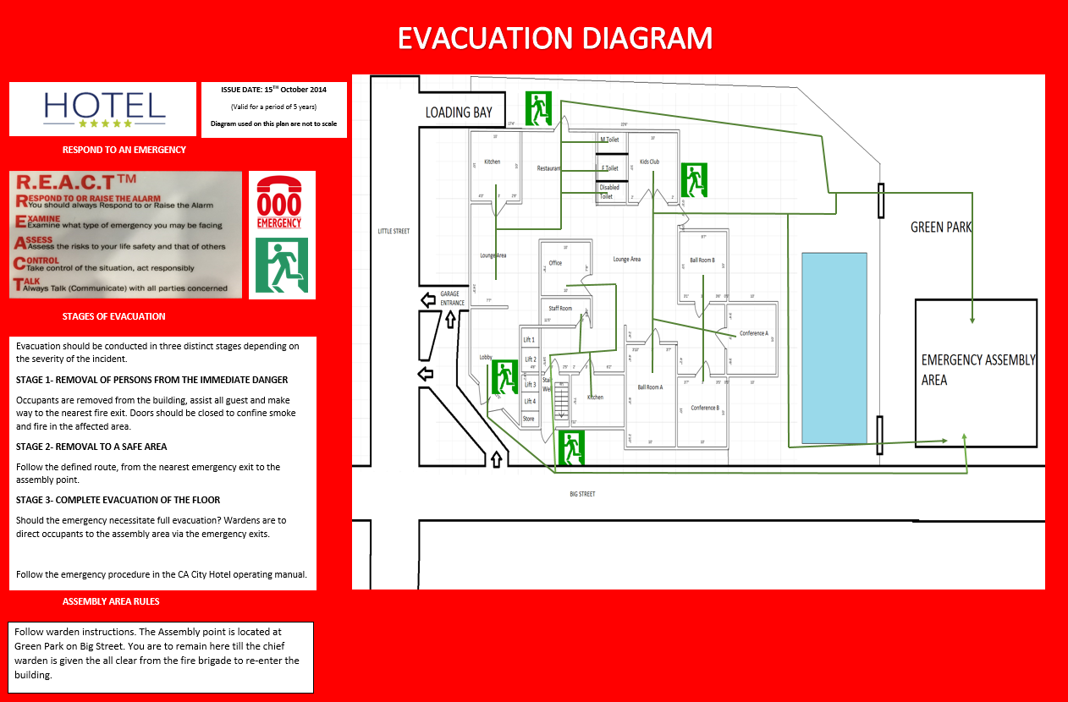
Adapted from First 5 Minutes

WHS Training Policy
The Hotel will fulfil its obligations to ensure CCRG employees are trained in WHS practices, as outlined in this Policy and in the following procedures.
All WHS practices are to be conducted within the approved budget, as advised by the General Manager of CA City Hotel. WHS Training provided at CCRG Hotel includes (but is not limited to):
- Induction
- Fire and emergency procedures and Emergency Warden
- Use of PPE
- Manual handling
- First aid compliance and First Aid Officer
- Safety representative/committee
- Risk assessments, e.g. ergonomics, hazardous chemicals

Responsibilities
Employers and PCBU’s are legally obligated to provide a safe workplace for employees, customers, and other people such as members of the public and visitors. This is a requirement under the Work Health & Safety Act 2011. CCRG has a legal duty to properly orientate, train and supervise employees to ensure safe work practices.

Approvals
As an employer and PCBU, CCRG has allocated an annual budget of $20,000, which is allocated at $5,000 each quarter. Any WHS training that has costs above $5,000 per quarter needs approval from the Director of Finance for CCRG.
All decisions on WHS training need to follow WHS consultation procedures, as per CCRG Policy and legislative requirements. Any issues, specific details or clarification for WHS training needs to be consulted and approved by the WHS Committee or assigned WHS Representatives.

WHS Training procedure
- Conduct a training needs analysis with all stakeholders of CCRG, to identify WHS training requirements
  - Training target or future goal
  - Assess existing skills and knowledge
  - Identify WHS training needs gap
- A training development plan/program is developed for each department to address training gap.
- Training is conducted within approved budget, according to training needs and plans.
- All WHS qualifications, licences and training records are to be recorded on the employee’s personnel file, in both hard copy and online in CCRG’s HRM system.
- Training practices are to be reviewed and monitored twice annually and as required by individual needs upon approval.

