BSBWHS411
Implement and monitor WHS policies, procedures and programs

ASSESSMENT SUMMARY

The assessment activities for BSBWHS411 Implement and monitor WHS policies, procedures and programs cover all aspects of the unit of competency. For Apprentices/Trainees, this includes supervisor completion of the Apprentice/Trainee Record (ATR).

Participants must read all the information given before starting any assessment task. The assessment tasks are intended to be fair, flexible, valid and reliable. If a Participant has any questions or requires alternative arrangements to be made such requests should be directed to their Trainer/Assessor, who should note such arrangements in the ‘Assessor Comments’ on the affected assessment. If a Participant feels they are not yet ready to be assessed, they should discuss their options with their Trainer/Assessor.

To satisfactorily complete the assessment, the Participant is required to answer all questions correctly and demonstrate their skills to industry standards. If a Participant does not answer all questions or perform all tasks, they will be deemed ‘Not Satisfactory’ for the task and ‘Not Yet Competent’ for the unit of competency.

The Trainer/Assessor can provide the Participant with additional information on interpreting the assessment outcomes and guide the Participant’s options. If a Participant is still deemed ‘Not Satisfactory’ they will have the opportunity to undertake a supplementary assessment or appeal the result as per the process in the Student Handbook.

By signing below, the Participant acknowledges:
- They understand the assessment instructions and requirements, and consent to being assessed.
- The work submitted is to be their own work – with the work of/with others needing to be clearly acknowledged and documented.
- They consent to any photo/video recording of their work that occurs during assessment.

Participant name | Chris Gwilliams
Participant signature | 

Pre-requisite unit(s) to be achieved and authenticated prior to undertaking assessment
Not applicable

Task | Date completed | Assessment Results
Theory Exam | Select Date. | Satisfactory | Not Satisfactory
Practical Assessment | Select Date. | Satisfactory | Not Satisfactory
Outcome for BSBWHS411 | Select Date. | Competent | Not Yet Competent

Evidence requirements checklist (ticked by assessor and evidence supplied to RTO)
Theory Exam  Practical Assessment | Completed team WHS training need  Additional workplace WHS hazard/risk assessment and incident reporting documents completed and submitted as evidence

Assessor Name
Assessor Signature | 

BSBWHS411
Implement and monitor WHS policies, procedures and programs

THEORY EXAM

Participant name | Chris Gwilliams

FOR THE PARTICIPANT
Instructions
- You will complete written questions as outlined on the following pages. You must attempt all questions and provide enough detail in your responses to demonstrate your knowledge.
- It is anticipated that you should complete this assessment within two (2) hours, but additional time may be allowed upon negotiation with the Assessor.
- You must complete all questions unassisted by the Assessor or other personnel but may refer to reference material as needed. All questions must be answered correctly for a ‘Satisfactory’ assessment outcome to be awarded.
  - An oral examination may be allowed under certain circumstances, whereby your answers will be documented by another party.
  - Any written questions that are incomplete, or not answered satisfactorily will need to be completed again after further training support.
    - If you answer a question incorrectly but modify your response, put your initials next to the written change (or the Assessor must initial a verbal change).
Resources required
Pen

FOR THE ASSESSOR
Instructions
- Where oral examination has occurred, ensure that this is acknowledged in writing (e.g. FT001 and Assessor Comments)
- All questions must be satisfactorily demonstrated by the Participant for a Satisfactory determination (indicated by an Assessor tick to the right of the question).
- Assessors are to complete marking in pen of a different colour to the Participant.
- If the Participant verbally modifies their response, write in the modified response verbatim and put your initials next to the written change.

ASSESSOR COMMENTS
As necessary, outline:
- Details on reattempts, alternative arrangements or reasonable adjustments made.
- Where a Participant is deemed ‘Not Satisfactory’, provide recommendations for future training.

- What is the purpose for consultation mechanisms to effectively manage health and safety risks in the workplace? Include in your answer three (3) different consultation mechanisms available in your industry.

Answer  1.  2.  3. | It is important to establish effective mechanisms which suit you particular organisation or business, to allow for regular communication on work health and safety  1.Company Notice Boards – This is a physical or digital surface used to display important information, such as company announcements, safety procedures, and upcoming events, to employees and visitors  2.Daily Pre Start Meetings – This is brief, interactive safety session held before the start of a work shift to review the day's tasks, discuss potential hazards, and ensure everyone is fit for duty  3. Emails – This is formal or inform messages sent to one person or a whole group

- Respond to the key elements of each of the following legislation as they apply to your industry.

Answer | Legislation | Provisions applicable to industry
 | WHS Act | This is a mandatory requirement which places duties on various individuals and parties within the workplace.
 | WHS Regulations | This provides more specific details about the requirements of the act
 | Codes of Practice | These provide a practical guide on how to comply with the legal duties under the work health and safety act and regulations

- Consider a scenario where your supervisor has asked you to prepare and communicate information about hazard identification and risk assessment to the team. Describe two (2) methods and tools you would use to achieve this and ensure the information is easily accessible.

Answer  1.  2. | JSA Workshop - This involves breaking down specific job tasks into individual steps. For each step, the team identifies potential hazards and then discusses the risks involved and potential control measures.  Digital Risk Register with Visual Tools - This centralizes hazard and risk information. The risk assessment matrix visually categorizes risks based on likelihood and consequence, providing a quick-glance summary of severity.

- How would you determine whether the methods and tools used in Q3. were effective in communicating the information.

Answer | -Getting feedback on information that was provided.  -Observing team members while undertaking tasks  -Checking reports involved with the tasks at hand  -Consult with workers  -Monitoring of workers and environment  -Follow up meetings  -Check incident reports to see if they have been effective

- What are the benefits of using mentoring for WHS focused learning to support the training for a worker wanting to progress to a team leader role?

Answer | Investing time into developing employees can help you make the most of an employee's skills and abilities and avoid expensive and time-consuming recruitment processes, and ensure that valuable knowledge stays within your business.

Read the following extract from the Safe Work and Return to Work Awards 2017 to respond to Q6.

Decmil Australia
Category four – Most significant improvement to work health and safety performance

After identifying a culture of poor reporting around minor incidents, hazard observations and near miss events, Decmil Australia made improvements to its operations and safety system including:
- communicating the importance of incident/near miss reporting
- reviewing targeted inspections, specific to each project
- implementing a behavioural based safety program
- providing hazard identification cards and setting measures for the entire team.
These changes are sustained, monitored and evaluated through Decmil's SHIELD program (Safety and Health in Every Level at Decmil). The company's health, safety and environment achievements since 2014 include:
- 500 days lost time incident free in April 2017
- seven months recordable incident free on 10 June 2017 for the QGC Project team (current QGC Project TRIFR is 0.00)

- improved communications and successful adoption of the new processes by employees including incident and near miss reporting.
Decmil Queensland Gas Company team

- Why is ‘near-miss reporting’ important and why did changes mentioned in the extract lead to the company winning the award for “Most significant improvement to work health and safety performance”?

Answer | Near-miss reporting is important because it allows organizations to proactively identify and address potential hazards before they cause an accident, injury, or damage. This practice helps prevent future incidents, fosters a stronger safety culture, and can save costs associated with accidents like medical expenses, compensation, and lost work time. By documenting and analysing near misses, companies can improve safety protocols, training, and employee awareness to create a safer work environment.  These changes may have led to this award due to the fact that previous reporting was poor. With an updated system allowing information to be documented easily and constantly there is a clearer indicator of when Decmil has long periods of near miss and incident free stages.

- You have been asked to present WHS information to new site inductees at your workplace. Write notes to support your presentation ensuring you cover relevant policies and procedures, the need for these, who can assist if there are issues and where documents are located.

Answer | WHS induction notes:  - -Give a brief overview of the site, including its layout, activities, and relevant policies.  - -Explain your company's WHS policies and your legal obligations, including the need to take reasonable care for their own and others' health and safety.  - -Discuss specific hazards and risks present on the site and how they are controlled.  - -Explain the required PPE for the site and for specific tasks, how to use it correctly, and how to store it.  - -Detail what to do in an emergency. This includes locations of assembly points, fire exits, emergency exits, and who the fire wardens are.  - -Instruct on the correct procedure for reporting hazards, incidents, and near misses, and to whom they should report them.  - -Explain how workers can provide feedback and raise WHS concerns, such as through meetings or suggestion boxes.  - -Inform them of any required training and competency requirements for their role and for using equipment.  - -Inform them of employees who can assist in site needs.

- Your team must dispose of old diesel drums. Complete the following Risk management Plan using information from the SDS in Handout 1.

Answer | Risk Management Plan
 | Completed by: Chris Gwilliams |  |  | Date: 22/08/2025
 | Hazard identification
 | Hazard: Dangerous Goods
 | Risk Assessment
 | What harm could the hazard cause? | Irritating to skin.
 | What harm could the hazard cause? | May produce discomfort of the eyes and respiratory tract
 | What is the likelihood of this happening? | Low/Moderate
 | Persons at risk | John Smith
 | Existing control measures | Do not breathe gas/fumes/vapour/spray
 | Consequence | -Repeated exposure may cause skin dryness and cracking.
 | Likelihood | Low/Moderate
 | Outcome | None
 | Control measures
 | Elimination | Use of forklift
 | Substitution
 | Isolation | Nil
 | Engineering
 | Administrative or PPE | Gloves, Respirator, Face Shield
 | Preferred control option | PPE
 | Implementation
 | Associated activities | Resources required | Person/s responsible |  | Sign off and date
 | Use of PPE | PPE | John Smith |  | 22/8/25
 | Review Scheduled review date:
 | Are control measures in place? Yes
 | Are controls eliminating/minimising risk? Yes
 | Are there any new problems with the risk? No

- How would you communicate the information collected in the previous question with your work team to ensure worker safety?

Answer | -Team Meeting  -Discussion  -Signage  -Risk Register  -Toolbox meeting

- When discussing site safety with the team this morning, concerns were shared around the ‘slips’ hazard when entering the site office.
The team suggested the consequence is a back injury which is quite serious, but the risk rating is only low. They are of the opinion that it should be medium or high risk.
As per company procedure and legal requirement, you, as team leader must advise the WHS committee of this consultation, request a review and advise of consultation outcomes. How would you go about this?

Answer | To advise the WHS Committee about the slips hazard, you firstly should formally document the consultation with the team, outlining the hazard, team concerns, and the perceived severity of the potential risks. You will need to request a formal review of the existing risk assessment for this hazard. Finally, you must then formally communicate the outcome of that review, along with any actions taken or recommended, back to the team and the committee.

- Workplace procedures require that you send an email to the WHS committee to ensure your request for a review of the team findings relating to slip hazard at the site office is received in writing. Complete the email below with your request.

Answer | 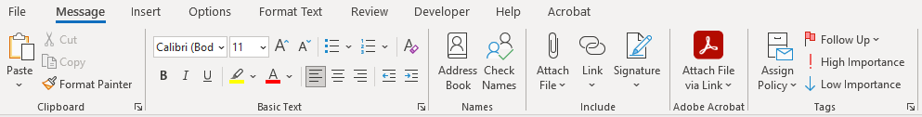  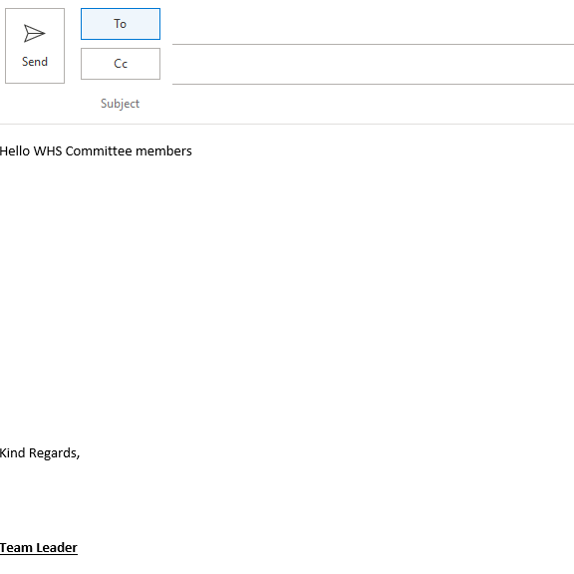  When discussing site safety with the team this morning, a concerns were shared about a potential slips hazard when entering the site office.  The team proposed the concern of a possible back injury while  The risk rating is only low. They are of the belief that it should be  medium or high risk.  As per company procedure I am informing the committee of this concern and request a review into the matter please.  Everything previously mentioned has been appropriately documented.  [Grab your reader’s attention with a great quote from the document or use this space to emphasize a key point. To place this text box anywhere on the page, just drag it.]

You have received the following email in response to your email to the WHS committee. Read this to respond to Q12.

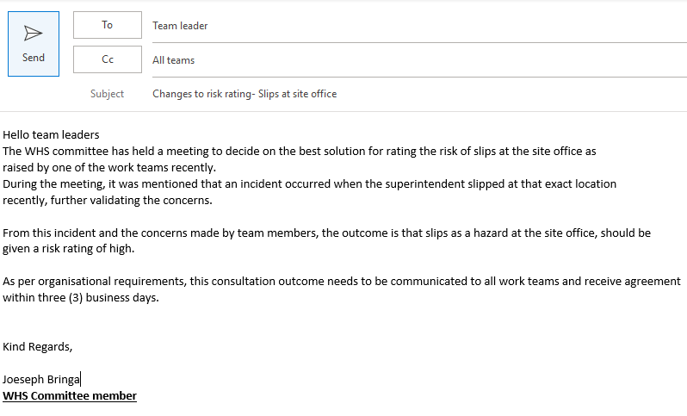

- Write a memo for the notice board to all team members about contacting you regarding their agreement to the changes mentioned.

Answer | Memo
Dear Team,

Recently an issue has been raised where there is concern of a slip hazard while entering the office. This was documented and was then referred to the WHS Committee.

After their review the likely hood of the risk has gone form a low rating to a high rating.

Further consultation will be documented and all feedback/input must be received within 2 business days which will conclude by the 12/10/2024.

Thank you to all who were involved in raising this issue.
If there are any issue or questions please contact me.

Regards Chris Gwilliams

You have collected all responses and calculated 85% of the workers agree with the changes to be made to the risk rating for slips at the site office. It has also been suggested that non-slip flooring be implemented to address the concerns.

- How will you communicate the results and the recommendations in a way to meet workplace reporting and recording requirements?

Answer | -The information will be posted to the company notice board  -There will be a group email sent to appropriate personal  -It will be mentioned in toolbox and prestart talks until the issue has been amended

- Considering safety training held at your workplace, what methods would you apply to train relevant workers in the following?

Answer  First aid  Drug use and work  Manual handling  Using SDS  Emergency  Procedure  Fatigue  Managing | First Aid course - Short external courses  Included in site induction  Toolbox/Coaching  Manual Handling training  Mentoring  Safety Data Sheet training and handbook  Safety training courses  Site induction- Emergency Skills training  Training in fatigue management course  Mentoring

Read the following team training record showing training that new workers have received, to respond to Q15. and Q16.
Team member | General Construction Induction training (White Card) | Site induction | Manual Handling | Emergency response | First Aid
Jeremy Still
Henry Oppenheim
Jules Freeman
Jake Monet
Antony Johns
Silvia Haack
Fred Hollows
Imogen Flank
Xavier French
Martin Short

- HR have provided you with the team training record for a new team you will be leading for a construction project. View the team training record above and explain what training must be prioritised and why.

Answer | A white card, also known as a general construction induction card, is the most important training needed by each member of the team. This is because it is a mandatory qualification for individuals working in the construction industry in Australia. It signifies that the holder has completed a general construction induction training course and is aware of basic safety requirements and procedures on a construction site.  -There are four members that have not completed their white card. This will need to completed before any further steps are taken.  -One other member has their white car but has not completed the site induction. This must be done before starting any work onsite.

- Complete the table using information from the training records to clarify the number of new employees requiring specific training.

Answer | Number of employees requiring training | White card | Site induction | Manual Handling | Emergency response | First aid
 | Number of employees requiring training | 4 | 5 | 3 | 6 | 4

- How will you ascertain which of the new employees will require first aid and fire warden training?

Answer | To determine which new employees need first aid and fire warden training, conduct a workplace risk assessment that considers the specific nature of the work, hazards, size, location, and the number and type of people at the workplace. This assessment will identify if any new employees have roles that involve higher risks or if there's a need for more trained personnel for adequate coverage. Make sure employees would like to do the first aid course. Capabilities of individuals are able to physically deliver CPR.

- Site inductions are held face to face every five (5) days by a WHS officer to meet the demands of this large site. What discussion will you need to have and with whom to confirm and book the team members into their site inductions? How will you consult/confirm details with these persons?

Answer | To book team members into site inductions, you will need to discuss availability with team leaders or supervisors, confirm the specific dates and times with the WHS officer, and then follow up with them to ensure they are aware of the bookings. The discussion with the WHS officer will focus on the site's specific WHS requirements, any booking procedures, and the number of available slots for your team, while communication with your team will involve confirming their availability and providing them with all necessary details  An example is that there is site specific PPE and task specifiv PPE that can be found on an SDS.

- Why would coaching be a good method of training regarding the use and purpose of Safety Data Sheets?

Answer | Coaching is an effective training method for Safety Data Sheets (SDS) because it provides personalized, hands-on guidance, reinforcing formal training through real-world scenarios to build employee confidence and proactive risk management.

- What is the importance of maintenance and storage of WHS incident records? Include in your response two (2) specific incident records you have maintained and how this was achieved.

Answer | Maintaining and storing Work Health and Safety (WHS) incident records is crucial for demonstrating legal compliance, improving workplace safety, and facilitating effective risk management through audits and investigations  1.Incident Report - A slip and fall by an employee on a wet floor, recorded in a digital system to track trends and inform future safety procedures. This was reported to the supervisor  2. A dropped tool narrowly missing a worker, documented in a physical logbook to identify hazardous work areas and encourage improved safety communication. This was also reported to my supervisor

- How do you keep up to date on changes to WHS laws, and related organisational policies and procedures relevant to your role?

Answer | To keep up-to-date with changes to WHS laws and company policies, actively monitor official sources like Safe Work Australia and state WHS regulators by subscribing to their newsletters and social media.

BSBWHS411
Implement and monitor WHS policies, procedures and programs

PRACTICAL ASSESSMENT

Participant name | Chris Gwilliams

FOR THE PARTICIPANT
Instructions
- The tasks outlined on the following pages will require performance of normal workplace activities, as a result of a structured activity set by an Observer in the workplace or a simulated activity set by your Assessor/Observer.
- The timeframe for these tasks will be established by your Assessor/Observer, in consideration of location conditions and industry requirements.
- You must complete all tasks unassisted by the Assessor or other personnel, unless the steps note this assistance.
- You must attempt all tasks (and itemised steps) for a ‘Satisfactory’ assessment outcome to be awarded.
  - For any observation conducted that is incomplete, or without satisfactory performance, the observation will need to be completed again after further training support.

FOR THE ASSESSOR/OBSERVER
Instructions
- The following observation record should be used to judge and record your observations of the Participant as they complete the task(s) set. You must record your observations of the Participant’s performance.
  - For each occasion, indicate the task performed and whether it was a simulation or workplace-based task.
    - Any simulated assessment must ensure the Participant still performs under workplace conditions which reflect industry standards.
  - In the comments, provide clear detail regarding the task that the Participant was required to do (e.g. PPE used, materials handled, attachments connected, plant types).
- All steps must be satisfactorily demonstrated by the Participant for a ‘Satisfactory’ determination (indicated by an Assessor tick to the right of each itemised step, or an Observer tick to the right of each itemised step, and confirmation by an Assessor in the Assessor Comments).
  - Where you have determined that one or more task steps have not been satisfactorily demonstrated, provide the Participant with additional support and outline details of such assistance in the Assessor/Observer Comments. Allow the Participant two (2) further opportunities to demonstrate the task again to allow an opportunity for a ‘Satisfactory’ assessment outcome to be achieved.
  - If after three (3) attempts the Assessor determines that the Participant cannot demonstrate the required steps, a ‘Not Satisfactory’ outcome is to be determined.

TASK OUTCOME
Task | Date | Task Type (Tick) | Location | Task outcome (Tick)
 |  |  |  | Satisfactory | Not Satisfactory
Task 1 | Select Date. | Workplace  Simulation

ASSESSOR COMMENTS: GENERAL
As necessary, outline:
- Details on reattempts, alternative arrangements or reasonable adjustments made.
- Where a Participant is deemed ‘Not Satisfactory’, provide recommendations for future training.

ASSESSOR COMMENTS: PRACTICAL TASK 1
Individual student (as named on cover page)
Multiple students [ All from Attendance Report, Specific students involved – identify students]
Task | Provide detail
1.1A. | Specify method used to share information and workplace polices/procedures shared:
1.1B. | Specify which identified hazards and controls were shared with team:
1.2A. | Specify method used to share the importance of consultation for managing WHS risks:
1.2C. | Specify issue raised through consultation:
1.2D. 1.2C. | Specify method of reporting issues upward:
1.2E. | Assessor describe how participant shared information with work team:
1.3C. | Specify type of training and method of training agreed on for one (1) participant:
1.3D. | Specify training arrangements made for one (1) team member:
1.3E. | Specify workplace learning opportunities provided for three (3) team members:
1.4B. | Specify procedure followed to report a hazard or incident:
1.5D. | Specify methods used to keep up-to-date:

BSBWHS411
Implement and monitor WHS policies, procedures and programs

Practical Task 1
Description of task:
The participant must demonstrate the ability to effectively implement and monitor the work health and safety (WHS) policies, procedures and programs for a team in one (1) work area in an organisation including demonstrating and providing evidence of the following:
- confirming and documenting team training needs to meet workplace and legislated requirements
- consult with stakeholders and make arrangements to meet WHS training needs of team members
- provide workplace training opportunities to team and individuals to support achievement of identified WHS training needs
- communicate information to work team about WHS laws, workplace policies, procedures and programs, the importance of consultation mechanisms, hazards and risk assessment including in the communication where information can be accessed
- adhere to workplace policies and procedures to apply consultation mechanisms for managing work area hazards, reporting issues raised and communicating both upward and downward throughout consultation to outcome
- manage monitor and report on hazards, controlling risks according to workplace procedures and legislated requirements
- identify and report inadequacies in existing risk controls monitoring outcomes of reports on inadequacies
- complete and maintain WHS incident records in work area
- use aggregate information and data from work area records to meet workplace recordkeeping requirements

These tasks may be simulated or real. The Participant is to gather evidence of how they have completed each component of the Practical Task, which is to be submitted with this Practical Assessment sheet. The Observer is to provide detailed comments on the tasks completed by the Participant (on the Observer Comments, overleaf). The Assessor is to verify the Observer’s comments, noting their findings in the Assessor Comments (on the back of the Practical Assessment cover page) and provide the assessment outcome.
Resources required:
Work team, workplace policies and procedures, WHS documents, records and recording documents, HR training records, access to current state regulator and legislation.
Observer details
Name of observer: | Tom Vyner
Role of observer  (Confirm suitability to sign) | Company Director
Email address of observer | tom@workingbucket.com
Signature of observer: | 
Date: | 24/08/2025

When completing the task, did the Participant: | Tick if satisfactorily completed.  Provide comments if left unticked.
1 Provide information to work team about WHS policies and procedures
- Locate and share with work team workplace and state appropriate and current WHS legislation and related workplace policies and procedures.
- Share information to work team about identified site hazards and outcomes of risk assessment and control.
- Communicate information in a way that was logically presented, clear and accurate.
- Communicate information using structure and language suitable for audience.
- Use questioning and active listening to clarify understanding and make the audience feel at ease during face to face communications.
- Use written format during WHS presentation that apply appropriate structure, layout and language to ensure the information is understandable by the audience.
2 Implement and monitor work team consultative arrangements for managing WHS
- Share information with team and demonstrate the importance of consultation mechanisms for the management of WHS risks using methods that are easy to understand.
- Adhere to workplace procedures for consultation by asking work team for opinions and information relating to the management of work area hazards.
- Manage issues raised through consultation using questioning, responding, explaining, clarifying and expanding on ideas and information as required, evaluating choices and determining severity based on workplace and legislated WHS requirements for determining risk levels and the hierarchy of controls.
- Communicate and report on potential new hazard upward according to site requirements.
- Communicate the outcomes of reporting upward with work team within acceptable workplace timeframes using appropriate verbal and written communication.
3 Implement and monitor organisational procedures for providing WHS training to work team
- Access relevant HR records to determine white card, site induction, qualifications and licences held by team members.
- Complete a table or relevant workplace document to demonstrate team members training needs to meet work and legislated requirements. (Evidence of document is required.)
- Discuss training needs and methods of training available with individual team members, discussing and agreeing on training required and method to be applied.
- Discuss and arrange training for team member with relevant stakeholder.(internal/external).
- Organise workplace learning opportunities for workers requiring or requesting specified WHS training.
4 Implement and monitor organisational procedures and legal requirements for identifying hazards, and assessing and controlling risks
- Consistently use workplace documents and follow procedures to identify and report on hazards in work area.
- Use workplace documents and undertake hazard and incident reporting according to workplace requirements to meet WHS legislation.
- Adhere to workplace requirements to control risks using the hierarchy of control measures.
- Identify, report and monitor outcomes of reports on inadequacies in existing risk controls using the hierarchy of control measures according to WHS laws.
- Use approved processes to monitor outcomes of reports on inadequacies, as required, to ensure prompt organisational response.
5. Implement and monitor organisational procedures for maintaining WHS records
- Complete and maintain WHS incident and near-miss records related to work area according to work place policies and procedures, and WHS laws.
- Use near-miss and historical data to determine risk levels when applying risk assessment.
- Apply appropriate procedures for incident response, investigation, notification and reporting
- Keep up to date on changes to WHS laws, and related organisational policies and procedures relevant to own role.

OBSERVER COMMENTS

