
AHCLSC306
Implement a paving project

Copyright © 2020 CSTC Pty Ltd

All rights reserved. No part of the contents of this publication may be reproduced or used in any form or by any means – graphic, electronic, or mechanical including photocopying, digitising, recording, or information storage-and-retrieval systems – without the written permission of CSTC Pty Ltd.
ASSESSMENT FOR AHCLSC306

Student name
Date of assessment submission | Click here to enter a date.

Trainer/Assessor’s name
Date of assessment marking | Click here to enter a date.
Outcome for unit | ☐ Competent  ☐ Not Yet Competent

TASK INSTRUCTIONS

- As part of the assessment for this unit of competency, you are required to complete a series of activities.
  - Some of these activities will require you to provide a response within this document, others will require you to gather evidence to demonstrate your knowledge and skills.
- At all times, the responses in your assessment must reference Australian (Queensland or Federal) documentation, including legislation, regulations, codes of practice, standards and guidance publications.

ACTIVITIES

Identify/list the scope of the work to be carried out from the concept plan shown.

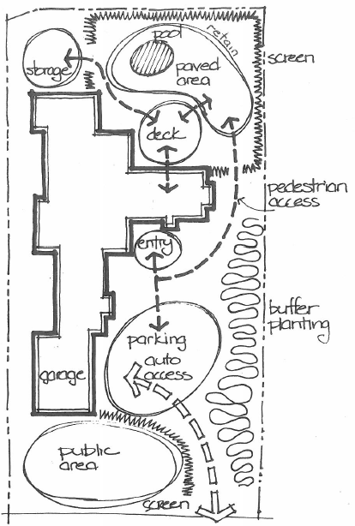

Response

Outcome for Activity 1 | ☐ Satisfactory  ☐ Not satisfactory
Trainer/Assessor comments

Identify/list the detail on the landscape plan shown.

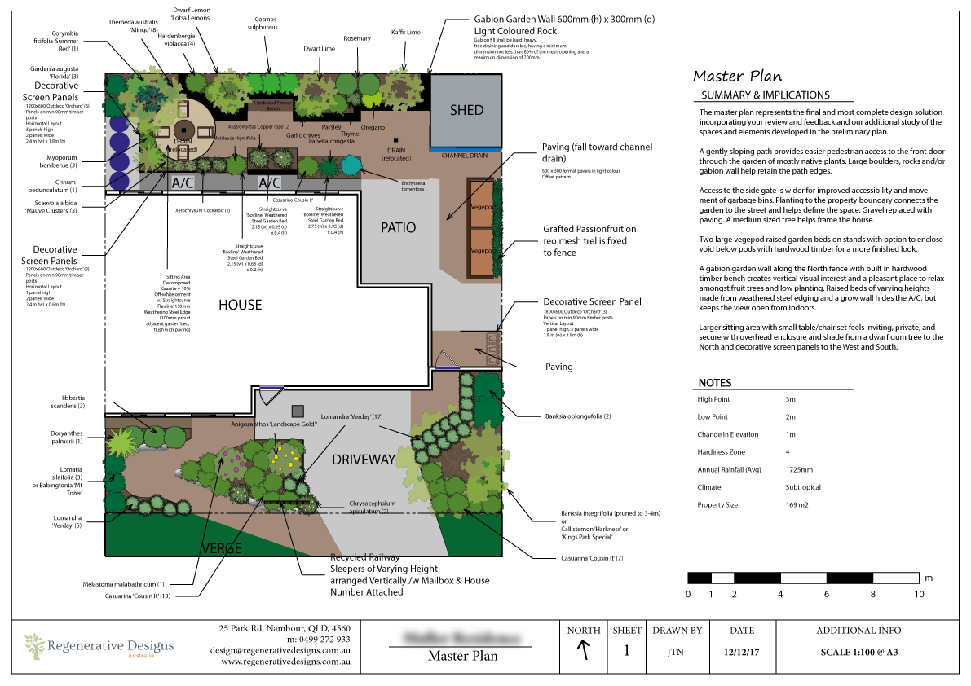

Response

Outcome for Activity 2 | ☐ Satisfactory  ☐ Not satisfactory
Trainer/Assessor comments

Using the graphics shown, create a simple plan that details a paved path through a garden with grass, trees, shrubs, rocks and steps.

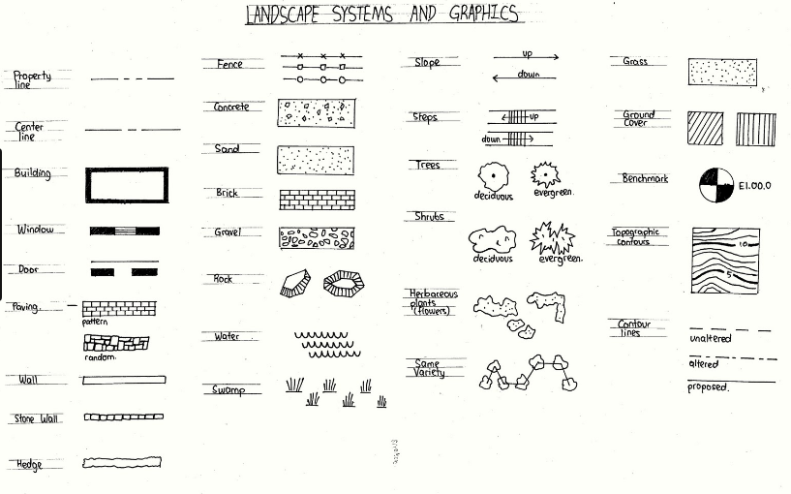

Response


Outcome for Activity 3 | ☐ Satisfactory  ☐ Not satisfactory
Trainer/Assessor comments

Research the advantages and disadvantages of concrete, clay and stone pavers.

For each material, provide one (1) example of a project where it would be most appropriate to use the material and one (1) example of a project where it would not be appropriate to use the material. Explain your responses.

Concrete pavers
Appropriate
Not appropriate

Clay pavers
Appropriate
Not appropriate

Stone pavers
Appropriate
Not appropriate

Outcome for Activity 4 | ☐ Satisfactory  ☐ Not satisfactory
Trainer/Assessor comments

Obtain photographs of common landscaping materials and finished landscapes (both soft and hard).

Explain the differences between your emotions/feelings when you see each photograph in black and white and in colour.

Photograph 1
Black and white: Emotions and feelings
Colour: Emotions and feelings

Photograph 2
Black and white: Emotions and feelings
Colour: Emotions and feelings

Photograph 3
Black and white: Emotions and feelings
Colour: Emotions and feelings

Photograph 4
Black and white: Emotions and feelings
Colour: Emotions and feelings

Outcome for Activity 5 | ☐ Satisfactory  ☐ Not satisfactory
Trainer/Assessor comments

Research and identify eight (8) different paving patterns, including the common usage, advantages and disadvantages for each pattern.

Pattern 1 name
Common usage
Advantages
Disadvantages

Pattern 2 name
Common usage
Advantages
Disadvantages

Pattern 3 name
Common usage
Advantages
Disadvantages

Pattern 4 name
Common usage
Advantages
Disadvantages

Pattern 5 name
Common usage
Advantages
Disadvantages

Pattern 6 name
Common usage
Advantages
Disadvantages

Pattern 7 name
Common usage
Advantages
Disadvantages

Pattern 8 name
Common usage
Advantages
Disadvantages

Outcome for Activity 6 | ☐ Satisfactory  ☐ Not satisfactory
Trainer/Assessor comments

Select a paver type (with known specifications) and calculate the material costs for a straight path that measures 6m long by 900mm wide.

Response

Outcome for Activity 7 | ☐ Satisfactory  ☐ Not satisfactory
Trainer/Assessor comments

Research the advantages and disadvantages of installing edging before and after laying pavers.

Installing edging before laying pavers
Advantages
Disadvantages

Installing edging after laying pavers
Advantages
Disadvantages

Outcome for Activity 8 | ☐ Satisfactory  ☐ Not satisfactory
Trainer/Assessor comments

List environmentally safe products for cleaning.

Response

Outcome for Activity 9 | ☐ Satisfactory  ☐ Not satisfactory
Trainer/Assessor comments

Have team members take photos and videos of your involvement with paving projects.

Identify each photo / video with a letter label and describe each photo / video in the table below. Submit the photo / video files along with this workbook.

Advantages
A
B
C
D
E
F
G
H
I
J
K
L
M
N
O
P
Q
R
S
T
U
V
W
X
Y
Z

Outcome for Activity 10 | ☐ Satisfactory  ☐ Not satisfactory
Trainer/Assessor comments

