BSBPMG512
Manage project scope

PRACTICAL ASSESSMENT INSTRUCTIONS

- The following practical assessment will require the participant to complete work related activities.
- The assessor will conduct observations of the participant’s work to determine whether they display sufficient practical skills and knowledge.
- Please fill in the details below, providing your name, signature and date of assessment.
  - Your signature acknowledges that the assessor provided clear instructions and the participant understood what was required to complete this assessment.
- The assessor may substitute a Practical Task with another task of equal value.
  - Alternate tasks must be fully documented by the assessor.

Participant name | Rue Grimston
Participant signature | 

Assessor name | Bruce Young
Assessor signature | 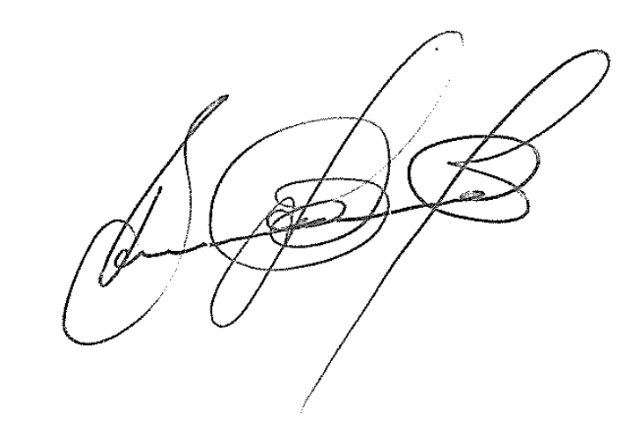

Date | 28/07/2020

Number of tasks | Number of tasks completed | Satisfactory?
1 |  | Yes | No

Assessor Comments
BSBPMG512
Manage project scope

Practical Task 1
Description of task:
A suitable observer is to verify the participant’s ability to determine and implement a project schedule, and assess time management outcomes.

These tasks may be simulated or real. The participant is to gather evidence of how they have completed each component of the Practical Task, which is to be submitted with this Practical Assessment sheet. The observer is to provide detailed comments on the tasks completed by the participant. The assessor is to verify the observer’s comments in the Assessor Comments section, and provide the Practical Assessment outcome on the front cover of this document.
Resources required:
Project documentation, Computer, Project Management software.
Assessment of task
Name of participant: | Rue Grimston
Name of observer: | Bruce Young
Role of observer  (Confirm suitability to sign) | Project Safety Manager
Email address of observer | Bruce.Young@seymourwhyte.com.au
Signature of observer:
Date: | 28/07/2020
When completing the task, did the participant: |  | Tick if satisfactorily completed.  Provide comments if left unticked.
1 Determine project schedule
- Develop work breakdown structure with sufficient detail to enable effective planning and control.
- Estimate duration and effort, sequence and dependencies of tasks, to achieve project deliverables.
- Use project scheduling tools and techniques to identify schedule impact on project time management, resource requirements, costs and risks.
- Contribute to achieving an agreed schedule baseline and communication of the schedule to stakeholders.
2 Implement project schedule
- Implement mechanisms to measure, record and report progress of activities according to agreed schedule.
- Conduct ongoing analysis to identify baseline variance.
- Analyse and forecast impact of changes to the schedule.
- Review progress throughout project life cycle and implement agreed schedule changes.
- Develop responses to potential or actual schedule changes and implement them to maintain project objectives.
3 Assess time management outcomes
- Review schedule performance records to determine effectiveness of time management activities.
- Identify and document time management issues and recommend improvements.
The participant’s performance was: Satisfactory Not Satisfactory

observer Comments
Rue was able to describe a comprehensive work breakdown structure of incident module that was being developed. The project was broken down into the following components:
Preparation – understanding the requirements and limitations of the software, scheduling of work preparations.
Converting paper-based form – breaking down form into specific sections people, injury, plant, environment, actions; review content to ensure what content will be automated and what will be free text.
Writing comprehensive notes – writing comprehensive notes for the programmer to write program; provide guidance on drop downs, free text, automation.
Software development – meeting to discuss information to be provided to the programmer; review notes; make amendments to areas not fully understood or required review to the programmer’s requirements.
Review – review and update notes to reflect changes ensuring it still meets the intent of the module.
Programmer – to commence work; request reviews throughout the process and update.
Review of module – finalisation of the module, ensuring all components following the paper-based product; send module to external parties for review.
Publish – review feedback; release to intended audience.

Rue describe the detail of the Gantt chart and describe the schedule baseline that was fixed schedule of the project. She outlined about schedule control the process of monitoring the status of the project and update project progress and manage changes to schedule baseline.

Rue key stakeholders were included key milestones deliverables and had access to schedule. The schedule progress was updated throughout the project life cycle and analyses and forecasting was undertaken.

There was an amendment to the documented time management, and this was possibly due to underestimating the external parties (programmer’s) effort, however, the time was managed well, and the project was delivered by the completion date.

