Practical Task 1
Description of task:
This assessment applies to National Construction Code (NCC) classifications:
- Residential - Class 1 and 10 buildings, maximum two storeys
- Commercial - Class 2 to 9, Type C only constructions

The participant must demonstrate the skills and knowledge to correctly apply site surveys and set-out procedures to a residential or commercial building on site. Demonstration must include:
- Prepare for and conduct site set-out.
  - Locate, read and adhere to the current plans and site set-out procedures.
  - Select and operate one surveying and one levelling device in accordance with SOPs (copy of booking sheet required as evidence).
  - Check accuracy of instrument by conducting a ‘two peg test’.
  - Carry out reduction in a closed level run by rise and fall method (copy of booking sheet required as evidence).
  - Carry out reduction in a closed level run by height of plane collimation (HPC) method (copy of booking sheet required as evidence).
  - Calculate accurate staff readings to enable a specific reduced level (RL) set-out.
  - Identify and explain errors in measured distances due to site characteristics and measurement methods.
  - Use digital tools to communicate with others.
- Develop a contour grid.
  - Determine set-out grid and levels.
  - Prepare a topographic contour plan from grid levels to specified tolerances and stated contour intervals (copy required as evidence).
  - Determine surface area being levelled and calculate cut and fill volumes.
  - Calculate and record trigonometric and geometric calculations commonly used with grid lines, off sets and right-angle triangles without error (copy of calculations required as evidence).
  - Calculate cut and fill quantities including: (copy of calculations required as evidence).
    - area and volume of land to be levelled.
    - area of land to be filled.
    - volume of fill required.
- Determine grades and levels
  - Draw longitudinal sections from RLs.
  - Determine levels and clearances from given grades and distances to specified tolerances.
  - Express calculation angles, percentages and run ratios in grades.
  - Determine calculations for batter levels from grades and distances.
  - Construct longitudinal sections and determine associated grades and levels in typical drainage and pipeline situations.

These tasks may be simulated or real. The Participant is to gather evidence of how they have completed each component of the Practical Task, which is to be submitted with this Practical Assessment sheet. The Observer is to provide detailed comments on the tasks completed by the Participant (on the Observer Comments, overleaf). The Assessor is to verify the Observer’s comments, noting their findings in the Assessor Comments (on the back of the Practical Assessment cover page) and provide the assessment outcome.

Within this practical assessment will show markups of my current worksite/project. Drawings shown are civil markups/plan/drawings for Morningside Station in South Brisbane. I’ve attached multiple drawings, with attached comments to items within this civil plan to show my understanding and knowledge on what’s stipulated on the drawings.

Firstly, before the I review the civil drawings and markups, I use a system called Revizto to help gauge the understanding of the site layout, construction, and scale of dimensions. This will help give a visual representation to help with logistics and outlook.

Morningside Revizto Models

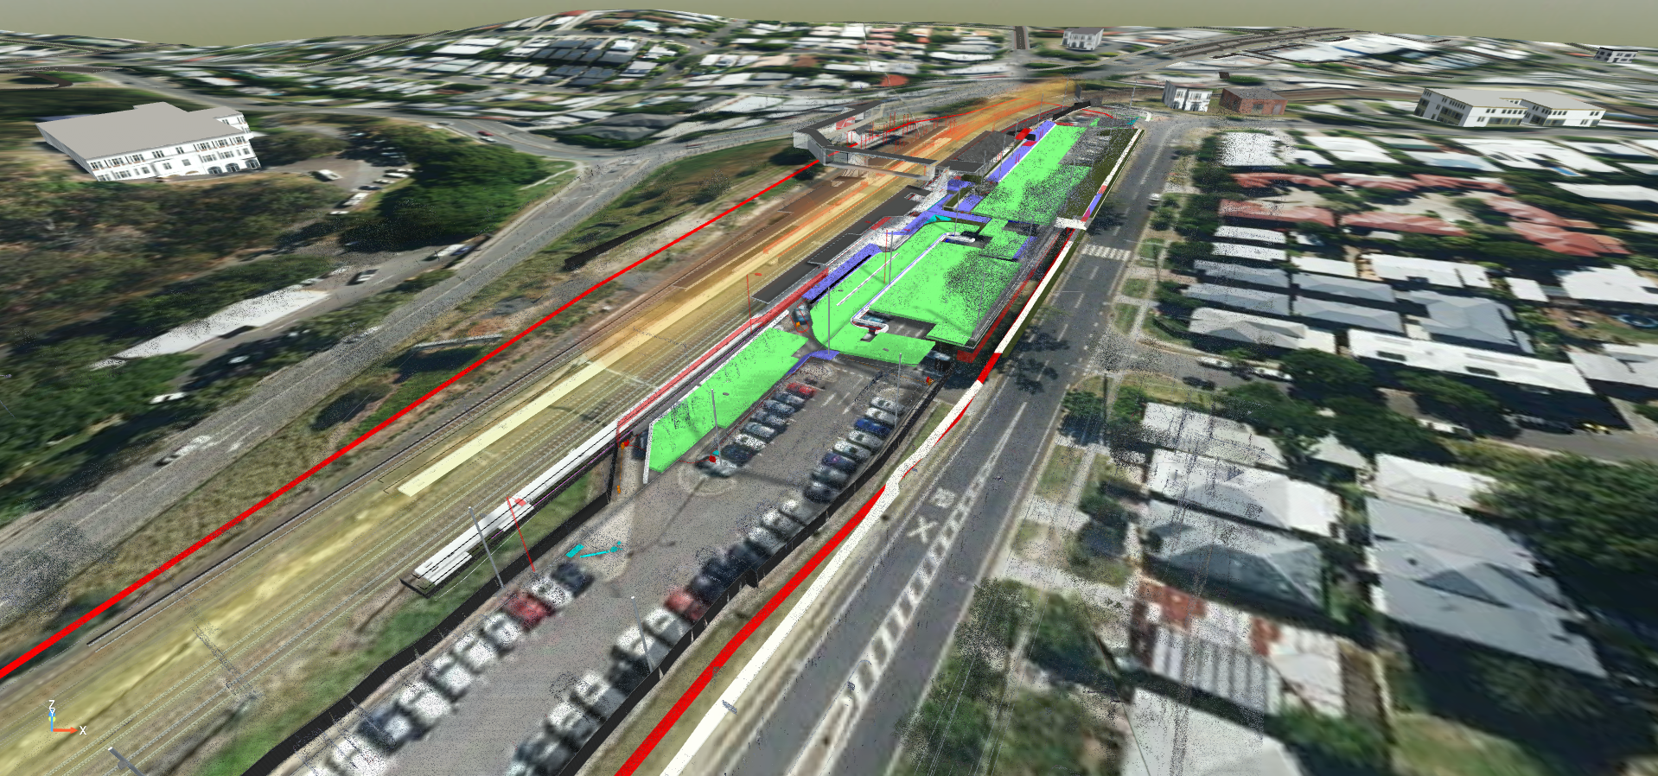

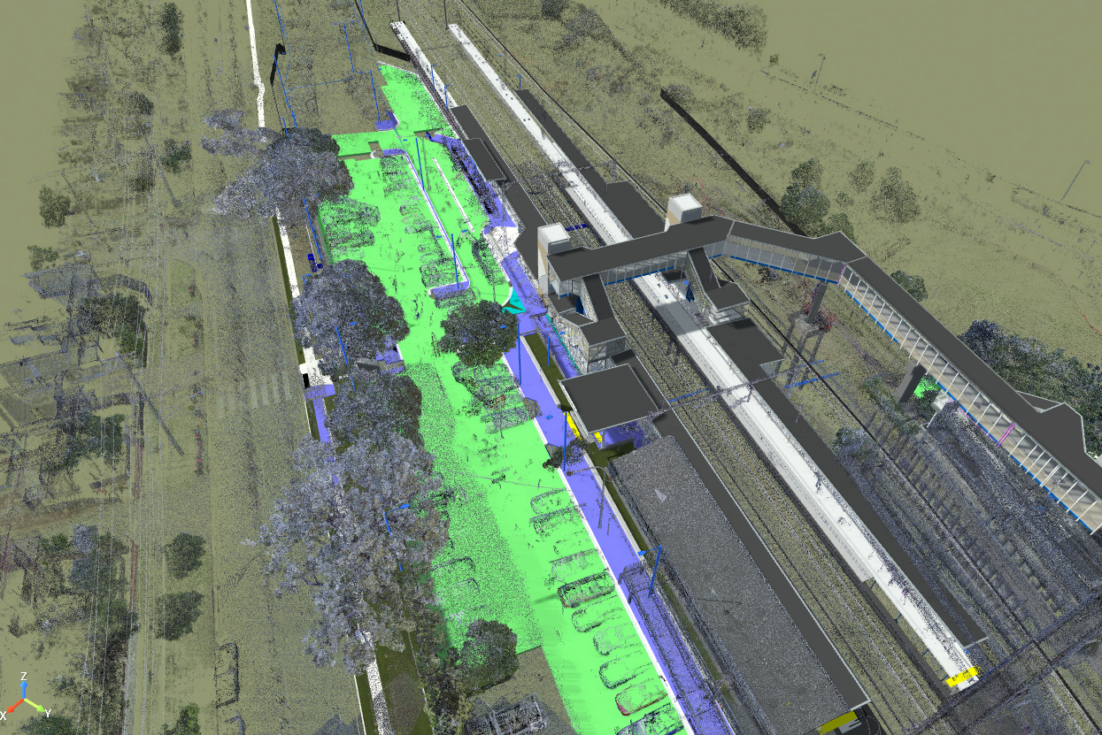

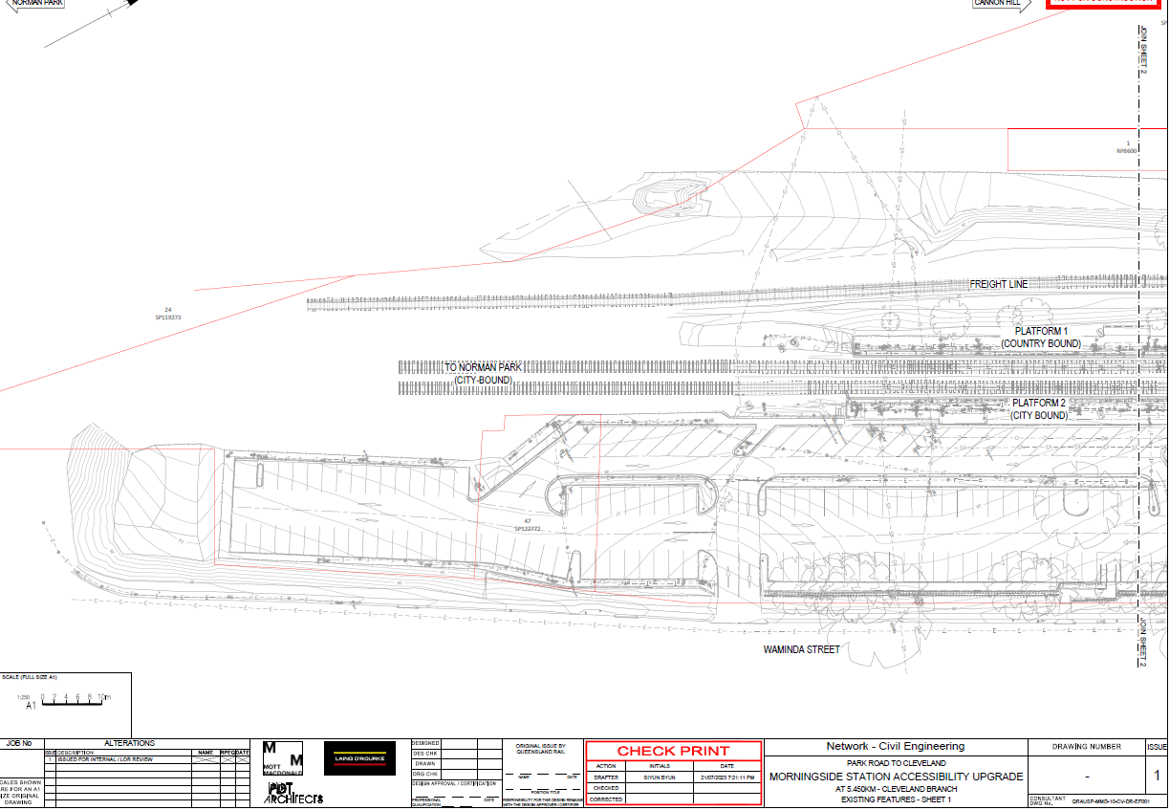
Snippet show’s contour lines stipulated within the civil drawing for Morningside station. These contour lines represent the ground elevation and depression measurement from sea/ground level. At the end of the station car park it shows the contour line highlighted at 28m then raising to 30m the further ground reaches Waminda street. This is representing a higher grade along these landscaped area’s to be filled. In conclusion 28m from ground/sea level of fill (certified material) is to be used to build this landscape up to meet design.
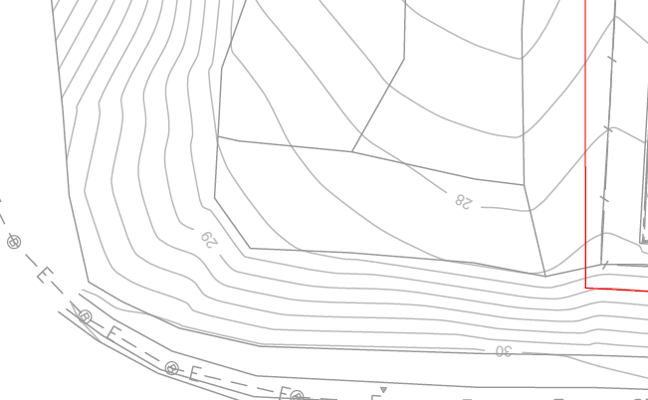
CONTOUR LINES

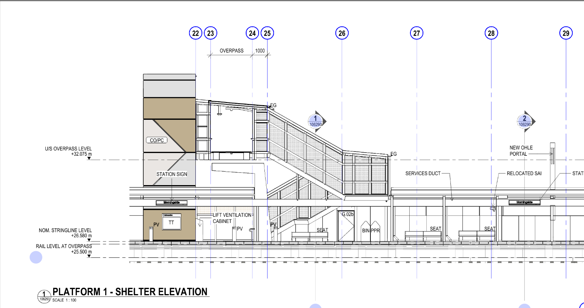
Snippet shown is an elevation plan supplied to us as the managing contractor by a sub-contractor after surveys have been completed. This plan show’s 3 different RL’s showing rail level at overpass, nominated stringline level, and overpass level. These RL’s and drawings will then be fed through our design of the station, and help me understand and attain the knowledge to ensure our sub-contractors build and excavate to the correct heights and levels. For an example the Rail level at overpass RL can be used to understand the height of our piling pad distances and depths. Throughout this project we will be consistently using this RLs and others to ensure the design is followed.
EXPLAINING RL’S

