

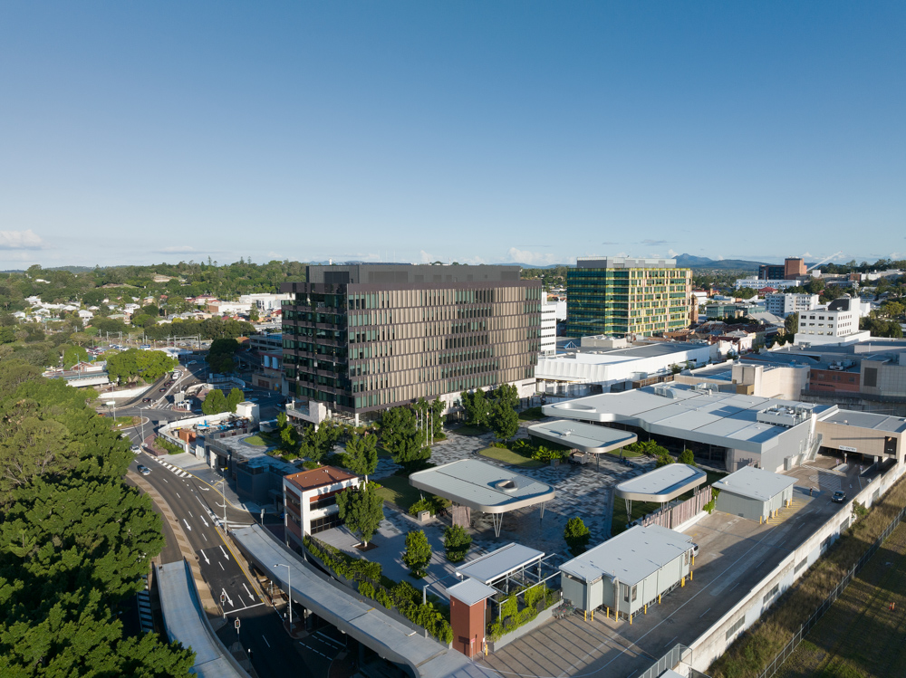

Work Health and Safety Management Plan
  - 205 North Quay
Version 15 – 7/02/2023 – Uncontrolled if printed

Contents
Definitions 3
1. Project Information 5
2. Plan Review and Approval 5
3. Introduction 6
3.1 Purpose 6
3.2 Objectives 6
3.3 Other Management Plans 7
4. Health and Safety Responsibilities 8
4.1 Work Health and Safety Policy 8
4.2 Project Team Structure and Responsibilities 8
4.3 Subcontractor Responsibilities 9
4.4 Worker Responsibilities 9
5. Risk Management 10
5.1 Project Risk Assessment 11
5.2 Task Specific Risk Management 11
6. Site Facilities and First Aid Provisions 14
6.1 Site Security and Public Protection Controls 14
6.2 Site Signage 14
6.3 Site Media / Posters and Information 15
7. Consultation, Information and Training 16
7.1 Internal Consultation, Cooperation and Coordination 16
7.2 External Consultation 17
7.1 Issue Resolution 18
7.2 Site Induction 19
7.3 Licences, Competencies and Training 20
7.4 Visitor Process 21
7.5 Personal Protective Equipment (PPE) 21
8. Worker Wellbeing 22
9. Plant 23
9.1 Plant Registration – Powered Plant (Mobile & Stationary) 23
9.2 Plant Movement – Mobile Plant 23
9.3 Operation of Plant – Powered Plant 24
9.4 Electrical Equipment 24
9.5 Temporary Fixed Plant / Support Structures 24
9.6 Chain of Responsibility 25
10. Hazardous Substances 26
10.1 Hazardous Chemicals 26
10.2 Silica (Respirable Crystalline Silica – RCS) 26
10.3 Hazardous Materials 27
11. Working Over or Adjacent to Water 28
12. Monitor and Review 28
12.1 Audits 28
12.2 Inspections 29
12.3 Project Performance 30
13. Incident Management 31
13.1 Incident Reporting and Internal Notification 31
13.2 Incident Recording 32
13.3 Incident Investigation 32
13.4 Notification to External Parties 32
13.5 Rehabilitation & Return to Work 33
14. Document Management and Record Control 33
15. Legal Requirements 34
Document Control 34

Attachments
Appendix 1
Health and Safety Responsibility Statements
Appendix 2
Project Risk Assessment
Appendix 3
Safe Work Method Statements (SWMS)
Standard Operating Procedures (SOP)
Appendix 4
Emergency Response Plan

Definitions
Term | Definition
Client | A customer that has engaged the company to perform works under a contractual agreement and any other subsequent customer post-completion that engages with the company in relation to the performance of the works (including statutory warranties).
Construction Team | Individual Team within the organisation that is managed autonomously by a Team Leader and comprises Project Teams and various support staff to procure and deliver construction projects to alignment with the company strategic objectives.
Health, Safety and Environmental Advisor (HSE Advisor) | Hutchies-assigned representative of the project’s health, safety and environmental objectives and activities throughout the course of the project’s life
Interested Party | A person or organisation that may have influence over or be affected by the project. This extends to a client, consultant, subcontractor, worker, and member of the public. (Interested party also may be referred to as a stakeholder).
Operations Team | Senior Management representatives appointed by the Managing Director and responsible for supporting Construction Teams in all aspects of the business including Tendering, Design, Construction, Contract Administration, Project Finance, Quality, Work Health and Safety, Environmental.
Project Manager* | Overall manager on a construction project. Where a Project Manager is not assigned to a construction project the functions of the Project Manager are automatically allocated to the Contracts Administrator to the extent determined by the Team Leader.
Project Team | Team of resources allocated to a project by the Team Leader and may include Project Manager, Design Manager, Cost Planner, Project Engineer, Contracts Administrator, Site Manager, Supervisor, Health, Safety and Environmental Advisor, Document Controller, Team Construction Manager, Team Health Safety and Environment Manager etc
Supervisor | Hutchies’ site personnel that supervise site activities including Structural / Finishes / Façade / External Works Supervisor etc
Team Leader | Overall manager of a Construction Team responsible for the procurement and delivery of projects undertaken by the team. The Team Leader is accountable for the performance of the team, upholding the company reputation, compliance to legislative requirements and adherence to company standards through implementation of Hutchies’ Key Principles and the use of company systems.
Site Management Team | Team of resources allocated to a project by the Team Leader and may include Site Manager, Supervisor/s and Site Health, Safety and Environmental Advisor.
* Project Manager to assess skill set of delegated resource assigned to multiple roles
Term | Definition
Corrective Action | The action taken to remedy a non-conformance.
Non-Conformance | Deviation from an approved procedure, legislated requirement, or site rule.
Risk | Potential event(s) resulting in an unintended outcome.
Code of Practice (COP) / Compliance Code | Codes of Practice set out industry standards of conduct. They are guidelines for managing exposure to risk and provide practice directions for a safe working environment.
High Risk Construction Work (HRCW) | Defined in legislation as the following activities all require an accompanying safe work method statement:  - Involves a risk of a person falling more than 2m  - Is carried out on a telecommunication tower  - Involves demolition of an element of a structure that is load bearing  - Involves demolition of an element of a structure that is related to the physical integrity of the structure  - Involves, or is likely to involve, disturbing asbestos  - Involves structural alteration or repair that requires temporary support to prevent collapse  - Is carried out in or near a confined space  - Is carried out in or near a shaft or trench deeper than 1.5 m or a tunnel  - Involves the use of explosives  - Is carried out on or near pressurised gas mains or piping  - Is carried out on or near chemical, fuel, or refrigerant lines  - Is carried out on or near energised electrical installations or services  - Is carried out in an area that may have a contaminated or flammable atmosphere  - Involves tilt-up or precast concrete  - Is carried out on, in or adjacent to a road, railway, shipping lane or other traffic corridor in use by traffic other than pedestrians  - Is carried out in an area of a workplace where there is any movement of powered mobile plant  - Is carried out in areas with artificial extremes of temperature  - Is carried out in or near water or other liquid that involves a risk of drowning  - Involves diving work
Incident | An unplanned event that results or could result in harm to a person or damage to the environment or property.
Issue (in issue resolution processes) | Any matter regarding health and safety at the workplace that remains unresolved after it is discussed by parties to the issue.
Improvement | The process of enhancing the Project Safety Management System as stated by the Work Health and Safety Management Plan to achieve improvements in overall safety in line with the Hutchies’ Work Health and Safety Policy.
A 'person conducting a business or undertaking' (PCBU) | A legal term under harmonised WHS laws for individuals, businesses or organisations that are conducting business. A person who performs work for a PCBU is considered a worker.
Personal Protective Equipment (PPE) | Clothing or equipment which, when used correctly, protects part or all the body from identified risks of injury or disease in the workplace.
Safe Work Method Statement (SWMS) | A study carried out to ensure that hazards are identified, analysed, and properly controlled to minimise, or, if practicable, eliminate risks. High risk construction work SWMS must be available at the point of use (either in hard copy or electronically) and approved by Hutchinson Builders before the commencement of high risk works.
Safety Data Sheet (SDS) | Safety Data Sheets are documented information which clearly identifies a hazardous substance and states the precautions to be taken for the safe use, storage, and disposal of the substance along with the health hazards and toxicity associated with the substance. Must be available at the point of use (either in hard copy or electronically).
Subcontractor | Any third party engaged by the Hutchies to undertake works on the project.
Supplier | Any third party providing goods to the Hutchies for the project.
Verification of Competency (VoC) | A method of documented evaluation of the skill level of a person against defined competency standards to evaluate the person's ability to carry out the relevant activity or works.
WHS / OHS | Workplace health and safety and / or occupational health and safety.
Worker | A person who carries out work in any capacity for a business or undertaking and includes employees, outworkers, apprentices, trainees, students gaining work experience, volunteers, contractors or subcontractors and their employees.
Work Group | A trade group (eg Hutchies, subcontractor trades etc)

- Project Information
Project Name | 205 North Quay
Project Number | 26544
Project Address | 205 North Quay, Brisbane QLD 4000
Contract Type | Design & Construct
Client Name | Cbus Property
Building Description | Commercial Office Tower
Brief Overview of the Project | The Proposed development is a 38-sorey commercial office tower located at 205 Nort Quay in Brisbane City. The building will feature an auditorium accessed from the Plaza level which will sit up to 234 people. The Public Plaza on level 00 is provided with level access to Herschel Street and will be an aesthetic architectural feature as it will be approx. 20m high space with access through to a public laneway at the rear of the site. The building will also contain a large portion of office space from levels 04 – Level 35, childcare on level 02 and Wellness Clinic on Level 01 which will include an external swimming pool.
Project Start Date | 17.06.2021
Project Duration (weeks) | 179 Weeks
- Plan Review and Approval
This plan and the relevant appendix items will be reviewed by Project Team and reviews recorded in Table 2.1.2:
- Following Safety Management Systems updates
- Following legislative updates / amendments impacting the content
- Following changes in the Project Team that result in a change in health and safety responsibilities
- Where there is significant or additional change to the scope of the project that results in the plan no longer being relevant
- For effectiveness and suitable implementation during the construction phase
The Project Manager is responsible for:
- Plan approval including all revisions, and
- Allocation of appropriate resources to implement the plan.
    - Access to this Plan
The plan will be made available to the Hutchies’ Project Team as well as their subcontractors and consultants prior to carrying out their relevant scope of works during the construction phase electronic versions of the Plan are available in HammerTech.
This plan will be communicated to all workers at induction and any changes to the plan will be communicated to all as appropriate via relevant project/site meetings.
A copy of this management plan is to be retained on HammerTech and a copy of the body of this plan retained in hard copy on site.
    - Revision History (Project Specific Document)
Revision | Date | Details | Method of communication with the Project | Approved
A | 27/08/2021 | Plan made project specific | ☐ Email | Chantelle Love  Team HSE Manager
B | 25/01/2022 | Update following personnel changes | ☐ Email | Chantelle Love  Team HSE Manager
C | 9/06/2022 | Update following personnel changes | ☐ Email | Chantelle Love  Team HSE Manager
D | 5/08/2022 | Sustainable Education section added following ESD Team Comments | ☐ Email | Chantelle Love  Team HSE Manager
E | 10/02/2023 | Plan made project specific following updated version release | ☐ Email | Chantelle Love  Team HSE Manager
F | 17/01/2024 | Update following personnel changes | ☐ Email | Andy Stacey  Site HSE Advisor
    - Plan Workshop Completed by
Name | Position | Date | Signature
Chantelle Love | Team HSE Manager | 10.02.2023
Andy Stacey | Site HSE Advisor | 10.02.2023
- Introduction
  - Purpose
This Project specific plan has been developed to:
- Establish project specific WHS objectives that align with ‘Hutchies’ Key Objectives’
- Communicate the processes necessary to deliver results in accordance with Work Health and Safety policy
- Describe the project organisational structure and the responsibilities of internal and subcontractor workers
- Identify the high-risk construction work and significant hazards that are anticipated in the delivery of the scope of the project
- Identify the arrangements for collection, assessment monitoring and review of high-risk construction work SWMS
- Describe the processes for communication and consultation with the workforce and with other interested parties
- Describe the incident management and reporting procedures
- Define the document control and record management requirements including the specified electronic collaboration platform(s)
- Identify the connections to and obligations of relevant legal requirements
- Establish any site specific processes.
  - Objectives
Project specific health and safety objectives have been developed to align with ‘Hutchies ‘Key Objectives’.
The following project specific objectives have been developed by the Project Team and will be monitored and reviewed throughout the project in the project planning meetings.
Hutchies’ Objective | Project Success Indicators | Project Actions
Ensure the health, safety and wellbeing of all workers and other parties who may be affected by our construction activities are not compromised | 100% of construction projects have completed a project specific risk assessment | Project Risk Assessment to be completed prior to project commencement and reviewed monthly to review upcoming project activities and control measures.
Observations raised are satisfactorily addressed within the nominated timeframes | All observations are closed out or before the due date. | All Safety Committee walk issues raised must be closed and signed off by Friday. Site HSE to walk project to ensure compliance and close of in Hammertech.
To provide and maintain a workplace which is fit for purpose | >90% of projects are completing a Weekly Inspection – Big 10 | Weekly Inspection to be completed by HSE Advisor as well as any roving HSE
Effective consultation with workers, subcontractors and interested parties in relation to health and safety matters | >75% of projects are facilitating a subcontractor coordination meeting to enable consultation on HSE matters | Safety Committee Meetings to be held where Subcontractor Coordination Meetings are not completed on project.
Provide early and safe return to work for all company members suffering a work-related injury or illness | 100% of injuries or illness categorized as RWI or LTI are to be assigned to Hutchies’ Wellness Facilitator for review and coordination as required | Team HSE to be notified of all incidents who will notify and liaise with Sandra Long (Where required)
Hutchies’ Key Objectives / HB-HSEQ-F-050
Project Planning Meeting / HB-HSEQ-F-057
  - Other Management Plans
This plan has been developed in conjunction with the below listed management plans and should not be referenced in isolation.
- Quality Management Plan
- Environmental Management Plan
- Construction Management Plan
- Traffic Management Plan

- Health and Safety Responsibilities
  - Work Health and Safety Policy
The Work Health and Safety Policy will be displayed on all sites and communicated to all employees and contractors at induction.
Work Health and Safety Policy / HU-Policy-001
Management Procedure 01 Work Health and Safety Policy Statement and Communication
  - Project Team Structure and Responsibilities
Role specific responsibility statements applicable to the Project Team are available in Appendix 1 of this plan and include the names, positions and responsibilities for health and safety.
A copy of signed responsibility statements will be retained with the plan and accessible on HammerTech. Responsibility Statements will be reviewed if there is a change to the Project Team Structure.
Contract Administrator
Ryan Allison
Luke Allen
Supervisor/s
Tim Blee
Site Manager
Dave Warner
Team Leader
John Berlese
Project Manager
Nikolas Cox
Team Health Safety and Environment Manager
Chantelle Love
Site Health Safety and Environment Advisor
Andy Stacey
Workers
Safety Committee
Where there are changes to the Project Team a record of staffing, induction into this plan and review of responsibilities will be recorded in the Project Team Staff Change Register and retained on HammerTech.
Health and Safety Responsibility Statements / Appendix 1
Project Team Staff Change Register / HB-HSEQ-F-007-Z
Management Procedure 02 Organisational Overview and Work Health and Safety Responsibility
  - Subcontractor Responsibilities
All subcontractors, suppliers and their employees performing works on this project are required to conform and comply with the relevant Workplace Health and Safety legislation, site directions, the conditions of the executed subcontractor agreement and Hutchies’ ‘Subcontractor HSE Requirements’.
Subcontractors are required to provide the site team with safe work method statements (SWMS) along with other health and safety information relevant to the project (eg safety data sheets (SDS), plant and equipment records, registers, prescribed authorisations, and licences etc) and that are documented in the subcontract.
The Project Team will review and approve submitted health, safety, and environment documentation for use in advance of subcontractors commencing works on site.
Subcontractors’ responsibilities include but not limited to:
- Provision of adequately trained and qualified supervision for the duration of their works on site
- Training and instruction of their workers in their work activities (SWMS / SOP etc), plant, equipment, tools, and processes, specific emergency response procedures
- Ensuring their employees have been inducted on the project prior to commencing work
- Ensuring all required health and safety documentation is provided to the site team and uploaded to HammerTech in advance of commencement on and maintain throughout duration of the project
- Notification to the Hutchies project team of all incidents, injuries and near misses
- Providing copies of all regulator notices issued on the project along with evidence of close out actions that have been implemented and accepted by the regulator
- Completing incident reports relating to their own workers / incidents and all legislative duties including notifications to regulatory bodies
- Provision of completed incident reports and regulatory notifications and close outs to the Project Team
- Monitoring and review of site-specific safe work method statements (SWMS) ensuring SWMS are adequate for the tasks being performed
- Communicate and consult with workers on site specific information (attendance at daily pre-start meetings/toolbox meetings)
- Completion of permit and inspections for work activities being performed
- Execution of their scope in alignment with legislative and the subcontractor’s system requirements
- Close-out of delegated health and safety issues/observations raised on the project
- Provision of rehabilitation and return to work processes for injured workers
- Ensuring their employees have access and suitable devices to access HammerTech
- Ensuring employees follow requirements for emergency response for the project and completing daily site sign in requirements.
Subcontractor HSE Requirements / HB-Requirements-Subbies-HSE
Project Procedure 03 Subcontractor Management
  - Worker Responsibilities
Workers must take reasonable care for their own health and safety while on the project to ensure that their acts or omissions do not impact the health and safety of others.
On a day-to-day basis, this includes:
- Complying with reasonable instructions from the Project Management Team
- Ensure that work is undertaken safely to the extent of the worker’s control or influence over working conditions and methods
- Ensure that the work area is left in a clean condition that is free of hazards
- Making proper use of all appropriate safety devices and personal protective equipment (PPE)
- Following agreed safe working practices (ie SWMS, SOPs, procedures etc) and site rules
- Reporting all known hazards, incidents, injuries and near misses as soon as possible on the day of occurrence
- Attendance at site meeting ie daily pre-start meetings/toolbox meetings
- Follow directions and requirements for emergency response procedures.
Each worker has the responsibility to notify their supervisor and Hutchies at the earliest opportunity if they are concerned that work tasks will expose themselves or others to risks to health and safety, or where works are ceased due to unsafe conditions.
- Risk Management
During the preconstruction phase, Hutchies’ Project Team have reviewed the scope of works and the design risk assessment and have considered the potential impacts on neighbouring or adjacent properties. Site hazards, assessment of the associated risk and required controls identified in the pre-construction planning phase are incorporated into project delivery planning and the site-specific Project Risk Assessment.
The following diagram illustrates the risk management process’ implemented on this project:
PRE CONSTRUCTION
Bid Strategy & War Room
Design Risk Management
Project Risk Assessment
Safe Work Method Statements / Safe Operating Procedures
Permit to Work
CONSTRUCTION
Management Procedure 10 Risk Assessment

  - Project Risk Assessment
Prior to the commencement of work the Project Team develop and review the ‘Project Risk Assessment’ with consideration of the pre-construction planning phase and the identified risks and hazards relevant to the construction phase.
The ‘Project Risk Assessment’ includes the following:
- Activity
- Identified hazards
- Proposed controls
- Person/s responsible for monitoring / evaluation
- Identified risk ratings
Review of the project hazards and controls shall occur at intervals not greater than three months or at times where there is a significant change in the scope of works.
Project Risk Assessment / Appendix 2
  - Task Specific Risk Management
Prior to commencement of construction activities workers will be provided with suitable and adequate information, training and instruction regarding the works that are being conducted, the known risks associated with the work and the control measures that are to be implemented to mitigate the risks. The following practices are implemented on the project to manage task risk and facilitate this process:
    - Safe Work Method Statements (SWMS)
Safe Work Method Statements (SWMS) are documents that clearly set out the details of the high risk construction work, the hazards arising from this work and the measures to be implemented to control the risks. During the preparation of SWMS relevant workers or their representatives will be consulted.
Prior to commencing any high risk construction work on site, SWMS are required to be provided to the Project Team by the trade performing the work. Submitted SWMS will be reviewed using ‘High Risk SWMS Review Checklist’ in HammerTech.
The Project Team will review submitted SWMS and approve for use or reject for amendment and resubmission. Where rejected additional comments will be provided to the subcontractor on areas for review. The process of collecting, assessing, monitoring, and reviewing SWMS using HammerTech is as follows:

    - Standard Operating Procedures (SOP)
Work activities on the project that are not by definition high risk construction work require information and training prior to commencing the activity. Information and training on non-high risk construction work may occur through a standard operating procedure (SOP), job Safety analysis (JSA), task methodology, toolbox talks or other approved risk assessment methods.
Training records for non-high risk construction work are to be provided to the Project Team by the trade performing the work. Submitted non-high risk documentation will be reviewed using ‘SOP / Non-High Risk SWMS Review Checklist’ in HammerTech or HB-HSEQ-F-021-A ‘Subcontractor SWMS Checklist’.
The Project Team will review submitted documentation and approve for use or reject for amendment and resubmission.
Standard operating procedures for Hutchies’ works are in Appendix 3 and / or on HammerTech.

Records
Accepted and signed SWMS and SOPs are to be retained in HammerTech with additional hard copies retained on the project to enable all subcontractors access to their work instructions in the relevant format.
SWMS will be kept for the duration of the construction project or, in the event of a notifiable incident, for a period of at least two years.
SWMS retained in hard copy will be scanned and loaded to HammerTech at the completion of the project.
Subcontractors are responsible for the information, instruction, and training of their workers into their work instructions. Subcontractors are to have an allocated (nominated representative) to ensure workers read, understand, and sign on to the relevant SOP for the work activities that they will be performing.
Subcontractors are required to provide SWMS for all high risk work activities conducted on the project including using mobile plant.
Management Procedure 10- Risk Assessment
Safe Work Method Statements / Standard Operating Procedures / Appendix 3
    - Permit to Work
The ‘Permit to Work’ system is an administrative control that seeks to reduce the risks associated with specific activities on the project to ‘As Low As Reasonably Practicable’ (ALARP). Risk reduction for the specified activities is achieved through the documented planning and communication to the Project Team of the required controls, persons involved and duration of the task. The Project Team approve or reject permits prior to commencement of respective activities (refer to permit process outlined here).
The following table outlines the details of the various permits to work:
Permit | Associated Risk/s | Maximum Permit Duration* | Activities / Work Environment requiring a permit
Isolation and lockout | Inadvertent contact with electricity or hazardous substances  Injury from mechanical movement  Stored energy | Duration of work | - Works on or near electricity  - plant (servicing /maintenance)  - equipment (servicing / maintenance)  - other (fire services / security etc)
Confined Space | Engulfment  Fire  Suffocation | 1 day | Legislated confined space areas defined in the confined space permit:  - enclosed or partially enclosed spaces  - spaces not intended to be occupied by a person  - spaces not designed to be at normal atmospheric pressure  - spaces that are likely to cause a risk to health and safety (eg unsafe oxygen levels, airborne contaminants, engulfment etc)
Hot Works | Fire  Injury | 1 Week | - flame (welding / soldering / brazing)  - hot objects (metal surface / plate etc)
Working at Heights | Fall from heights  Falling objects  Worker suspension  Injury | 1 Week | All works where edge protection is not provided, and the risk of falling is greater than 2 metres  - harness use  - EWP boom lift  - swing stage  - mast climber  - man box
Excavation Trenching and Penetration | Trench collapse  Worker engulfment  Inadvertent contact with services  Injury | 1 Week | - bulk cut  - trenching  - drilling / piling – sheet/column
Coring / Cutting/ Drilling | Structural collapse  Inadvertent contact with services  Injury | 1 day | Work that requires the activity of breaking into walls/ tilt up panels / soffits / ceilings / ground  - coring  - cutting  - drilling
Works on suspended slab | Structural collapse  Injury | 1 Week | - Operation of plant on a suspended slab
Permit to energise | Inadvertent contact with services  Injury | Duration of the work | - electrical commissioning and testing  - energisation of a circuit for another subcontractor
* Permit durations are to be assessed on the environmental risks. Permits will be approved for a duration that aligns with the risk.

Permit application and approval process
Trade Supervisor to complete the permit application.
Project Team to review the permit application and approve or return to the Trade Supervisor.
Works completed in alignment with the approved permit and required controls.
Trade Supervisor to close the permit and confirm close-out with the Project Team.
Permit closed.
Trade Supervisor to start the permit
KEY Blue / Hutchinson Builders / Purple / Subcontractor or Hutchinson Builders
Management Procedure 10 Risk Management
- Site Facilities and First Aid Provisions
The Project Team will provide facilities and first aid provisions, taking into consideration project size, work activities, location and the number and composition of workers on site. Project facilities include, but are not limited to:
- Toilets
- Hand washing facilities
- Drinking water
- Crib room facilities
- First aid provisions
Site facilities will be maintained in good working order and kept clean, safe, and accessible during the construction phase. The location, configuration and number of facilities provided on the project will be assessed in the ‘Project Risk Assessment’, prior to commencement of construction activities. Site facility requirements are reviewed where there is significant change to project activities, worker numbers and / or the change in the ability of the facilities to meet the project requirements. Site establishment / set up audit is completed to review the site set up.
Project Procedure 04 Construction Amenities
Project Procedure 05 First Aid
Project Risk Assessment / Appendix 2
  - Site Security and Public Protection Controls
Prior to commencing works the project will have full containment to delineate the construction site and prevent inadvertent access to the site by members of the public and / or visitors.
The requirements for vertical containment controls are assessed throughout the course of the project in ‘Project Planning Meetings’ and through review of the ‘Project Risk Assessment – Public Protection Controls’. Site security and public protection controls will be monitored and reviewed throughout the course of the project by the Project Team and documented on the HB-HSEQ-F-049 ‘Weekly Inspection – Big 10’.
Weekly Inspection – BIG 10 / HB-HSEQ-F-048
Project Risk Assessment / Appendix 2
  - Site Signage
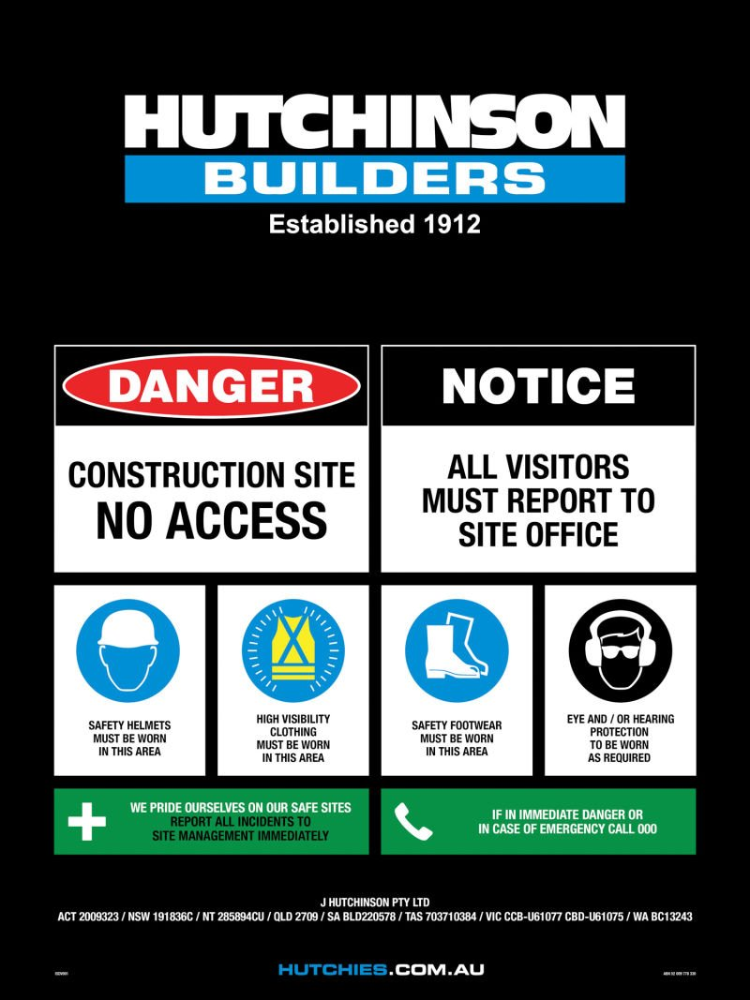
Suitable signage will be installed on the perimeter of the project at the pedestrian entry point with details of:
- Building licence (specific to each ‘state / territory jurisdiction)
- Project contact numbers (including out of hours contact details)
- Project specific personal protective equipment (PPE) requirements
- Restricted access notification
Failure to display these signs may breach building and construction laws.
The following signage types may also be displayed on the project during construction.

Safety Requirements Sign (ISDV001)

Site Information Board
Site information to be displayed in the induction room or site office to include:
- Project name and address
- Emergency contacts
- Site map indicating evacuation muster point and emergency equipment locations etc
- Site rules
- First aid officer details
- Nearest medical centre information
- Policy statements (work health and safety, environment, and quality)
Additional information to be displayed in the site office:
- Project organisational chart with site supervisor details
- Hutchies’ objectives
Site Information & Notice Board (IBH) / IBH019

Directional Signage
Directional signage (eg Site Office, Amenities, Crib Room etc) is required on all projects to enable clear instruction for all workers and visitors to navigate form the entry point to the site office.

Emergency Signage
Signage indicating the location or direction to emergency related facilities and first aid or safety equipment (eg First Aid, Emergency Assembly Area etc) will be installed and maintained on the project.
Signage directing the path to emergency exits and assembly points will be installed and maintained current for the duration of the project.

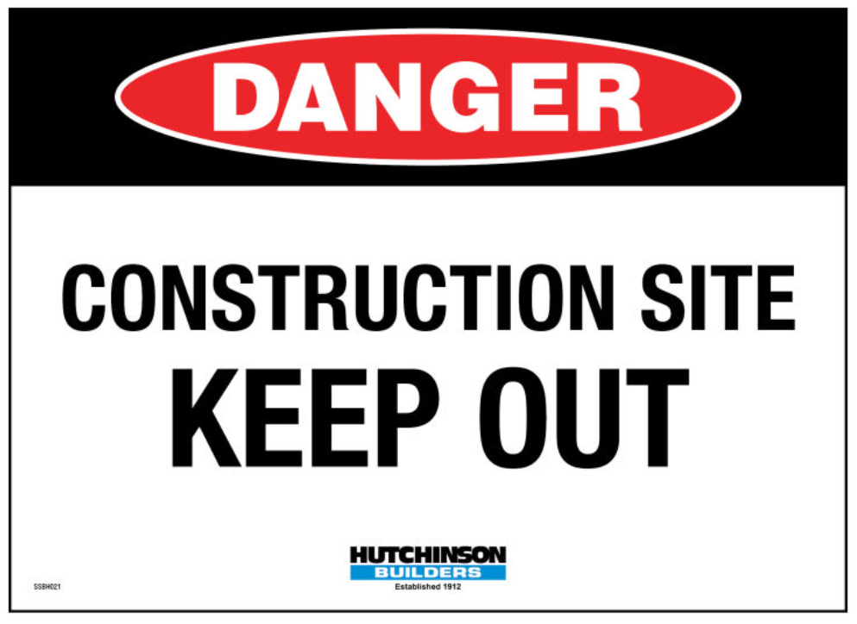
Danger Signage
Additional signage warning of hazardous and dangerous situations that could be life threatening (eg Construction Site Keep Out, Deep Excavation, etc) will be installed as per the relevant Safe Work Method Statements and in line with the Project Risk Assessment.

Ordering Site Signage
All of Hutchies’ site signage can be ordered via the Toolbox Shop.
Toolbox Shop / toolbox.hutchies.com.au/shop?category=signage
  - Site Media / Posters and Information
An extensive library of site posters available for use on projects in such locations as site sheds, crib facilities, amenities, and notice boards.
The Toolbox should be reviewed and the relevant information displayed on the project as required.
Posters / toolbox.hutchies.com.au/resources/posters

- Consultation, Information and Training
  - Internal Consultation, Cooperation and Coordination
The Project Team will consult with all relevant internal parties as appropriate. Formal communications and consultation processes will be completed in the English language. Employers of workers who are not conversant with written or spoken English will be required to provide suitable translation assistance.
Consultation during the construction phase enables those impacted by the project activities to remain informed of identified hazards and risks and decide who is best placed to take action to mitigate the risks. Effective consultation throughout the construction phase ensures positive outcomes for all involved.
Consultation is also provided to communicate project emergency procedures and the process by which emergency evacuation drills are conducted.
    - Project Team Meetings
The Project Manager will ensure that the Project Team meet at regular intervals to review and discuss project progress, milestones, upcoming programme of work, quality requirements, subcontractor management and project health, safety and environmental elements and new process or equipment.
Project Planning Meeting / HB-HSEQ-F-057
    - Subcontractor Coordination Meetings
Site meetings involving subcontractor groups shall be convened on a regular basis to discuss the upcoming works program, anticipated or potential operational issues and health and safety or environmental issues and the introduction of new processes or equipment.
Subcontractors shall be required to have appropriate representatives attend and participate in the subcontractor meetings.
Project Procedure 03 Subcontractor Management
    - Daily Pre-start Meetings
All workers are required to attend daily pre-start meetings prior to the commencement of each work shift. The daily pre-start meetings are implemented to communicate project specific information such as daily work activities and any changes in the project specific to health and safety that will impact workers or raise any issues relating to the project.
Records of daily prestart meetings and attendees will be retained in HammerTech.
Project Procedure 06 Consultative Arrangements On-Site
Daily Prestart Meeting Agenda / HammerTech
    - Toolbox Meetings
Toolbox meetings shall be held fortnightly or at intervals required by the project. Toolbox meetings are short information sessions where the site management involves the workers in discussion regarding the current works, incident and hazard updates, possible operational improvements and / or any safety or environmental issues or alerts requiring attention.
Site toolbox meetings foster open communication and consultation and facilitate two-way dialogue and participation in the continuous safety process on site.
Records of toolbox meetings and signatures of attendees will be retained in HammerTech.
Project Procedure 06 Consultative Arrangements On-Site
Toolbox Talk Form / HammerTech

    - Health and Safety Committee Meetings
Health and safety committee meetings facilitate cooperation and communication between subcontractor groups and the Site Management Team. The Health and Safety Committee shall comprise of the elected Hutchinson Builders Health and Safety Representative, the Site Manager, the Health, Safety and Environmental Advisor and the elected subcontractor Health and Safety Representatives.
A Health and Safety Committee will be established on the project within two months of being requested by either:
- A trained Health and Safety Representative (HSR)
- Five or more workers on site
- As required by legislation or
- As the Project Team deems necessary.
Where a Health and Safety Committee is established for the project, the formation of work groups, committee elections, consultation processes and functions in accordance with ‘Health and Safety Committee Functions and Terms of Reference’ as well as the applicable legislative requirements.
Health and safety committee meetings will be held at predetermined intervals and the agenda, minute and action items shall be documented on the ‘Project Health and Safety Committee Agenda’. It is the responsibility of the Health and Safety Representatives to communicate to the committee issues and progress that is raised by their work group and communicate to their work group the outcomes of Health and Safety Committee Meetings at the earliest opportunity after each meeting. Health and Safety Representatives are responsible for raising issues as soon as they are aware of such issues with the relevant committee members, and it is incumbent upon Hutchinson Builders to seek to address issues at the earliest convenience.
Records will be distributed to all members following meetings.
Project Procedure 06 Consultative Arrangements On-Site
Project Health and Safety Committee Agenda / HB-HSEQ-F-058
Health and Safety Committee Functions and Terms of Reference Form / HB-HSEQ-F-058-A
  - External Consultation
    - Community consultation
Where it is identified that construction activities have the potential to affect the client, members of the public or other interested parties, Hutchinson Builders facilitate appropriate communication and consultation through, letter box drops, email correspondence, community meetings and / or other effective means as may be identified in contractual obligations. The details of consultant are to be recorded in the Meetings module as a ‘Community Consultation’ in HammerTech.
Where feedback or complaints are received from members of the public or other interested parties, the details are to be recorded in the Meetings module as a ‘Community Consultation’ in HammerTech.
Relevant observations are to be raised to address the issues and actions that are implemented are to be recorded. All records are to be retained in HammerTech.
Consultation Register / HammerTech
    - Simultaneous Operations
Where Hutchies is engaged to undertake activities on a site where the client activities remain operational (eg operational shop, office building etc), a detailed plan is required to be established and agreed by all relevant parties to ensure the appropriate considerations are in place to enable a timely and safe execution of the proposed works, and to document the actions required of each party in respect of emergency and evacuation situations.
Project Procedure 06 Consultative Arrangements On-Site
Project Risk Assessment / Appendix 2
Simultaneous Operations Plan / HB-HSEQ-F-086
  - Issue Resolution
Issue resolution processes are legislative requirements, which are aimed at providing fair and effective workplace representation, consultation, and cooperation processes on the project. Issue resolution processes are communicated to all workers on the project during the site specific induction.
The definition of an ‘issue’ is as any matter regarding health and safety matters at the workplace that remains unresolved after it is discussed by parties to the issue.
Worker / work group is to inform the relevant party and the Hutchies’ Project Team of the issue at the earliest opportunity.
All involved parties to meet to attempt
to solve the issue.
Immediate risks resulting from the
issue are to be assessed.
Involved parties are to agree on the means of resolving the issue. Individuals within the involved parties are to be assigned responsibilities to close out the issue.
The agreed outcome shall be documented, reflecting the issue along with the proposed resolution and all items above. All involved parties are to receive a copy of the documented outcome including, where necessary, the site HS Committee.
The issue is deemed to be closed when the resolution has been satisfactorily applied.
All relevant parties to be advised.
Project Procedure 06 Consultative Arrangements On-Site

  - Site Induction
Prior to commencing work on the project, all Project Team members and workers will attend a Site Induction. Site inductions will be site specific and delivered to workers in accordance with ‘Induction Training Procedure’.
These inductions will provide workers with:
- Project overview
- Site specific information (ie traffic control requirements, hazard, and risk information etc)
- Site contacts
- Site rules
- Emergency procedures
- Incident reporting requirements
- Issue resolution processes
- WHS management plan content and availability
- Site facilities
Inductees are required to provide evidence of high-risk work licences and all competencies relevant to the work intended to be undertaken by the inductee. All inductee details and induction confirmations will be securely stored in HammerTech.
Project specific induction sticker with unique number shall be issued to each worker at the satisfactory completion of the induction training session, the site induction number to be record on the induction profile. Signature captured for the worker at the completion of the site induction.
Process Procedure 02 Induction Training
HSE Induction Form / HammerTech
    - Site Rules
Site rules are the nominated set of rules that establish the benchmark of acceptable behaviours across all of Hutchies’ projects that applies to all inducted workers and visitors on the project.
The site rules will be displayed in the induction area and may be complemented by additional project and client specific requirements. Site rules an integral part of workplace inductions.
Site Rules / HB-HSEQ-F-025-B
    - Sustainable Buildings – Construction Practices
The Sustainable Buildings – Construction Practices component of the site induction provides workers with training and knowledge on the following:
- Concepts of global warming, climate change and the health impacts of minimum building practices,
- Sustainable building certification(s) for the project,
- Explain the value of certification, and
- Role of site workers in delivering a sustainable certified building.
The site posters library available also includes posters on Sustainability which will be used in locations such as site sheds, crib facilities, and notice boards.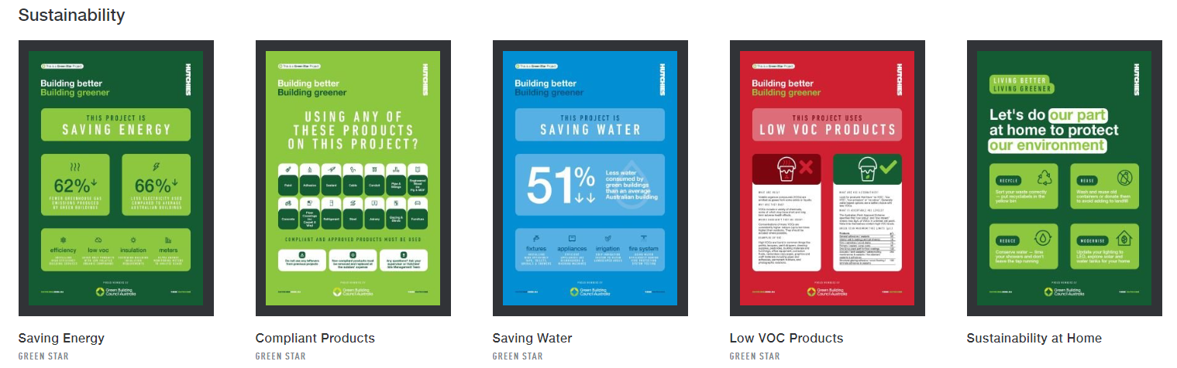
Sustainable Buildings – Construction Practices / HB Sustainable Practices Video
Posters / toolbox.hutchies.com.au/resources/posters

  - Licences, Competencies and Training
Worker licences, competencies and relevant training shall be verified and recorded during the induction process.
Hutchies’ ‘Minimum Licencing Guidelines’ will be used to assess the suitability and validity of licences, competencies, and training prior to the commencement of engaged works.
The ‘Minimum Licencing Guidelines’ are used to confirm inductee licences align with the applicable guidelines as well as the competencies / training outlined in the relevant Safe Work Method Statements (SWMS).
Supervisors of each trade are required to ensure all inductees are suitably trained and inducted into the SWMS for the activities they are engaged to perform.
The HammerTech Training Matrix or a team equivalent (HB-HSEQ-F-031 or alike) is maintained to capture the completed training for Hutchies’ company members and to facilitate training plans / requirements in alignment with the Minimum Licencing Guidelines.
Management Procedure 04 Training & Competency
Minimum Licencing Guidelines
HammerTech / Reports

    - Mobile Plant
The following evidence of competency is accepted for mobile plant operation on the project for mobile plant operation on the project:
- High-risk work licence issued by A State or Territory Under the National Certification System as per the legislation or
- Where a high-risk work licence is not required by legislation:
  - Licence or Certificate of Competency issued under previous state or territory legislation for which there is no longer a high-risk work licence required (eg load shifting equipment) or
  - Statement of Attainment or Certificate issued by a Registered Training Organisation for the successful completion of the appropriate unit of competency in the Nationally Recognised Training package or
  - Evidence of formal VoC assessment against defined competency standards, which should:
    - Be completed, or confirmed as having been completed, by the accredited company to an acceptable level, such as the relevant NRT, internal VoC process, or equivalent
    - Include a detailed and documented assessment standard
    - Be completed by a person (or persons) who meets the documented competency as defined by the company to conduct a VoC assessment
    - Be evidenced by a signed, completed VoC assessment
A letter signed by an employer or supervisor claiming the worker is competent will NOT be accepted as evidence of competency
Note The criteria for mobile plant licencing and competency are defined by the Office of the Federal Safety Commissioner (OFSC) and applies to Hutchies activities as an accredited contractor of the OFSC.
Management Procedure 04 Training and Competency
Project Procedure 02 Induction Training
Minimum Licencing Guidelines
  - Visitor Process
All visitors are required to sign on to the project and always remain accompanied by an inducted worker. Before departing the project, all visitors are required to sign off the project.
Visitors are required to abide by the site rules whilst on the project and are not permitted to undertake any work of any nature, including supervision, whilst on the project.
  - Personal Protective Equipment (PPE)
Hutchies shall provide personal protective equipment (PPE) for all directly employed company workers and project visitors. PPE that is issued shall be fit for the intended purpose and be compliant with the relevant Australian Standard.
Workers shall be instructed on the proper use, maintenance, and storage of the items of PPE as issued and shall be responsible for all issued PPE items.
Workers and visitors shall abide by the PPE requirements for the project whilst on site.
Subcontractors are responsible for the provision, training, and maintenance of all mandatory and task specific PPE for workers engaged for approved work activities.

- Worker Wellbeing
Hutchies maintains company policies and associated procedures that provide guidance in the management of worker wellbeing whilst on the project.
Internal procedures have been published to assist Project Teams to manage situations such as worker impairment (ie physical, and psychological), extreme environmental conditions, bullying, discrimination, and harassment.
During induction and via site media, all workers are provided information on accessing available support services including Hutchies’ Employee Assistance Program (EAP) provider Converge International for Hutchinson Builders’ direct employees and other industry support providers such as Mates in Construction available to all subcontractors.
Additional management plans may be required to align with client and contractual requirements for the management of worker wellbeing or impairment on the project.
Respect and Support Policy / HU-Policy-007
Management Procedure 14 Bullying, Discrimination and Harassment
Specific Procedure 04 Fitness for Work
Wellbeing Information / toolbox.hutchies.com.au/resources/wellbeing
    - Alcohol and Drugs
Hutchies’ Respect & Support Policy and procedures extend to managing situations that may arise in relation to alcohol and drugs in the workplace.
All alcohol and drug breaches shall be managed in accordance with internal procedures and any project specific contractual agreements (as applicable).
Respect and Support Policy / HU-Policy-007
Specific Procedure 04 Fitness for Work
    - Smoking
Smoking on project sites shall be restricted to authorised, designated outdoor smoking areas (DOSAs) and such areas shall not be located within 4 metres of the entry points to the project. Location of the designated areas is subject to contractual requirements.
    - Weather Procedures
Inclement weather conditions that may affect the project will be considered in the project planning and Project Risk Assessment development, considering project location, anticipated weather conditions and the processes and controls required on site to mitigate the risk to workers and the public.
Site specific responses will be determined by the Project Team and communicated to the project as applicable to communicate site requirements to maintain a safe working environment.
All subcontractors have an obligation to train workers in the defined processes of their business and the task specific risks associated with their engaged works where weather conditions will impact the health and safety of their employees (ie heat, rain, wind etc). Each subcontractor is responsible for the identification of weather related risks and the implementation of relevant and effective control measures required to address such situations.
Weather records will be maintained in HammerTech and aligned with the site diary actions.
Project Risk Assessment / Appendix 2
- Plant
Plant on the project is categorised into the following subcategories and the requirements for each category are defined below:
  - Plant Registration – Powered Plant (Mobile & Stationary)
Prior to the operation of powered plant on the project, the following information is required to be provided by the responsible subcontractor via HammerTech:
- Type of equipment including make, model, registration/plant number, serial number
- Gross weight and safe working loads
- Plant documentation (ie plant hazard risk assessment, operator logbooks etc)
- Plant inspection reports and maintenance logs
- Manufacturer specifications
- Servicing frequencies (in alignment with PP 07 Plant and Equipment – Appendix 1)
- Suitability of the plant for the task (fit for intended purpose)
- Safe work method statements (SWMS)
- Authorised operators
- The plant can operate within capabilities (OEM manuals)
- ‘Initial Plant Inspection Checklist’
Where plant is assessed as conforming, the Project Team issue a ‘PROJECT AUTHORISATION – MOBILE PLANT’ sticker to be affixed to the plant.
Plant assessed to be non-conforming, will not be permitted to be operated on the project and a ‘DO NOT OPERATE THIS ITEM OF PLANT’ sticker to be affixed to the plant until conformance is achieved or the plant is removed from the project.
Service records and associated records are to be maintained by the plant owner / operator in HammerTech for the duration of the use on the project.
Project Procedure 07 Plant and Equipment on Site
  - Plant Movement – Mobile Plant
The Project Team will assess and manage plant movement processes on the project to mitigate the risks to workers and visitors. Project planning for the movement of plant and interaction with workers is considered during the pre-construction phase and progressively managed throughout construction.
To manage the people and plant interactions on the project, the following (or a combination of) may be implemented:
- Separation of people and plant via visual indicators (ie flagging and signage)
- Spotter/s
- Designated access paths – plans indicating people and plant separation
- Reduction in vehicle movements
- Creation of plant ring roads (if possible)
- Provision of clear signage indicating plant movements / pedestrian walkways
- Effective communications
Processes for the management of plant movement on the project are defined in Project Procedure 03 ‘Plant’ and the risk associated with plant operations and movements on the project have been addressed in the ‘Project Risk Assessment’.
Project Procedure 07 Plant and Equipment on Site
Project Risk Assessment / Appendix 2

  - Operation of Plant – Powered Plant
Prior to the operation of plant on site, the responsible party (ie subcontractors, owners, consignees, and operators) is required to:
- Provide Hutchies with SWMS for the operation and works around mobile plant prior to use on the project
- Complete the daily logbook / inspection in alignment with manufacturer’s requirements
- Provide adequate supervision
- Ensure the plant is suitably registered as required
- Provide training in the procedures (ie Safe Work Method Statement etc) associated with the use of plant
- Provision of appropriate procedures, instruction and training for emergencies involving plant
- Ensure plant is used within manufacturer’s defined capability
- Ensure any damaged plant is removed from service, tagged out and adequately reported for service (to the owner of the plant)
- Ensure operator/s are suitably licenced in accordance with section 5.5 Licencing and Competency
- Ensure plant is maintained and serviced with updated records maintained in HammerTech
- Monitor the electrical compliance of plant ensuring adequate test and tag compliance
  - Electrical Equipment
Electrical and battery operated hand tools and equipment in use on the project are required to have the following records, inspection and maintenance inspections completed:
- Prior to commencement
  - Electrical equipment to be test and tagged in alignment with AS3012 Electrical installations – Construction and demolition sites requirements
  - Electrical equipment register is to be added to HammerTech (Register > Test and Verification)
  - Equipment is to be fit for intended purpose (DIY equipment not permitted on the project)
  - Workers are to be trained in the use of the equipment via SWMS, SOP, Toolbox, JSA or equivalent
- During construction
  - Maintenance of test and tag requirements
  - Faulty equipment is to be reported to the direct trade supervisor and removed from service.
  - Upon repair equipment is to be retested and tagged prior to being returned to use.
Note electrical leads and portable RCD units are classed as electrical equipment
  - Temporary Fixed Plant / Support Structures
During the construction phase temporary fixed plant or support structures may be installed to enable the successful construction of project. The following equipment types shall be loaded to the project in HammerTech as required for use on the project:
- Gantries
- Scaffold
- Tower Cranes
- Loading Bays
- Hoists
- Mast Climbers
- Formwork (including jumps)
- Screens
Prior to commissioning and installation of these types of plant the requirements outlined in the Project Risk Assessment are to be fully actioned with the required high risk checklists completed for each plant type at the required intervals.
During construction plant is to be inspected and maintained in accordance with the relevant Australian Standards and jurisdictional requirements and in alignment with Hutchies internal processes (including weekly inspection items) with records maintained and updated in HammerTech throughout the project.
Project Risk Assessment / Appendix 2 – Temporary Fixed Plant / Temporary Support Structures
  - Chain of Responsibility
National Heavy Vehicle Laws generally address the on-road actions of vehicle operators however, breaches of these laws can be caused by off-road parties involved in the transport supply chain.
Heavy vehicle transport operations, directly influenced by the Project Team, are conducted in a manner that:
- Complies with applicable NHVL legislation
- Adheres to the local council transport requirements
- Does not cause damage to assets and infrastructure
- Takes reasonable steps to prevent harm and / or adverse effects on the environment, workers (drivers, operators, site workers), or community, and other road users

- Hazardous Substances
  - Hazardous Chemicals
Hazardous chemicals are substances that can be a health hazard if not handled or stored correctly and are easily identified by the label on the container or packaging.
In advance of the use or arrival of hazardous chemicals to the project the substances are to be registered with the site team on HammerTech. Registration requires that a current Safety Data Sheet (SDS) is uploaded with information on the substance along with any additional risk assessments or training documentation.
A Hazardous Chemical Register is maintained in HammerTech and can be accessed by all workers (along with the relevant SDS) via site posters located in the site compound and at designated storge locations. Full registers can be downloaded by the site team as required.
Additional information for Hutchies’ company members related to the handling, storage, training, and disposal of hazardous chemicals is located within the SDS, SWMS and associated training documentation.
Each employer or workgroup is responsible for:
- Provision of training for workers involved in handling and using materials
- Provision of safety data sheet related to the material
- Provision of risk assessment relevant to the intended volumes, and the specific application or the material on the project
- Provision of appropriate PPE and other equipment
- The provision of process and equipment that may be required in the event of an incident
The ‘Project Risk Assessment’ identifies project specific controls required for the safe storage, labelling and use of hazardous chemicals.
Specific Procedure 01 Hazardous Chemicals
Hazardous Chemicals Register / HammerTech
Project Risk Assessment / Appendix 2
Subcontractor HSE Requirements / HB-Requirements-Subbies-HSE
  - Silica (Respirable Crystalline Silica – RCS)
Silica dust is generated through high energy processes such as cutting, sawing, drilling, polishing, scabbling and crushing of silica containing materials.
Each employer or workgroup engaged on the project is required to implement controls to manage the risks associate with silica dust generation and implement clean up practices that do not cause harm to workers on the project.
The following (or a combination of) may be implemented:
- Tools affixed with shrouds to contain dust
- Extraction equipment (M-class HEPA filtered vacuums)
- Fit-tested Respiratory Protective Equipment (minimum P2)
- Maintenance and training in use and maintenance of equipment and PPE
- Sequencing of works
- General cleaning practices implemented in alignment with the Project Risk Assessment controls
Processes for the management construction activities where respirable crystalline silica is a risk on the project have been addressed in the ‘Project Risk Assessment’ and in the Subcontractor HSE Requirements.
Project Risk Assessment / Appendix 2
Subcontractor HSE Requirements / HB-Requirements-Subbies-HSE
  - Hazardous Materials
Hazardous materials are those items or agents (biological, chemical, or physical) that have the potential to cause harm to health and may include asbestos, lead, contaminated materials, animal excrement, polychlorinated biphenyls (PCB), mould etc.
Where there are hazardous materials identified on the project a specific management plan will be developed to mitigate the risks associated with the remediation, removal or containment of the materials and any potential impacts to worker health.
Health surveillance / monitoring will be conducted as required by jurisdictional legislation for prescribed works and records retained in a secure manner.
Processes for the management of construction activities where hazardous materials are a risk on the project have been addressed in the ‘Project Risk Assessment’.
Specific Procedure 04 Fitness for work
Project Risk Assessment / Appendix 2

- Working Over or Adjacent to Water - Not Applicable
- Monitor and Review
The Project Team will undertake and participate in a variety of monitoring and review activities in alignment with Management Procedure 05 ‘Inspections and Monitoring of Health and Safety’.
Audits and inspections will be completed to review:
- Compliance with legal obligations
- Suitability of health and safety procedures
- Compliance health and safety procedures
- Effectiveness of risk assessment processes
- Effectiveness of operational controls
- The status of the project in achieving its objectives
Each subcontractor has the same obligation for monitoring and reviewing the works under their control whilst engaged on the project.
  - Audits
    - External Audits
This project may be subject to external audits in alignment with Hutchies’ annual audit schedules. The Project Team will participate in the audit process and address project specific non-conformance items in alignment with Management Procedure 06 ‘Non-compliance with Health and Safety Requirements’.
Audits of management systems and operational activities may also be conducted by accreditation bodies, clients, and other interested parties as a means of identifying opportunities for continual improvement. All findings are reviewed and considered to correct issues, evaluate effectiveness in process, promote efficiency, and enable improvements.
External audits to be retained in HammerTech along with any raised non-conformances and close out actions.
    - Internal Audits
Internal audits will be conducted on the project for the following reasons:
- Review the application of the Work Health and Safety Management Plan and associated procedures
- Review of project controls at intervals that align with a change in the phases of the project (ie demolition to ground works etc)
- Where there is an increase in incident trends or where there has been a serious incident
- In response to regulatory interest
- Where there has been significant change (ie new/modified equipment, substances, processes, or operational environment)
- To assess the results of previous audits
- Where concerns raised by inspection reports
The Team Health, Safety and Environmental Manager or the Team Leader will schedule internal audits in alignment with the team audit schedule and organise with the Project Team accordingly.
The timing and frequency of internal auditing will be determined by the project risk profile with consideration to external influences impacting project health and safety.
Health and Safety Management Systems Audits may be completed on the project, in alignment with the Health and Safety Systems Audit Schedule, by a person independent of the project.
MP 05 Inspections and Monitoring of Health and Safety
Site Establishment / Set Up Audit / HammerTech
Project HSE Systems Audit / HammerTech
    - Audit Schedule
The following audits shall be completed on the project in alignment with the construction team internal audit schedule:
Audit | Interval | Responsible Person to complete Audit | Audit Attendee/s
Site Establishment / Set Up Audit | Within 1 month of arrival and any form of establishment / commencement | Team HSE Manager* | Site Manager  Site HSE Advisor
Project HSE Systems Audit | 3 monthly or sooner where additional risks are identified | Team HSE Manager | Site Manager  Supervisor  Site HSE Advisor
Client Safety Audit | Monthly Project Walks | Greencap (Client Engaged) | Site Manager  Team HSE Manager /  HSE Advisor
Client Safety Audit | Quarterly Site Audit | Greencap (Client Engaged) | Site Manager  Team HSE Manager /  HSE Advisor
* Where there is not a Team HSE Manager the Project Manager will ensure Project Audits are scheduled and completed by a suitable person.
MP 05 Inspections and Monitoring of Health and Safety
Site Establishment / Set Up Audit / HammerTech
HSEQ Internal Audit Schedule / HB-HSEQ-F-046
  - Inspections
Formal and informal inspections of the project will be completed throughout the construction phase to evaluate the effectiveness of implemented control measures or identified hazards. Inspections and reviews of high-risk construction work activities are completed to monitor that adequate work processes have been implemented.
    - Weekly Health, Safety, Environment Inspections (BIG 10)
The Project Team (Project Manager, Site Manager, Supervisors and Health Safety and Environmental Advisor) will ensure that a weekly inspection is completed for the project with documented records maintained in HammerTech. Issues identified during inspections will be recorded and assigned to the relevant trade supervisor responsible for the rectification. Closure of the issues will require action in HammerTech and a review by the inspection owner once addressed. Subcontractors will be engaged to participate in site inspections as and when required.
HSE Weekly Inspection – BIG 10 / HB-HSEQ-F-048 and HammerTech
    - Task Observations
Task Observations are to be completed on high risk construction work activities performed by both subcontractors and Hutchinson Builders company members.
Recording and communicating the safe behaviours as well at risk behaviours observed during the Task Observation enables the Project Team to determine:
- Whether the controls nominated in the SWMS are effective
- Whether workers engaged in the task have been trained in the content of the SWMS and signed int to the process
- If all plant has been registered on the project
- If permits have been approved (where applicable)
- Licensing and competency of operators
- Daily Prestart have been completed or equipment
- The extent of the review or amendment requires for continuous improvement
- The requirement for additional training
Task Observation / HB-HSEQ-F-052
    - Non-Conformance and Corrective Actions
Non-conformances and corrective actions may be identified on the project in the following instances:
- During inspections
- During meetings (prestart meetings and committee meetings)
- As a result of task observations
- Informally (ie deviation from an approved procedure, legislated requirement, or site rule)
- Incident investigations
The Project Team will review and determine, in conjunction with the subcontractor or person responsible for the work area affected, the action/s that are required to address the non-conformance and prevent re-occurrence.
Prior to issuing a corrective action for non-conformances the Project Team will consider the contributing factors, which may include:
- Previous occurrences of the same or similar non-conformance
- Non-compliance with process
- Breach of site rules
- Instruction, process, or documentation
- Incorrect selection of tools or equipment
- Supervision or resourcing
- Skills and experience
- Personal Protective Equipment (PPE) selection or use etc
Non-conformances and / or corrective actions should be raised in HammerTech to enable the Project Team to ensure close out actions adequately rectify the identified issue/breach in accordance with MP:06 ‘Non-compliance with Health and Safety Requirements’. Corrective actions may also be raised using HB-HSED-F-029-A ‘Corrective Action Report’.
Management Procedure 05 Inspections and Monitoring of Health and Safety
Management Procedure 06 Non-Compliance with Health and Safety Requirements
  - Project Performance
    - Project Management Review
The Project Team will convene regular meetings to discuss various aspects of the project and review health and safety data along with planned upcoming high-risk works and the project health and safety objectives.
Following the completion of the project, the Project Team will evaluate and review the overall performance of the project and identify areas of improvements that can be applied to company systems and / or future projects.
Management Procedure 05 Inspections and Monitoring of Health and Safety
Project Planning Meeting / HB-HSEQ-F-057
Project Evaluation Meeting /HB-HSEQ-F-092

- Incident Management
An incident is an occurrence, condition, or situation arising in the course of work that results in or could have resulted in injuries/ human damage, environmental harm or property and equipment damage.
The following flowchart illustrates the process for incident management (except minor first aids).
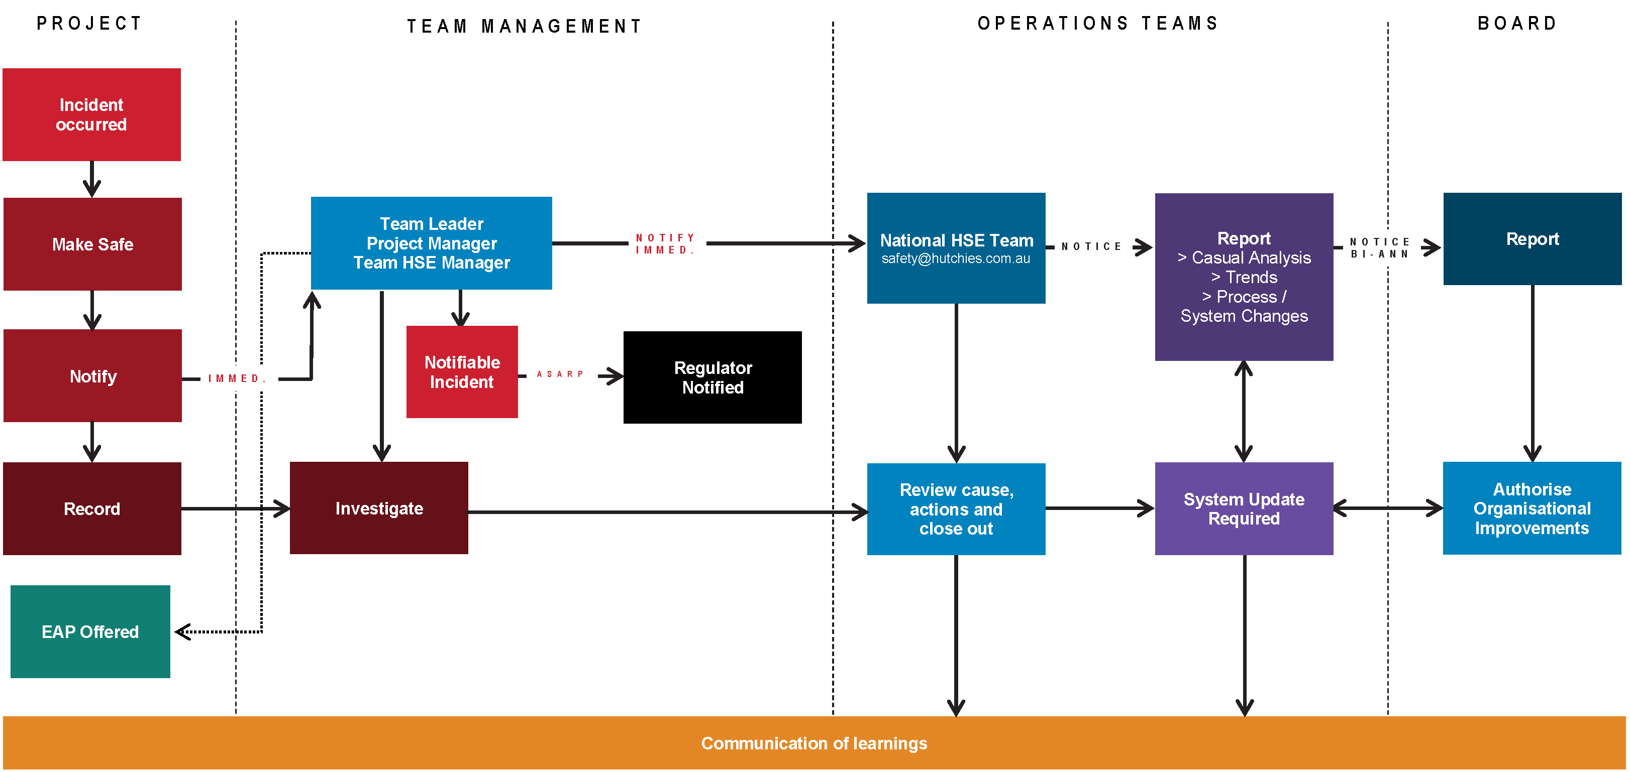
  - Incident Reporting and Internal Notification
All incidents that occur on the project are to be reported to the Project Team on the day of the event by fastest possible means. The requirement to report an incident is communicated to all subcontractors and workers during site inductions, project meetings and via site media during the construction phase.
Incidents could include:
- Near miss (ie hazard not resulting in an injury)
- Minor first aid
- Injury (ie requiring medical treatment)
- Notifiable incident (ie incidents requiring notification to the state regulator)
- Regulator Notice (ie improvement, prohibition, or infringement)
The Project Team will respond to the report of an incident on site in alignment with Management Procedure 08 Incident Reporting, Recording and Investigation.
Where there is an incident that results in a worker requiring medical treatment or an incident that is notifiable to the state regulator the Project Team will notify the Team Health Safety and Environment Manager and Project Manager via phone as soon as possible followed by entry into HammerTech.
Notification of all other incidents will occur when the incident is entered into HammerTech, at which point an automatic notification be sent Project Team and National Health Safety and Environmental Team.
Note Where the Team Health Safety and Environment Manager is notified of a notifiable incident it is their responsibility to notify the National Health and Safety Manager of the occurrence. The Project Manager is responsible for notifying the Team Leader of all notifiable incidents at the earliest opportunity.
Explanation of notifiable incidents is covered in Management procedure 08 Incident Reporting, Recording and Investigation.

    - Preserving the incident scene
The area involved in a notifiable incident shall be preserved until formally released by the regulator.
Preserving the area of the incident may include:
- Installing flagging or other physical barriers
- Prohibiting access to the area
- Securing involved plant, substance, structure, or thing ie equipment and materials
An expedited release of the area may be required where the scene presents additional risk to other workers. In all instances the regulator is required to be preserved for the purposes of internal investigation.
To enable accurate incident investigation a scene may be required to be preserved outside of notifiable incident types.
Management Procedure 08 Incident Reporting, Recording and Investigation
  - Incident Recording
Following notification of an incident on the project, the Project Team will record the incident in HammerTech. Incidents raised in HammerTech automatically notify the Project Team and the National Health, Safety and Environment Team.
All incidents (ie near miss, minor first aid, injury, and notifiable event) are to be recorded via the incident module of HammerTech.
Subcontractors are required to maintain records of incidents and injuries that involve workers under their instruction and control.
  - Incident Investigation
The Project Team may utilise the Incident Report Form [HB-HSEQ-F-027-B] to capture preliminary details relating to the incident and enter into HammerTech once information gathering is completed.
Incident investigations will be conducted for notifiable events and for incidents where a worker is injured and unable to perform normal duties (ie restricted work injuries and lost time injuries).
Following a notifiable incident, the Team Health, Safety and Environmental Manager or Project Manager (where there is not a Team Health, Safety and Environmental Manager) will initiate an incident investigation in consultation with the Project Team.
Subcontractors are required to provide incident reports/investigations for events that occur during works under their control. Reports/Investigations are to be provided to the Project Team.
Those undertaking incident investigations are to be trained in the incident investigation process, which is outlined in Management Procedure 08 ‘Incident Reporting Recording and Investigation Procedure’ and utilise HB-HSEQ-F-027-E ‘Incident Investigation Form’.
Incident Report / HammerTech
Incident Investigation Form / HB-HSEQ-F-027-E
  - Notification to External Parties
Where a notifiable incident occurs on the project, there is a legislative duty to ensure the state regulator(s) is notified within their mandated timeframe. Incidents involving Hutchinson Builders Employees will have notification to the state regulator completed by the Team Health, Safety and Environmental Manager or their delegate.
Where a notifiable incident occurs from works under a subcontractor’s control notification to the State Regulator shall be completed by the PCBU in control of the activity in consultation with the Hutchinson Builders Project Team. Following notification by the subcontractor all records of notification will be retained by the Project Team.
Client notifications will be completed by the Project Manager, in accordance with the project’s contractual requirements.
All other relevant parties shall be notified of an incident that has occurred within their area of responsibility at the earliest, convenient timeframe and shall be kept up to date with relevant information as and when it comes to hand.
Full investigation reports and records will not be disclosed to any third party unless approved by the National Health, Safety Environmental Manager, or their delegate.
    - Records
The Work Health and Safety Management Plan and all associated records related to a notifiable incident will be retained for a period of 30 years following project completion.
  - Rehabilitation & Return to Work
Injured worker packs will be maintained on the project and accompany injured workers to the engaged medical centres following injury.
Rehabilitation and Return to Work (RRTW) processes for Hutchies’ company members will be initiated as soon as the Project Team becomes aware that an injury sustained has impacted a worker’s capacity.
The Rehabilitation and Return to Work process for workers shall be applied in accordance with Management Procedure MP:15 ‘Rehabilitation and Return to Work’.
The Rehabilitation and return to Work Coordinator is responsible for liaising with payroll and the relevant workers compensation authority where there is an incident involves medical treatment, restricted work capabilities or lost time.
Management Procedure 15 Rehabilitation and Return to Work
Injured Worker Pack / https://toolbox.hutchies.com.au/resources/hse#process
- Document Management and Record Control
The project is required to maintain documents and records in alignment with Management Procedure 12 ‘Health and Safety Records and Document Development’ and legislative requirements.
Approved health and safety documentation is accessible on the Toolbox in the Document Library. Operational documentation is accessible on HammerTech.
Template documentation may to be adjusted to account for project specific requirements and should not be carried over between projects.
For the duration of the project, HammerTech will be utilised to capture the following information as a minimum:
- Subcontractor information
- Worker inductions
- Safe Work Method Statements (SWMS)
- Site diaries (including hours worked)
- Incident records
- Registers
- Monitoring records
- SDS
- Scaffold inspections
- Calibration records
Additional functions of HammerTech enable the Project Team to complete other health and safety functions as listed in this plan.
Projects retain all information on the HammerTech in accordance with the document retention requirements.
The Work Health and Safety Management Plan and all associated records related to a notifiable incident will be retained for a period of 7 years following project completion.
Management Procedure 12 Health and Safety Records and Document Development
HammerTech – Hutchies’ User Guide / toolbox.hutchies.com.au/resources/hse
HammerTech – Subcontractor User Guide / subbies.hutchies.com.au/resources
Document Matrix / HB-HSEQ-F-002

- Legal Requirements

Queensland
Legislation  Work Health and Safety Act 2011  Work Health and Safety Regulation 2011  Electrical Safety Act 2002  Electrical Safety Regulation 2013  Workers' Compensation and Rehabilitation Act 2003  Workers' Compensation and Rehabilitation Regulation 2014  AS4758.1 Lifejackets – General requirements  Code of Practice  Concrete pumping 2019  Confined spaces 2021  Demolition work 2021  Electrical safety 2020 – works  Excavation work 2021  First aid in the workplace 2021  Formwork 2016  Austroads Guide to Temporary Traffic Management (AGTTM)  Hazardous manual tasks 2021  How to manage and control asbestos in the workplace 2021  How to manage work health and safety risks 2021  How to safely remove asbestos 2021 | Labelling of workplace hazardous chemicals 2021  Managing electrical risks in the workplace 2021  Managing noise and preventing hearing loss at work 2021  Managing the risks of hazardous chemicals in the workplace 2021  Managing the risk of falls at workplaces 2021  Managing the risks of plant in the workplace 2021  Managing the work environment and facilities 2021  Mobile crane 2006  Preparation of safety data sheets for hazardous chemicals 2021  Safe design of structures 2021  Scaffolding 2021  Spray painting and powder coating 2021  Steel construction 2004  Tilt up and pre-cast 2003  Tower crane 2017  Traffic Management for construction maintenance work 2008  Welding process 2021  Work health and safety consultation, cooperation, and coordination 2021  Working near overhead and underground electric lines – Electrical safety 2020

Document Control

Revision History (Template)
Version | Date | Details | Authorised  Name / Position
0 | 10/11/2008 | Plan Developed | Paul Adams / National HSE Manager
1 | 27/11/2008 | Plan Amendment | Paul Adams / National HSE Manager
2 | 03/04/2009 | Plan Amendment | Paul Adams / National HSE Manager
3 | 01/05/2009 | Plan Amendment | Paul Adams / National HSE Manager
4 | 16/02/2010 | Plan Amendment | Paul Adams / National HSE Manager
5 | 01/08/2010 | Plan Amendment | Paul Adams / National HSE Manager
6 | 30/06/2011 | Plan Amendment | Paul Adams / National HSE Manager
7 | 17/02/2012 | Plan Amendment | Gareth Davies / National HSE Manager
8 | 24/01/2013 | Plan Amendment | Gareth Davies / National HSE Manager
9 | 20/04/2015 | Plan Amendment | Jamie Gilbert / National HSE Coordinator
10 | 28/07/2017 | Plan Amendment | Danny O’Reilly / National HSE Manager
11 | 11/05/2018 | Plan Amendment | Danny O’Reilly / National HSE Manager
12 | 09/01/2019 | Plan Amendment | Danny O’Reilly / National HSE Manager
13 | 1/01/2020 | Plan Amendment | Danny O’Reilly / National HSE Manager
13.1 | 15/04/2020 | Plan Amendment | Danny O’Reilly / National HSE Manager
14 | 09/08/2021 | Multiple Changes refer Amendment Register | Jamie Spooner / Systems Manager
15 | 7/02/2023 | Multiple Changes refer Amendment Register | Jamie Spooner / Systems Manager

Improvements
If you have any suggestions on the content of this document, please email systems@hutchies.com.au or log improvements at Hutchies’ Toolbox toolbox.hutchies.com.au/improvements

Confidentiality & Copyright
Hutchies is proud of the relationships we have built over time and the trust embedded in all our collaborations. Those in-the-know tell us we sometimes need more than trust though, so just to cover all bases, here’s the formal legal stuff that protects our IP:
Unless otherwise expressly agreed in writing, J Hutchinson Pty Ltd trading as Hutchinson Builders (ABN 52 009 778 330) (us / our / we) owns all material (including, but not limited to, designs, methodologies, programs, value management, policies, procedures, and other intellectual property) created by us and our employees, agents, and subcontractors in the development of this document and contained within this document. Any use made of that material without our prior written approval is an infringement of our legal rights.  Further, this document and its contents are protected by copyright which is and will remain at all times owned by us, and all rights are strictly reserved. This document must not be copied in whole or in part without our prior written approval.  This document is provided to the recipient for information only and is non-binding. We reserve the right to withdraw or void any or all its contents at any time without notice to the recipient. If a validity period or expiration date is specified within, it is automatically void after this period unless we agree to an extension in writing. | The information, including any intellectual property, contained within this document is (to the extent permitted by law) confidential and proprietary to us. It may only be used by the person to whom it is provided for the stated purpose for which it is provided and must not be imparted to any third person without our prior written approval.  Any recipient of this document agrees to keep confidential, and to ensure its employees, agents and subcontractors keep confidential, all information contained herein which is confidential and not to disclose that confidential information without our prior written approval.  We reserve all our legal rights and remedies in relation to any infringement of our rights in respect of this document and information contained within it.  You must not rely on this document for your own purposes, and we disclaim any responsibility or liability to you arising from or in connection with your use of this document for unauthorised purposes.



Appendix 1
Health and Safety Responsibility Statements

Responsibility Matrix
Title | Start of Project | Daily | Weekly | Monthly | Periodically
Team Leader  HB-HSEQ-F-007-A  Note  Team Leaders to take on responsibilities of the Team HSE Manager where the team does not have an appointed person. | - Total responsibility for overall health and safety on the project.  - Overall project resourcing.  - Ensure Project Team is aware of allocated roles and responsibilities for the project. | - Be available to resolve any HSEQ issues on the project as raised by team members. | - Ensure that the administration requirements for the project are being actioned.  - Take an active role in quality management including budget, timeframe, and product quality. | - Review HSE data and relevant reports or audit findings.  - Report on project performance.  - Ensure project roles and responsibilities are implemented.  - Participate in Monthly Project Planning Meetings (as required). | - Carry out performance reviews with project staff as required.  - Review the adequacy of resourcing on the project.
Project Manager  HB-HSEQ-F-007-B  Note:  The following roes may be completed by the same person as determined by project size:  - Team Leader / Project Manager  - Project Manager / Contracts Administrator | - Approve for use the developed management plans (WHSMP, EMP, QMP and other plans as applicable).  - Ensure WHSMP, EMP, QMP and other plans as applicable) are available prior to work on site.  - Ensure roles and responsibilities are appropriately assigned and all Project Team members.  - Ensure the Project Team is aware of the roles and responsibilities.  - Ensure Project is set up on HammerTech. | - Be available to resolve health and safety issues as raised by team members.  - Approve invoices.  - Ensure completion of roles and responsibilities by the Project Team.  - Monitor resources and allocate appropriately. | - Take an active role in ensuring Health & Safety for the project with the site team.  - Conduct walk-throughs of the site.  - Plan for the week ahead and ensure health and safety impacts are considered and actions determined.  - Monitor outstanding non-conformances and corrective actions.  - Review project weekly health and safety reports and incidents and investigations that have occurred.  - Overall Design Risk Assessment. | - Conduct site inspection then coordinate and attend Monthly Project Planning Meeting and performance registers.  - Participate in monthly walk through with the Team Leader.  - Ensure project objectives and. targets are met on site. | - Ensure reviews are conducted of the project specific management plans and Project Risk Assessment in accordance with the review schedule.  - Carry out performance reviews with project staff as required.  - Review the adequacy of resourcing on the project  - New Project team are added to WHSMP, EMP, QMP and other plans as applicable) and responsibilities.
Contracts Administrator  HB-HSEQ-F-007-J | Administration Set up:  - Complete tasks as identified in the ‘Administrators Priority Checklist’  - Assist in the development of the project management plans (Work Health and Safety, Environmental, Quality etc)  - Upload to HammerTech and print the project management plans (Work Health and Safety, Environmental, Quality etc)  - Set up Subcontractor Pack for the project including specific scope of works for each trade package.  - Enter contractors into HammerTech, confirm all details are correct and send welcome email. | - Ensure SWMS from subcontractors are reviewed and approved before work starts on site on HammerTech  - Ensure the plant and equipment is reviewed and the register is maintained on site.  - Approve invoices.  - Assist with completion of quality checklist including, ITPs if applicable, and file appropriately. | - Prepare Safety Committee Agenda, complete and distribute meeting minutes to committee members as required (where the project does not have a site based HSE Advisor)  - Prepare subcontractor send out documents, enter subcontractors into HammerTech and request receipt of HSE documents to commencement on site. Refer to: Subcontractor HSE Requirements | - Prepare Monthly Project Planning Meeting agenda.  - Collate project reports from HammerTech for meetings.  - Prepare Design Risk registers for meeting.  - Participate in monthly walk through with the Team Leader. | - Assist in maintenance of project programme.  - Facilitate the review of the SWMS using HammerTech  - Facilitate the review of the SDS using HammerTech
Site Manager & Supervisors  HB-HSEQ-F-007-C  HB-HSEQ-F-007-D  Note  Site Manager or Supervisor to take on health, safety, and environment responsibilities where the project does not have a full-time Health Safety and Environmental Advisor. | Site Set Up:  - Assist in the development of project management plans and Project Risk Assessment.  - Set up site hoardings and amenities.  - Set up site induction process.  - Complete Site Establishment / Set Up Audit | - Conduct Daily Pre-start Meetings with subcontractor (PCBU’s) foreman.  - Conduct daily walk through inspection with actions taken to ensure health and safety standards are maintained.  - Review work activities on site.  - Inspect public areas including gantries and hoarding fences.  - Ensure site inductions are carried out.  - Be available to resolve health & safety issues as raised by team members or workers.  - Liaise and instruct the HSE Advisor on the requirements and tasks for the day.  - Complete electronic daily diary  - Review and provide additional supervision as required for high-risk tasks.  - Review subcontractor’s SWMS (when required).  - Monitor resources and allocate appropriately.  - Ensure completion of quality checklist including ITPs if applicable.  - Ensure all environmental controls have been maintained.  - Manage workload and resources to suit project programme. | - Maintain short term program  - Review/undertake weekly site inspection ‘Weekly Inspection Checklist – BIG 10’.  - Monitor and sign off on ‘Corrective Action Reports’.  - Establish a Health and Safety Committee as required.  - Ensure Incidents / Near Miss / Regulator Notices are entered into HammerTech and communicated to the Team HSE Manager.  - Attend Health and Safety Committee Meetings and ensure effective operation and function of committee members.  - Conduct toolbox talks with subcontractors. | - Ensure monthly scaffold inspection reports and scaffold signoffs are obtained.  - Undertake and complete Task Observations on high risk construction work.  - Attend Monthly Project Planning Meeting. | - Participate in walk through with Team Leader / Project Manager  - Ensure there are appropriate first aid facilities and trained personnel onsite.  - Obtain formwork drawings and sign off certificates prior to a pour.  - Ensure there are appropriate amenities on site, which are kept in a safe, clean, and hygienic state.  - Ensure all personnel have general and site specific induction.  - Review Subcontractor SWMS with HSE Advisor.  - Review all incident investigations Incident Reports.  - Ensure underground services are identified and located on site and ensure subbies are notified before excavation commences.  - Ensure reviews of the WHSMP and PRA are completed with the Site Management Team.  - Ensure that Hutchies employees are trained in company SWMS & SOPs  - Report to Team Leader and Project Manager on any outstanding health & safety issues not being effectively managed on site.  - Ensure all community stakeholders are advised of any potential disturbances.
Team Health, Safety and Environment Manager  HB-HSEQ-F-007-I | - Assist in the development of the WHS Management Plan.  - Assist in collation of the site induction and set up materials  - Ensure project establishment / set up audits are completed within 1 month of establishment  - Ensure project is created in HammerTech, prior to starting on site  - Ensure project specific items have been set up and are configured in HammerTech | - Be available to attend projects to assist in resolving health and safety issues  - Assist the Project Team with compliance to legislation.  - Ensure induction records are being maintained. | - Attend the project and participate in the completion of site inspections  - Complete incident investigations as required.  - Ensure HSE documentation are being reviewed and accepted by project team  - Ensure HSE documentation are being maintained as current by project team  - Ensure the HSE Advisor items are being actioned  - Ensure outstanding items / observations are closed out | - Collation of Team HSE information and relay to National HSE Team and Team Leader.  - Relay incident / accident information and alerts to the project.  - Review training needs for the project.  - Attend company forums / meetings and relay all relevant information to site.  - Support the National HSE Team in rolling out health and safety initiatives to the project.  - Team HSE Manager to review incidents and ensure all relevant information and documents are loaded, review before closing | - Completion of 3 monthly HSE Audit.  - Monitor the completion of Site Establishment / Set Up Audit  - Monitor the revision of the project management plans  - Communicate all systems and HammerTech updates to the construction team and assist with implementation  - Attend periodic Team HSE Manager meetings and relay relevant information to the construction team.  - Conduct or participate in Internal Audits for the project in alignment with the Company Audit Schedule.  - Participate in site Health and Safety Committee meetings. (as required)  - Maintain Team Audit Schedule
Health Safety Environment Advisor  HB-HSEQ-F-007-E | - Generate and maintain all health and safety records identified for the site.  - All documents identified within the Work Health and Safety Plan and Health and Safety Procedures to be available on site.  - Assist in meeting health and safety objectives  - Assist in the development of the Work Health and Safety Plan for the project.  - Set up all site induction resources. | - Conduct daily walk through inspections with actions taken to ensure health and safety standards are maintained.  - Conduct project site inductions.  - Review subcontractor’s SWMS.  - Issue site Corrective Actions to subcontractors for non-conformance of OHS issues.  - Report to Site Manager and Supervisor/s on performance for the day.  - Review and if needed update the Hazardous Substances Register and Hazardous Training Records  - Ensure workers are signed into site  - Ensure workers have signed onto Daily Prestart | - Conduct weekly site inspections.  - Conduct task observations against SWMS.  - Review updated plant and equipment information to accept for use on site.  - Review public safety measures including Traffic Management Plan and signage.  - Attend and coordinate Health and Safety Committee Meetings.  - Complete minor first aid records in HammerTech  - Ensure incident reports are entered onto HammerTech  - Ensure Incidents / near miss / regulator notices are communicated to the Team HSE Manager and entered into HammerTech.  - Immediately notify the Team Health Safety and Environment Manager of any Improvement, Prohibition and / or Infringement Notices on site.  - Ensure workers are signed onto Toolboxes | - Attend Monthly Project Planning Meetings.  - Obtain monthly scaffold inspection reports and scaffold signoffs. | - Provide toolbox talks to Hutchinson’s employees on health and safety issues.  - Provide training in Hutchinson Builders’ SWMSs & SOPS to Hutchies’ employees.  - Provide training to site team in relevant SDS.  - Provide the project induction.  - Coordinate electrical inspections of RCDs/Switch Boards and temporary electrical wiring on a 3 monthly basis.  - Review first aid supplies  - Review check fire extinguisher during inspections.  - Assist with Completion Site Establishment / Set Up Audit
NOTE: Signed responsibility statements relevant to the roles applicable to the project are to be retained with this management plan.
Responsibility Statements / HB-HSEQ-F-007 SET

Appendix 2
Project Risk Assessment

Appendix 3
Safe Work Method Statements (SWMS)
Standard Operating Procedures (SOP)

Safe Work Method Statements
Required | Title
☐ | Confined Spaces
☐ | Control of Exposure to Respirable Crystalline Silica Dust
☐ | Demolition Work
☐ | Elevated Work Platform Operation
☐ | Excavations, Trenching and Ground Penetration
☐ | Forklift Operation
☐ | Hazardous Chemicals and Dangerous Goods
☐ | Kwik Stage Scaffolds
☐ | Man Material Hoist Operation
☐ | Mobile Scaffold
☐ | Operating and Working Around Mobile Plant
☐ | Precast Panel Installation
☐ | Quick Cut Demolition Saw Operation
☐ | Refuelling Plant and Equipment
☐ | Suspended Swing Stage Scaffolds
☐ | Telehandler Operation
☐ | Tilt-Up Panel Fabrication and Erection
☐ | Traffic Control
☐ | Work on Mast Climber
☐ | Working Near Overhead Power Lines
☐ | Work at Heights >2m

Safe Operating Procedures
Required | Title
☐ | Bin Lifter
☐ | Chainsaw
☐ | Explosive Power Tools
☐ | Hot Work
☐ | Housekeeping
☐ | Ladders
☐ | Lasers
☐ | Manual Handling
☐ | Manufactured Roof Trusses
☐ | Penetrations and Openings
☐ | Personal Protective Equipment
☐ | Portable Power Tools
☐ | Starter Bars
☐ | Trestle Platforms <2m

Appendix 4
Emergency Response Plan

