CHCECE024
Design and implement the curriculum to foster children’s learning and development
Learner Guide

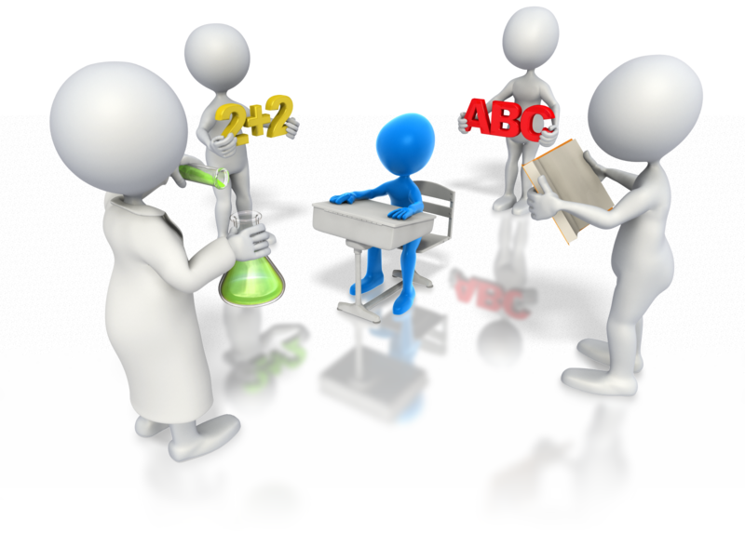
Table of Contents

Unit of Competency 4
Application 4
Performance Criteria 5
Foundation Skills 7
Assessment Requirements 8
1. Develop appropriate settings and environments 10
1.1 – Evaluate and modify the learning environment and materials to support all aspects of children’s learning, and promote opportunities for sustained shared thinking and collaborative learning 11
Learning environment 11
Learning materials 12
Supporting aspects of learning 14
Shared thinking 17
Activity 1A 18
1.2 – Assess and modify the learning environment and materials to ensure that families and the community are respected 19
Respecting families and communities 19
Avoiding stereotypes 20
Activity 1B 22
1.3 – Implement learning environment modifications 23
Modifying the learning environment 23
Activity 1C 25
1.4 – Promote an appreciation of the natural environment 26
Promoting the natural environment 26
Bring the natural environment indoors 26
Activity 1D 28
2. Design and implement curriculum in consultation with others 29
2.1 – Consult with children and families to assist in reflecting on the current curriculum and learning environments and identify current strengths and goals 30
Reflecting on current curriculum and learning environment 30
Activity 2A 32
2.2 – Design and implement curriculum that reflect the philosophy of the service 33
What is curriculum? 33
Designing curriculum 34
Creating contexts for learning and development 36
Activity 2B 41
3. Design learning experiences to foster children’s learning and development 42
3.1 – Collect data on each child 43
Data collection 43
Ethical issues 46
Activity 3A 47
3.2 – Analyse data collected to identify each child’s interests, strengths and goals in conjunction with the approved learning framework 48
Analysing data 48
Identifying interests, strengths and goals 50
Activity 3B 51
3.3 – Clarify specific objectives, learning environment, role of the educator and assessment/evaluation methods and evidence using the approved framework’s learning outcomes, principles and practices 52
Early Years Learning Framework 52
Activity 3C 56
3.4 – Design learning experiences to foster holistic learning and to provide continuity of learning and transitions 57
Holistic learning 57
Continuity of learning and transitions 60
Activity 3D 62
3.5 – Plan for ways to monitor and assess children’s learning, consistent with the principles and practices of the approved framework, ensuring that both planned and unplanned experiences are considered for assessment 63
Monitoring and assessing children’s learning 63
Planned and unplanned experiences 65
Activity 3E 66
4. Implement learning experiences to foster children’s learning and development 67
4.1 – Ensure that required materials are identified and available at time of implementation 68
4.2 – Set up the physical learning environment 68
Required materials 68
Setting up physical learning environment 70
Activity 4A 71
4.3 – Co-construct meaning with children and ensure there are sustained interactions 72
Co-construct 72
Interacting with children 72
Activity 4B 73
4.4 – Model and promote enabling learning dispositions 73
Learning dispositions 74
Modelling and promoting learning dispositions 75
Activity 4C 76
4.5 – Monitor and reflect on children’s learning and own pedagogical practices and continuously refine 76
Monitoring and reflecting on children’s learning 77
Pedagogical practices 77
Activity 4D 79
5. Assess and evaluate planned and unplanned teaching and learning 80
5.1 – Use or establish opportunities to gather feedback from families and children 81
Gathering feedback 81
Activity 5A 82
5.2 – Collect data using a range of methods in order to assess and evaluate teaching and learning, both planned and unplanned, using approved frameworks 83
5.3 – Ensure assessment and evaluation of the curriculum and learning experiences are regular and in accordance with service guidelines 83
Assessing and evaluating teaching and learning 83
Assessing and evaluating the curriculum 84
Activity 5B 85
5.4 – Use assessment and evaluation to influence the design of future curriculum and learning experiences 86
Future design 86
Activity 5C 87
Summative Assessments 88
References 89

Unit of Competency

Application

This unit describes the skills and knowledge required by educators to design, implement and evaluate the curriculum to foster children’s learning and development.
This unit applies to educators working in a range of education and care services.
The skills in this unit must be applied in accordance with Commonwealth and State/Territory legislation, Australian/New Zealand standards and industry codes of practice.
Unit Mapping Information

No equivalent unit.

Performance Criteria
Element  Elements describe the essential outcomes. | Performance Criteria  Performance criteria describe the performance needed to demonstrate achievement of the element.
- Develop appropriate settings and environments | - Evaluate and modify the learning environment and materials to support all aspects of children’s learning, and promote opportunities for sustained shared thinking and collaborative learning  - Assess and modify the learning environment and materials to ensure that families and the community are respected  - Implement learning environment modifications  - Promote an appreciation of the natural environment
- Design and implement curriculum in consultation with others | - Consult with children and families to assist in reflecting on the current curriculum and learning environments and identify current strengths and goals  - Design and implement curriculum that reflect the philosophy of the service
- Design learning experiences to foster children’s learning and development | - Collect data on each child  - Analyse data collected to identify each child’s interests, strengths and goals in conjunction with the approved learning framework  - Clarify specific objectives, learning environment, role of the educator and assessment/evaluation methods and evidence using the approved framework’s learning outcomes, principles and practices  - Design learning experiences to foster holistic learning and to provide continuity of learning and transitions  - Plan for ways to monitor and assess children’s learning, consistent with the principles and practices of the approved framework, ensuring that both planned and unplanned experiences are considered for assessment
- Implement learning experiences to foster children’s learning and development | - Ensure that required materials are identified and available at time of implementation  - Set up the physical learning environment  - Co-construct meaning with children and ensure there are sustained interactions  - Model and promote enabling learning dispositions  - Monitor and reflect on children’s learning and own pedagogical practices and continuously refine
- Assess and evaluate planned and unplanned teaching and learning | - Use or establish opportunities to gather feedback from families and children  - Collect data using a range of methods in order to assess and evaluate teaching and learning, both planned and unplanned, using approved frameworks  - Ensure assessment and evaluation of the curriculum and learning experiences are regular and in accordance with service guidelines  - Use assessment and evaluation to influence the design of future curriculum and learning experiences

Foundation Skills
This section describes language, literacy, numeracy and employment skills incorporated in the performance criteria that are required for competent performance.
Foundation skills essential to performance are explicit in the performance criteria of this unit of competency.

Assessment Requirements
Performance Evidence
The candidate must show evidence of the ability to complete tasks outlined in elements and performance criteria of this unit, manage tasks and manage contingencies in the context of the job role. There must be demonstrated evidence that the candidate has completed the following tasks:
- Designed and implemented curriculum on at least one occasion, including:
- evaluating and modifying environments to enhance opportunities for children’s learning from other educators, children and their families
- gathering information to use as a basis for design to address identified needs
- designing learning experiences to foster children’s development
- assessing and evaluating curriculum and learning experiences in accordance with guidelines
- Performed the activities outlined in the performance criteria of this unit during a period of at least 240 hours of work in at least one regulated education and care service.
Knowledge Evidence
The candidate must be able to demonstrate essential knowledge required to effectively do the task outlined in elements and performance criteria of this unit, manage the task and manage contingencies in the context of the work role. These include knowledge of:
- How to access:
- the National Quality Framework
- the National Quality Standards
- the relevant approved learning framework
- How to navigate through framework and standards documents to find areas relevant to this unit of competency
- How to design programs and environments that foster children’s development
- Evaluation strategies
- Organisation standards, policies and procedures.

Assessment Conditions
Skills must be demonstrated in a regulated education and care service.
In addition, simulations and scenarios must be used where the full range of contexts and situations cannot be provided in the workplace or may occur only rarely. These are situations relating to emergency or unplanned procedures where assessment in these circumstances would be unsafe or is impractical.
Simulated assessment environments must simulate the real-life working environment where these skills and knowledge would be performed, with all the relevant equipment and resources of that working environment.
Assessment must ensure use of:
- National Quality Framework for Early Childhood Education and Care
- The relevant approved learning framework under the National Quality Framework for Early Childhood Education and Care.
Assessors must satisfy the Standards for Registered Training Organisations (RTOs) 2015/AQTF mandatory competency requirements for assessors.
Links
Companion volumes are available from the CS&HISC website - http://www.cshisc.com.au/
Companion Volume implementation guides are found in VETNet - https://vetnet.education.gov.au/Pages/TrainingDocs.aspx?q=5e0c25cc-3d9d-4b43-80d3-bd22cc4f1e53

1. Develop appropriate settings and environments
1.1. Evaluate and modify the learning environment and materials to support all aspects of children’s learning, and promote opportunities for sustained shared thinking and collaborative learning
1.2. Assess and modify the learning environment and materials to ensure that families and the community are respected
1.3. Implement learning environment modifications
1.4. Promote an appreciation of the natural environment


1.1 – Evaluate and modify the learning environment and materials to support all aspects of children’s learning, and promote opportunities for sustained shared thinking and collaborative learning
By the end of this chapter, the learner should be able to:
- Explain how an aspect of children’s learning can be supported by the learning environment and materials
- Identify how the environment and materials of their current workplace support children’s learning and development and how this might be improved
- Explain what shared thinking is and provide examples of how to promote opportunities for this.

Learning environment
Before you take on the challenge of designing and implementing a curriculum, you should ensure that the learning settings and environments are appropriate for the children using your service. A child’s learning environment will be an important influence on their achievement. A child will learn and develop best in an environment that is safe, challenging, stimulating and interesting.
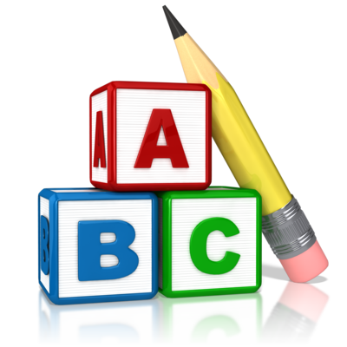
A learning environment is a combination of the social and physical qualities that create a ‘classroom’ experience; whether it’s a nursery setting or a home setting, the same rules apply. Learning environments can refer to physical locations, how the space is organised and furnished and classroom management procedures.
A stimulating learning environment should incorporate a variety of:
- Textures
- Visuals
- Sounds
- Colour.
It is important that a learning environment has enough physical space for all children to move freely and easily, including children with physical challenges. Safety is a priority; a learning environment should be safe for everyone (e.g. you, each child and their families).
In early years learning, characteristics of effective learning include active learning, playing, exploring and thinking critically. Each child’s needs, interests and capabilities should be understood and reflected within the learning environment. It is your responsibility to ensure that the learning environment supports all aspects of the children’s learning.

Aspects of early years learning may include:
- Social and emotional development
- Physical development
- Intellectual development
- Spiritual development.
Based on these aspects, an early years learning environment should offer:
- Learning opportunities through play
- Stimulating resources
- Support for children to take risks and explore.
Ask yourself:
- How does your current working environment support the children’s learning and development?
- Do you have areas for indoor and outdoor play?
- How do you encourage play and exploration?
- How do you encourage independence?

Learning materials
As well as the environment itself, the materials supplied within it should also support the learning and development of the children.
Think about the materials that you have within your current workplace.
They may include:
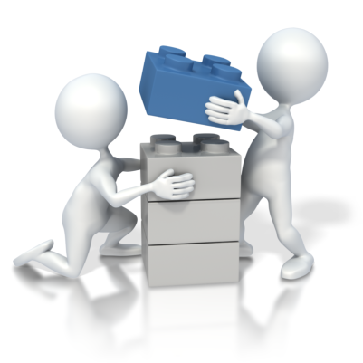
- Books
- Play dough
- Building blocks
- Cars
- Trains
- Puzzles
- Dolls
- Play kitchen
- Art materials.
The materials within a learning environment are used by the children to investigate and explore. You should try and arrange materials in a way that encourages this. Where possible, have duplicate materials. This will avoid arguments and allow children to play together with the same things. Encourage children to learn where to find and put things by labelling everything. Have ‘Books’ written in large letters on the book shelf; you could even put a picture of books next to it for the younger children.
The materials that you have within your workplace should match the stage of development and the age of the children. Are the children babies, toddlers or 3-5-year-olds?
Babies
Appropriate materials and toys may include:
- Rattles
- Stuffed toys
- Simple, colourful books (with round edges)
- Push and pull toys.
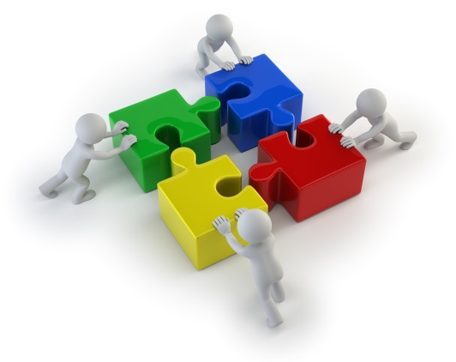
Toddlers
Appropriate materials and toys may include:
- Shape sorters
- Simple puzzles
- Blocks
- Modelling clay
- Picture books
- Musical toys.
3-5-year-olds
Appropriate materials and toys may include:
- Puzzles
- Basic musical instruments
- Modelling clay
- Ride-on toys
- Wooden train sets
- Art materials
- Dress-up clothes
- Basic board games.

Supporting aspects of learning
How can learning environments and materials directly support different aspects of learning?
As we have discovered, children need a learning environment and materials that help them to develop and learn.
As mentioned above, aspects of early years learning may include:
- Social and emotional development
- Physical development
- Intellectual development
- Spiritual development.
Social and emotional development
In order to support social and emotional development, a learning environment should make the children and their families feel welcome, comfortable and safe. The atmosphere should be caring, relaxed and ‘homey’. It is your responsibility to arrange the environment, to ensure the children feel secure and as though they belong.
In order to support each child’s sense of belonging and self-worth, you should have a variety of resources that encourage children to work and play together in groups. This will widen each child’s understanding of who they are and how they can contribute to the world. Children should be encouraged to share toys and take it in turns. Children also need to learn how to control their emotions, and this will increase when they are playing with other children.
Think about how you can encourage participation, interaction and working together, whilst promoting opportunities for collaborative learning within your setting.
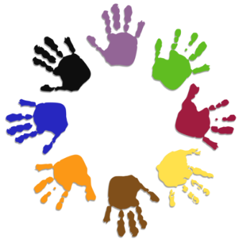
For example, you could:
- Ask children to create a group picture (e.g. painting/drawing)
- Create a group mural including every child’s hand print in their favourite colour
- Get children to work in groups to put on a little play
- Set the group a simple problem that they must work together to solve
- Encourage imaginative play (e.g. play kitchen or dress-up box).

Within this aspect of learning, you should:
- Be responsive
- Excite and engage the children
- Promote self-esteem
- Encourage exploration
- Show an interest
- Provide opportunities
- Help to manage the children’s feelings.
Physical development
The physical aspect of a child’s learning is about using their senses, body and muscles – even just the small muscles. You should provide a learning environment that is safe and has clear limits, allowing children to explore. You should aim to have both indoor and outdoor areas in which children can move around and play.
There are many ways to encourage the physical development of children, including:
- Experiment corners (e.g. digging in the mud or sand)
- Outdoor space for climbing, jumping, running and cycling

- Play areas (e.g. climbing frame, see-saw, slide and swing)
- Music and dance areas
- Building and construction areas.
Even simple tasks and materials can use small muscles in a child’s body, encouraging physical development.
For example:
- Building blocks
- Toy cars
- Dolls
- Painting
- Colouring
- Teapots (e.g. tea parties)
- Dressing-up box
- Puzzles.
Think of ways that you can engage a child’s senses, for example:
- Touching (e.g. feely boxes)
- Smelling (e.g. learning about the garden by smelling flowers)
- Tasting (e.g. trying new fruits and vegetables)
- Listening (e.g. guess the animal noise).
Intellectual development
The intellectual aspect of a child’s learning involves their language and cognitive development, and you can support this by providing rich resources that promote deeper learning and creative thinking. A child’s intellectual development involves how a child organises their thoughts and ideas to make sense of the world. For older children, their learning environment should reflect their own suggestions and interests; let them make choices about their own learning.
The resources should engage children in:
- Discussing
- Exploring

- Reading
- Experimenting
- Constructing
- Imagining
- Representing own understandings.
There are many activities that can support a child’s intellectual development, including:
- Role play games
- Reading/being read to
- Trial and error tasks
- Learning the alphabet
- Listening and questioning activities
- Singing
- Repeating tasks.
Perhaps one child is going on holiday to Spain. You could incorporate this into the daily activities and teach the children about Spain. What foods do they eat? What clothes do they wear? Create a display and get all children involved.
Spiritual development
The spiritual development of a child involves learning about the wonder and beauty of the natural world around us. This will be discussed further in Chapter 1.4.

Shared thinking
Shared thinking is about continually finding a shared interest to find out more. This can be between you and a child or between the children themselves.
There are many ways you can promote opportunities for sustained shared thinking, including:
- Adult modelling/offering your own experiences
- Asking open-ended questions
- Freely chosen play activities
- Asking children to elaborate
- Making suggestions
- Showing genuine interest
- Re-capping and clarifying.
To summarise, a learning environment and the materials within it should:

- Be safe and appropriate
- Encourage thinking critically
- Be challenging and stimulating
- Create opportunities
- Promote shared thinking and collaborative learning
- Reflect each child’s needs, interests and capabilities
- Be interesting
- Encourage active learning, playing and exploring
- Support all aspects of children’s learning.


Activity 1A

1.2 – Assess and modify the learning environment and materials to ensure that families and the community are respected
By the end of this chapter, the learner should be able to:
- Identify things which should be developed in a learning environment which respects diversity
- Provide ways to ensure that the learning environment and materials within this are reflective of the diverse world
- Suggest ways to ensure that the learning environment and materials within it do not display stereotypes.

Respecting families and communities
In the previous chapter, we looked at how a learning environment and the materials within it can support a child’s learning. This chapter will look at how you can ensure that your environment and materials respect the families and communities using the service. A learning environment should value every person regardless of their religious, cultural, economic, linguistic or ethnic background. A child’s learning environment should feel welcoming, while reflecting the diverse world that we live in.
You should look at each child with interest and openness and build the environment around them based on them as an individual, as well as your group as a whole. You should never judge, and each child should feel part of a safe and supportive environment, in which bullying or discrimination is not tolerated. The learning environment should build a level of respect for the culture and communities of everyone using the service. Each child should have access to a nurturing setting that they can thrive within, as well as stimulating resources that are relevant to their family, culture and community.

As an educator, you should aim to learn about each child and their family and community.
Ask yourself:
- What are their beliefs?
- What is their history?
- What clothes do they wear?
- What foods do they eat?
- How can I incorporate this into the learning environment?
Once the children are old enough, you can get them involved in the process. They can learn about other families, whilst sharing information about their own. You could get them all involved in creating a large display that looks at each child’s family and community, getting them to bring photos and symbolic things to add to the display.

Think of the different materials and activities that can reflect diversity, for example:
- A dress-up box with a diverse range of options
- A variety of musical instruments
- A range of foods from around the world
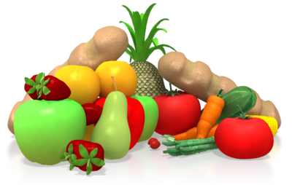
- A selection of artwork
- Cultural trips and visits
- Singing a wide range of songs
- Different cooking and eating utensils
- A selection of puzzles and books
- Recognising appropriate celebrations.

Avoiding stereotypes
Think about the inadvertent ways that the environment and materials can reflect different families and influence the children. Consider the different ways that your environment and materials could be seen as stereotypical.
Your environment and materials should represent diversity within:
- Family structures
- Gender roles
- Cultures
- Daily routines
- Communities
- Body types
- Abilities.
Review the books that the children have access to; do they represent diversity? These books should not be stereotypical and should display a range of cultures, family structures and body types. For example, books should show people of both genders, all ages and within a variety of family structures. Within the real-life play settings that you create for the children (e.g. play kitchen), make sure a variety of cultures are represented. For example, don’t just provide typical Australian utensils and food; introduce a variety of utensils and foods (e.g. chopsticks and plastic exotic fruits). Avoid any images of stereotypical representations of different cultures. For example, Australian people do not all wear cork hats, and Mexican people don’t all wear sombreros and ponchos.
Take care with the language that you use in front of the children. For example, refrain from referring to ‘parents’. Instead, use ‘the grown-up in your home’ or ‘person in charge’. This will ensure that any children whose parents aren’t present will not feel alienated within their learning environment.
A learning environment that respects diversity will develop:
- A child’s self-concept
- Opportunities for introducing activities about diversity
- Positive ideas about self and others
- Fair and inclusive groups
- A child’s positive attitude.

Activity 1B

1.3 – Implement learning environment modifications
By the end of this chapter, the learner should be able to:
- Respond to a range of workplace scenarios, identifying how to implement modifications to the learning environment.


Modifying the learning environment
As we established in Chapter 1.1, a learning environment should be based on a child’s needs and interests, whilst supporting their learning and development. A learning environment should also support the curriculum. This may leave you needing to modify the learning environment in a variety of ways. Whether it is simply getting a specific book for a child or completely rearranging the furniture setup, you will need to implement all necessary modifications.
Does the environment have resources that will interest each child? Are these resources accessible? Does the environment have defined areas (e.g. for play, sleep and work)? If not, how can you modify your environment? For example, if a child has developed an interest in trains, you could get books about trains to add to your shelves or baskets. You could also introduce a variety of wooden train tracks into the play area. You should also think about the location of the resources; can each child get what they want easily? For example, are your bookshelves at a height that allows a child to choose their own book?
Does the environment have the necessities? Do the children have appropriate toilet facilities? Do you have somewhere appropriate for them to eat? Have you got the appropriate space for them to take a nap if they need to? Do you have both active play areas and quiet play areas?
You will also need to consider children with additional needs when modifying your environment. If one of the children is a wheelchair user, what modifications will need to be implemented? You may need to add a ramp to the entrance, rearrange the layout so that they can move through easily or introduce different outdoor games so that they can be involved. Children with visual impairments may need books in braille or large letters. What about children with an attention problem? How can you minimise distractions?
What if a child is currently being breastfed and the mother would like to come in to do this? Do you have a specific area in which she can do this? Is it private? Maybe one of the children needs daily medication. Do you have an area in which they can have this privately and safely?

General tips for modifying a learning environment:

- Have clear, defined areas for different activities (e.g. play/work/eat/sleep)
- Allocate places for different materials and toys within the correct areas
- Ensure that these resources are accessible by everyone
- Consistently return materials to its correct space
- Arrange furniture safely (e.g. not placed haphazardly)
- Avoid clutter
- Use curtains and blinds to control light.

Activity 1C

1.4 – Promote an appreciation of the natural environment
By the end of this chapter, the learner should be able to:
- Identify reasons why children should have a stimulating outdoor environment
- Provide examples of things which can be incorporated into a child’s outdoor area
- Suggest ways to bring the natural environment indoors.

Promoting the natural environment
It is not only the indoor environment that is important for children; children will benefit from a stimulating outdoor environment too. The natural environment can support the spiritual aspect of a child’s learning (refer to Chapter 1.1). You should strive to provide a learning environment that is balanced between an indoor and outdoor setting. The natural environment gives the children the opportunity to interact with nature and provides them with a range of sensory experiences. When thinking of outdoor play, don’t assume children just want a climbing frame and a swing; children want to learn about the world around them. Their natural environment offers multi-sensory experiences, and they can observe, touch, smell and hear a variety of new and exciting things.
You should aim to incorporate many things in their outdoor area, for example:
- Plants and flowers (e.g. teach children about different plants and flowers – get them involved in planting and growing them)
- Water (e.g. get a paddling pool)
- Sand (e.g. have a sandpit in which children can have fun and explore)
- Dirt (e.g. create an outside ‘kitchen’ – have pots and pans for children to play with mud and make mudpies.

Think about the different ways that you can incorporate nature into trips for the children. An interest in sand could inspire a trip to a nearby beach, and an interest in trees and leaves could inspire a trip to nearby woodlands.

Bring the natural environment indoors
As well as providing children with an outdoor environment, you should think about the different ways that you can incorporate the outdoor environment and natural materials into the indoor learning environment. Not only should children be able to play outdoors, but they should also be able to learn about the outdoors. By incorporating the natural world into the indoor learning environment, children will develop a strong appreciation of nature.
Think of the different aspects of the natural environment that can create possibilities for learning, for example:
- Rainbows
- Clouds
- Puddles
- Shadows
- Water
- Plants and flowers
- Animals, insects and birds
- Fruits and vegetables.

Children are fascinated by new things. When a rainbow appears, take the opportunity to teach the children about it. Take them outside to take photographs of it. You can then create an activity around it, getting the children to draw or paint a rainbow. You could even develop it into a new display. Embrace nature; when it rains, get the children to put their wellies on and go outside to splash in the puddles. You should strive to get the children interested in nature. You could create a little vegetable patch for them to grow their own fruit and vegetables. You can then use these ingredients to get children interested in growing and preparing healthy foods. You could introduce a pet for the children, even if it’s just a fish, a rabbit or a hamster. This will open up new interests and help to develop a sense of responsibility. You could have a rota that allows children to take it turns to feed the animal. You could also create a learning experience involving water. Have a bucket of water and a range of different objects and get children to guess whether it will sink or float.
You could put a basket together that includes various natural resources, for example:
- Stones
- Feathers
- Pine cones
- Shells
- Twigs
- Leaves.
These can then be used by the children to create artwork. They could make pictures of a tree using actual twigs and leaves. You could even make it a group project and create a ‘nature’ display, incorporating many natural resources.

Activity 1D

2. Design and implement curriculum in consultation with others
2.1. Consult with children and families to assist in reflecting on the current curriculum and learning environments and identify current strengths and goals
2.2. Design and implement curriculum that reflect the philosophy of the service

2.1 – Consult with children and families to assist in reflecting on the current curriculum and learning environments and identify current strengths and goals
By the end of this chapter, the learner should be able to:
- Identify the methods used to consult with children about current curriculum and learning environments
- Identify the methods used to consult with families about current curriculum and learning environments
- Identify the strengths of the curriculum and learning environment based on past findings
- Provide an example of a weakness found and explain how the new curriculum can be developed to improve this weakness.

Reflecting on current curriculum and learning environment

According to The Early Years Learning Framework, curriculum is the interactions, experiences, activities, routines and events (planned or unplanned) that occur in an environment designed to foster children’s learning and development. The curriculum will provide a range of different learning opportunities for the children within your service. Before developing a new curriculum, you will need to reflect on the current curriculum and learning environment. You may need to consult with the children and their families to assist you in this process. How could you do this? Families should feel as though they can approach you with any ideas regarding the curriculum. From the start, you should make it clear that you welcome opinions and suggestions; encourage families to work with you to provide the best possible learning environment for their child.
There are many ways to gather opinions and feedback from families, including:
- Monthly meetings (one-to-one or as a group)
- Having a suggestions box
- Sending out forms
- Making phone calls
- Sending out emails.
Gathering the opinions of the young children within your service can be more complicated. Simply asking the children can be appropriate in some cases, but not in others. You should aim to come up with a system that allows the children to express their feelings regarding their daily activities and the environment in which they are carrying them out. You could create a daily list of everything that you have done with the children and ask them to draw a smiley face if they enjoyed it and a sad face if they didn’t. Keep these safe and refer to them when it comes to reflecting on the current curriculum. You could also hold a monthly group meeting with the children, asking them what new things they would like to see within the environment or new things they would like to learn about. You will be able to see what children enjoy, what they don’t enjoy and new things that they want to learn about. Along with the feedback from their families, the children’s opinions can be taken into consideration when designing and implementing the new curriculum.
After reflecting on the current curriculum and learning environments, you should be able to identify the current strengths and goals; what’s working and what isn’t? This will be a good starting point for designing your next curriculum. The strengths that you have identified can be built on for the new curriculum, and any weaknesses can be turned into goals. For example, if a few children have expressed that they would like to go on more day trips, you could create a goal for arranging a monthly trip that is related to the current stage of learning and the children’s interests. If children are not enjoying the current mathematics activities that you are doing, you can focus on creating new ways to teach them mathematics. If families are concerned that the children spend too much time indoors, you can develop the curriculum to facilitate outdoor play and learning. You can think of ways to take the learning environment outside.

Activity 2A

2.2 – Design and implement curriculum that reflect the philosophy of the service
By the end of this chapter, the learner should be able to:
- Identify factors that a curriculum should involve
- Give examples of theories that a curriculum could refer to.

What is curriculum?
The information regarding designing and implementing a curriculum is extensive. This chapter aims to provide you with the basics, along with areas you can explore through your own research. As we established in the previous chapter, curriculum is the interactions, experiences, activities, routines and events (planned or unplanned) that occur in an educational environment. The curriculum will provide a range of different learning opportunities for the children within your service. The curriculum should be divided to represent the sum of a child’s experiences and should support the early learning goals for children’s learning. It is important that the curriculum that is designed and implemented reflects the philosophy of the service. Think about your own service; what is the philosophy? It could refer to providing a safe, challenging and supportive environment for each child and their families. How can you design curriculum that reflects this?
The curriculum must:
- Be based on the children’s needs and interests

- Promote health and safety of children
- Be enjoyable
- Be appropriate for the children involved (e.g. ages and stages of development)
- Encourage equality of opportunity
- Cover all aspects of a child’s learning and development
- Allow for spontaneity
- Involve parents, visitors and other professionals
- Refer to the early learning goals
- Support needs (e.g. special educational needs)
- Be varied.

A curriculum should refer to relevant theories, for example:
- Critical theories
- Post-structuralist theories
- Development theories
- Socio-cultural theories
- Socio-behaviourist theories.

Designing curriculum
A quality early years curriculum should engage the hearts, minds, bodies and spirits of each child. The Early Years Learning Framework suggests that curriculum decision-making is an ongoing cycle. In order to design the curriculum for your service, you will need to develop an understanding of the children. A holistic curriculum should be the starting point, engaging the children with learning as a whole. From this, you can respond to the children’s interests and ideas to provide further support and learning. The curriculum will depend on the age of the children within your service. The process of planning your curriculum will depend on your particular setting, but it should be made up of many tasks, involving the children and their families. Using the strategies discussed in Chapter 2.1 you can learn from the children and their families, using the information to create a stronger curriculum. At the end of the planning process, you should have a plan that will guide the activities within your service. Remember the importance of the early years curriculum; it lays the foundation for the children’s future.
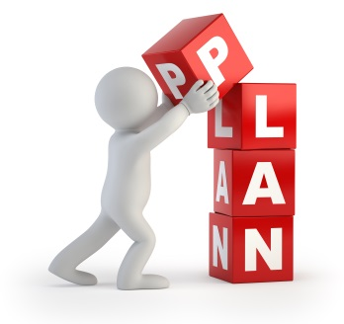
The different approaches to planning curriculum include:
- Structured
- Unstructured
- Experiential
- Thematic.
There are three stages of curriculum planning:
- Long-term planning
- Medium-term planning
- Short-term planning.
According to the Early Years Curriculum Guidelines, there is a framework that can help guide the development of the curriculum and learning.

This framework includes:
- Key components
  - understanding children
  - building partnerships
  - flexible learning environments
  - contexts for learning
  - what children learn
- Interactive processes for curriculum decision making

  - planning
  - interacting
  - monitoring and assessing
  - reflecting
- Contexts for learning
  - play
  - real-life situations
  - investigations
  - routines and transitions
  - focused learning and teaching
- Early learning areas
  - social and personal learning
  - health and physical learning
  - language learning and communication
  - early mathematical understandings
  - active learning processes

- Phases that describe children’s learning and development
  - becoming aware
  - exploring
  - making connections
  - applying.
More information can be found at Early Years Curriculum Guidelines: https://www.geteduca.com/frameworks/early-years-learning-framework/ (Accessed 08.02.2018)
Let’s take a look at an aspect of the framework in more detail; contexts for learning and development.

Creating contexts for learning and development
It is your responsibility to create opportunities for the children to learn within each of the five main contexts. A balanced curriculum will provide daily opportunities for the children to participate in each context. Children may engage in these contexts indoors or outdoors, individually, in small groups or as a whole class.
The five main contexts are:
- Play
- Real-life situations
- Investigations
- Routines and transitions
- Focused learning and teaching.
Play
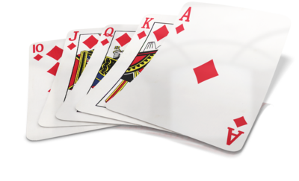
Play is important in an early years learning environment; it supports a child’s learning and development. Play encourages children to express themselves, develop an enquiring mind and develop physical awareness and gross motor skills. Carefully structured play will encourage a child’s communication, discovery, imagination and creativity.
What else can be learnt through play?
- Literacy and numeracy skills
- Problem-solving strategies
- Oral language capabilities
- Personal identities
- Sustained concentration.

Play can take many forms, for example:
- Physical (e.g. moving through obstacle courses)
- Exploratory (e.g. looking through a magnifying glass)
- Socio-dramatic (e.g. using plastic food to play shops)
- Fantasy (e.g. creating own props for pretend adventures)
- Games with rules (e.g. card and board games)
- Manipulative (e.g. making beaded necklaces).
Real-life situations
Real-life learning situations can provide children with the opportunity to build connections between their home, the community and their learning experiences. Connections can be built by inviting family and community members into the learning environment to share their experience and knowledge with the children. These real-life situations allow you to demonstrate how, where and why people use literacy, numeracy and spoken language in everyday life. When planning these learning experiences, you should draw on the cultural diversity within the group of children.
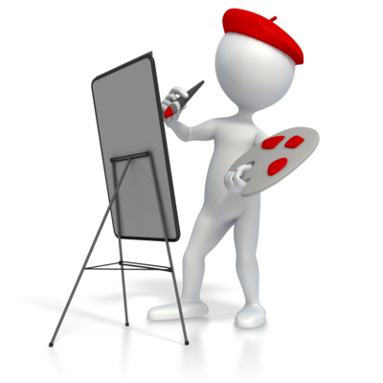
There are many ways to incorporate real-life situations into the curriculum and learning environment, including:
- Gardening activities
- Cooking activities
- Conducting experiments
- Talking to visitors (e.g. family or community members)
- Searching the internet
- Reading and writing for real-life purposes
- Trips and visits into the community
- Making artworks.
Investigations
By incorporating investigations into the curriculum, children will be given the opportunity to inquire, explore and test ideas. Investigations can often stem from the questions that the children ask, their ideas and their areas of curiosity.

In the early stage of learning, investigations provide many opportunities, including chances to:
- Investigate different environments
- Explore different ways to communicate
- Experiment with mathematical, technological, artistic and scientific ideas.
Examples of investigations may include:
- Using books to read about a favourite topic
- Exploring how sound is created using vibrations
- Creating maps and diagrams
- Examining features and characteristics of different environments
- Experimenting with different art materials and processes
- Constructing a play space
- Asking questions and finding the answers.
Routines
The routines within a child’s learning environment will differ from those at home. Children will need to develop a familiarity with their new routines; they will need to know when it is tidy-up time, meal time, toilet time and relaxing time and how to behave appropriately. Routines are an important part of the curriculum, and they should take each child’s diverse needs into consideration.
Routines require children to:
- Take turns
- Be independent
- Be responsible
- Develop their understanding.
Transitions
Transitions are about facilitating the children’s gradual movement through different learning contexts whilst providing learning experiences. For example, you may use a musical game that takes children from a group exercise to their meal time. Transitions should be considered and planned carefully in order to make them a meaningful part of the curriculum.

Transition times can be used to:
- Recall information
- Introduce new concepts
- Think about patterns
- Think about relationships
- Share personal knowledge.
Once you have designed the curriculum, it is then time to implement it. You will need to think about your curriculum and plan your daily activities according to it. How will you incorporate each aspect into your daily plan?
Your daily activities will vary depending on the children’s ages, their abilities and the philosophy of your service.
Here are some example activities:
- Simple bingo – in a 3x3 grid get children to write numbers 1-9 in a jumbled up order, call out numbers in a random order and the first child to cross off a line or column wins a prize (e.g. picks the story to read that day)
- Name game – write each child’s name on card and get them to copy it; make this fun by making it into an art project with different colour and glitter
- My favourites – collect a variety of magazines and get the children to create a collage of cut-outs of the different things they like
- The alphabet song – involve the children in creating their own song to learn the alphabet; make picture cards with items that begin with that letter as extra aids (e.g. A is for apple)
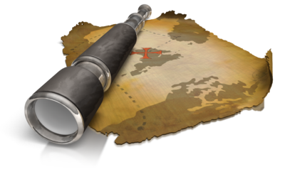
- Treasure hunting – this is a good idea at Easter time; hide treats around the learning environment and draw up little treasure maps for the children.
It is important to take your own beliefs into consideration when designing the curriculum. By understanding this, you can understand why you make certain decisions. Think about everything that stems from the curriculum and how you can ensure your beliefs don’t influence any decision-making.

You will make many decisions regarding the curriculum, including:
- Content; the things you are going to teach
- How you set up your environment
- What resources you choose
- The approaches that you use for managing behaviour
- The teaching strategies that you will use.

Activity 2B

3. Design learning experiences to foster children’s learning and development
3.1. Collect data on each child
3.2. Analyse data collected to identify each child’s interests, strengths and goals in conjunction with the approved learning framework
3.3. Clarify specific objectives, learning environment, role of the educator and assessment/evaluation methods and evidence using the approved framework’s learning outcomes, principles and practices
3.4. Design learning experiences to foster holistic learning and to provide continuity of learning and transitions
3.5. Plan for ways to monitor and assess children’s learning, consistent with the principles and practices of the approved framework, ensuring that both planned and unplanned experiences are considered for assessment

3.1 – Collect data on each child
By the end of this chapter, the learner should be able to:
- Give examples of information they might want to find out about each child
- Identify the five learning outcomes that the Early Years Learning Framework describe as the key reference points when collecting data.

Data collection
The Early Years Learning Framework refers to ‘reflective practice’ – it is a form of ongoing learning. Its intention is to gather information and insights that assist and support the decision-making process regarding children’s learning. In order to ensure that the learning environment and experiences are relevant and appropriate for each child, it is essential to gather data on each child within your service. This data will enable to plan an appropriate curriculum that fulfils the needs of each individual. Think about your current workplace; what data do you collect and how do you do it?
There is a variety of information that you may want to find out about each child, for example:
- What they do and don’t enjoy learning about
- The new things that they would like to learn about

- What toys they like and don’t like playing with
- The new toys that they would like to play with
- What they are good at
- What they struggle with
- How they learn best
- How they interact with the other children
- What their family life is like
- Any particular interests.
The Early Years Learning Framework outlines that the five learning outcomes can be used as the key reference points when collecting data and information.

These learning outcomes are:
- Children have a strong sense of identity
  - do children explore aspects of identity through role play?
- Children are connected with and contribute to their world
  - do children display an interest in learning about the world around them?
- Children have a strong sense of well-being
  - can children make choices and accept challenges?
- Children are confident and involved learners
  - do children continue with tasks even if they are finding it difficult?
- Children are effective communicators
  - are children able to convey and construct verbal messages?
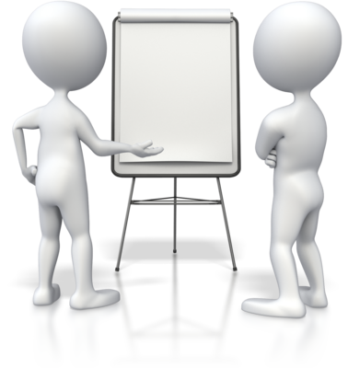
Now, let’s consider the ways in which you can gather your information. There are many ways that you can do this; a combination of quantitative and qualitative methods will provide you with an accurate picture.
For example:
- Discussing with families
- Asking children themselves
- Observing children.
Discussing with families
A child’s first carers and educators are their family; they know their child better than anyone. Therefore, it is a good place to start when gathering data on a child. You should encourage families to share any details that can help you to give their child a better experience.

In order to find out what you need to know, you could:
- Hold regular meetings
  - ask families how they think their child is getting on – have they expressed a particular like or dislike?
- Set up a forum for families to use
  - a forum that you can oversee may highlight areas that you would never think of – common dislikes amongst children can be dealt with
- Make regular phone calls
  - make families aware that you care about their child – ask them if they are having any difficulties that you could help with
- Create notice boards
  - invite families to share photos and notes about their child’s new interests on a communal notice board.
By discussing a child with their families, you can gain an insight into their family life. Ask to be kept up-to-date with their progress at home in order to continue this within your service. Consider creating a diary for each child; both you and their family can add notes into it daily.
Asking children themselves
A good way to find out how a child feels about their learning environment and what they do and don’t like is to simply ask them. This may take more sensitivity than when you are asking their families; children sometimes don’t know how to express themselves verbally. There are other ways to get a child to show you what they think. For example, you could give each child a disposable camera and ask them to take pictures of the things they do and don’t like within their learning environment. After they are developed, get the children to make a folder and arrange their photos into likes and dislikes.
You could also arrange a group activity in which you get them to draw a smiley face on a piece of card and a sad face on another piece of card. You can then talk about what you have done recently and ask them to show their smiley face if they enjoyed it or their sad face if they didn’t.
Observing children
Observation is the key to understanding each child as a learner. An issue with asking the children themselves is that young children can often have difficulty in expressing themselves verbally. If this is the case, you could observe the children in their daily activities to further support what they have told you. Observation can involve watching children’s actions, behaviours, gestures and expressions. You could observe them in their day-to-day interactions, watching where they go, what they play with and who they play with. If this matches what they have told you, you have solid data. Wherever possible, you should record what you have observed so that you can return to it at a later date. Sometimes, you may need to join in with their activities, asking and responding to questions wherever necessary. When observing children, remember it requires a respectful and sensitive approach to the children’s play.
Observation should be something that becomes second nature to you as a practitioner. Even if you are not recording what you are seeing, you should develop the ability to document significant information you notice throughout each day. Observations should take place every day, everywhere. By observing the children in a range of contexts, a more accurate picture will be outlined. Many observations happen incidentally; these can offer useful insights into a child’s learning to take any opportunities that arise.

Ethical issues
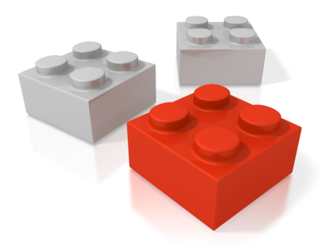
When observing children in their daily activities, you should be aware of the ethical tensions surrounding the process. You should always strive to take the necessary steps to ensure confidentiality and privacy, whilst considering the perspective of each child. A child’s family have a right to know if their child is being observed or if information is being collected within the service. They should also be aware of why it is being collected and how it is going to be used. You can provide this information when they first enrol their child, gaining written consent that they will allow it. Depending on the age of the child, you should also do your best to gain their consent. Explain to them what it is that you are doing in a way that they understand. If you need to take photos, ensure that you ask them that it is okay to do so.

Activity 3A

3.2 – Analyse data collected to identify each child’s interests, strengths and goals in conjunction with the approved learning framework
By the end of this chapter, the learner should be able to:
- Refer to a time when they have collected data on children in their workplace and summarise what they found in terms of the child(ren)’s interests, strengths and goals.

Analysing data

All of the information that you gather regarding the children in your service will need to be manageable. Think about how you can store this information. You could create a portfolio for each child containing the observations, photos and notes concerning them. Think about combining the information that their family gave you, what they told you themselves and what you have observed. You could then put together a whole portfolio that summarises each child’s portfolio in one large document.
The information that you collect may tell you many things, including:
- That you need to adjust interaction styles
- That you need to introduce new experiences
- That you need to change the routine
- That you need to rearrange the environment
- Areas of interest that you can follow up
- Areas of weakness that you can work on to improve.
Gathering the information is not enough; it is only the first stage in understanding children. It needs to be used correctly in order to create opportunities for the children’s learning and development. The combination of gathering and analysing information can be referred to as ‘assessment for learning’. To use the information that you have gathered, you need to analyse it first. This analysis should be in conjunction with the Early Years Learning Framework and should reflect on what you found and what you could change to improve the children’s experience. This reflection involves examining all the information that you have gathered and asking yourself a range of questions.

These questions may include:
- What are my understandings of each child?
- What theories, philosophies and understandings shape and assist my work?
- Who is advantaged when I work in this way? Who is disadvantaged?
- What questions do I have about my work? What am I challenged by? What am I curious about? What am I confronted by?
- What aspects of my work are not helped by the theories and guidance that I usually draw on to make sense of what I do?
- Are there other theories or knowledge that could help me to understand better what I have observed or experienced? What are they? How might those theories and that knowledge affect my practice?
Questions taken from the Early Years Learning Framework: https://www.acecqa.gov.au/sites/default/files/2018-02/belonging_being_and_becoming_the_early_years_learning_framework_for_australia.pdf (Accessed 08.02.2018)
In the previous chapter, we looked at three different ways to collect data about the children; discussing with the children’s families, asking the children themselves and observing the children. If you have gathered information in all three ways, you will need to analyse the information together. Do your findings from each method support each other?
Elsie’s example
From the day Elsie started at your service, you have implemented a ‘daily diary’ system. In this diary, you add notes each day regarding what she has done that day. For example, ‘Elsie counted to five today’ or ‘Elsie wrote her name today’. To this diary, her parents can add notes about what Elise does and says at home. For example, ‘Elsie told us she had lots of fun skipping with Amy today’ or ‘Elsie mentioned she struggled with the alphabet today’.
You also hold monthly family meetings, inviting Elsie’s parents to discuss her progress. You have had meetings with Elsie’s parents and have kept a record of what was discussed. For example, in the most recent meeting, Elsie’s parents talked about how she seems to have made more friends and talks about the service all the time. She seems to be really enjoying it. She is practising her counting at home but is struggling with the alphabet.
You have also been observing Elsie within her daily activities, interacting with her and asking her relevant questions. You have noticed that she chooses to play with the skipping ropes regularly, usually with Amy. Elsie tends to daydream when learning about the alphabet but is very keen when the group are counting. She also particularly enjoys playing in the sand pit, but hates mud. When asked what she likes to do, Elsie refers to skipping with Amy, running, singing, counting and drawing. When asked what she doesn’t like to do, she refers to reading and learning the alphabet.
By combining all of the information that you have collected, you will be able to work out Elsie’s interests, strengths and weaknesses.

Identifying interests, strengths and goals
After analysing your information, you should be able to identify each child’s interests, strengths and weaknesses (turned into goals). The Early Years Learning Framework suggests that educators need to be responsive to each child’s interests, abilities and strengths. The information that you gather can assist you in designing and implementing the curriculum to reflect these interests, abilities and strengths. After examining your findings, you should be able to generate new ideas and improvements.
Refer back to Elsie; what do the findings indicate? We know that Elsie’s interests seem to be skipping, counting, singing and drawing. The information highlights that Elsie is good at counting but struggles with the alphabet. So, how can you use this information to improve Elsie’s learning experience? You could incorporate an alphabet song – she likes singing. This may help her with her alphabet. You could even integrate this alphabet song into skipping. This would hopefully make the alphabet more enjoyable for Elsie.

Activity 3B

3.3 – Clarify specific objectives, learning environment, role of the educator and assessment/evaluation methods and evidence using the approved framework’s learning outcomes, principles and practices
By the end of this chapter, the learner should be able to:
- Summarise the learning outcomes, principles and practices of the Early Years Learning Framework
- Explain how they use the learning outcomes, principles and practices to develop objectives
- Explain how their learning environment takes the learning outcomes, principles and practices into account
- Outline the role of an educator and identify how this relates to the learning outcomes, principles and practices.

Early Years Learning Framework
Although the Early Years Learning Framework is not a model, a syllabus or curriculum itself, it provides you with a framework of outcomes, principles and practices that you can use to make decisions and build your own curriculum. Let’s take a brief look at these learning outcomes, principles and practices.
Learning outcomes
These learning outcomes aim to capture the complex learning and development of all children. They are observable and acknowledge that children develop in a variety of ways.

As established in Chapter 3.1, the learning outcomes are:
- Children have a strong sense of identity
- Children are connected with and contribute to their world
- Children have a strong sense of well-being
- Children are confident and involved learners
- Children are effective communicators.
Principles and practices
The relationship between principles and practices is dynamic; what you do will affect what you believe/think and what you believe/think will affect what you do.

These principles and practices are founded on the beliefs that:
- Children are capable and competent
- Children actively construct their own learning
- Learning is dynamic, complex and holistic
- Children have agency. They have capacities and rights to initiate and lead learning and be active participants and decision makers in matters affecting them.
The principles underpin the practices that are focused on assisting each child to make progress in relation to the learning outcomes.
These principles include:
- Secure, respectful and reciprocal relationships

- Partnerships
- High expectations and equity
- Respect for diversity
- Ongoing learning and reflective practice.
Practices are there for educators to draw on to promote learning and include:
- Adopting holistic approaches
- Being responsive to children
- Planning and implementing learning through play
- Intentional teaching
- Creating physical and social learning environments that have a positive impact on children’s learning
- Valuing the cultural and social contexts of children and their families
- Providing for continuity in experiences and enabling children to have successful transition
- Assessing and monitoring children’s learning to inform provision and to support children in achieving learning outcomes.
Using these learning outcomes, principles and practices from the Early Years Learning Framework, you will need to clarify your own specific objectives, learning environment, role of educator and assessment/evaluation methods and evidence. This chapter will provide an overview of these areas; you may need to think specifically about your own workplace.
Objectives
When creating the objectives for your particular service, you should consider the aspects of the Early Years Learning Framework. How can you incorporate them into your objectives?
Common objectives include developing:
- Reading and writing skills
- Language and communication
- Social skills
- Attention skills
- Well-being
- Positive attitudes
- Creativeness
- Fine and gross motor skills
- Knowledge and understanding of the world
- Mathematics skills.
Learning environment
A learning environment is an important influence on a child’s achievement and refers to the combination of social and physical qualities that create a ‘classroom’ experience. A learning environment is the sum of the emotional environment, the indoor environment and the outdoor environment.
Think about how the learning environment can support a child’s learning; it should:
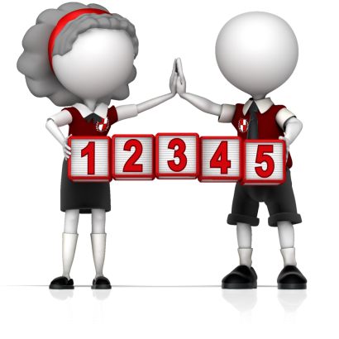
- Have enough space
- Be welcoming
- Cater for different learning styles and capacities
- Invite children and families to contribute questions, ideas and interests
- Enable exploration
- Be safe
- Encourage play-based learning.

Learning environments were discussed in depth in Chapter 1.1. You should think about how you can incorporate the framework’s learning outcomes, practices and principles when creating your learning environment.
Role of educator
Keeping the learning outcomes, practices and principles in mind, think about your role as an educator. What does it involve?
For example, an educator will need to:
- Develop a partnership with each child’s family
- Be responsive to each child’s strengths, abilities and interests
- Build on each child’s existing knowledge and skills to enhance learning
- Be culturally competent.

Assessment and evaluation
You need to have measures in place for you to assess how well each child is doing. This information can be used to keep improving the learning experience. What can the children do and what do they know? The purpose of an early years setting is to prepare each child for education. How can you tell if you have achieved this? You can use the objectives (discussed earlier) to assess children. For example, how can you assess whether they have developed the sufficient reading and writing skills? Can they write their name? Can they write all the letters in the alphabet? Can they write numbers 1-10? Can they read the simple labels when putting their toys away? Can they read the appropriate level of book?
You could also use the methods discussed in Chapter 3.1 to assess the children’s abilities. A combination of observing them, asking them questions and consulting with their family should provide you with an overview of how they are getting on.
The information in this chapter was taken from:
Early Years Framework: https://www.acecqa.gov.au/sites/default/files/2018-02/belonging_being_and_becoming_the_early_years_learning_framework_for_australia.pdf (Accessed 08.02.2018)

Activity 3C

3.4 – Design learning experiences to foster holistic learning and to provide continuity of learning and transitions
By the end of this chapter, the learner should be able to:
- Design and plan a learning experience and:
  - describe this learning experience
  - outline how it will foster holistic learning
  - outline how it will provide continuity of learning and transitions.

Holistic learning
What is a learning experience?
A learning experience is any interaction or experience in which learning takes place, whether it is traditional or untraditional. Regardless of whether it is formal or informal learning, this particular interaction or experience should result in a change in behaviour, thinking or understanding.
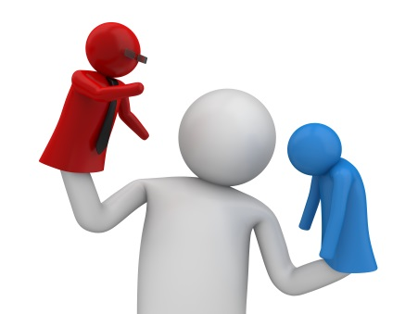
You will need to design learning experiences to foster holistic learning. Holistic learning is a process that can enable children to learn more effectively. Rather than forcing learning, the goal of holistic learning is to create webs of information that link together, constructing an underlying understanding. This process of learning involves merging the things that you are learning into everything that you already understand. In an early years learning environment, a holistic approach to learning involves focusing on the complete physical, emotional and psychological well-being of a child, rather than the traditional milestones of academic development. The connectedness of the mind, body and spirit is recognised within a holistic approach to learning, along with the importance of a connection between the children, their families and their community. Educators should also strive to develop a child’s understanding of and respect for the natural environment.
Holistic learning takes the focus away from learning numbers, colours and shapes academically and aims to uncover these understandings through daily interactions and natural discoveries.
Along with the cognitive aspects of learning, holistic learning pays attention to a child’s:
- Spiritual well-being
- Personal well-being
- Social well-being
- Physical well-being
- Emotional well-being.
Young children learn best through hands-on experiences that offer them the opportunity to explore, discover and investigate the world around them based on their own interests. How can you design learning experiences that give the children the opportunities that they need?

There are many ways that you can design learning experiences to foster holistic learning within your own environment. This chapter will look at a range of examples, but you should consider your own learning environment and experiences.
Art activities
Whether it’s painting, drawing or sticking, children love to get messy. You can design activities to incorporate art activities whilst providing opportunities for the children to learn and develop too. Think about the physical benefits of art activities. Holding brushes and pencils, spreading glue, cutting out shapes and sprinkling glitter can help with a child’s spatial awareness, fine motor control, hand-eye coordination and accuracy.
Art activities give you a chance to introduce new and different areas of learning for the children to explore. For example, rather than simply asking them to draw a picture, you could take the children outside to look at nature. They could take their pencil and sketch book with them and draw flowers, clouds or trees. You could also introduce things like the alphabet into art activities and make it more fun to learn. Each child could be responsible for their own letter to draw on a piece of card, colour it in and add a picture that starts with their letter. These cards can then be used as a learning tool. By simply adding colours, pictures and glitter, children will become enthusiastic about their ABCs.
Imaginative play
Whatever type of imaginative play the child participates in, they are demonstrating that they can use their language and imagination to think and remember what has happened in particular situations. If a young girl is playing in the ‘home’ corner, she will probably be imitating what she has seen her mother do at home.
Imaginative play can help a child to develop:
- Social skills
- Counting
- Pre-reading skills
- An ability to express feelings and emotions
- Hand-eye coordination.

How can you encourage imaginative play?
It could include:
- A dress-up box
- A ‘home’ corner (e.g. a play kitchen)
- A play house
- A ‘shop’ with tills and toy food
- A telephone
- Puppets
- Dolls and prams
- Toy cars and trains.
Physical play
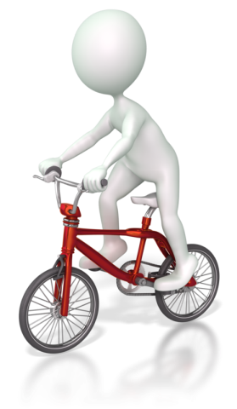
As a young child, it is important to develop fundamental movement skills. Physical play can be a key part of this development as it can help to produce muscles, spatial awareness, balance, strength, confidence and coordination.
Physical play can also include:
- Follow the leader
- Skipping
- Hop-scotch
- Hide-and-seek
- Climbing
- Kicking, throwing and catching balls
- Dancing
- Cycling.
Physical play can also involve less-physical activities that help to develop fine motor skills.
For example:
- Doll houses
- Cars and trains
- Lift-up books
- Dressing dolls and action figures
- Building blocks.
The development of fine motor skills is needed for children to become competent in many areas of life, including using cutlery, turning the pages in a book and writing.
By looking at the range of examples above, you can see that everything entwines. Different activities benefit children in a range of ways. These activities demonstrate a holistic learning experience.

Continuity of learning and transitions
Continuity of learning refers to an uninterrupted flow of learning, and it is essential in order to provide a sense of stability for the children. Although it can be difficult in a busy learning environment, designing learning experiences that foster the continuity of learning is essential. You need to provide children with connected learning, and in some cases, a routine will make this difficult. Although children need a routine, a routine that is too rigid can affect their learning in a negative way. Repetition is the key to continuity of learning. Repeated opportunities to develop skills, use resources and engage with new ideas will result in more meaningful learning for the children.
In order to foster continuity of learning, you should:
- Have a daily schedule/routine (but not too rigid)
- Allow for extended blocks of uninterrupted time to engage in learning experiences
- Create opportunities for children to go back to something they were doing
- Ensure careful transition between learning stages.
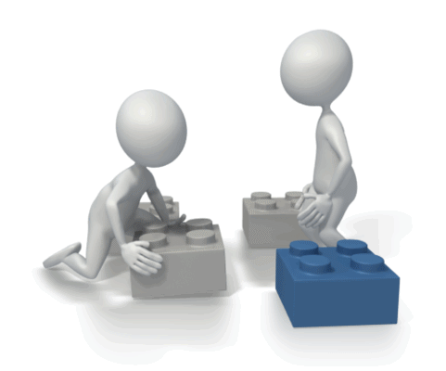
Although some change is important in early years learning to keep the children interested, too much change can reduce the chance they have to re-engage with things and master them. Children should be able to decide when they are finished with something and whether or not they want to continue with a task. Think about the different ways that you can encourage this. Although it is not always possible, a ‘don’t pack away corner’ allows children to leave their unfinished work in a safe place so that they can come back to it if they want to. This will promote continuity of learning and encourage children to take on more complex tasks. If a child knows that they will only have 30 minutes to play with something, they are unlikely to try anything complex. More enthusiasm and energy towards a task will be present if a child knows that they can start something and return to it later. If leaving things out is not an option, think about taking photos of the children’s work to prompt them when they return back to that task.
As an educator, you will need to develop the skills needed to recognise and select the materials and experiences that can foster continuity of learning. You need to encourage meaningful learning as an ongoing process. How can you make the learning experiences rewarding, interesting and engaging?
Examples of learning experiences that create endless possibilities and promote continuity of learning include:
- Sand pit
- Water
- Blocks
- Drawing
- Painting.
The examples above are experiences that give children repeated chances to use them. This means they can quickly develop competence in these areas, developing the ability to use them to express their more complex ideas.
The learning experiences should also provide a continuity of transitions, making it as easy as possible for children to go through the various types of transitions that they face in early childhood education.
Examples of the different transitions that children may face include:
- Between home and the service
- Between the baby area, the toddler area, the kindergarten area and school
- Between different home settings
- A new addition or loss in the family
- Between everyday routines (e.g. play time, to lunch time, to reading time).
The learning experiences that children participate in should support them in learning to:

- Realise that change is a part of life
- Develop meaningful rituals to help in times of change
- Discover that expected changes are easier to handle
- Build on understandings from previous changes to help manage new ones.
Think about all of the transitions that happen within your learning environment every day. Which ones could be improved? How would you improve them?

Activity 3D

3.5 – Plan for ways to monitor and assess children’s learning, consistent with the principles and practices of the approved framework, ensuring that both planned and unplanned experiences are considered for assessment
By the end of this chapter, the learner should be able to:
- Identify what the process of assessing learning helps educators to do
- Outline the differences between assessment for, of and as learning
- Outline the difference between planned and unplanned experiences
- Identify methods for gathering information needed to assess learning.

Monitoring and assessing children’s learning
Assessment is an important part of early years learning as it can improve the outcomes for the children. Why should you monitor and assess learning?
It can help educators, in partnership with children and their families, to:

- Plan effective future learning
- Identify children who may need additional support
- Determine how children are progressing
- Identify anything that may be impeding progress
- Evaluate the effectiveness of learning opportunities and environment.
Whatever method you use to assess the children’s learning, you should ensure that you keep the principles and practices within the Early Years Learning Framework in mind. The learning outcomes outlined within this framework can be used as key reference points in order to identify, document and communicate progress.
To recap, these learning outcomes are:
- Children have a strong sense of identity
- Children are connected with and contribute to their world
- Children have a strong sense of well-being
- Children are confident and involved learners
- Children are effective communicators.
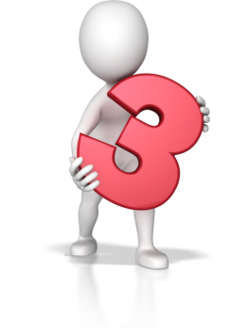
There are three different categories when it comes to assessment in a learning environment.
They are:
- Assessment for learning
- Assessment of learning
- Assessment as learning.
Assessment for learning
Assessments for learning are made in order to make decisions about the next stage of learning. Assessment should be ongoing, done throughout each day and be an integral part of the whole learning cycle. This type of assessment is continuously occurring alongside learning, and an educator should use the children’s body language and responses to make minute-by-minute decisions throughout the day.
There are many ways you can monitor and assess learning but, as a start, you can ask yourself the following questions:
- What could the children already do?
- What have the children learnt?
- What can the children do now?
- What do the children understand?
- How do the children engage with learning?
- How can you help the children to move on in their learning?
Assessment of learning
This is the most common form of assessment and happens at a particular point in time, summarising the learning and development that has taken place previously. The purpose of this type of assessment is to be able to clarify a child’s learning in order to report to their families. In an early years setting, it would involve a small-scale assessment that focuses on the child as an individual.
Assessment as learning
Assessment as learning occurs when children are involved in the assessment process. This gives the child an opportunity to monitor what they are learning and use feedback given to make any necessary adjustments. Because this method allows a child to see a reward for the effort they put into learning, it is often linked to higher levels of self-efficacy.

There are many different ways to gather the information that you need when assessing learning, including:
- Making observations
- Taking notes
- Using rating scales
- Capturing images
- Collecting samples of work
- Recording interviews.
Depending on you and your workplace, there can be different focuses when assessing learning. For example, the focus may be on specific learning experiences, specific areas within the learning or a group of children each week. Whatever the method, the information that you collect will need to be analysed in order to identify each child’s strengths, interests and abilities.

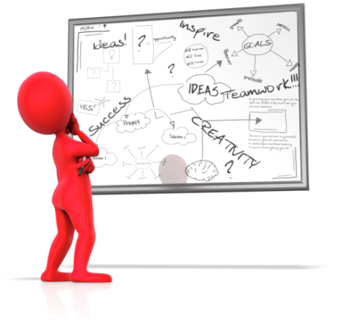
Planned and unplanned experiences
When planning your own methods for monitoring and assessing children’s learning, ensure that both planned and unplanned experiences are considered. Remember that your methods need to be consistent with the Early Years Learning Framework.
Planned experiences are the experiences that you plan in order to manage the learning process. These experiences are usually goal-directed or outcome-directed, and you will have an idea about how the children can achieve the particular outcome. Unplanned experiences are usually a by-product of other experiences and can take place without specific learning goals or outcomes.

Activity 3E

4. Implement learning experiences to foster children’s learning and development
4.1. Ensure that required materials are identified and available at time of implementation
4.2. Set up the physical learning environment
4.3. Co-construct meaning with children and ensure there are sustained interactions
4.4. Model and promote enabling learning dispositions
4.5. Monitor and reflect on children’s learning and own pedagogical practices and continuously refine

4.1 – Ensure that required materials are identified and available at time of implementation

4.2 – Set up the physical learning environment
By the end of this chapter, the learner should be able to:
- List the activities that occur in a typical day within their service and:
  - list the materials that will be needed
  - describe how the physical environment will need to be set up.

Required materials
In order to implement the learning experiences that you have designed to foster the children’s learning and development, you will need to ensure that the materials you require are available at the time that they are needed. First, you need to identify the materials that you require. It is a good idea to have a plan of the daily learning experiences that you are going to introduce to the children. In this plan, you can list any materials that you will need, allowing you to check that they will be available at the time you need them.

Let’s take a look at an example.
Daily Activities | Materials needed | Materials available?
Name writing  Get children to make themselves a new peg label.  Write each child’s name on piece of paper.  Get them to copy their name using colourful crayons.  Let them decorate it however they like.  Laminate it and hang it above their peg. | - Paper  - Crayons  - Art supplies for decoration (e.g. glitter, glue and paint)  - Laminator  - Hole punch  - String. | Yes
Puppets  Set up a ‘puppet making’ corner with a range of supplies.  Get the children to make their own puppet.  Ask the children to use their puppets to make a play for you. | - Makeshift puppet stage  - Supplies for puppets:  - fabrics  - glue  - sequins  - buttons  - scissors. | Yes
Art project  Take the children outside to explore nature.  Help them to take pictures of a variety of things (e.g. clouds, trees, insects and rainbows).  Come inside, print pictures and give each child their own photo.  Arrange an art table (e.g. glue, paint, a range of materials and glitter) and allow children to re-create their photo. | - Camera(s)  - Printer  - Photo paper  - Art supplies:  - glitter  - range of materials  - glue  - paint  - crayons  - paper. | Yes

Setting up physical learning environment
Depending on the learning experiences that you have planned, you may need to set up the physical learning environment in a particular way. How would you need to alter the physical learning environment to allow for your planned daily activities?
Example: Puppets
Whilst making their puppets in the ‘puppet making’ corner, children should have the sufficient space needed to create their puppet. You may need to arrange a few tables into one large table big enough to offer the children a variety of materials and enough space to work in. You could have different baskets within the area containing a range of fabrics, perhaps arranged into different colours. When it is time for the children to show you their play, you may want to create a ‘stage’ area.
To recap on the information discussed throughout this unit, remember that a learning environment should:
- Have enough space
- Be welcoming
- Cater for different learning styles and capacities
- Invite children and families to contribute questions, ideas and interests
- Enable exploration
- Be safe
- Encourage play-based learning.

Activity 4A

4.3 – Co-construct meaning with children and ensure there are sustained interactions
By the end of this chapter, the learner should be able to:
- Identify the aims of co-construction
- Outline the different ways they use co-construction within their workplace.

Co-construct
A child is a powerful player in their own learning, and they construct their learning by actively engaging in and shaping their experiences and environments. As an educator, you need to interact with the children in order to gain an understanding of their expertise. Co-construction is the process of the educator and the children working in partnership to develop learning experiences. The meaning of these learning experiences should also be co-constructed with the children.
The aims of co-construction include:
- To break down traditional roles, creating an environment in which the teaching and learning process merge
- To ensure that prior learning is the starting point for further learning
- To allow children to take risks with their learning
- To get children to use communication and learning modes in a way they don’t normally
- To develop skills needed to become an independent learner and to take ownership of their own learning.


Interacting with children
When interacting with children to co-construct meaning, think about the best way to do this. This will be dependent on the age of the child.
Different ways to interact with children include:
- Pointing
- Nodding/shaking head
- Picture cards
- Simple conversation
- Open-ended questions.
Whatever method you use, you should ensure that the interaction is an ongoing process, not just short and functional.

Activity 4B

4.4 – Model and promote enabling learning dispositions
By the end of this chapter, the learner should be able to:
- Give examples of positive learning dispositions
- Outline how they model and promote the learning dispositions identified.

Learning dispositions
Learning dispositions refer to a combination of learning inclinations, specific behaviours, interests, values and attitudes that will enable and support a child’s learning. Early years education can help to develop these positive enabling learning dispositions through interactive experiences with the learning environment and, as an educator, it is your role to model and promote them. These learning dispositions can be fostered, learned and taught. In order to foster them, a respectful and trusting relationship must be developed; children need to feel safe in order to participate, take risks and succeed in their learning experiences.
There are many examples of positive learning dispositions, including:

- Persistence
- Curiosity
- Playfulness
- Keeping going when things get tough
- Collaboration
- Concentration
- Questioning
- Using trial and error
- Resilience
- Creativity
- Taking responsibility
- Being brave
- Reciprocity.
It is not only the learning experiences that are important in a child’s learning but the layers of learning that these activities encourage. The learning dispositions discussed above are needed in order to drive a child’s desire to learn. As an educator, it is your job to model and promote these learning dispositions.

Modelling and promoting learning dispositions
As an educator, it is your responsibility to become a role model and display the appropriate behaviour. Children will shape their own behaviour on what they watch you do. You need to encourage positive learning dispositions by demonstrating them yourself and setting the correct example.
Let’s take a look at a few of the examples from the list above.
Persistence
In order to foster and promote persistence, you should promote the children’s self-confidence by supporting and encouraging their achievements. You should use sustained shared thinking in order to support any questions the children may have along with asking meaningful questions of your own.
Curiosity
In order to foster and promote curiosity within the learning environment, you should provide real experiences and meaningful opportunities for each child to engage with. You should provide activities and resources that children can interact with and experience a range of different sensory experiences. Whilst interacting with these activities and resources, children should be supported and encouraged.
Creativity
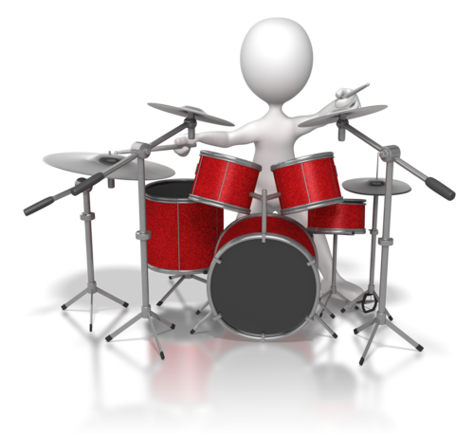
In order to foster and promote creativity, you should plan resources, time and space that can be used flexibly. In order to develop their creativity, children need to feel like part of a safe emotional environment. Activities should allow for children to explore and express their unique creativity whilst being continually supported by their educator. Activities that can promote creativity include different types of art projects, experimenting with musical instruments and a variety of imaginative play.
You should also think about the effects of a bad disposition; the children will be at risk of absorbing it, and this can have a negative impact on their learning.

Activity 4C

4.5 – Monitor and reflect on children’s learning and own pedagogical practices and continuously refine
By the end of this chapter, the learner should be able to:
- Outline the methods used within their workplace to monitor children’s learning
- Summarise pedagogical practices
- Explain why it is important to reflect on own pedagogical practices.

Monitoring and reflecting on children’s learning

Throughout this unit, we have looked at different ways to monitor children’s learning within early years education. The process of monitoring and reflecting on children’s learning is important in ensuring that their learning experiences are the best that they can possibly be.
To recap, there are many different ways to gather the information that you need when monitoring, assessing and reflecting on learning, including:
- Making observations
- Taking notes
- Rating scales
- Capturing images
- Collecting samples of work
- Recording interviews.
A combination of these methods can be more effective in gaining a clearer picture of the children’s learning. When reflecting on the children’s learning, you should identify the areas that have proved successful and those that haven’t. This way, you can highlight any necessary changes that are needed in order to improve the children’s learning.

Pedagogical practices
Simply, pedagogy refers to teaching. However, many argue that it isn’t just about teaching, particularly in early years learning. It is the process of accompanying learners, caring for and about them and bringing learning into life. Therefore, your pedagogical practices are the activities that you design and carry out that will enhance the overall learning experience for the children. Your practices should be directed at the needs of the children and should be based on strong evidence and research. You should aim to select and use the highest quality resources.

There are three aspects of pedagogy:
- Action
  - working with the children so that they are able to make changes
- Animation
  - offering new experiences and bringing ‘life’ into situations
- Reflection
  - creating spaces and moments for the children to explore lived experiences.

In order to become more responsive to the children’s needs, you should adopt reflective practices. You should monitor your practices and take a step back to think about them. What else could you do in order to help children develop and learn? How can you adapt your practices and strategies to benefit the children?
Reflective practice is one of the principles within the Early Years Learning Framework, and it can help you become more thoughtful about the work you are doing. It can encourage you to look deeper at your practices and explore new approaches and ideas. Reflective practice should be part of your everyday practice. By combining your reflection of your own practices with the reflection of the children’s learning you should be able to gain a clearer picture. This picture should highlight areas of weakness as well as areas of strength.

Activity 4D

5. Assess and evaluate planned and unplanned teaching and learning
5.1. Use or establish opportunities to gather feedback from families and children
5.2. Collect data using a range of methods in order to assess and evaluate teaching and learning, both planned and unplanned, using approved frameworks
5.3. Ensure assessment and evaluation of the curriculum and learning experiences are regular and in accordance with service guidelines
5.4. Use assessment and evaluation to influence the design of future curriculum and learning experiences

5.1 – Use or establish opportunities to gather feedback from families and children
By the end of this chapter, the learner should be able to:
- Identify ways to gather feedback from children and their families within their own roles.

Gathering feedback
When evaluating the teaching and learning within the service, as well as self-reflecting and observing, you should seek feedback from the children and their families. The opinions of the children and their families are very important. They can help you to identify the strengths and weaknesses of both the teaching and learning within the service. The key sources of evidence will come from those that are closely linked with the service; i.e. the children and their families.
Should they arise, you should use any opportunity to gather feedback from families and children. For example, if a child asks you ‘why do we have to read this story?’ you can use this as a starting point for feedback. You could ask the child if they like the story or why they don’t like reading. A good educator will be able to identify these opportunities, should they arise.
When opportunities to gather feedback do not arise, you need to establish them yourself.
In order to gather feedback from the children’s families you could:
- Organise family events
- Encourage informal daily contacts
- Send out periodic questionnaires
- Draw on their responses in a time of concern.
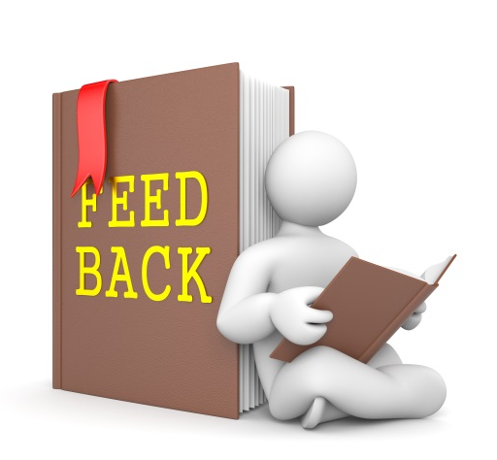
Gathering feedback from children was discussed in Chapter 2.1, and it was suggested that developing a system in which children can express their feelings regarding their learning is a good way to obtain the children’s opinions. Children know what works for them; you just need to find out what this is.
There are many ways to gather feedback from children, including:
- Watching and listening to them play
- Talking in small groups
- One-to-one discussions whilst you are working with them.

Activity 5A

5.2 – Collect data using a range of methods in order to assess and evaluate teaching and learning, both planned and unplanned, using approved frameworks

5.3 – Ensure assessment and evaluation of the curriculum and learning experiences are regular and in accordance with service guidelines
By the end of this chapter, the learner should be able to:
- Identify methods they might use to collect the data needed to assess and evaluate the teaching and learning within their service
- Detail how to carry out one of the methods identified in the previous question.

Assessing and evaluating teaching and learning
Whether planned or unplanned, teaching and learning will need to be assessed and evaluated. The assessment and evaluation are key stages of curriculum development and can help you to identify how effective the teaching/learning process has been. Both teaching and learning occur in a variety of ways so assessment and evaluation will also need to be varied. It shouldn’t just focus on the end points of learning; what about the journey? Also, small steps of achievement should be recognised as well as the giant leaps of achievement. Assessment should be a regular ongoing process in which you use evidence and observations to analyse teaching and learning. It should also include the interpretation of children’s learning against the learning outcomes. This will allow you to report back to families and plan for further learning.
In order to assess and evaluate teaching and learning, you will need to use a range of methods to collect the relevant data. Your chosen assessment and evaluation method should match your curriculum. The learning experiences that occur within your service can also be assessed using a range of methods. Usually, feedback from the children can help you to gain a picture of how successful the learning experiences have been.
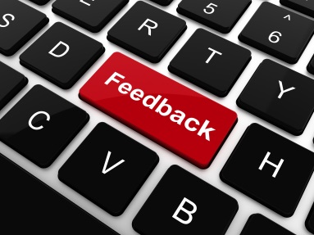
Examples of methods include:
- Interviews
- Questionnaires
- Discussions
- Self-assessment
- Reflection
- Observations
- Feedback.

The Early Years Learning Framework suggests that no single assessment tool or method will give you a full picture of teaching and learning. Instead, a range of assessment methods or tools should be used in order to gain a holistic view. You should also consider carrying out your assessments in collaboration with the children and their families. When involved in the assessment process, children will develop an understanding of themselves as learners.

Assessing and evaluating the curriculum
As well as assessing and evaluating teaching, learning and the learning experiences, you should regularly assess and evaluate the curriculum as a whole. In your assessment and evaluation of the curriculum, you could draw on all the other assessments you have made. For example, the assessments of learning and teaching will assist you in assessing the curriculum as a whole.
Does it produce the desired outcomes? How can it be improved?
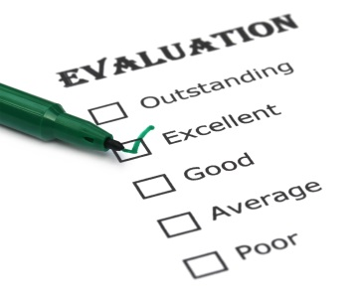
Evaluation of the curriculum is usually concerned with:
- The content and design compared with recent advances and changes
- The impact on the children
- The process through which it was developed
- Any possible directions for the future.
Any assessment or evaluation should be carried out in accordance with your service’s guidelines.

Activity 5B

5.4 – Use assessment and evaluation to influence the design of future curriculum and learning experiences
By the end of this chapter, the learner should be able to:
- Access records of assessment and evaluation that have been carried out within their workplace and use these records to suggest areas of improvement for future designs.

Future design
As we have established, developing a curriculum is a continuous process in which reflection is key. We know that a curriculum is the combination of the interactions, activities, experiences that foster children’s learning and development. Whether planned or unplanned, the learning experiences that occur will have an impact on the children. After assessing and evaluating all aspects of your service, you will be able to identify areas that need improvement. This can help to design the future curriculum and learning experiences.

Ask yourself:
- What’s working?
- What’s not working?
- What could be improved?
- Is there anything that is being overused?
- Is there anything that is being overlooked?
Areas of improvement may include:
- Teaching strategies
- Types of play
- Learning areas.
So, how can you use your evaluations to design the future curriculum and learning experiences?
Your assessment and evaluation may highlight that the children do not enjoy learning by watching and observing. The children may have indicated that they learn better when left to explore and try something, rather than watching you do it. This information can be then used when designing future activities. You can incorporate more activities that will allow for this, making the learning experience better for the children. Your evaluations may have shown that families think that more outdoor activities need to be introduced. This can be incorporated into any future designs.

Activity 5C

Summative Assessments
At the end of your Learner Workbook, you will find the Summative Assessments.
This includes:
- Skills Activity
- Knowledge Activity
- Performance Activity.
This holistically assesses your understanding and application of the skills, knowledge and performance requirements for this unit. Once this is completed, you will have finished this unit and be ready to move onto the next one – well done!

References

These suggested references are for further reading and do not necessarily represent the contents of this unit.
Australian Capital Territory legislation: http://www.legislation.act.gov.au/a/2011-42/default.asp
Belonging, Being and Becoming: https://www.acecqa.gov.au/sites/default/files/2018-02/belonging_being_and_becoming_the_early_years_learning_framework_for_australia.pdf
Early Years Curriculum Guidelines: https://www.geteduca.com/frameworks/early-years-learning-framework/
My Time, Our Place: Framework for School Age Care in Australia https://www.acecqa.gov.au/sites/default/files/2018-02/educators_my_time_our_place.pdf
New South Wales legislation: http://www.legislation.nsw.gov.au/sessionalview/sessional/act/2010-104.pdf
NQF: https://www.acecqa.gov.au/nqf/about
Queensland legislation: http://www.legislation.qld.gov.au/LEGISLTN/ACTS/2011/11AC038.pdf
South Australia legislation: http://www.legislation.sa.gov.au/LZ/C/A/EDUCATION%20AND%20EARLY%20CHILDHOOD%20SERVICES%20(REGISTRATION%20AND%20STANDARDS)%20ACT%202011.aspx
Tasmania legislation: http://www.thelaw.tas.gov.au/tocview/index.w3p;cond=;doc_id=48%2B%2B2011%2BAT%40EN%2B20120522120000;histon=;prompt=;rec=;term=
Victoria legislation: http://www.legislation.vic.gov.au/Domino/Web_Notes/LDMS/PubStatbook.nsf/51dea49770555ea6ca256da4001b90cd/b73164fe5da2112dca2577ba0014d9ed!OpenDocument
Western Australia: http://www.slp.wa.gov.au/legislation/statutes.nsf/main_mrtitle_12929_homepage.html

All references accessed on and correct as of 13.09.2017, unless otherwise stated.

