BSBLDR414
Lead team effectiveness

ASSESSMENT SUMMARY

The assessment activities for BSBLDR414 Lead team effectiveness cover all aspects of the unit of competency. For Apprentices/Trainees, this includes supervisor completion of the Apprentice/Trainee Record (ATR).

Participants must read all the information given before starting any assessment task. The assessment tasks are intended to be fair, flexible, valid and reliable. If a Participant has any questions or requires alternative arrangements to be made such requests should be directed to their Trainer/Assessor, who should note such arrangements in the ‘Assessor Comments’ on the affected assessment. If a Participant feels they are not yet ready to be assessed, they should discuss their options with their Trainer/Assessor.

To satisfactorily complete the assessment, the Participant is required to answer all questions correctly and demonstrate their skills to industry standards. If a Participant does not answer all questions or perform all tasks, they will be deemed ‘Not Satisfactory’ for the task and ‘Not Yet Competent’ for the unit of competency.

The Trainer/Assessor can provide the Participant with additional information on interpreting the assessment outcomes and guide the Participant’s options. If a Participant is still deemed ‘Not Satisfactory’ they will have the opportunity to undertake a supplementary assessment or appeal the result as per the process in the Student Handbook.

By signing below, the Participant acknowledges:
- They understand the assessment instructions and requirements, and consent to being assessed.
- The work submitted is to be their own work – with the work of/with others needing to be clearly acknowledged and documented.
- They consent to any photo/video recording of their work that occurs during assessment.

Participant name | Caroline Jane
Participant signature | 

Pre-requisite unit(s) to be achieved and authenticated prior to undertaking assessment
Not applicable

Task | Date completed | Assessment Results
Theory Exam | Select Date. | Satisfactory | Not Satisfactory
Practical Assessment | Select Date. | Satisfactory | Not Satisfactory
Outcome for BSBLDR414 | Select Date. | Competent | Not Yet Competent

Evidence requirements checklist (ticked by assessor and evidence supplied to RTO)
Theory Exam | Practical Assessment  Team development plan

Assessor Name
Assessor Signature | 

BSBLDR414
Lead team effectiveness

THEORY EXAM

Participant name | Caroline Jane

FOR THE PARTICIPANT
Instructions
- You will complete written questions as outlined on the following pages. You must attempt all questions and provide enough detail in your responses to demonstrate your knowledge.
- It is anticipated that you should complete this assessment within two (2) hours, but additional time may be allowed upon negotiation with the Assessor.
- You must complete all questions unassisted by the Assessor or other personnel but may refer to reference material as needed. All questions must be answered correctly for a ‘Satisfactory’ assessment outcome to be awarded.
  - An oral examination may be allowed under certain circumstances, whereby your answers will be documented by another party.
  - Any written questions that are incomplete, or not answered satisfactorily will need to be completed again after further training support.
    - If you answer a question incorrectly but modify your response, put your initials next to the written change (or the Assessor must initial a verbal change).
Resources required
Pen

FOR THE ASSESSOR
Instructions
- Where oral examination has occurred, ensure that this is acknowledged in writing (e.g. FT001 and Assessor Comments)
- All questions must be satisfactorily demonstrated by the Participant for a Satisfactory determination (indicated by an Assessor tick to the right of the question).
- Assessors are to complete marking in pen of a different colour to the Participant.
- If the Participant verbally modifies their response, write in the modified response verbatim and put your initials next to the written change.

ASSESSOR COMMENTS
As necessary, outline:
- Details on reattempts, alternative arrangements or reasonable adjustments made.
- Where a Participant is deemed ‘Not Satisfactory’, provide recommendations for future training.

- Identify a team that may exist in the workplace. Consider the purpose of the team, its goals and objectives. Name and describe the roles and responsibilities for at least three (3) team members. Finally, identify at least one (1) method that will assist with monitoring progress towards the team goals.

Answer | Point | Detail
 | Team purpose | Plant Team
 | Goals and objectives | Short term | To fix individual plant each day
 | Goals and objectives | Long term | To support all QLD projects
 | Team members | Role | Description | Responsibilities
 | Team members | 1 | Everyone | - Maintain awareness of hazards in my work area  - Regularly review the effectiveness of critical controls  - Plan the necessary steps to do the job well  - Always ask “what could go wrong”  - Check my own and others understanding of the work – do not assume  - Reassess hazards if changes occur in the work area.  - Understand the hazards  - Follow the rules and directions from the PCBU. Seek approval or advice if there are changes to the plan, use the right tools and equipment for the job and take appropriate time to complete the task, no rushing!  - Speak up – cease work if it is unsafe and warm others  - Get involved: share knowledge with others, contribute to team discussions and collaborate, suggest improvements. Ask for support and additional resources / training where required.  - Attend any consultation meetings, brainstorming sessions and training.
 | Team members | 2 | Supervisors | - Take time to plan work with your team to identify hazards, assess risk and put controls in place  - Reassess hazards, risks and controls if and when changes occur  - Challenge habits and assumptions about routine work within teams  - Promote the reporting of incidents  - Stay involved in incident investigations to identify learning and any improvements  - Promote risk awareness  - Positively reinforce standards to workers – lead by example and be a good role model. Check that your team understand any changes and check your team are competence and capable of performing the tasks. Regularly engage with your team and to maintain compliance, standards and procedures are followed. Continually review work methods  - Encourage the team: be available to your team. Seek and be open to suggestions, concerns and ideas – collaboration. Empower your team to stop if the job is unsafe or they need clarity on instructions.  - Involve the team – initiate team discussions and encourage questions. Speak time with your team to identify their strengths and any opportunities they could be encouraged to go for. Support, promote and encourage your team to implement improvements and new ideas. Make sure you ask for support if and when needed.  - Plan consultation meetings, brainstorming sessions and training sessions. – Be engaged when attending these.  - Consider group dynamics – ensure that work is fairly delegated within the team
 | Team members | 3 | Managers | - Challenge and improve – act on risks associated with changes. Seek out and act on early warning signals. Encourage the team to remain alert to potential hazards / incidents. Be actively involved in incident investigation and outcomes. Be visible and talk face-to-face with the team about how work is done. Monitor learnings for incidents and ensure they are implemented and procedures are updated.  - Set high standards – lead by example! Be the role model for good work practices. Monitor workloads and resources and take appropriate actions. Clearly explain expectations to your team and hold people to account. Promote a focus on identifying new and better ways to deliver work – collaboration! Check regularly for implementation of the management systems. Address significant issues without delay and then follow up on any agreed actions.  - Maintain openness – listen, act and provide honest feedback to any concerns raised by workers. Communicate clearly to your staff regarding reporting incidents, unplanned events and any concerns they have. Clearly communicate the lessons that have been learned and provide this feedback to the entire team. Recognise good individual and team performances.  - Provide support – create a positive, fair and inclusive work environment. Own your agreed initiatives and provide workers with sufficient time to achieve these initiatives. Provide adequate resources for the development and maintenance of workforce competencies. Delegate responsibility and encourage team members to make decisions that will help improve not only their work but the team’s workload. Coach and mentor team members. Take action to improve performance – show enthusiasm and support for everyone.  - Plan consultation meetings, brainstorming sessions and training sessions.  - When planning to achieve team outcomes, this should start from the top and be collaborated with by everyone – consider the S.M.A.R.T. approach.
 | Progress monitoring | One method to assist with monitoring the progress of the goals set out by the Plant Team could be by implementing regular performance reviews and check-in catch ups which could assess the milestones, identify challenges and to ensure alignment with the current objectives. It could also be measured with completed work and satisfaction from the Projects feedback on the state of the equipment. The Plant Yard is constantly receiving excellent feedback from QLD Projects. If there is ever “negative” feedback, we take this as lessons learned and consider the reasons why this area was missed and plan ahead to ensure this isn’t missed again.

- True or False (Tick your response): A team leader is more of a mentor than overseer who checks work.

Answer |  | True
 |  | False

- Match the leadership styles and definitions by writing the appropriate letter next to each number in the centre column.

Answer | Style |  |  | Definition
 | 1 | Authoritarian | 1 - B | A | Leaders who let the team function without much interference
 | 2 | Democratic | 2 - C | B | Leaders who fully control their team
 | 3 | Laissiz-Faire | 3 - A | C | Leaders who try to include everyone in the decision-making process

- Identify two (2) benefits and two (2) drawbacks of transactional leadership.

Answer | Benefits | Drawbacks
 | Employee security in  knowing there are no  surprises regarding  expectations of  outcomes | Employees feel like  followers, rather  than innovators or  leaders
 | Clearly defined rewards  and consequences for  meeting or not meeting  those goals | Personal initiative is  not rewarded or  valued

- Which of the following are characteristics of transformational leaderships? Tick all that apply.

Answer | Choice | Possible Answers
 |  | The leader acts as a role model to employees
 |  | Close, consistent focus on the company vision
 |  | A high value on interpersonal relationships
 |  | Inspiration as a tool to motivate employees

- Why is it important for team leaders to include team members in the planning process?

Answer | It is important for many reasons:  - Team members will better understand all the tasks involved and what the whole team’s goals are  - Team members will take more responsibility  - It encourages a sense of ownerships, engagement and collaboration  - It allows for diverse perspectives  - Encourages creative solutions  - It can boost morale by making everyone feel valued and invested in the teams goals.

- For each of the listed activities in the table below, identify two (2) methods that team leaders can use to involve team members.

Answer | Activity | Method/s to involve team members
 | Goal setting | - Collaborative workshops – during brainstorming sessions, team members can actively contribute to defining what the goals are for the team. It will help the team by discussing strategies, identifying potential challenges and encourage openness with idea sharing and creating a collective sense of ownership within the team.  - Individual input – some people don’t find it easy to share in front of others. Know your workers and if they would benefit from one-on-one meetings, organise this with them to gather their insights and suggestions to go towards the teams goal setting. This will allow each team member to voice their opinions, provide feedback and put in their individual objectives. Collaboration each of these with the teams overall goals will mean more to everyone.
 | Decision making | - Group meetings – collaboration. By holding team meetings where important decisions are presented to the group will open up various options to be discussed. Encourage the team to share ideas, opinions, concerns and ideas from lessons learned. Allow the group to collectively come to an agreement on the best course of action. This will help ensure that the team is well-informed and the decision are made by the team.  - In some instances, it would be beneficial to give the workers the responsibility to make decisions within their areas of expertise. They must follow the policies provided by the PCBU, however, allowing them to choose the best course of action will promote empowerment and ownership for everyone.
 | Work allocation | - Skills, strengths and interest matching – The team leader could have conversations with each team member to understand what their skills, strengths and areas of interest are. They could then match the tasks to the individuals. This approach will enhance job satisfaction and also improve the quality of work that is produced.  - Rotate tasks – We use this one in the Plant Yard. We have implemented a rotation systems where each team member takes turns each week for checking various items and completed daily prestarts. This method has allowed everyone to participate and contribute to the team.  Rotate tasks.

- True or False (Tick your response): Diverse teams produce more creative results than teams in which members are less diverse.

Answer |  | True
 |  | False

- Provide two (2) examples of how the knowledge, skills and background of team members can enhance team practices.

Answer | Please see below for two examples:  - Bob is an excavator operator with 25 years experience, skills and background. He has a wealth of knowledge he can pass along to the entire crew.  - Sally is the office administrator, she has been in this role for 10 years with Damstra experience and able to advise the staff regarding onboarding and induction processes.

- Provide two (2) reasons that responsibilities must be carefully delegated within the work team.

Answer | - People’s skills can be diverse and some tasks are better suited to an individuals strengths rather than weaknesses.  - Experience and knowledge needs to be considered for many activities.

- Describe what innovation brings to the workplace. Provide one (1) example of innovative practice.

Answer | Innovation brings to the workplace, new ideas and better ways (processes) of achieving the same goals. For example, when I started at the plant yard, there were 4 different spreadsheets to be completed that were all different and took 4 times as long to complete. I restricted theses to all be the same meaning I could copy and past my data 4 times, freeing up days of work.

- Describe (3) methods that may be used to measure a team’s innovation.

Answer | - Changing processes  - Time of the job  - Progress – comparing old data with the new data to see positive changes.

- Explain how encouraging team members to assist each other in undertaking their roles and responsibilities can improve productivity.

Answer | Encouragement is always received well and has been shown to improve productivity in many workers. It can provide individual team members with more confidence and make them more engaged in their work = which helps improve productivity.

- Describe (3) methods that may be used to measure a team’s productivity.

Answer | - KPIs  - Time spent on the job  - Revenue

- Which of the following are likely outcomes from involving team members in all aspects of a job? Tick all that apply.

Answer | Choice | Possible Answers
 |  | Causes members to resent the team
 |  | Makes the work more meaningful
 |  | Improves self-esteem of team members
 |  | Improves team morale
 |  | Team members take more responsibility for their individual work

- Explain how providing feedback to team members can encourage and motivate team members – building trust and positive working relationships.

Answer | If a worker is doing something wrong, they might not realise this until they are given feedback. It this is provided in the right way, it can help put more meaning into the individual workers job and encourage them to improve their self-esteem, making the whole team more positive.

- Identify one (1) issue, concern or problem that may be identified by team members. Describe the signs that you would recognise to identify the issue and how the matter could be resolved by internal team negotiation.

Answer |  | Response
 | Issue, problem, or concern | Reduced productivity
 | Signs | workers chatting to much and spending to much time on mobile devices.
 | Solution via negotiation | Identify to the workers the problem by showing past and present data on productivity. set boundaries around when mobile devices are acceptable to be used (i.e. break times, crib room only). Brainstorm with all workers regarding solutions so everyone feels part of the solution and that it is a team decision.

- Identify one (1) issue, concern or problem that would need to be resolved by an external party. Describe the signs that you would recognise to identify the issue and who the matter should be referred to.

Answer |  | Response
 | Issue, problem, or concern | Fire on site
 | Signs | There is a fire
 | Solution via negotiation | if we have tried to put out the fire as per CPB policies / procedures and cannot, we follow the emergency procedure and call the fire brigade.

- Identify three (3) ways that the team leader can serve as a role model to, and motivate, the team.

Answer | By consulting with the team via meetings, brainstorming, face-to- face, email, phone etc.  1.encouragement  2.consultation  3.communication

- For each of the following areas, provide one (1) example of how the team leader’s contributions to the work team can enhance the organisation’s image:
- Internally, within the work team and the organisation
- Externally, with clients/customers

Answer | Question | Response
 | Within the work team and organisation | Providing information and guidance on matters regarding the day to day operations of the team so that the team knows exactly what they need to do.
 | With clients and customers | By providing this information, and the team knowing exactly what they need to do, this portrays a positive organised and professional image to clients and customers.

- Provide three (3) communication methods that a team leader may encourage the team to use, and situations that each communication method would be suitable for.

Answer | Method | Suitability
 | Mentorship | Everyday, in the environment that the work is undertaken by the team.
 | Actively listen | When a team member has a question or concern about the process, it is important to validate this by actively listening.
 | Non-verbal communication | Some people learn better through “doing”, rather than being told how to do it.

- Identify two (2) ways that the team leader can establish open communication with management.

Answer | 1 Asking questions and actively listening to answers.  2 provide encouragement when a team member raises concerns / speaks up

- Identify two (2) issues, concerns and problems that may be raised by the team to management.

Answer | 1 training  2 safety concerns

- Identify two (2) issues, concerns and problems related to the team that may be raised by management back to the team.

Answer | 1 productivity  2 morale

- Describe one (1) situation where the team leader may have to negotiate with management on behalf of the team.

Answer | 1 When a decision is handed down from management that is counter productive to the goal

Refer to the extract below from an Escalation Policy and Procedure to respond to Q26. to Q28.

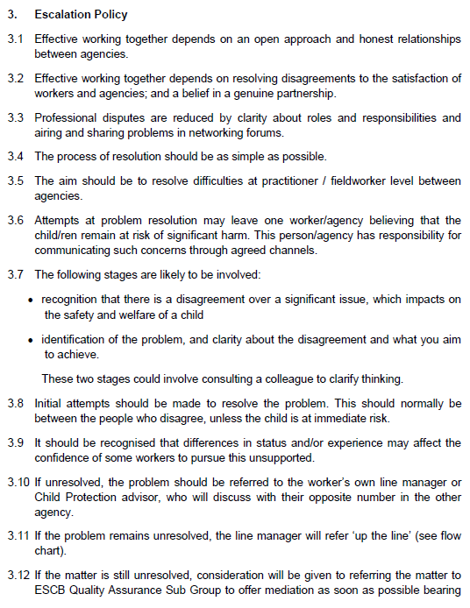
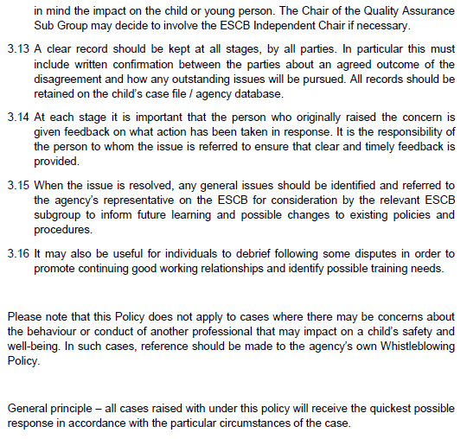
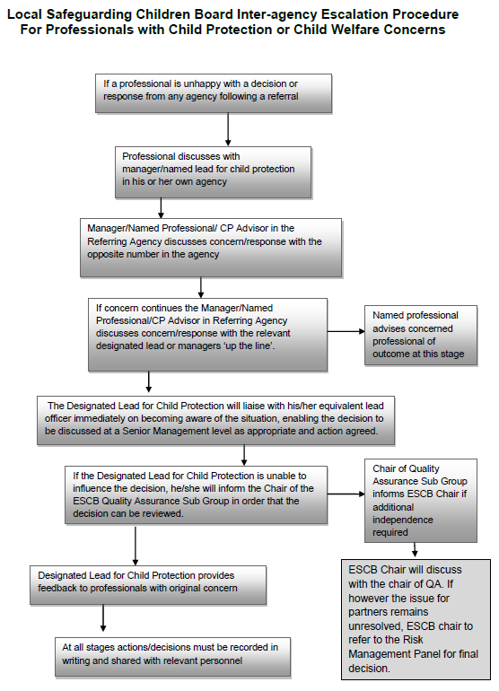

- Order the following steps from 1 to 5 to identify the correct order of issue escalation where a problem is unresolved.

Answer | Step Number | Steps
 | 1 | The people who disagree should make the initial attempts to resolve the problem
 | 5 | When the issue is resolved, any general issues should be identified and referred back to the agency’s representative to inform future learning and possible changes to existing policies and procedures
 | 3 | If the problem remains unresolved, line manager will refer ‘up the line’
 | 4 | If the matter is still unresolved, the matter may be referred to the Quality Assurance Sub Group to offer mediation
 | 2 | If unresolved, the problem should be referred to the worker’s own line manager

- True or False (Tick your response): It is the goal for all cases raised under this policy to receive the quickest possible response.

Answer |  | True
 |  | False

- If the ESCB Chair cannot resolve the issue, which body can make the final decision?

Answer | Risk Management Panel

BSBLDR414
Lead team effectiveness

PRACTICAL ASSESSMENT

Participant name | Caroline Jane

FOR THE PARTICIPANT
Instructions
- The tasks outlined on the following pages will require performance of normal workplace activities, as a result of a structured activity set by an Observer in the workplace or a simulated activity set by your Assessor/Observer.
- The timeframe for these tasks will be established by your Assessor/Observer, in consideration of location conditions and industry requirements.
- You must complete all tasks unassisted by the Assessor or other personnel, unless the steps note this assistance.
- You must attempt all tasks (and itemised steps) for a ‘Satisfactory’ assessment outcome to be awarded.
  - For any observation conducted that is incomplete, or without satisfactory performance, the observation will need to be completed again after further training support.

FOR THE ASSESSOR/OBSERVER
Instructions
- The following observation record should be used to judge and record your observations of the Participant as they complete the task(s) set. You must record your observations of the Participant’s performance.
  - For each occasion, indicate the task performed and whether it was a simulation or workplace-based task.
    - Any simulated assessment must ensure the Participant still performs under workplace conditions which reflect industry standards.
  - In the comments, provide clear detail regarding the task that the Participant was required to do (e.g. PPE used, materials handled, attachments connected, plant types).
- All steps must be satisfactorily demonstrated by the Participant for a ‘Satisfactory’ determination (indicated by an Assessor tick to the right of each itemised step, or an Observer tick to the right of each itemised step, and confirmation by an Assessor in the Assessor Comments).
  - Where you have determined that one or more task steps have not been satisfactorily demonstrated, provide the Participant with additional support and outline details of such assistance in the Assessor/Observer Comments. Allow the Participant two (2) further opportunities to demonstrate the task again to allow an opportunity for a ‘Satisfactory’ assessment outcome to be achieved.
  - If after three (3) attempts the Assessor determines that the Participant cannot demonstrate the required steps, a ‘Not Satisfactory’ outcome is to be determined.

TASK OUTCOME
Task | Date | Task Type (Tick) | Location | Task outcome (Tick)
 |  |  |  | Satisfactory | Not Satisfactory
Task 1 | Select Date. | Workplace  Simulation

ASSESSOR COMMENTS
As necessary, outline:
- Details on reattempts, alternative arrangements or reasonable adjustments made.
- Where a Participant is deemed ‘Not Satisfactory’, provide recommendations for future training.

ASSESSOR COMMENTS: PRACTICAL TASK 1
Individual student (as named on cover page)
Multiple students [ All from Attendance Report, Specific students involved – identify students]
Task | Provide detail
1.B. | Feedback provided to team members:
1.C. | Support offered to identify and resolve problems, issues and concerns:
1.D. | Issues passed from management to the team and vice versa:

BSBLDR414
Lead team effectiveness

Practical Task 1
Description of task:
A suitable observer is to verify the participant’s ability to lead team effectiveness, including:
- Leading and consulting with the team to develop a team development plan that addresses –
  - Team cohesion
  - Innovation and productivity measures
  - Issues management and actions
- Communicating with team members and management to –
  - Consult, encourage, support and provide feedback to the team
  - Model team leadership behaviours and approaches
  - Resolve problems

The Observer is to provide detailed comments on the tasks completed by the Participant (on the Observer Comments, overleaf). The Assessor is to verify the Observer’s comments, noting their findings in the Assessor Comments (on the back of the Practical Assessment cover page) and provide the assessment outcome.
Resources required:
Team Development Plan Template
Observer details
Name of observer: | Andrew Neal
Role of observer  (Confirm suitability to sign) | Plant Supervisor
Email address of observer | Andrew.neal@cpbcon.com.au
Signature of observer: | 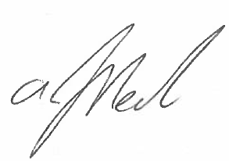
Date: | 21/08/2023

When completing the task, did the Participant: | Tick if satisfactorily completed.  Provide comments if left unticked.
- Lead and consult with the team to establish and document a team development plan, incorporating:
- Team purpose, roles, responsibilities, goals, objectives and plans
- Consideration of organisational goals, objectives and plans
- Team cohesion
- Innovation and productivity measures
- Issues management and actions
- Lead team to develop cohesion, including:
- Providing opportunities for input of team members into planning, decision making and operational aspects
- Encouraging and supporting team members to take responsibility for own work and to assist each other
- Providing feedback to team members to encourage, value and reward individual and team efforts and contributions
- Participate in and facilitate work team, including:
- Leading and supporting team members in meeting expected outcomes
- Actively encouraging team members to participate in and take responsibility for team activities and communication processes
- Giving the team support to identify and resolve problems, issues and concerns
- Acting as a role model to enhance the organisation’s image for work team, clients and customers
- In line with organisational escalation policies and procedures, maintain open communication by passing information from management to the team and vice versa (including issues, concerns and problems).

OBSERVER COMMENTS
Caroline clearly identified the roles, responsibilities goals and objectives for each individual responsibility. She measured the productivity via the S.M.A.R.T. method by breaking down each step of the task.

Caroline led the team by providing opportunities for each of the workers to have equal input and any opportunity to include more. She provided feedback where needed and always had a lot of positive reinforcement.

Caroline always acts as a responsible role model, and you can see the passion in her work. As far as I can see, Caroline has followed organisational policies and procedures and communicated all information to the team and management and vice versa.

TEAM DEVELOPMENT PLAN

DATE OF EFFECT
Start | 14/08/2023 |  | End |  | 15/09/2023
GOALS, PLANS AND OBJECTIVES
Outline the team’s purpose, goals, and objectives. Identify how this fits within the organisation’s goals, objectives and plans.
The team’s purpose and objectives are to streamline the maintenance and repairs of plant and equipment. The goal of the organisation is that it needs all the equipment to be in safe, running order, as per legislation and CPB Contractors policy. This will ensure the Plant Yard maintains its responsibilities and supports all the projects in QLD and northern NSW for CPB Contractors.

The roles and responsibilities are defined above and below.

OBJECTIVES FOR TEAM
Objective |  | Work process |  | Responsible employee |  | Start date | End date
Team cohesion |  | Collaboration session daily (30 mins) |  | Andrew |  | 14/08/2023 | 18/08/2023
Innovation |  | Looking for technological improvements |  | Luke |  | 21/08/2023 | 25/08/2023
Productivity |  | Performance Reviews |  | Caroline |  | 14/08/2023 | 15/09/2023
Issues management |  | Processes and procedural documentation |  | Andrew |  | 14/08/2023 | 15/09/2023
REVIEWING AND ASSESSMENT METHODS
How will you track the plan’s implementation, the team’s progress (e.g. through team meetings, reports)?
We will track the plans implementation by using the S.M.A.R.T. approach. To begin we will make sure we have established clear roles and responsibilities (for detail, see above). By making sure to include various skilled team members in the planning, will allow for better solutions and improved productivity by streamlining processes. Making sure all meetings and discussions are clearly documented will help when tracking the plans implantation and teams progress. Make sure to capture the number of new ideas proposed, what the selected ideas for implementation are, the number of projects / ideas that were unsuccessful, the revenue generated from the new ideas, feedback and satisfaction from the projects and any lessons learnt. This will allow for us to measure if we meet our objectives. This has been done by toolbox talks, daily prestart’s and reporting from the data collected. At CPB we also use Synergy and other reporting platforms where it is easy to review data and see trends / solutions and how they play out.
ADDITIONAL SUPPORT
Is there any additional support needed to reach the desired goals (e.g. courses, classes, resources).
Yes, training and development on key areas i.e., technological improvements and collaborative training. It the team requires additional training to help in their job, management will need to provide this for them. The team leader may help and guide the worker/s on the best type of training that is needed.
As part of our plan, Luke is has been instructed to find any technological improvements. As part of this plan, Luke has managed (with the help of others) to implanted a program called ChekRite, which has allowed all the paperwork to be completed on either a tablet, smart phone or computer. It also allows photos to be uploaded directly to the plant account cutting out the middle person (myself) by having to take the SD card from the inspector and uploading at a later date. While there are still issued with this program, it is at the first exciting stage of how technological improvements are helping at the Plant Yard.
EXPECTED OUTCOME
Team leader’s expectations on the outcome based on the data.
The team leader’s expectations are that the outcomes will be positive, and the data will back this up to show the improvements. They can do this through various ways such as; Encouraging the team members who are involved, provide feedback to the team, address any team issues and problems, model the behaviours they would like to see and expect in their team, liaise with management, make sure the team has sufficient resources to help carry out the work and duties expected of them.
OUTCOME IF GOALS AND OBJECTIVES ARE NOT MET
Identify the consequences and further steps if the team fails to satisfy the standards set by the plan.
Some consequences could be; decreased productivity, poor morale among the team, missed project deadlines, increased safety risks and negative impacts over all projects by equipment and plant not being ready to be delivered to sites, holding up multiple projects across QLD and NSW.
A review of the plan to see what the root causes are, and a fresh plan can help ensure the team has a good understanding of what the purpose, goals and objectives are. Make sure the goals are specific enough and truly achievable! Reminding the workers what their roles and responsibilities are will help to build a good team that can work together to accomplish what they want to achieve. Using brainstorming sessions and collaboration to involve everyone will help build the commitment from the workers to achieve something together. This will also allow the team to discuss the shortcomings and achieve the new goals set. Also consider the skills and experience of each worker and how they can better contribute to the team. Group dynamics needs to also be considered and potentially moving the workers around to collaborate with different workers might be useful, do not force relationships that could cause conflict. Encourage a culture of accountability and teamwork to collaborate and problem solve together.
Team leaders must regularly monitor the plan and works and make any necessary adjustments to stay on track.
Seek guidance or mentorship from high-up workers or experts within CPB or consider consultation from external experts if needed.

