

BSBITU305
Conduct online transactions
Learner Workbook

Table of Contents

Table of Contents 2
Candidate Details 3
Assessment – BSBITU305: Conduct online transactions 3
Competency Record to be completed by Assessor 4
Observation/Demonstration 5
Activities 6
Activity 1A 6
Activity 1A continued... 7
Activity 1B 9
Activity 1C 11
Activity 2A 12
Activity 3A 17
Activity 4A 18
Skills and Knowledge Activity 19
Major Activity 20

Candidate Details

Assessment – BSBITU305: Conduct online transactions
Please complete the following activities and hand in to your trainer for marking. This forms part of your assessment for BSBITU305: Conduct online transactions.
Name: Zoe Lwin
Address: 79 Waterview Avenue, Wynnum, 4178
Email: zoejade_98@hotmail.com
Employer: Lwins Cleaning
Declaration
I declare that no part of this assessment has been copied from another person’s work with the exception of where I have listed or referenced documents or work and that no part of this assessment has been written for me by another person.
Signed: ____________________________________________________________
Date: ____________________________________________________________
If activities have been completed as part of a small group or in pairs, details of the learners involved should be provided below;
This activity workbook has been completed by the following persons and we acknowledge that it was a fair team effort where everyone contributed equally to the work completed. We declare that no part of this assessment has been copied from another person’s work with the exception of where we have listed or referenced documents or work and that no part of this assessment has been written for us by another person.
Learner 1: ____________________________________________________________
Signed: ____________________________________________________________
Learner 2: ____________________________________________________________
Signed: ____________________________________________________________
Learner 3: ____________________________________________________________
Signed: ____________________________________________________________

Competency Record to be completed by Assessor
Learner Name: _______________________________________________________
Date of Assessment: _______________________________________________________
The learner has been assessed as competent in the elements and performance criteria and the evidence has been presented as;
Assessor Initials
Authentic
Valid
Reliable
Current
Sufficient

Learner is deemed: COMPETENT NOT YET COMPETENT (Please circle)

If not yet competent, date for re-assessment: ____________________________________

Comments from Trainer / Assessor:
__________________________________________________________________________________________________________________________________________________________________________________________________________________________________________________________________________________________________________________________________________________________________________________________________________________________
Assessor Signature: ________________________________________________________

Observation/Demonstration

Throughout this unit, you will be expected to show your competency of the elements through observations or demonstrations. Your instructor will have a list of demonstrations you must complete or tasks to be observed. The observations and demonstrations will be completed as well as the activities found in this workbook. An explanation of demonstrations and observations:
Demonstration is off-the-job
A demonstration will require:
- Performing a skill or task that is asked of you
- Undertaking a simulation exercise
Observation is on-the-job
The observation will usually require:
- Performing a work based skill or task
- Interaction with colleagues and/or customers
Your instructor will inform you of which one of the above they would like you to do. The demonstration/observation will cover one of the unit’s elements.
The observation/demonstration will take place either in the workplace or the training environment, depending on the task to be undertaken and whether it is an observation or demonstration. Your instructor will ensure you are provided with the correct equipment and/or materials to complete the task. They will also inform you of how long you have to complete the task.
You should be able to demonstrate you can:
- Identify and investigate online service provider
- Perform online transactions
- Maintain records of online transactions
- Review online transactions
You should also demonstrate the following skills:
- Learning
- Reading
- Writing
- Oral communication
- Navigate the world of work
- Interact with others
- Get the work done

Activities

Activity 1A
Estimated Time | 30 Minutes
Objective | To provide you with an opportunity to undertake online research to identify suppliers of required products/services.
Case Study | Read, understand and clarify organisation's purchasing strategies
  Workplace Activity
  - Have you a copy of your organisation's purchasing strategies?
  - If so, read, understand and clarify this document
  When a product of service is required, the purchasing officer will investigate suppliers and prices and place on order; online, over the phone or in person.
  - Aim to find the most cost-effective purchases from efficient and reliable suppliers.
  - Ensure authenticity of supplier.
  - Maintain good relationship with suppliers to get the best deals.
  Criteria for making purchases:
  - Depending on the situation – an organisation may prefer to purchase locally to avoiding waiting a long time for products to arrive or paying too much in freight cost.
  - Cost effective
  - Know legal requirements, policies, procedures and guidelines for purchasing from various entities such as partners, alliance members and local/distant suppliers e.g. online
  Online suppliers might include: banks and other financial institutions, e-auction, e-brokerage service, e-mail, e-procurement service, e-shop or third party market place.
  Products/services may include: financial services, goods, insurance, loans, shares.
Estimated Time | 30 Minutes
Objective | To provide you with an opportunity to undertake online research to identify suppliers of required products/services.
Case Study | Undertake online research for online purchases  TICK those areas that are relevant
  Purchase | Attributes
  Does your purchase include these examples? | Price |  | Reliability | Stability |  | Other  What?
  Financial services
  Goods
  Services
  Insurance
  Loans
  Shares
  Price may include:  - Getting discounts  - Special offers  - Negotiated contracts  - Reward points  - Cash incentives  - Etc |  | Reliability may include:  - Service  - Warranties  - Proven use  - Existing stock  - Special needs  - Replacement parts  - Etc |  |  | Stability may include:  - Existing relationship  - Directives  - Unique products  - Proven quality  - Supply is guaranteed  - Service  - Etc
  Your comments |  | Your comments |  |  | Your comments
  Getting the best price possible is relevant to all types of purchases. However, there are some cases where quality and reliability of products and services takes precedence over price. |  | Reliability particularly relates to physical purchases such as goods as these need to be long lasting, however it is also important for services to be consistent and dependable. |  |  | Stability within a purchasing strategy ensures that purchase agreements and relationships between suppliers are strong.

Activity 1B
Estimated Time | 30 Minutes
Objective | To provide you with an opportunity to assess service provider confidentiality, security and privacy facilities in accordance with individual and organisational requirements.
Case Study | Using your WORKPLACE for practical examples or as directed by the instructor, provide comment on how your organisation may have addressed a recent or past issue on confidentiality, security or privacy with purchasing online.  Reference all or some of these examples WHICHEVER may apply to your organisation  - Access to independent reviews of financial services such as:  - Australian competition and consumer commission (ACCC)  - Financial planning association of Australia (FPA)  - Authentication services  - Disclaimers  - Firewall protection  - Jurisdiction  - Level of encryption  - Limit of liability  - Personal identification number (pin)  - Physical site security of web server  - Receipting  - Terms and conditions of website use  - Use of 'cookies' - small files automatically downloaded from a web server to the computer of someone browsing a website - information stored in cookies can be accessed any time computer returns to the site user name and password  - Warranties.
  # | Your Organisation Experience
  Confidentiality | Within my organisation, confidentiality is maintained by using unique personal identification numbers, user names and passwords. The information required for making business purchases online is made confidential so only authorised users have access.
  Security | Security is enforced using authentication services, receipting, user name and password and understanding terms and conditions of website use.
  Privacy Facilities | Unique user names and passwords are a key way to ensure that a high level of privacy is maintained. Firewall protection is also an important feature in this regard.

Activity 1C
Estimated Time | 30 Minutes
Objective | To provide you with an opportunity to assess potential products/services for authenticity.
Case Study
  Look for signs that the business is legitimate if you haven’t already used them | - Find out what other purchasers say about the goods or services you are investigating  - Ask lots of questions!  - Look for a third-party seals of approval  - Check the online business with online references for any complaints  - Use a filter that warns you of suspicious websites  - OTHER...
  Your comments on these actions or other methods you have used to establish authenticity:
  Before making online purchases, it is vital to ensure the authenticity of the business or website.
  If you have dealt with the provider before, whether online or face-to-face, you may have knowledge of their professionalism and have already built up a level of trust. However, if the seller is unknown to you, it is very important to ask a lot of questions. Not only does this help to ensure their authenticity, but it helps both parties to gain an understanding of the specifications, degree and quality of the products/services you require. A strong supplier relationship is important.
  It is best practice not to make purchases from ‘unqualified’ websites as this may put the organisations privacy and security at risk.

Activity 2A
Estimated Time | 40 Minutes
Objective | To provide you with an opportunity to perform online transactions.
Case Study | Perform online transactions  - Discuss or detail, or as directed by the instructor, the following suggested requirements of performing online transactions  - Use practical examples of online transactions if you have the computer and internet facilities available in class  Form examples  Your organisations purchase order: 12345  The online provider may issue back the following:  Ensure that products/services are received in accordance with YOUR INITIAL terms of online transaction
  Selecting the online purchasing methods that are appropriate:
  Confirm your organisational requirements:
  For online purchases, complete a report of recommended choices for suppliers including information about the supplier, details of the products/services required, costs involved, how to make the transaction and delivery options.
  - Who?
  This may involve consultation with various parties such as managers, supervisors, financial department and those within the organisation who are requiring the goods/services.
  - How?
  Selecting purchasing methods would also involve online research into various suppliers and available products. Investigation into product specification and prices would need to take place. To choose which supplier best suits your needs, you would need to carry out an assessment of the positives and negatives or each one.
  EXAMPLE
  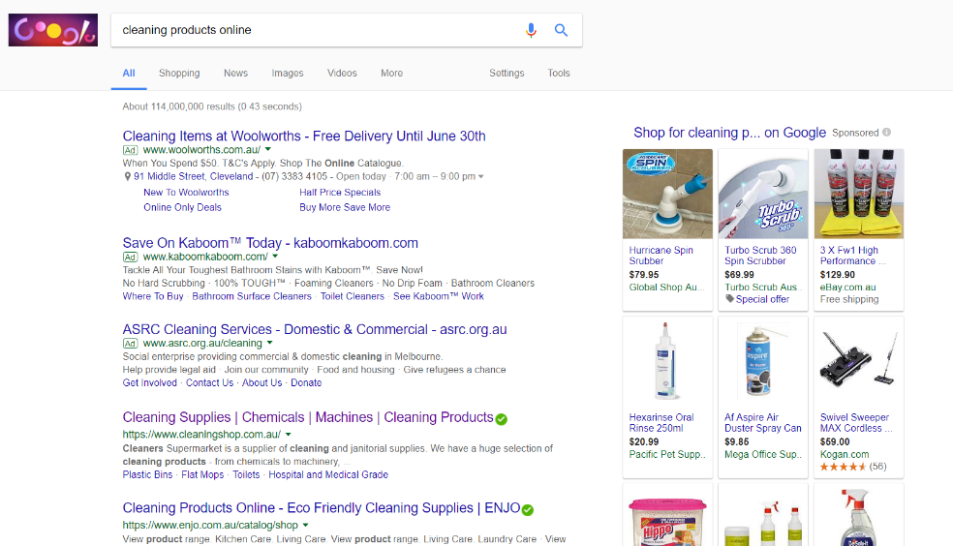
  When searching for a product/service online, the research stage may include looking at various websites and businesses. Consider the example below.
  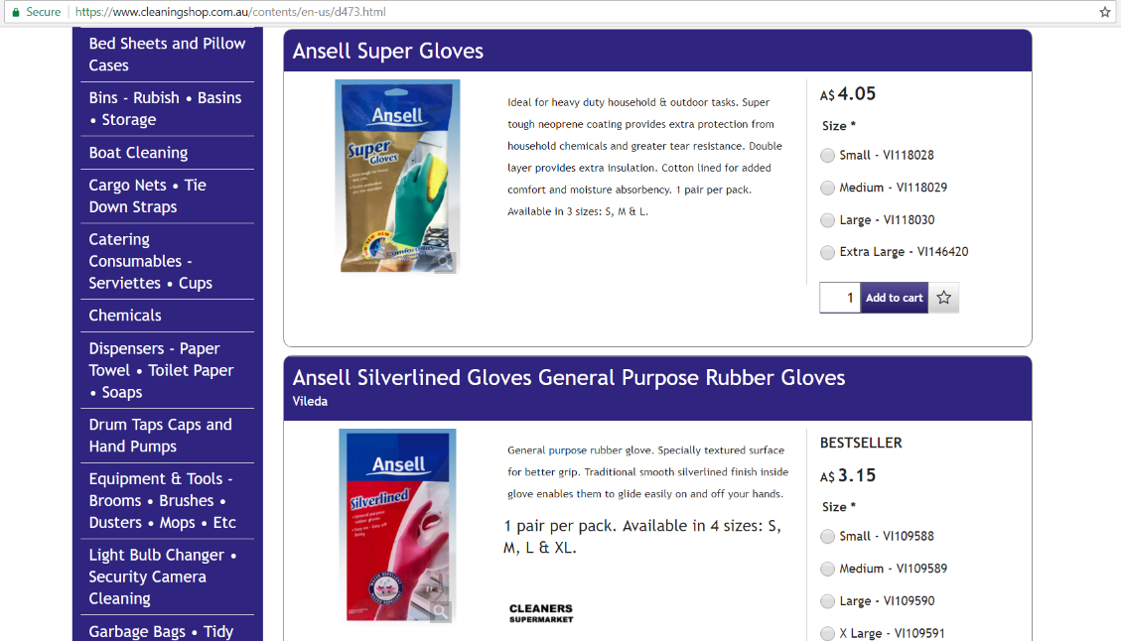
  Supplier online sites will allow you browse product options.
  Obtaining approvals for online purchases:
  Confirm your organisational requirements:
  Before obtaining approvals for online purchases, it is important to confirm the authenticity of the seller or business. If products have not been purchased from that supplier in the past, a trust can be built up by contacting the seller directly.
  While a purchase can be made by phoning the supplier, most websites will provide an online checkout. Using this service will often require the user to sign up to the website/business with a unique user name/email address and password.
  - Who?
  When ensuring that the website is authentic, it may be necessary to contact the supplier directly. Obtaining approvals for online purchasing might also involve consultation with a manager, supervisor or financial officer.
  - How?
  The process of gaining approvals would involve researching products and collating information about suppliers, product specifications and prices. To make final decisions on a purchase, consultation with the necessary parties would then need to take place. Before making a purchase, you may also need to obtain a company credit card or payment information.
  EXAMPLE
  Most websites will have a Contact Us page, as shown in the example below. Using this page, you can get in touch with the business by phone or email to find out more information regarding products and prices. Contacting the supplier also allows you to develop a trust.
  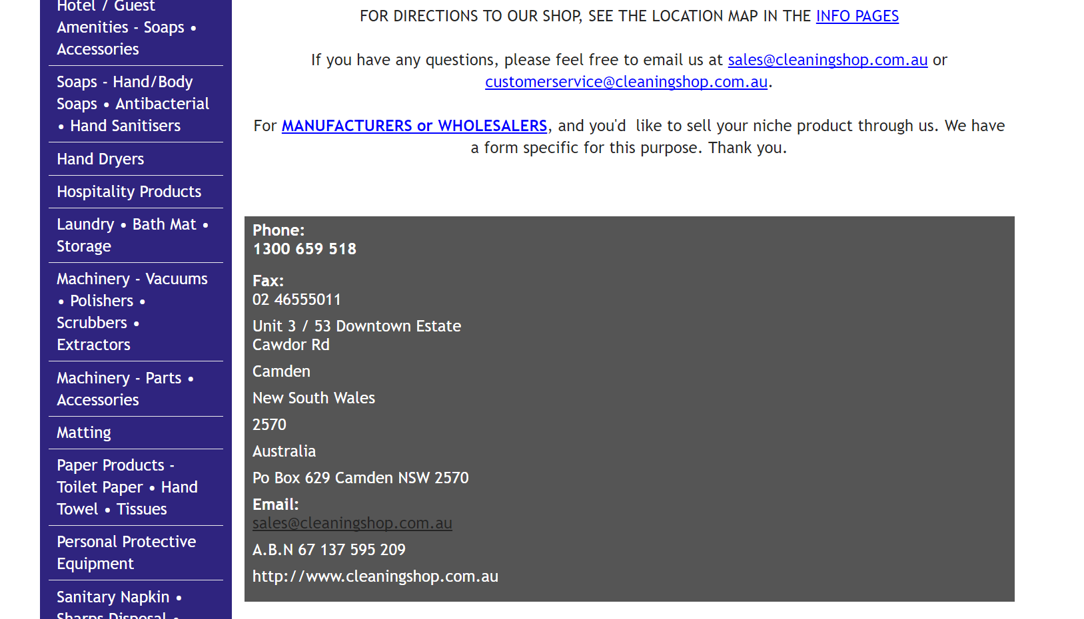
  Obtain quotations from suppliers:
  Confirm your organisational requirements:
  Obtaining quotes from various suppliers allows you to weigh up a number of options in order to make the most practical and cost-effective decision.
  - Who?
  To obtain quotes, it is necessary to contact the supplier by getting in touch with the sales department.
  - How?
  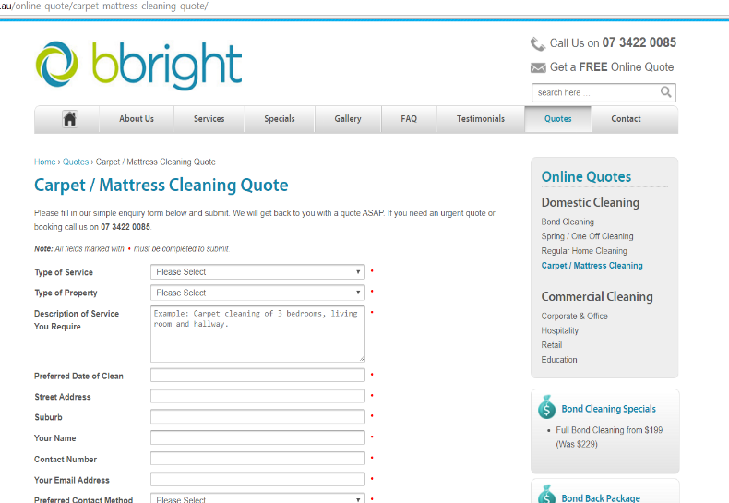
  This can often be done by sending a message or email to the supplier from their site. Since online services are automated, messages are received straight away to ensure speed of service.
  EXAMPLE
  The image (right) shows
  an example of a website
  feature which allows you
  to obtain an immediate
  quote from the supplier
  by filling out an online
  form.
  Address any issues, delays, price changes from suppliers:
  Confirm your organisational requirements:
  A service provider is an external company contacted to manage your technological needs. If you experience issues with online facilities, contacting a service provider may be your first point of call.
  - Who?
  The organisations IT department will also work with the necessary service provider to resolve issues. If problems persist, it might be necessary to contact the supplier to find out if they are having difficulties with their own online facilities.
  - How?
  A service provider will attempt to resolve issues by; ensuring the online connection is working, and maintaining services and equipment supplied.
  EXAMPLE
  Select the suppliers, place orders and make purchases:
  Confirm your organisational requirements:
  Before placing an order, organisational requirements outline the need to have the necessary documentation and records, including signed confirmation. It is vital to confirm all terms of the transaction including payment terms, delivery methods and details, exchange/return policies etc. Make sure a receipt of products/services is issued.
  - Who?
  This stage of purchasing mainly involves consultation with the supplier when confirming purchasing terms.
  - How?
  Making the transaction is one of the final stages of purchasing. When placing an order, it is also necessary to ensure that credit card/payment information is correct, and that you have selected the right products and the correct quantities etc. The use an order number provides an ongoing reference for the purchase.
  EXAMPLE
  Purchase order number: 12345
  Date: 24/6/2017
  Your company name: Golf Corporation
  Your company address: 5 Driver Road, Brisbane, QLD
  Your contact details:
  Ph: 07 1234 5678
  Email: purchasing@golfcorporation.com
  Providers details:
  Name: Umbrella Planet
  Address:
  Umbrella Planet
  Level 9, 64 Castlereagh Street
  Sydney NSW 2000
  Australia
  Contact details:
  Ph: 1300 858 288
  Email: sales@umbrellaplanet.com.au
  https://www.umbrellaplanet.com.au/contact-us.html
  Purchase details....goods services etc
  Regular, printed, large, silver golf umbrellas
  Quantity / price: 50 @ $16.00 Each (Save 8%)
  Delivery details
  Please advise once order has been shipped. Deliver to 5 Driver Road, Brisbane, QLD between 8.00am and 5.00pm Monday to Friday.
  Special terms / instructions
  The Online Provider: Umbrella Planet
  Order Number: 12345
  Date you ordered the goods or services: 24/6/2017
  Thank You.
  - Once we have finished processing your order we will advise you that it has been shipped
  - You will receive an email with an updated delivery date estimate
  - For delivery date information, click here
  To: Golf Corporation
  Credit or terms purchasing details: Payment terms: COD
  Order Details
  Description of goods or services:
  $16.00 QTY: 50 TOTAL: $800.00
  Subtotal $800.00
  GST $80.00
  Order Total $880.00
  (8% Discount - Qty 50)
  SHIPPING INSTRUCTIONS / DETAILS: Please advise once order has been shipped. Deliver to 5 Driver Road, Brisbane, QLD between 8.00am and 5.00pm Monday to Friday.
  SPECIAL TERMS / INSTRUCTIONS
  Purchase order number: 12345
  Date: 24/6/2017
  Your company name: Golf Corporation
  Your company address: 5 Driver Road, Brisbane, QLD
  Your contact details:
  Ph: 07 1234 5678
  Email: purchasing@golfcorporation.com
  Providers details:
  Name: Umbrella Planet
  Address:
  Umbrella Planet
  Level 9, 64 Castlereagh Street
  Sydney NSW 2000
  Australia
  Contact details:
  Ph: 1300 858 288
  Email: sales@umbrellaplanet.com.au
  https://www.umbrellaplanet.com.au/contact-us.html
  Purchase details....goods services etc
  CHECK DETAILS
  Quantity / price
  CHECK DETAILS
  Delivery details
  CHECK DETAILS
  Special terms / instructions
  CHECK DETAILS

Activity 3A
Estimated Time | 30 Minutes
Objective | To provide you with an opportunity to maintain records of online transactions.
Case Study | - In teams of THREE (3) or as directed by the instructor, select a series of examples from your WORKPLACE of irregularities with online records  - Detail how your organisation deals with the process to report these errors or discrepancies in transactions documents
  Workplace activity
  Common or likely error / discrepancies | How it is addressed and resolved?
  - Bank charges | If incorrect bank charges occur, the error would need to be referred to the bank to be readjusted or resolved. Within my role, I would first alert a supervisor to make them aware of the error.
  - Interest | An error in interest charged/received may be evident when a bank statement is received. Again, this type of error could be resolved by contacting the bank.
  - Tax Codes | This type of error can occur when incorrect tax codes or amounts are displayed on an invoice. If this is a purchase invoice, a discrepancy such as this would need to be referred to the supplier so that it could be adjusted.
  - Purchase invoices | A number of errors in documentation can occur on purchase invoices. These may include incorrect amounts, quantities, products or discounts etc. Through consultation with the supplier, these can be resolved.

Activity 4A
Estimated Time | 30 Minutes
Objective | To provide you with an opportunity to review online transactions.
Case Study | - Using your WORKPLACE as a reference, detail what action to resolve non-compliance online purchasing issues with the supply of goods or services would apply to a selection of circumstances?  - Select your own set of WORKPLACE examples  - Reference your WORKPLACE purchasing policy or strategy if this applies
  - Goods are received and found to be non-compliant with purchase order.
  First, make a record of the damaged/non-compliant goods on the appropriate form or electronic system. A statement of non-acceptance could be recorded on the goods and returned to the supplier. The relevant personnel would then issue a request for the goods to be credited or replaced.
  - Goods are received and paid for (receipt is issued) and found to be non-compliant with purchase order.
  If a receipt is already issued for payment of the goods, however they are later found to be damaged or non-compliant with the original purchase order, then a reversal of the goods receipt can be requested. Information and documentation would need to be provided to the accounts department.
  - Non-compliant to specifications
  In this instance, the goods received may not be damaged, however they do not meet the specifications requested on the original purchase order. A request for replacement of goods through a similar process would be appropriate.
  - Non-compliant with Australian Standards
  If the products supplied falsely claim to meet voluntary or Australian standards, this is a violation of legal requirements. In this instance, as in any other, the relevant personal should address the matter.

Skills and Knowledge Activity
Estimated Time | 90 Minutes
Objective | To provide you with an opportunity to demonstrate your knowledge of the foundation skills, knowledge evidence and performance evidence.
Activity | Complete the following individually and attach your completed work to your workbook.  The answers to the following questions will enable you to demonstrate your knowledge of:  - Learning  - Reading  - Writing  - Oral communication  - Navigate the world of work  - Interact with others  - Get the work done  - Key provisions of relevant legislation that affect aspects of business operations  - Policies and procedures relating to use of internet and online purchasing  - Service provider requirements  - Legal and ethical requirements relating to a range of online transactions  Answer each question in as much detail as possible, considering your organisational requirements for each one.  - Research a product/service online for your organisation. Write a report on your research into purchasing this and include the following information:  - Details of the product/service  - The suppliers found  - Requirements for the product/service needed  - If you needed to contact suppliers to obtain information and the outcome of this  - Requirements to making online transactions with the suppliers  - How orders can be made with the suppliers.  As a commercial cleaning business, cleaning products and supplies are an essential cost of operating. The products within this category can be sourced from various online suppliers. After researching carpet cleaning equipment in the local area, some of the suppliers found include; Brisbane Wholesale Cleaning Supplies, CleanX, Klean King and Carpet Cleaners Warehouse. Some of the products/services offered by these suppliers include equipment, accessories, chemicals or parts & maintenance.  Contacting the supplier before purchasing any products is a good way to find out more information and build a trust with the supplier. This also allows you to negotiate prices and discounts.  Once the required products have been selected, you can proceed through the online checkout to complete the purchase. As a purchaser, you are required to obtain and pass on the relevant information to the supplier such as an order number, contact/delivery details and any other requests. It is also important to maintain the appropriate records throughout the purchasing process, in accordance with organisational and legislative requirements.  - Describe the policies and procedures that you need to follow at your organisation in the process of online purchasing and for keeping records, and the relevant legislation and ethical requirements that affect this.  Before placing an order, organisational requirements outline the need to have the necessary documentation and records, including signed confirmation. It is vital to confirm all terms of the transaction including payment terms, delivery methods and details, exchange/return policies etc. Make sure a receipt of products/services is issued.  When placing an order, it is also necessary to ensure that credit card/payment information is correct, and that you have selected the right products and the correct quantities etc. The use an order number provides an ongoing reference for the purchase.  - Detail the service providers that your organisation uses and the services they provide.
  Service/Product | Service Providers
  Vehicle/Machinery/Equipment Maintenance | Border Pumps & Sprays, Burson Automotive, Goondiwindi Autoglass, Goondiwindi Hydraulics, Goondiwindi Mower & Bearings, Goondiwindi Tyre Service, Hi-Tech Auto Repairs, Oztune
  Vehicle Fuel | BP, Caltex, Coles Express, Freedom Fuels
  Freight | Followmount Transport, Australia Post
  Stationary and Office Supplies | Australia Post, Bishops News and Stationary
  Communications/Administration (phone, internet, subscriptions) | Kaspersky, Myob, Telco4U, Telstra
  Electrical | Country Energy, Lumo Energy
  Cleaning Equipment and Supplies | Bunnings Warehouse, Carpet Cleaners Warehouse, Intercity Cleaning Suppliers, Coles, JNL, Cyndan Chemicals
  Insurance | AAMI, Instrat Insurance Brokers, NRMA
  Advertising | Electrocut Signs, Pocket Books
  Training | CSTC Pty Ltd

Major Activity
Estimated Time | 1 Hour
Objective | To provide you with an opportunity to demonstrate your knowledge of the entire unit.
Activity | This is a major activity – your instructor will let you know whether you will complete it during class or in your own time.  Attach your completed answers to the workbook.  You must individually, answer the following questions in full to show your competency of each element:  - Identify and investigate online service provider  - Perform online transactions  - Maintain records of online transactions  - Review online transactions  - What should you do when identifying and investigating online service providers?  There are a number of steps involved in making online purchases. The first of those is identifying and investigating online service providers. When doing so, it is important to understand the requirements for the product/service needed. In most instances, it is necessary to contact suppliers to obtain quotes and further information regarding product specifications. After carrying out this research, you can review your options by considering the positives and negatives of each supplier in order to make the best decision.  - What should you do when performing online transactions?  When making online transactions, maintaining confidentiality and privacy of business information is vital, therefore it is necessary to investigate the authenticity of the online supplier and the security of their online site/service.  You must also ensure that credit card/payment information is correct, and that you have selected the right products and the correct quantities etc.  - What should you do when maintaining records of online transactions?  Organisational requirements outline the need to have the necessary documentation and records, including signed confirmation. It is vital to confirm all terms of the transaction including payment terms, delivery methods and details, exchange/return policies etc. Make sure a receipt of products/services is issued.  - What should you do when reviewing online transactions?  To ensure all information is accurate, check the details of the original purchase including purchase/payment terms, price/quantity, delivery details, special terms/instructions etc. If there is an issue or discrepancy within any of the purchase documentation, this must be recorded and referred to the appropriate personnel to be adjusted.

