CPCCBC4006B
Select, procure and store construction materials for low rise projects

THEORY EXAM INSTRUCTIONS

- This exam will occur under standard assessment conditions.
  - An oral examination may be allowed under certain circumstances.
Answers will be documented and FT003 (Oral examination declaration form) must be completed.
- Participants must provide enough detail in their responses to demonstrate their knowledge and skills.
- Please fill in the details below, providing your name, signature and date of assessment.
  - Your signature acknowledges that this is your own work.
- If a participant initially answers a question incorrectly but modifies their response, they must follow the instructions below:
  - If a participant changes their response in writing, they must put their initials next to the written change.
  - If a participant changes their response verbally, this must be noted on the exam paper by the assessor.

Participant name | Test Student
Participant signature | 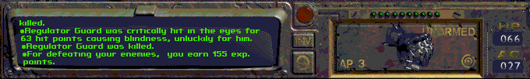

Assessor name | Mel Dobbs
Assessor signature | 

Date | 17/11/2017

Number of questions | Number of questions answered correctly | Satisfactory?
32 |  | Yes | No
Assessor Comments
This assessment reflects on what is required to supervise the systems through which materials are typically selected, acquired and stored on site for projects described by the Building Code of Australia (BCA) as low rise building or construction work (low rise' licensing classification with reference to Class 1 and 10 construction and Class 2 to 9 with a gross floor area not exceeding 2000M², not including Type A or Type B construction). It ensures the delivery to the site of materials that meet contract specifications and service requirements for low rise projects.

- Who is responsible for supervision on a building construction site?

Answer | I have completed all of the assessment. Did I pass?

- Who is then responsible for supervision when a Builder has a Construction Manager on site?

Answer

- Who is responsible to supervise and coordinate tradespeople working on site?

Answer

- Identify ten (10) materials commonly used for low rise buildings in your region (with slab on ground, prefabricated timber wall frames and roof trusses, brick veneer construction, plasterboard linings and texture coated external finish over brickwork along with metal or concrete tiled roof).
For each material, identify the following:
- Its name
- A supplier for this material
- Properties of the material

Answer | # | Material name | Supplier | Properties
 | 1
 | 2
 | 3
 | 4
 | 5
 | 6
 | 7
 | 8
 | 9
 | 10

- For each of the materials in Q4. identify the following:
- Quality of the material (i.e. safety, required fire resistance rating, suitability to the application, durability, serviceability, cost effectiveness and compliance with Australian Standards)
- Compatibility and non-compatibility of the material (i.e. what it would/would not be suitable for)

Answer | # | Quality | Compatibility
 | 1
 | 2
 | 3
 | 4
 | 5
 | 6
 | 7
 | 8
 | 9
 | 10

- For each of the materials in Q4. identify the following:
- Environmental impacts
- Tolerances for installing and assembling these materials in regard to the nature of the work being performed and the requirements of Housing/Residential industry and the Australian standards

Answer | # | Environmental impact | Tolerances
 | 1
 | 2
 | 3
 | 4
 | 5
 | 6
 | 7
 | 8
 | 9
 | 10

- For this task, please refer to the brief below. You are required to develop a preliminary quote and construction timeframe with schedule.
You have been approached as a local builder by Ian and Grace Fleming to build their home on their 1 hectare of level accessible land at 106 Blue Heeler Drive, Greenbank, Queensland.

The home is a slab on ground, four bedrooms and is of standard brick veneer construction with plasterboard internal lining and metal roof over 600mm eaves and two car garage with attached and roofed alfresco deck off the lounge and kitchen areas (see floor plan supplied below).

Levelling for the house pad requires a cut of 350mm to nothing (west to east) from the garage side of the building with north south reasonably level across the floor slab pad. The deck is facing in a northerly direction.

The Clients have provided you with a contour survey and the geotechnical report which suggests stable substrate soils with the possibility of small to medium boulder size rock within a metre underground. They also advise you, with photographs, that several large eucalypt trees will need to be removed for the house slab location. They want these trees chipped and all bark to be stockpiled on the site for future landscaping.

There is a 7 metre wide double gate access and 100 metres of cracker dust and gravel road into the property and ending literally at the future location of the garage doors. The block is fully fenced with timber posts and chain wire approximately 2 metres high. There is a concrete causeway rated to 120T at the entry gate and crossing over the roadside water table. There is bitumen road access all the way to the property from all access routes with nearest major community hubs being Springfield, and Greenbank/Browns Plains/Parkinson.

In preparation for developing your preliminary quote you need to create a schedule for this build describing estimates for time and labour. You are using sub-contract labour only except for the plumber and electrician who will supply both labour and materials). You have your own team of 3 carpenters with one apprentice. You are to schedule your supply chain for ordering and delivery of materials, including hiring additional plant and equipment for this build.

The list below is not definitive and you can add and subtract as determined:
Base Stage | Framing Stage | Enclosed Stage | Fixing Stage
- Site located and confirmed  - Site signs installed  - Safety signage installed  - Traffic Management Plan established  - Safety Plan instigated  - Land clearing determined and actioned  - Temporary sanitary units established  - Temporary power supply installed  - Sedimentary controls installed  - Waste skip installed  - Profiling/Layout for foundations  - Excavation  - Footings established  - Base brickwork installed  - Reinforcement installed  - Rough in (Electrician & Plumber)  - Other (Security/VacuMaid/etc.)  - Slab on ground established | - Erect load bearing walls  - Erect non-load bearing walls  - Install sheet, and strap bracing, tie downs etc.  - Roofing timbers installed (Trusses)  - Other? | - External brickwork established and laid (excluding sills)  - Fascia and gutters installed  - Roof fixed (without soffit lining, final scribing and screwing off)  - External windows fixed  - External doors fitted with locks  - Garage doors fitted or if not then internal door from garage to house fitted with lock | - Internal linings (stopping setting and finishing)  - Roof (final scribing and fully screwed off)  - Soffits lined and brick sills installed  - Architraves (http://www.woman.com.au/julie-rainbow-clarity-road/)  - Cornices  - Skirting  - Doors to rooms  - Baths  - Shower trays  - Wet area waterproofing  - Wet area tiling  - Built-in shelves fitted and fixed  - Built-in cabinets fitted and fixed  - Built-in cupboards fitted and fixed

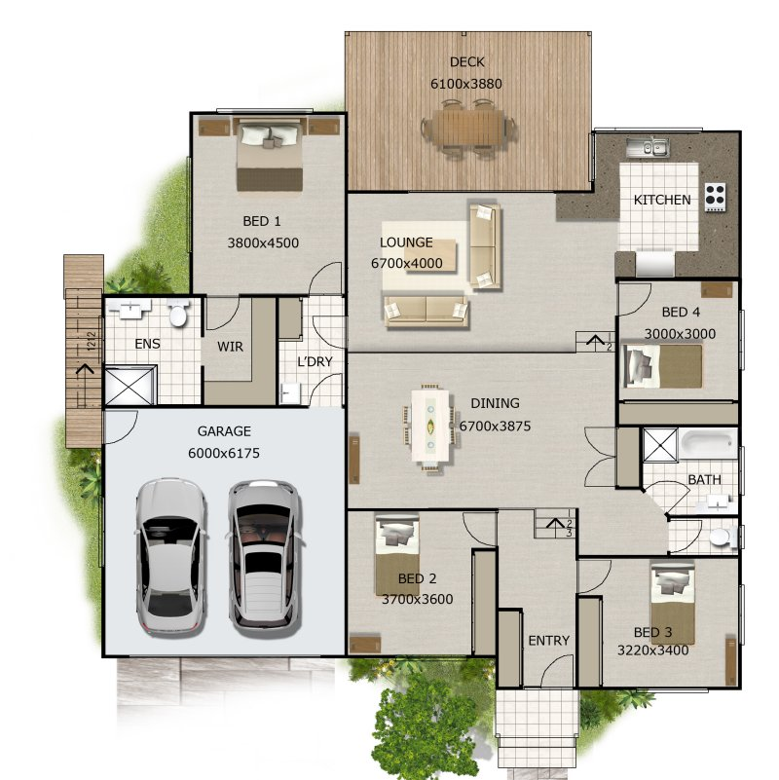

Answer

- There are four types of residential structures nominated in the BCA. Two of these are residential structures with concrete skeleton and slabs and residential structures constructed from non-metallic materials.
Name the other two.

Answer

- Building materials can be generally categorised into two sources: Natural and Synthetic. Explain these two terms.

Answer

- Name at least five (5) naturally occurring materials that were and can still be used to create homes to suit local climate and weather conditions.

Answer

- Choose any five of these building materials from Q10. and discuss the materials’ properties, and pros and cons for use and incorporation in a low rise residential construction.
Answer

Answer

Answer

Answer

Answer

Answer

- Every building material comes with an environmental cost of some sort. Discuss the principles that can help guide our choice of sustainable materials and construction systems.

Answer

- When using building systems what are the five steps we can follow for considering ways of reducing environmental impacts when erecting building structures?

Answer

- You or the company you work for should have a Building Quality Standards Policy. Why would such a policy be needed and what would be useful source and reference materials in developing such a policy?

Answer

- What is the purpose of a building specification in conjunction with the plans and drawings for the building of a residential home or other building structure?

Answer

- Explain the two terms Building Life Cycle (BLC) and Life Cycle Costing (LCC).

Answer

- When would Life Cycle Costing (LCC) and sustainable solutions need to be considered?

Answer

- What is a ‘Green Home’?

Answer

- When considering alternative building materials what must we take into consideration, other than the clients’ requirements?

Answer

- How do you take a delivery and deal with damages of materials and products delivered to site?

Answer

- What is a critical factor to consider when coordinating the delivery of materials to site?

Answer

- Explain in detail how building materials are handled on a building site.

Answer

- What is the main aim when storing materials on a construction site?

Answer

- What does it mean to store materials safely and carefully?

Answer

- What are some of the general points for storage of materials that office and worksite personnel should be aware of?

Answer

- How might you convey information to the workforce and visiting personnel when it comes to the use and installation of materials stored and/or delivered to site for immediate installation?

Answer

- Paying attention to natural phenomena affecting design/build considerations is important. A region and site location will present unique biological, geographical, geological, and meteorological conditions which may require special materials and methods.
Briefly explain who you can go to if you need further advice in this regard.

Answer

- What can you do (on-site and in the office) to improve reliable documentation and records of deliveries from suppliers, material, plant and equipment acceptance at site from delivery and installations by your own tradespeople and sub-contractors?
Answer

- What considerations come into play when selecting building materials? When would it be appropriate to consider alternative materials or building practices?
Answer

- Explain the difference between ferrous and non-ferrous metals. What is the principal reason why in cosmetic applications non-ferrous metals would be preferred over ferrous metals in building and construction?
Answer

- Supervision of your project requires a consistent, organised approach to each phase of construction. What would this entail?
Answer

Please read the information below in responding to Error! Reference source not found.

Given the variety of circumstances in residential construction, it becomes very difficult to create a master checklist covering all circumstances. Checklists by their very nature need to be comprehensive enough to provide sufficient information upon which to act or react and serve merely be regarded as a guide and should NOT be used as a means to troubleshoot your project.

The most important aspect of the checklist is to understand the level of detail you'll encounter should you decide to act as the builder or when using the services of a construction manager or general contractor to assist in project management duties.

- You are to produce a sample quality control checklist.
Keep in mind that whilst your checklist needs to be reasonably comprehensive, it will not become a substitute for good observation and critical thinking about quality control for your project and the product and material specifications applicable to it.
Your checklist should cover everything about the build from begin to end.

As an example could have headings like:
- PRECONSTRUCTION – including site access, temporary facilities, storage and protection, cleaning and debris
- SITEWORKS – including demolition layout, site clearing, excavation, back fill, grading, retain walls, asphalt paving, concrete paving, brick paving, public utilities, storm water controls, foundation drainage, trees plants groundcover
- FOUNDATION – including slabs, damp proofing, including set outs, footings including white ant system protection, walls, slabs, damp proofing and wall and crawl spaces
- FRAMING – including floor, wall, roof, roof sheeting and flashing etc.

Answer

