BSBLDR414
Lead team effectiveness

ASSESSMENT SUMMARY

The assessment activities for BSBLDR414 Lead team effectiveness cover all aspects of the unit of competency. For Apprentices/Trainees, this includes supervisor completion of the Apprentice/Trainee Record (ATR).

Participants must read all the information given before starting any assessment task. The assessment tasks are intended to be fair, flexible, valid and reliable. If a Participant has any questions or requires alternative arrangements to be made such requests should be directed to their Trainer/Assessor, who should note such arrangements in the ‘Assessor Comments’ on the affected assessment. If a Participant feels they are not yet ready to be assessed, they should discuss their options with their Trainer/Assessor.

To satisfactorily complete the assessment, the Participant is required to answer all questions correctly and demonstrate their skills to industry standards. If a Participant does not answer all questions or perform all tasks, they will be deemed ‘Not Satisfactory’ for the task and ‘Not Yet Competent’ for the unit of competency.

The Trainer/Assessor can provide the Participant with additional information on interpreting the assessment outcomes and guide the Participant’s options. If a Participant is still deemed ‘Not Satisfactory’ they will have the opportunity to undertake a supplementary assessment or appeal the result as per the process in the Student Handbook.

By signing below, the Participant acknowledges:
- They understand the assessment instructions and requirements, and consent to being assessed.
- The work submitted is to be their own work – with the work of/with others needing to be clearly acknowledged and documented.
- They consent to any photo/video recording of their work that occurs during assessment.

Participant name | Brenton Judge
Participant signature | 

Pre-requisite unit(s) to be achieved and authenticated prior to undertaking assessment
Not applicable

Task | Date completed | Assessment Results
Theory Exam | Select Date. | Satisfactory | Not Satisfactory
Practical Assessment | Select Date. | Satisfactory | Not Satisfactory
Outcome for BSBLDR414 | Select Date. | Competent | Not Yet Competent

Evidence requirements checklist (ticked by assessor and evidence supplied to RTO)
Theory Exam | Practical Assessment  Team development plan

Assessor Name
Assessor Signature | 

BSBLDR414
Lead team effectiveness

THEORY EXAM

Participant name | Brenton Judge

FOR THE PARTICIPANT
Instructions
- You will complete written questions as outlined on the following pages. You must attempt all questions and provide enough detail in your responses to demonstrate your knowledge.
- It is anticipated that you should complete this assessment within two (2) hours, but additional time may be allowed upon negotiation with the Assessor.
- You must complete all questions unassisted by the Assessor or other personnel but may refer to reference material as needed. All questions must be answered correctly for a ‘Satisfactory’ assessment outcome to be awarded.
  - An oral examination may be allowed under certain circumstances, whereby your answers will be documented by another party.
  - Any written questions that are incomplete, or not answered satisfactorily will need to be completed again after further training support.
    - If you answer a question incorrectly but modify your response, put your initials next to the written change (or the Assessor must initial a verbal change).
Resources required
Pen

FOR THE ASSESSOR
Instructions
- Where oral examination has occurred, ensure that this is acknowledged in writing (e.g. FT001 and Assessor Comments)
- All questions must be satisfactorily demonstrated by the Participant for a Satisfactory determination (indicated by an Assessor tick to the right of the question).
- Assessors are to complete marking in pen of a different colour to the Participant.
- If the Participant verbally modifies their response, write in the modified response verbatim and put your initials next to the written change.

ASSESSOR COMMENTS
As necessary, outline:
- Details on reattempts, alternative arrangements or reasonable adjustments made.
- Where a Participant is deemed ‘Not Satisfactory’, provide recommendations for future training.

- Identify a team that may exist in the workplace. Consider the purpose of the team, its goals and objectives. Name and describe the roles and responsibilities for at least three (3) team members. Finally, identify at least one (1) method that will assist with monitoring progress towards the team goals.

Answer | Point | Detail
 | Team purpose | Construction Management Services purpose is to deliver Capital Works on behalf of the Central Highlands Regional Council.
 | Goals and objectives | Short term | Year on year delivery of its capital delivery program.
 | Goals and objectives | Long term | Develop and implement the 10-year capital delivery program based on asset condition and Asset Management Plans.
 | Team members | Role | Description | Responsibilities
 | Team members | 1 | Manager Infrastructure | Accountable for the corporate Key Performance Indicator and ensuring staff have resources and support to achieve KPI
 | Team members | 2 | Coordinator Road Construction | Utilise tools to develop and ensure frameworks are followed
 | Team members | 3 | Project Costing Officer | Undertake the reporting to ensure trajectory towards KPI are on target and reports to Coordinator and Manager any abnormalities that may threaten achieving the KPI.
 | Progress monitoring | Progress monitoring is undertaken on a monthly basis for the delivery of the annual capital program and a quarterly basis for the development of the 10 year capital delivery program.

- True or False (Tick your response): A team leader is more of a mentor than overseer who checks work.

Answer |  | True
 |  | False

- Match the leadership styles and definitions by writing the appropriate letter next to each number in the centre column.

Answer | Style |  |  | Definition
 | 1 | Authoritarian | 1 - B | A | Leaders who let the team function without much interference
 | 2 | Democratic | 2 - C | B | Leaders who fully control their team
 | 3 | Laissiz-Faire | 3 - A | C | Leaders who try to include everyone in the decision-making process

- Identify two (2) benefits and two (2) drawbacks of transactional leadership.

Answer | Benefits | Drawbacks
 | Clearly defined short and long-term goals | Little room for flexibility or adaptability
 | Streamlined, efficient chain of command | Personal initiative is not rewarded or valued

- Which of the following are characteristics of transformational leaderships? Tick all that apply.

Answer | Choice | Possible Answers
 |  | The leader acts as a role model to employees
 |  | Close, consistent focus on the company vision
 |  | A high value on interpersonal relationships
 |  | Inspiration as a tool to motivate employees

- Why is it important for team leaders to include team members in the planning process?

Answer | Involving the various skilled team members in the planning allows for improved practices inclusive of:  - Innovation for better solutions to meet requirements  - Productivity for improved output of works

- For each of the listed activities in the table below, identify two (2) methods that team leaders can use to involve team members.

Answer | Activity | Method/s to involve team members
 | Goal setting | Method to involve your team in goal setting process and ensure their buy-in and commitment to the goal includes the following steps:  1 – Clarify the vision: Before you start setting a specific goal, the big picture and purpose of the team work.  2 – Solicit Input and feedback: One of the best ways to involve your team members in the goal-setting process is to ask for their input and feedback.  3 – Define SMART Goals: Specific, Measurable, Actionable, Relevant and Timebound  4 – Align and prioritise goals: After you have defined the SMART goals, you need to align and prioritize them with your team members. Alignment means ensuring that the goals are consistent and supportive of each other, as well as the vision and the organisation's objectives.  5 – Delegate and empower: The next step is to delegate and empower your team members to execute the goals. Delegation means assigning the right tasks to the right people, based on their skills, availability, and preference.  6 – Monitor and support: The final step is to monitor and support your team members as they work towards the goals. Monitoring means checking in regularly, tracking the progress, and measuring the results.
 | Decision making | Method for involving every team member in a decision making process is to:  1 – Assess the situation: Is the type of the decision you are facing: urgent, complex or impact others. It is important to assess whether there is enough time to consult everyone.  2 – Choose the right method: It important to choose the right method to involve your team members. There are many methods you can use, depending on the level of involvement and resources available.  3 – Communicate clearly and openly: The method chosen needs to be able explain the purpose, scope, and criteria of the decision, as well as the level and method of involvement you expect from them. [For example survey, email chain, team meetings]
 | Work allocation | Method for work allocation for every team member:  1 – Break down goals into individual tasks  2 – Analyse the competencies needed for each task  3 – List the competencies of each team member  4 – Proposed match tasks to people capabilities  5 – Consult and obtain feedback  6 – Implement and monitor performance

- True or False (Tick your response): Diverse teams produce more creative results than teams in which members are less diverse.

Answer |  | True
 |  | False

- Provide two (2) examples of how the knowledge, skills and background of team members can enhance team practices.

Answer | 1 – Team Experience and perspective can provide valuable insight and perspective. Previous lessons learnt, challenges, or opportunities for improvement in works can be of tremendous value.  2 – Team Experience and perspective from different skillsets can approach problems from different elements. The different experiences and cross collaboration can encourage and promote innovation and diverse approaches to work tasks.

- Provide two (2) reasons that responsibilities must be carefully delegated within the work team.

Answer | 1 – Over delegation of staff can be a risk. It is important to delegate staff roles / responsibility within their capability. Over delegation can result in a high risk to the business with lack of optimal decision progressing costing the business time and money.  2 – Under delegation of staff can result in excess work for the upper management who will be required to approve multiple things. Additionally, if can make staff feel a lack of value and underappreciated resulting in a reduction in staff retention.

- Describe what innovation brings to the workplace. Provide one (1) example of innovative practice.

Answer | Innovation can bring new practices into the workplace and has the potential to improve quality, cost or time of delivery.

- Describe (3) methods that may be used to measure a team’s innovation.

Answer | Methods to measure team innovation include:  * Self-assessment: where team members rate their own or their peers’ innovation and creativity skills  * Expert evaluation: where an expert reviews the team work and provides feedback and rating on their innovation and creativity skills.  * External stakeholder: stakeholder measures the impact of and value of the team’s work

- Explain how encouraging team members to assist each other in undertaking their roles and responsibilities can improve productivity.

Answer | The benefits of working together in a team and collaborating to enable team members in their roles and responsibility is inclusive of:  - Enabling better problem solving  - Unlock potential for innovation  - Collaboration makes employees happier with mutual respect, and personal openness were encouraged, team members were 80 percent more likely to report higher emotional well-being.  - Enhances personal growth / career development  - Lowers the risk of burnout  - Opportunities for growth  - Boost productivity  - Allows teams to be smarter risk-tasking  - Teamwork yields fewer mistakes  - Teamwork sparks creativity

- Describe (3) methods that may be used to measure a team’s productivity.

Answer | 1 – Collect insight from your team through 1 on 1’s:  Candid conversations about productivity, internal and external processes, as well as discussing relationships with other teams can all prove to be an effective way to evaluate any immediate or long-standing issues that need to be addressed.  2 – Key Performance Indicators  Measure team progress towards Key Performance Indicators and progress to achieving milestones and targets.  3 – Monthly Reporting and Baseline Monitoring  Utilising monthly meetings and reporting to review the deliverables that have been achieved and the targeted objectives at the beginning of the month. Review and reset and monitor each month accordingly.

- Which of the following are likely outcomes from involving team members in all aspects of a job? Tick all that apply.

Answer | Choice | Possible Answers
 |  | Causes members to resent the team
 |  | Makes the work more meaningful
 |  | Improves self-esteem of team members
 |  | Improves team morale
 |  | Team members take more responsibility for their individual work

- Explain how providing feedback to team members can encourage and motivate team members – building trust and positive working relationships.

Answer | Provide feedback improves a team performance by providing direction: by identifying performance indicators and allowing team members to understand their progress towards goals.  Feedback encourages team members to complete goals and objectives, they provide individuals feedback on their performance and encourages two-sided engagement.

- Identify one (1) issue, concern or problem that may be identified by team members. Describe the signs that you would recognise to identify the issue and how the matter could be resolved by internal team negotiation.

Answer |  | Response
 | Issue, problem, or concern | An individual from the team feels excluded by a colleague through correspondence and debriefing.
 | Signs | Signs can be email chains that exclude members or meetings where individuals have not been included
 | Solution via negotiation | Consultation and collaboration with impacted members to discuss the importance of incorporating all impacted team members in correspondence.

- Identify one (1) issue, concern or problem that would need to be resolved by an external party. Describe the signs that you would recognise to identify the issue and who the matter should be referred to.

Answer |  | Response
 | Issue, problem, or concern | Mix messaging received by different members of the team.
 | Signs | Third Parties communicating messaging that is inconsistent with the team objectives and what they are trying to achieve.
 | Solution via negotiation | Regular meetings within the team to communicate progress and actions being undertaken and correspondence of significance to any third parties.

- Identify three (3) ways that the team leader can serve as a role model to, and motivate, the team.

Answer | 1 – A leader can be a role model by being accountable for their own actions and mistakes  2 – Demonstrate that no task is beneath them and therefore not beneath any of their team members  3 – Integrity and transparency by being honest and transparent

- For each of the following areas, provide one (1) example of how the team leader’s contributions to the work team can enhance the organisation’s image:
- Internally, within the work team and the organisation
- Externally, with clients/customers

Answer | Question | Response
 | Within the work team and organisation | Team leader contribution and coordination of works can ensure that the deliverables and their timeline stay on scope / track. They can identify and intervene when agreement on approach can’t be reached and keep the team from not getting caught up on items that are not the corporate objective.
 | With clients and customers | The Team leader can represent to the client and customers the service that is being delivered. They often serve as the point of contact so individuals don’t get confused by an organisation internal processes and tasks to not know who to talk to.

- Provide three (3) communication methods that a team leader may encourage the team to use, and situations that each communication method would be suitable for.

Answer | Method | Suitability
 | Meetings | Can be suitable for the discussion of actions that required to be undertaken and come to agreement for who will be responsible for relevant tasks.
 | Email | Can be suitable for the conveyance of progress, impacts or potential changes for the works being undertaken.
 | Visual Displays | Use of tools such as a whiteboard can be impactful for informing the progress of works. Sign in and sign out board for team member movements and reporting each other progress for the task undertaken.

- Identify two (2) ways that the team leader can establish open communication with management.

Answer | 1 - Communicate Often: Through facilitating regular updates and communicating regularly with management. The team can feel accessible to management  2 – Accessibility: By being flexible and facilitating opportunities, it can establish open communication with management. An example could be a standing invite to monthly team meetings.

- Identify two (2) issues, concerns and problems that may be raised by the team to management.

Answer | 1 – Unrealistic timeframes / budgetary constraints. Often management can identify an organisational priority without all the nuances that are required to be considered, this can commonly lead to unrealistic timeframes for delivery or insufficient budget to carry out the task.  2 – Insufficiently sized project team / skillsets. Management may inappropriately assume a team have the correct skillsets to undertake the objective works.

- Identify two (2) issues, concerns and problems related to the team that may be raised by management back to the team.

Answer | 1 – Concern over the scope of deliverables / intent of management not being met by the Project Team and the works have morphed away from managements objectives.  2 – Management concern over lack of perceivable progress in the deliverables from the team.

- Describe one (1) situation where the team leader may have to negotiate with management on behalf of the team.

Answer | A team leader may have to negotiate on behalf of the team management timelines for deliverables, budget allocation or resourcing for the project.

Refer to the extract below from an Escalation Policy and Procedure to respond to Q26. to Q28.

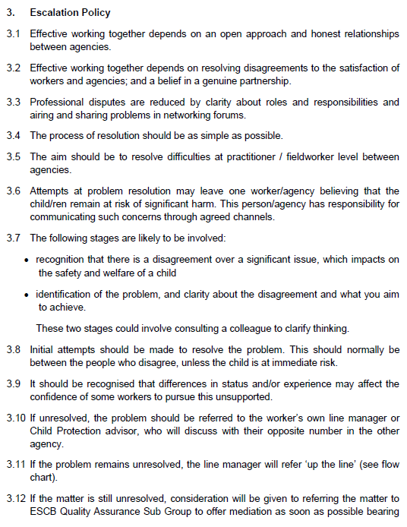
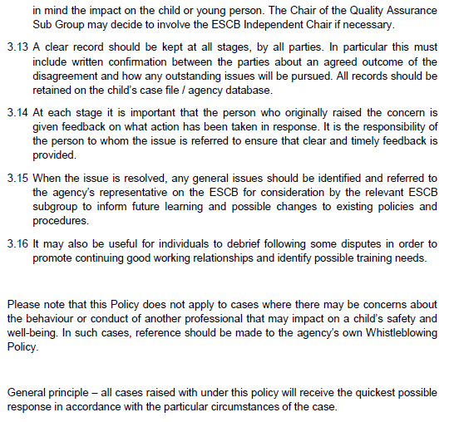
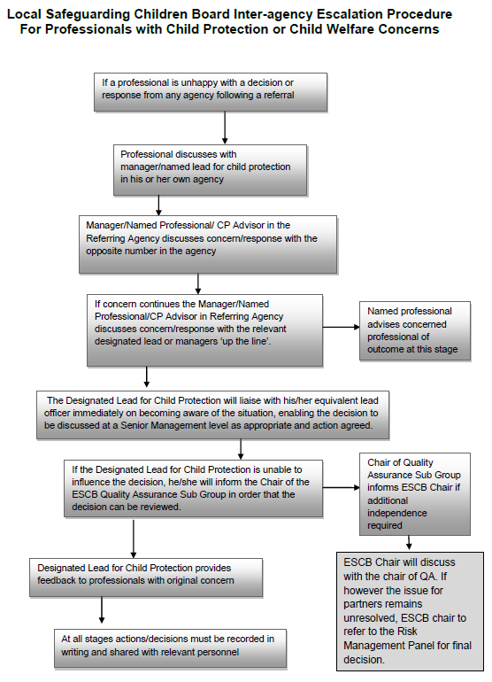

- Order the following steps from 1 to 5 to identify the correct order of issue escalation where a problem is unresolved.

Answer | Step Number | Steps
 | 1 | The people who disagree should make the initial attempts to resolve the problem
 | 5 | When the issue is resolved, any general issues should be identified and referred back to the agency’s representative to inform future learning and possible changes to existing policies and procedures
 | 3 | If the problem remains unresolved, line manager will refer ‘up the line’
 | 4 | If the matter is still unresolved, the matter may be referred to the Quality Assurance Sub Group to offer mediation
 | 2 | If unresolved, the problem should be referred to the worker’s own line manager

- True or False (Tick your response): It is the goal for all cases raised under this policy to receive the quickest possible response.

Answer |  | True
 |  | False

- If the ESCB Chair cannot resolve the issue, which body can make the final decision?

Answer | Designated Lead for Child Protection

BSBLDR414
Lead team effectiveness

PRACTICAL ASSESSMENT

Participant name | Brenton Judge

FOR THE PARTICIPANT
Instructions
- The tasks outlined on the following pages will require performance of normal workplace activities, as a result of a structured activity set by an Observer in the workplace or a simulated activity set by your Assessor/Observer.
- The timeframe for these tasks will be established by your Assessor/Observer, in consideration of location conditions and industry requirements.
- You must complete all tasks unassisted by the Assessor or other personnel, unless the steps note this assistance.
- You must attempt all tasks (and itemised steps) for a ‘Satisfactory’ assessment outcome to be awarded.
  - For any observation conducted that is incomplete, or without satisfactory performance, the observation will need to be completed again after further training support.

FOR THE ASSESSOR/OBSERVER
Instructions
- The following observation record should be used to judge and record your observations of the Participant as they complete the task(s) set. You must record your observations of the Participant’s performance.
  - For each occasion, indicate the task performed and whether it was a simulation or workplace-based task.
    - Any simulated assessment must ensure the Participant still performs under workplace conditions which reflect industry standards.
  - In the comments, provide clear detail regarding the task that the Participant was required to do (e.g. PPE used, materials handled, attachments connected, plant types).
- All steps must be satisfactorily demonstrated by the Participant for a ‘Satisfactory’ determination (indicated by an Assessor tick to the right of each itemised step, or an Observer tick to the right of each itemised step, and confirmation by an Assessor in the Assessor Comments).
  - Where you have determined that one or more task steps have not been satisfactorily demonstrated, provide the Participant with additional support and outline details of such assistance in the Assessor/Observer Comments. Allow the Participant two (2) further opportunities to demonstrate the task again to allow an opportunity for a ‘Satisfactory’ assessment outcome to be achieved.
  - If after three (3) attempts the Assessor determines that the Participant cannot demonstrate the required steps, a ‘Not Satisfactory’ outcome is to be determined.

TASK OUTCOME
Task | Date | Task Type (Tick) | Location | Task outcome (Tick)
 |  |  |  | Satisfactory | Not Satisfactory
Task 1 | 27/09/2024 | Workplace  Simulation | Emerald Depot

ASSESSOR COMMENTS
As necessary, outline:
- Details on reattempts, alternative arrangements or reasonable adjustments made.
- Where a Participant is deemed ‘Not Satisfactory’, provide recommendations for future training.

ASSESSOR COMMENTS: PRACTICAL TASK 1
Individual student (as named on cover page)
Multiple students [ All from Attendance Report, Specific students involved – identify students]
Task | Provide detail
1.B. | Feedback provided to team members:
1.C. | Support offered to identify and resolve problems, issues and concerns:
1.D. | Issues passed from management to the team and vice versa:

BSBLDR414
Lead team effectiveness

Practical Task 1
Description of task:
A suitable observer is to verify the participant’s ability to lead team effectiveness, including:
- Leading and consulting with the team to develop a team development plan that addresses –
  - Team cohesion
  - Innovation and productivity measures
  - Issues management and actions
- Communicating with team members and management to –
  - Consult, encourage, support and provide feedback to the team
  - Model team leadership behaviours and approaches
  - Resolve problems

The Observer is to provide detailed comments on the tasks completed by the Participant (on the Observer Comments, overleaf). The Assessor is to verify the Observer’s comments, noting their findings in the Assessor Comments (on the back of the Practical Assessment cover page) and provide the assessment outcome.
Resources required:
Team Development Plan Template
Observer details
Name of observer: | Tyronne Meredith
Role of observer  (Confirm suitability to sign) | Manager Infrastructure
Email address of observer | tmeredith@chrc.qld.gov.au
Signature of observer: | 
Date: | 27/09/2024

When completing the task, did the Participant: | Tick if satisfactorily completed.  Provide comments if left unticked.
- Lead and consult with the team to establish and document a team development plan, incorporating:
- Team purpose, roles, responsibilities, goals, objectives and plans
- Consideration of organisational goals, objectives and plans
- Team cohesion
- Innovation and productivity measures
- Issues management and actions
- Lead team to develop cohesion, including:
- Providing opportunities for input of team members into planning, decision making and operational aspects
- Encouraging and supporting team members to take responsibility for own work and to assist each other
- Providing feedback to team members to encourage, value and reward individual and team efforts and contributions
- Participate in and facilitate work team, including:
- Leading and supporting team members in meeting expected outcomes
- Actively encouraging team members to participate in and take responsibility for team activities and communication processes
- Giving the team support to identify and resolve problems, issues and concerns
- Acting as a role model to enhance the organisation’s image for work team, clients and customers
- In line with organisational escalation policies and procedures, maintain open communication by passing information from management to the team and vice versa (including issues, concerns and problems).

OBSERVER COMMENTS
Brenton delivery of Team Development Plan aligns with expectation of management and timeframes to achieve Federal Safety Accreditation.

TEAM DEVELOPMENT PLAN

DATE OF EFFECT
Start | 27/09/2024 |  | End |  | 31/03/2025
GOALS, PLANS AND OBJECTIVES
Outline the team’s purpose, goals, and objectives. Identify how this fits within the organisation’s goals, objectives and plans.
Central Highlands Regional Council seeks to obtain Federal Safety Accreditation (FSA) by March 2025
OBJECTIVES FOR TEAM
Objective |  | Work process |  | Responsible employee |  | Start date | End date
Team cohesion |  | Coordinate and Manage meetings to ensure progress on targets in obtaining Federal Safety Accreditation |  | Hayley Connolly |  | 27/09/2024 | 31/03/2025
Innovation |  | To review existing needs and proposed systems and opportunity to streamline and consolidate requirements to minimise operational rework |  | Brenton Judge |  | 27/09/2024 | 31/03/2025
Productivity |  | Develop processes necessary – identified from audit to comply with requirements for FSA |  | Kim Willard |  | 27/09/2024 | 31/03/2025
Issues management |  | To review documentation and ensure alignment with requirements and that all procedures developed do not contradict one another |  | Todd McCorkell |  | 27/09/2024 | 31/03/2025
REVIEWING AND ASSESSMENT METHODS
How will you track the plan’s implementation, the team’s progress (e.g. through team meetings, reports)?
Monitoring of progress on deliverables and percentage achieved to date based on initial desktop audit of Federal Safety Audit
ADDITIONAL SUPPORT
Is there any additional support needed to reach the desired goals (e.g. courses, classes, resources).
Nil
EXPECTED OUTCOME
Team leader’s expectations on the outcome based on the data.
An integrated Safety System that aligns to the requirements of the Federal Safety System
OUTCOME IF GOALS AND OBJECTIVES ARE NOT MET
Identify the consequences and further steps if the team fails to satisfy the standards set by the plan.
Delays in obtaining Federal Safety Accreditation inhibits council ability to deliver it own internal works that receive Federal grant funding.

