CPCCBC4010B
Apply structural principles to residential low rise constructions

CPCCBC4011B
Apply structural principles to commercial low rise constructions

THEORY EXAM INSTRUCTIONS

- This exam will occur under standard assessment conditions.
  - An oral examination may be allowed under certain circumstances.
Answers will be documented and FT003 (Oral examination declaration form) must be completed.
- Participants must provide enough detail in their responses to demonstrate their knowledge and skills.
- Please fill in the details below, providing your name, signature and date of assessment.
  - Your signature acknowledges that this is your own work.
- If a participant initially answers a question incorrectly but modifies their response, they must follow the instructions below:
  - If a participant changes their response in writing, they must put their initials next to the written change.
  - If a participant changes their response verbally, this must be noted on the exam paper by the assessor.

Participant name | Gavin Wong
Participant signature | 

Assessor name
Assessor signature

Date | Click here to enter a date.

Number of questions | Number of questions answered correctly | Satisfactory?
134 |  | Yes | No
Assessor Comments
- What are the four (4) primary loads which a structure must resist?

Answer | Dead Loads (fixed vertical)  Live Loads (variable but mostly vertical)  Negative and Positive wind loads (variable but mostly horizontal)  Hydrostatic pressure from water in the ground

Refer to the table shown below to respond to Q2. to Q3.

Live loads for floors as per building usage | Uniformly distributed load (kPa or kN/m²)
Houses | 1.5
Flats, motel bedrooms, apartments | 2.0
Offices | 3.0
Workshops | 5.0
Parking, vehicle >2.5t | 5.0
Hospitals, school assembly areas with fixed seating | 3.0
Dance halls, bars, lounges | 5.0

- Calculate the live load of a dance hall measuring 23m x 8m.
Show your calculations.

Answer | Area = 23 x 8 = 184m²  Live load = 5 kN/m²  Total live load = 184 x 5 kN = 920kN

- Calculate the live load of a commercial office premises floor measuring 33m x 11m. Show your calculations.

Answer | Area = 33 x 11 = 363m²  Live load = 3 kN/m²  Total live load = 363m² x 3kN/m² = 1089KN

- What happens when wind flows around a building?

Answer | Wind creates positive and negative lateral loads on a building

- Explain the difference in pressure exerted by wind on a building, as compared to a wind vortex.
What must be done to the building structure to prevent it being blown away?

Answer | Wind creates negative and positive lateral loads on a building  Wind vortex causes negative vertical loads on a building  Buildings must be tied-down to prevent them being blown away

- What are some of the factors to be considered for wind loadings?

Answer | Diagonal bracing  Rigid Frame  Shear Wall  Braced Frame  Horizontal Floor  Lift Shaft with Solid Walls  Triangulation

- Explain the term ‘load path’ in reference to a building.

Answer | Load Path is the path that a load travels through the structure of a building  Each structural member must be designed for all loads that pass through it

Please refer to the information below in responding to Q8. to Q14.

There is a building 21 metres long x 10 metres wide x 8 metres high with a 25⁰ pitched gable roof.
The rafter line on the metal clad roof measures 5.5 metres on the rafter line, that is, from the fascia/gutter line up to the ridge line.

The wind load rates are as follows:
- Windward wall is 21 metres long x 8 metres high with a wind load rate of +1.5KN/m²;
- Leeward wall 21 metres long x 8 metres high with a wind load rate of -0.8kN/m²;
- Windward roof with a wind load rate of +0.8kN/m²; and
- Leeward roof with a wind load rate of -1.5kN/m²

- What is the wind load rate for the windward wall? Tick your response.

Answer | Choice | Possible Answers
 | ☒ | +1.5kN/m²
 | ☐ | -1.5kN/m²
 | ☐ | +0.8kN/m²
 | ☐ | -0.8kN/m²

- What is the wind load rate for the leeward wall? Tick your response.

Answer | Choice | Possible Answers
 | ☐ | +1.5kN/m²
 | ☐ | -1.5kN/m²
 | ☐ | +0.8kN/m²
 | ☒ | -0.8kN/m²

- What is the wind load of the windward wall (Area of wall x wind load rate)? Tick your response.

Answer | Choice | Possible Answers
 | ☐ | -252kN
 | ☐ | 134.4kN
 | ☒ | 252kN
 | ☐ | 86.4kN

- What is the wind load for the leeward wall (Area of wall x wind load rate)? Tick your response.

Answer | Choice | Possible Answers
 | ☒ | -134.4kN
 | ☐ | -94.2kN
 | ☐ | 252kN
 | ☐ | 134.4kN

- What is the wind load rate for the windward roof? Tick your response.

Answer | Choice | Possible Answers
 | ☒ | +0.8kN/m²
 | ☐ | -43.2kN/m²
 | ☐ | -1.5kN/m²
 | ☐ | +1.5kN/m²

- What is the wind load for the leeward roof? (Area of roof x wind load rate). Tick your response.

Answer | Choice | Possible Answers
 | ☒ | -173.25kN
 | ☐ | 92.4kN
 | ☐ | 173.25kN
 | ☐ | -134.4kN

- What is the wind load for the windward roof? (Area of roof x wind load rate). Tick your response.

Answer | Choice | Possible Answers
 | ☐ | 252kN
 | ☐ | -92.4kN
 | ☐ | -252kN
 | ☒ | 92.4kN

- What are the main structural principles that apply to residential and commercial low rise structure erection and demolition?

Answer | Behaviour of structural principles  Loads and loading  Performance of beams  Performance of columns  Performance of roof trusses  Section properties  d\solution of force systems  wind bracing

- How is the classification of a building (or part of a building) determined?

Answer | The classification of a building or part of a building is determined by the purpose for which it is designed, constructed or adapted

- Refer to the BCA A3.2 building classes and give the classification definition for the classes of buildings listed in the table below.

Answer | Class | Classification definition
 | 1 | One or more buildings which in association constitute: a. Class 1a – a single dwelling b. Class 1b – boarding house, hostel
 | 2 | A building containing 2 or more sole-occupancy units each being a separate dwelling
 | 3 | A residential building, other than a building of class 1 or 2, which is a common place of long term or transient living for a number of unrelated persons (E.g.: boarding house, school, hotel)
 | 4 | A dwelling in a building that is Class 5, 6, 7, 8 or 9 if it is the only dwelling in the building
 | 5 | An office building used for professional or commercial purposes, excluding buildings of Class 6, 7, 8 or 9
 | 6 | A shop or other building for the sale of goods by retail or the supply of services direct to the public
 | 7 | A building which is Class 7a (a car park) or class 7b (for storage or display of goods or produce for sale)
 | 8 | A laboratory or building for the production, assembling, altering, repairing, packing, finishing or cleaning of goods for sale
 | 9 | A building of a public nature: Class 9a – health-care building, Class 9b – an assembly building, Class 9c – aged care building
 | 10 | A non-habitable building or structure: Class 10a – non-habitable building, Class 10b – fence, mast, pool, Class 10c - Shelter

- What is the purpose of understanding loads on a building?

Answer | Loads exert forces on a building which need to be analysed so you know the effects of materials and their structural performance under loads  You need to understand the loads on a building so you can design and build the structure to withstand all the forces that may be exerted upon it.

- Forces are represented as vectors and have three (3) properties.
Name these properties.

Answer | Magnitude – the size of the force  Direction – the direction of the force  Position – the body effect of the force

- How can you best visualise where a building’s loads are being transmitted (felt) on the structural elements of the building?

Answer | You can visualise which portion of the building’s load is transmitted to which structural element by following the load paths.  Load path analysis is a technique of mechanical and structural engineering used to determine the path of maximum stress in a non-uniform load-bearing member in response to an applied load. Load path analysis can be used to minimize the material needed in the load-bearing member to support the design load.

- What do the structural members of a building consist of?

Answer | Beams  Columns  Retaining walls  Floors  Wind bracing

- What are the two (2) main principles of structural effectiveness for structural members when considering the shape and type of material to use?

Answer | Mechanical properties – strength, toughness, elasticity, plasticity, ductility, malleability, brittleness, hardness  Sectional properties – the mathematical properties of structural shapes

- Explain the beam types listed in the table below.

Answer | Type | Explanation
 | Simply supported beam | Simply supported beams are supported at each end only. If downwards pressure is applied bending would occur at the middle of the beam
 | Continuously supported beam | Continuously supported beams are supported by three or more support points. They deflect less than simple beams of the same span because the positive and negative bending cancel each other out. Generally 20% more efficient than a simple span
 | Cantilevered beams | Cantilever beams overhang their supports. The cantilever section of the beam cannot support the same loads as the back span which is the section of beam between the supports. A typical allowance for the amount of cantilever in a beam is 30% of the back span therefore a 45 m beam could have a cantilever section 15 m long.

- Explain the terms listed in the table below.

Answer | Term | Explanation
 | Strength | The resistance to the load up till the point of fracture
 | Hardness | The degree of resistance to indentation or abrasion
 | Toughness | The resistance to fracture by repeated bending or twisting after its yield or breaking point has been passed.
 | Elasticity | The ability of a material to deform under loading and then return to its origin shape when un loaded
 | Plasticity | The opposite to elasticity – I f a material does not return to its original shape after being deformed. If permanent deformation occurs after the load is removed. This is called plastic behaviour.
 | Ductility | The property which allows a material to be drawn out in the direction of its length. Wire for example. A ductile material will not fail suddenly or snap without lengthening before it fails.
 | Brittleness | The property which cause a material to break or snap without any noticeable warning
 | Malleability | A material that can be hammered or otherwise worked into various shapes.

- Discuss the terms compression, tension and shear forces when applied to materials and structural members of a building.

Answer | Term | Explanation
 | Compression | When a beam bends the top fibres will be under compression  Column are vertical support members subjected to compressive loads  When the load is central to the centre of gravity axis it produces a direct compressive stress within the column  Eccentric column, where the load is off centre, the column experiences bending and compressive stress.
 | Tension | When a beam bends the top fibres will be in tension
 | Shear | Vertical shear forces on beams are generated by the load exerting a downward force and the supports reacting against that force. In most cases the maximum shear value occurs close to the supports

- What is a column and how does it transmit load forces?

Answer | Vertical support members

- Is a column, stump or post in compression, tension or shear?
Explain your answer.

Answer | Compression – loads are applied from the top and are transmitted vertically downward. The reaction of the upward support and the downward force causes the column to be in compression.

- Explain the letters ‘CHS’ and ‘SHS’ with reference to columns, pillars, posts/stumps and stanchions as vertical (usually steel or concrete pipe) support members subjected to compressive loads.

Answer | Circular Hollow Section  Square Hollow Section

- Explain the terms listed in the table below with relation to structural performance of columns.

Answer | Term | Explanation
 | Axially load column | When the load is central to the centre of gravity axis, it produces a direct compressive stress within the column. Axially loaded columns are sometimes referred to as 'concentric columns'.
 | Non-axially loaded column | When the load is off-centre the column is called an 'eccentric column'. This results in bending and compressive stress being applied to the column.
 | Buckling | Buckling is a major consideration in designing all compression members. Buckling is deformation (deflection, bending) at right angles to the direction of the applied load.  Buckling will always occur about the weakest axis unless some form of lateral (sideways) restraint is used to prevent it
 | Slenderness ratio | The maximum load a column can be allowed to support depends on the slenderness ratio and the material from which the column is made. The slenderness ratio involves:  • the column height  • the size and shape of its cross-section  • the manner in which the two ends of the columns are supported or fixed
 | End fixity and effective length | The way in which a column buckles is affected by how rigidly it is connected to other members at the top and the bottom. The term for the type of end fixing is end fixity and this affects the way a column buckles. The length of a column which may buckle is defined as the effective length.

- How will bearers, joists, lintels, beams or girders transmit load forces?

Answer | The bearers, joists, lintels, beams or girders transmit the forces through the structure to the foundation. These elements provide support for transmitting loads on the building.

- How do floor boards transmit load forces? Explain with reference to residential and commercial low rise structures.

Answer | Floors are generally distributed loads (kN per m)  Floor boards distribute the load along their length to the joists which distribute the load along their length to the bearers which distribute the load along their length to the supports (walls, columns, post, stumps) and down to the foundations.

- How do walls, floors, and roofs transmit load forces?

Answer | Load forces are transmitted along the load path to the foundations

- Explain what load imposition from torsion (twisting) can do to a building’s structure.

Answer | Torsional phenomena include  - Twist of beams under loads not passing through the shear centre  - Torsion of shafts  - Torsional buckling of columns  - Lateral torsional buckling of beams

- Explain what retaining walls are and what is critical to their sufficiency of structure.

Answer | A retaining wall is built to retain soil. It supports soil were a sloping site requires excavation and there is insufficient room or it is impractical to batter the soil  Retaining wall over one metre high must be designed by a qualified structural engineer  Retaining walls must be able to resist soil pressurel

- Draw two separate hand sketches to explain the difference between a batter and a retaining wall.

Answer
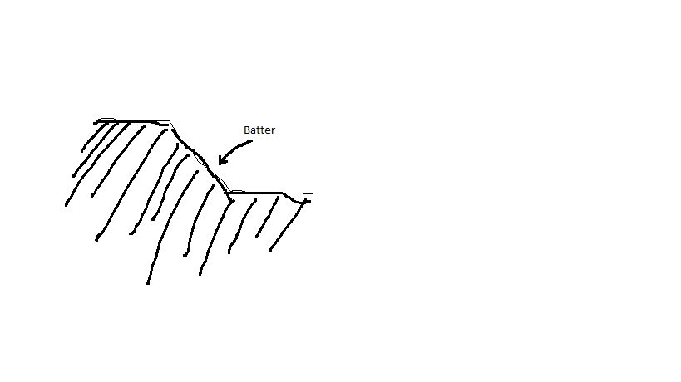

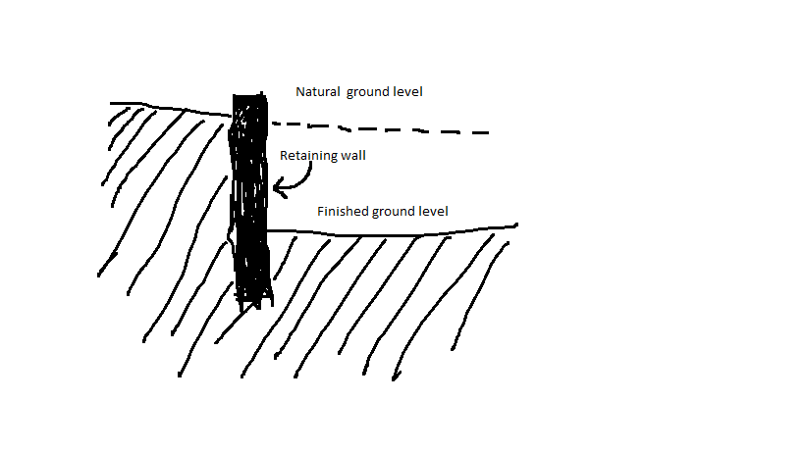

- Explain the differences between an inclined retaining wall, a gravity retaining wall and a cantilevered retaining wall.

Answer | An inclined retaining wall leans into the excavated soil and is constructed at an angle between 45 and 80 degrees. It may be constructed from brickwork or pre-cast interlocking concrete units.  A gravity retaining wall relies on its own weight to resist overturning forces from the soil. It is typically constructed of heavy materials such as stone, brickwork or concrete  A cantilever retaining wall is the most complex of the three types and must be carefully designed by an engineer. It relies upon the correct placement of steel reinforcement and varying thickness of concrete to resist the compressive and tensile forces exerted on the wall by soil pressures.

- What is a ground level concrete slab floor?

Answer | Ground slabs are poured directly into excavated trenches in the ground and rely on the existing ground for support. The ground (or foundation) must be strong enough to support the concrete slab.

- What is a slab subfloor made of?

Answer | concrete

- What should you consider when selecting the type of slab floor?

Answer | The bearing capacity of the ground

- Name and describe each of the general soil classifications that are followed in Australia.

Answer | Class A  Mostly sand and rock sites, with little or no ground movement expected.  Class S  Slightly reactive clay sites. Only slight ground movement from moisture changes expected.  Class M  Moderately reactive Clay or Silt sites which can experience moderate ground movement from moisture changes.  Class H  Highly reactive clay sites. Can experience high ground movement from moisture changes.  Class E  Extremely reactive sites. Can experience extreme ground movement from moisture changes.  Class P  A problem site. This can includes soft soils, such as soft clay or silt, varying depths of Fill, loose sands, landslips, mine subsistance, collapsing soils, soils subject to erosion, reactive sites subject to abnormal moisture conditions, or sites which cannot be classified otherwise.  Soil types M, H, and E may also have an added classification of ‘D’. This indicates deep seasonal moisture variation which can mean significant expansion and contraction.  For example, from a dry to a saturated state

- What purpose does the soil report serve? Who prepares a soil report?
Which Australian Standard (AS) will be relevant to the soil report?

Answer | Soil Report  The soil report is prepared by a geo-technical engineer. A series of soil samples are taken from the site and assessed in the lab which determines:  - the site soil classification  - the soil bearing capacity (much weight it can support)  - Its Reactivity (how much soil moves when moisture content in soil is varied  The soil classification is the most important conclusion as an engineer uses this information to design a footing system/slab from AS 2870. The report is then passed on to the structural engineer who uses this data to design an appropriate footing system.

- There are many different types of on-the-ground concrete slabs. Write a brief description for those listed in the table below.

Answer | Term | Explanation
 | Slab on ground | Slab-on-grade or floating slab foundations are a structural engineering practice whereby the concrete slab that is to serve as the foundation for the structure is formed from a mould set into the ground. The concrete is then placed into the mould, leaving no space between the ground and the structure.
 | Stiffened raft slab | A stiffened raft consists of a concrete slab on ground stiffened by integral edge beams and a grid of internal beams. It is also referred to as a slab-on-ground footing. The floor slab is placed at the same time as the external and internal beams all of which are reinforced.
 | Waffle raft slab  (aka waffle pod slab) | Waffle raft slab construction is quite different from stiffened raft and footing slab structures. The slab ribs are formed on top of the ground using a grid of polystyrene void forms which are laid out on a levelled area. It is ideally suited to very reactive clay sites and does not have the problems associated with stiffened raft slabs that have their beams embedded in the reactive clays.
 | Pier and slab | On sites with more reactive soils, it's common for concrete piers to be sunken into the soil to improve stability. This is normally done by digging holes at intervals and depths determined by an engineer, then pouring concrete into them and attaching the slab to these piers.

- Briefly explain how a concrete slab sub-floor is installed.

Answer | For a standard slab on the ground, first the site is scraped back to the soil, keeping it as level as possible and ridding it of all plant matter. Then, formwork is put up around the edges of the slab to prevent the concrete from spreading. Trenches are dug around the edges for all stiffening beams, and bedding sand is laid down to level things out. A plastic vapour barrier is used to coat the site and prevent dampness from rising through the slab. Rebar or mesh is then spread out to cover the area. In some situations a layer of gravel may be laid down to provide a solid base. The concrete is then poured on top, spread out and levelled.

- Where are ground-level concrete slab sub-floors used?
What are the advantages and disadvantages concrete slab sub floors over conventional timber or steel sub-floor framing on stumps/posts with strip or sheet flooring?

Answer | - Ground slabs are very common these days and can be found almost anywhere in Australia where there is ready access to concrete. These foundations are generally used to support heavier building materials like brick and steel.  - Advantages  - Extremely durable and hardy base for a floor  - Typically well insulated, because the underside of the floor is not exposed  - No maintenance once the concrete has cured  - Disadvantages  - Impossible to access piping once the slab has cured  - Cracks can cause major structural damage, and may be unrepairable  - Can increase unwanted noise

- Explain the terms listed in the table below.

Answer | Term | Explanation
 | Foundation movement | All house foundations move. Foundation movement is caused by changing soil conditions, hydrostatic pressure, structural instability of footings or piers, invasive tree roots and poor exterior drainage management. Earthquakes, floods and frost heave also can contribute to soil shifts and foundation movement.
 | Slab bending | When there is foundation movement because of reactive soils, the slab will bend. The resulting movement is classified as either dishing or doming.  The type of bending will determine where steel reinforcement needs to be placed in the concrete slab
 | Stiffening beams | The design of the arrangement of stiffening beams is influenced by the reactivity of the foundation soils.  Ground slabs are typically constructed with stiffening beams which are placed along the perimeter of the slab

- Buildings are usually designed to support the vertical loads created by dead and live loads. They also need to be able to resist lateral loads from wind and vortex loads. In building we use numerous techniques to overcome this problem.
Briefly explain the three common cable bracing techniques and sketch diagrams to explain your answer.

Answer | Knee bracing  K-bracing  Cross bracing

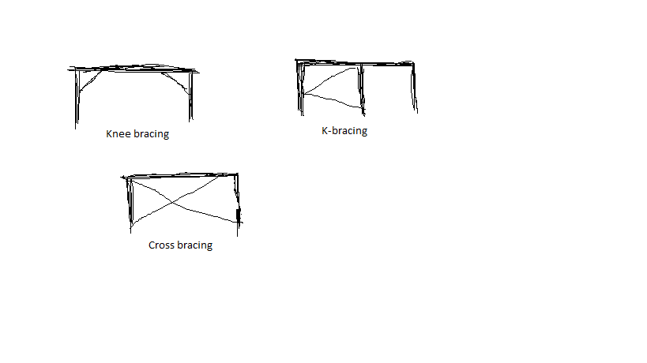

- Different bracing systems are used in residential and commercial construction which when operating together contribute to bracing a building against lateral wind, vortex and other forces.
Explain the bracing systems listed in the table below.

Answer | Term | Explanation
 | Rigid frame | A steel or reinforced concrete frame with rigid joints will resist changes resulting from forces in different directions.
 | Shear wall | A wood, concrete or masonry wall will resist changes in shape. The wall will transfer lateral loads to the foundation.
 | Braced frame | The frame is timber or steel and is braced with diagonal members.
 | Horizontal floor | A rigid floor structure is like a deep flat beam. The floor transfers lateral loads to the shear walls and to the braced or rigid frames.
 | Lift shaft with solid walls | Most office blocks are made stiff by using an internal concrete shaft as a stiff central core to which all the floors are rigidly fixed.  The floors act as horizontal diaphragms which transfer the stiffness from the core to the whole building.
 | Theory of triangulation | Triangulation involves the use of triangular shapes to give stability to structures. It relates particularly to pinned or hinged structures. Usually these types of structures offer no resistance to bending moments when a force is applied.

- What are important considerations when undertaking demolition work?

Answer | Get a demolition permit  Employ a building surveyor to assist in completing the application process  Get a planning permit

- What must be included in an application for a permit to demolish or remove a building?

Answer | An application for a permit to demolish or remove a building must include the following information:  - a description of the building  - a site plan showing the building in relation to boundaries, other buildings on the site and adjacent sites, streets, footpaths and crossings  - structural computations demonstrating the structural adequacy of the building if it is only to be partially demolished  - details of protection, hoardings, barricades and protective awnings  - a written description of the demolition procedure  - evidence that the demolisher has the necessary knowledge, experience, equipment and facilities to properly conduct the demolition operations

- Describe the process of applying for a demolition permit using a simple flow diagram.

Answer
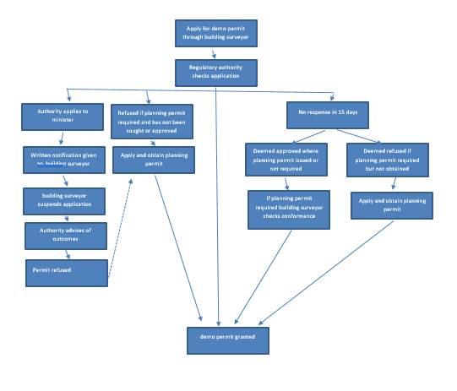

- Name the primary Australian Standard and codes of practice to be followed when performing demolition of structures.

Answer | - AS 2601: The demolition of structures  - code of practice - Demolition 1991  - code of practice for the safe removal of asbestos, second edition 2005.

- When performing demolishing what are some of the agencies which might be accessed for information and guidance?

Answer | - Australian Safety and Compensation Council  www.ascc.gov.au  - National Occupational Health and Safety Commission  www.nohsc.gov.au  - Queensland WorkCover Authority  www.workcover.qld.gov.au

- Name some of the people included in the construction process, from professionals involved in building design to specialist tradespeople.

Answer | - Architects  - Engineers  - Drafts people  - Building surveyors  - Land surveyors  - Quantity surveyors

- Who would you consult to gain insight to using the right sized and right shaped materials for a project?

Answer | An structural engineer

- Briefly describe the role of an architect.

Answer | Architects are people who design buildings and in many cases also supervises their construction. They help you to set a viable and realistic budget, guide you through the planning process and obtain competitive quotes and manage consultants.  Architects also:  - Developing a client design brief  - Preparing concept sketches and working out what is possible  - Preparing site analysis reports including documentation of site constraints  - Preparing contract documentation, including the contract, specifications and working drawings  - Organising tendering  - Overseeing contract administration  - Organising design development and permit applications  - monitor the budget

- Briefly describe the role of a structural engineer.

Answer | A great deal of what structural engineers do involves designing structures such as buildings, bridges, tunnels, etc. The majority of structural engineers work primarily as consultants to architects or design-build contractors.  Engineers also:  - Preparing reports on how to protect neighbouring properties  - Designing the structure of retaining walls, columns, beams and loading walls in building projects  - Preparing reports on the structural adequacy of existing buildings  - Conduct Soil testing  - Write Floor plans  - Design footing systems detailing positions of bearers and joists  - Design concrete slabs

- What is the difference between a building surveyor and a land surveyor?

Answer | Building surveyors provide professional advice on property and construction, which spans across residential, commercial, industrial, leisure and agriculture projects. They work on the design and development of new buildings as well as the restoration and maintenance of existing ones. They also:  - Assess building plans submitted for approval to ensure compliance  - Provide advice/assistance to builders/owners before finalisation/lodging plans  - Pre-purchase inspecting of all types of buildings  - Inspecting buildings during construction to ensure methods and materials Keeping records and writing reports of building progress and instances where regulations have been breached – plans altered  - Giving evidence in court when prosecutions are necessary for breaches of building regulations  - Issuing compliance certificates on completion  Land surveyors assess the surrounding terrain and landscape for the purpose of development. They commonly use specialised technology and equipment to do this as many of today's development, subdivision, building and tunnelling projects are so complex.  Land surveyors also:  - Taking levels on a site to produce detailed contour plans  - Determining location of existing buildings and other features on a site  - Setting out the building line, marking the location of columns or the external perimeter of a building  - Checking the vertical alignment of a building during construction  - Conducting boundary surveys and re-establishment of survey pegs  - Checking the positioning and overall height of a structure at completion to ensure compliance with the conditions of permits

- What is a quantity surveyor and work do they perform?

Answer | A quantity surveyor (QS) is a professional working within the construction industry concerned with construction costs and contracts. Services provided by a quantity surveyor may include: Cost planning and commercial management throughout the entire life cycle of the project from inception to post-completion.  They also:  - Initial cost advice during the pre-contract stage, preparing approximate estimates  - Costing planning information concerned with the development of a design  - Preparing the necessary tender documents, critically examining the tenders and priced bill of quantities when lodged for tender  - Valuing the work during the construction stage at required intervals  - Recommending the amounts to be paid to the main contractors including assessment of any variations  - Controlling costs during the construction stage  - Outlining the economics of alternative methods of construction

- Name some of the building approval plans that will be necessary to see a project through its construction.

Answer | Contract plans  Original contour plans  Registered plans  Site plans

- What is a land title and what would you expect it to contain?

Answer | A land title is an official record of who owns a piece of land. It can also include information about mortgages, covenants, caveats and easements. It contains:  - A Plan with lot number  - Name of owner  - Reference numbers  - Certificate stamp

- Why would you need a construction permit or building permit?

Answer | A construction permit or building permit is a permit required in most jurisdictions for:  - new construction  - adding onto pre-existing structures  - major renovations.  Generally, the new construction must be inspected during construction and after completion to ensure compliance with national, regional, and local building codes. Failure to obtain a permit can result in significant fines and penalties, and even demolition of unauthorized construction if it cannot be made to meet code.

- What is a building permit and what does it show and record?

Answer | A building permit is the document which shows that your plans have been approved by a building surveyor. The building surveyor checks that the plans meet building regulations and includes:  - Occupation permit  - Progress payments  - Relevant dates  - Building surveyor  - Inspection dates  - Paperwork you are required to comply with

- What other permits could be required? Give two examples.

Answer | Demolition permit  Planning permit

- What would be reasonable to expect to see in a project specification?

Answer | Project specifications contain all the written information that accompanies the plans. Your building specifications provide supplementary information to the drawings, and they take precedence over any notations on the drawings.  The sections included in a project specification include descriptions about:  - the job  - the site  - the proprietor  - other parties in the contract arrangement, for example: a trades section detailing standards and quality of work.

- What is a sub-division plan and what is its purpose?

Answer | The plan of the subdivision is prepared for planning approval prior to the development of the land. It is a good source of information relating to adjoining properties.

- What would a site plan tell you?

Answer | The site plan shows a 'bird's eye view' of the building site which:  - Shows the location of a structure on a block of land  - minimises the risk of building on the wrong block of land  - is usually drawn to a smaller scale than a floor plan  - Is adequate at a 1:500 scale  - Is informative when looking at adjoining properties  As the roof line is detailed, the downpipe locations and stormwater drainage system can also be indicated as well as setback distances from the front and side boundaries.

- Explain what a floor plan will tell you.

Answer | Floor plans are like cross sections which are taken horizontally half way up the wall and are drawn to a scale of 1:100 or 1:50 (depending on project type).  Floor plans show a vast amount of detail including:  - all horizontal dimensions such as room size and wall thickness  - size and location of windows and doors  - location of fixtures and fittings  - any particular requirements in a room such as floor coverings  - an indication of the materials used for wall construction  - the overall floor area

- What is the purpose of a cross sectional drawing?

Answer | Cross Sections are a slice taken vertically through a given point along the building and are:  - generally drawn to a bigger scale than floor plans for more detail  - indicate the type of structural materials

- What information would you expect Municipal (Council) drainage plans and Water Authority documentation to provide you?

Answer | Municipal drainage plans provide details of legal points of discharge for stormwater drainage

- Briefly discuss the purpose of footing design and name the Australian Standard (AS) which applies for low rise commercial building projects.

Answer | Footing designs for residential projects are made to comply with AS 2879 - 2006 Residential slab and footing - construction. Dimensions are not generally shown so they must be read with the architectural plans.

- What are contour plans? Describe their purpose in building and construction projects.

Answer | Contour plans are a graphical representation of the lay of the land and show the degree of slope on a site. They typically relate back to a site datum and can be used to determine:  - the extent of cut and fill needed  - height of retaining walls  - overall finished height of buildings (referenced back to natural ground level)

- What is a site condition report and what is its purpose?

Answer | The site condition report is a record of details about:  - the existing site  - buildings on adjacent boundaries and setbacks of structures  - condition of fences  - vegetation on the site on the boundaries  - location of services (water, gas, electricity and telephone lines)  .

- What does the AS3959 refer to?

Answer | AS 3959 provides a method of assessing the bushfire risk of a site by categorising the terrain including the slope and type of vegetation present.

- Australia is zoned into four regions for high winds. What and where are these regions?

Answer | - Region A - Normal  - Region B –Intermediate  - Region C - Tropical cyclones  - Region D - Severe tropical cyclones.

- The acceleration coefficient is a number which indicates the expected severity of the earthquake ground movement. Which Australian Standard should be referenced for this information?

Answer | The acceleration coefficient is a number which indicates the expected severity of the earthquake ground movement as determined under AS 1170.4

- What defines an alpine area in Australia?

Answer | Alpine areas are defined as 1,200 m or more above Australian height datum (AHD) for NSW, ACT and Victoria and 900 m or more above AHD for Tasmania. Sub-alpine areas are those areas 600 - 1,200 m in NSW, ACT and Victoria and between 300 - 900 m in Tasmania.

- Where in the Building Code of Australia (BCA) can you find information relating to alpine and sub-alpine areas in which the snow loads could play a significant part in design and construction?

Answer | BCA, Section 3.7.5 Alpine areas

- What can we reference when intending to use new and emerging building technologies in the construction of a building?

Answer | The BCA has requirements to allow for new and emerging building technologies. Any new technology must satisfy performance requirements and this can be determined by using the following assessment methods:  - documentary evidence  - verification methods  - expert judgement  - comparison to deemed to satisfy provisions

- What are some of the critical considerations to be made about footings and the transfer of loads from the building to its footing foundations?

Answer | Pressure of foundation soils – the BCA requires a minimum bearing pressure of :  - 100 kPa for under strip and pad footing systems  - 50 kPa for under slab footings  Footings selection, size and type, for example:  - Cladding  - Brick veneer  - Solid Brick  Stump materials:  - Timber  - Concrete  - Steel  Pier and beam - Blinding concrete is used to transfer the loads from the house to the good bearing.

- What codes and standards should be checked to ensure footings specified within the building plan are compliant?

Answer | - your BCA Volumes  - Section 3.2.4.5 for information on strip footing dimensions and reinforcement.  - Australian Standard AS 1684 'Residential timber framed construction'  - AS 2870-1996 'Residential slabs and footings - construction‘  - Australian Standard AS/NZS 2904:1995 'Damp-proof courses and flashings'  - AS 3660.1-1995 'Protection of new buildings from subterranean termites

- Name the relevant Australian Standard for protection against subterranean termites.

Answer | - AS 3660.1-1995 'Protection of new buildings from subterranean termites

- What should be considered when constructing a floor system?

Answer | When constructing the floor system it is important to take into consideration the type of flooring, the laying of pipes and reinforcement. The type of flooring in a house must be adequately supported by the flooring structure below.

- When designing and installing a concrete residential slab and footings what Australian Standard applies?

Answer | AS 2870-1996 'Residential slabs and footings - construction

- What are bearers in a sub floor framing system?

Answer | Bearers are the first of the sub-floor frame members to be installed. They are positioned over stumps, piers or other supports. In most cases they are timber, however, a wide variety of engineered timber products are available. As well, mild steel and cold-formed steel sections may be used to achieve greater spans.

- What are floor joists in a sub-floor framing system?

Answer | Floor joists are the next series of members for the sub-floor frame. They are supported by the bearers.  Typically the floor joists run over the tops of bearers, however, they may be attached to the sides of bearers. Like bearers, floor joists may be single span or continuous span. They can be made of timber or steel.

- Sketch free hand compact simple drawing in section to show the following floor system components of the external load bearing wall and bottom plate, joist and bearer to include:
- Wall frame
- Sheet flooring
- Floor joist
- Bearer
- Brick pier with stump cap

Answer
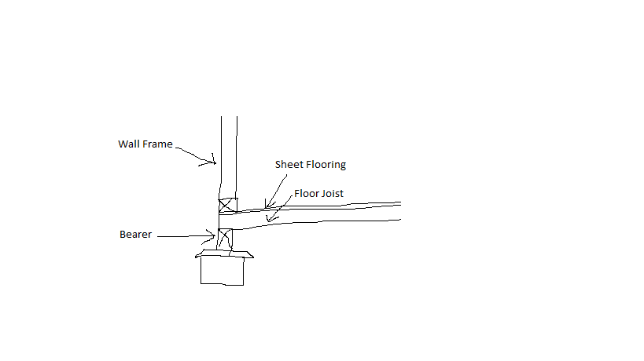

- What is a strip timber flooring system (also sometimes referred to as a fitted floor)?

Answer | Strip flooring is a type of wood flooring that is laid out with only solid pieces of wood in parallel rows. It is typically characterized by the thickness and width of the wood planks that are used.  Strip flooring/Fitted floors (cut-in floors) are installed after walls have been erected and after roofing, wall cladding, doors and windows have been installed.  Where boards are laid parallel with walls, a minimum 10 mm gap shall be provided between the board adjacent to the bottom plate and the bottom plate.  Board lengths have to be at least the equivalent of two joist spacings. Finger-jointed hardwood flooring manufactured in accordance with AS 2796 is equivalent to continuous strip flooring.

- Explain the benefit or otherwise of a platform floor.

Answer | A platform floor provides a working platform for the builder as the floor is laid before erecting the wall and roof framing.  The platform floor:  - should be protected from getting wet by rain and/or wet trades  - are laid with the face grain of the plies at right angles to the line of the supporting joists  - Edges of sheets, unless tongued and grooved, are joined over noggings between joists. Noggings (70 x 35 mm sections) are set flush with the top of the joists  You can glue and secret nail boards directly onto the platform floor. The other main advantage is that you have a nice flat surface to build on ... rather than spending month walking joists trying not to break a leg.  If the platform floor is exposed to the weather for too long it can swell at the edges.

- Briefly explain drilled or driven piles as a footing system for commercial/industrial type buildings.

Answer | Driven piles are deep foundation elements driven to a design depth or resistance. If penetration of dense soil is required, predrilling may be required for the pile to penetrate to the design depth. Types include timber, pre-cast concrete, steel H-piles, and pipe piles.  A drilled pier is a deep foundation system that is a large diameter concrete cylinder constructed by placing fresh concrete and reinforcing steel into a drilled shaft. It is also called as caissons, drilled shafts, drilled piers, Cast-in-drilled-hole piles (CIDH piles) or Cast-in-Situ piles.

- Which section of the Building Code of Australia addresses piling as a foundation system?

Answer | The Building Code of Australia Volume 1:  BCA Volume 1, B1.4 Determination of structural resistance of materials and forms of construction  The structural resistance of materials and forms of construction must be determined in accordance with the following, as appropriate:  (g) Piling: AS 2159.

- Explain the term ‘screw piles’. What must preface to approve the use of screw piles as a foundation system?

Answer | Screw piles/Power driven steel screw in columns  Power driven galvanised steel columns are an alternative pier system to timber piles. The piles have a helix auger on the ends, which enables the pile to drill itself into the ground.

- What does a concrete pier typically consist of?

Answer | A concrete pier typically consists of a:  - round or square concrete pillar  - footer piece which serves to spread the load carried by the pier  - footer is placed below the frost line and top end above the ground surface  - the concrete pier top is typically equipped with a frame or bracket which support structures upright beams are attached  - effective for most soil types in areas which have little or no earthquake or hurricane activity

- Where could you use a bulk pier and beam system?

Answer | Bulk pier (and beam systems) are satisfactory where good bearing soil is located between 800 mm and 1,200 mm below the NGL. Bulk piers are excavated using a simple backhoe and the excavation is usually 1 metre x 1 metre in area and extends to the founding depth (800 - 1,200 mm). Piers are normally located at 3 - 5 metre centres.

- What is the construction method for bulk pier and beam?

Answer | - Excavate the pier holes. The number, location and spacing will be shown on the design engineer's drawings.  - Pour concrete in the piers. The concrete is poured to approximately 500 mm below the NGL or FGL. No reinforcement is required in the pier holes. The concrete would be 20 MPa compressive strength.  - Excavate the strip footing. After three days, excavate the strip footing (or concrete beams) between the piers. These concrete beams will be excavated around the entire perimeter of the house.  - Position steel reinforcement for the beam.  - Pour the beam

- Name the framing system shown below.

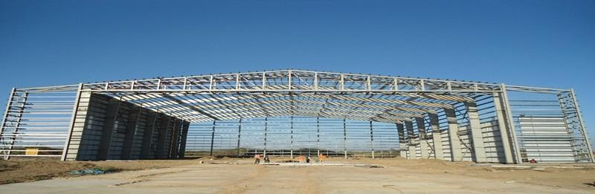

Answer | Portal Frame Construction

- Name the framing system shown below.

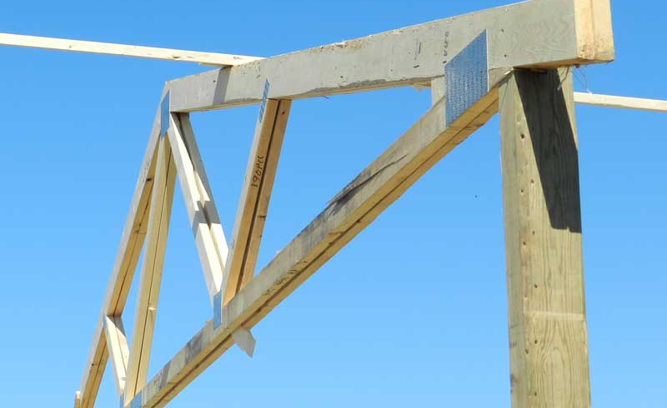

Answer | Pole and Truss Wall

- Name the building system shown below.

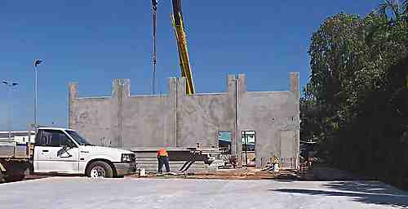

Answer | Tilt Slab

- Which section of the Building Code of Australia addresses masonry components for a building?

Answer | The Building Code of Australia Volume 1:  BCA Volume 1, B1.4 Determination of structural resistance of materials and forms of construction  The structural resistance of materials and forms of construction must be determined in accordance with the following, as appropriate:  (a) Masonry (including masonry-veneer, unreinforced masonry and reinforced masonry): Australian Standard 3700.

- What are masonry coatings?

Answer | Masonry Coatings is a generic term for any wall or masonry covering. This could be a exterior wall coatings, masonry paints, wall rendering, textured coatings or even pebble dashing.

- A ‘wythe’ or ‘leaf’ is the building and masonry term given to the width of a single brick or concrete block unit. A brick or block masonry wall might incorporate any of cavity brick, single-leaf masonry (brick or block) or lightweight autoclaved (aerated) concrete block (AAC). The cavity between ‘wythes’ can be anything from 50mm to 110mm.
Draw freehand sketches of the following and label your sketches:
- A single masonry wall founded on a cavity brick base with engaged pier,
- A cavity brick masonry wall with 50mm cavity
- A brick veneer and timber framed wall with 50mm cavity
- A masonry retaining wall one (1) metre high

Answer
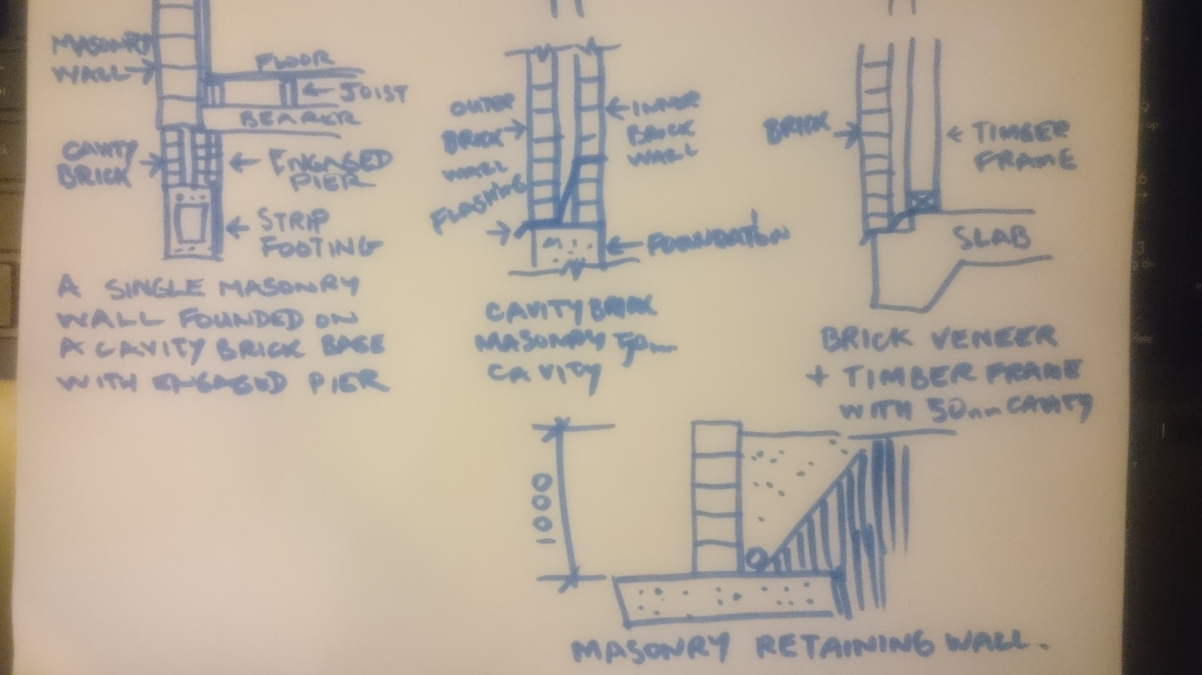

- What is cladding? What BCA section and Australian Standard address specific aspects of cladding?

Answer | Cladding covers the structure of a building it form the envelope that encloses the building and provides protection from the elements and contribute to the ease of maintenance of a building.  External cladding contributes to the comfort, structural integrity and look of a building.  Cladding may include  - Brick Veneer  - Coatings over base materials  - Colorbond or zincalume sheeting  - Fibre cement or compressed wood panelling  - Weatherboards  The Australian Standards for timber cladding are  - Hardwood (AS 2796 'Seasoned hardwood - Milled products' sets out the grades and tolerances for hardwood , AS 082 and AS 083 set out the grades for unseasoned sawn weatherboards)  - Cypress pine (AS 093 'Unseasoned cypress pine - Milled weatherboards (Chamferboard)'  - Preserved Treated pine (AS 1784 'Preservative treated cladding milled from Australian grown conifers' sets out grades and tolerances for treated pine, AS 1495 sets out grades and tolerances for preservative treated radiata pine cladding)  - Imported timbers (There is no Australian Standard to govern the grades and tolerances of imported timbers)  The Australian Standards for sheeting are  - Exterior plywood cladding (AS 2271 'Plywood and Blockboard for Exterior Use')  - Exterior hardboard cladding (AS 2858)  The Building Code Section - BCA Volume 2 – Part 3.5.3 Wall Cladding

- Explain timber cladding systems like chamfer boards and weatherboards.

Answer | Weatherboards provide smooth horizontal lines that help to articulate the large flat planes that are typical in contemporary design. They also come in a variety of shapes, sizes and materials allowing you to tailor your cladding to the specific requirements of your building project.  Classic weatherboard  These have a wedge profile that is overlapped to form a weatherproof cladding. The wedge shape is simple to cut from raw timber and allows the boards to be overlapped without progressively adding to the thickness of the wall. Because of its ease of manufacture, wedge-shaped weatherboards are the traditional form of cladding used throughout Australia.  Installation of classic weatherboards begins at the base of the wall and moves upward, with each subsequent board overlapping the previous. Nails are driven through both the thin end of the board underneath and then hidden by the board which is installed over.  Because of their wedge shape, classic weatherboards cannot be easily mitred or joined, and they do present detailing challenges. Usually the termination of this type of weatherboard is handled with a corner piece or elements such as window or door frames.  Shiplap  Shiplap weatherboards have a more complex tongue-and-groove shape that allows for the installation of a flat, weatherproof cladding. Shiplap boards are flat planks with the tongue and groove components of the board cut in such a way that allows a thin reveal to maintain the horizontal banding that is so important to the appearance of weatherboards.  In most cases, the installation of shiplap weatherboards starts at the bottom of the wall and works upwards. Nails are driven through the tongue of each board before the upper board is slotted into place. The tongue-and-groove system will normally be designed so that the upper board covers the nails of the lower board, ensuring the nail fixings are concealed and protected.  Because shiplap boards are flat they can be easily mitred or scarfed into long lengths to ensure long, smooth and contemporary horizontal lines. The flexibility in detailing allows shiplap to be terminated in a variety of details.  Chamferboard is a form of weatherboarding which in turn is the cladding of a house consisting of long thin timber boards that overlap one another, horizontally on the outside of the wall. They usually have a tongued and grooved joint arranged to link the boards together. It is good practice to leave the lower part of a wall free of cladding to avoid dampness caused by air not circulating which could subsequently rot the weatherboarding.

- Describe plywood cladding.

Answer | Exterior plywood cladding is available in various veneer grades and profiles. Plywood should comply with AS 2271 'Plywood and Blockboard for Exterior Use'. If a plywood cladding is structural, the manufacturer will indicate the stress grade. Plywood cladding can also provide structural bracing and roof hold-down resistance.  Plywood has standard tolerances on length, width, squareness, thickness and edge straightness. Plywood can be treated for protection against insect and fungal attacks

- Describe exterior hardboard cladding.

Answer | Exterior hardboard cladding that is manufactured for use as an exterior cladding must comply with AS 2858. The manufacturers' guidelines should be consulted when using hardboard sheet cladding as structural bracing or for diagonal or vertical applications.  Manufactured from sawmill waste and forest thinnings this environmentally friendly hardboard offers excellent machinery and working properties. Used in a wide range of applications, Standard Masonite can be shaped bent and is impact resistant and will not split splinter or crack. Masonite Standard is the ideal choice for general purpose building applications.

- Many additional services can be installed in a building and the building plans and relevant standards and codes must be identified and adhered to ensure appropriate allowances are made for the installation of these services.
Name some of the services that can fall under this scope of additional installations.

Answer | Ducting for heating and cooling  Electrical, electronic and communication systems  Extractive vacuum and exhaust systems  Passive and active fire detection and prevention systems  Plumbing and drainage  Powered system for operating doors and windows  Smoke control and containment systems

- What is a roof system? Name some roof types and what a roof might be built from.

Answer | The structure that forms the roof of a building  Can be a timber frame roof built in situ or a prefabricated truss system built elsewhere and assembled on site  Types of roof systems include  - Gable  - Hip  - North light truss and lattice girder  - Rafter and purlin  - Skillion  - Pre-fabricated and site fabricated trussed roof system

- Draw simple line diagrams to represent a gable roof, a hipped roof, hip and valley roof and a skillion roof.

Answer
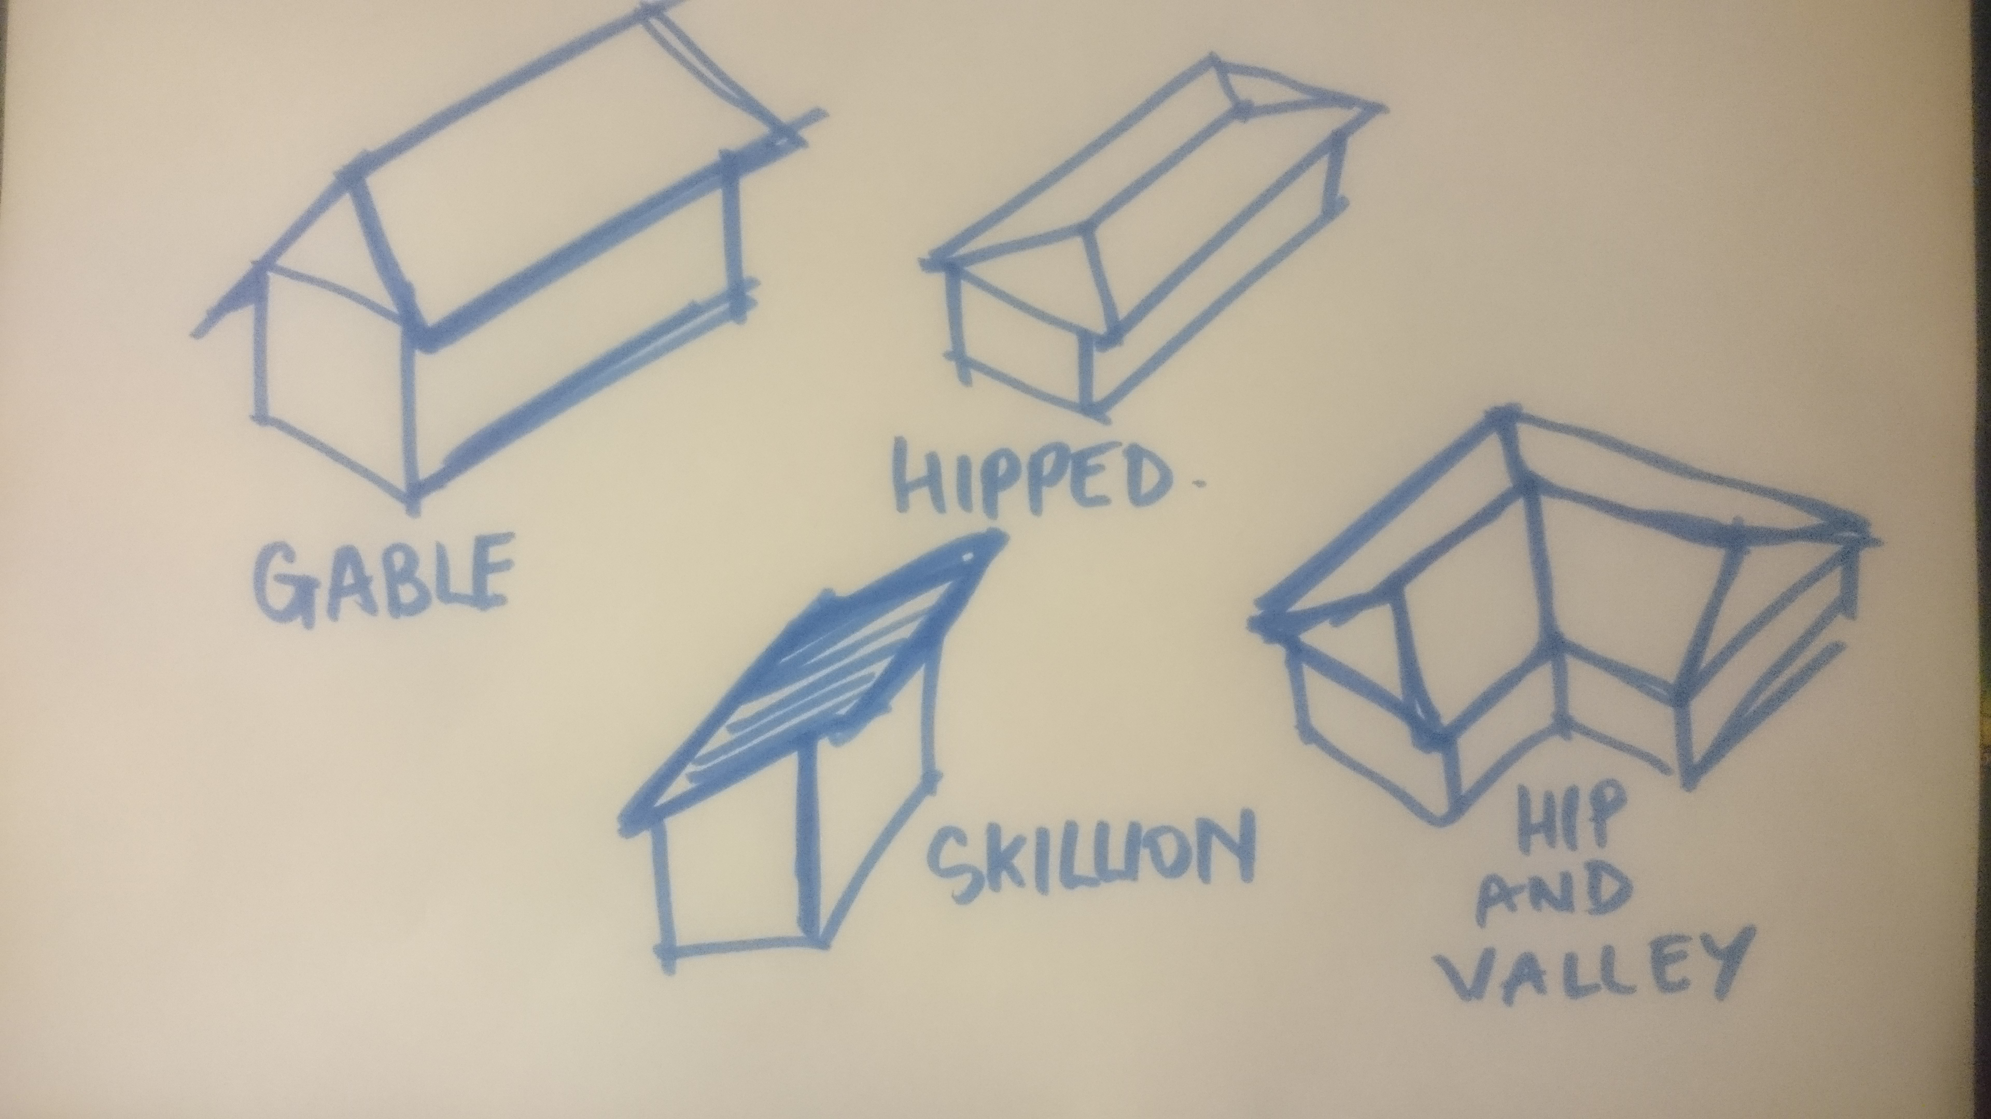

- Name at least eight (8) practical advantages of using prefabricated roof trusses.

Answer | strong yet light to erect  can suit most roof shapes  less on-site fabrication therefore saving on labour  automated production  high quality control  makes maximum use of timber  capable of long spans  internal walls can be non-load bearing therefore lighter

- What is roof cladding? What are the two most common materials used in Australia?

Answer | Roof cladding is the material used to protect the building from the weather  The two most common in Australia are  Roof tiles  Metal sheeting

- What pitch of roof should roof tiles be applied? Are there exceptions?

Answer | Generally 15 degrees but some materials require 25 degrees

- Describe the materials listed in the table below.

Answer | Term | Description
 | Terracotta tile | Formed from wet clay then fired to give a durable, long life roofing product. Terracotta tiles have a life greater than 50 years.
 | Concrete tile | Modelled on terracotta tile however, made from concrete. Stable and warp free and have a useful life span approaching that of terracotta. Colour is applied and tends to fade with time.
 | Slate tile | Naturally occurring rock
 | Fibre cement shingles | Like slate tiles but formed from reinforced cement
 | Timber shingle/shake | Made of sawn or split timber boards
 | Aluminium or steel pressed tile | Metal that is shaped to imitate a tile

- Devise a useful roof framing checklist for ensuring the quality of the roof frame once it is installed.

Answer | Does the roof pitch match the plan?  Is the ridge, hips, rafters and under purlins propped at the correct centres?  Are there adequate collar ties?  Check the line of the rafter, hips and valleys  Check the support to strutting beams  Check the fascia and barge boards are fixed correctly  Check all tie-downs and fixings  Check ceiling joist and alignment with rafters  Check hanging beams  Check trimmers for location  Check trimmers for access hole

- Describe the intent of wall systems and the materials they are typically made from.
What part of the BCA and the AS reference wall systems?

Answer | Wall systems support the roof  Allow for installation of services  Provide structural support for internal and external cladding  Provide spatial arrangement and demarcation of living spaces  Wall system include  Composite walls - tilt-slab, post and beam, pole and truss and portal frame  Earth walls – rammed earth and mud brick  Framed walls – timber, engineered timber, and lightweight sectional steel  Masonry walls – cavity brick, single-leaf masonry and lightweight concrete  BCA Vol. 1  B1.4 Determination of structural resistance of materials and forms of construction The structural resistance of materials and forms of construction must be determined in accordance with the following, as appropriate:  (a) Masonry (including masonry-veneer, unreinforced masonry and reinforced masonry): AS 3700.  (b) Concrete construction (including reinforced and prestressed concrete): AS 3600. (c) Steel construction—  (i) Steel structures: AS 4100.  (ii) Cold-formed steel structures: AS/NZS 4600.  (iii) Residential and low-rise steel framing: NASH Standard 'Residential and Low-Rise Steel Framing' Part 1 or Part 2.  (d) Composite steel and concrete: AS 2327.1.  (e) Aluminium construction: AS/NZS 1664.1 or AS/NZS 1664.2.  (f) Timber construction:  (i) Design of timber structures: AS 1720.1.  (iii) Timber structures: AS 1684 Part 2, Part 3 or Part 4.

- Explain the purpose of bracing.

Answer | Bracing provides lateral support to maintain stability  Bracing may be diagonal such as knee bracing, k-brace or cross bracing  Bracing may also consist of sheeting such as plywood

- You are to provide a pictorial sketch with labels to show a common timber stud or steel wall and ceiling frame and include the following members:
- Hanging Beam
- Ceiling joists
- Top plate
- Lintel
- Common stud
- Jamb stud
- Jack stud
- Nogging
- Bottom plate
- Timber or metal bracing
- Sheet flooring
- Floor joists
- Bearers
- Stumps

Answer

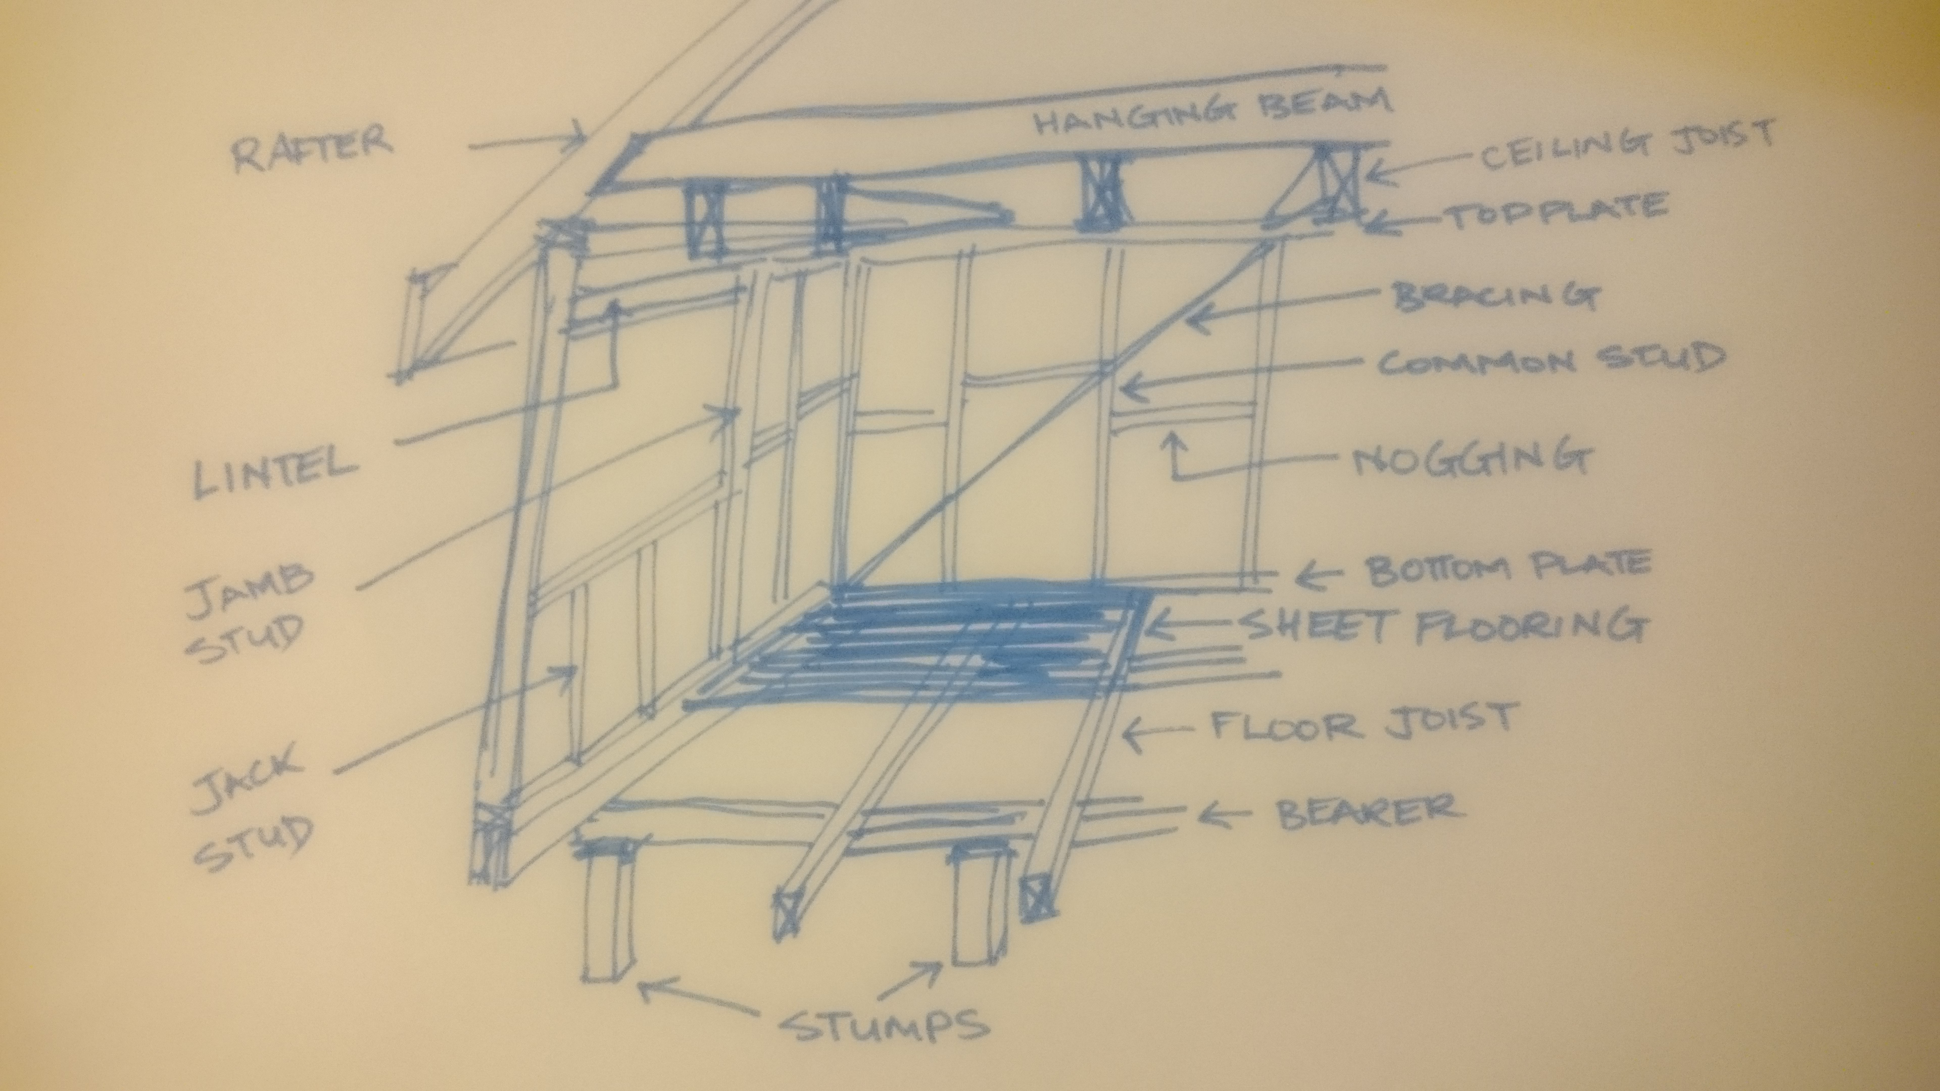

- Name the relevant volume and part in the Building Code of Australia (BCA) as well as the two (2) relevant Australian Standards that apply to the design, application and installation of timber framing for residential housing.

Answer | BCA Vol 1  B1.4 Determination of structural resistance of materials and forms of construction  f) Timber construction:  (i) Design of timber structures: AS 1720.1.  (iii) Timber structures: AS 1684 Part 2, Part 3 or Part 4.

- What might be a typical checklist to be used for ensuring the quality of the frame members and the frame as a whole?

Answer
  Check plans and contract documents for any variations
  Room set outs and wall locations consistent with approved plans
  Wall frame plumb and straight sufficient to receive wall finishes
  Tie down fixings to slab at least 50mm from slab edge
  Bottom plate not overhanging slab edge by more than 10mm.
  All wall bracing in position as required on approved plans and properly fixed including tie-down rods. Nails not overdriven
  Roof and truss point loads supported and blocked if required
  Truss layout consistent with truss plan and fixed at correct centres
  Trusses plumb (max allowable 50mm or height/50) and not bowed (max allowable 50mm or bowed section/200)
  Saddle trusses properly fixed to supporting truss top chord
  Roof tie down in accordance with approved plans and truss manufacturers requirements
  Strengthening for installation of solar hot water system installed
  Roof steel bracing properly installed in accordance with truss plan. Where fixed to wall frame bracing nailed flat to avoid interfering with wall sheet or cornice
  Truss bottom chord bracing installed where suspended ceilings or metal furring channel ceiling battens used.
  Binders installed
  Transfer noggings installed connecting bracing walls to trussed roof frame
  Non load bearing walls set down a minimum of ceiling batten depth + 10mm from the level of external load bearing walls.
  Non load bearing walls connected to trusses with slotted wall brackets where required.
  Entry bulkheads straight and level
  Ceilings nogged for plaster sheet joins and at change of direction
  Internal door opening sizes consistent with plans
  Bottom plate removed from all internal doorways
  Internal bulkheads installed plumb and straight
  Plumbing duct and vent pipe framing plumb and straight
  Lintel sizes as shown on approved plan
  Windows fixed in accordance with window manufacturers requirements or Aust Window Assoc. recommendations
  Windows plumb and level
  Bath properly framed up and supported with appropriate clearance for tiles and sheeting
  Nogging installed for WC cistern and toilet roll holder
  Nogging installed for ensuite cistern and toilet roll holder
  Nogging installed for bathroom towel rails
  Nogging installed for ensuite towel rail
  Noggings installed for panel lift door
  Noggings installed for clothes dryer
  Other noggings required and installed
  Manhole correctly positioned & framed.
  Fascia fixed and aligned properly
  Fascia properly aligned for external cladding or brickwork where there is no eaves overhang
  Trimmers and battens installed to eaves to properly fix eaves lining
  Temporary bracing removed
  Windows checked to ensure they are not damaged
  House swept and clear of debris
  Site clear of rubbish
  Frame inspection passed

- What is sarking? What purpose does it serve?

Answer | Sarking is boarding or building felt fixed over the rafters of a roof before the roof cladding is added  Roof sarking improves performance and comfort by providing the following benefits:  - Helps protect your home from unseen mould growth or even worse, ceiling staining or permanent damage which can result from the entry of storm driven rain into the roof cavity  - Limits dust entering the home through gaps around downlights and vents by reducing draughts that blow dust into the roof space  - Improves thermal performance by reducing heat flow through the roof, helping provide a more energy efficient and comfortable home (Bradford thermoseal for example)  - Helps manage the risk of condensation by allowing moisture to escape whilst preventing the entry of water (Bradford enviroseal for example)  - Provides a secondary form of ember protection for the roof space for BAL (12.5 to 40) regions

- What is flashing?

Answer | Flashing refers to thin pieces of impervious material installed to prevent the passage of water into a structure from a joint or as part of a weather resistant barrier (WRB) system

You are to refer to the roof section diagram below in responding to Q120. to Q126.

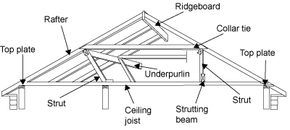

- What is a ceiling joist?

Answer | A joist is a horizontal structural member used in framing to span an open space.  The joists run horizontally between opposite walls and attach to the tops of the walls with a wall plate. Building regulations dictate how many joists need to be installed, the distance between them, and how thick they should be. Once the joists have been constructed, other beams are installed which help support the walls and roof of your home.  Typically, the ceiling joists and beams are clad with plasterboard to create a flat surface for your ceiling. Other materials can also be used to clad the joists and beams, including metal and timber. There are many options for ceiling finishes and cladding.

- What is the purpose of a hanging beam?

Answer | A 'hanging beam' is generally a deep timber beam located perpendicular (at right angles or 90º) to ceiling joists and directly above them. The function of a hanging beam is to reduce the span of the ceiling joists.

- What is the purpose of roof struts?

Answer | A timber roof truss is a structural framework of timbers designed to bridge the space above a room and to provide support for a roof. Trusses usually occur at regular intervals, linked by longitudinal timbers such as purlins

- What is the ridge board in a conventional framed roof?

Answer | A ridge board is a non-structural member that serves as a prop for opposing rafters to rest against and connect to. Ridge boards can only be used in roofs with slopes from 3 in 12 up to 12 in 12.

- What function do rafters perform in a roof?

Answer | A rafter is one of a series of sloped structural members that extend from the ridge or hip to the wall plate, downslope perimeter or eave, and that are designed to support the roof deck and its associated loads. A pair of rafters is called a couple.

- Explain the role of under purlins in a conventional roof frame system.

Answer | Purlins, also called underpurlins, are fixed to the underside of the rafters parallel to the ridge and wall plates. They provide continuous support under the rafters, similar to bearers under joists in a floor frame.

- What are collar ties used for in a conventional roof frame system?

Answer | They are light sectioned horizontal members used for additional support, like spreaders, to prevent the rafters from sagging at the purlin position. These are fixed to alternative pairs of rafters, i.e. at 900 to 1200 mm spacings, and placed on top of the purlins running parallel to the ceiling joists.

- What advantages can be gained from installing roof trusses as against a conventional stick framed roof?

Answer | Prefabricated roof trusses have several practical advantages:  - they’re strong and engineered to accommodate heavy loads  - easy to handle  - lightweight and simple to install  - saves you time and money

- What must the design of a timber roof truss adhere to?

Answer | The design of the timber roof truss must be assessed for compliance with relevant codes and accepted industry construction principles

- Discuss timber cladding and reference the relevant Australian Standard as it applies to the specific cladding. Be sure to name what part of the BCA deals with cladding.

Answer | Timber cladding has natural advantages on sites that are subject to high winds, extreme climate, highly reactive soils and subsidence or earth tremors. Timber's natural resilience and high strength-to-weight ratio enables it to withstand far greater stresses and movement than other materials and:  - performs best with wide eaves and verandahs  - provides weather protection to walls  Cladding must be watertight with adequate flashing and sarking in accordance with best industry practice. Special care has to be taken with detailing and protection at ground level and north facing walls.

- What must be checked when installing skylights, windows and doors?

Answer | You must always check against the building’s plan and then supervise installation to ensure it is compliant with standards/accepted industry construction

- What is the relevant Australian Standard to be referenced for glazing of windows and doors?

Answer | BCA Vol 1 Clauses B1.4, FV1, F1.13, J3.4  AS 2047

- Write a descriptive interpretation of the extract of the window schedule shown below.

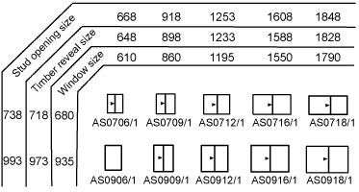

Answer | The extract of the window schedule above shows the window sizes.  The schedule details the appearance of the window frame when viewed from the outside. It also shows the finished height and width of the frame.

- Illustrate by sketch the correct positioning of flashings and sarking for timber cladding.
Your sketches should reflect the use of weatherboard stops for installation of timber chamfer boards or timber weather boards where the internal and external corner joins has the cladding butting up to the weatherboard stop.
Alternate installations still require flashings and sarking for man-made manufactured boards such as HardiePlank or PrimeLine in which case sketches would reflect the use of internal and external corner jointers supplied by the manufacturer.

Answer

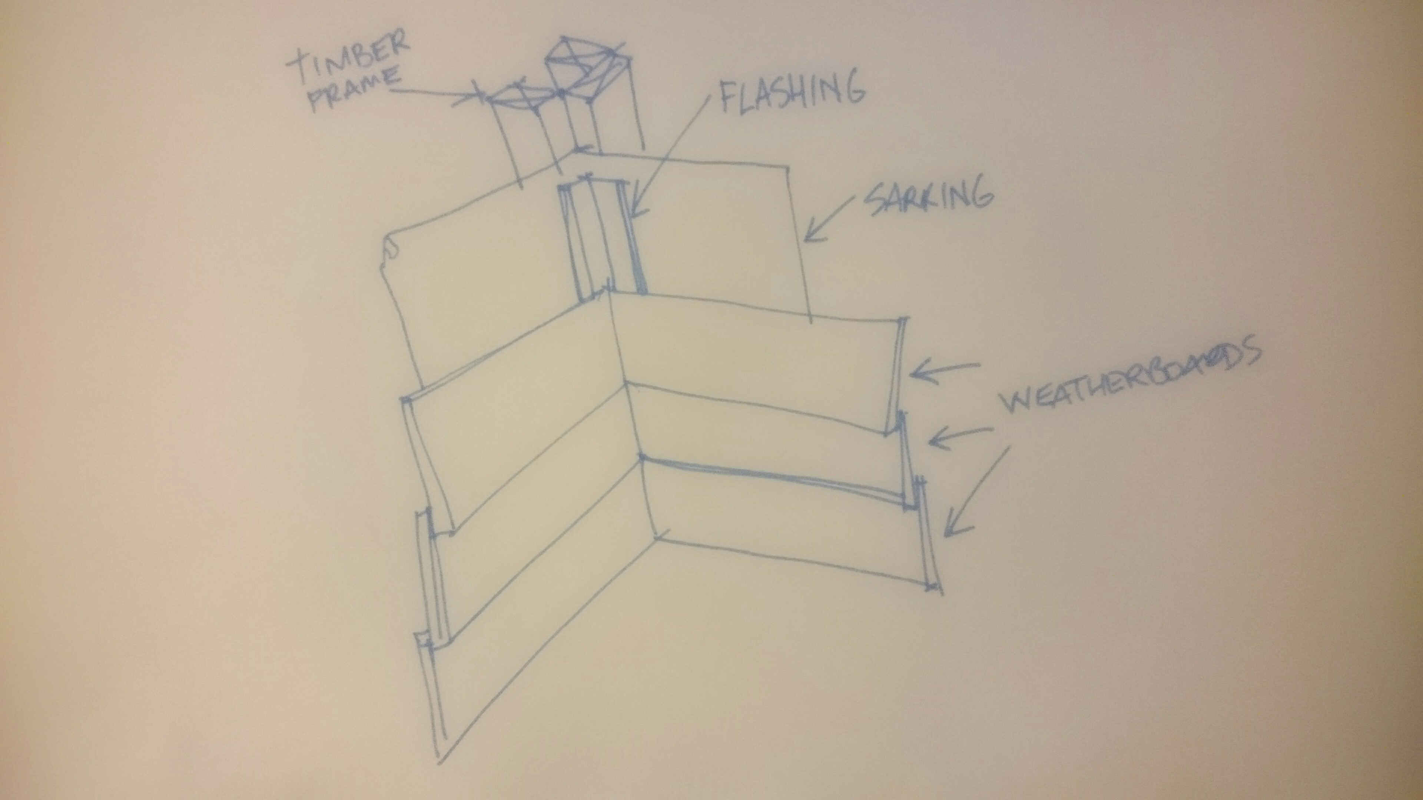

- Briefly describe each of the building materials listed below and outline the related construction methods used for low rise commercial projects.

Answer | Term | Explanation
 | Brick veneer construction | A brick veneer wall is constructed by having a non-structural external layer, usually with bricks and it is backed by an air cavity  The inner element Is structural and can consist of wood, metal framing or masonry
 | Cavity brick construction | Cavity walls consist of two 'skins' separated by a hollow space (cavity).^{[1]} The skins are commonly masonry such as brick or concrete block. Masonry is an absorbent material, and therefore will slowly draw rainwater or even humidity into the wall, as well as from the inside of the house as from outside. The cavity serves as a way to drain water back out through weep holes at the base of the wall system or above windows. The weep holes allow wind to create an air stream through the cavity and the stream removes evaporated water from the cavity to the outside. Usually weep holes are created by intentionally leaving several vertical joints, also open head joints, open about two meters apart at the base of in every story. Weep holes are also placed above windows to prevent dry rot of a wooden window frame. A cavity wall with masonry as both inner and outer skins is more commonly referred to as a double wythe masonry wall.
 | Earth wall construction | Rammed earth construction is a technique for building walls, foundations, and floors using natural raw materials such as earth, chalk, lime or gravel.  Stabilised rammed earth is a variant of traditional rammed earth that adds a small amount of cement (typically 5–10%) to increase strength and durability.  Rammed earth is very strong in compression and can be used for multi-storey loadbearing construction. Research in New Zealand indicates that monolithic earth walls perform better under earthquake conditions than walls made of separate bricks or blocks.
 | Autoclaved aerated concrete block construction | Lightweight concrete construction, such as construction of autoclaved aerated concrete (AAC).  This is concrete that has been manufactured to contain lots of closed air pockets. It is lightweight and fairly energy efficient and produced by adding a foaming agent to concrete in a mould, then wire-cutting blocks or panels from the resulting ‘cake’ and ‘cooking’ them with steam (autoclaving).
 | Pole frame construction | Pole frame construction uses primary structural frames including clear span truss supported by columns, supported/ connected by purlins, girts and sheathing.
 | Portal frame construction | A portal frame building comprises a series of transverse frames braced longitudinally. The primary steelwork consists of columns and rafters, which form portal frames, and bracing.  The connections between the columns and the rafters are designed to be moment-resistant, i.e. they can carry bending forces.  Portal frame construction is therefore typically seen in:  - Warehouses  - Barns
 | Post and beam construction | Post and beam construction is a system of horizontal beams that transfer structural loads to a system of vertical posts. More traditional post and beam construction also employs a series of diagonal braces that reinforce the beams and help to make the structure rigid.
 | Post and truss construction | Similar to post and beam but using trusses instead of beams.  A roof truss mostly wooden with two principal rafters and two vertical Queen posts with a restraining tie beam at the bottom and a straining beam at the top.
 | Single leaf concrete masonry construction | Single Leaf Masonry Construction (Internal Insulation) Masonry construction is defined as small masonry units jointed together with mortar. The masonry unit could be of: Natural stone (either completely or partially dressed for squareness) Solid or cellular brick or block.
 | Tilt panel or tilt slab construction | Tilt up is a pre-cast concrete system of building walls.  Traditional pre-cast concrete products are made in a factory, and then have to be delivered to the site. Tilt slabs are poured on site.

