BSBITU304
Produce spreadsheets
Learner Workbook



Table of Contents

Table of Contents 2
Candidate Details 3
Assessment – BSBITU304: Produce spreadsheets 3
Competency Record to be completed by Assessor 4
Observation/Demonstration 5
Activities 6
Activity 1A 6
Activity 1B 7
Activity 1C 9
Activity 2A 11
Activity 2B 12
Activity 3A 13
Activity 3B 14
Activity 4A 15
Activity 4B 16
Activity 5A 17
Activity 5B 18
Activity 5C 19
Skills and Knowledge Activity 20
Major Activity 21

Candidate Details

Assessment – BSBITU304: Produce spreadsheets
Please complete the following activities and hand in to your trainer for marking. This forms part of your assessment for BSBITU304: Produce spreadsheets
Name: Zoe Lwin
Address: 79 Waterview Avenue
Email: zoejade_98@hotmail.com
Employer: Lwins Cleaning
Declaration
I declare that no part of this assessment has been copied from another person’s work with the exception of where I have listed or referenced documents or work and that no part of this assessment has been written for me by another person.
Signed: ____________________________________________________________
Date: ____________________________________________________________
If activities have been completed as part of a small group or in pairs, details of the learners involved should be provided below;
This activity workbook has been completed by the following persons and we acknowledge that it was a fair team effort where everyone contributed equally to the work completed. We declare that no part of this assessment has been copied from another person’s work with the exception of where we have listed or referenced documents or work and that no part of this assessment has been written for us by another person.
Learner 1: ____________________________________________________________
Signed: ____________________________________________________________
Learner 2: ____________________________________________________________
Signed: ____________________________________________________________
Learner 3: ____________________________________________________________
Signed: ____________________________________________________________

Competency Record to be completed by Assessor
Learner Name: _______________________________________________________
Date of Assessment: _______________________________________________________
The learner has been assessed as competent in the elements and performance criteria and the evidence has been presented as;
Assessor Initials
Authentic
Valid
Reliable
Current
Sufficient

Learner is deemed: COMPETENT NOT YET COMPETENT (Please circle)

If not yet competent, date for re-assessment: ____________________________________

Comments from Trainer / Assessor:
__________________________________________________________________________________________________________________________________________________________________________________________________________________________________________________________________________________________________________________________________________________________________________________________________________________________
Assessor Signature: ________________________________________________________

Observation/Demonstration

Throughout this unit, you will be expected to show your competency of the elements through observations or demonstrations. Your instructor will have a list of demonstrations you must complete or tasks to be observed. The observations and demonstrations will be completed as well as the activities found in this workbook. An explanation of demonstrations and observations:
Demonstration is off-the-job
A demonstration will require:
- Performing a skill or task that is asked of you
- Undertaking a simulation exercise
Observation is on-the-job
The observation will usually require:
- Performing a work based skill or task
- Interaction with colleagues and/or customers
Your instructor will inform you of which one of the above they would like you to do. The demonstration/observation will cover one of the unit’s elements.
The observation/demonstration will take place either in the workplace or the training environment, depending on the task to be undertaken and whether it is an observation or demonstration. Your instructor will ensure you are provided with the correct equipment and/or materials to complete the task. They will also inform you of how long you have to complete the task.
You should be able to demonstrate you can:
- Select and prepare resources
- Plan spreadsheet design
- Create spreadsheet
- Produce simple charts
- Finalise spreadsheets
You should also demonstrate the following skills:
- Reading
- Writing
- Oral communication
- Numeracy
- Navigate the world of work
- Interact with others
- Get the work done
Activities

Activity 1A
Estimated Time | 30 Minutes
Objective | To provide you with an opportunity to adhere to ergonomic, work organisation and occupational health and safety requirements.
Activity | Take time to review the Australian Standard AS 3590 as it relates to workplace ergonomic requirements  Australian Standard AS 3590  SCOPE. This Standard specifies performance requirements for visual display units (VDUs) incorporating cathode-ray tubes. The Standard does not apply to CAD units or to test equipment. This Standard sets out guidelines for the evaluation, design, setting-up, and selection of furniture for desk-top, screen-based workstations in offices. The guidelines are aimed at selection of furniture and equipment that will suit particular screen-based tasks and encourage appropriate posture in screen-based equipment (SBE) operators. This Standard does not apply to special cases such as schools, where the height of counters, for example, might vary from those given. The Standard does not include requirements for wheelchair access.

Activity 1B
Estimated Time | 45 Minutes
Objective | To provide you with an opportunity to use energy and resource conservation techniques to minimise wastage.
Activity | In groups of THREE (3) or as directed by the instructor, discuss the advantages and disadvantages of each of these suggested energy conservation techniques, as they may apply to your WORKPLACE.  Be prepared to discuss the findings with the class and add additional energy saving ideas that are not mentioned in the examples provided.
  Suggested area | Advantages | Disadvantages
  Turn off the lights | Decreases energy consumption, reducing energy costs.  Improves carbon footprint and is beneficial for the environment. | Can be difficult to ensure all members of staff consistently remember turn all lights off.
  Remove yourself from junk mail lists | Receive less unimportant mail.  Decreases paper waste which is beneficial for the environment.
  Send your monitor to sleep | Saves power, which decreases energy costs and is beneficial for the environment. | Takes extra time to start when the computer is required.
  Utilising power-save options for equipment | Saves power, which decreases energy costs and is beneficial for the environment. | Can make equipment run less efficiently.
  Use the stairs (if you have ‘em?) | Saves power, which decreases energy costs and is beneficial for the environment.  Good exercise, especially if most of the day is spent sitting at a desk. | Can take much longer, depending on the location of your office.
  Re-using paper for rough drafts (observing confidentiality requirements) | Saves on resources, costing less and benefiting the environment.
  Make your printer's toner last (how do you do this while still printing?) | Saves on printing costs | Unable to print as freely
  Leave the car at home | Save on fuel costs and preserves condition of vehicle (saves on servicing costs).  Decreases fossil fuel gases being released into the atmosphere, benefits the environment.  Less chance of having and accident. | May take longer to get to work, if you are walking or having to waiting for public transport.
  Recycle and reuse office supplies besides paper | Saves on resources reducing costs, less waste - beneficial for the environment.
  Buy 100 percent recycled paper | Promotes environmentally friendly practices – benefits environment and business image. | Likely to be more expensive/difficult to access.
  Curb phantom electricity (many appliances still use energy even when they're turned off. Items left plugged into the wall, such as a mobile phone charger or laptop adapter) | Saves power, which decreases energy costs and is beneficial for the environment. | Difficult to ensure all staff remember to unplug devices/appliances after use.  Takes extra time.
  Recycle paper by printing  double-sided | Saves resources, reducing costs and is beneficial for environment. | Organisation may prefer one-sided printing.
  OTHER: Switch off computers at the end of the day. | Saves power, which decreases energy costs and is beneficial for the environment.  Computer often runs better after its been shut down for a time. | May take a little longer to start.
  OTHER: Access and use electronic documents on the computer rather than printing. | Reduces paper usage which decreases costs and is beneficial for the environment. | Sometimes physical documents are easier to store and access.

Activity 1C
Estimated Time | 40 Minutes
Objective | To provide you with an opportunity to identify spreadsheet task requirements in relation to data entry, storage, output and presentation.
Activity | Determine a range of TASKS suitable for a spreadsheet to use as an exercise.  Rank by a score of 1-5 (1 being the LOWEST NOT SUITABLE to 5 being the HIGHEST MOST SUITABLE) the application for using a spreadsheet and do they match the headings providing.
  TASK 1 | Grouping/sorting numerical data
  2 | Grouping/sorting personnel files (eg client, employee information)
  3 | Creating charts which organise numerical data
  4 | Creating charts to organise groups or written data
  5 | Forming graphs for analysis (eg business progress, financial projections)
  6 | Calculating budgets
  7 | Tracking/managing accounts
  8 | Calculating/tracking expenses
  9 | Timelines and schedules: Manage, alter and track due dates, business targets etc
  10 | Calendar (eg. manage upcoming tasks)
  Task # | Data entry | Storage | Output | Reporting | Presentation
  1 Grouping/sorting numerical data | 5 | 1 | 2 | 4 | 3
  2 Grouping/sorting personnel files (eg client, employee information) | 4 | 3 | 2 | 1 | 5
  3 Creating charts which organise numerical data | 5 | 1 | 2 | 3 | 4
  4 Creating charts to organise groups or written data | 5 | 1 | 2 | 3 | 4
  5 Forming graphs for analysis (eg business progress, financial projections) | 5 | 1 | 2 | 3 | 4
  6 Calculating budgets | 5 | 2 | 1 | 3 | 4
  7 Tracking accounts | 5 | 3 | 2 | 1 | 4
  8 Calculating/tracking expenses | 5 | 1 | 2 | 3 | 4
  9 Timelines and schedules: Manage, alter and track due dates, business targets etc | 2 | 3 | 4 | 1 | 5
  10 Calendar (eg. manage upcoming tasks) | 2 | 3 | 4 | 1 | 5

Activity 2A
Estimated Time | 30 Minutes
Objective | To provide you with an opportunity to ensure spreadsheet design suits purpose, audience and information requirements of task.
Activity | As an exercise, if you were preparing to design a spreadsheet for a WORKPLACE function, answer the following questions for an EXAMPLE of your choice and be prepared to discuss your reasons with the class.
  Your spreadsheet name/details: ‘Workplace Function’ Budget and Organiser
  Questions To Answer | Your Answer
  What is it for? | This spreadsheet is designed to track what needs to be organised; location, time, invites, catering, speakers etc and manage a budget in preparation for the workplace event.
  What questions does it seek to answer? | Spreadsheet will allow you to manage and track outstanding tasks, what has been completed, how much it is expected to cost, and manage a budget.  Specific questions about the event:  Who will be attending?  Where will it be help?  What time will it be?  How much will it cost?
  What data will be used and where does it come from? | Data will come from research and communication with others, researching costing online, communicating with venues, caterers, staff etc.  Within the section which tracks an ongoing budget, information will be gradually updated as the event is organised.
  What formulas do you intend to use to do the calculations? | - ‘Sum of’ formula to calculate totals  - Averages, to see the difference between amounts
  Does this spreadsheet design allow you to add or change data later? | The design will allow you to manipulate data within the spreadsheet as details develop and change.
  Is that important for this particular spreadsheet? | For this spreadsheet, it is necessary to be able to update information and ensure it is current.  For example, the spreadsheet outlines the budgeting goals that have been set, however the actual outcome/costing of events may vary meaning the spreadsheet will need to be adjusted accordingly.

Activity 2B
Estimated Time | Approx 1 Hour
Objective | To provide you with an opportunity to ensure spreadsheet design enhances readability and appearance, and meets organisational and task requirements for style and layout; and use style sheets and automatic functions to ensure consistency of design and layout.
Activity | - Create, design and observe the areas raised in this session for a consistent excel spreadsheet exercise.  - In your WORKPLACE, select a layout design for a spreadsheet requirement, either current or future.  - Be prepared to discuss your design with the class.  Spreadsheet deign principles:  - Fonts that are easy to read  - Use backgrounds and colours for good contrast and easy reading  - Consider print layout as well as how It looks on screen  - Use labels and titles that make the purpose and function clear  - Make sure key values (like totals) stand out from the crowd  - Style sheets and automatic functions ensure consistency of layout  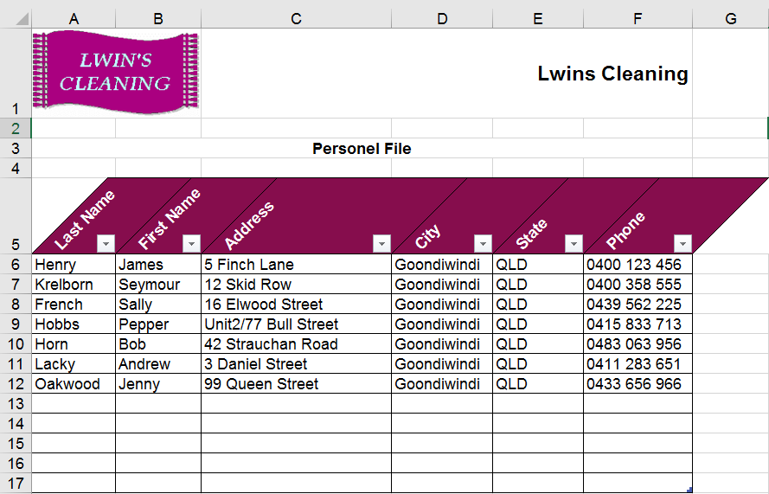  - Layout design features have been used to enhance this basic spreadsheet.
  Workplace Activity
  - Ensure spreadsheet design suits the purpose
  - Ensure spreadsheet design enhances readability and appearance
  - Ensure spreadsheet meets organisational and task requirements for style and layout
  - Use style sheets and automatic functions to ensure consistency of design and layout

Activity 3A
Estimated Time | 40 Minutes
Objective | To provide you with an opportunity to ensure data is entered, checked and amended to maintain consistency of design and layout, in accordance with organisational and task requirements; and format spreadsheet using software functions to adjust page and cell layout to meet information requirements, in accordance with organisational style and presentation requirements.
Activity | In your WORKPLACE create a spreadsheet using the practical application of the two Elements detailed below.  Select a spreadsheet function from within your WORKPLACE either currently in place or a new project.
  Workplace Activity
  Describe the spreadsheet requirement:
  While the previous activity focussed on spreadsheet design, this requirement highlights this importance of accurate data entry. Methods of checking data allow you to ensure all information (i.e. numbers and text) is correct. Checking may include;
  - Accuracy of data
  - Accuracy of formulae with calculator
  - Ensuring instructions regarding consistency of format have been followed
  - Proofreading
  - Spelling
  Excel’s data validation feature allows to control the type of values that can be entered a cell. This can be used to improve consistency of the spreadsheet and reduce the chance of error.
  - Ensure the data is entered, checked and amended to maintain consistency using the details discussed in that element.
  - Format the spreadsheet using software functions to adjust page and cell layout to meet information requirements REFERENCING the list of examples provided above.
  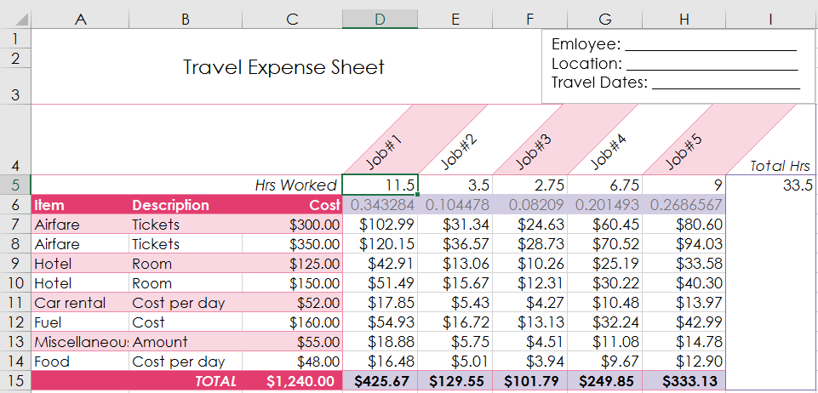
  - The following spreadsheet has been designed using a range of data formats, design features, formulae and automatic software functions. To maintain consistency and ensure accuracy of information, the spreadsheet has been checked as per the above spreadsheet requirement.

Activity 3B
Estimated Time | 40 Minutes
Objective | To provide you with an opportunity to ensure formulae are tested and used to confirm output meets task requirements, in consultation with appropriate personnel as required; and use manuals, user documentation and online help to overcome problems with spreadsheet design and production.
Activity | Create spreadsheet  Select a spreadsheet function from within your WORKPLACE either currently in place or a new project.
  Workplace Activity
  Demonstrate, using your previous Activity excel example or project, your understanding and knowledge of:
  - Testing Excel formulas and detail how this technique confirms output AND meets the task requirements of your organisation.
  - Detail what manuals, online help or user documentation you have used or currently use to overcome problems with spreadsheet design and production
  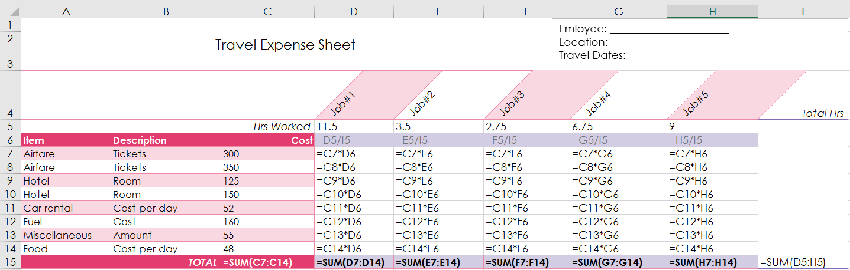
  - Spreadsheet in formula view:
  Viewing the spreadsheet in auditing format lets you to see all formulas that have been used. This allows you to ensure accuracy and consistency of the spreadsheet by checking the formulas and confirming that the output data/calculated values are correct.
  2
  Manuals and user documentation can provide instruction that is specific to the software or program making them helpful in overcoming a range of problems that may arise. In the past, I have found online help to be very effective. Website forums and FAQ pages often offer solutions to common problems that users face.

Activity 4A
Estimated Time | Approx 1 Hour
Objective | To provide you with an opportunity to select chart type and design that enables valid representation of numerical data, and meets organisational and task requirements; and create charts using appropriate data range in spreadsheet.
Activity
  Workplace Activity
  - Your turn!
  - Create charts using appropriate data range in the spreadsheet
  - Discuss with the instructor the types of charts to be used or reach another form of pre-selection
  - Use WORKPLACE examples for preference
  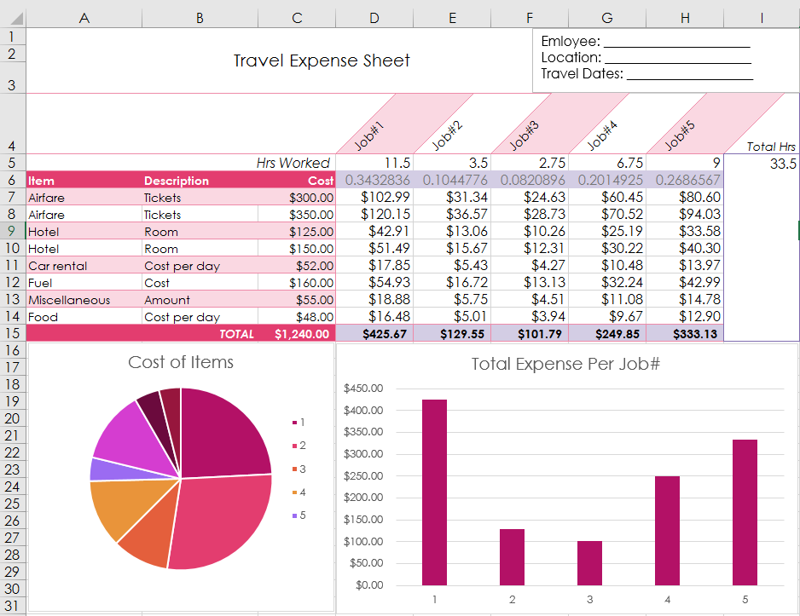
  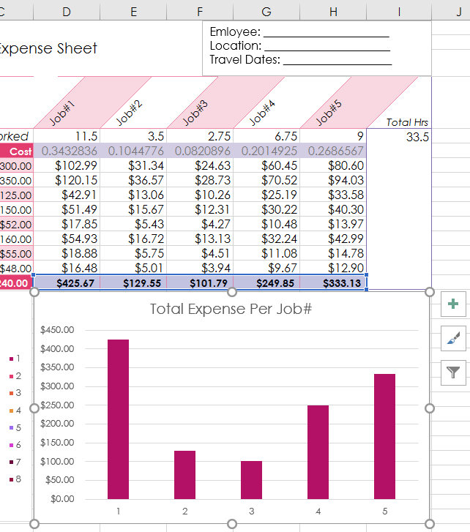
  A column chart such as the one used below is helpful in comparing values directly. In this instance, it has been used to compare the cost of each job# over the total trip.

Activity 4B
Estimated Time | Approx 1 Hour
Objective | To provide you with an opportunity to modify chart type and layout using formatting features.
Activity
  Workplace Activity
  - Your turn!
  - Modify chart type and layout using BOTH manual and auto formatting features
  - Discuss with the instructor the types of charts to be used or reach another form of pre-selection
  - Use WORKPLACE examples for preference
  - Adjusted automatic design style
  - Added chart elements such as axis titles, gridlines etc
  - Manually formatted chart design
  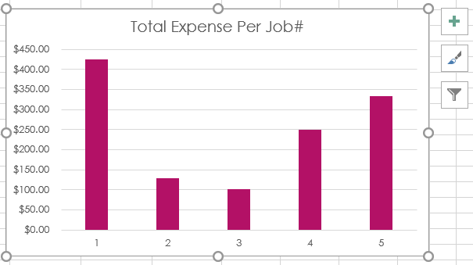
  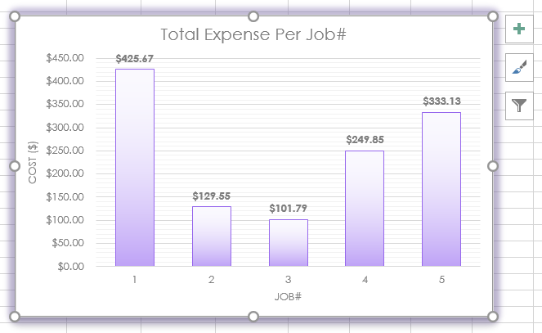

Activity 5A
Estimated Time | 40 Minutes
Objective | To provide you with an opportunity to preview, adjust and print spreadsheet and any accompanying charts, in accordance with task requirements.
Activity
  Workplace Activity
  - Your turn!
  - Preview, adjust and print spreadsheet and any accompanying charts, in accordance with task requirements
  - Discuss with the instructor the spreadsheets to be used or reach another form of pre-selection
  - Use WORKPLACE examples for preference
  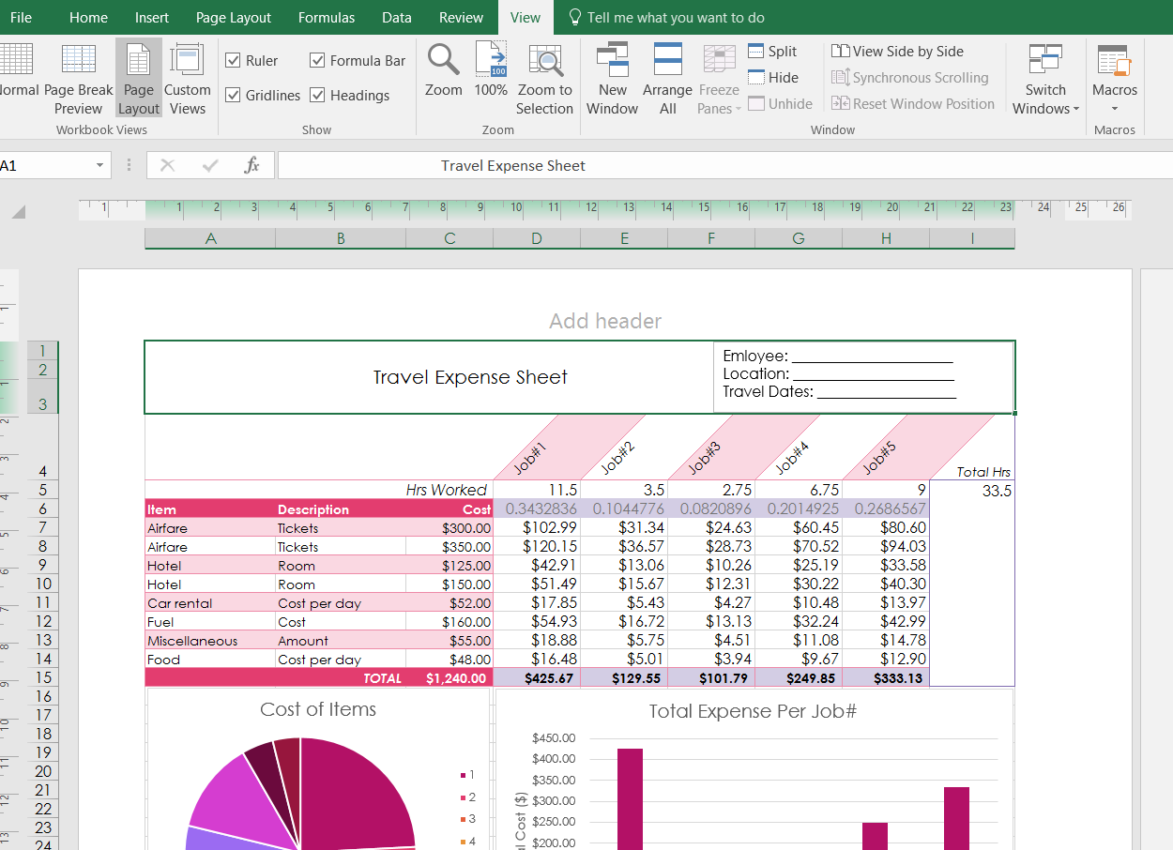
  Previewing the spreadsheet in page layout allows you to see how it will look when printed. The layout can be then be adjusted accordingly. In this instance, I have changed the page orientation to landscape to fit the spreadsheet and charts to one page.
  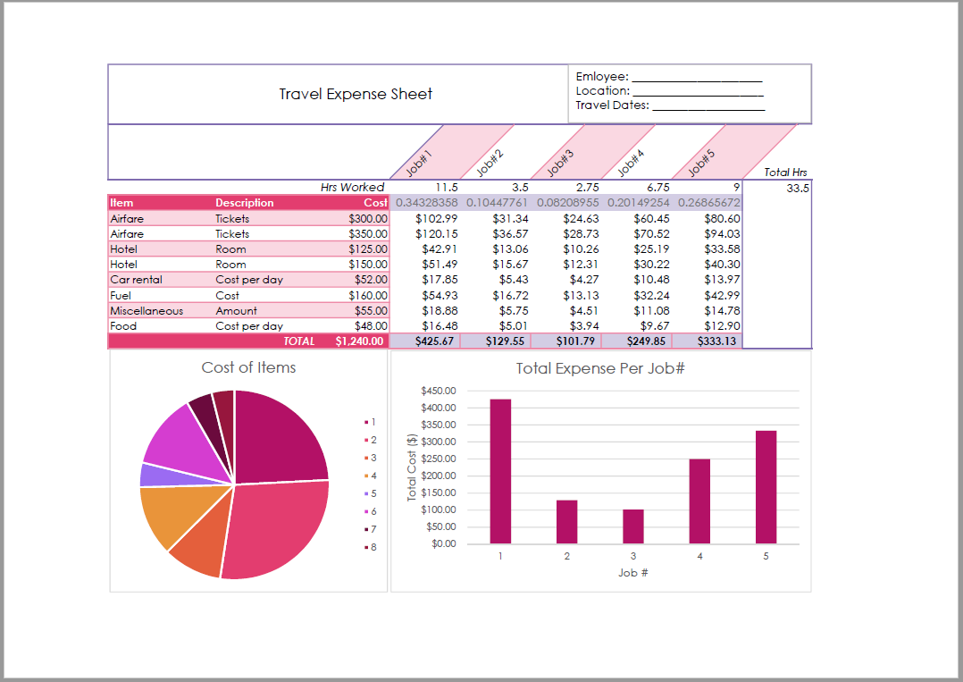
  In accordance with organisational requirements, the spreadsheet has been printed to a pdf and saved and stored in the appropriate location.

Activity 5B
Estimated Time | 30 Minutes
Objective | To provide you with an opportunity to Ensure data input meets designated timelines and organisational requirements for speed and accuracy.
Activity | Describe your WORKPLACE experiences for these examples of meeting timelines
   | Examples of YOUR timelines may include
  Communicate the importance. If no one thinks the deadline important, then no one will bother to meet it. | Before starting a task, it is vital that every person involved is aware of the timeline and what is involved in meeting it. Deadlines can only be met if every group member understands the importance.
  Don’t set trivial deadlines. The opposite of ensuring a deadline is communicated, is not crying wolf when deadlines are not important. | Prioritising tasks ensures that the most important deadlines take precedence. If trivial deadlines are enforced (i.e tasks that are not a priority), this could affect the amount of time given to more important jobs.
  Follow up. Follow up whether a deadline has been missed or met. Praise for a job well done and investigation when milestones are missed. | Tracking timelines allows you continually to review whether deadlines have been met. This is most effectively done using organisational documents that are kept up to date regularly rather than rough documents.
  Work together to solve problems. Any deadline of any importance will likely have difficulties. So get together with other team members, or another colleague, to talk through the difficult stuff and find new answers | Solving problems as a team has many benefits. It ensures every group member is involved and up to date with the progress of the task, it builds effective workplace relationships, and saves time when problems arise. It is also much easier to overcome issues in a group setting as each person sees the situation in an unique way.
  There are no magic answers to making things happen. Deadlines are a key tool in performance management but they need everyone to believe in what is being aimed for. | It is important to remember, planning timelines and tracking progress is one thing, but actually working on the task is another. At some point, you just need to knuckle down and get it done.

Activity 5C
Estimated Time | 30 Minutes
Objective | To provide you with an opportunity to Name and store spreadsheet in accordance with organisational requirements and exit application without data loss/damage.
Activity | What are your organisations requirements?
  Workplace activity
  Authorised access | What are your organisations requirements?  Within my organisation, authorised access requirements are used to maintain security of information. Files are stored so that only specific personnel can access them. Permissions to different types of documents are set up to suit the roles and responsibilities of each user/staff member.
  Organisational policy for backing up files | What are your organisations requirements?  Backing up files is a key way to reduce the chances of loss or damage. Organisation requirements outline that all files should be backed up onto an external drive.
  Organisational policy for filing hard copies of spreadsheets | What are your organisations requirements?  Filing hard copies can also be an effective way to keep information secure. Within my organisation, this is done depending on the type of document and its importance.  To save space and resources, the number of documents saved as a hard copy has been gradually reduced overtime with the advance of technology.
  Storage in electronic folders/sub-folders | What are your organisations requirements?  It is important that any documents or files stored electronically are sorted and organised into appropriately named folders and subfolders. This ensures they can be easily located later on.
  Storage on CD-ROM, USB, tape back-up, server | What are your organisations requirements?  Within my organisation, USB’s and external drives are often used to back up documents, however CD-ROM’s and tape back-ups are not commonly used.

Skills and Knowledge Activity
Estimated Time | 120 Minutes
Objective | To provide you with an opportunity to demonstrate your knowledge of the foundation skills, knowledge evidence and performance evidence.
Activity | Complete the following individually and attach your completed work to your workbook.  The answers to the following questions will enable you to demonstrate your knowledge of:  - Reading  - Writing  - Oral Communication  - Numeracy  - Navigate the world of work  - Interact with others  - Get the work done  - Formatting requirements of workplace documents  - Organisational guidelines on spreadsheet design and use  - Organisational requirements for ergonomic standards, work periods and breaks, and conservation techniques  Answer each question in as much detail as possible, considering your organisational requirements for each one.  - You are tasked to produce two spreadsheets for your organisation – before producing these, assess your work area and resources for ergonomic requirements and produce a checklist so you can correctly prepare the area for working.  Meeting ergonomic requirements means ensuring that office lighting, sound, furniture and desk space are set up in a way that promotes safe and healthy work practices.  - Produce the two spreadsheets for your organisation – use two different spreadsheet styles to illustrate the same data. Appropriately style the spreadsheets to your organisation’s style and format requirements. Produce finalised versions with data-checked for accuracy and proofread for finalising. Save files and print the documents to work procedures.  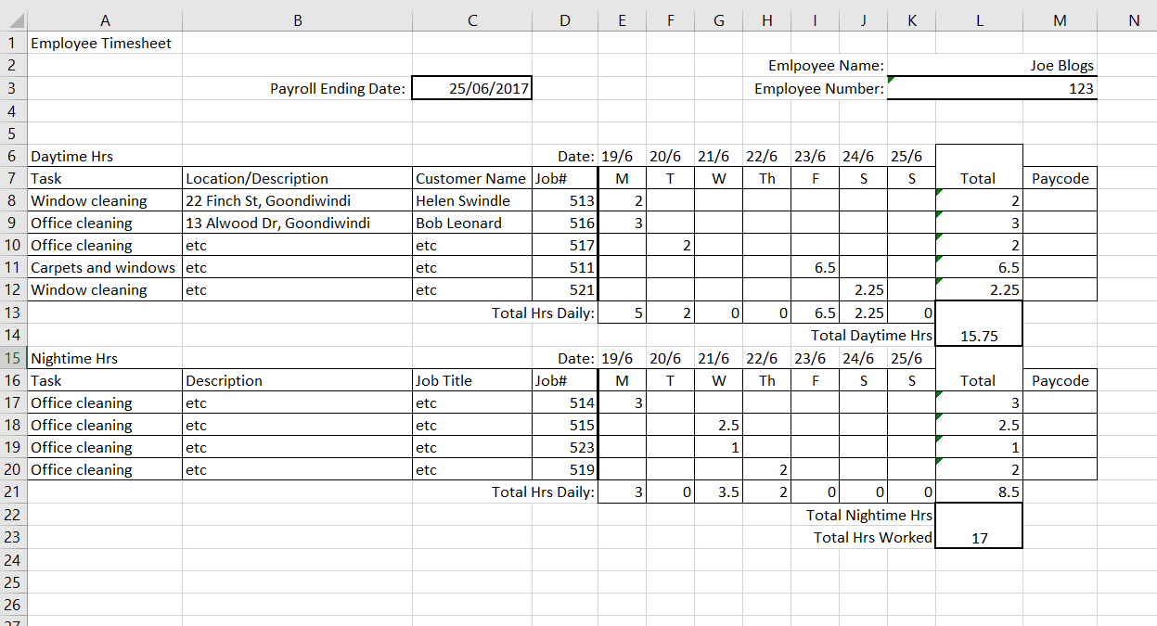  Employee Timesheet Version 1:  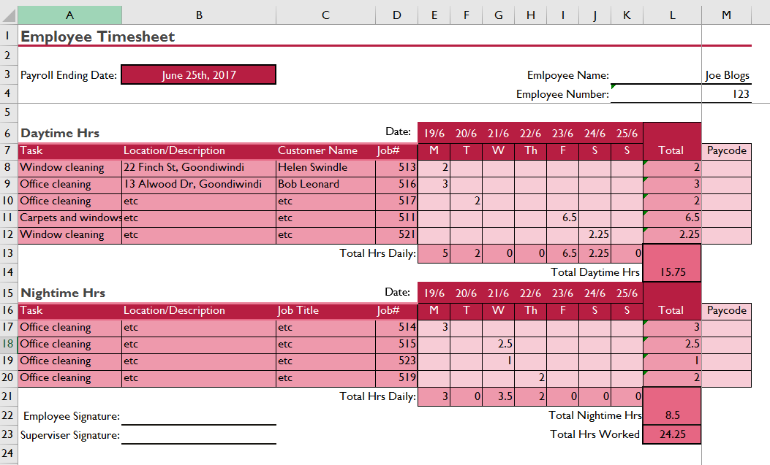  Employee Timesheet Version 2:  - Present these to another person in your group and explain the differences in style and use of charts, and which you think best illustrates the data.  The information presented in both spreadsheets is exactly the same, however version 2 is enhanced by the use of spreadsheet design. Using formatting and styles that make key information stand out and draw focus to the principal parts of the spreadsheet allows for easy reading and understanding. Software functions used within the spreadsheet also contribute to ease of use.

Major Activity
Estimated Time | 90 Minutes
Objective | To provide you with an opportunity to demonstrate your knowledge of the entire unit.
Activity | This is a major activity – your instructor will let you know whether you will complete it during class or in your own time.  Attach your completed answers to the workbook.  You must individually, answer the following questions in full to show your competency of each element:  - Select and prepare resources  - Plan spreadsheet design  - Create spreadsheet  - Produce simple charts  - Finalise spreadsheets  - When selecting and preparing resources, why should you:  - Adhere to ergonomic, work organisation and occupational health and safety requirements  - Use energy and resource conservation techniques to minimise wastage  - Identify spreadsheet task requirements in relation to data entry, storage, output and presentation?  Safety in the workplace is extremely important, therefore, when selecting and preparing resources, it is vital to ensure that your practices meet ergonomic and safety requirements such as those outlined by organisational or legislative OH&S policies. In order to minimise wastage and manage your effect on the environment, you must always consider energy resource conservation techniques. These decrease your carbon footprint, save money by reducing ongoing costs and are known to have a positive effect on your health. Furthermore, identifying your task requirements when selecting resources helps you to clearly understand the appropriate practices regarding data entry, storage, output and presentation.  - When planning a spreadsheet design, why should you  - Ensure spreadsheet design suits purpose, audience and information requirements of task  - Ensure spreadsheet design enhances readability and appearance, and meets organisational and task requirements for style and layout  - Use style sheets and automatic functions to ensure consistency of design and layout?  It is important that an appropriate amount planning is carried out before producing a spreadsheet. This ensures that you have a clear idea of what you want to achieve and helps the design process run smoothly and systematically. The design of your spreadsheet needs to suit the purpose and audience; it must enhance readability and appearance so that the information required can clearly understood.  - When creating a spreadsheet, why should you:  - Ensure data is entered, checked and amended to maintain consistency of design and layout, in accordance with organisational and task requirements  - Format spreadsheet using software functions to adjust page and cell layout to meet information requirements, in accordance with organisational style and presentation requirements  - Ensure formulae are tested and used to confirm output meets task requirements, in consultation with appropriate personnel as required  - Use manuals, user documentation and online help to overcome problems with spreadsheet design and production?  There are various stages involved in creating a well-deigned spreadsheet. In accordance with the purpose of the spreadsheet, the data must be entered and checked to ensure consistency of design and layout. The format, styles and design features must enhance readability and understanding. When formulae are used within a spreadsheet, this must also be checked to ensure any errors are found and eliminated. If problems arise throughout this process, user manuals/documentation and online help can be used to understand the issue so that it can be overcome.  - When producing a simple chart, why should you:  - Select chart type and design that enables valid representation of numerical data, and meets organisational and task requirements  - Create charts using appropriate data range in spreadsheet  - Modify chart type and layout using formatting features?  Microsoft excel provides a broad range of charts and graphs that are appropriate for various types of data sets. When using a chart, it is important to choose one which makes the meaning of the data clear, especially if comparisons are being presented. Formatting of a chart can also enhance readability and understanding, making key information stand out.  - When finalising spreadsheets, why should you:  - Preview, adjust and print spreadsheet and any accompanying charts, in accordance with task requirements  - Ensure data input meets designated timelines and organisational requirements for speed and accuracy  - Name and store spreadsheet in accordance with organisational requirements and exit application without data loss/damage?  Before printing a spreadsheet, it is important to use Excel’s print preview feature so that you can clearly see how the final document will look.  As you continually input data into a spreadsheet, it is helpful to keep track of your progress and ensure that organisational timelines and deadlines are met. Doing so will mean that information is always kept up to date. Finally, to avoid loss or damage and uphold requirements regarding security and privacy, it is important that spreadsheets are appropriately saved and stored.

