BSBITU306
Design and produce business documents
Learner Workbook



Table of Contents

Table of Contents 1
Candidate Details 2
Assessment – BSBITU306: Design and produce business documents 2
Competency Record to be completed by Assessor 3
Activities 5
Activity 1A 5
Activity 1B 6
Activity 1C 7
Activity 1D 8
Activity 2A 9
Activity 2B 10
Activity 2C 11
Activity 2D 12
Activity 3A 13
Activity 3B 14
Activity 3C 15
Activity 3D 16
Activity 4A 17
Activity 4B 18
Activity 4C 19
Activity 4D 20
Skills and Knowledge Activity 21
Major Activity 22

Candidate Details

Assessment – BSBITU306: Design and produce business documents
Please complete the following activities and hand in to your trainer for marking. This forms part of your assessment for BSBITU306: Design and produce business documents.
Name: __Kira Wesley-Rousch_________________________________________________
Address: __1 Bangalow Street___________________________________
_____________________________________________________________
Email: ___kwesl2@eq.edu.au_______________________________________________
Employer: ____Ms Grigg________________________________________________
Declaration
I declare that no part of this assessment has been copied from another person’s work with the exception of where I have listed or referenced documents or work and that no part of this assessment has been written for me by another person.
Signed: ___Kira________________________________________
Date: ___17 October 2019______________________________________________
If activities have been completed as part of a small group or in pairs, details of the learners involved should be provided below:
This activity workbook has been completed by the following persons and we acknowledge that it was a fair team effort where everyone contributed equally to the work completed. We declare that no part of this assessment has been copied from another person’s work with the exception of where we have listed or referenced documents or work and that no part of this assessment has been written for us by another person.
Learner 1: ____________________________________________________________
Signed: ____________________________________________________________
Learner 2: ____________________________________________________________
Signed: ____________________________________________________________
Learner 3: ____________________________________________________________
Signed: ____________________________________________________________

Competency Record to be completed by Assessor
Learner Name: _______________________________________________________
Date of Assessment: _______________________________________________________
The learner has been assessed as competent in the elements and performance criteria and the evidence has been presented as:
Assessor Initials
Authentic
Valid
Reliable
Current
Sufficient

Learner is deemed: COMPETENT NOT YET COMPETENT (Please circle)

If not yet competent, date for re-assessment: ____________________________________

Comments from Trainer / Assessor:
__________________________________________________________________________________________________________________________________________________________________________________________________________________________________________________________________________________________________________________________________________________________________________________________________________________________
Assessor Signature: ________________________________________________________
Observation/Demonstration

Throughout this unit, you will be expected to show your competency of the elements through observations or demonstrations. Your instructor will have a list of demonstrations you must complete or tasks to be observed. The observations and demonstrations will be completed as well as the activities found in this workbook. An explanation of demonstrations and observations:
Demonstration is off-the-job
A demonstration will require:
- Performing a skill or task that is asked of you
- Undertaking a simulation exercise
Observation is on-the-job
The observation will usually require:
- Performing a work based skill or task
- Interaction with colleagues and/or customers
Your instructor will inform you of which one of the above they would like you to do. The demonstration/observation will cover one of the unit’s elements.
The observation/demonstration will take place either in the workplace or the training environment, depending on the task to be undertaken and whether it is an observation or demonstration. Your instructor will ensure you are provided with the correct equipment and/or materials to complete the task. They will also inform you of how long you have to complete the task.
You should be able to demonstrate you can:
- Select and prepare resources
- Design document
- Produce document
- Finalise document
You will also need to show:
- Reading
- Writing
- Oral communication
- Navigate the world of work
- Interact with others
- Get the work done
Activities

Activity 1A
Estimated Time | 20 Minutes
Objective | To provide you with an opportunity to select and use appropriate technology and software applications to produce required business documents.
Activity | What is a business document?  - Business documents are written or electronic documents that represent an organisation in relation to its external parties.  Give examples of types of business documents.  - Accounts statements  - Client databases  - Newsletters  - Project reviews  - Proposals  - Reports  - Web pages.  When producing business documents, it essential to use the correct technology and software. Give examples of these.  Technology may include:  - Computers  - Photocopiers  - Printers  - Scanners.  Software may include:  - Accounting packages  - Database packages  - Presentation packages  - Spreadsheet packages  - Word processing packages.  In relation to your own organisation, decide on a business document. Describe what this document may include. What is the correct technology and software that you should use to produce your business document?  A document might include the fortnightly timesheet which excel is used to correctly produce it

Activity 1B
Estimated Time | 25 Minutes
Objective | To provide you with an opportunity to select layout and style of publication according to information and organisational requirements.
Activity | Give examples of different layouts and styles you may need to consider when developing business documents.  - Page orientation  - Colour  - Fonts  - Text Size  - Headings  - Margins  - Spacing  - Page numbers  When selecting layouts and styles, you must take organisational requirements into consideration. What can these include?  - Budgets  - Correctly identifying and opening files  - Legal and organisational policies, guidelines and requirements  - Locating data  - Log-on procedures  - Manufacturers' guidelines  - Occupational health and safety policies, procedures and programs  - Quality assurance and/or procedures manuals  What may organisational policies and procedures outline?  - How to develop the documents  - Where to keep copies of the documents  - How much to spend when developing the documents  - Any quality assurance checks that may be required  - Any security issues that should be considered  - Any legal policies or procedures relating to documents  - The correct way to store any data  - The style guide to develop documents from.  Why is consistency important when developing business documents?  - Consistency is important as it ensures:  - The content flows smoothly  - It looks professional  - The document is easier to follow/use  - Everything makes sense.  How can you ensure consistency?  To ensure consistency within your business documents, you should use a template or style guide (if available).  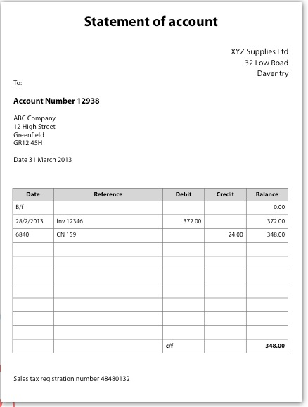  Using a business document that applies to your organisation as an example, outline the correct layouts and styles.  - This statement of account template is used for all statements to ensure document are shown in a consistent and professional manner. The format is simple and easy to understand for the receiver making it effective and organised.

Activity 1C
Estimated Time | 25 Minutes
Objective | To provide you with an opportunity to ensure document design is consistent with company and/or client requirements, using basic design principles.
Activity | What things should you remember when designing business documents?  - People remember text information better with visual information  - The human eye can be easily overloaded and distracted with inappropriate colours and fonts  - When appropriate, funny and sexy things are remembered better  - Bad spelling, poor punctuation and bad grammar can be distracting and confuse the meaning of the document  - Images of humans are remembered better than images of objects.  Name the four principles you should consider. What do they involve?  Contrast  When contrasting elements, they should be completely different; not similar. Contrast demonstrates emphasis and highlights key elements within a business document. It helps guide the reader to where to look first.  Alignment  Each item on a page of a business document should have a visual connection with something else on the page.  - Aids the overall coherence for the document  - Creates an ordered design  - Eliminates any mess  - Creates a visual connection between elements.  Repetition  Visual elements should be repeated throughout the document as it can:  - Connect individual elements  - Strengthen a design  - Creates associations  - Ensure consistency.  Proximity  Related items within a business document should be grouped together or visually connected in order to help create organisation. It provides a focal point and creates a relationship between the elements within the group.  We often associate different colours with a variety of things. Choose three colours and outline what you associate these with.  - Red: aggression, danger, strength  - Green: money, health, nature  - Pink: soft, femininity, healthy  - Black: seriousness, dramatic, classy  - White: simple, clean, pure.  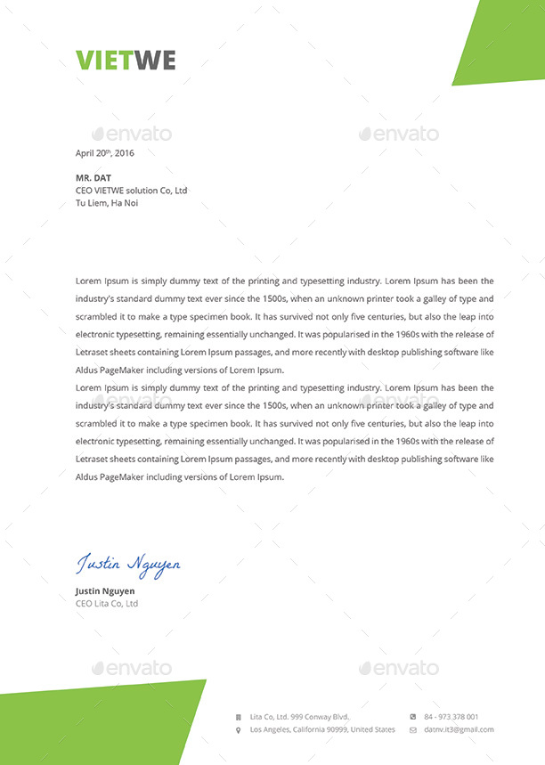  Using a business document that relates to your own organisation, show how you can apply the basic design principles to them.  This document has a clean, simple look while also implementing some green, by choosing green it shows money, health and nature which isn’t a confronting colour and doesn’t take away from the professionalism of the document

Activity 1D
Estimated Time | 15 Minutes
Objective | To provide you with an opportunity to discuss and clarify format and style with person requesting document/publication.
Activity | When should you discuss and clarify the format and style of a business document with the person that has requested it?  It is important to discuss the format, layout and style you have decided on for your business document with the person that requested it. They should clarify that it is acceptable before you design and produce it. This will ensure no time or money is wasted on developing a document that is incorrect in some way.  Although the discussion and clarification should initially take place before anything is designed, it may be necessary to clarify throughout the designing and development of the document. For example, if a problem surfaces or you don’t feel like something is working, discuss this with the person that has requested the document. The process of discussing and clarifying may depend on the organisational procedures and plans; each organisation will have a particular way to do this.  Give examples of the things you may discuss and clarify.  - The size of text  - The size of images  - A colour scheme  - The positioning of information.  Explain a situation in which you have had to seek clarification from the person that has requested the document you are about to develop.  I had to design a document for a client and didn’t know was format and style they wanted so I discussed it with them to get clarification.

Activity 2A
Estimated Time | 20 Minutes
Objective | To provide you with an opportunity to identify, open and generate files and records according to task and organisational requirements.
Activity | For TWO different types of business documents (that relate to your own organisation), give details on how you would identify, open and generate files and records.  Accounts statements  In most cases, there will be a template to use when developing accounts statements. You should be able to locate where this template is stored. Usually, an accounts statement will be produced using a spreadsheet (e.g. Microsoft Excel). This allows you to set a system up that will do the majority of the work. For example, a spreadsheet can be programmed to total the sum of a particular column or subtract one cell from another cell. Whatever program is favoured within your organisation should be used to create any accounts statements.  Newsletters  Organisations often use an e-mail newsletter to promote the business and keep their clients and customers up-to-date with the business. Despite there being a wide range of e-mail templates available online, it is a good idea to develop your own custom template that expresses your organisation. Many organisations will use a regular e-mailing program such as Microsoft Outlook or Hotmail. You should be aware of how to use the appropriate program.

Activity 2B
Estimated Time | 20 Minutes
Objective | To provide you with an opportunity to design document to ensure efficient entry of information and to maximize presentation and appearance of information.
Activity | Why is the efficient entry of information important?  It is important as in order to ensure efficiency of the entry of the information you should ensure the design of the document is the best it can possibly be. This will also minimise or eliminate any information entry errors.  Outline ways in which you can design documents to minimise the chance of information errors occurring.  One way of ensuring documents are efficient and free from human errors is to link it with other document. For example, in a document that you need to include ‘Customer Name’, rather than typing out each individual name (which would leave opportunity for incorrect spellings), it may be more efficient to use an existing list of customers that you have within another business document.  Another way to avoid errors in documents is to put a system in place that will recognise ‘improper’ information. Within a spreadsheet, for example, there are ways to flag up mistakes such as adding a number to something that requires text; or vice versa.  Give an example of a document you have created and how you maximised the presentation and appearance.  I created a poster and maximised the presentation and appearance by considering;  - Colours  - Shapes  - Fonts  - Sizes  - Positioning.

Activity 2C
Estimated Time | 15 Minutes
Objective | To provide you with an opportunity to use a range of functions to ensure consistency of design and layout.
Activity | Give examples of the functions that may ensure consistency of the design and layout of your documents.  Functions may include:  Alternating headers and footers  Editing  Merging documents  Spell checking  Table formatting  Using columns  Using styles.  Using one of the examples you have just given, describe the process of carrying it out.  To use spell check you can do it manually or go the review tab and complete the spelling and grammar check.

Activity 2D
Estimated Time | 20 Minutes
Objective | To provide you with an opportunity to operate input devices within designated requirements.
Activity | Define input devices.  An input device is any piece of equipment that feeds some sort of data into a computer.  Give examples of input devices.  Input devices may include:  Keyboard  Mouse  Numerical key pad  Scanner.  Choose one device and explain its function.  Mouse  A computer mouse is used to input spatial data to the computer by detecting movement across a physical surface. The movement of the cursor on the computer screen mirrors the movement of the computer mouse. Using a mouse is more appropriate than using the arrow keys on a keyboard because it is much quicker.  Choose a type of document and list the input devices you require to develop it.  Invoice  Mouse  Keyboard  Numerical key pad  Printer  Maybe photocopier

Activity 3A
Estimated Time | 15 Minutes
Objective | To provide you with an opportunity to complete document production within designated timelines according to organisational requirements.
Activity | What is a timeline?  Timelines are where key planned events and tasks are marked in the required sequence of their occurrence on a suitable scale. You need to ensure that the document you are producing is completed within the designated timelines of your organisation  Give examples of good time management.  Good time management tips may include:  - Recording your deadlines  - Prioritising your tasks  - Keeping track of your progress  - Ensuring you choose the best technology and software  - Knowing how to deal with possible problems that may arise.  Give an example of a time you needed to produce something within a designated timeline. How did you do this? How could improve this?  A school assignment. I didn’t manage my time well and left it till last minute. Next time I will not procrastinate and prioritise my tasks

Activity 3B
Estimated Time | 10 Minutes
Objective | To provide you with an opportunity to check document produced to ensure it meets task requirements for style and layout.
Activity | Give examples of the things that you may need to check.  The things that you may need to check may include:  Line spacing  Paragraph spacing  Margin size  Justification  Text size  Text colour  Font  Structure  Use of bold  Use of italics  Page numbering  Page breaks  Table properties  Image properties.  For two different types of business documents, list the specific things you will need to check.  Report  - Line spacing  - Text size  - Page numbering  PowerPoint  - Image properties  - Text size and colour  - Font

Activity 3C
Estimated Time | 15 Minutes
Objective | To provide you with an opportunity to store document appropriately and save document to avoid loss of data.
Activity | Outline the disadvantages of storing documents in their paper form.  Storing paper documents can create many problems, including:  Limited space  Difficult to find  Expensive  Harmful to the environment  Poses risks of damage or loss.  Outline the advantages and disadvantages of storing documents electronically.  Devices can malfunction  You can lose device  Some devices aren’t compatible with all computers  Possible for viruses to wipe out data  Online storage may be hacked  Online storage relies on a good internet connection.  Outline the procedures in place within your organisation regarding saving and storing documents. Make suggestions on how to improve these procedures.  Important documents are kept in paper and digital form to ensure they aren’t lost and are kept in an organised paper document file and are easily labelled for finding paper document. Online files are also labelled and stored neatly for quick and easy access

Activity 3D
Estimated Time | 25 Minutes
Objective | To provide you with an opportunity to use manuals, training booklets and/or help-desks to overcome basic difficulties with document design and production.
Activity | Briefly describe what manuals are and what they include.  Manuals are documents that intend to give assistance to a person who is using a particular system. They are often written documents that use accompanying images or diagrams (e.g. screen shots). Manuals aim to use language that the user will understand and they use jargon minimally. If the use of jargon is necessary, it is usually thoroughly explained.  They include:  - Frequently asked questions  - Where to find further help, including contact details  - Information on how to navigate through manual  - A troubleshooting section  - A glossary and/or index.  What are training booklets? What are they used for?  Training booklets contain the instructions related to a specific action or task, aiming to improve the quality of the performance of this action or task. As well as being useful in the training stages, a training booklet can also come in handy after the training. People often use training booklets as general reference documents to help overcome basic problems.  What makes a training booklet effective?  An effective training booklet:  - Uses illustrations to improve understanding  - Is easy to read  - Has easy to follow instructions  - Has an attractive design  - Can be used for future reference.  How can you get help-desk support?  You may be able to get help-desk support through various channels, including:  - Websites  - Instant messaging  - E-mails  - Free telephone numbers.  If a basic difficulty arose in the production of one of your business documents, how would you deal with this? Explain why you chose this method.  Say for example, the printer closest to me wasn’t printing, I would ensure the printer has paper and ink in it and turn it off and back on if that doesn’t work I would turn my computer on and off. If that doesn’t work use a colleges computer or print from a different printer

Activity 4A
Estimated Time | 10 Minutes
Objective | To provide you with an opportunity to proofread document for readability, accuracy and consistency of language, style and layout prior to final output.
Activity | What is proofreading?  Proofreading is a process that should be done before you print and finalise a document. By reading and rereading a document, you can detect any errors and give yourself a chance to correct them.  What can proofreading help to detect errors in?  - Spelling  - Grammar  - Language  - Punctuation  - Style  - Elements of layout such as:  - Colours  - Headings  - Images.  Outline the steps needed to test readability.  There are many tests available for assessing the readability of a document, including:  - The Flesch formulas  - Fry Readability Graph  - The Gunning Fog formula  - McLaughlin’s Smog Formula  - The Dale-Chall formula  - The Lexile Framework.  To test readability of a Word document:  - Click the ‘File’ tab  - Click ‘Options’  - Click ‘Proofing’  - Tick the ‘Check grammar with spelling’ box  - Click ‘Show readability statistics’  - Open the file you want to test  - Run ‘spell check’  - After checking spelling and grammar, the reading level of your document will be displayed.

Activity 4B
Estimated Time | 10 Minutes
Objective | To provide you with an opportunity to make any modifications to document to meet requirements.
Activity | Give examples of the modifications you may need to make to your documents.  - Correcting spelling, grammar and punctuation mistakes  - Improving the readability score of your document  - Making the style of your document consistent.  How can you improve the readability of your documents?  Ways to improve your readability score may include:  - Using words with one or two syllables  - Using illustrations, bullet points or graphs  - Using short, simple sentences wherever possible  - Highlighting important things in bold or italics  - Elaborating on difficult words  - Using connective words to help guide the reader.  The key here is to remember who will be reading the document. The readability should be aimed at them.

Activity 4C
Estimated Time | 20 Minutes
Objective | To provide you with an opportunity to name and store document in accordance with organisational requirements and exit application without data loss/damage.
Activity | Give an example of a bad document name.  Sarah Mc’cains taxfile tempplate  Give an example of a good document name.  Sarah M - TAXFILETEMP  What tips should you consider when naming your documents?  - Use keywords  - Use your name or initials  - Use date  - Use alphabetic codes  - Use version numbers  - Be detailed  - Be consistent.  What issues may arise when naming and storing documents?  - Too many characters (file names can only be up to 260 characters)  - Restricted characters (< > ? \ / ; * are all characters that cannot be used in file names)  - Compatibility issues.  Outline the procedures in place within your organisation outlining how you should store your documents.  Document should be stored in the correct place with appropriate naming so all employees will be able to find documents easily. Files should be backed up and when needed paper version back up

Activity 4D
Estimated Time | 10 Minutes
Objective | To provide you with an opportunity to print and present document according to requirements.
Activity | Outline the steps for printing a document.  - Click ‘File’  - Click ‘Print’  - Choose the amount of copies you need  - Alter the settings to the your requirements  - When you are satisfied, click ‘Print’  What are the requirements for how you should present your documents?  - In a folder  - In plastic wallets  - Stapled  - In a ring binder.

Skills and Knowledge Activity
Estimated Time | 1 Hour
Objective | To provide you with an opportunity to demonstrate your knowledge of the foundation skills, knowledge evidence and performance evidence.
Activity | Complete the following individually and attach your completed work to your workbook.  The answers to the following questions will enable you to demonstrate your knowledge of:  - Reading  - Writing  - Oral communication  - Navigate the world of work  - Interact with others  - Get the work done  - Appropriate technology for production requirements  - Functions and features of contemporary computer applications  - Organisational policies, plans and procedures  - Organisational requirements for document design  Answer each question in as much detail as possible, considering your organisational requirements for each one.  - Create three different documents using two different software applications in each. Ensure these follow any organisational policies or requirements that are in place, are correctly presented and can be printed for presenting at a meeting – write a brief dialogue for your presentation on each document, stating what they are and their purpose.  All 3 templates are simple and follow the same colour scheme. Titles and logos have been included so when an employee is filling out these document they know what goes where and can ensure an easy to read and simple document for the receiver.

Major Activity
Estimated Time | 1 Hour
Objective | To provide you with an opportunity to demonstrate your knowledge of the entire unit.
Activity | This is a major activity – your instructor will let you know whether you will complete it during class or in your own time.  Attach your completed answers to the workbook.  You must individually, answer the following questions in full to show your competency of each element:  - Select and prepare resources  - Design document  - Produce document  - Finalise document  Using one type of business document as an example:  - Select the appropriate technology and software applications to use.  Word  - Select the layout and style you would use and explain how this related to organisational requirements.  Client infill document  - Explain how you could use basic design principles to ensure design is consistent with requirements.  I will use a simple colour scheme of blue and white and a simple logo so it remains professional but is interesting  - Say you were to discuss and clarify this with the person that has requested this document; when would you do this? What would you discuss?  For people requesting this document I would discuss with them to fill out all the information aske don the document and ask me any question regarding it if they need too  - Identify the files and records you would need to open and/or generate. Briefly describe this process.  This document is a template so you would simply open the files, go into the folder templates and select ‘client intake temp’  - Outline ways in which you would design your document to ensure efficient entry of information.  The document has efficient entry of information because if clearly states where cusmoters can write and where the business/manager writes. There is also sufficient amount of room for writing and filling it in  - Outline the functions that you would use to ensure consistency of design and layout.  Same font, simple colour shceme, simple layout, spell check, grammer check,  - List the input devices that you would need to use in order to develop your document.  Mouse, keyboard (for online), pen, printer if needed  - Describe the techniques you would use in order to meet the designated time line.  Ask clients to fill it out immediately upon arrival at doctors  - List the aspects of the style and layout of your document that you would need to check meet the requirements.  Word choice, font, font size, colours, layout  - Outline how you would save and store your document in order to avoid loss of data.  Put the template on a backup device or usb  - If you were to face basic difficulties, where would you turn?  To the manager  - How would you proofread your document?  With words grammar and spelling check, read out loud  - If you were to find mistakes when proofreading, how would you rectify these?  Change the mistake  - Describe how you would name and store your document.  Client Intake Temp  - Give details on how you would print your document.  Click File  Click Print  Check Print Layout  Check Printer properties  Print

