
PRODUCE
CPCCBC4005A
LABOUR AND
MATERIAL
SCHEDULES
FOR
ORDERING
ASSESSMENT SUMMARY

The assessment activities for CPCCBC4005A Produce labour and material schedules for ordering cover all aspects of the unit of competency required. To demonstrate competence in this unit, a participant must undertake all tasks and complete them satisfactorily and consistently. For Apprentices and Trainees, this includes employer completion of the Employer Record Book (ERB).

Participants must read all the information given before starting any assessment task. The assessment tasks are intended to be equitable, fair and flexible. If a participant has any questions or requires alternative arrangements to be made such requests should be directed to their Trainer/Assessor, who should note such arrangements in the ‘Assessor Comments’ on the affected assessment. If a participant feels they are not yet ready to be assessed, they should discuss their options with their Trainer/Assessor.

To satisfactorily complete the assessment, the participant is required to answer all questions correctly and demonstrate their skills to industry standards. If a participant does not answer some questions or perform some tasks, they will be deemed ‘Not Satisfactory’ for the task and ‘Not Yet Competent’ for the unit of competency. The Trainer/Assessor is able to provide the participant with additional information on interpreting the assessment outcomes and provide guidance on the participant’s options. Should a participant still be deemed ‘Not Satisfactory’ they will have the opportunity to undertake a supplementary assessment or appeal the result.

By signing the cover page for each assessment item, the participant acknowledges they understand the assessment instructions and requirements and consent to being assessed. The participant also verifies and assures the RTO that the work submitted is their own work.

UAA Darshika
Participant Name

Theory Exam | ◻ Satisfactory | ◻ Not Yet Satisfactory
Practical Assessment | ◻ Satisfactory | ◻ Not Yet Satisfactory
 | ◻ Competent | ◻ Not Yet Competent

Assessor Name | Myles Walder
Assessor Signature |   Click here to enter a date.
Unit Competence Determination Date


PRODUCE
CPCCBC4005A
LABOUR AND
MATERIAL
SCHEDULES
FOR
ORDERING
THEORY EXAM INSTRUCTIONS

- This exam will occur under standard assessment conditions.
  - An oral examination may be allowed under certain circumstances, whereby the Participant’s answers will be documented by a party other than the Participant. This must be acknowledged in writing (e.g. FT001 and Assessor Comments)
- Participants must provide enough detail in their responses to demonstrate their knowledge and skills.
- Please fill in the details below, providing your name, signature and date of assessment.
  - Your signature acknowledges that this is your own work.
- Assessors are to complete marking in pen of a different colour to the Participant.
- If a Participant initially answers a question incorrectly but modifies their response, they must follow the instructions below:
  - If a Participant changes their response in writing, they must put their initials next to the written change.
  - If a Participant changes their response verbally, this must be noted on
the exam paper by the assessor.

Participant name UAA Darshika Participant signature Dars³ika
Date 06/03/2021

Assessor name Myles Walder Assessor signature

Date Click here to enter a date.

Number of questions | Number of questions answered correctly | Task outcome (Tick)
30 |  | Satisfactor y | Not Yet  Satisfactor y
30 |  | ◻ | ◻

ASSESSOR COMMENTS

Q1. Which of the following contractual requirements will influence orders and labour and material schedules? Tick all that apply.

Answer ◻
Choice | Possible Answers
x | Commencement date
x | Completion date
x | Contract price

Q2. Identify three (3) suppliers and three (3) contractors that you may need to work with when undertaking a building project.

Answer ◻
Suppliers | Contractors
Concrete | Plumbing
Sand and gravel | Electrical
Windows and doors | Carpentry

Q3. Explain the difference between employees and contractors and how they are influenced by scheduling.

Answe
Generally, a contractor is someone who runs their own business and provides services to other businesses or individuals.An employee works in and is part of a business.
- A builder can closely direct the work to be undertaken by an employee
- A contractor can decide what work they do, how it is to be carried out and the hours when the work is to be completed
It is important to schedule tasks, as builders will not always have employees on hand who have the specialist skills required to complete a project.
◻
r

Q4. Identify one (1) local government authority and one (1) regulatory body that must be considered when producing schedules.

Answe
Local council
Department of Housing and Public Works
◻
r

Q5. Why should colour selections be included on the schedules?

Answe
There is a lot to consider within your schedule and so it is important to factor in the owners’ requirements for colour schemes and selections. Some colour requests may require a special order to be made.
You must ensure that your building contract covers matters such as colour selections for interior and exterior components, including:
- Whether any surfaces are to be painted (walls, trims)
- Colour and quality of paint to be used
- Colour choice for tiles
- Colour choice for roof
- Colour choices for carpets
◻
r

Q6. True or False (Tick your response): If a project is in a heritage protected area, the council may specify the colours that should be used.

Answer ◻
x | True
◻ | False

Q7. Identify your local council’s requirements regarding working hours and days. Explain how these requirements may affect your schedules.

Answer ◻
Brisbane city council - 6.30am to 6.30pm Monday to Saturday The proposed construction works cannot be undertaken during the prescribed daytime or evening hours (6.30am to 6.30pm Monday to Saturday).
Scheduling will have to be adjusted accordingly.

Q8. Identify three (3) common drawings/specifications commonly used in the industry. Explain what information is provided by each document and how this influences labour and material schedules for ordering.

Answer ◻
Drawing/Specificatio  n | Information provided for labour and material schedules
Material  specifications | Include details of the type, strength and size of material to be used

Product  specifications | Include items such as whitegoods, electrical goods, lights and switch types
Floor and wall covering specifications | Include details of the type and colour of material used for floors and walls

Q9. What three (3) things should a builder do when variations are made to a contract for a project?

Answe
Step 1
- Put it in writing
- Client/subbies must agree to before commencement of work

Step 2
- Only exception for not putting it in writing is if it is not practical to produce a document before work commences (but it then MUST be done within 24 hours). Variations should not be made verbally as they are difficult to prove. So make sure they are on paper or provided and agreed to in an email

Step 3
- All subsequent documentation must be completed by the client/subbies within 5 business days of when the variation was agreed to.
As with any contract, changes to any terms, including the cost, must be dated and signed by all the parties to the contract and addended (added) to the contract documentation – you should also give copies to the client for their own records
◻
r

Q10. Identify two (2) variations that may be raised by the client and explain how it would affect the schedules.

Answer ◻
Variation | Effect on schedules
Changes to room sizes | Changes of material, labour and work schedules

Redesigning kitchens and kitchen layouts | Changes of material, labour and work schedules

Q11. Identify two (2) variations that may be raised by the builder and explain how it would affect the schedules.

Answer ◻
Variation | Effect on schedules
If rock is discovered when the footings are being excavated, | it will increase the cost of excavation and may delay progress.
Delayed work due to weather | Changes of work schedule such as timeline and deliverables

Q12. Order the following steps from 1 to 5 to outline how a builder should select a supplier/contractor.

Answer ◻
Step Number | Steps
2 | Builder to seek quotes from suppliers/contractors
1 | Builder to note supplier/contractor details and ordering times on schedule
4 | Builder to accept a tender
3 | Suppliers/Contractors tender prices back to the builder
5 | Parties to sign agreement

Q13. What is an ‘overlay drawing’?

Answe

Overlay drawings are drawings that show further detail on top of any existing plans and specifications. Overlay drawings are generally designed to:

- Provide more visual clarity about a building process

- Provide advice if there have been changes that require subsequent engineering redesign/specialist changes (e.g. from architects, soil experts)
◻
r

Q14. Which of the following individuals may sketch overlay drawings?
Tick all that apply.
Answer ◻
Choice | Possible Answers
x | Architects
x | Builder
x | Draftsmen
x | Engineers

Q15. Identify three (3) details that should be included on a work order and reflected on the labour schedule.

Answe

- Work

- Time period

- Agreed rates
◻
r

Q16. Identify nine (9) details that should be included on a purchase order.

Answe

- Order date and delivery date

- Purchase order number

- Supplier details

- Delivery details

- Supplier contact information

- Project manager details

- Product description

- Terms and conditions

- Total order cost
◻
r

Q17. What is a ‘call forward sheet’?

Answe

A call forward sheet is a sheet used to track when materials are needed and when they should be ordered. This tool allows site personnel to schedule and coordinate activities that are to be undertaken on-site.
◻
r

Q18. True or False (Tick your response): A builder would usually complete all the purchase orders before preparing a call forward sheet.

Answer ◻
x | True
◻ | False

Q19. Identify two (2) approved plans that should be included with the site documents.

Answe
Architectural plans Land survey plans
◻
r

Q20. Match the site files and definitions below by writing the appropriate letter next to each number in the centre column.

Answe
Answers ◻
- - B
Document
1 | Permits
2 | Quotes
3 | Reports
4 | Specifications
5 | Variations

Definition
A | May include engineering data
B | Council inspectors may issue a stop work notice until these documents are  produced
C | Changes requested using a standard  form in writing. Need to be signed by both builder and client.
D | List the materials to be used, fittings  and fixtures to be installed, and types of finishing required.
E | Used to ensure purchase orders are  developed using the correct price.

- - E

- - A

- - D

- - C

Q21. In the table below, estimates for labour and actual costs for each trade are listed. Calculate the cost difference for each trade.

Answer ◻
Trade | Estimate | Actual cost | Cost difference
Carpentry | 10,000 | 8,500 | -1,500
Electrical | 3,000 | 4,250 | 1,250
Painting | 4,000 | 3,900 | -100
Plumbing | 8,000 | 8,000 | 0
Tiler | 4,500 | 4,750 | 250

Q22. In the table below, the Prime Cost (PC) sums from a contract and actual costs for items are listed. Calculate the cost difference for each item.

Answer ◻
Item | PC sum | Actual cost | Cost difference
Basin taps | 100 | 130 | 30
Oven | 2,500 | 1,500 | -1000
Rangehood | 500 | 900 | 400
Shower bases | 250 | 265 | 15
Shower screen | 400 | 350 | -50
Shower taps | 150 | 120 | -30
Stove | 900 | 1,200 | 300

Q23. Where the actual costs are higher than the estimated costs due to a client variation, who is responsible to pay the difference?
Tick your response.
Answer ◻
Choice | Possible Answers
◻ | Builder
x | Client
◻ | Supplier

Q24. Where the actual costs are higher than the estimated costs due to price increases of materials, who is responsible to pay the difference?
Tick your response.

Answer ◻
Choice | Possible Answers
x | Builder
◻ | Client
◻ | Supplier

Q25. You are given the following table containing the costs for each month of the project.

Month | Estimated cost | Actual cost
March | $36,450 | $38,980
April | $65,560 | $62,350
May | $62,450 | $64,960
June | $61,340 | $61,050
July | $40,590 | $38,990
August | $42,650 | $42,550
September | $35,780 | $34,750
Total | $344,820 | $343,630

Using the information in this table, how would you find out in which month the builder actually spent the most? Tick your response.
Answer ◻
Choice | Possible Answers
◻ | Plot both the estimated and actual costs on a graph
x | Plot the actual cost on a graph
◻ | Work out the difference between the estimated and actual costs

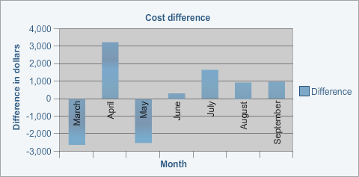
Q26. The following graph is a visual representation of the difference in each month.

By looking at this graph can you see if the overall project was overestimated or underestimated? Tick your response.
Answer ◻
Choice | Possible Answers
◻ | No, you cannot see this directly from the graph
x | Yes, you can see this from the graph

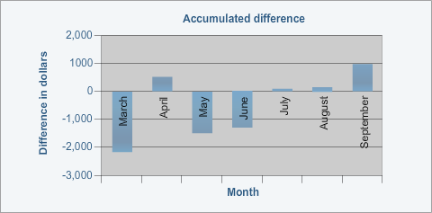
Q27. The following graph is a visual representation of the accumulated difference across the project.

Overall, was the project overestimated or underestimated? Tick your response.
Answer ◻
Choice | Possible Answers
x | Overestimated
◻ | Underestimated

Refer to the following scenario and house plan to respond to Q28. to Q30.
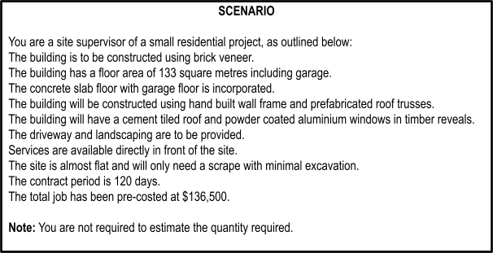

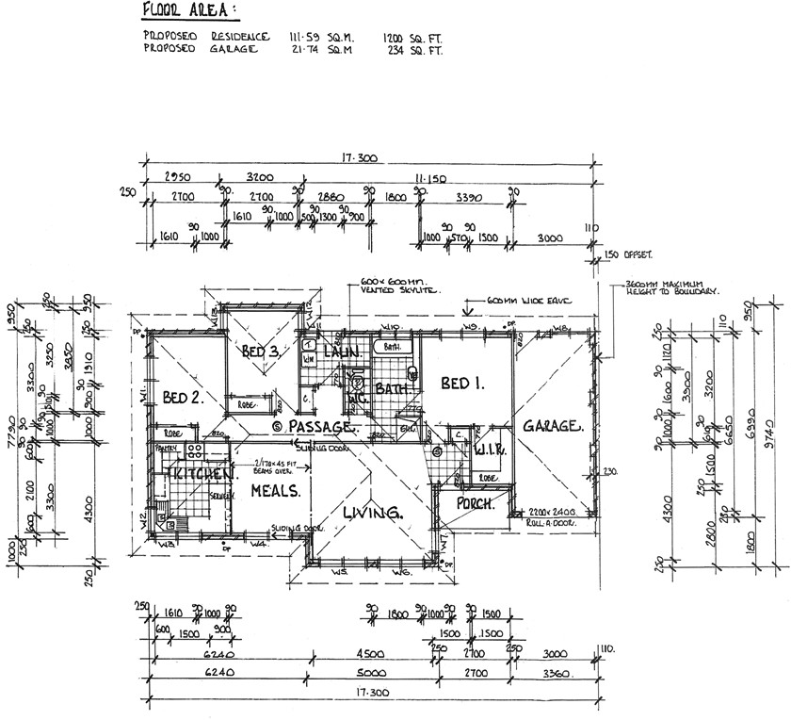

Q28. Using the list of materials prepared, find the following information for four (4) materials of your choice:

Answer ◻
Material | Lead-in time | Delivery date | Order date | Delivery  requirements/ special considerations
brick veneer | 10 days | 10/01/2021 | 01/01/202  1 | strength of the  bricks
concrete | 10 days | 20/01/2021 | 10/01/202  1 | mixture and material quality of concrete  ,  supplier details

cement tiles | 11 days | 26/02/2021 | 15/02/202  1 | product  descripti on, supplier details
powder  coated aluminiu m window  s | 24 days | 16/03/2021 | 20/02/202  1 | product  descripti on

Q29. Describe the process of ordering the following materials for your project. Be sure to consider the things that need to be considered:
Answer ◻
Material | Ordering process | Considerations
External cladding | - Get the best price - When preparing a quote for a project, send out the list of specified items to a number of suppliers to try to find the best price  - Tender a price – The suppliers will tender a price back to the builder  - Accept a tender – Choose the supplier offering the best price with  consideration to quality, availability and delivery  timelines | color, product  specifications, design, quality, availability and delivery timelines
Wall frame | - Get the best price - When preparing a quote for a project, send out the list of specified items to a number of suppliers to try to find the best price  - Tender a price – The suppliers will tender a price back to the builder  - Accept a tender – Choose the supplier  offering the best price with | product specifications, quality, availability and delivery timelines

consideration to quality, availability
and delivery timelines
Windows | - Get the best price - When preparing a quote for a project, send out the list of specified items to a number of suppliers to try to find the best price  - Tender a price – The suppliers will tender a price back to the builder  - Accept a tender – Choose the supplier offering the best price with  consideration to quality, availability and delivery  timelines | product specifications, quality, availability and delivery timelines

Q30. While excavating one corner of the project, you find the soil below is unsuitable for supporting the foundation. Refer to the relevant Building Regulator and complete their standard builder variation request documentation to be presented to the client.

Answe
- Put it in writing about the details of cost increase of excavation and progress delays.
- Client/builder must agree to before commencement of work

- All subsequent documentation such as additional cost and time delays must be completed by the client/builder within 5 business days of when the variation was agreed to
◻
r


PRODUCE
CPCCBC4005A
LABOUR AND
MATERIAL
SCHEDULES
FOR
ORDERING

PRACTICAL ASSESSMENT INSTRUCTIONS

- The following practical assessment will require the Participant to complete work related activities.
- The Assessor will conduct observations of the Participant’s work to determine whether they display sufficient practical skills and knowledge.
- Please fill in the details below – providing your name, signature and date of assessment.
  - The Participant’s signature acknowledges that the Assessor provided clear instructions and the Participant understood what was required to complete this assessment.
- The Assessor may substitute a Practical Task with an alternate task of equal value.
  - Alternate tasks must be fully documented by the assessor in the Assessor Comments area.

Participant name UAA Darshika Participant signature Dars³ika
Date 06/03/2021

Assessor name Myles Walder Assessor signature

Date Click here to enter a date.

Task | Task outcome (Tick)
Task | Satisfactory | Not Yet Satisfactory
Task 1 (Occasion 1) | ◻ | ◻
Task 1 (Occasion 2) | ◻ | ◻

ASSESSOR COMMENTS

MATERIAL
CPCCBC4005A
PRODUCE
LABOUR AND
SCHEDULES
FOR
ORDERING

Practical Task 1 (2X)
Description of task:
On two (2) occasions, a suitable observer is to verify the participant’s ability to produce schedules of resource requirements so that orders can be placed for materials and labour for projects, and costs can be recorded and tracked as they are incurred.
- Occasion 1: Residential project
- Occasion 2: Commercial project

The participant is to gather evidence of how they have completed each component of the Practical Task, which is to be submitted with this Practical Assessment sheet. Evidence to be submitted may include:
- A copy of a material/labour schedule or supplier list for a project
- A copy of a purchase order for purchasing materials or other resources
- A cost report
- Site condition reports or dilapidation reports
- Contract documents
- Call forward sheets
- Variations

The observer is to provide detailed comments on the tasks completed by the participant. The assessor is to verify the observer’s comments in the Assessor Comments section, and provide the Practical Assessment outcome on the front cover of this document.
Resources required:
Contract documentation (including plans and specifications), computer.
Assessment of task
Name of participant:
Name of observer:
Role of observer (Confirm suitability to sign)
Email address of observer
Signature of observer:
Date: | Click here to enter a date.
When completing the task, did the participant: |  | Tick if satisfactorily completed. Provide comments if left unticked.
 |  | 1st  Occasion | 2nd  Occasion
- Consider all contract conditions in the schedules, including:  - All contractual requirements  - Local government and regulatory bodies’ conditions of approval  - Colour selections  - Variations to contracts, raised by the client or builder |  | ◻ | ◻
- Produce material and labour schedules, including:  - Details of nominated suppliers and contractors in work schedules  1) Application of contract rates |  | ◻ | ◻
1.C. Produce relevant overlay drawings. |  | ◻ | ◻

1.D. Include contract details and instructions on orders. | ◻ | ◻
- Prepare site files, including:  - All necessary site documents, including plans and specifications  - Preparation of call forward sheets, detailing all orders | ◻ | ◻
1.F. Analyse project costs against estimates during construction. | ◻ | ◻
1.G. Analyse approved variation costs. | ◻ | ◻
1.H. Provide a final project cost analysis. | ◻ | ◻
- Maintain data files of standard costs, including:  - Approved variation cost increases  - Changes to standard plans, specifications, and cost files | ◻ | ◻
1.J. Effectively communicate using the following methods:  - Verbally using language/concepts appropriate to cultural differences  - Non-verbal communication | ◻ | ◻
The Participant’s performance was: ◻ Satisfactory ◻ Not Satisfactory
OBSERVER COMMENTS

