
AHCLSC305
Construct stone structures and features

Copyright © 2020 CSTC Pty Ltd

All rights reserved. No part of the contents of this publication may be reproduced or used in any form or by any means – graphic, electronic, or mechanical including photocopying, digitising, recording, or information storage-and-retrieval systems – without the written permission of CSTC Pty Ltd.
ASSESSMENT FOR AHCLSC305

Student name | Morgan Anstee
Date of assessment submission | Click here to enter a date.

Trainer/Assessor’s name
Date of assessment marking | Click here to enter a date.
Outcome for unit | ☐ Competent  ☐ Not Yet Competent

TASK INSTRUCTIONS

- As part of the assessment for this unit of competency, you are required to complete a series of activities.
  - Some of these activities will require you to provide a response within this document, others will require you to gather evidence to demonstrate your knowledge and skills.
- At all times, the responses in your assessment must reference Australian (Queensland or Federal) documentation, including legislation, regulations, codes of practice, standards and guidance publications.

ACTIVITIES

Identify/list the scope of the work to be carried out from the concept plan shown.

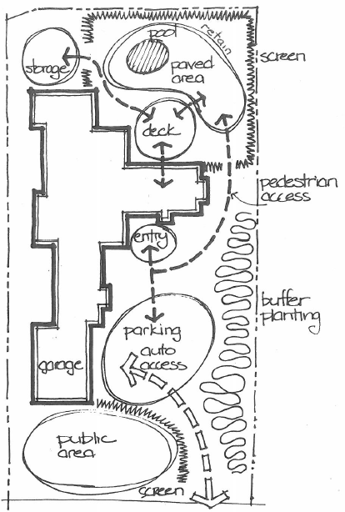

Response
- Install screening in the backyard around the pool area
- Install screening between the public access and auto access area.
- Install plants as a buffering
- Construct a retaining wall behind the pool area
- Build a deck in the back yard
- Install a pool and pave around the pool area
- Install pathways for pedestrian access
- Install a storage area behind screening in back yard

Outcome for Activity 1 | ☐ Satisfactory  ☐ Not satisfactory
Trainer/Assessor comments

Identify/list the detail on the landscape plan shown.

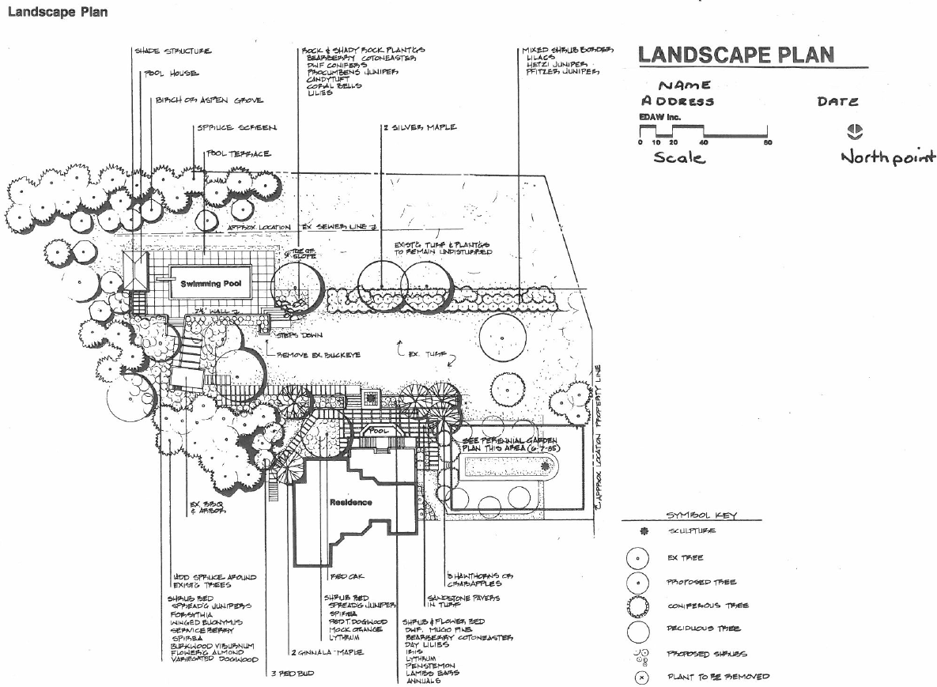

Response
* Symbol Key
* Scale
* Date
* Structures
* North Point
* Plant Species
* Name
* Address
* Landscape Layout
* Plant species

Outcome for Activity 2 | ☐ Satisfactory  ☐ Not satisfactory
Trainer/Assessor comments

List the materials required to complete the water feature, by using the wall and water feature construction plan shown.

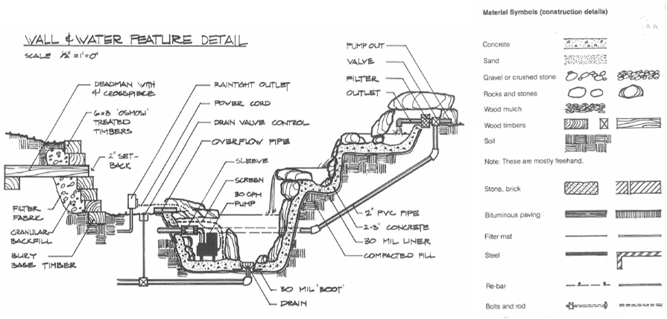

Response
- Concrete
- Sand, Gravel or crushed stone
- Rocks, Stones, Wood Mulch, Soil, Fill
- Wood timbers
- Filter fabric
- Re-bar
- Anchor bolts
- Form work
- PVC pipe
- Overflow pipe
- Pump, Outlets, Filter, Power, Drain valve control
- Stone Bricks and Bituminious paving
- Drain, sleeve, bolts and rods, steel

Outcome for Activity 3 | ☐ Satisfactory  ☐ Not satisfactory
Trainer/Assessor comments

Identify formal and informal stone structures and describe their features.

 | Features
- Formal stone structures | Formal stone structures often feature a simplistic and geometric design, straight edges, long sightlines, symmetry, hard angles  By using a straight path this leads the eye directly to the focal point of the garden such as a stone fountain,  Stone features may include Retaining walls, stone pavers, water features, pathways and boarders
- Informal stone structures | Informal Landscape is more free flowing with Curved lines, meandering paths, less restrictive. Can be symmetrical or asymmetrical.  Stone features may include Staked boulder walls, feature rocks, stepping stones, boarders, pathways

Outcome for Activity 4 | ☐ Satisfactory  ☐ Not satisfactory
Trainer/Assessor comments

List the components for four (4) common surface drainage systems used in landscape construction.

System | Components
- Spoon | Components  Machinery is used to shape the land to channel excess water (e.g. into sub-surface drain or storm water drain)  these are used in smaller landscape areas.
- Channel and grate | An indivually designed drain which intercepts a surface run-off and direct it to a known water course.  An example includes diverting storm water
- Pit | A water collection pit or storage container  it is not designed to hold all the runoff, but needs to be large enough to contain the water pouring into it long enough to allow it to drain through the drainage pipes at a rate that keeps up with the flow of water.
- Contour | A water carrying or water holding channel or ridge constructed of earth, located on or near a contour line  They are used to slow down the flow of water across a slope.

Outcome for Activity 5 | ☐ Satisfactory  ☐ Not satisfactory
Trainer/Assessor comments

List the advantages and disadvantages of drainage behind and through the stone wall (as shown).

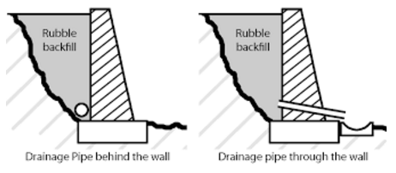

Drainage pipe behind the wall
Advantages
Simple to install, cost effective, simplicity
Aesthetically pleasing as hidden behind the wall
Disadvantages
Water build up behind the wall if fill and filters are not used adequately
water has to travel along behind the wall to escape

Drainage pipe through the wall
Advantages
Simple to install, cost effective, water can escape through the wall instead of building up behind.
Disadvantages
Could get blocked, therefore allowing water to build up
regular cleaning of pipe required
not as aesthetically pleasing
Have to ensure water coming through the wall can not get waterlogged on the land below.

Outcome for Activity 6 | ☐ Satisfactory  ☐ Not satisfactory
Trainer/Assessor comments

Research and list a variety of admixes.

Admix | Description
- Air – Entraining Admixture | Air-entraining admixtures are added to concrete to improve its workability and cohesiveness and to reduce the water demand, thereby reducing bleeding and material segregation. Excessive amounts will reduce potential strengths. AS 1379 allows up to 5% air entrainment.
- b) Set-Retarding Admixtures | Set-retarding admixtures slow the setting of concrete. They are useful during warm to hot weather conditions, and when a concrete mix must be transported long distances.
- c) 'Set-Accelerating' ADMIXTURE | reduce the setting times of concrete. They are often used during cool to cold weather conditions.
- d) Water-reducing admixtures | disperse the cement particles and improve the work-ability of the concrete without the addition of water

Outcome for Activity 7 | ☐ Satisfactory  ☐ Not satisfactory
Trainer/Assessor comments

Research other methods of damp proofing (excluding DPC and base course) and identify the materials used.

Damp proofing method | Materials
- Membrane Damp Proofing | Polyethylene sheeting laid under a concrete slab to prevent the concrete from gaining moisture through capillary action.  Membrane damp proofing is made from flexible materials such as bitumen, mastic asphalt, bituminous felts, plastic or polythene sheets or metal sheets.
- Integral Damp Proofing | Putting additives into the concrete mix to make the concrete itself impermeable  chalk, talc, fullers earth, which may fill the voids of concrete under the mechanical action principle.  i.Compounds like alkaline silicates, aluminum sulphate, calcium chlorides, etc. which react chemically with concrete to produce water proof concrete.  ii.Compounds like soap, petroleum, oils, fatty acid compounds such as stearates of calcium, sodium, ammonia etc. work on water repulsion principle. When these are mixed with concrete, the concrete becomes water repellent.
- Surface Coating | Using a thin waterproof material for resistance to moisture.  layer of water repellent substances or compounds are applied on these surfaces through which moisture enters. The use of water repellent metallic soaps such as calcium and aluminum oletes and stearates are much effective against rain water penetration. Pointing and plastering of the exposed surfaces must be done carefully, using water proofing agents like sodium or potassium silicates, aluminum or zinc sulphates, barium hydroxide and magnesium sulphates etc.
- d) Pressure grouting | Injecting a grout material into the structure.  rcing cement grout under pressure, into cracks, voids, fissures and so on present in the structural components of the building, or in the ground. Thus the structural components and the foundations which are liable to moisture penetration are consolidated and are thus made water-penetration-resistant

Outcome for Activity 8 | ☐ Satisfactory  ☐ Not satisfactory
Trainer/Assessor comments

Research and describe suitability of various patterns for stone work projects.

Pattern | Suitability
- Face Brick | Housing walls, walls, fences
- Bush Rock | Walkways, Pathways, Driveways
- Slate | Walkways, Pathways, Driveways
- 45 Herringbone | Walls, Housing walls, Driveways, Pathways

Outcome for Activity 9 | ☐ Satisfactory  ☐ Not satisfactory
Trainer/Assessor comments

List the advantages and disadvantages of mortared and dry stone features.

Mortared stone features
Advantages
Strong, Security
Disadvantages
Time consuming

Dry stone features
Advantages
Can be done cheaply, low maintenance
Disadvantages
Can break under pressure of the stones/weight

Outcome for Activity 10 | ☐ Satisfactory  ☐ Not satisfactory
Trainer/Assessor comments

Research the different types of stone work finishes.

Response
- Axed finish
- Boasted finish
- Combed finish
- Circular finish
- Chisel-draughted margins
- Molded finish
- Furrowed finish
- Plain finish
- Polished finish
- Hammer dressed finish
- Rubbed finish
- Reticulated finish
- Punched finish
- Tooled finish
- Scrabbling finish
- Vermiculated finish
- Sunk finish
- Quarry faced finish

Outcome for Activity 11 | ☐ Satisfactory  ☐ Not satisfactory
Trainer/Assessor comments

List environmentally safe products for cleaning.

Response
Water, Some oils, Some degreasers.

Outcome for Activity 12 | ☐ Satisfactory  ☐ Not satisfactory
Trainer/Assessor comments

Have team members take photos and videos of your involvement with stone features.

Identify each photo / video with a letter label and describe each photo / video in the table below. Submit the photo / video files along with this workbook.

Advantages
A
B
C
D
E
F
G
H
I
J
K
L
M
N
O
P
Q
R
S
T
U
V
W
X
Y
Z

Outcome for Activity 13 | ☐ Satisfactory  ☐ Not satisfactory
Trainer/Assessor comments

