Workplace Assessment 15 – Assessor’s Checklist
(This form is for the assessor’s use only)

Purpose
This Assessor’s Checklist lists the specific criteria that the candidate’s submission for Workplace Assessment 15 must satisfactorily meet.
This form is to be completed by the candidate’s assessor to document their assessment of the candidate’s submission in Workplace Assessment 15.

Task Overview
For this task, the candidate is required to draft the complete Client Contract for the project they are undertaking.
In this task, the candidate will be assessed in their:
- Practical knowledge of appropriate client contract
- Practical skills relevant to completing appropriate client contract

Instructions to the Assessor

During the assessment
- Review the candidate’s Client Contract submission.
- For each criterion listed in this checklist:
  - Tick YES if you confirm the candidate’s submission satisfactorily meets the criterion.
  - Tick NO if you confirm the candidate’s submission does not satisfactorily meet the criterion.
- Write specific comments on the candidate’s performance in each criterion. Your feedback/insights will help address any area/s for improvement.

After the assessment
- Complete all parts of the Assessor’s Checklist, including the Assessor Declaration on the last page of this form. Your signature must be handwritten.

Candidate Details
Candidate name | Dawei Yang

Assessor Details
Candidate is assessed by | Steve Zhu

Context of the Assessment
Workplace/organisation | Dawn construction
Building and construction project | Granny flat and massage shop
Building classification | class1&5

Resources required for the assessment | - Building and construction project  - Residential project, AND  - Commerical project  - Opportunities to draft the complete Client Contract  - Template for drafting Client Contract

Assessor’s Checklist
The client contract varies, depending on the building and construction project and the involved client organisation. Note that the below checklist is a generic format and thus, needs to be updated/adapted/revised accordingly.
The candidate’s Client Contract submission: | YES/NO | Assessor’s comments
- States identifying information
- Name of candidate’s organisation | Residential  YES NO  Commercial  YES NO
- Address of candidate’s organisation | Residential  YES NO  Commercial  YES NO
- Name of client organisation | Residential  YES NO  Commercial  YES NO
- Address of client organisation | Residential  YES NO  Commercial  YES NO
- States the scope of work
- Services to be provided | Residential  YES NO  Commercial  YES NO
- Description of materials | Residential  YES NO  Commercial  YES NO
- Quality of work | Residential  YES NO  Commercial  YES NO
- Schedule of work | Residential  YES NO  Commercial  YES NO
- Start date | Residential  YES NO  Commercial  YES NO
- Completion date | Residential  YES NO  Commercial  YES NO
- Technical specifications | Residential  YES NO  Commercial  YES NO
- States the cost and payment terms
- Payment timelines | Residential  YES NO  Commercial  YES NO
- Amount due | Residential  YES NO  Commercial  YES NO
- Mode of payment | Residential  YES NO  Commercial  YES NO
- Consequences for late payments | Residential  YES NO  Commercial  YES NO
- Stop work clause | Residential  YES NO  Commercial  YES NO
- Stop payment clause | Residential  YES NO  Commercial  YES NO

The candidate’s Client Contract submission: | YES/NO | Assessor’s comments
- Defines the authority to make decisions during the project, including:
- Who will be making the decisions | Residential  YES NO  Commercial  YES NO
- The scope of decision to be made | Residential  YES NO  Commercial  YES NO
- States conditions for change orders | Residential  YES NO  Commercial  YES NO
- Provides a statement of warranty | Residential  YES NO  Commercial  YES NO
- Reflects the amendments made in Task 12.
Assessor to list the amendments made in Task 12 below.
- liquidated damages | Residential  YES NO  Commercial  YES NO
- termination | Residential  YES NO  Commercial  YES NO
- The documents compiled follow organisational format. | Residential  YES NO  Commercial  YES NO
- The documents are clear and definite | Residential  YES NO  Commercial  YES NO
- The documents are presented using appropriate organisational templates  e.g. Contract template, client contract template | Residential  YES NO  Commercial  YES NO
- The documents have no unnecessary markings | Residential  YES NO  Commercial  YES NO
- Provides response fields for candidate organisation’s sign-off | Residential  YES NO  Commercial  YES NO
- Provides response fields for client organisation sign-off | Residential  YES NO  Commercial  YES NO
- Provides response fields for legal officer sign-off | Residential  YES NO  Commercial  YES NO

Assessor Declaration
By signing here, I confirm that I have thoroughly reviewed the candidate’s client contract submission for this workplace assessment task.
I confirm that the information recorded on this Assessor’s Checklist is true and accurately reflects the candidate’s submission for this workplace task.
Assessor’s signature | 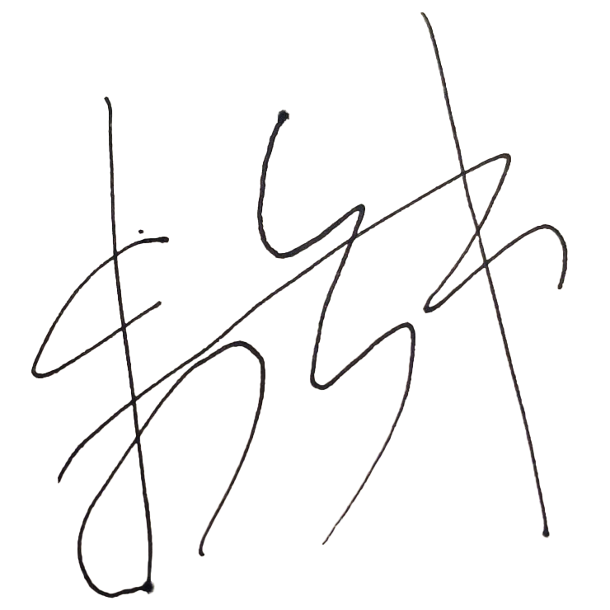
Assessor’s name | Steve Zhu
Date signed | 19/01/2023

End of Workplace Assessment - Assessor’s Checklist

