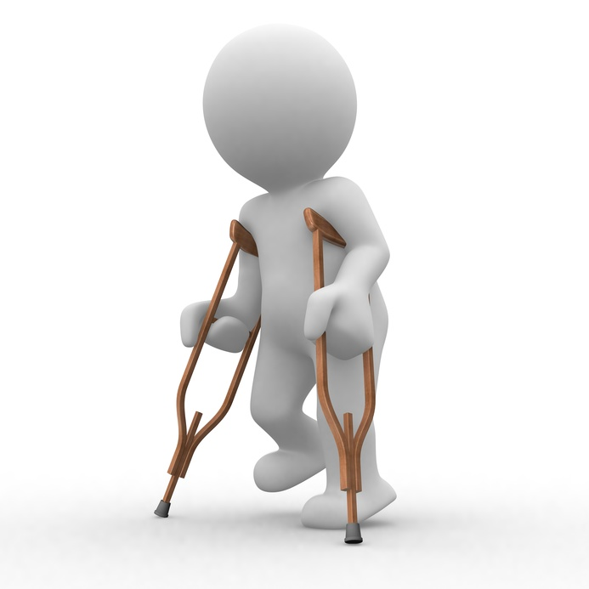

HLTWHS003
Maintain work health and safety
Learner Workbook

Table of Contents

Table of Contents 1
Candidate Details 2
Assessment – HLTWHS003: Maintain work health and safety 2
Competency Record to be completed by Assessor 3
Activities 5
Activity 1A 5
Activity 1B 6
Activity 1C 7
Activity 1D 8
Activity 2A 9
Activity 2B 10
Activity 2C 11
Activity 2D 12
Activity 3A 13
Activity 3B 14
Activity 3C 15
Skills and Knowledge Activity 16
Major Activity 17

Candidate Details

Assessment – HLTWHS003: Maintain work health and safety
Please complete the following activities and hand in to your trainer for marking. This forms part of your assessment for HLTWHS003: Maintain work health and safety.
Name: _____________________________________________________________
Address: _____________________________________________________________
_____________________________________________________________
Email: _____________________________________________________________
Employer: _____________________________________________________________
Declaration
I declare that no part of this assessment has been copied from another person’s work with the exception of where I have listed or referenced documents or work and that no part of this assessment has been written for me by another person.
Signed: ____________________________________________________________
Date: ____________________________________________________________
If activities have been completed as part of a small group or in pairs, details of the learners involved should be provided below:
This activity workbook has been completed by the following persons and we acknowledge that it was a fair team effort where everyone contributed equally to the work completed. We declare that no part of this assessment has been copied from another person’s work with the exception of where we have listed or referenced documents or work and that no part of this assessment has been written for us by another person.
Learner 1: ____________________________________________________________
Signed: ____________________________________________________________
Learner 2: ____________________________________________________________
Signed: ____________________________________________________________
Learner 3: ____________________________________________________________
Signed: ____________________________________________________________

Competency Record to be completed by Assessor
Learner Name: _______________________________________________________
Date of Assessment: _______________________________________________________
The learner has been assessed as competent in the elements and performance criteria and the evidence has been presented as:
Assessor Initials
Authentic
Valid
Reliable
Current
Sufficient

Learner is deemed: COMPETENT NOT YET COMPETENT (Please circle)

If not yet competent, date for re-assessment: ____________________________________

Comments from Trainer / Assessor:
__________________________________________________________________________________________________________________________________________________________________________________________________________________________________________________________________________________________________________________________________________________________________________________________________________________________
Assessor Signature: ________________________________________________________
Observation/Demonstration

Throughout this unit, you will be expected to show your competency of the elements through observations or demonstrations. Your instructor will have a list of demonstrations you must complete or tasks to be observed. The observations and demonstrations will be completed as well as the activities found in this workbook. An explanation of demonstrations and observations:
Demonstration is off-the-job
A demonstration will require:
- Performing a skill or task that is asked of you
- Undertaking a simulation exercise
Observation is on-the-job
The observation will usually require:
- Performing a work based skill or task
- Interaction with colleagues and/or customers
Your instructor will inform you of which one of the above they would like you to do. The demonstration/observation will cover one of the unit’s elements.
The observation/demonstration will take place either in the workplace or the training environment, depending on the task to be undertaken and whether it is an observation or demonstration. Your instructor will ensure you are provided with the correct equipment and/or materials to complete the task. They will also inform you of how long you have to complete the task.
You should be able to demonstrate you can:
- Contribute to workplace procedures for identifying hazards and controlling risks
- Implement policies and procedures into work team processes
- Support consultation, cooperation and communication
You should also demonstrate the following skills:
- Written communication
- Oral communication
Activities

Activity 1A
Estimated Time | 20 Minutes
Objective | To provide you with an opportunity to identify existing and potential hazards and record them according to workplace procedures.
Activity | If you are appointed to undertake health and safety duties in the workplace, what are your primary tasks?  Name three types of hazards that you may find in the workplace?  What process should you follow when identifying hazards in the workplace?  Name two items which should be included in your organisation’s emergency procedures.

Activity 1B
Estimated Time | 15 Minutes
Objective | To provide you with an opportunity to contribute to the development of strategies for implementing risk controls in line with workplace procedures and policies.
Activity | What is a risk assessment process?  Should you include staff in the risk assessment process, and if so, how?  What is a risk matrix?  Name two strategies to control risk.

Activity 1C
Estimated Time | 15 Minutes
Objective | To provide you with an opportunity to implement risk controls in line with the hierarchy of risk control and workplace and legislative requirements.
Activity | After identifying the controls needed how can you plan to make costly changes?  What are the hierarchy of risk controls (in order of effectiveness)?  Why are manual tasks and lifting a risk to employees?  What is a safety data sheet (SDS)?

Activity 1D
Estimated Time | 10 Minutes
Objective | To provide you with an opportunity to identify and report issues with risk controls, including residual risk, in line with workplace and legislative requirements.
Activity | What should you check for when looking at how the risk controls are working?  What is residual risk?  What steps should you take after reporting issues of concern with current risk control measures?

Activity 2A
Estimated Time | 15 Minutes
Objective | To provide you with an opportunity to regularly provide information about WHS policies and procedures to the work team.
Activity | What does PCBU stand for?  What does the WHS Act S.28 stipulate that all workers should do?  What is a duty of care in the workplace?  What is negligence in the workplace?

Activity 2B
Estimated Time | 15 Minutes
Objective | To provide you with an opportunity to provide information about identified hazards and the outcomes of risk assessment and risk controls to the work team.
Activity | Why should you communicate about risk assessment and controls to the work team?  What should your team be provided with?  What should you do if a member of your work team is required to use PPE and it does not fit?

Activity 2C
Estimated Time | 10 Minutes
Objective | To provide you with an opportunity to monitor housekeeping practices to ensure that WHS policies and procedures are followed.
Activity | What is housekeeping at work?  Name four things that you/your team may need to do for housekeeping duties.

Activity 2D
Estimated Time | 15 Minutes
Objective | To provide you with an opportunity to maintain WHS incident records in the work area according to workplace procedures and legislative requirements.
Activity | List what needs to be recorded on an incident/accident record for the details regarding the incident/accident.  What is a notifiable incident?  When should this be reported?  Who do notifiable incidents relate to at work?

Activity 3A
Estimated Time | 15 Minutes
Objective | To provide you with an opportunity to support workplace consultative procedures by encouraging work team participation in consultative activities.
Activity | Who should be included in a health and safety consultation?  Who can be a health and safety representative (HSR)?  Which people may be included in a health and safety committee?  Which Section of the WHS Act refers to the function of a health and safety committee?

Activity 3B
Estimated Time | 10 Minutes
Objective | To provide you with an opportunity to report health and safety issues in line with workplace procedures and legislative requirements.
Activity | Who benefits from keeping records of health and safety incidents?  What is issue resolution?  If no issue resolution procedure exists at your organisation, what will occur?

Activity 3C
Estimated Time | 15 Minutes
Objective | To provide you with an opportunity to encourage and assist work team members to contribute to WHS.
Activity | How would you communicate with your work team to encourage contributions to WHS?  Which states/territories practice harmonisation of WHS legislation?  What effects may industry-specific requirements have on health and safety at work?

Skills and Knowledge Activity
Estimated Time | 120 Minutes
Objective | To provide you with an opportunity to demonstrate your knowledge of the foundation skills, knowledge evidence and performance evidence.
Activity | Complete the following individually and attach your completed work to your workbook.  The answers to the following questions will enable you to demonstrate your knowledge of:  - Written communication  - Oral communication  - State/territory legislation and how it impacts on workplace regulations, codes of practice and industry standards  - Hazards common to the work environment and how they cause harm  - Principles of hazards and risk assessment  - Workplace emergency procedures  - Workplace policies and procedures for WHS  Answer each question in as much detail as possible, considering your organisational requirements for each one.  - Describe an emergency situation that may occur within the workplace. List the safety procedures that should be followed in the control of this, ensuring that WHS procedures and legislation are accounted for.  - From this emergency situation – describe the hazards involved in the event and explain how the event could have been prevented through a risk assessment process.  - Present your report as a verbal communication to two other people in your group  - Provide a written workplace risk assessment on the hazards.  - Produce and complete a workplace incident record – this may be related to the emergency situation or from another incident within the workplace.

Major Activity
Estimated Time | 1 Hour
Objective | To provide you with an opportunity to demonstrate your knowledge of the entire unit.
Activity | This is a major activity – your instructor will let you know whether you will complete it during class or in your own time.  Attach your completed answers to the workbook.  You must individually, answer the following questions in full to show your competency of each element:  - Contribute to workplace procedures for identifying hazards and controlling risks  - Implement policies and procedures into work team processes  - Support consultation, cooperation and communication  - Why should you record identified and potential hazards to workplace procedures?  - Why are strategies for implementing risk control needed for workplace procedures and policies?  - Why should a hierarchy of risk controls be followed when looking to control risk?  - Why should you identify and report issues with risk controls, in line with workplace and legislative requirements?  - Why should you regularly provide information about WHS policies and procedures to the work team?  - What is the purpose of providing information to the work team on identified hazards, the risk assessment and risk controls that are to be put in place?  - How can housekeeping duties ensure that WHS policies and procedures are followed?  - What should you do with WHS incident records in the workplace?  - Why is a consultative procedure in the workplace necessary to encourage employee participation in consultative activities?  - Why are reports of health and safety issues needed to be in line with work procedures and legislative requirements?  - How can you encourage and assist work team members to contribute to WHS?

