CPCCBC4014A
Prepare simple building sketches and drawings

THEORY EXAM INSTRUCTIONS

- This exam will occur under standard assessment conditions.
  - An oral examination may be allowed under certain circumstances.
Answers will be documented and FT003 (Oral examination declaration form) must be completed.
- Participants must provide enough detail in their responses to demonstrate their knowledge and skills.
- Please fill in the details below, providing your name, signature and date of assessment.
  - Your signature acknowledges that this is your own work.
- If a participant initially answers a question incorrectly but modifies their response, they must follow the instructions below:
  - If a participant changes their response in writing, they must put their initials next to the written change.
  - If a participant changes their response verbally, this must be noted on the exam paper by the assessor.

Participant name | Justin Skehan
Participant signature | 

Assessor name
Assessor signature | 

Date | 19/10/2018

Number of questions | Number of questions answered correctly | Satisfactory?
12 |  | Yes | No

Assessor Comments
Refer to the drawing below to respond to Q1. to Q2.

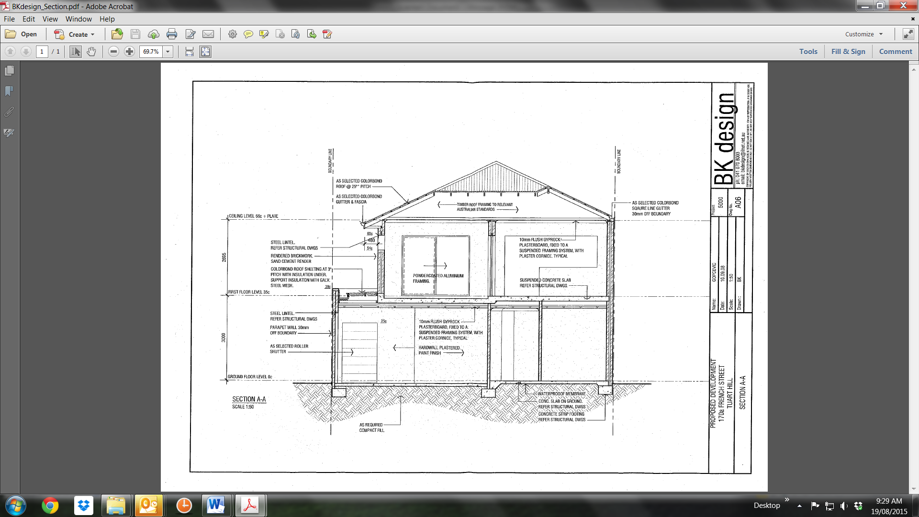

- Reproduce the Section Drawing. Apply dimensions using an appropriate scale and insert your own Title Block.

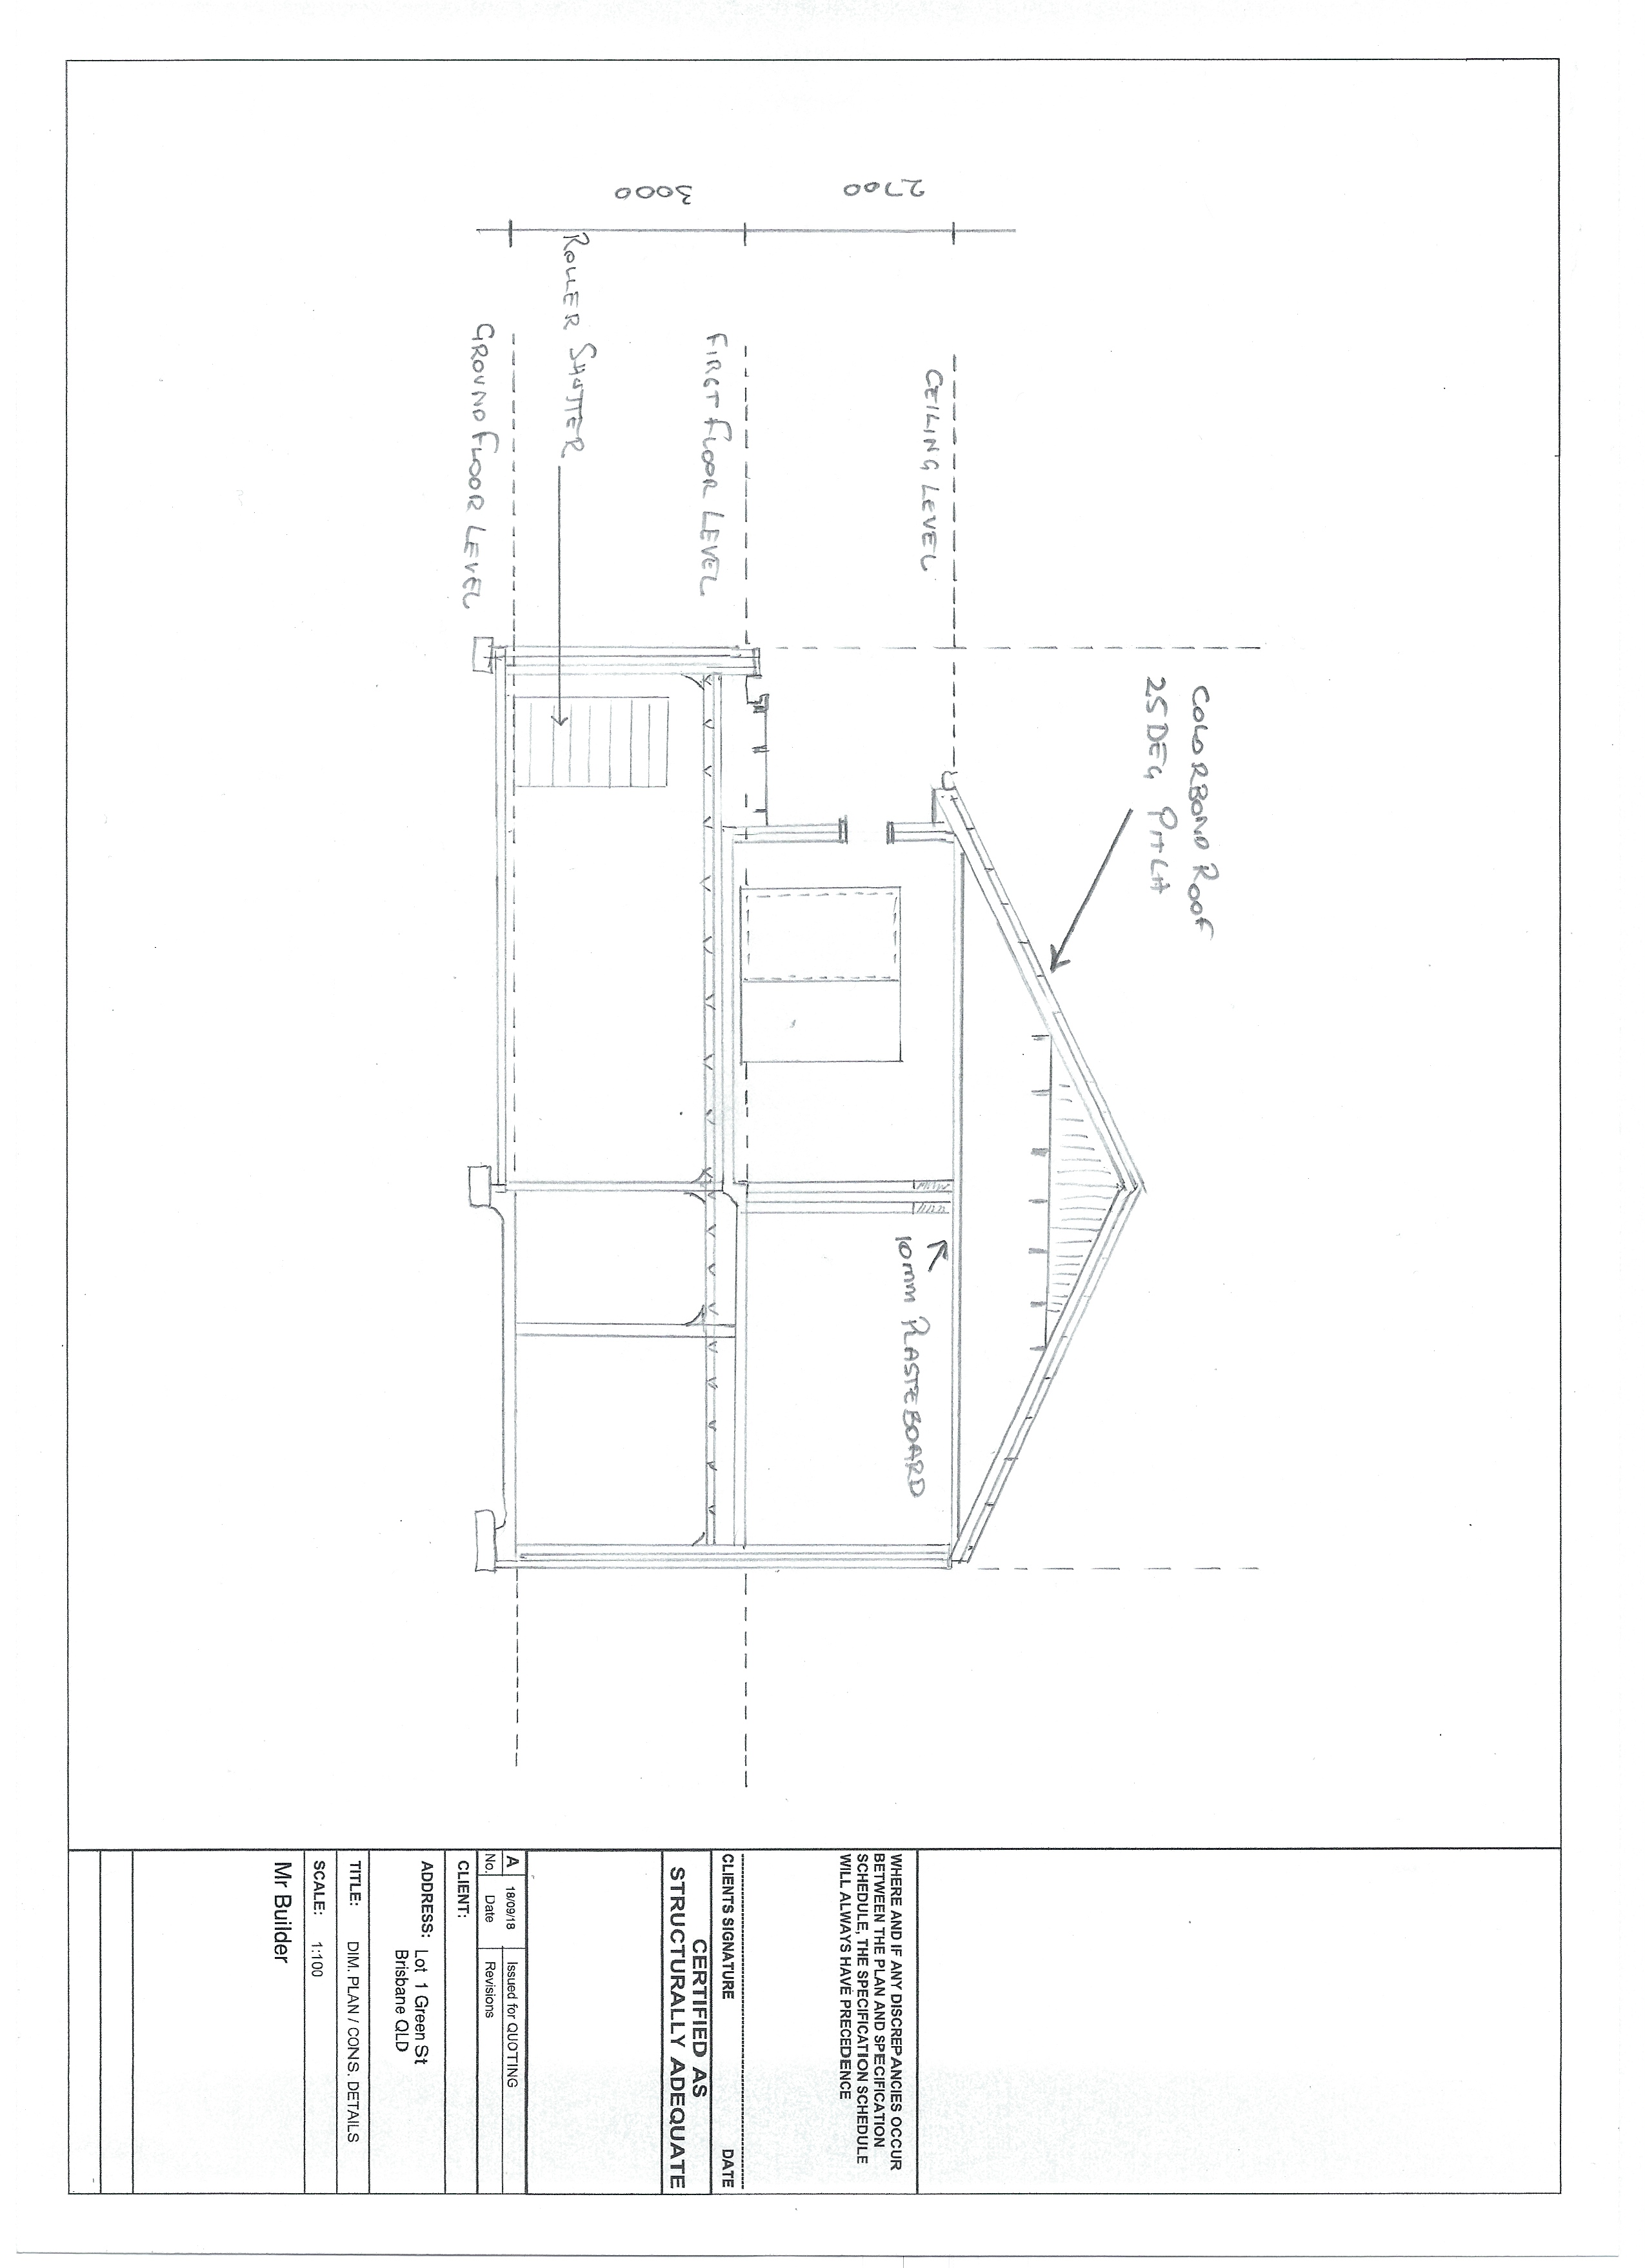

Answer

- Write a paragraph or two sufficient to explain this dwelling’s sectional view to a client or trade contractor.

Answer | This is a 2-storey brick veneer house with a 25 deg Colorbond timber framed roof structure complete with Colorbond fascia and gutter. The ground floor is a slab on ground with internal timber framed walls with plasterboard lined ceiling and walls with plater cornice.  The first floor consists of a suspended slab ground with internal timber framed walls with plasterboard lined ceiling and walls with plater cornice.

Refer to the floor plan below to respond to Q3. to Q12.
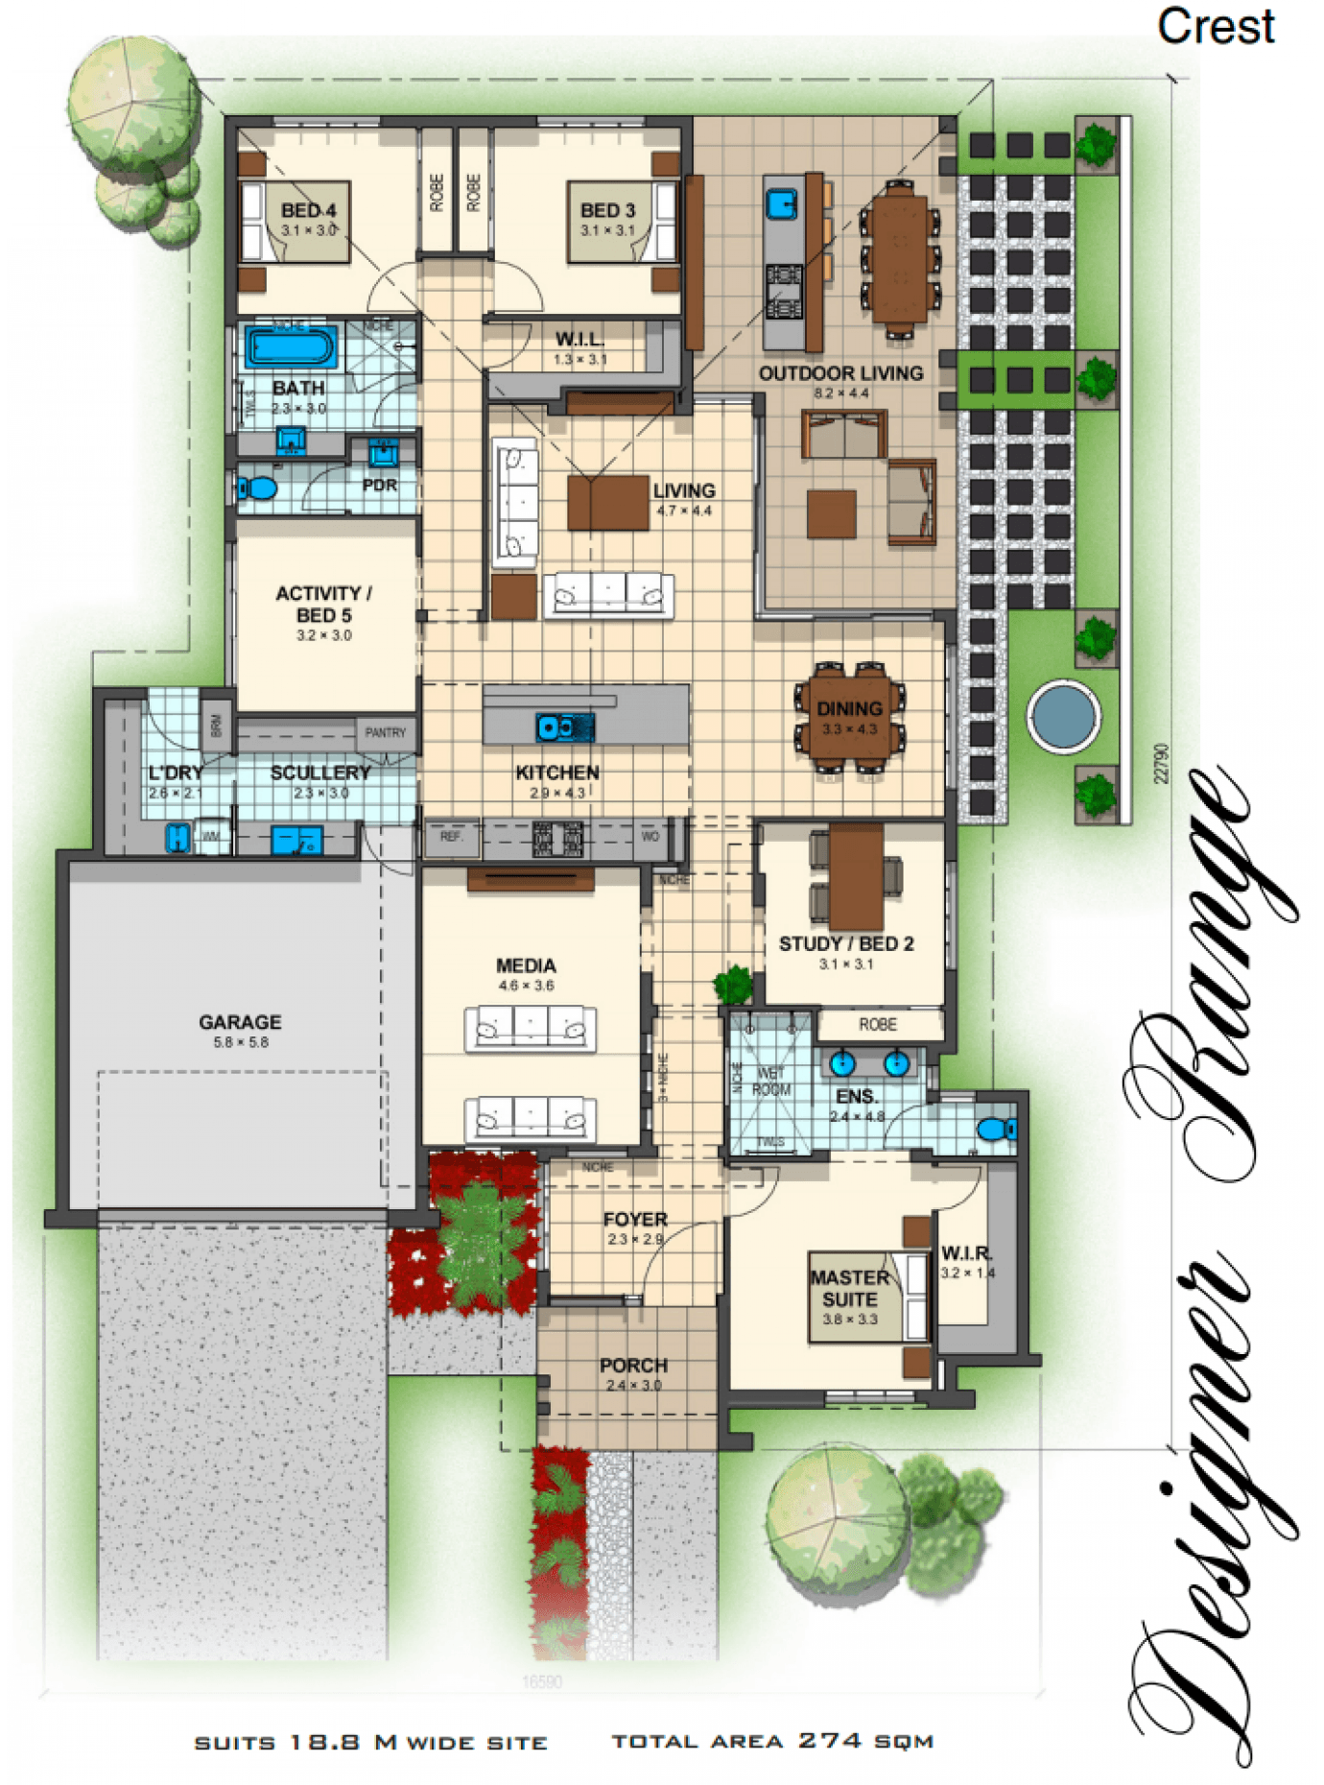

- Use the floor plan to create your own title block and produce the North, South, East and West Elevations.

- Determine your own finished ceiling height and aluminium window and door sizes appropriate to the scale of the rooms and building (and applicable standards/codes).
- Assume it is slab on ground, rendered brick veneer construction, timber trussed roof and concrete roof tiles; metal fascia and gutters, driveway and paths are exposed aggregate.

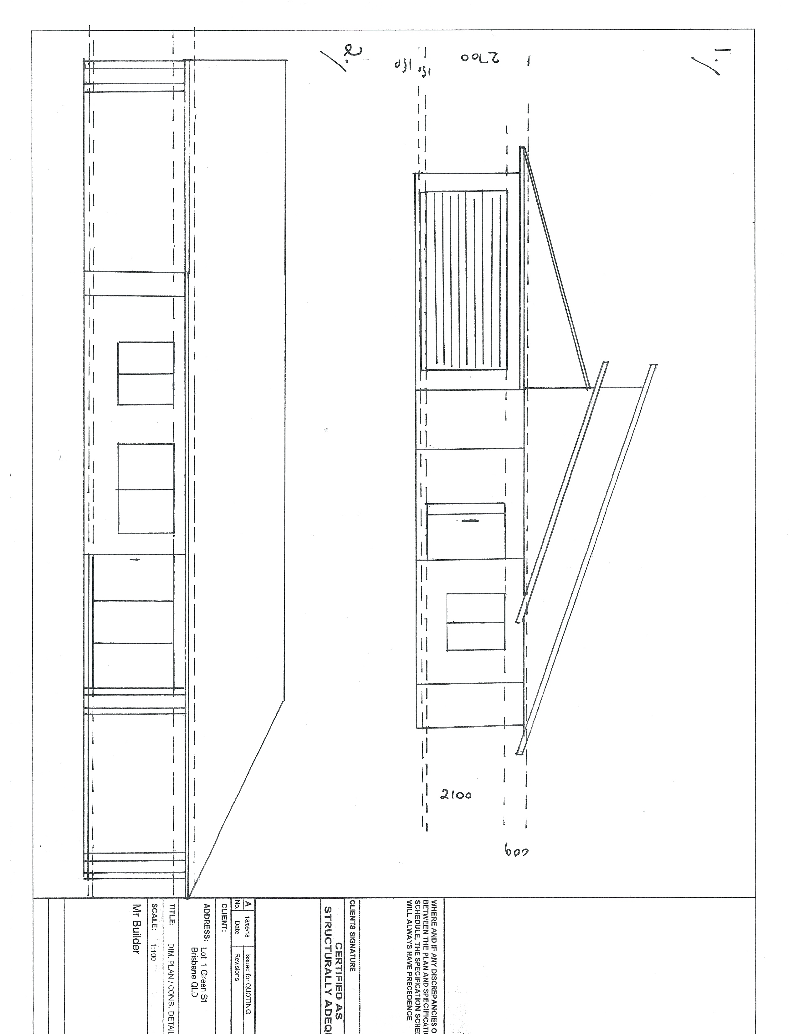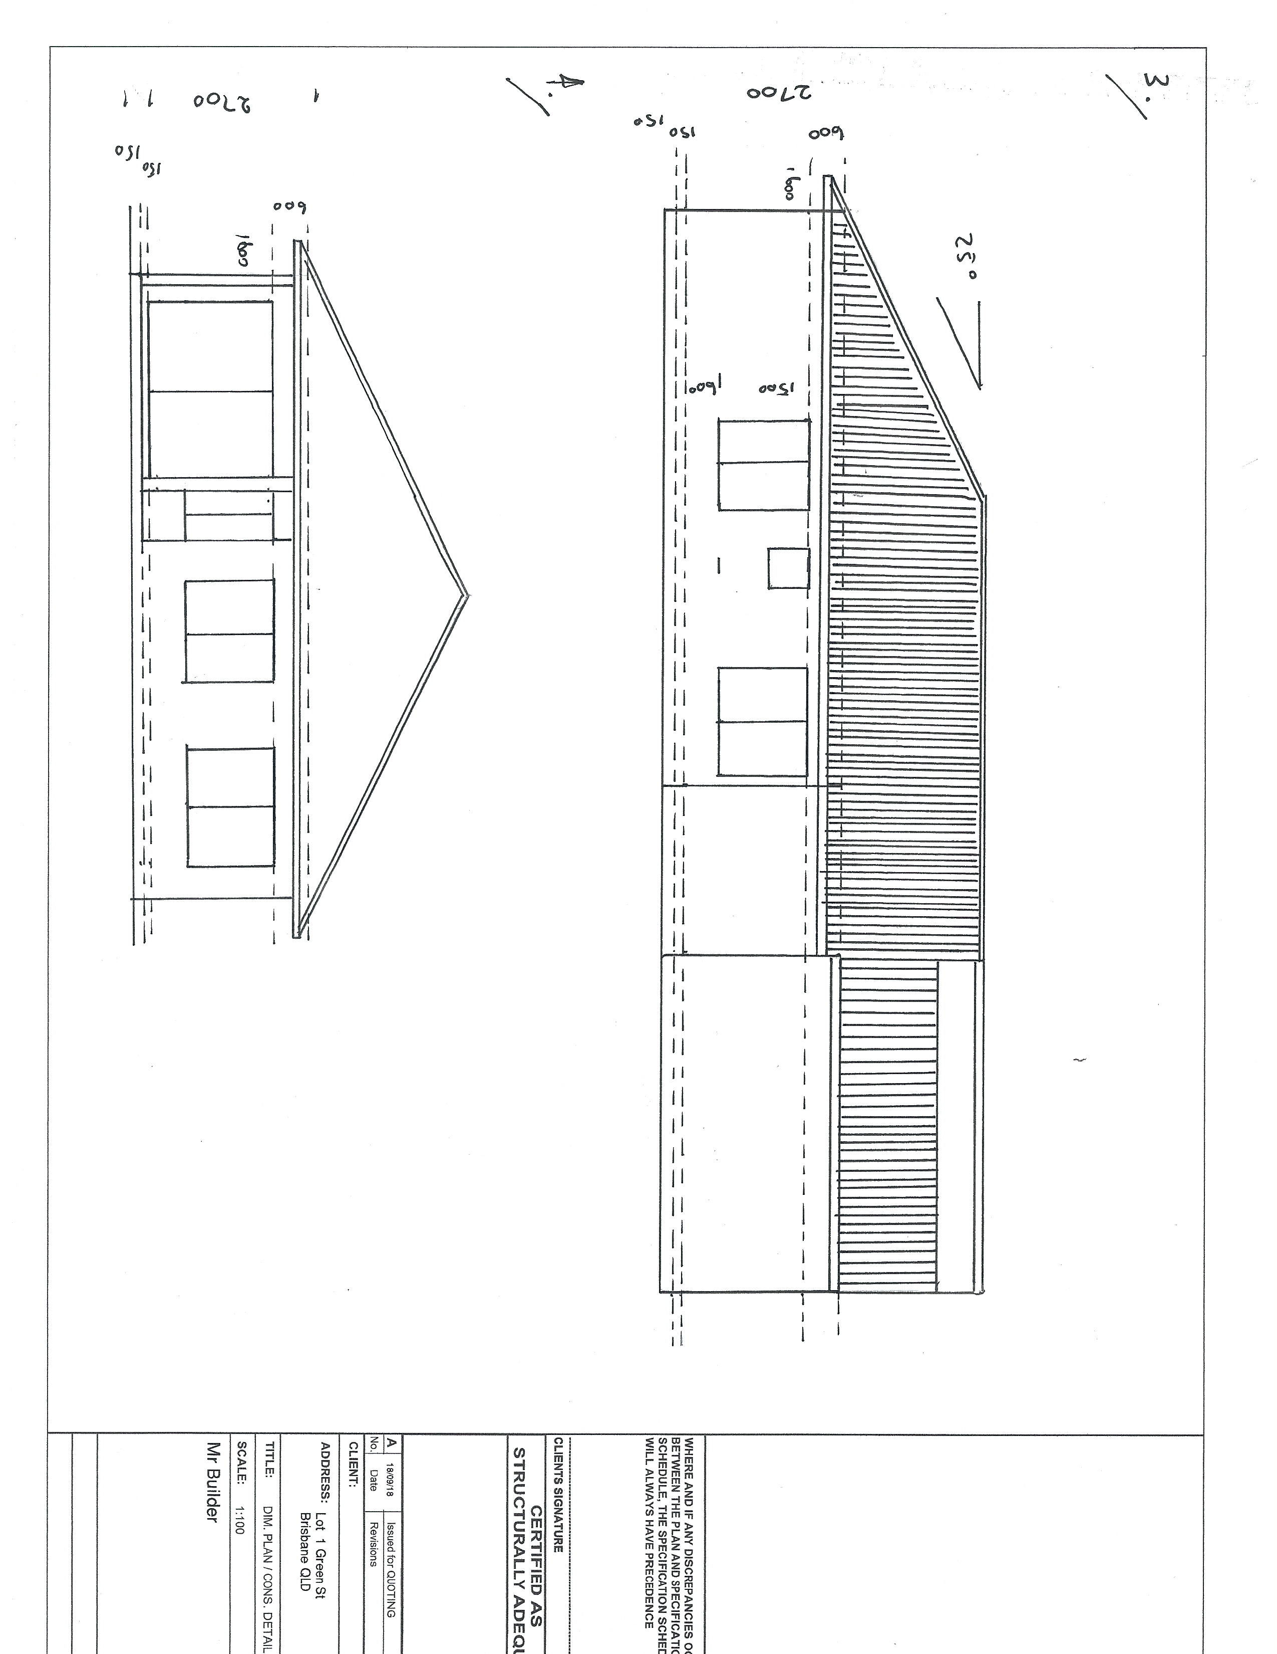

Answer

- Identify an address with fictitious house and lot number and the block of land and land shape for the home and then create a Site Plan.
- Your boundary set offs are to accord with Brisbane City Council requirements. You are to determine these by contacting Brisbane City Council.
- Clearly mark the direction and contours on this site plan.
- Identify on your site plan the location of any existing buildings, trees, fences and other structures.
- Determine the ingress and egress points for traffic management to, from and over the site.
- Using appropriate drawing conventions, you are to mark the location of utilities and services including water, telecommunications, sewerage, storm water and electrical.

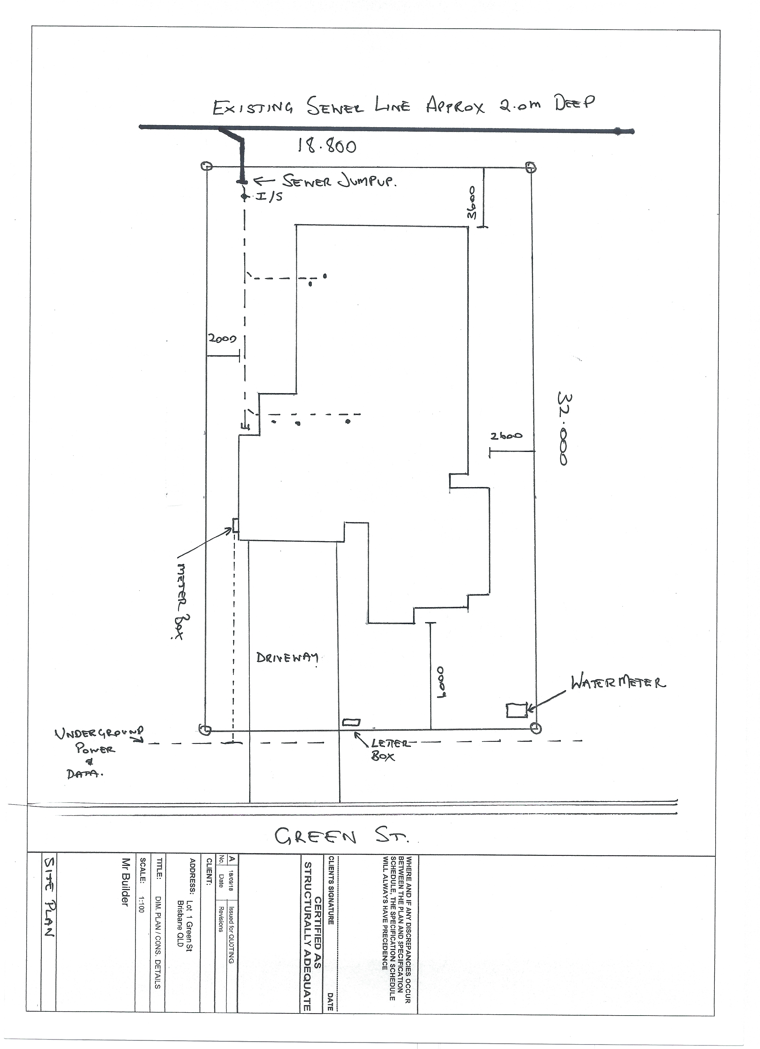

Answer

- Referring to the floor plan, create a windows and doors schedule.

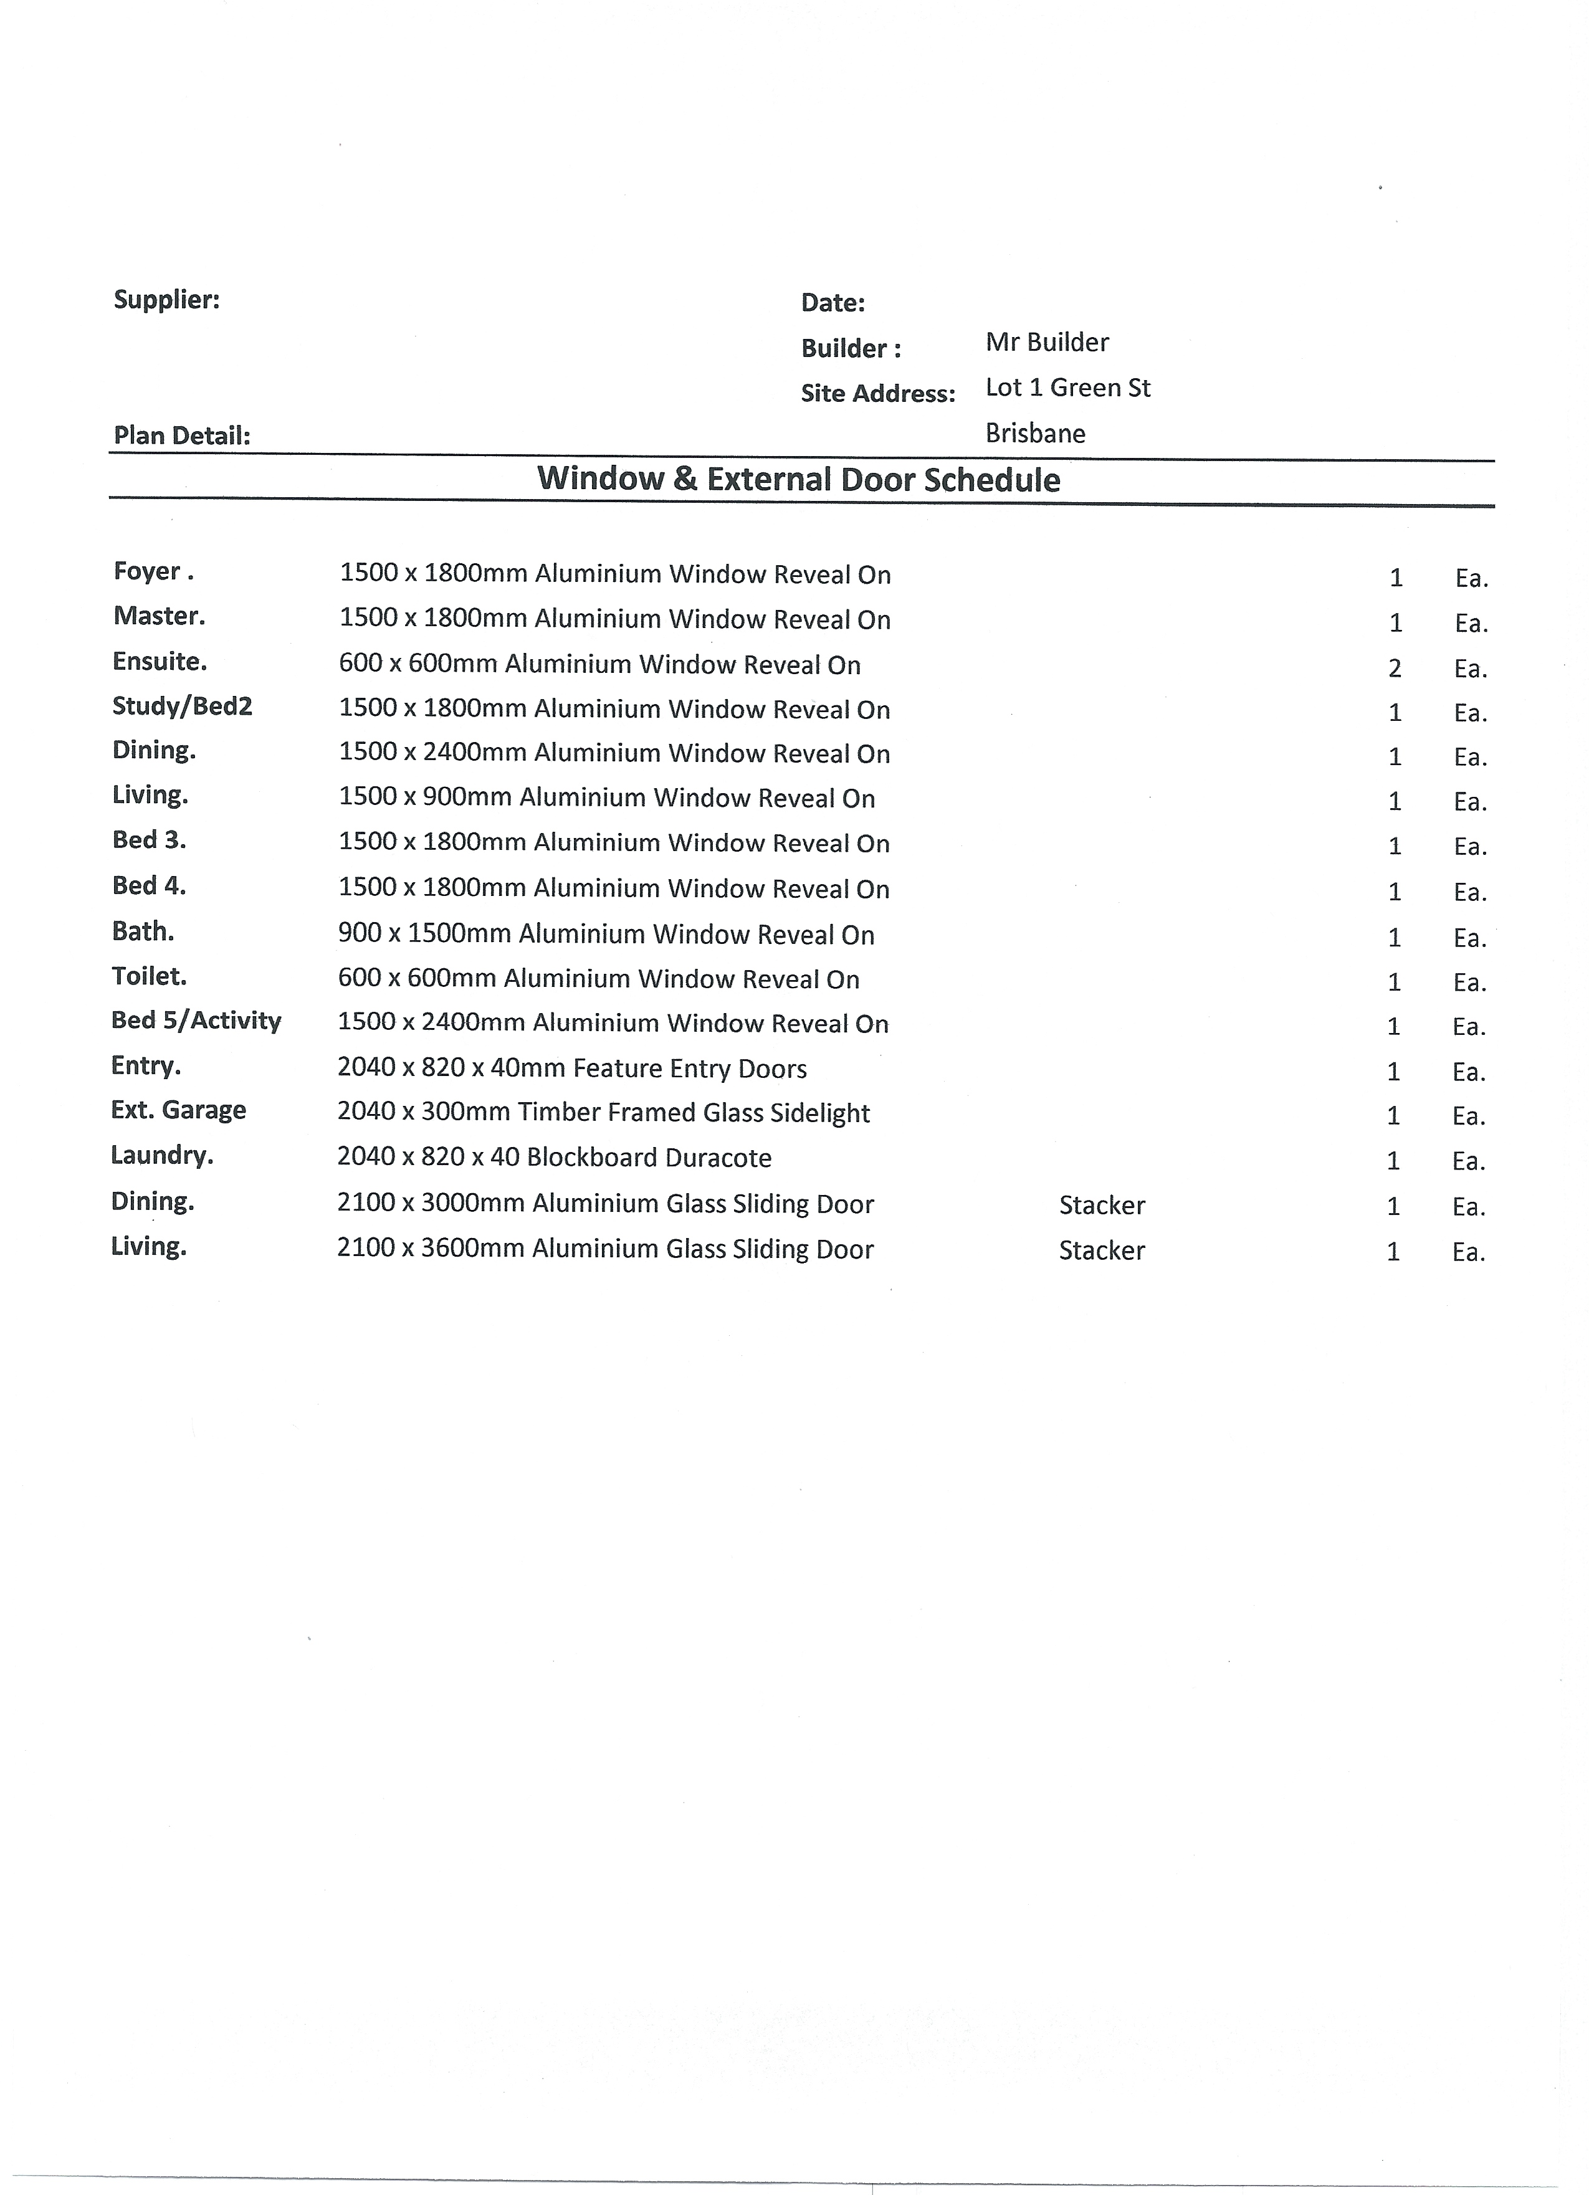

Answer

- Referring to the floor plan, create a lighting plan and determine single and double GPO locations to be used as a guide by your electrical sub-contractor for a preliminary wiring quote.

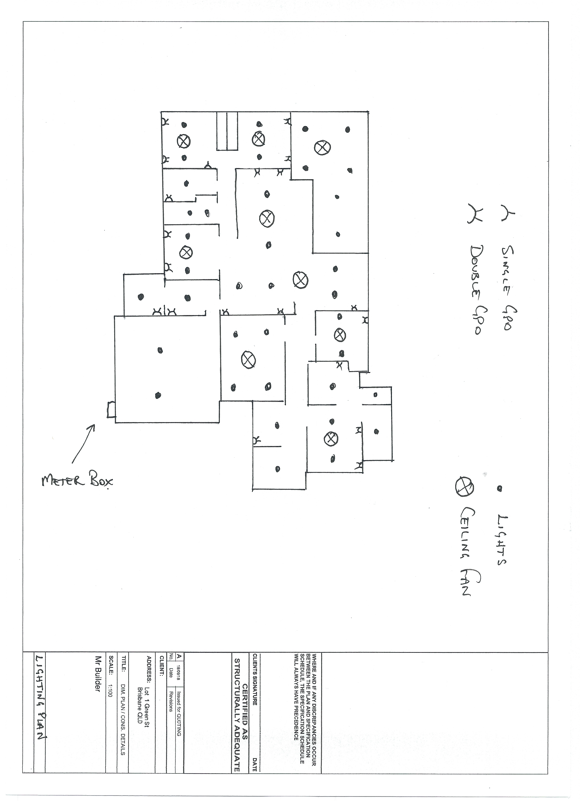

Answer

- Draw a schematic preparatory drawing of all pipework (including sewerage, plumbing, electrical and other services).
To assist with determining the location and installation details for all the in-ground and under-slab services (i.e. prior to pouring of the foundations and concrete slab), refer to the floor plan and the site plan you developed in 0

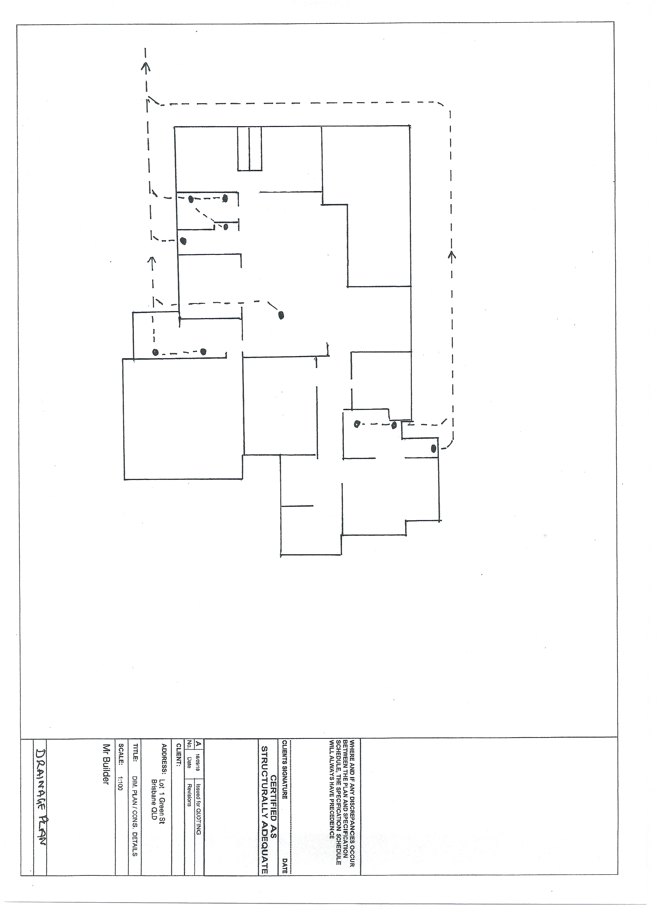

Answer

- Identify all internal and external wall penetrations and create a schedule and sketch to be provided to each of the affected trade sub-contractors.
Refer to the drawings in Q3. and 0to assist with this task.

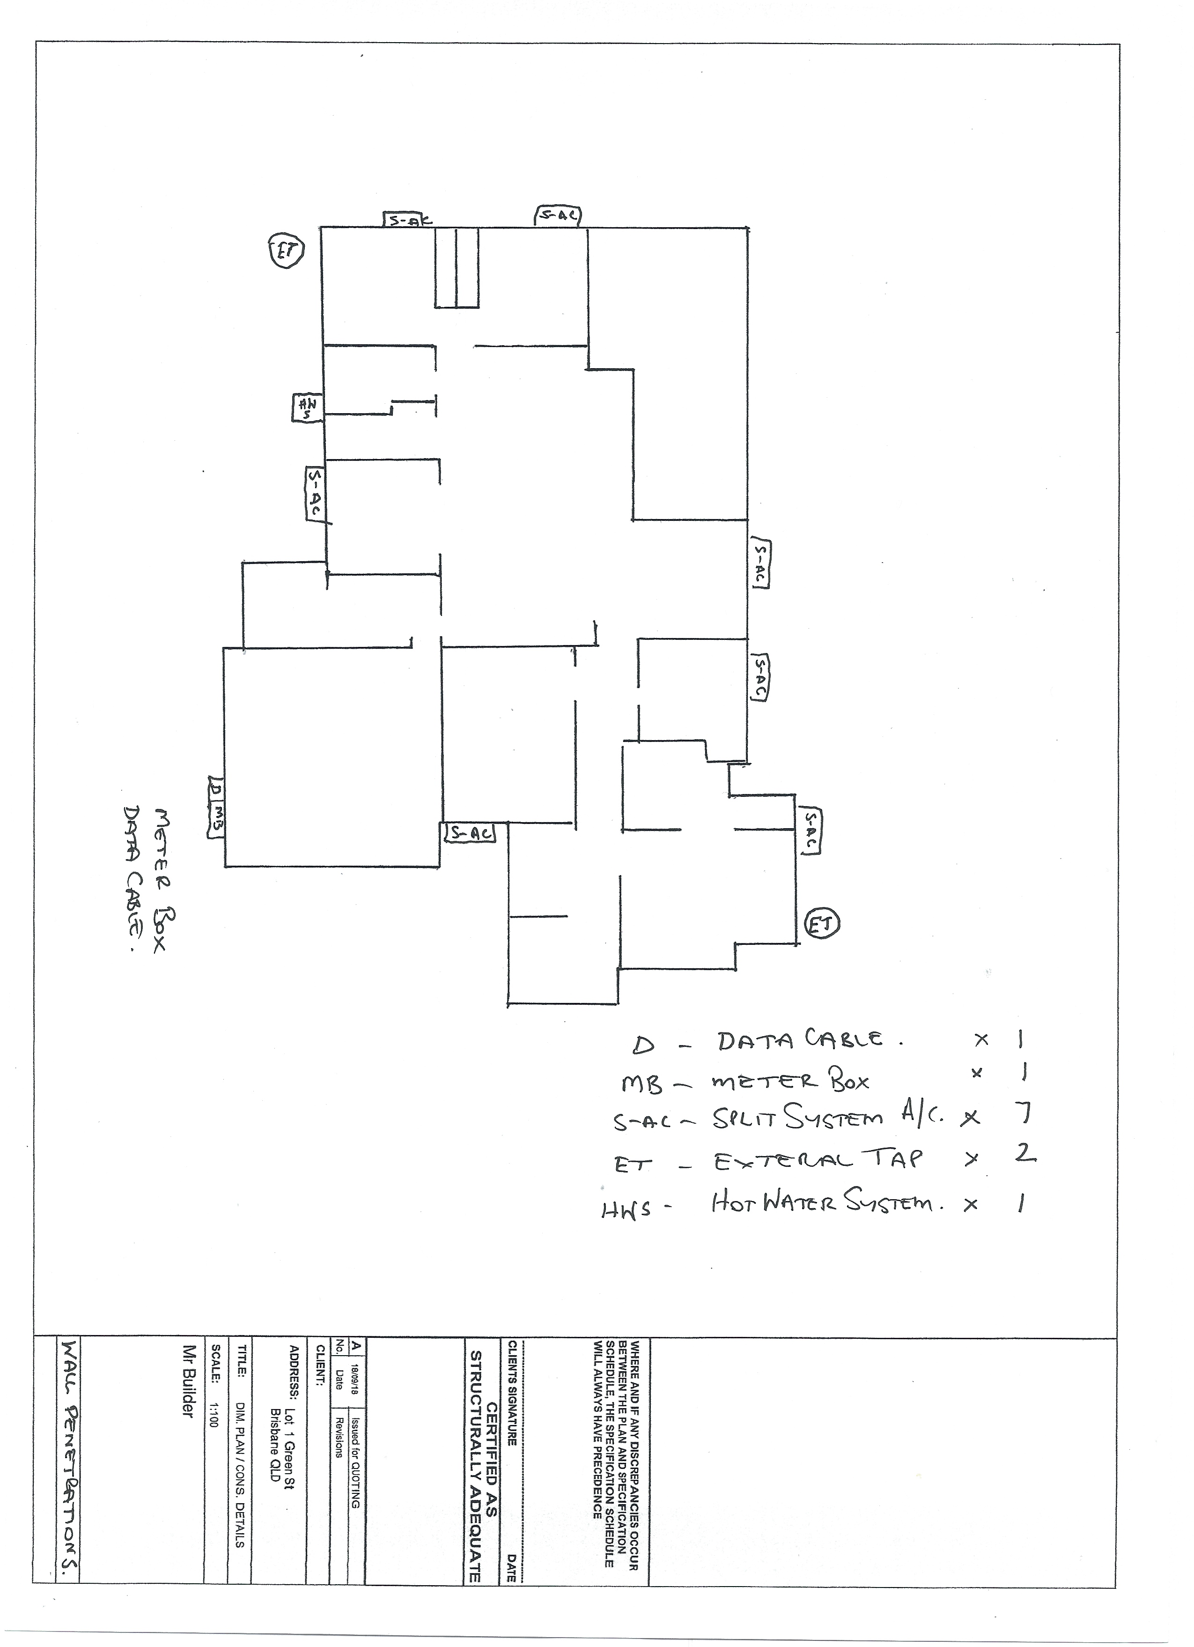

Answer

- Your client has approached you seeking consideration to redesign the area of the laundry, scullery and Bedroom 5. They are considering foregoing Bedroom 5 altogether and increasing the scullery to make it a large butler’s walk-in pantry and essentially leaving the laundry as is.
They have asked you to redesign this area of the home and have agreed to pay you for it separately. You have agreed to terms in this regard. You have agreed you will prepare formal floor plan sketch/es of this area redesigned for discussion with the client in two weeks’ time.
You are to also present a pros and cons written argument for the client to help them determine if they should proceed with this variation.

TIPS

Your initial research should consider what goes into a Butler’s Pantry, what are others doing with designs and layouts including refrigeration, storage, preparatory areas, electrical equipment and white goods.

You should intend to visit and/or research new and existing housing estates and establish what other Developers and Builders are incorporating in Butler’s Pantry in their housing designs then to capture camera and computer images so you can discuss these various options and the drawn variation with the client as you present your ideas and sketch floor plan amendments for reconfiguring this area of their home.

Answer | Dear Client  I have attached a sketch of the floor plan showing the changes as discussed. As the inclusion of the butler’s pantry opens a large area I thinks we can utilise this to increase the bench space around the cook top by moving the fridge in to the space where the sink in the scullery would have been this will also allow for the use of free-standing twin fridge-freezer units this would also allow for a larger cooktop and canopy to be utilised. Within the pantry itself I suggest extra bench space for appliances with cabinets under and a secondary sink. The end wall could also be utilised for open or enclosed shelving increasing storage. Some of the appliances you could include are, Dishwasher, wine fridge ovens etc.  I have listed below some pros and cons to consider  Pros – increase functionality of the kitchen space for entertaining as well as general use, increased property value  Cons – Increased cost to project, time delay as an extension in time will be required

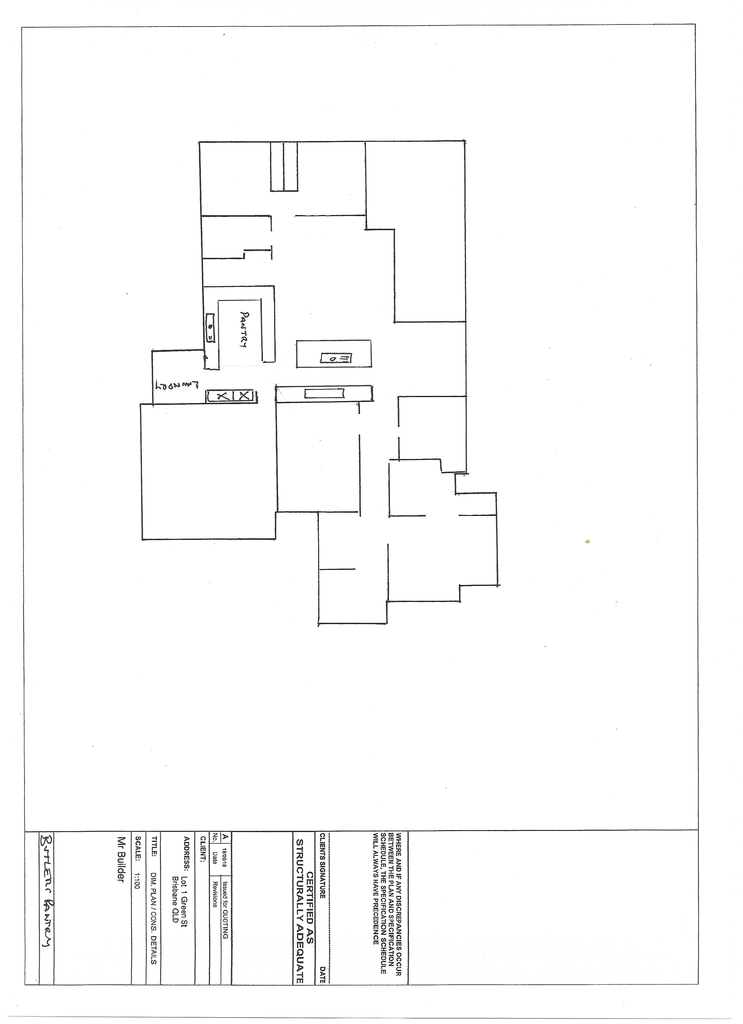

- Consider the erection of scaffolding for the brick layer, metal fascia and gutter installation and soffit installation.
Draw a scaffold plan for the entire building and draw an elevation showing a minimum of two bays and one corner return. Ensure the plans follow all relevant standards, codes and authority requirements.

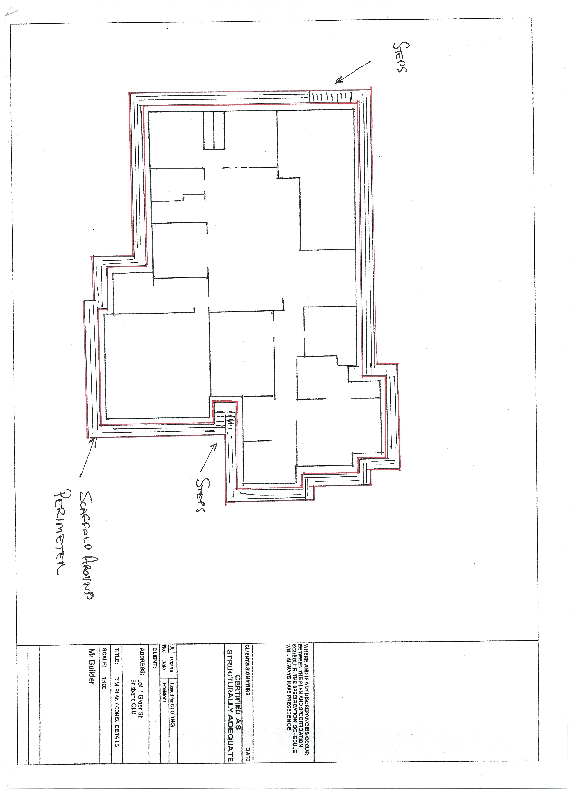
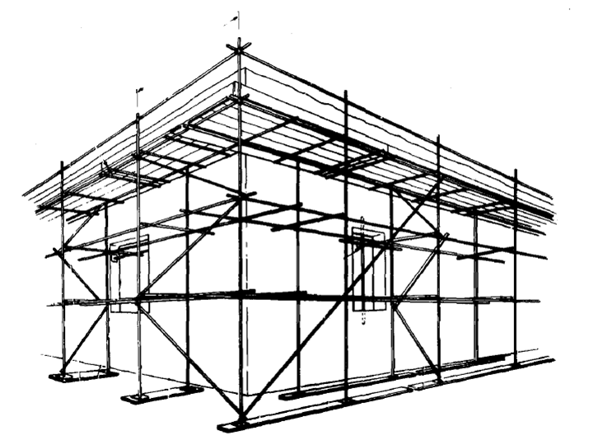

Answer

- Write a personal protective equipment (PPE) plan and from this prepare a PPE induction toolbox talk for the site.

Answer | Once the hazards of the site have been identified, the safety officer will determine if the hazards can first be eliminated or reduced by methods other than PPE, i.e., methods that do not rely on employee behaviour, such as engineering controls and elimination.  Personal protective equipment will be provided, used, and maintained when it has been determined that its use is required to ensure the safety and health of our employees and that such use will lessen the likelihood of occupational injury and/or illness  PPE refers to anything used or worn to minimise risk to workers' health and safety. The following PPE may be required for use on this site and will be available as required, please liaise with the safety officer:  - Boots  - ear plugs  - face masks  - gloves  - goggles  - hard hats  - high visibility clothing  - respirators  - safety harnesses  - safety shoes  - sunscreen.  The PPE user is responsible for following the requirements of the PPE policies.  1. Properly wearing PPE as required.  2. Attending required training sessions.  3.Properly caring for, cleaning, maintaining, and inspecting PPE as required.  4. Following PPE policies and rules.  5. Informing the supervisor of the need to repair or replace PPE.  Any worker required to wear PPE will receive training in the proper use and care of PPE before being allowed to perform work requiring the use of PPE. Periodic retraining will be offered to PPE users as needed. The training will include, but not necessarily be limited to, the following subjects:  - When PPE is necessary to be worn  - What PPE is necessary  - How to properly don, doff, adjust, and wear PPE  - The limitations of the PPE  - The proper care, maintenance, useful life, and disposal of the PPE  After the training, the employees will demonstrate that they understand how to use PPE properly, or they will be retrained.

- Write a Hazards Identification Plan for the site which details local pedestrian and traffic flow as well as ingress and egress for cars and trucks, deliveries and personnel overhead cabling and power supply, power access for trades services and locations, dealing with waste materials and general public and on-site worker safety.

Answer
  Manual Material Handling | Yes | No
  - Are mechanical devices being used in place of manual handling of material? | ___ | __
  - Are ropes, slings, chains, hook, cables, and chokers in good condition?  Traffic Management  - Site Entry and Exit Signage?  - Pedestrian Signage?  - Traffic management required for large delivery or crane use? | ___ | __
    Housekeeping: Slips, Trips and Falls
    - Are walking and working surfaces clear and free of debris?
    - Are waste and trash containers provided, and used?
    - Is there regular removal of waste and trash from the containers?
    Fire Protection and Prevention
    - Are all flammable liquid containers clearly identified
    - Have proper storage practices for flammables been observed?
    - Are extinguishers readily accessible and serviced regularly?
    - Are hydrants clear and accessible for emergency personnel?
    Electrical
    - Are all switch gear, panels, and devices that are energized marked and/or guarded?
    - Lockout devices available/used on circuits that could become energized while being worked?
    - Are all temporary circuits properly guarded and grounded?
    - Are extension cords in continuous lengths without splice?
    Excavation/Trenching
    - Have utility companies been notified of proposed excavation work?
    - Are all tools, equipment, and shoring materials readily available prior to job start up?
    - Are overhead utility lines noted and precautions taken to avoid contact with equipment?
    Medical
    - Are first-aid kits available and properly stocked?
    - Are all emergency phone numbers posted?
    - Are employees aware of the address of the site/ capable of giving directions to emergency crew?
    - Is anyone trained in first aid and CPR?
    Barricading
    - Are floor openings planked and secured or barricaded?
    - Are direction signs used to inform the public of upcoming construction work?
    - Is the sidewalk protection effective?
    - Is a flag person provided to direct traffic when needed?
    - Has the person been trained on how to direct traffic and the public?
    - Are open excavation, road drop offs, manholes, uneven surfaces barricaded?
    Tools: Hand and Power | Yes | No
    - Are tools free of any obvious physical damage? | ___ | __
    - Are tools inspected for frayed or damaged cords? | ___ | __
    - Are tools and cords properly grounded (ground pins are in good condition? | ___ | __
    - Are double insulated tools in use and in good condition? | ___ | __
    - Are the handles on all tools in good condition (not bent, splintered or broken)? | ___ | __
    - Are all hoses on air or hydraulic tools in good condition? | ___ | __
    - Are all shields and guards in place on the tools and in good condition? | ___ | __
    - Operator qualified and instructed to use powder actuated tools? | ___ | __

