
SISFFIT004 Incorporate anatomy and physiology principles into fitness programming

Copyright © 2021 CSTC Pty Ltd

All rights reserved. No part of the contents of this publication may be reproduced or used in any form or by any means – graphic, electronic, or mechanical including photocopying, digitising, recording, or information storage-and-retrieval systems – without the written permission of CSTC Pty Ltd.
ASSESSMENT FOR SISFFIT004

Student name | Eva
Date of assessment submission | Click here to enter a date.

Trainer/Assessor’s name
Date of assessment marking | Kranen
Outcome for units | ☐ Competent  ☐ Not Yet Competent

TASK INSTRUCTIONS

- The assessment for these units of competency consists of the following:
  - Quiz: You are required to complete a series of multiple choice questions to demonstrate your knowledge and skills.
  - Short answer activities: You are required to provide short written responses to a series of activities to demonstrate your knowledge and skills.
  - Case studies: You are required to provide written responses to a series of case study scenarios to demonstrate your knowledge and skills.
  - Practical task: You will be required to put your knowledge and skills into practice, through observed tasks and work experience.
- At times, you will be provided with a specific context to which you must respond, otherwise it is anticipated that you will use a scenario of your choosing to provide context to the task.

QUIZ

QUESTIONS | CORRECT
- What are the planes of body motion?  ☐ Sagittal, Frontal, Reverse  ☒ Sagittarius, Frontal, Transverse  ☐ Transverse, Sagittal, Frontal  ☐ Back, Front, Side | ☐
- What is the term associated with moving towards the midline of the body?  ☐ Superior  ☐ Inferior  ☐ Plantar  ☒ Medial | ☐
- What is the focussed movement in the movement of a shrug?  ☐ Superior and then Inferior  ☐ Anterior and then Medial  ☒ Elevation and Depression  ☐ Protraction and Retraction | ☐
- Which of the following are examples of connective tissue?  ☐ Muscle, Bone, Cartilage, and Skin  ☐ Ligaments, Tendons, Fascia, and Cartilage  ☒ Tendons, Bones, Ligaments, and Muscle  ☐ Muscle, Fascia, Cartilage, and Tendons | ☐
- What are the major muscles required for the flexion and extension of the elbow?  ☐ Quadriceps and Hamstring  ☐ Pectoral and Latissimus Dorsi  ☐ Biceps Femoris and Triceps  ☒ Biceps and Triceps | ☐
- What two (2) sections can the skeleton be divided into?  ☒ Axial and Appendicular  ☐ Axial and Appendages  ☐ Torso and Limbs  ☐ Long bones and Short bones | ☐
- What three (3) sections can joints be classified into?  ☐ Fibrous, Cartilage, Synovial  ☒ Fibre, Cartilaginous, Synovial  ☐ Fibrous, Cartilaginous, Synovial  ☐ Fibro, Hyaline, Symphasis | ☐
- What are fast twitch fibres known as?  ☒ Type I  ☐ Type II  ☐ Type IA and Type IB  ☐ Type III | ☐
- What does the mechanics of breathing involve?  ☒ Breathing in and breathing out  ☐ Inspire and exhale  ☐ Inspiration and expiration  ☐ Respiration and expiration | ☐
- What does ATP stand for?  ☐ Adenosine Two Phosphate  ☐ Adenosine Tri Phosphate  ☐ Adenosine Three Phosphates  ☒ Adrenaline Tri Phosphate | ☐
- True or False: In multicellular organisms, including humans, all cells, tissues, organs, and organ systems of the body work together to maintain the life and health of the organism.  ☒ True  ☐ False | ☐
- What are the four (4) tissue types?  ☐ Isokinetic, Isometric, Concentric, Eccentric  ☐ Connective, Muscle, Nervous, Epithelial  ☐ Superficial, Inferior, Deep, Anterior  ☒ Muscle, Nervous, Connective, Organism | ☐

- Which of the following methods will keep you aware of emerging knowledge of anatomy and physiology relevant to the development of your own professional practice? Select all that apply.  ☐ Reading journal articles  ☒ Newsletters from health professional associations  ☐ Networking within your industry | ☐

- Fill in the blanks for the statements below, selecting the correct option.  Statement Option 1 Option 2  The pectoralis major is _____ to the rhomboids. ☐ Anterior ☒ Posterior  The soleus is _____ to the gastrocnemius. ☐  Deep ☒ Superficial  The pectoralis major is _____ to the rhomboids. ☒  Deep ☐ Superficial  The rhomboids are _____ to the trapezius. ☒ Anterior ☐ Posterior  The bicep femoris is _____ to the semimembranosus. ☐  Lateral ☒  Medial  Anterior deltoid is _____ to rectus abdominus. ☒ Superior ☐  Inferior  Rectus abdominus is _____ to the obliques. ☐  Lateral ☒  Medial  The elbow joint is _____ to the shoulder joint. ☐ Superior ☒  Inferior  The wrist joint is _____ to the elbow joint. ☐  Distal ☒  Proximal  The knee joint is _____ to the ankle joint. ☒  Distal ☐  Proximal | ☐
- Match the terms below with the appropriate movement, placing the corresponding movement letter label next to each term.  Letter Term Movements  - Flexion The movement of a limb sideways direction towards the midline of the body  - Extension Extension at the ankle  - Adduction To allow a joint to perform movement through all possible axes  - Abduction The straightening of a joint. It occurs when the angle at a joint increases and the two opposing surfaces move apart  - Pronation To turn the sole of the foot laterally  - Supination To turn the sole of the foot medially  - Dorsiflexion To turn the palm posterior  - Plantarflexion The bending of a joint. It occurs when the angle of the joint becomes smaller and the two opposing surfaces move together  - Circumduction Flexion at the ankle  - Inversion To turn the palm anterior  - Eversion The movement of a limb in a sideways direction away from the midline of the body | ☐
- Identify the type of muscle tension for each listed exercise.  Exercise Isokinetic Isometric Isotonic  Pushing against a wall ☒ ☐ ☐  Performing a bicep curl ☐ ☒ ☐  Holding a push up position at the bottom of the movement ☒ ☐ ☐  Swimming ☐ ☐ ☒  Holding a shopping bag ☐ ☒ ☐  Performing a squat ☒ ☐ ☐  Cycling on a stationary bike ☐ ☒ ☐ | ☐
- Match the terms below with the appropriate diagram label, placing the corresponding number label next to each term.  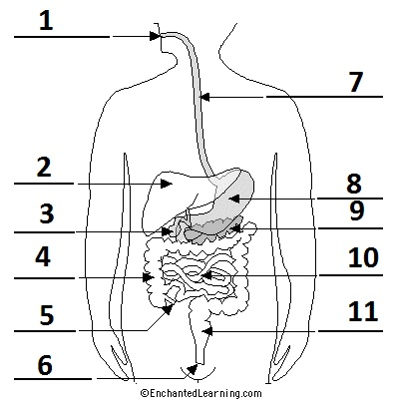  Number Term  6 Anus  5 Appendix  7 Esophagus  3 Gall bladder  4 Large intestine  2 Liver  1 Mouth  9 Pancreas  11 Rectum  10l Small intestine  8 Stomach | ☐

- What effect does regular cardiovascular exercise have on the following respiratory volumes? Select the correct option.  Respiratory volume Increase in size Decrease in size  Vital capacity ☒ ☐  Residual volume ☒ ☐  Total lung capacity ☐ ☒ | ☒

Outcome for Quiz | ☐ Satisfactory  ☐ Not satisfactory
Trainer/Assessor comments

SHORT ANSWER ACTIVITIES

Consider the relevance of the anatomical position.
- Provide a definition of the anatomical position.
- Explain the reason for this body position in relation to health screening.

Definition
Standing straight up and facing straight with each arm hanging on each side
Relation of health screening
Anatomical position provides a straight forward and consistent way of describing humans

Outcome for Activity 1 | ☐ Satisfactory  ☐ Not satisfactory
Trainer/Assessor comments

Explain the path of an oxygen molecule from the initial phase of inspiration, starting at the nasal cavity.

Path of oxygen molecule
Oxygen moves along thin walls to blood vessels that are called capillaries and dive into the blood

Outcome for Activity 2 | ☐ Satisfactory  ☐ Not satisfactory
Trainer/Assessor comments

Draw and label a sketch of a long bone.

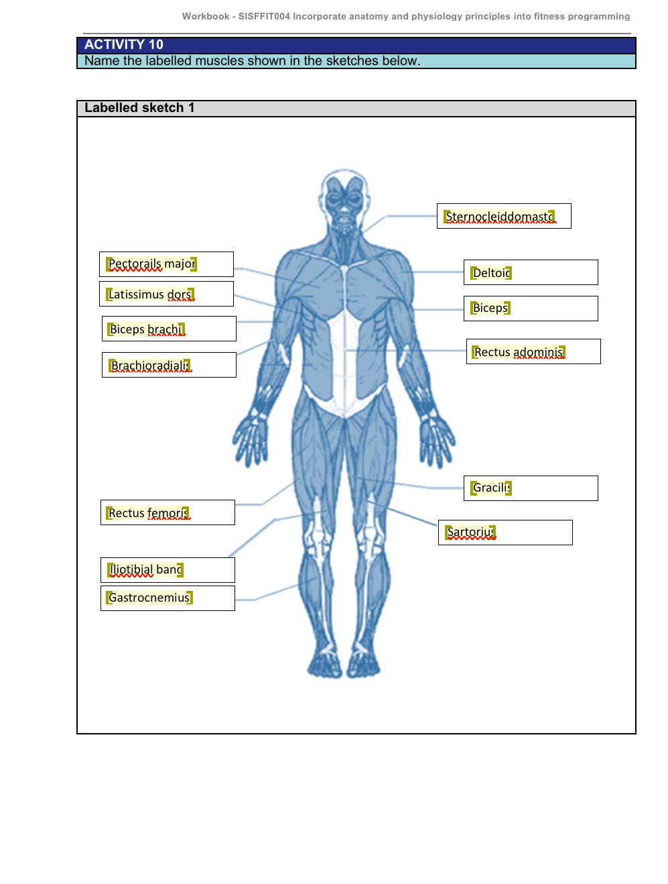
Labelled sketch


Outcome for Activity 3 | ☐ Satisfactory  ☐ Not satisfactory
Trainer/Assessor comments

Identify three (3) types of muscle. Describe these muscles and explain where they are found in the body.

Muscle 1
Name of muscle | Skeletal
Description and location | The shoulder muscles, abdominal muscles and ham string muscles are all skeletal muscles . This is found in arms and legs
Muscle 2
Name of muscle | Smooth
Description and location | Skeletal muscles fibers occur in muscles that are connected to the skeleton. Located in the walls of hollow visceral organs
Muscle 3
Name of muscle | Cardiac
Description and location | Appear striped and are under involuntary control. Cardiac is located in the walls of the heart

Outcome for Activity 4 | ☐ Satisfactory  ☐ Not satisfactory
Trainer/Assessor comments

Draw and label a sketch of the cardiovascular system.

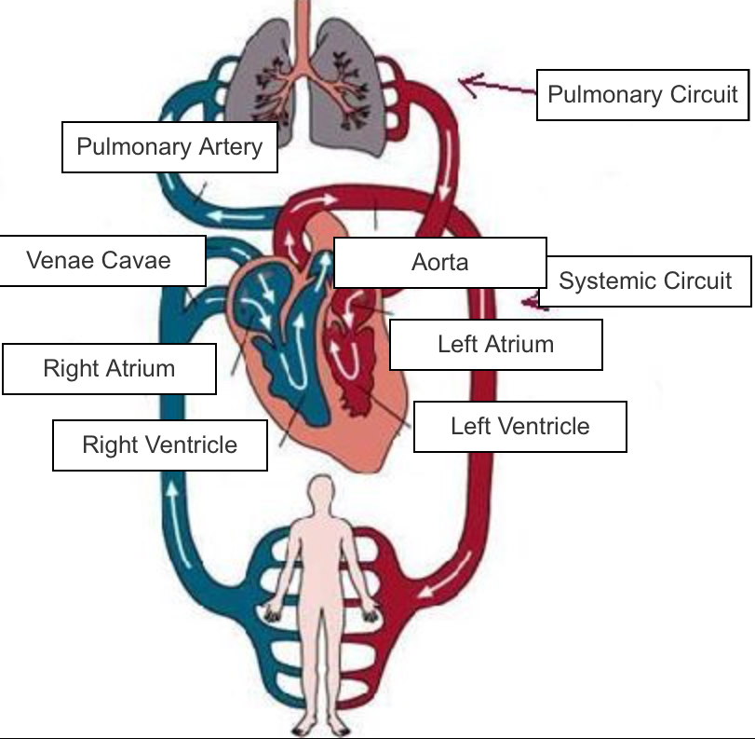
Labelled sketch

Outcome for Activity 5 | ☐ Satisfactory  ☐ Not satisfactory
Trainer/Assessor comments

Consider the movements in a push up.
- Describe the agonists and antagonists responsible for movement.
- Describe the role synergists play in this movement.
- Describe the role connective tissue plays in this movement.
- Describe the role of a Fixator or Stabilizer during an exercise movement, such as a push up.
- Describe the role of a Prime Mover in muscle movement.

Agonists and antagonists
Your three muscles chest, anterior deltoids and triceps all work together to do a push up
Synergists
The synergists in a push up is the muscles that make a joint surround which movement is coming.
Connective tissue
Muscle contraction plays a role in how a person performs the movement of the push up
Fixator or Stablizer
They maintain the form of the structure of the body and organs, this provides cohesion
Prime Mover
The muscle that supply’s the primary force controlling the action

Outcome for Activity 6 | ☐ Satisfactory  ☐ Not satisfactory
Trainer/Assessor comments

Write a description of cross bridging. Include references to the following:
- All or none theory
- Motor units
- CNS
- Structure of a muscle

Description
All or none theory
This is a principle that means that the strength of a response of a nerve muscle or cell fiber is not dependent on the strength of the stimulus
• Motor units
Fast fatigue, high force, fast contraction speed and fatigue in a few seconds
• CNS
CNS is two large structures: the spinal cord and the brain
• Structure of a muscle
The muscle has many muscle tissues all together and around epimysium, a rough connective tissue is similar to cartilage.

Outcome for Activity 7 | ☐ Satisfactory  ☐ Not satisfactory
Trainer/Assessor comments

Muscle fibres can be classified as either fast twitch or slow twitch.
  - Describe each twitch type.
  - Provide an example of a specific sport where they are most used.

Description
Fast Twitch
Description
Fast twitch provide a huge and powerful, for smaller times and tiredness faster. These are more anaerobic cause of small blood supply
Slow Twitch
Description
Slow muscles are in the back of your lower kegs and the muscles in the back are basically created up of slow-twitch fibers
Sports where most used
Fast twitch
Rugby
Soccer
Slow twitch
Swimming
Cycling

Outcome for Activity 8 | ☐ Satisfactory  ☐ Not satisfactory
Trainer/Assessor comments

It is important to have a detailed knowledge of the human skeleton as part of fitness programming.
  - Name the labelled parts of the skeleton shown below.
  - Give three (3) examples of bony landmarks from the diagram.

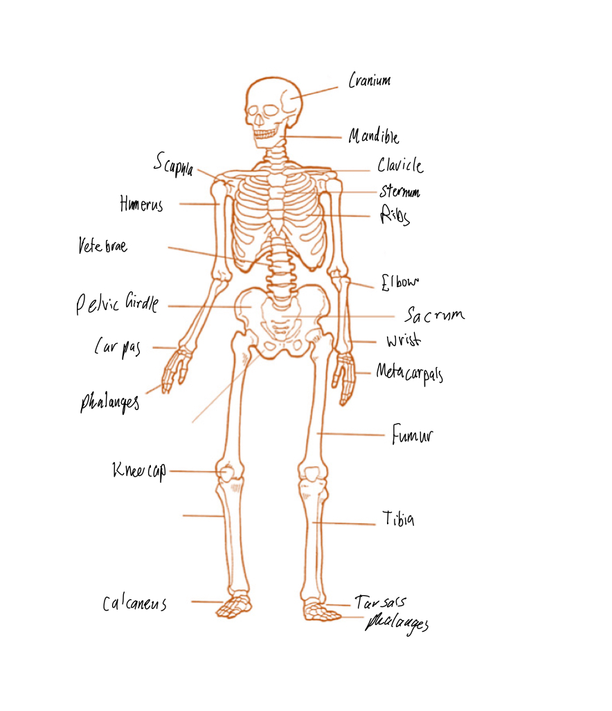
Labelled sketch
Bony landmarks

Outcome for Activity 9 | ☐ Satisfactory  ☐ Not satisfactory
Trainer/Assessor comments

Name the labelled muscles shown in the sketches below.

Labelled sketch 1

Labelled sketch 2
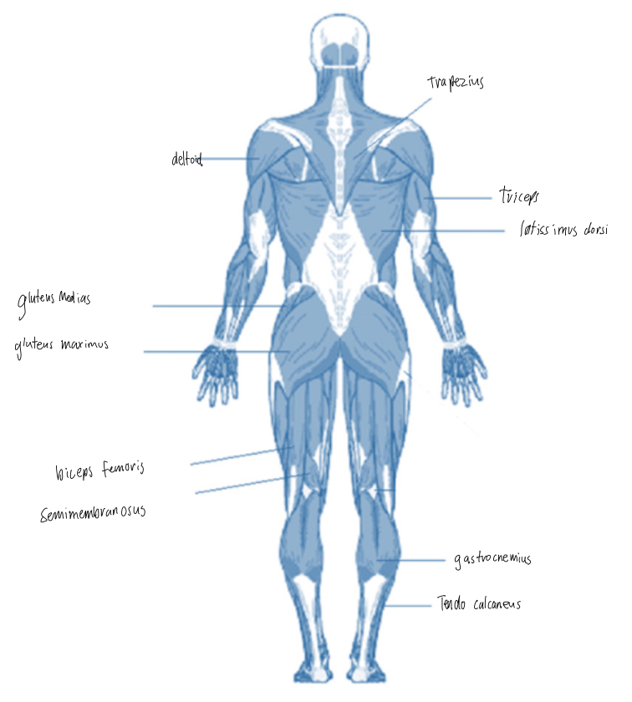

Outcome for Activity 10 | ☐ Satisfactory  ☐ Not satisfactory
Trainer/Assessor comments

Consider the role of thermoregulation.
- Provide a description of this term.
- Outline the role it plays in exercise.
- Describe what a person can do to ensure their body is prepared to undertake the stresses of exercise in relation to body temperature, as well as accounting for environmental conditions.

Description
Thermoregulation allows your body to maintain its core internal temperature
Role in exercise
Enlargers heat loss and sweating induced by the nervous system
Preparing the body for exercise
their body is prepared to undertake the stresses of exercise in relation to body temperature, as well as accounting for environmental conditions

Outcome for Activity 11 | ☐ Satisfactory  ☐ Not satisfactory
Trainer/Assessor comments

Explain the difference between motor and sensory neurons. Be sure to refer to afferent and efferent nerves.

Motor and sensory neurons
Motor neurons system to outer parts of the body and sensory neurons carry waves from the outer parts of the body.

Outcome for Activity 12 | ☐ Satisfactory  ☐ Not satisfactory
Trainer/Assessor comments

Why does oxygen demand increase when you are physically active?

Oxygen demand
Muscles are working harder this means the demand for oxygen increases. The reason for this is because oxygen is need to decrease calories more efficiently

Outcome for Activity 13 | ☐ Satisfactory  ☐ Not satisfactory
Trainer/Assessor comments

CASE STUDIES

A 39 year old female client, Janice, has shown indications of scoliosis during her exercise pre-screening. The postural problem is causing problems with her work and has been slowly getting worse since she started playing social tennis three (3) nights a week.

Janice has come to you looking for advice on how to relieve these symptoms and improve her overall strength. She has concerns that lifting weights will make her bulky and put her at risk of further injury.

Respond to the following points:
- Write a 200 word response to Janice allaying her concerns and giving suitable advice. Be sure to consider the following:
- What anatomical positioning would indicate these symptoms
- Why the factors indicated would make her muscles imbalanced
- Where to access further information to help you prior to writing Janice’s program
- Any Allied Health Professionals (AHPs) you would recommend Janice visit prior to commencing her training program with you
- Using the template below, write a program from Janice to commence her training with you. Be mindful of the following points:
- Janice has never been to the gym before and intends to come to you three (3) times a week initially
- Janice’s doctor has recommended that she improve her lower back and abdominal strength, as well as improve the balance of strength in her upper back
- Currently, Janice’s right side is much stronger than her left
- Ensure you provide exercises to prevent the development of pathological postures and provide correction of joint alignment
- Explain how both the Golgi tendon reflex and the Stretch reflex will potentially assist Janice. Include a description of how the reflex arc works and the response it will have.

Advice to Janice
The diagonal shoulders is a huge sign to the condition, Janice’s shoulders are not uniform which is developing pains, hurting with Janice’s job and is why Janice’s shoulders are worsing.She has scoliosis that’s is a huge warning to Janice’s body. The muscles and joints can be not balanced because of the diagonal shoulders, this will effect Janice’s work and exercise. The Golgi tendon reflex works as shield system mechanism to take power the tension of working muscle while effecting peacefulness before the tendon high to abs affected or be damaged. https://www.healthline.com/health/scoliosis/exercises-at-home
https://www.spineuniverse.com/conditions/scoliosis
https://www.healthdirect.gov.au/scoliosis

FIT TO LEARN PROGRAM CARD
Name | Janice
Trainer | Eva G
Date | 3rd of may 2021
Goals/Aims | My aim is to improve Janice’s overall strength and balance to help her scoliosis condition that has not been diagnosed.
Contraindications | Unidentified scoliosis
Session length | 45 min
Exercise |  | Sets | Reps | %1RM/Weight |  | Rest
Squat |  | 3 | 8-10 | 70% |  | 60 sec
Single arm fly |  | 3 | 8 | 60% |  | 30 sec
Dum bell press |  | 3 | 8 | 50% |  | 30 sec
Arnold press |  | 3 | 8 | 50% |  | 30 sec
Bulgarian spilt press |  | 3 | 8 | 60% |  | 30 sec
Dum bell chest press |  | 3 | 8 | 40% |  | 30 sec
Ski Erg |  | 3 | 8 | 50% |  | 30 sec
Lat pull down |  | 3 | 8 | 60% |  | 30 sec
Dumb bell rows |  | 3 | 8 | 50% |  | 30 sec
Cardiovascular training method |  | Time/Distance |  |  | Level/Resistance/Intensity
Continuous treadmill |  | 8 minutes |  |  | 50% max HR
Continuous static bike |  | 8 minutes |  |  | 50% max HR
Cool down | A drink of water. Stretch body with bar.
Stretches | Use bar to stretch back and shoulders

Outcome for Case Study 1 | ☐ Satisfactory  ☐ Not satisfactory
Trainer/Assessor comments

Steven is a 22 year old athlete who is trying to transition from a junior career as a 100m sprinter into playing state league Australian Rules football. While he is very lean and muscular, he says that he is feeling very tired after the first 10 minutes of each quarter. Also, as a result of moving from a short distance sport to an endurance sport, he is finding the DOMS he is experiencing seem to be lasting longer than the other members of his team.

Steven has always played sport but is wants to better understand how different energy systems and training styles can impact on his health, performance and recovery.

Respond to the following points:
  - Using Steven’s sports and symptoms, describe how understanding muscle types, energy systems and training methods can help to improve sport performance. Include definitions of key terms.
  - What training advice would you give Steven to help make his transition to a new sport easier in the coming months?
  - Explain the role the nervous system plays in Steven’s training.

 | Response
a) | He needs to understand the sport Steven’s playing, the high level training required in ability. The sport AFL is a high intensity sport. This means that Steven needs to have a cardiovascular training program as target. When Steven can train and get educated about the muscles and body types, this will be a very safe way to improve fitness places and will improve Steven’s agility on game day.
b) | Replacing can be a beneficial resolution because it opens your body to new training abilities. This can be enormously healthy both mentally and physic. I would suggest him to concentrate on strength and cardiovascular endurance, this will extremely improve his strength on game day and stamina. More over, concentrate on developing common along with the strength development necessary for the sport as well as the physical training required for the sport
c) | While he dose the suggested training the blood flow will boost, and his brain will be revealed to extra and extra nut and oxygen. This helps the let go of crucial and the main proteins in Steven’s brain. These proteins will enhance Steven’s brain cells, this will assist the growth of new neurons. Therefore his endurance training and strength will effect Steven’s nervous system as the flow of blood will boost and Steven will be revealed to more nutrients and oxygen.

Outcome for Case Study 2 | ☐ Satisfactory  ☐ Not satisfactory
Trainer/Assessor comments

PRACTICAL TASK

You are required to have a suitable observer verify your ability to complete the following tasks. These tasks may be simulated or real.

TASKS | VERIFIED
- You are to plan for and provide five (5) clients with instruction on the following body systems – cardiovascular, respiratory, musculoskeletal (with attention to bone strength, muscle endurance, muscle strength), nervous and digestive. Your clients will include beginners, intermediate and advanced participants, and will require instruction for low and high impact. During each client session, you are to complete the following:  - Explain and demonstrate:  - The major movements of the body, while identifying major muscles  - Actions of major joints during exercise  - Relevant information regarding structure and function of skeletal muscle, and process of muscle contraction during exercise  - Muscle actions and functions during different types of contractions  - Complete an evaluation of your work (including associated documentation) identifying improvements for your professional practice | ☐

Outcome for Practical Task | ☐ Satisfactory  ☐ Not satisfactory
Trainer/Assessor comments

