CPCCBC4001
Apply building codes and standards to the construction process for Class 1 and 10 buildings

ASSESSMENT SUMMARY

The assessment activities for CPCCBC4001 Apply building codes and standards to the construction process for Class 1 and 10 buildings cover all aspects of the unit of competency. For Apprentices/Trainees, this includes supervisor completion of the Apprentice/Trainee Record (ATR).

Participants must read all the information given before starting any assessment task. The assessment tasks are intended to be fair, flexible, valid and reliable. If a Participant has any questions or requires alternative arrangements to be made such requests should be directed to their Trainer/Assessor, who should note such arrangements in the ‘Assessor Comments’ on the affected assessment. If a Participant feels they are not yet ready to be assessed, they should discuss their options with their Trainer/Assessor.

To satisfactorily complete the assessment, the Participant is required to answer all questions correctly and demonstrate their skills to industry standards. If a Participant does not answer all questions or perform all tasks, they will be deemed ‘Not Satisfactory’ for the task and ‘Not Yet Competent’ for the unit of competency.

The Trainer/Assessor can provide the Participant with additional information on interpreting the assessment outcomes and guide the Participant’s options. If a Participant is still deemed ‘Not Satisfactory’ they will have the opportunity to undertake a supplementary assessment or appeal the result as per the process in the Student Handbook.

By signing below, the Participant acknowledges:
- They understand the assessment instructions and requirements, and consent to being assessed.
- The work submitted is to be their own work – with the work of/with others needing to be clearly acknowledged and documented.
- They consent to any photo/video recording of their work that occurs during assessment.

Participant name | Mohsin Ali Ch.
Participant signature | 

Pre-requisite unit(s) to be achieved and authenticated prior to undertaking assessment
Not applicable

Task | Date completed | Assessment Results
Theory Exam | Select Date. | Satisfactory | Not Satisfactory
Workbook | Select Date. | Satisfactory | Not Satisfactory
Practical Assessment | Select Date. | Satisfactory | Not Satisfactory
Outcome for CPCCBC4001 | Select Date. | Competent | Not Yet Competent

Evidence requirements checklist (ticked by assessor and evidence supplied to RTO)
Theory Exam  Workbook  Practical Assessment | Fire protection inspection checklist  Documentation of design and construction (suitability or evidence of suitability)

Assessor name
Assessor signature | 

CPCCBC4001
Apply building codes and standards to the construction process for Class 1 and 10 buildings

THEORY EXAM

Participant name | Mohsin Ali Ch.

FOR THE PARTICIPANT
Instructions
- You will complete written questions as outlined on the following pages. You must attempt all questions and provide enough detail in your responses to demonstrate your knowledge.
- It is anticipated that you should complete this assessment within two (2) hours, but additional time may be allowed upon negotiation with the Assessor.
- You must complete all questions unassisted by the Assessor or other personnel but may refer to reference material as needed. All questions must be answered correctly for a ‘Satisfactory’ assessment outcome to be awarded.
  - An oral examination may be allowed under certain circumstances, whereby your answers will be documented by another party.
  - Any written questions that are incomplete, or not answered satisfactorily will need to be completed again after further training support.
    - If you answer a question incorrectly but modify your response, put your initials next to the written change (or the Assessor must initial a verbal change).
Resources required
Pen

FOR THE ASSESSOR
Instructions
- Where oral examination has occurred, ensure that this is acknowledged in writing (e.g. FT001 and Assessor Comments)
- All questions must be satisfactorily demonstrated by the Participant for a Satisfactory determination (indicated by an Assessor tick to the right of the question).
- Assessors are to complete marking in pen of a different colour to the Participant.
- If the Participant verbally modifies their response, write in the modified response verbatim and put your initials next to the written change.

ASSESSOR COMMENTS
As necessary, outline:
- Details on reattempts, alternative arrangements or reasonable adjustments made.
- Where a Participant is deemed ‘Not Satisfactory’, provide recommendations for future training.

- Explain why it is important to understand references the NCC makes to Australian Standards.

Answer | The NCC provides the criteria for building classification and the minimum technical requirements that building projects throughout Australia must follow.  It provides the minimum mandatory requirements for safety, health, amenity, and sustainability for building works of both new and existing buildings throughout Australia. Building work is defined broadly in the NCC and includes the following activities:  - Construction  - Alteration  - Extension  - Restoration  - Repair  - Demolition  - Dismantling  - Installation of fittings such as heating, lighting, sanitation, ventilation, power supply, drainage, etc.  - Any operation to prepare for or finish the activities mentioned above, including site clearance, laying of foundations, provision of access works, etc  These standards provide detailed technical guidelines that promote uniformity and consistency across the industry.

- You have been asked to develop a tender proposal for a housing development taking State/Territory. Discuss in depth any legislation and Codes your submission must comply with?

Answer | Depending on the state/territory that you are in and the classification of your building, there are different acts and regulations that you must follow for your project.  Act is a legislation passed by the parliament and amended by only other act.  Regulation contains guidelines that tell you how to apply the provisions of an act.  State/Territory Building Legislation:  Developing a tender proposal for a housing development in Queensland requires compliance with the NCC and various Queensland-specific acts and regulations, including:  Building Act 1975  Building Regulation 2021  Planning Act 2016  Queensland Development Code  Local government planning schemes  Environmental Protection Act 1994  Work Health and Safety Act 2011  Disability Discrimination Act 1992  Fire and Emergency Services Act 1990  Plumbing and Drainage Act 2018.  Ensuring adherence to these laws and standards is essential for legal compliance, safety, sustainability, and the successful approval and execution of the development project.
  State/Territory | Act | Regulations
  Western Australia | Housing Act 1980 | Health (Construction Work) Regulations 1973
  Victoria | Residential Tenancies Act 1997 | Residential Tenancies (Rooming House Standards) Regulations 2012
  Tasmania | Building Act 2016 | Building Regulations 2016
  South Australia | Supported Residential Facilities Act 1992 | Supported Residential Facilities Regulations 2009
  Queensland | Building Act 1975 | Building Regulation 2006
  Northern Territory | Building Act 1993 | Building Regulations 1993
  New South Wales | Building Products (Safety) Act 2017 | Boarding Houses Regulation 2013
  ACT | Building Act 2004 | Building (General) Regulation 2008

- Describe the listed NCC compliance assessment methods used to determine compliance using a Performance Solution pathway.

Answer | Assessment method | Description
 | Evidence of suitability | - This is also known as ‘documentary evidence.’ This entails showing evidence that the use of material, plumbing, and drainage product or form of construction or design meets the Performance Requirements or a DTS Provision. Consists of one or a combination of the following:  - A CodeMark Australia or CodeMark Certificate of Conformity for Volumes One and Two of NCC (for Volume Three, a Watermark license is used instead)  - a Certificate of Accreditation or a Certificate of Conformity  - a current certificate issued by a certification body (apart from the two mentioned above) accredited by the Joint Accreditation System of Australia and New Zealand (AS-ANZ)  - a report issued by an Accredited Testing Laboratory or a Registered Testing Authority  - a report or certification from a professional engineer or another appropriately qualified person  - other documents adequately showing suitability, such as but not limited to Product Technical Statements and detailed manufacturer’s specifications.  - Any documentary evidence submitted must be a complete copy of the original certificate, report, or document.
 | Verification methods | - Tests – verifies that a product or system reaches the required performance level using a technical procedure. It can be conducted either on-site or in a laboratory.  - Inspections (or inspection reports) – typically a visual examination conducted by appropriately qualified persons to confirm that a certain component is constructed or installed according to the Performance Requirements.  - Calculations – include analytical methods or mathematical methods.  - The methods to be used are not limited to those listed in the NCC. Other methods, such as overseas codes or standards (e.g., ISO Standards), can also be used as long as an Appropriate Authority approves them.
 | Comparison with DTS Provisions | - This method applies to Performance Solutions. It involves doing a comparative analysis to determine whether Performance Solutions provide the superior or same level of health, safety, amenity, or sustainability as using the DTS provisions.  - There must be a defined benchmark provided to the building surveyor. This method is done by subjecting both the DTS Solution and Performance Solution to the same level of analysis using the same methodology.
 | Expert Judgement | - An expert can either be a person or an organization with the necessary skills and experience to make a judgement concerning NCC compliance. The legal definition of an expert varies per State and Territories. In cases where you are unsure who qualifies as an expert, you must consult with an Appropriate Authority.  - The Appropriate Authority may refer to the following questions in deciding if a person or organization can be recognized as an expert:  - Does the person or organization have current and relevant qualifications and experience?  - Does the person or organization have the experience that is appropriate to the given situation?  - Does the person or organization have the appropriate level of expertise consistent with the degree of complexity needed for the project?  - Expert judgement documentation varies in complexity. It can range from a simple email explanation to a fully developed technical paper.

- Discuss the listed levels found in the NCC Performance Hierarchy.

Answer | Performance Hierarchy | Description
 | Objectives | - To ensure the safety, health, and wellbeing of building occupants.  - To protect the property and environment.  - To promote energy efficiency and sustainability.
 | Functional statements | - This fundamental principle is guided by what you call a ‘performance hierarchy’ or a hierarchy of guidance and code compliance levels:  - The compliance options are:  - Performance solutions.  - Deemed to satisfy solution  - Combination of a performance solution and deemed to satisfy solution
 | Performance requirements | - The Performance Requirements sit at the top of the compliance hierarchy. These are requirements that state the minimum level of performance for buildings, plumbing, and drainage installations. Performance Requirements are qualitative statements that describe the needs of building occupants.
 | Building Solutions | - Building Solutions are the specific methods or means of meeting the Performance Requirements. These can be either Performance Solutions or Deemed-to-Satisfy (DTS) Solutions.  - Their purpose is to provide practical and measurable ways to comply with the NCC and to offer flexibility in achieving compliance.

- Why may you need to use a combination of Performance Solutions and Deemed-to-Satisfy (DtS) solutions to comply with the Performance Requirements of the NCC?

Answer | A combination of the two solutions can be used when satisfying a single Performance Requirement. This is possible when Performance Requirements cover several elements within a building. The Assessment Method to be used depends on which compliance option was applied.

- The client is showing you the plans for them to build a duplex on their site. Determine what classification would be assigned to this building. Explain your answer.

Answer | The classification of a building under the National Construction Code (NCC) of Australia is determined based on its intended use. For a duplex, which is a residential building with two separate dwelling units, the appropriate classification would be Class 1a.

- Another client would like to install a swimming pool. Determine what classification would be assigned to this. Explain your answer.

Answer | Structures like:  - Fence  - Mast  - Antenna  - Retaining wall  - Swwimming pool  other such similar structures are classified in Class 10b under NCC.

- Explain why the plans for a residential building with landscaping features may have more than one classification.

Answer | It can have more than one classification under NCC due to different purposes within the same project.  - Residential building (Class 1a): The main residential building, such as a detached house or duplex, is classified as Class 1a. This classification covers structures intended for long-term residential use, ensuring they meet standards for health, safety, and amenity.  - Landscaping Features (Class 10b): ese features enhance the usability and aesthetic appeal of the property but are non-habitable. They fall under Class 10b as they are ancillary structures with specific performance and safety requirements. For Example: swimming pools, fences, retaining walls etc

- AS 2870 is referenced in both NCC Volumes One and Two. Respond in the table, what the Australian Standard is referenced in relation to.

Answer | NCC Volume | Referenced in relation to
 | Volume One | - Volume One of the NCC covers the technical design and construction requirements for all Class 2 to 9 buildings (multi-residential, commercial, industrial, and public assembly buildings) and all their associated structures
 | Volume Two | - Volume Two of the NCC covers the technical design and construction requirements for certain residential and non-habitable buildings and structures, specifically Class 1 and 10 buildings.

- Outline workplace policies and procedures that should be held on-site.

Answer | - Occupational Health and Safety (OHS) Policy  - Emergency Management and Evacuation Procedures  - First Aid Policy and Procedures  - Site Induction and Training Procedures  - Hazardous Materials Management

- Why is it important to document quality assurance and quality control processes relevant to the build?

Answer | It has numerous benefits to a building project like:  - clarifying standards and requirements;  - minimising misunderstandings and potential conflict;  - satisfying the requirements of the clients and instilling confidence in the organisation;  - meeting the organisation’s requirements, including compliance with relevant regulations and provision of products and services in the most cost-effective and resource-efficient manner;  - lowering costs by reducing waste;  - minimising the potential for error; and  - defining, controlling, and improving processes.

- Discuss the basic principles of structural design that must be considered in any building design.

Answer | Basic Principles include:  Safety  Serviceability  Durability  Stability  Functionality  Compliance with Australian Standards

- Provide five conformity assessment pathways that can be used individually, or in combination, to demonstrate product compliance.

Answer  1.  2.  3.  4.  5. | Evidence of Suitability  Verifications Methods such as ( Tests, Inspections, Calculations)  Expert Judgement  Comparison with DTS provisions  Performance Solution

- Provide the six (6) bushfire attack level ratings that AS 3959 uses to establish the requirements for construction. Explain each rating.

Answer  1.  2.  3.  4.  5.  6. | BAL – LOW  Represents a very low risk of bushfire attack. No special construction requirements are necessary beyond standard building practices.  BAL – 12.5  Measures are required to protect against ember attack and radiant heat up to 12.5 kW/m².  BAL – 19  Additional construction features are needed, including enhanced ember protection, use of non-combustible materials, and protection of windows, doors, and roof spaces.  BAL – 29:  Measures are required to protect against higher levels of ember attack and radiant heat up to 29 kW/m². Buildings require more stringent construction methods, including tougher requirements for materials, window protection, and sealing of gaps to prevent ember intrusion.  BAL – 40 :  Represents a very high risk of bushfire attack. Measures are required to protect against severe ember attack, radiant heat up to 40 kW/m², and some likelihood of direct flame contact.  BAL – FZ:  Measures are required to protect against direct exposure to flames, radiant heat exceeding 40 kW/m², and severe ember attack. The highest level of protection is needed, including extensive use of non-combustible materials, special glazing, and robust protection for all building elements to withstand direct flame contact and high levels of radiant heat. 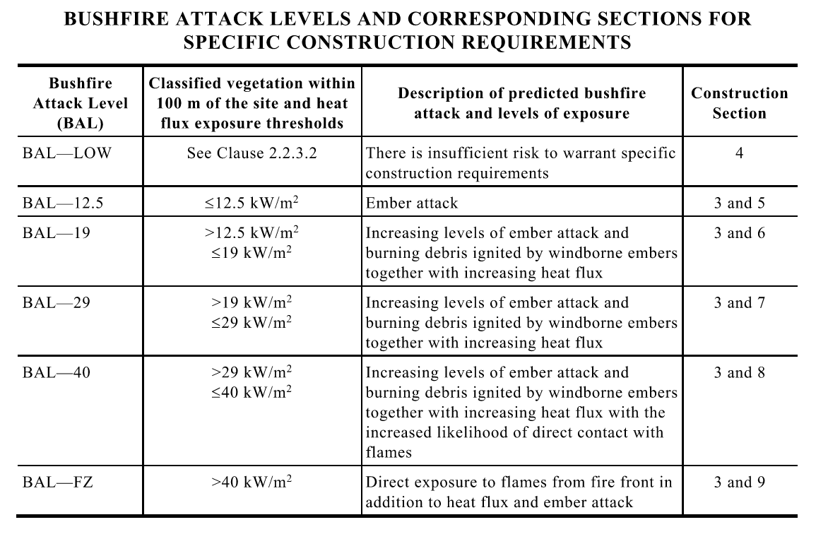

- Complete the table below by identifying the type of fire-resisting construction (i.e. Type A, Type B, or Type C) given the following class of building and number of storeys each class of building has.

Answer | Rise in Storeys | Class of building:  2,3,9 | Class of building:  5,6,7,8
 | 4 or more | - Type A | - Type A
 | 3 | - Type A | - Type A
 | 2 | - Type B | - Type B
 | 1 | - Type C | - Type C

- Provide a brief explanation of each step of the development of Performance Solutions.

Answer | Steps in Developing Performance Solutions | Brief explanation of each step
 | Prepare a performance-based design brief | - A performance-based design brief (PBDB) is a document that is developed in collaboration with key stakeholders as part of a proposed performance-based design and approval process. When completed, the PBDB becomes the platform upon which the proposed design is constructed. The purpose of the PBDB is to record fundamental activities and outcomes of the performance-based design process, as agreed during key stakeholder negotiations. When the PBDB is finalised, all critical activities and outcomes would have been identified. Consequently, the design process can be commenced with a high degree of confidence that provided the requirements of the PBDB are achieved, the proposed design is likely to be approved. The process of developing a PBDB is typically initiated by the designer through round table discussions amongst key stakeholders. A need for ongoing discussion is usually determined by the success of initial negotiations and/or the complexity of the proposed solution(s) 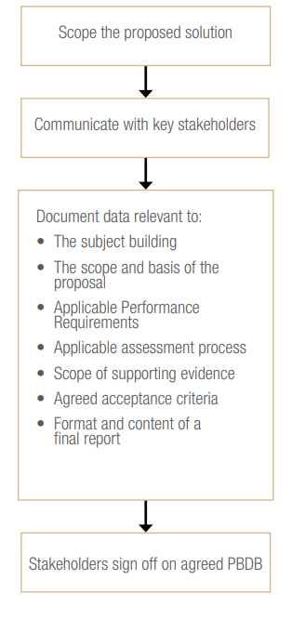
 | Carry out analysis, modelling, or testing | - Given that each performance solution is unique, each proposal will require a specific analysis, modelling or testing process relevant to its complexity. In order to assure compliance with the NCC, a performance solution must be evaluated according to one or more of the Assessment Methods outlined in the NCC. Any analytical assessment should be completed as agreed in the PBDB 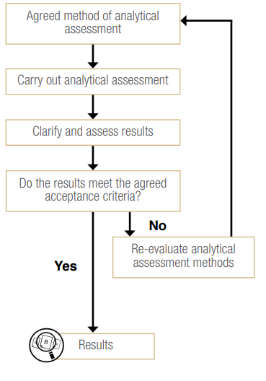
 | Collate and evaluate results | - It is then necessary to collate and evaluate these results and draw conclusions to form the final report. The evaluation needs to take into account the agreed acceptance criteria for the analysis as set out in the PBDB and the results of any uncertainties or sensitivities. Further analysis, modelling and/or testing may be required if the outcomes are not consistent with the agreed acceptance criteria. 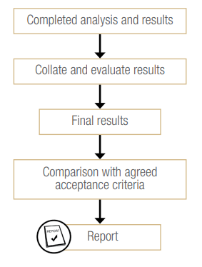
 | Prepare a final report | - The final report should clearly demonstrate that compliance with the NCC Performance Requirements agreed in the PBDB has been acheived. The content of a typical final report might include:  - An overview of the PBDB, including – Scope of the project – Relevant stakeholders – Applicable NCC Performance Requirements – Approaches and methods of analysis – Any assumptions that were made – Acceptance criteria and safety factors agreed to by stakeholders • Overview and outline of the analysis, modelling and/or testing carried out – Method of analysis used – Calculations and outcomes – The sensitivities, redundancies and uncertainty studies carried out – The results obtained and relevance to the PBDB • Evaluation of results including: – Comparison of results with acceptance criteria – Any further sensitivity studies undertaken – Any expert judgement applied and its justification • Conclusion – Specifications of the final design that are deemed to be acceptable – The NCC Performance Requirements that were met – All limitations to the design and any conditions of use

- Discuss two (2) properties, two (2) characteristics and two (2) limitations of concrete when used for buildings.

Answer |  | Concrete
 | Properties | - 1. Compressive Strength: Concrete has high compressive strength, which means it can withstand significant amounts of pressure without crushing
 | Properties | - 2. Durability: Concrete is highly durable and can last for many decades under normal environmental conditions.
 | Characteristics | - 1. Thermal Mass: Concrete has a high thermal mass, meaning it can absorb and store large amounts of heat.
 | Characteristics | - 2. Workability: Workability refers to how easy it is to mix, place, and finish concrete. This characteristic can be adjusted by altering the water-cement ratio and adding admixtures.
 | Limitations | - 1. Tensile Strength: Concrete has relatively low tensile strength compared to its compressive strength.
 | Limitations | - 2. Cracking: Concrete is prone to cracking and shrinkage as it dries and cures, and under load or thermal expansion and contraction.

- Discuss three (3) benefits of using glass in buildings.

Answer  1.  2.  3. | Glass allows natural light to penetrate deep into buildings, reducing the need for artificial lighting during the daytime.  Glass offers a sleek and modern aesthetic that can enhance the visual appeal of buildings.  Advanced glass technologies, such as double or triple glazing and low-emissivity (low-E) coatings, provide excellent thermal and acoustic insulation properties.

- Respond to the following items regarding zero-energy building.

Answer | Item | Zero energy building
 | Definition | - Zero-energy building is the construction of buildings that produce as much energy as they consume. It is called a ‘zero-energy’ building because, ideally, the difference between the energy produced by the building and the energy consumed by the building is zero.
 | One (1) technique used in zero energy building | - Integrating renewable energy sources that power the building
 | The procedure in implementing the technique you have identified | - One of the more popular renewable energy sources, especially in hotter climates, is solar energy which can be harnessed by installing solar panels on the roofs of buildings.

CPCCBC4001
Apply building codes and standards to the construction process for Class 1 and 10 buildings

WORKBOOK

Participant name | Mohsin Ali Ch.

FOR THE PARTICIPANT
Instructions
- You will complete written activities as outlined on the following pages. You must attempt all questions and provide enough detail in your responses to demonstrate your knowledge.
- The timeframe for these tasks will be established by your Assessor or Training Plan, but additional time may be allowed upon negotiation with the Assessor.
- You must complete all questions unassisted by the Assessor or other personnel but may refer to reference material as needed. All questions must be answered correctly for a ‘Satisfactory’ assessment outcome to be awarded.
  - An oral examination may be allowed under certain circumstances, whereby your answers will be documented by another party.
  - Any written questions that are incomplete, or not answered satisfactorily will need to be completed again after further training support.
    - If you answer a question incorrectly but modify your response, put your initials next to the written change (or the Assessor must initial a verbal change).
Resources required
Pen

FOR THE ASSESSOR
Instructions
- Where oral examination has occurred, ensure that this is acknowledged in writing (e.g. FT001 and Assessor Comments)
- All questions must be satisfactorily demonstrated by the Participant for a Satisfactory determination (indicated by an Assessor tick to the right of the question).
- Assessors are to complete marking in pen of a different colour to the Participant.
- If the Participant verbally modifies their response, write in the modified response verbatim and put your initials next to the written change.

ASSESSOR COMMENTS
As necessary, outline:
- Details on reattempts, alternative arrangements or reasonable adjustments made.
- Where a Participant is deemed ‘Not Satisfactory’, provide recommendations for future training.

NOTE

At times, you will be provided with a specific context to which you must respond, otherwise it is anticipated that you will use a workplace of your choosing (your own, or hypothetical) to provide the context to the task.

At all times, the responses in your assessment must reference Australian (Queensland or Federal) documentation, including legislation, regulations, codes of practice, standards and guidance publications.

Access the National Construction Code (NCC) to:
- Briefly explain what the General Requirements of buildings are.
- Briefly explain what the Performance Requirements of buildings are.
- Briefly explain the relationship between a building’s Performance Requirements and compliance options (e.g. performance solutions, deemed-to-satisfy solutions).

- Briefly explain what the General Requirements of buildings are.
- interpretation of the NCC
- referenced documents such as Australian Standards
- acceptance of design and construction (such as evidence of suitability and other related documentation)
- classification of buildings

- Briefly explain what the Performance Requirements of buildings are.
- These are requirements that state the minimum level of performance for buildings, plumbing, and drainage installations. Performance Requirements are qualitative statements that describe the needs of building occupants.
- Briefly explain the relationship between a building’s Performance Requirements and compliance options (e.g. performance solutions, deemed-to-satisfy solutions).
- The relationship between a building’s Performance Requirements and compliance options is fundamental to the regulatory framework provided by the National Construction Code (NCC) of Australia. This relationship ensures that buildings meet essential safety, health, amenity, and sustainability standards

Satisfactory Outcome

Provided in the table below are different building elements of Class 1 and Class 10 buildings. For each building element, provide one performance requirement according to the National Construction Code (NCC) Volume 2.
- Structural stability and resistance.
- Weatherproofing.
- Automatic fire warning for occupants.
- Personal hygiene and other facilities.
- Movement to and within a building.

- Structural stability and resistance
- Building elements must be designed and constructed to provide adequate structural stability and resistance to various loads and actions to ensure the building remains safe and does not undergo excessive deformation or collapse.
- Weatherproofing
- Building elements exposed to the weather, such as roofs and external walls, must prevent water penetration that could cause unhealthy or dangerous conditions, deterioration of building elements.
- Automatic fire warning for occupants
- Smoke alarms must be installed in Class 1 and Class 10 buildings to provide occupants with early warning of a fire, ensuring they have sufficient time to evacuate the building safely. Smoke alarms must be compliant with AS 3786
- Personal hygiene and other facilities
- Class 1 buildings must include facilities for personal hygiene, such as bathrooms and toilets, and other necessary facilities like kitchens, ensuring they are adequate, accessible, and promote health and safety for occupants.
- Movement to and within a building
- Buildings must be designed to allow safe and convenient movement to and within the building for people, including those with disabilities. This includes providing appropriate access routes, stairs, ramps, and other necessary features to ensure accessibility.

Satisfactory Outcome

Provided in the table below are different building elements of Class 1 and Class 10 buildings. Describe the how the verification method for each building element of the buildings must be implemented.

- Structural robustness
- (a) assessment of the structure such that upon the notional removal in isolation of— (i) any supporting column (ii) any beam supporting one or more columns; or (iii) any segment of a load bearing wall of length equal to the height of the wall, the building remains stable and the resulting collapse does not extend further than the immediately adjacent storeys; and (b) demonstrating that if a supporting structural component is relied upon to carry more than 25% of the total structure, a systematic risk assessment of the building is undertaken and critical high risk components are identified and designed to cope with the identified hazard or protective measures chosen to minimise the risk.
- Room space or height
- A room must have a height that does not contradict its purpose. Consider the DTS Provision regarding the height of a habitable room (excluding the kitchen) which states that the height must not be less than 2.4 metres. You may not be able to comply with these for several reasons. You may be working on a heritage building with rooms lower than the height required, and trying to renovate may affect the integrity of the building. Another reason is that the ceiling may have an irregular shape.
A Performance Solution may be more suitable than a DTS Solution in cases where it is difficult to overcome the existing spatial limitations within your building.

Satisfactory Outcome

Access and review the following documents included with this workbook regarding quality management systems of Cascade Peaks Construction:
Handout 2 (HO2) Cascade Peaks Construction Quality System – Beginning Construction
Handout 3 (HO3)Cascade Peaks Construction Quality System – Mandatory Inspections

Once you have accessed and reviewed the documents above, answer the following questions:
- Briefly explain why proper procedures for demolition and temporary fencing is needed during construction.
- Briefly explain why mandatory inspections are needed during the construction of new buildings.
- Identify two (2) tasks that should be done before demolition starts.
- Identify two (2) characteristics that temporary fencing around a construction site should have.
- Identify two (2) inspections that must be done by a building certifier.
- Identify two (2) areas in a building that must be inspected for weatherproofing by a building certifier.

- Briefly explain why proper procedures for demolition and temporary fencing is needed during construction.
- Building and demolition work usually requires using plenty of heavy machinery and equipment. It is therefore important to know how to control demolition works and demarcate zones that should not be accessed by the general public to ensure the safety of not only the workers but the general public as well.
- Briefly explain why mandatory inspections are needed during the construction of new buildings.
- To ensure that the building meets relevant standards, local regulations, and requirements of the Building Code of Australia (BCA). These inspections ensure the safety of the users of the building when the building is finally completed.
- Identify two (2) tasks that should be done before demolition starts.
- Apply for necessary demolition permits.
- Disconnect existing utilities, such as power, drainage, gas, and water
- Identify two (2) characteristics that temporary fencing around a construction site should have.
- Have the necessary signs and devices for traffic and pedestrian management that are placed in a way that they do not pose a hazard to either pedestrians or traffic.
- Be between 1.8 and 2 meter tall.
- Have gates and doors that swing only inwards.

- Identify two (2) inspections that must be done by a building certifier.
- excavation – after excavation of foundation material and before the concrete for the footings, or slab, for the building are poured.
- slab – if the building is to have a slab—after the placement of formwork and reinforcement for the slab but before the concrete for the slab is poured.

- Identify two (2) areas in a building that must be inspected for weatherproofing by a building certifier.
- external face of single-leaf masonry walls
- roof junctions
- Location and spacing of weepholes to cavity masonry walls.

Satisfactory Outcome

Access and review:
Handout 4 (HO4) Cascade Peak Construction’s Safety Policies and Procedures

After reviewing the policies and procedures, provide the following information below:
- Cascade Peaks Construction’s safety policy.
- Cascade Peaks Construction’s field standard safety clothing and equipment policy.
- Four (4) registers that Cascade Peaks Construction should keep regarding the safety of its workers.
- Five (5) safety clothing that workers must wear regardless of their task.

- Cascade Peaks Construction’s safety policy.
- Cascade Peak Construction Pty Ltd is committed to creating a workplace environment that is conducive to safety as well as to productivity. To achieve this aim, management and employees will comply with all relevant legislation and safety regulations that are in force both in the office and in the client’s work environments
- Cascade Peaks Construction’s field standard safety clothing and equipment policy.
- Steel Cap Footwear (boots)
- Hard Hats and highly visible (orange) vests
- Long Sleeved shirts
- Long Pants
- Gaiters where suitable
- Four (4) registers that Cascade Peaks Construction should keep regarding the safety of its workers.
- Phone/contact details – Staff Medical Advisors, Ambulance, Police etc.
- Accident: Minor and Serious
- Inductions
- Safety training courses attended.

- Five (5) safety clothing that workers must wear regardless of their task.
- Steel Cap Footwear (boots) – at discretion of safety officer
- Wide brim hat
- UV protection sunscreen
- Long sleeve shirts buttoned or affixed at wrist
- Collard Shirts

Satisfactory Outcome

Consider the columns in the photo below and answer the following questions:
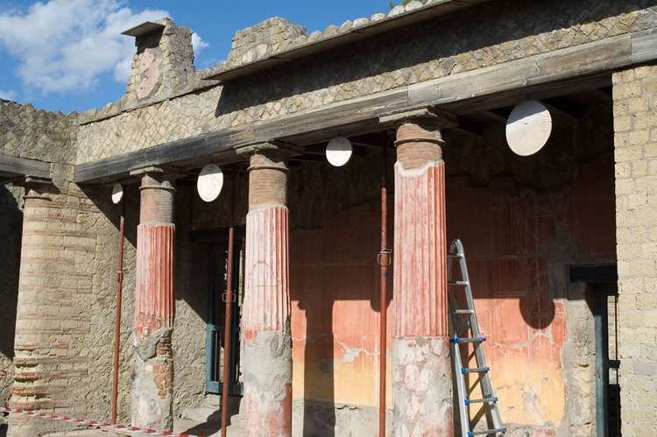

- What kind of stress is being applied on the columns by the ceiling?
- Describe the deformation that the columns are possibly undergoing due to the stress that the ceiling is applying on them.
- Describe what would happen to the columns if the ceiling were too heavy to be supported.

- What kind of stress is being applied on the columns by the ceiling?
- Compressive Stress: The stress on materials that leads to a reduction in volume. It is the force per unit area applied in a direction that compresses the material. his downward force compresses the columns, pushing them together and trying to shorten them. The columns must be designed and constructed to resist this compressive stress to prevent collapse.

- Describe the deformation that the columns are possibly undergoing due to the stress that the ceiling is applying on them.
- Shortening: Compressive stress causes columns to shorten along their length. This is a direct result of the vertical load applied by the ceiling.
- Cracking: Over time, compressive stress can cause internal microcracks in the material of the columns, leading to spalling (the breaking off of surface layers.
- Buckling: Buckling is a form of deformation that occurs when a column is subjected to compressive stress, especially if the column is slender and tall relative to its cross-sectional area.
- Describe what would happen to the columns if the ceiling were too heavy to be supported.
- If the ceiling is too heavy, the columns could undergo severe structural failure, leading to crushing, buckling, cracking, and potentially a total collapse, posing serious safety hazards.

Satisfactory Outcome

The handrail of a staircase in a two-storey house located in a termite-risk area broke off while a resident was climbing down the stairs. The handrail was hollow and was infested with termites. Upon further inspection, most of the staircase was constructed from untreated timber, and the project plans made no mention of the fact that the house was made in a termite-risk area.

Given the information above:
- Identify two factors that contributed to the degradation of the house’s staircase.
- Identify which Part from the NCC Volume 2 was not properly applied.
- Briefly explain how the identified clause from the Building Code of Australia Volume 2 was not properly applied.
- Identify which Australian standard was not properly applied.
- Briefly explain how the identified Australian standard was not properly applied.
- Identify one practice endorsed by Safe Work Australia was not properly applied.
- Briefly explain how the identified practice endorsed by Safe Work Australia was not properly applied.
- Identify what other defect the house would have considering the deviations of the construction from the code and standard.
- Describe the extent of the work that needs to be done to rectify the termite infestation.

- Identify two (2) factors that contributed to the degradation of the house’s staircase.
- The staircase was constructed from untreated timber, which is highly susceptible to termite damage.
- The project plans did not account for the house being in a termite-risk area, leading to inadequate termite protection.

- Identify which Part from the NCC Volume 2 was not properly applied.
- Part 3.1.3: Termite Risk Management
- Briefly explain how the identified Part from the NCC Volume 2 was not properly applied.
- This part requires that appropriate termite management systems are implemented in areas where there is a known risk of termite infestation. This includes using termite-resistant materials or treatments and ensuring that structural components are protected from termite attack.
- The clause was not properly applied as the staircase was made of untreated timber and no termite protection measures were mentioned or implemented, leading to termite infestation and degradation of the staircase.

- Identify which Australian standard was not properly applied.
- AS 3660.1- 2014: Termite Management - New Building Work
- Briefly explain how the identified Australian standard was not properly applied.
- This standard outlines the necessary steps and materials required to protect buildings from termite infestation. This includes the use of termite-resistant materials, chemical treatments, and physical barriers.
- The standard was not properly applied as the staircase was constructed using untreated timber, which is not termite-resistant. Additionally, no chemical treatments or physical barriers were implemented to protect against termites, as required by the standard
- Identify one practice endorsed by Safe Work Australia was not properly applied.
- Hazard Identification and Risk Assessment
- Briefly explain how the identified practice endorsed by Safe Work Australia was not properly applied.
- SWA emphasizes the importance of identifying potential hazards and assessing the associated risks to implement appropriate control measures.
- This practice was not properly applied because the risk of termite infestation in a known termite-risk area was not identified or assessed

- Identify what other defect the house would have considering the deviations of the construction from the code and standard.
- Structural Integrity Issues.
- Moisture Damage
- Safety Hazards
- Describe the extent of the work that needs to be done to rectify the termite infestation.
- Inspection
- Termite Treatment
- Material Replacement
- Structural Repairs
- Preventive measures

Satisfactory Outcome

CPCCBC4001
Apply building codes and standards to the construction process for Class 1 and 10 buildings

PRACTICAL ASSESSMENT

Participant name | Mohsin Ali Ch

FOR THE PARTICIPANT
Instructions
- The tasks outlined on the following pages will require performance of normal workplace activities, as a result of a structured activity set by an Observer in the workplace or a simulated activity set by your Assessor/Observer.
- The timeframe for these tasks will be established by your Assessor/Observer, in consideration of location conditions and industry requirements.
- You must complete all tasks unassisted by the Assessor or other personnel, unless the steps note this assistance.
- You must attempt all tasks (and itemised steps) for a ‘Satisfactory’ assessment outcome to be awarded.
  - For any observation conducted that is incomplete, or without satisfactory performance, the observation will need to be completed again after further training support.

FOR THE ASSESSOR/OBSERVER
Instructions
- The following observation record should be used to judge and record your observations of the Participant as they complete the task(s) set. You must record your observations of the Participant’s performance.
  - For each occasion, indicate the task performed and whether it was a simulation or workplace-based task.
    - Any simulated assessment must ensure the Participant still performs under workplace conditions which reflect industry standards.
  - In the comments, provide clear detail regarding the task that the Participant was required to do (e.g. PPE used, materials handled, attachments connected, plant types).
- All steps must be satisfactorily demonstrated by the Participant for a ‘Satisfactory’ determination (indicated by an Assessor tick to the right of each itemised step, or an Observer tick to the right of each itemised step, and confirmation by an Assessor in the Assessor Comments).
  - Where you have determined that one or more task steps have not been satisfactorily demonstrated, provide the Participant with additional support and outline details of such assistance in the Assessor/Observer Comments. Allow the Participant two (2) further opportunities to demonstrate the task again to allow an opportunity for a ‘Satisfactory’ assessment outcome to be achieved.
  - If after three (3) attempts the Assessor determines that the Participant cannot demonstrate the required steps, a ‘Not Satisfactory’ outcome is to be determined.

TASK OUTCOME
Task | Date | Task Type (Tick) | Location | Task outcome (Tick)
 |  |  |  | Satisfactory | Not Satisfactory
Task 1 | Select Date. | Workplace  Simulation

ASSESSOR COMMENTS: GENERAL
As necessary, outline:
- Details on reattempts, alternative arrangements or reasonable adjustments made.
- Where a Participant is deemed ‘Not Satisfactory’, provide recommendations for future training.

ASSESSOR COMMENTS: PRACTICAL TASK 1
Individual student (as named on cover page)
Multiple students [ All from Attendance Report, Specific students involved – identify students]
Task | Provide detail
1.1A. 1.1B. 1.1C. | Specify () where building classifications, criteria requirements and performance solutions were documented:  Workplace Quality document Quality Assurance Template Other (please specify):  Document attached as evidence
1.2D. | Specify () who was consulted regarding compliance options:  Project management Relevant tradesperson Builder Supplier  Other (please specify):
1.3C. | Specify existing building checked for compliance with active fire protection requirements:  Is checklist used attached as evidence

CPCCBC4001
Apply building codes and standards to the construction process for Class 1 and 10 buildings

Practical Task 1
Description of task:
The participant must demonstrate the skills and knowledge to apply building codes and standards to the construction process one Class 1 or 10) building or structure project to a maximum of two storeys. Documented evidence of all criteria must be presented (template (HO1) available for use if required)The participant must also inspect one existing buildings for fire protection compliance using workplace or created document (See HO5 for information). Assessor and observer will be looking for evidence including:
- Classify building and document findings.
- Read the plans and specifications to determine the nature of the building, its use and arrangement.
- Read and correctly interpret relevant Parts of the NCC and related Australian Standards for the project.
- Determine and document the classification applicable to the building and all ancillary buildings and structures. (template available- HO1)
- Determine construction compliance requirements.
  - Determine NCC Performance Requirements relevant to Class 1 and 10, up to two storeys, building projects.
  - Determine range of criteria to ensure that construction methods comply with NCC Performance Requirements.
  - Identify and document non-conforming construction methods against NCC Performance Requirements. (template available- HO1)
  - Propose and discuss Performance Solution with design and building and construction professionals. Document consultation. (template available- HO1)
  - Analyse and apply Assessment Methods to determine compliance with Performance Solution or Deem-to-Satisfy Solution (DTS). (template available- HO1)
  - Meet the evidence of suitability requirements for building materials and products stated in the NCC.
  - Complete documentation demonstrating how the project design and construction will meet NCC requirements (template available- HO1) including:
    - energy efficiency
    - damp and weatherproofing
    - fire safety
    - health and amenity
    - structure
    - safe movement and access
    - ancillary provisions
- Determine fire protection requirements.
  - Read the NCC and other legislative requirements for passive and active fire control elements in buildings.
  - Write or obtain a checklist describing the level of fire resistance required for the construction of various buildings.
  - Inspect one existing building for compliance with passive and active fire protection requirements.

These tasks may be simulated or real. The Participant is to gather evidence of how they have completed each component of the Practical Task, which is to be submitted with this Practical Assessment sheet. The Observer is to provide detailed comments on the tasks completed by the Participant (on the Observer Comments, overleaf). The Assessor is to verify the Observer’s comments, noting their findings in the Assessor Comments (on the back of the Practical Assessment cover page) and provide the assessment outcome.
Resources required:
Construction plans, drawings and specifications for one (1) building Class 1 or 10) building or structure project to a maximum of two storeys; workplace quality policies and procedures; technology to access building and related industry codes, standards and manufacturer product information and materials specifications; Technology to access the NCC and current relevant Acts and Regulations. PPE as required. Documentation of design and construction (suitability or evidence of suitability) (template available- (HO1).Fire protection checklist.
Observer details
Name of observer: | Matthew Groves
Role of observer  (Confirm suitability to sign) | Project Engineer
Email address of observer | Matthew.groves@cbgujv.com.au
Signature of observer: | 
Date: | 5/06/2024

When completing the task, did the Participant: | Tick if satisfactorily completed.  Provide comments if left unticked.
1 Classify building
- Read the plans and specifications to determine the nature of the building and ancillary provisions, use and arrangement.
- Read and correctly interpret relevant Parts of the NCC and related Australian Standards for the project.
- Determine and document the classification applicable to the building and all ancillary buildings and structures. (attach evidence -template available- HO1)
2 Determine construction compliance requirements
- Determine NCC Performance Requirements relevant to Class 1 and 10, up to two storeys, building projects. (attach evidence -template available- HO1)
- Determine range of criteria to ensure that construction methods comply with NCC Performance Requirements. (attach evidence -template available- HO1)
- Identify and document non-conforming construction methods against NCC Performance Requirements. (attach evidence -template available- HO1)
- Propose and discuss Performance Solution with design and building and construction professionals. Document consultation. (attach evidence -template available- HO1)
- Analyse and apply Assessment Methods to determine compliance with Performance Solution or Deem-to-Satisfy Solution (DTS). (attach evidence -template available- HO1)
- Meet the evidence of suitability requirements for building materials and products stated in the NCC.
- Complete documentation demonstrating how the project design and construction will meet NCC requirements for energy efficiency (attach evidence -template available- HO1).
- Complete documentation demonstrating how the project design and construction will meet NCC requirements for damp and weatherproofing (attach evidence -template available- HO1).
- Complete documentation demonstrating how the project design and construction will meet NCC requirements for fire safety (attach evidence -template available- HO1)
- Complete documentation demonstrating how the project design and construction will meet NCC requirements for health and amenity. (attach evidence -template available- HO1).
- Complete documentation demonstrating how the project design and construction will meet NCC requirements for structure. (attach evidence -template available- HO1).
- Complete documentation demonstrating how the project design and construction will meet NCC requirements for safe movement and access. (attach evidence -template available- HO1).
- Complete documentation demonstrating how the project design and construction will meet NCC requirements for ancillary provisions. (attach evidence -template available- HO1).
3 Determine fire protection requirements.
- Read the NCC and other legislative requirements for passive and active fire control elements in buildings.
- Write or obtain a checklist describing the level of fire resistance required for the construction of various buildings.
- Inspect one existing building for compliance with passive and active fire protection requirements (attach checklist as evidence)

Observer comments:
Mohsin was able to demonstrate a thorough understanding of the NCC and relevant Australian Standards to document the construction process to ensure compliance in various aspects of the process. He was able to apply knowledge of the NCC to a wide range of construction tasks from site preparation, through the main construction elements of concrete, masonry, framing and glazing, as well as critical aspects such as fire safety, energy efficiency, and health and safety measures.

