CPCCBC4016A
Administer a construction contract

THEORY EXAM INSTRUCTIONS

- This exam will occur under standard assessment conditions.
  - An oral examination may be allowed under certain circumstances.
Answers will be documented and FT003 (Oral examination declaration form) must be completed.
- Participants must provide enough detail in their responses to demonstrate their knowledge and skills.
- Please fill in the details below, providing your name, signature and date of assessment.
  - Your signature acknowledges that this is your own work.
- If a participant initially answers a question incorrectly but modifies their response, they must follow the instructions below:
  - If a participant changes their response in writing, they must put their initials next to the written change.
  - If a participant changes their response verbally, this must be noted on the exam paper by the assessor.

Participant name | Emma Carew
Participant signature | 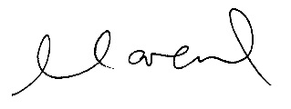

Assessor name
Assessor signature | 

Date | 12/05/2018

Number of questions | Number of questions answered correctly | Satisfactory?
49 |  | Yes | No
Assessor Comments

- Identify the various types of building and construction contracts and explain when it is appropriate to apply each type of contract.

Answer | There are a number of building contracts available for use which include the following:  - Industry Contracts  Industry contracts include: Master Builders, QBCC, HIA and ABIC Simple Works.  Types of QBCC contracts that can be downloaded for free include:  - New Home Construction Contract – Construction of entire home  - Renovations, Extension and Repair Contract – renovations, extensions, improvements to a home, duplex or home unit  - Natural Disaster Repairs Contract – Repairs from damage caused by natural disasters  - Contract for Small Business Projects up to $3,300 – small renovation, maintenance, repairs where contract price is up to but does not exceed $3,300  - Demolition Contract for Residential Premises – demolition of homes severely damaged by a natural disaster  Types of MBA Contracts that can be purchased include:  - Residential Building Contract – Lump sum used for new houses or major residential works/extensions/alterations where an architect is the owner’s agent.  - Residential Renovation Contract – Lump sum for large renovation or alteration to the value of $1M  - Minor Works Contract – Lump sum for minor works up to $80,000  - Trade Contract – Lump sum used by a trade contractor, contracting directly with an owner  - Simple Works Contract – Lump sum for contractor dealing directly with owner for residential building work – contract value less than $3,300  - Pool Building Contract – Lump sum for use in construction of swimming pool or spa when contracting directly with owner  - Australian Standard Contracts (Including AS2124 & AS4000 Series)  Designed for major building and engineering projects where a ‘superintendent’ is engaged to administer the contract who is an independent professional (or a firm of consultants) or an employee of the principal. The contract price may be calculated as a lump sum or re-measurement (SOR/BOQ) or a combination of these  - Construction Industry Contracts (CIC) suite  The Australian Building Industry Contracts (ABIC) are jointly published by the Australian Institute of Architects and Master Builders Australia.  They are intended for use in building projects where an architect administers the contract.  - Contracts required / supplied by regulatory authorities  - Individual Organisational Contracts  Many public authorities and local government bodies have their own standard forms. Master Builders recommends Australian Standards and the ABIC Suites but also has its own forms  - JCC Suite Contracts (Joint Contracts Committee)  Comprised of representatives from:  - Royal Australian Institute of Architects  - Master Builders Federation of Australia  - Property Council of Australia  JCC Suite of contracts were previously recognised industry contract standard. When the ABIC series of contracts were introduced in 1999, it was agreed that the JCC suite would be withdrawn from use and no longer available after 2002.  - Simple Building Works (SBW) – Including Series 1 and 2  Used for building works that are not complex in nature.

Answer

- Use the drawings you completed in the assessment for CPCCBC4014A (from the floor plan below) and the listed task requirements to prepare the new dwelling contract documentation for the client’s signature.

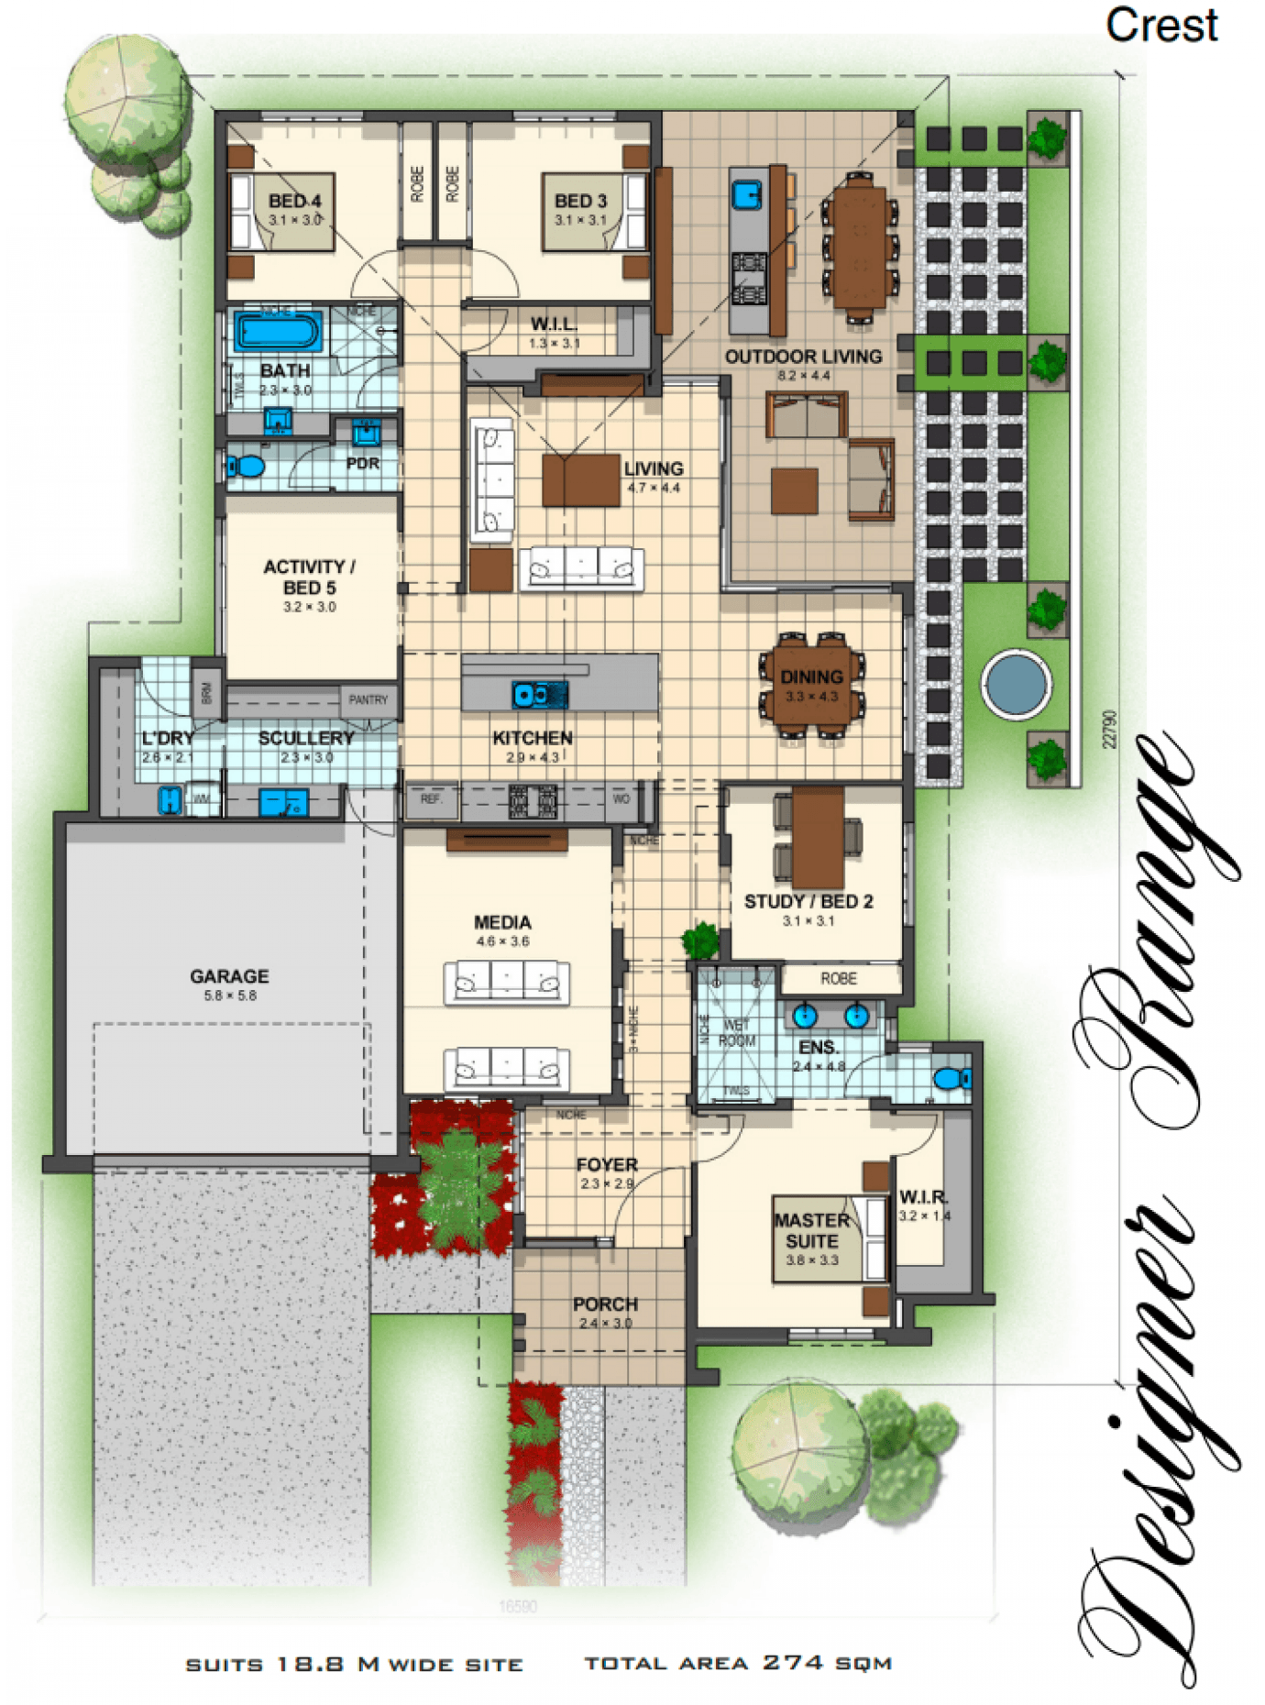
TASK REQUIREMENTS

You are to download the contract documents from the Queensland Building and Construction Commission (QBCC) website at: http://www.qbcc.qld.gov.au/sites/default/files/QBCC_New_Home_Construction_Contract.pdf

Your should:
- Analyse the various types of building and construction contracts you will need and then apply the appropriate application of each type of contract;
- Identify and apply legislative requirements relating to building and construction contracts.
- Identify and apply essential terms and elements of a valid contract;
- Analyse the importance of identifying an intention to create legal relations;
- Identify and analyse rights and liabilities of parties under a contract;
- Identify and apply common building contract terms and procedures;
- Identify and analyse circumstances that bring about a breach of contract;
- Accurately select the contract, appropriate for the type of construction;
- Accurately identify and prepare the range of documents collectively make up a contract;
- Accurately identify and apply requirements associated with an offer and acceptance of a contract;
- Confirm the capacity of the parties to form a binding agreement in the form of a contract; and
- Identify and apply factors associated with the parties' consenting to a contract.

Answer

- How should you handle any customer complaint?

Answer | With a common sense approach most customer complaints can be resolved quickly and efficiently. If handled correctly, complaints can present an opportunity to turn a negative situation into a positive one.  - Always refer to the contract first – determine responsibility & direct the contractor if defects need to be attended to or works completed.  - Act promptly and deal with the complaint straight away.  - Stay calm and professional  - Identify the problem and decide what can be done  - Arrange a second option to confirm your view  - Keep records so can avoid misunderstandings  - Fix the problem

- What does the ‘cooling off’ period refer to when undertaking domestic building work with a total contract price of $20,000 or more?

Answer | When referencing the QBCC New Home Construction Contract – You may withdraw from the contract in writing within 5 business days of receiving copies of the signed contract and the Consumer Building Guide.  Costs for home owners to withdraw are generally $100 plus any out of pocket expenses reasonably incurred by the contractor.

- What are the consequences for a client not using a QBCC licensed contractor?

Answer | The consequences for a client not using a licensed QBCC contractor are:  - The building works may not be covered under the Queensland Home Warranty Scheme.  - The contractor is not insured for the works they perform which will put the clients project at risk  - The client is not protected as the QBCC offers a free dispute resolution service when using licenced contractors.

- What is the Queensland Home Warranty Scheme?

Answer | The QBCC administers the Queensland Home Warranty Scheme to provide insurance cover for residential construction work in Queensland.  Licensed contractors must pay a premium for residential work they carry out that is for a value of $3,300 or over on behalf of the consumer.  Home owners are provided with cover for loss where the licensed contractor does not complete the contracted works or fails to rectify defective work for up to 6 years from completion, provided a licensed contractor performs the work.  The premium to be paid is based on the insurable value of the work. The cost of the premium is included as part of the contract value and must be paid to the QBCC 10 business days after the contract was entered or before the works start (whichever is earlier). The QBCC will issue the home owner with a Certificate of Insurance and Policy Booklet within two weeks.  If there is a claim, the QBCC pays the home owner and then pursues the builder to recover the claim amount.

- What are the consequences of Cost Plus and Construction Management contracts on Home Warranty Insurance protection?

Answer | QBCC strongly recommends against the use of these contracts for domestic building work as their use frequently results in large cost blowouts, reduced Home Warranty Insurance protection, high risk of disputes and a reduction in legal rights and protection in the event a dispute arises.

- At the commencement of a contract valued over $20,000, what must the contractor give to the owner? What timeframes apply?

Answer | The contractor must give the owner a signed Commencement Notice within 10 business day of the work commencing on site. It must state the date work started on site and the Date for Practical Completion.

- Where must the total contract price be stated?

Answer | The total contract price must be stated on the first page of the contract schedule, along with a warning about any provisions that may cause the price to change, any allowances must be stated in the contract schedule.

- What are the maximum deposits recommended and how should progress payments be scheduled?

Answer | The maximum deposit allowed is:  - 10% where the total contract price is under $20,000  - 5% where the price is $20,000 or more  - 20% for a contract of any price where the value of the work to be performed off site is more than 50% of the total contract price  All progress payments over $20,000 in value must have a progress payment schedule.  Progress payments must match the work carried out and for cost plus contracts be supported by receipts / other verifying documents.  Sometimes the bank will have special requirements for progress payments and this may be included in the contract.  Progress Payment Schedule  - Deposit = 5% (Contract Sum)  - Base Stage = 15%  - Frame Stage = 20%  - Enclosed Stage = 25%  - Fixing Stage = 20%  - Practical Completion = Balance

- Who has responsibility of building inspections and approvals?

Answer | The QBCC New Home Contracts states that Building approvals and inspections are the responsibility of a Building Certifier.  The CSTC power point presentation notes that home owners are ultimately responsible for ensuing building approvals are granted and the required inspections are carried out.

- Identify and describe the term used to describe circumstances such as:
- Where there has been a change to the materials used or
- A change to the scope of the work to be performed under the contract?

Answer | A Variation is any change to the materials used or the scope of work to be performed under the contract.  Variations must be detailed in writing and copied to the owner by the contractor within five business days after they are agreed to and before any variation work starts.

- How do you reduce the risk of dispute?

Answer | - Carefully read and understand the contract  - Check any associated plans and specifications before signing  - Discuss any questions with your contractor  - Seek legal advice if you have any concerns

- What is the process for dispute resolution?

Answer | - Advise the contractor in writing, allowing them a reasonable amount of time to respond.  - Explore the QBCC’s free Early Dispute Resolutions Service (EDR) and your legal obligations  - Engage a practising solicitor before terminating the contract as incorrect termination may have legal consequences and reduce the Home Warranty protection.

- When might an extension of time (EOT) apply? How is it approved?

Answer | An EOT might apply with there are delays to the project due to inclement weather or changes in the scope of works.  An EOT claim must be issued in writing to the client requesting approval to extend the contract period for practical completion. If the EOT is not approved by the client then this is deemed to be disputed.

- When is the client/home owner required to pay the final contract payment?

Answer | Final contract payment is due at the point of practical completion.

- What are implied warranties?

Answer | Under the Act, a range of warranties are deemed to be part of all regulated domestic building contracts. The warranty period for structural defects is six years and one year for all other defects.

- Explain the responsibilities of an Owner Builder.

Answer | You must follow the conditions of your permit:  - Only carry out work covered in the permit  - Anyone engaged by the Owner Builder must be a licensed contractor  - Cannot perform any occupational work such as plumbing, draining, gasfitting or pest control unless you have an occupational licence.  - Must have the appropriate licence to perform any fire protection work higher than $1,100  Display an owner builder sign before work starts, failure to do so could mean a fine. The sign must:  - Be clearly visible from the street  - Show your owner builder permit number  - Be weatherproof  - Be at least half a square metre in size  - Be printed in letters at least 50mm high  Supervise  Maintain quality control, oversee the standards of workmanship and be responsible for carrying out safe work practices.

Answer

- What is ‘notifiable work’, who is responsible and to whom does it apply?

Answer | Notifiable work is a type of plumbing and drainage work which is performed in existing buildings and includes changes to existing water supply and drainage systems.  For example:  - Kitchen and bathrooms renovations, extensions, additions.  - Installing or replacing hot water heaters – electric, solar or heat pumps  - Installing or relocating fixtures such as toilets, showers and sinks.  A licensed plumber or drainer is responsible for completing and lodging a Form 4 (or Form 4A) to the QBCC within 10 days of completing notifiable work.  Failure to submit a Form 4 to the QBCC is an offence.  Once a Form 4 is lodged, a plumbing inspector from local government may inspect the work to ensure it complies with the required codes and standards.

Answer

Answer

- What is the difference between the Prime Cost Item Schedule and the Provisional Sum Schedule in a contract? Give one example to help explain your answer.

Answer | Prime Cost Item Schedule sets out items which the owner has not finally selected or the contractor is not able to reasonably determine the cost at the date of the contract. The schedule sets out the contractor’s best estimate for the cost of each item and any margin.  PC items examples include - tiles, carpet, taps, doors, bathroom fittings as these all vary in quality and price.  Provisional Sum Schedule sets out items of work where the extent at the date of the contract is not known and despite the contractor making reasonable enquiries is unable to price accurately at this stage.  The schedule sets out the rates or prices applicable to each item of work and the contractor’s best estimate..  Provisional Sum examples include - removal of trees or excavation of the property as there could be rock underground that you cannot see which could hold up the works.  If the actual cost of the PC item or Provisional Sum is more than the estimate, the owner must pay the increase plus margin. If the actual cost of the PC item or Provisional Sum is less than the estimate, the contractor must deduct the difference, plus margin from the contract price.  The contractor warrants that each such estimate for a PC item or Provisional Sum has been prepared with reasonable skill and care and represents the reasonable cost of supplying and delivery each item or providing the item of work including the contractor’s margin.

- What does Section 109 of the Queensland Building and Construction Commission Act 1991 provide to the consumer/client?

Answer | Section 109 - Access to building sites  A building contractor must, at the request of a consumer allow the consumer reasonable access to a building site at which building work is being carried out for the consumer.

- What are some of the preliminary contracts that a builder could ask a client to sign prior to signing the main contract?

Answer | - Pre-construction contract  - Preparatory work agreement  - Quote or estimate  - Order  - Preliminary contract  - Provisional quote  - Authorised tender acceptance  - Contract request

- What are liquidated damages in terms of a signed building contract?

Answer | In a signed building contract, liquidated damages refers to a fixed sum of money which the builder agrees to pay the client if they fail to complete the contract by the time nominated or fail to achieve the performance obligations.  The amount of liquidated damages needs to be a genuine pre-estimate of the loss which a client might suffer as a result of not completing the work on time. This estimate is assessed at the time of entry in to the contract.

- What contract documentation would you review to identify any unusual aspects related to materials and installations for a low rise construction project?

Answer | Schedule of Finishes, construction plans, drawings and specifications

- Where would you find any possible penalties associated with a build?

Answer | Liquidated damages – Condition 24  Item 10 – QBCC New Home Construction Contract

- What is the Australian Standard Contracts - AS2124 and AS4000 series?

Answer | The AS2124 and AS4000 contracts are designed for us on major building and engineering projects where a ‘superintendent’ is engaged to administer the contract who is an independent professional or employee of the principal.

- How does the Queensland Building and Construction Commission (QBCC) regulate the Queensland building industry?

Answer | The QBCC regulates the Queensland building industry through:  - Licensing contractors  - Educating contractors and consumers about their legal rights and responsibilities  - Handling disputes fairly and equitably  - Protecting homeowners against loss through the Queensland Home Warranty Scheme  - Implementing and enforcing legislative reforms and where necessary prosecuting people who do not comply with the law.

- What industry legislation should builders and trade contractors have a good understanding of?

Answer | - QBCC Act - Queensland Building & Construction Commission Act 1991  - QCAT – Queensland Civil Administrative Tribunal Act  - Building Act 1975 & Regulations  - BCIPA – Building & Construction Industry Payments Act 2004  - WHS Act – Workplace Health & Safety Act 2011

- What supporting documents should you be aware of and include in your contracts with the consumer?

Answer | - Termite Management Documentation  - Engineering Specification Confirmation  - Foundation Maintenance Declarations  - Cooling off period

- What are the four (4) essential elements of an agreement for it to be regarded as a contract?
What is the consequence if any essential element is missing?

Answer | The four essential elements are: 1. Offer, 2. Acceptance, 3. Intention of legal consequences and 4. Consideration  If any essential element is missing, the consequence is that the agreement will not be legally binding.

- When would an offer be considered to have lapsed?

Answer | An offer will lapse when:  - When the time for acceptance expires  - If the offer is withdrawn before it is accepted  - After reasonable time in the circumstances (greater the value of the contract, the longer life of the offer)

- What is able to be ‘accepted’? What happens to the offer if new terms are suggested?

Answer | Only what is offered can be ‘accepted’.  If new news are suggested, they are regarded as a counter offer which can be accepted or rejected.

- What does it mean when a contract is supported by valuable consideration?

Answer | Valuable consideration means the following:  - When one party promises to do something in return for a promise to the other party  - Consideration is what each party gives each other as the agreed priced for the others promises  - Usually the consideration is the payment of money

- Identify the term for each of the definitions listed in the table below.

Answer | Term | Definition
 |  | Any construction or change to a building or facility that increases its external dimensions and cubic contents.
 |  | A procedure for resolving disputes that involves less formality than a court hearing. An arbitrator’s decision is final and cannot be appealed.
 |  | Assists builders, contractors and owners by ensuring that construction projects meet building regulations and codes of practice. Inspections assess design documentation and make on-site inspections during building work.
 |  | Demonstrates that a building, other than a dwelling has been inspected and passed.
 |  | The achievement of performance criteria described in a regulation or other statutory requirement. This is usually demonstrated by a compliance or approval certificate.
 |  | An agreement entered into between two or more parties that involves an exchange or specified goods and/or services for specified financial reimbursement or other considerations.
 |  | One or more buildings which in association constitute a single dwelling being a detached house or one or more attached dwellings.
 |  | A person who carries out domestic building work on his her own land, who is not in the business of building.
 |  | Independent professionals with the same power to issue building permits and occupancy permits as municipal building surveyors.
 |  | A person accepted by the appropriate authority as qualified to design, construct (or install) or supervise the erection of, buildings or services; usually recognised by a certificate of registration.
 |  | That part of an allotment which is covered by buildings, expressed as a percentage of the area of the allotment.
 |  | A minor clause in a contract the remedy for breach of which is damages for any loss. Also, a promise to repair or replace defective goods.

- Explain the terms listed in the table below.

Answer | Term | Definition
 | Minor breach
 | Material breach
 | Fundamental breach

- Who are the parties that need to be consulted with for binding agreements to be confirmed?

Answer | The parties that need to be consulted for binding agreements to be confirmed are:  - Buyers advocates: Licensed agent who acts for a buyer instead of a seller  - Legal practitioners: hold a practising certificate, have professional indemnity insurance, can advise on terms and conditions to be included in the contract and perform legal work and provide advice to the client.  - Conveyancers: Can undertake property conveying work and legal work/provide legal advice.

- What is consent?

Answer | Consent is implied in every agreement.  It is an act of reason and deliberation.

- When might ‘apparent consent’ be negated?

Answer | Apparent consent maybe negated due to mistake, fraud, innocent misrepresentation, duress or undue influence – all of which are defences to the enforcement of the contract.

- A construction contract can be terminated for ‘cause’ or for ‘convenience’. Explain these two terms.

Answer | Termination for Cause occurs when one party stops work due to the other party failing to perform. The law provides little recourse to the terminated party as they were failing to perform.  Termination for Convenience occurs when the owner stops work for reasons other than contractors failing to perform. The law may provide assistance to the contractor against the owner in this circumstance.

- What does repudiation mean?

Answer | Repudiation is a term used to describe the rejection of a proposal or idea.

- Explain the concept ‘conditions for completion at the cost of the contractor’.

Answer | The contractor must make good any defects of omissions in the work under the contract within 6 months of the Date of Practical Completion  The owner must give the contractor written notice to make good such defects or omissions within the 6 month period and must give the contractor access to site to attend to these issues.  The contractor must within 28 calendar days of notice rectify any defects during usual business hours.

- What does ‘abandonment of contract’ mean?

Answer | Contract abandonment is where both parties have conducted themselves in such a way that the original contract is no longer valid.  Both parties may mutually agree to do this or it can become part of a claim.

- Throughout the building schedule, progress payments are made when each new stage is ready to commence.
Nominate the recommended stages and percentages for these progress payments on a typical new residential housing building project.

Answer | Stage 1 – Deposit – 5% (Contract Sum)  Stage 2 – Base Stage – 15%  Stage 3 – Frame Stage – 20%  Stage 4 – Enclosed Stage – 25%  Stage 5 – Fixing Stage – 20%  Practical Completion - Balance

- Which section of the Subcontractors’ Charges Act 1974 (Qld) address vexatious notices of claim?

Answer | Section 22

- Describe the circumstances in which a person is deemed to give notice of a claim of charge without unreasonable grounds.

Answer | A contractor could give notice to terminate the contract if there has been persistent failure by the owner to make payment of the amounts due.

- Who should you consult if you are considering ousting a contractor from a building site?

Answer | Your lawyer to understand your rights and obligations.

- What document should you refer to if you are considering ousting a contractor from a building site?

Answer | You should refer to the contract.

- Contract Cost Adjustment Provisions address risk by providing mechanisms for adjusting contract payment to reflect changes in costs.
What can cost adjustment apply to?

Answer | Cost adjustments can be applied to:  - Labour and materials  - Currency exchange rates for goods purchased in foreign currency  - Costs for duties, taxes, shipping and transport

- What document will outline the time extensions you are entitled to over the contract period?

Answer | Extension of Time

