CPCCBC6014
Apply structural principles to the construction of large, high-rise and complex buildings

ASSESSMENT SUMMARY

The assessment activities for CPCCBC6014 Apply structural principles to the construction of large, high-rise and complex buildings cover all aspects of the unit of competency. For Apprentices/Trainees, this includes supervisor completion of the Apprentice/Trainee Record (ATR).

Participants must read all the information given before starting any assessment task. The assessment tasks are intended to be fair, flexible, valid and reliable. If a Participant has any questions or requires alternative arrangements to be made such requests should be directed to their Trainer/Assessor, who should note such arrangements in the ‘Assessor Comments’ on the affected assessment. If a Participant feels they are not yet ready to be assessed, they should discuss their options with their Trainer/Assessor.

To satisfactorily complete the assessment, the Participant is required to answer all questions correctly and demonstrate their skills to industry standards. If a Participant does not answer all questions or perform all tasks, they will be deemed ‘Not Satisfactory’ for the task and ‘Not Yet Competent’ for the unit of competency.

The Trainer/Assessor can provide the Participant with additional information on interpreting the assessment outcomes and guide the Participant’s options. If a Participant is still deemed ‘Not Satisfactory’ they will have the opportunity to undertake a supplementary assessment or appeal the result as per the process in the Student Handbook.

By signing below, the Participant acknowledges:
- They understand the assessment instructions and requirements, and consent to being assessed.
- The work submitted is to be their own work – with the work of/with others needing to be clearly acknowledged and documented.
- They consent to any photo/video recording of their work that occurs during assessment.

Participant name | Alan Leeder
Participant signature | 

Pre-requisite unit(s) to be achieved and authenticated prior to undertaking assessment
Not applicable

Task | Date completed | Assessment Results
Theory Exam | Select Date. | Satisfactory | Not Satisfactory
Workbook | Select Date. | Satisfactory | Not Satisfactory
Practical Assessment | Select Date. | Satisfactory | Not Satisfactory
Outcome for CPCCBC6014 | Select Date. | Competent | Not Yet Competent

Evidence requirements checklist (ticked by assessor and evidence supplied to RTO)
Theory Exam  Workbook  Practical Assessment  Site and soil assessment | Document/screenshot showing performance characteristics required of structural elements  Document/screenshot showing performance requirements of materials in the building plan

Assessor name | Alan Leeder
Assessor signature | 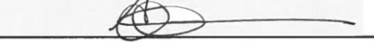

CPCCBC6014
Apply structural principles to the construction of large, high-rise and complex buildings

THEORY EXAM

Participant name | Alan Leeder

FOR THE PARTICIPANT
Instructions
- You will complete written questions as outlined on the following pages. You must attempt all questions and provide enough detail in your responses to demonstrate your knowledge.
- It is anticipated that you should complete this assessment within two (2) hours, but additional time may be allowed upon negotiation with the Assessor.
- You must complete all questions unassisted by the Assessor or other personnel but may refer to reference material as needed. All questions must be answered correctly for a ‘Satisfactory’ assessment outcome to be awarded.
  - An oral examination may be allowed under certain circumstances, whereby your answers will be documented by another party.
  - Any written questions that are incomplete, or not answered satisfactorily will need to be completed again after further training support.
    - If you answer a question incorrectly but modify your response, put your initials next to the written change (or the Assessor must initial a verbal change).
Resources required
Pen

FOR THE ASSESSOR
Instructions
- Where oral examination has occurred, ensure that this is acknowledged in writing (e.g. FT001 and Assessor Comments)
- All questions must be satisfactorily demonstrated by the Participant for a Satisfactory determination (indicated by an Assessor tick to the right of the question).
- Assessors are to complete marking in pen of a different colour to the Participant.
- If the Participant verbally modifies their response, write in the modified response verbatim and put your initials next to the written change.

ASSESSOR COMMENTS
As necessary, outline:
- Details on reattempts, alternative arrangements or reasonable adjustments made.
- Where a Participant is deemed ‘Not Satisfactory’, provide recommendations for future training.

- a) What is the Building Act 1975 relevance in Queensland?
b) Who is affected by the Building Act 1975?

Answer  a)  b) | 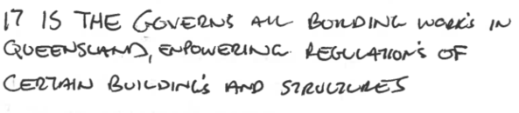
Answer  a)  b) | 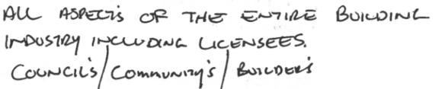

- Discuss the basic principles of structural design and how stress or strain occurs.

Answer | 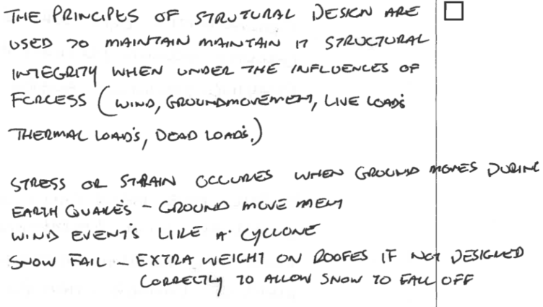

- Discuss the impact the following forces can impose on a building structure.

Answer | Force | Impact
 | Wind | 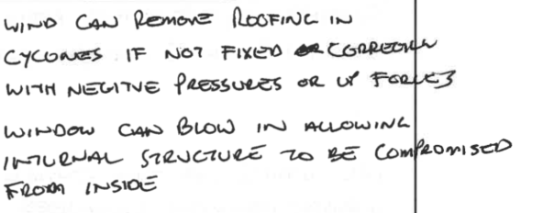
 | Snow | 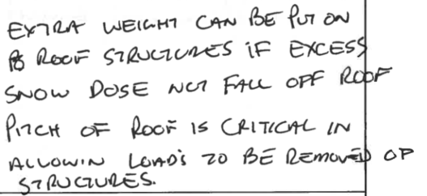
 | Groundwater | 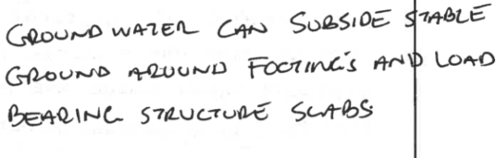
 | Earthquake | 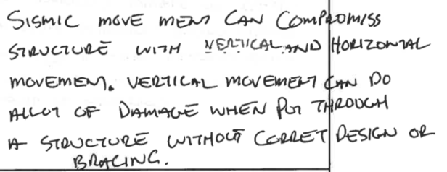
 | Question continued over page
Answer | Force | Impact
 | Liquid pressure | 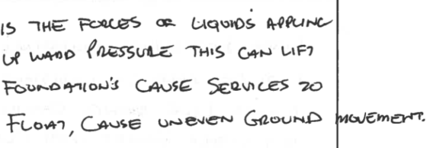
 | Rainwater | 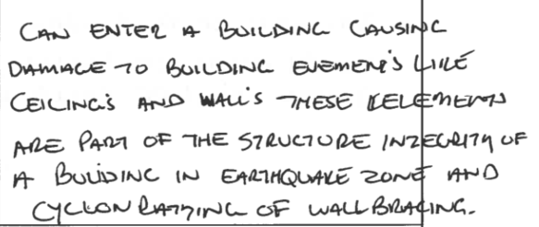
 | Earth pressure actions | 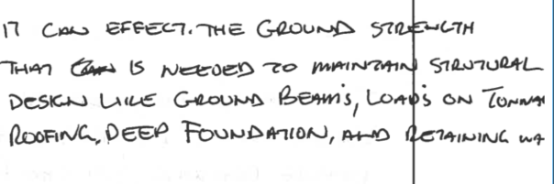

- Discuss the basic principles of structural design that must be considered in any building design.

Answer | 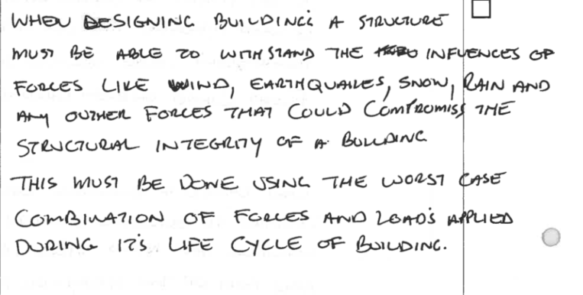

- Discuss compressive and tensile stresses on buildings.

Answer | 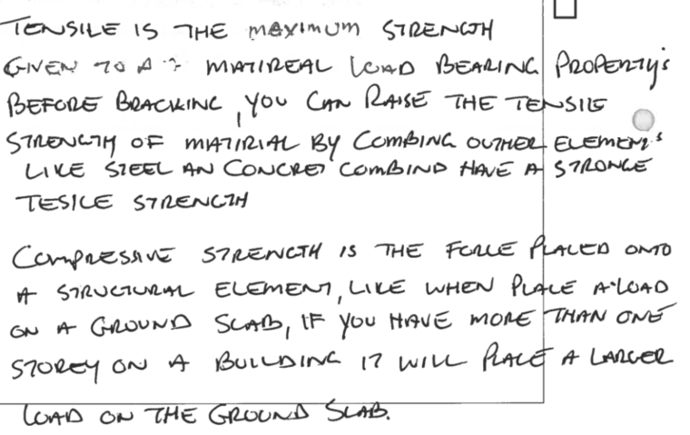

- Discuss the structural significance of building basements in tall buildings.

Answer | 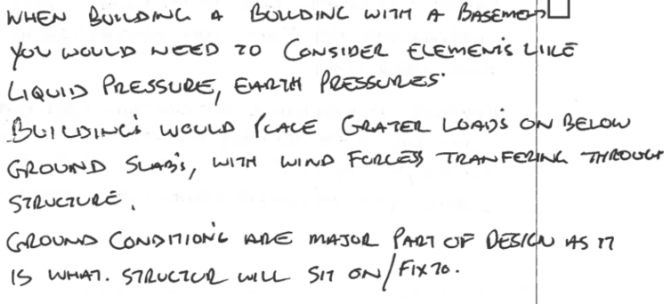

- What is meant by the term the ‘aesthetics’ of a structural design?

Answer | 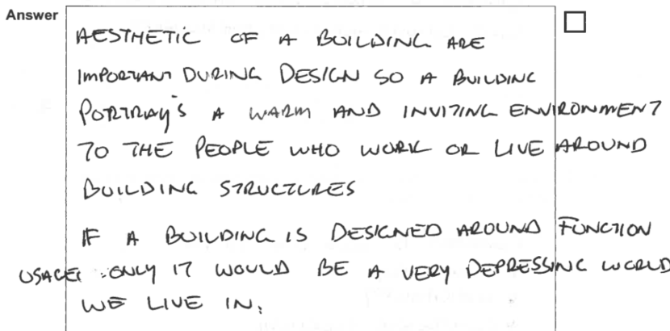

- Explain economic factors and how these affect design.

Answer | 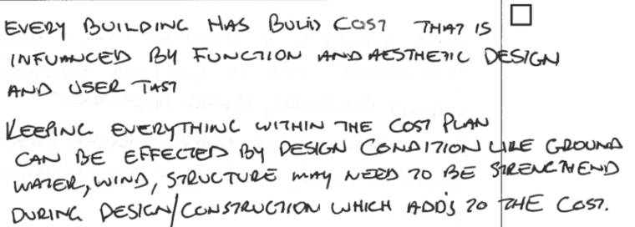

- ‘The function of a structure is to resist forces in equilibrium’ - What does this mean?

Answer | 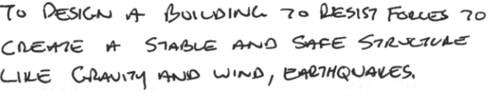

- Explain why reinforced concrete is commonly used for the construction of high-rise buildings.

Answer | 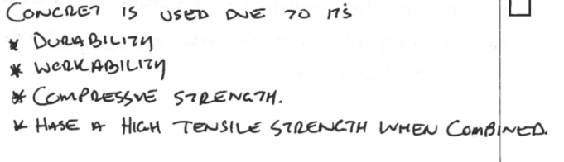

- Why might you need to consult the structural engineer regarding the loads and forces acting on a beam or column?

Answer | 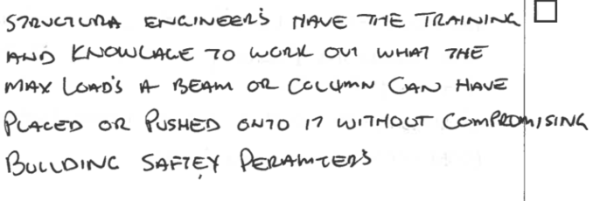

- Determine the bending behaviour of a column under axial load.

Answer | 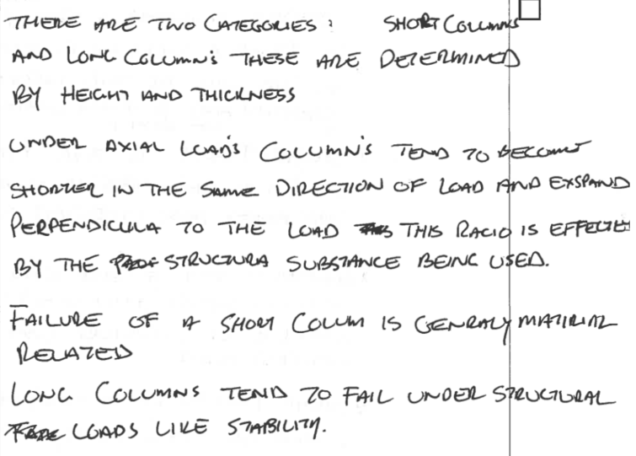

- What is the performance characteristic of columns under eccentric load?

Answer | 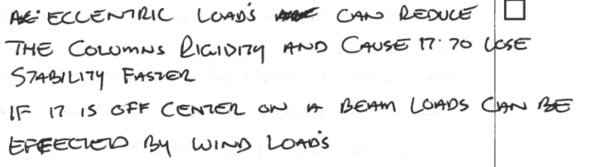

- Discuss bending moments, shear forces, deflection and torsion of beams and slabs.

Answer | Beams/Slabs | Response
 | Beams | 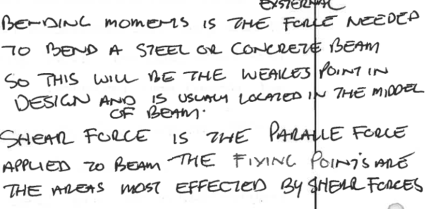
 | Slabs | 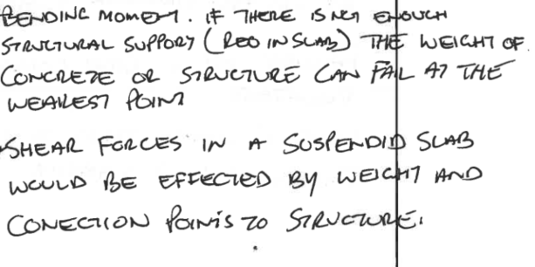

- Discuss how beams are connected to columns. Explain your answer.

Answer | 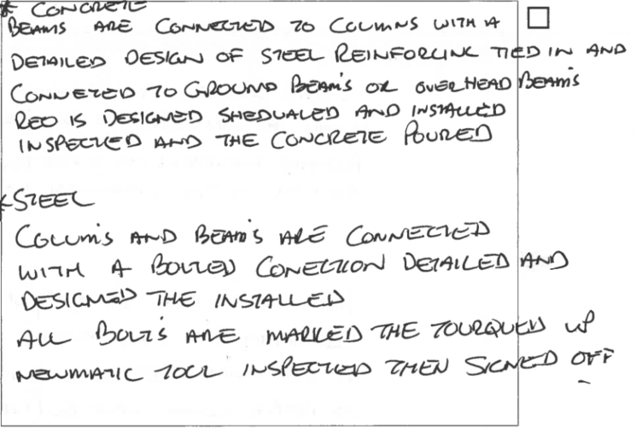

- Describe the slenderness ratio and its effect on columns.

Answer | 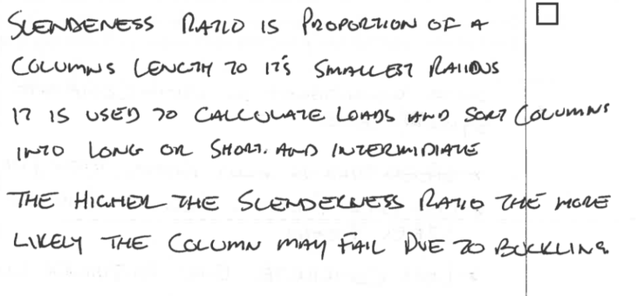

- Discuss the characteristics of dead loads and live loads. Include how each is calculated.

Answer | Load | Characteristics and calculations
 | Dead load | 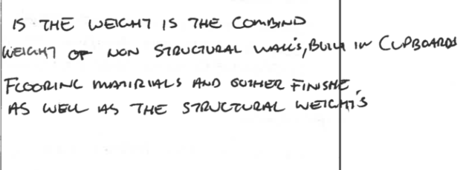
 | Live load | 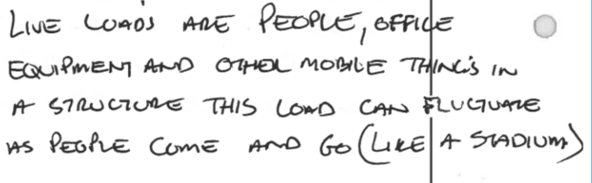

- Discuss the advantages of using composite floor systems consisting of steel beams, profiled metal decking, and reinforced concrete slabs.

Answer | 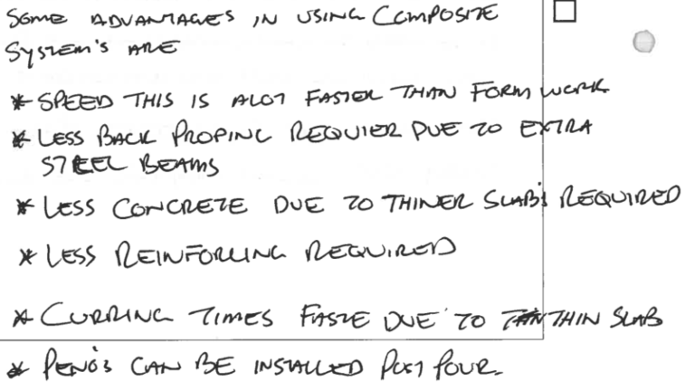

- Discuss the characteristics of the following high performance structural elements.

Answer | Structural element | Characteristics
 | Castellated beams | 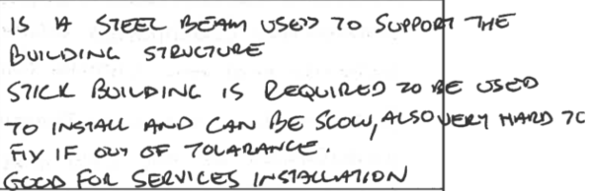
 | Laminated beams | 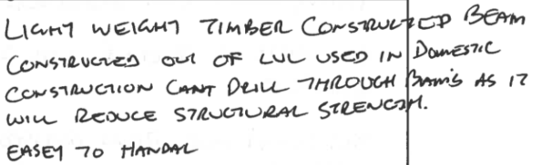
 | Pre-stressed concrete beams | 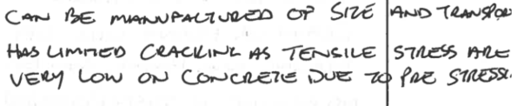
 | Trusses | 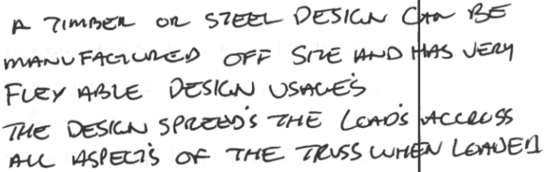
 | Waffle slabs | 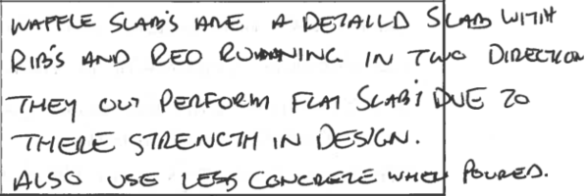

- Describe the process associated with fabricating and installing tilt-up concrete panels.

Answer | 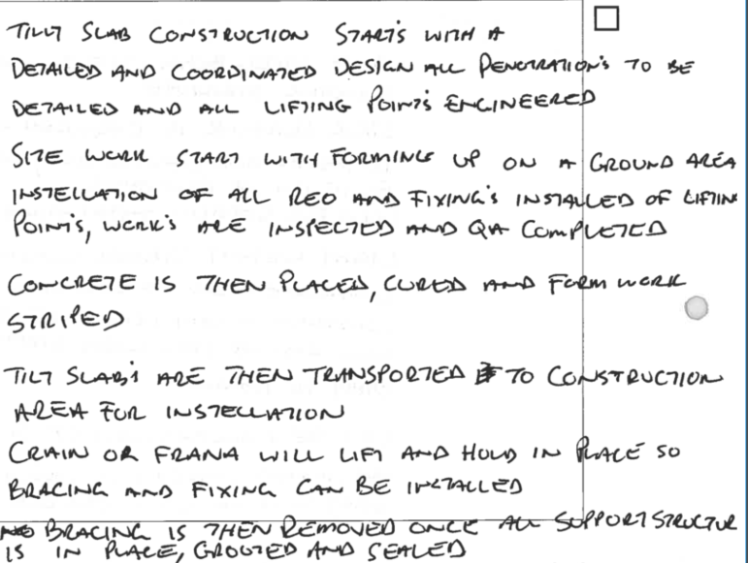

- Discuss considerations that must be made when using masonry in the construction of high-rise buildings.

Answer | 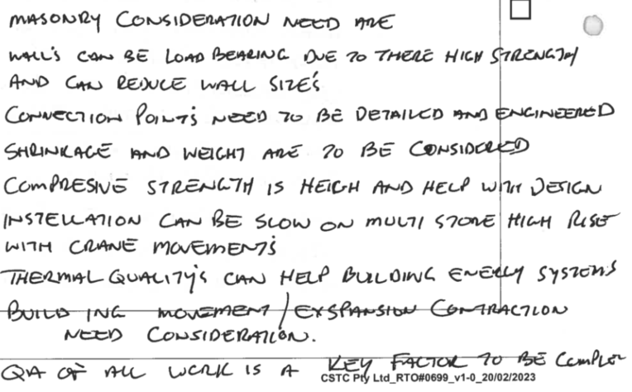

- Discuss what must be organised as part of the site assessment to ensure the soil in the site can support the construction loads.

Answer | 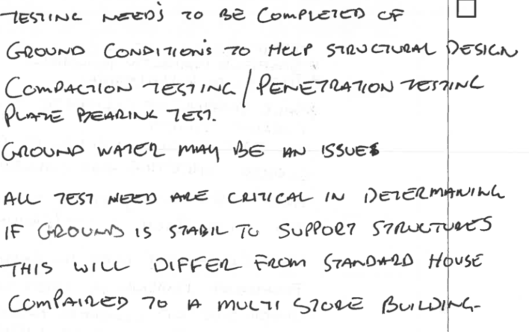

- What are the requirements relating to retaining walls over 1m in height according to the NCC and the Building Regulations 2006 (Qld)?

Answer | 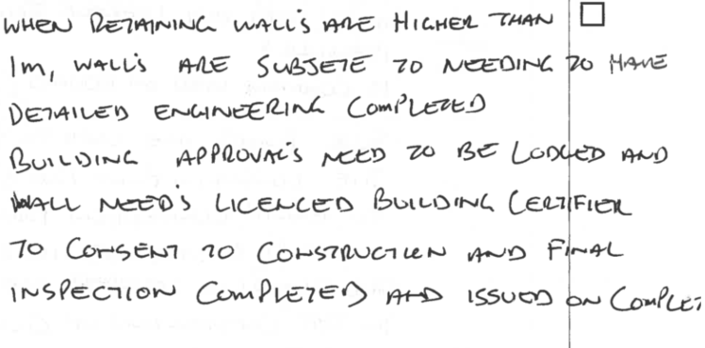

- Discuss the use of the following temporary structures and components in the construction of large and complex buildings.

Answer | Temporary structure | Use
 | Bracing | 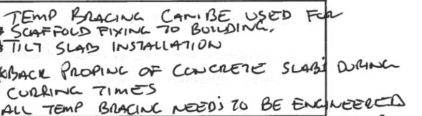
 | Closed Sheeting | 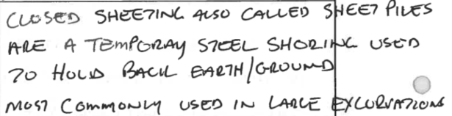
 | Formwork props | 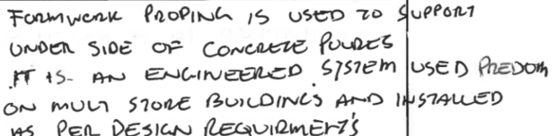
 | Pressure resistant formwork | 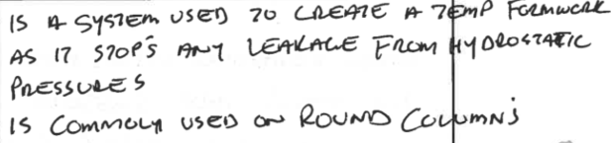
 | Scaffolding sole plates | 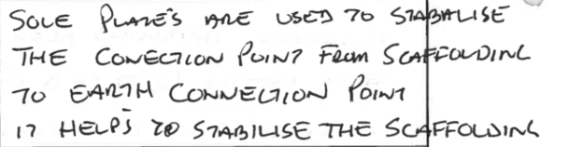
 | Shields | 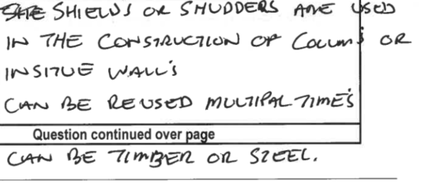
 | Question continued over page
Answer | Temporary structure | Use
 | Shoring collar set | 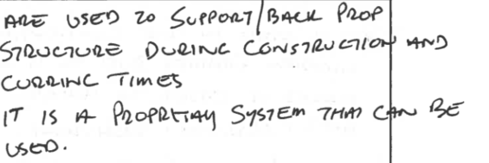
 | Soldier set | 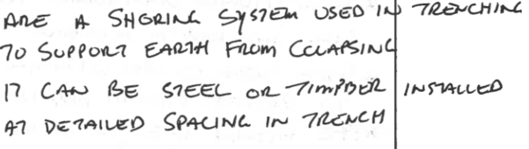
 | Ties | 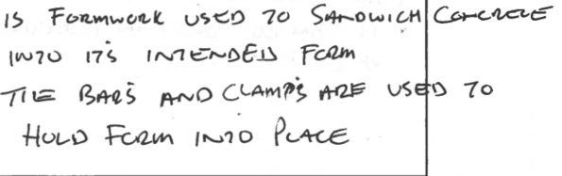

- Explain the differences between structural steel and cold-formed steel.

Answer | 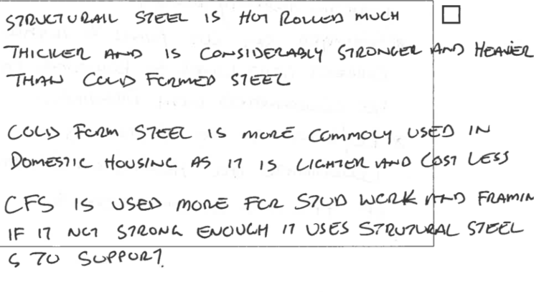

- Discuss three (3) uses of aluminium in the construction industry and why it is used.

Answer  1.  2.  3. | 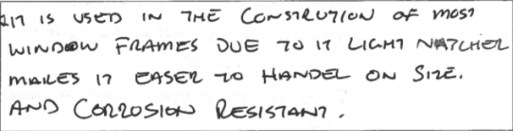
Answer  1.  2.  3. | 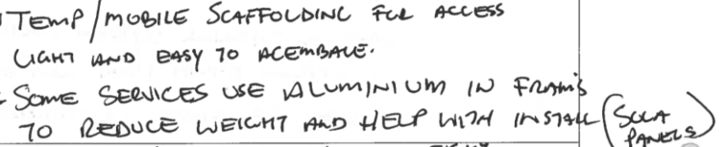
Answer  1.  2.  3. | 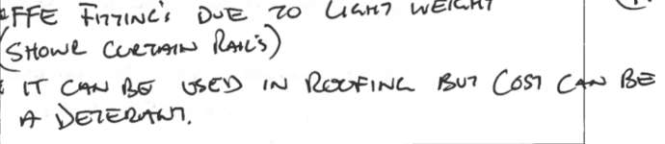

- Explain what is involved when coordinating the set-out of the building.

Answer | 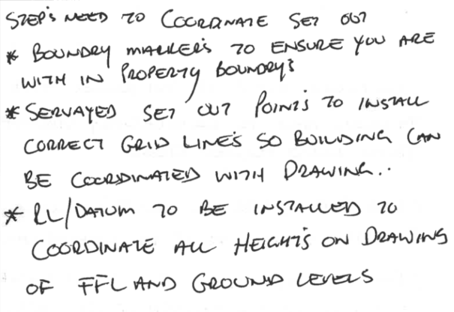

- What different items should you assess in the building plan before laying footings? Explain your answer.

Answer | 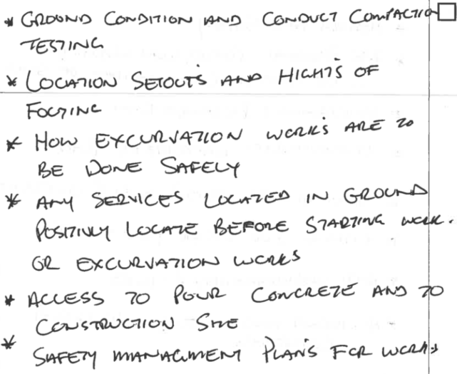

- How do you ensure allowances have been made for plumbing, electrical conduits and other services to be installed?

Answer | 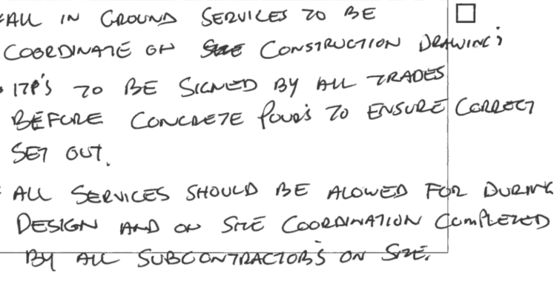

- Outline workplace policies and procedures that should be held in the site office.

Answer | 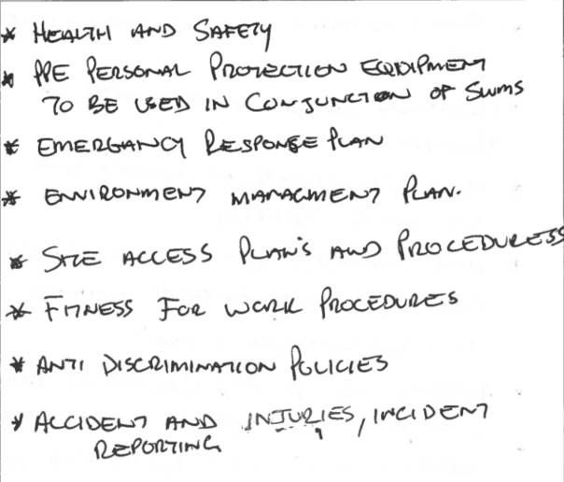

CPCCBC6014
Apply structural principles to the construction of large, high-rise and complex buildings

WORKBOOK

Participant name

FOR THE PARTICIPANT
Instructions
- You will complete written activities as outlined on the following pages. You must attempt all questions and provide enough detail in your responses to demonstrate your knowledge.
- The timeframe for these tasks will be established by your Assessor or Training Plan, but additional time may be allowed upon negotiation with the Assessor.
- You must complete all questions unassisted by the Assessor or other personnel but may refer to reference material as needed. All questions must be answered correctly for a ‘Satisfactory’ assessment outcome to be awarded.
  - An oral examination may be allowed under certain circumstances, whereby your answers will be documented by another party.
  - Any written questions that are incomplete, or not answered satisfactorily will need to be completed again after further training support.
    - If you answer a question incorrectly but modify your response, put your initials next to the written change (or the Assessor must initial a verbal change).
Resources required
Pen

FOR THE ASSESSOR
Instructions
- Where oral examination has occurred, ensure that this is acknowledged in writing (e.g. FT001 and Assessor Comments)
- All questions must be satisfactorily demonstrated by the Participant for a Satisfactory determination (indicated by an Assessor tick to the right of the question).
- Assessors are to complete marking in pen of a different colour to the Participant.
- If the Participant verbally modifies their response, write in the modified response verbatim and put your initials next to the written change.

ASSESSOR COMMENTS
As necessary, outline:
- Details on reattempts, alternative arrangements or reasonable adjustments made.
- Where a Participant is deemed ‘Not Satisfactory’, provide recommendations for future training.

NOTE

At times, you will be provided with a specific business context to which you must respond, otherwise it is anticipated that you will use a workplace of your choosing (your own, or hypothetical) to provide the context to the task.

At all times, the responses in your assessment must reference Australian (Queensland or Federal) documentation, including legislation, regulations, codes of practice, standards and guidance publications.

The following activities require access to the internet.

Access the Queensland Building and Construction Commission and clearly describe its purpose and its relationship to the National Construction Code (NCC).

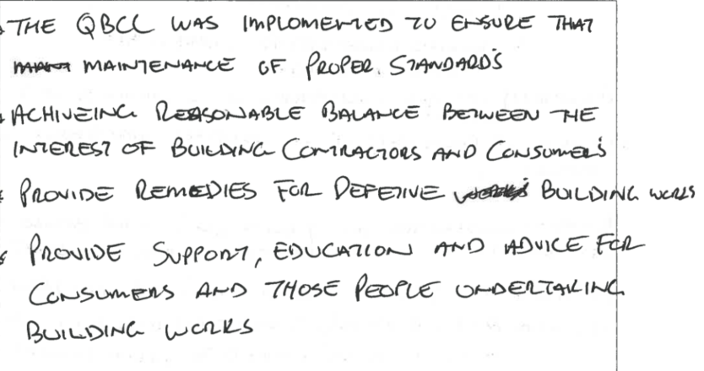

Satisfactory Outcome

Access the National Construction Code (NCC) Volume Two Amendment 1 – Part 3.0 Structural provisions and discuss what the following points explain.
a) 3.0.2 Resistance to actions
b) Construction in cyclonic areas

a) Resistance to actions
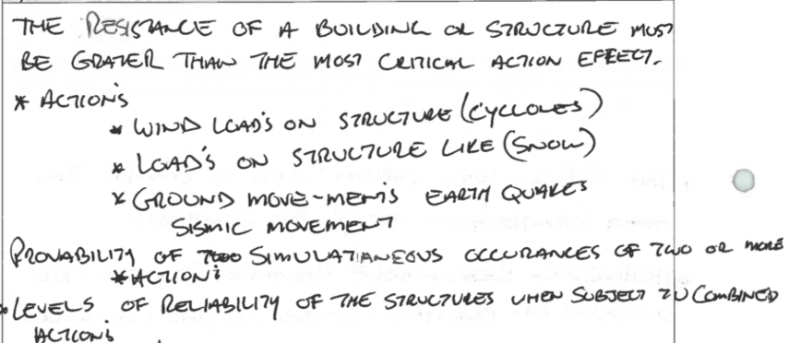
b) Construction in cyclonic areas
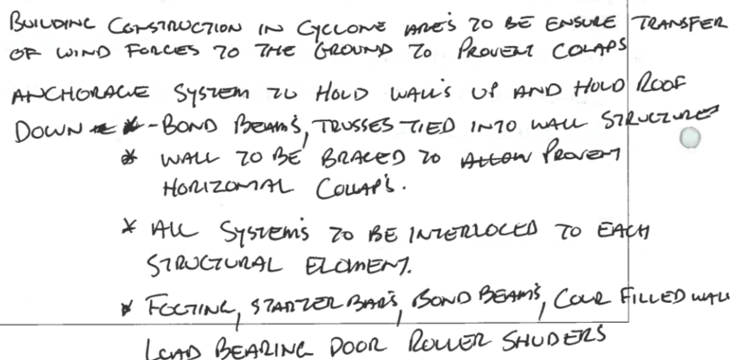

Satisfactory Outcome

Access the NCC via the internet to locate the requirements applicable to a building development in the Brisbane area, containing 6 sole-occupancy units, two (2) on each level, each being a separate dwelling.
This building includes one (1) basement level designated for car parking.
The proposed building structure requires reinforced concrete floors and columns.
Document your findings or where in the NCC the information can be located.

Building Description
Classification
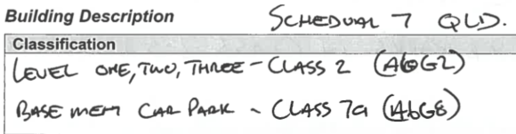

Rise in Storeys
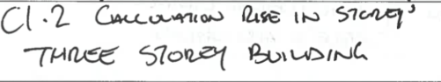
Number of Storeys
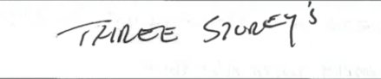
Type of construction
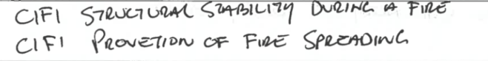
Climate Zone and description
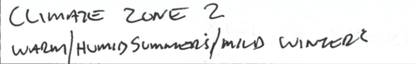
Fire resistance and stability
Locate fire resistance information
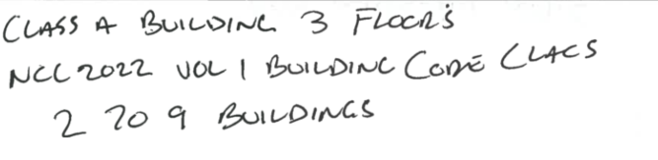
Compartmentation and fire separation
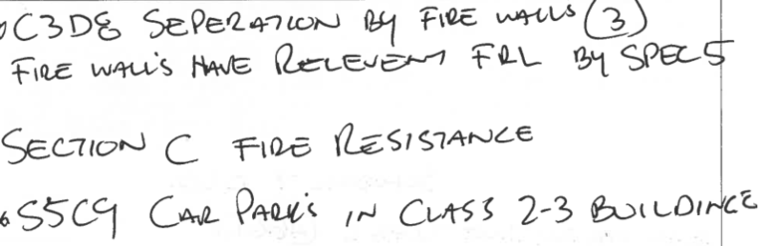

Fire hazard properties of materials, assemblies, fixtures and linings
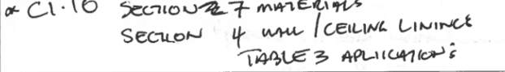
Material requirements
Reinforced concrete requirements relative to Australian Standards
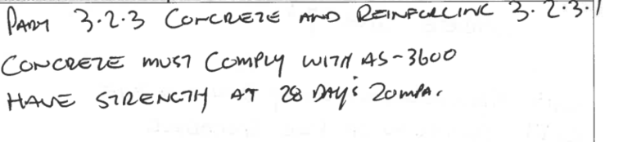
Glazing requirements specifically for windows, sliding doors with frames and balconies.
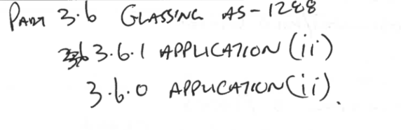

Satisfactory Outcome

Research the Euler–Bernoulli beam theory and respond to the questions below.
- What is the Euler-Bernoulli beam theory?
- Provide a Euler-Bernoulli equation.
- What is the Euler-Bernoulli theory (EBT) generally used for?

a) What is the Euler–Bernoulli beam theory?
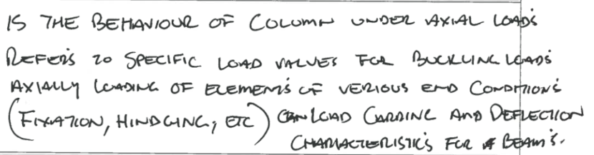
b) Provide a Euler–Bernoulli equation
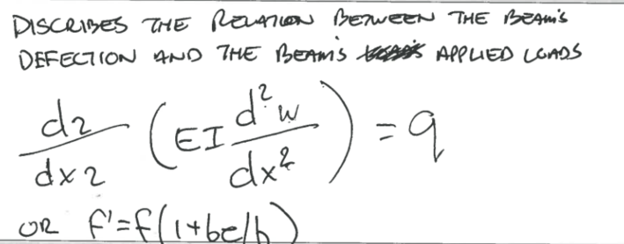
c) What is the Euler-Bernoulli beam theory (EBT) generally used for?
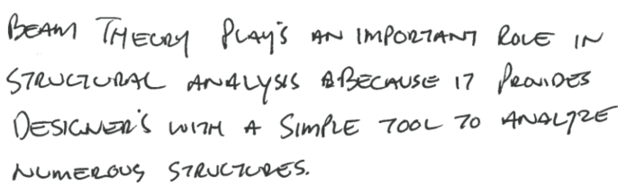

Satisfactory Outcome

CPCCBC6014
Apply structural principles to the construction of large, high-rise and complex buildings

PRACTICAL ASSESSMENT

Participant name | Alan Leeder

FOR THE PARTICIPANT
Instructions
- The tasks outlined on the following pages will require performance of normal workplace activities, as a result of a structured activity set by an Observer in the workplace or a simulated activity set by your Assessor/Observer.
- The timeframe for these tasks will be established by your Assessor/Observer, in consideration of location conditions and industry requirements.
- You must complete all tasks unassisted by the Assessor or other personnel, unless the steps note this assistance.
- You must attempt all tasks (and itemised steps) for a ‘Satisfactory’ assessment outcome to be awarded.
  - For any observation conducted that is incomplete, or without satisfactory performance, the observation will need to be completed again after further training support.

FOR THE ASSESSOR/OBSERVER
Instructions
- The following observation record should be used to judge and record your observations of the Participant as they complete the task(s) set. You must record your observations of the Participant’s performance.
  - For each occasion, indicate the task performed and whether it was a simulation or workplace-based task.
    - Any simulated assessment must ensure the Participant still performs under workplace conditions which reflect industry standards.
  - In the comments, provide clear detail regarding the task that the Participant was required to do (e.g. PPE used, materials handled, attachments connected, plant types).
- All steps must be satisfactorily demonstrated by the Participant for a ‘Satisfactory’ determination (indicated by an Assessor tick to the right of each itemised step, or an Observer tick to the right of each itemised step, and confirmation by an Assessor in the Assessor Comments).
  - Where you have determined that one or more task steps have not been satisfactorily demonstrated, provide the Participant with additional support and outline details of such assistance in the Assessor/Observer Comments. Allow the Participant two (2) further opportunities to demonstrate the task again to allow an opportunity for a ‘Satisfactory’ assessment outcome to be achieved.
  - If after three (3) attempts the Assessor determines that the Participant cannot demonstrate the required steps, a ‘Not Satisfactory’ outcome is to be determined.

TASK OUTCOME
Task | Date | Task Type (Tick) | Location | Task outcome (Tick)
 |  |  |  | Satisfactory | Not Satisfactory
Task 1 | 7/08/2024 | Workplace  Simulation

ASSESSOR COMMENTS: GENERAL
As necessary, outline:
- Details on reattempts, alternative arrangements or reasonable adjustments made.
- Where a Participant is deemed ‘Not Satisfactory’, provide recommendations for future training.

ASSESSOR COMMENTS: PRACTICAL TASK 1
Individual student (as named on cover page)
Multiple students [ All from Attendance Report, Specific students involved – identify students]
Task | Provide detail
1.2B. | Specify retaining walls applied to planning process:
1.2C. | Specify temporary structural elements added to planning process:
1.2D. 1.5A. 1.5B. | Specify digital tools/devices used to communicate and collaborate with professionals, suppliers, HR and others:
1.2E. | Specify equipment used to access and extract information:
1.3A. | Specify set-out coordinated:
1.3B. 1.3C. | Specify footing laid:
1.3D. | Specify damp coursing and termite barriers installed:
1.4A. 1.4B. 1.4C. 1.5B. | Specify how processes and construction elements were checked for compliance with manufacturer specifications and relevant Australian Standards and codes.
1.5D. 1.5E. 1.5F. 1.5G. 1.5H. 1.5I. 1.5K. | Specify how the effect of force and movement were assessed against structural material properties and design.
1.5L. | Specify faults identified and action undertaken:

CPCCBC6014
Apply structural principles to the construction of large, high-rise and complex buildings

Practical Task 1
Description of task:
The participant must demonstrate the skill and ability to take responsibility for ensuring the structural integrity of materials and building and construction work for a large, high-rise, or complex building project so that site safety and quality control measures are maintained including:
- Apply structural principles to the planning of a construction project.
  - Determine structural principles applicable to the construction of the large, high-rise or complex structure.
  - Document the performance characteristics required of structural elements of the project.
  - Document performance of materials in the building plan as part of the schedule and requirements.
- Coordinate and manage the site assessment and job set-up.
  - Organise site and soil assessment.
  - Confirm and schedule the instalment of retaining walls to meet legislated requirements.
  - Determine and schedule the requirements for temporary structural elements.
  - Use digital tools and devices to communicate and collaborate effectively with others.
  - Use equipment and programs to access, extract information and develop relevant documentation.
- Coordinate and manage construction of footing systems.
  - Coordinate the set-out of the building in accordance with documented building plans, following the full assessment of the site.
  - Assess structural performance of the footings specified in the building plan for compliance with relevant codes and accepted industry construction structural principles.
  - Lay footings, as specified in the building plan, and check for compliance with standards and accepted industry construction principles.
  - Plan, implement and check damp coursing and the provision of termite barriers and other relevant techniques in accordance with codes, standards and industry practice.
- Coordinate and manage structural elements of the construction process.
  - Identify and analyse technical construction principles and performance characteristics of construction materials in the planning of project.
  - Determine, schedule and check processes for construction of all structural elements for compliance with manufacturer specifications and relevant Australian Standards and codes.
  - Confirm building plans and relevant standards and schedule appropriate allowances for plumbing, electrical conduits and other services to be installed.
- Analyse and plan for structural integrity of buildings.
  - Consult and coordinate professional input to evaluate structural integrity of large and complex buildings.
  - Consult effectively with professionals, using relevant industry terminology and concepts.
  - Assess structural requirements and loads of the building design.
  - Analyse the effects of force and movements on structural elements.
  - Analyse properties and behaviours of structural materials.
  - Analyse section properties of structural elements using standard industry formulas and performance comparisons.
  - Evaluate performance characteristics of columns using standard industry techniques.
  - Assess methods used for stress distribution in connections between structural elements.
  - Assess impact of various loads on the building structure.
  - Consider design impact of high-performance structural elements.
  - Select, position and size all structural members that form fixed or temporary building structures.
  - Identify typical faults and problems and the action required to rectify such faults.

These tasks may be simulated or real. The Participant is to gather evidence of how they have completed each component of the Practical Task, which is to be submitted with this Practical Assessment sheet. The Observer is to provide detailed comments on the tasks completed by the Participant (on the Observer Comments, overleaf). The Assessor is to verify the Observer’s comments, noting their findings in the Assessor Comments (on the back of the Practical Assessment cover page) and provide the assessment outcome.
Resources required:
Access to: relevant current government building and construction and WHS legislation; The NCC, and other relevant industry and Australian codes and standards; environmental requirements and sustainability principles; Manufacturer’s materials and product ``s and installation instructions for building materials in the project specifications; Project plans, design brief, working drawings and specifications.
Observer details
Name of observer: | Aidan Ahearn
Role of observer  (Confirm suitability to sign) | Medium Rise Building/Site Supervisor Commercial Projects
Email address of observer | Aidan107@hotmail.com
Signature of observer: | 
Date: | 7/08/2024

When completing the task, did the Participant: | Tick if satisfactorily completed.  Provide comments if left unticked.
1 Apply structural principles to the planning of a construction project
- Determine structural principles applicable to the construction of the large, high-rise or complex structure
- Document the performance characteristics required of structural elements of the project. (attach copy or screenshot)
- Document performance of materials in the building plan as part of the schedule and requirements. (attach copy or screenshot)
2 Coordinate and manage the site assessment and job set-up.
- Organise site and soil assessment.(attach copy)
- Confirm and schedule the instalment of retaining walls to meet legislated requirements.
- Determine and schedule the requirements for temporary structural elements.
- Use digital tools and devices to communicate and collaborate effectively with others
- Use equipment and programs to access, extract information and develop relevant documentation
3 Coordinate and manage construction of footing systems.
- Coordinate the set-out of the building in accordance with documented building plans, following the full assessment of the site.
- Assess structural performance of the footings specified in the building plan for compliance with relevant codes and accepted industry construction structural principles.
- Lay footings, as specified in the building plan, and check for compliance with standards and accepted industry construction principles.
- Plan, implement and check damp coursing and the provision of termite barriers and other relevant techniques in accordance with codes, standards and industry practice.
4 Coordinate and manage structural elements of the construction process
- Identify and analyse technical construction principles and performance characteristics of construction materials in the planning of project.
- Determine, schedule and check processes for construction of all structural elements for compliance with manufacturer specifications and relevant Australian Standards and codes.
- Confirm building plans and relevant standards and schedule appropriate allowances for plumbing, electrical conduits and other services to be installed.
5. Analyse and plan for structural integrity of buildings
- Consult and coordinate professional input to evaluate structural integrity of large and complex buildings
- Consult effectively with industry professionals, and use relevant industry terminology and concepts
- Assess structural requirements and loads of the building design.
- Analyse the effects of force and movements on structural elements.
- Analyse properties and behaviours of structural materials.
- Analyse section properties of structural elements using standard industry formulas and performance comparisons.
- Evaluate performance characteristics of columns using standard industry techniques.
- Assess methods used for stress distribution in connections between structural elements.
- Assess impact of various loads on the building structure.
- Consider design impact of high-performance structural elements.
- Select, position and size all structural members that form fixed or temporary building structures
- Identify typical faults and problems and the action required to rectify such faults.

Observer comments:
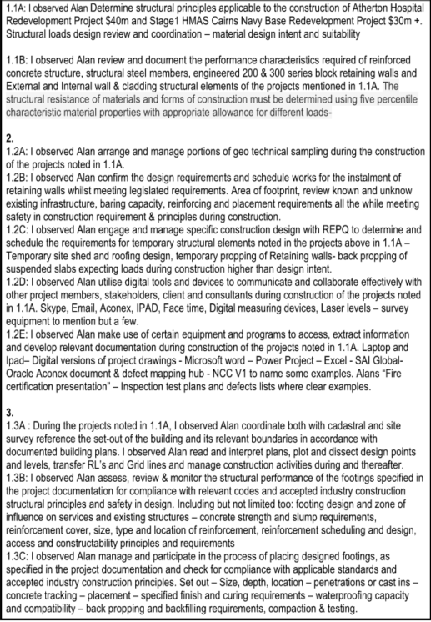
Atherton Hosptial documentation

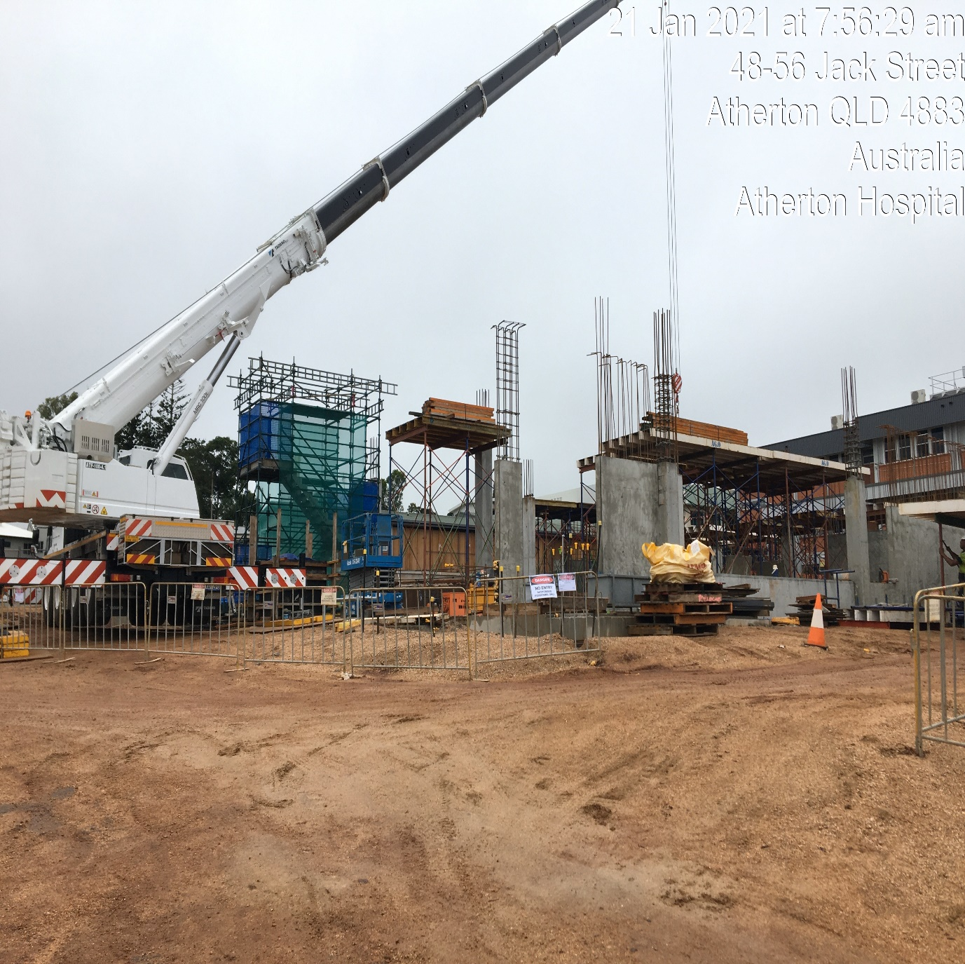

HMAS Cairns Documetation


