BSBPMG512
Manage project time
ASSESSMENT SUMMARY

The assessment activities for BSBPMG512 Manage project time cover all aspects of the unit of competency required. To demonstrate competence in this unit, a participant must undertake all tasks and complete them satisfactorily and consistently. For Apprentices and Trainees, this includes employer completion of the Employer Record Book (ERB).

Participants must read all the information given before starting any assessment task. The assessment tasks are intended to be equitable, fair and flexible. If a participant has any questions or requires alternative arrangements to be made such requests should be directed to their Trainer/Assessor, who should note such arrangements in the ‘Assessor Comments’ on the affected assessment. If a participant feels they are not yet ready to be assessed, they should discuss their options with their Trainer/Assessor.

To satisfactorily complete the assessment, the participant is required to answer all questions correctly and demonstrate their skills to industry standards. If a participant does not answer some questions or perform some tasks, they will be deemed ‘Not Satisfactory’ for the task and ‘Not Yet Competent’ for the unit of competency. The Trainer/Assessor is able to provide the participant with additional information on interpreting the assessment outcomes and provide guidance on the participant’s options. Should a participant still be deemed ‘Not Satisfactory’ they will have the opportunity to undertake a supplementary assessment or appeal the result.

By signing the cover page for each assessment item, the participant acknowledges they understand the assessment instructions and requirements and consent to being assessed. The participant also verifies and assures the RTO that the work submitted is their own work.

Participant Name | Ben Dudman

Task | Assessment Results
Theory Exam | Satisfactory | Not Yet Satisfactory
Practical Assessment | Satisfactory | Not Yet Satisfactory
Outcome for Unit of Competency | Competent | Not Yet Competent

Assessor Name
Assessor Signature | 
Unit Competence Determination Date | Click here to enter a date.

BSBPMG512
Manage project time

THEORY EXAM INSTRUCTIONS

- This exam will occur under standard assessment conditions.
  - An oral examination may be allowed under certain circumstances, whereby the Participant’s answers will be documented by a party other than the Participant. This must be acknowledged in writing (e.g. FT001 and Assessor Comments)
- Participants must provide enough detail in their responses to demonstrate their knowledge and skills.
- Please fill in the details below, providing your name, signature and date of assessment.
  - Your signature acknowledges that this is your own work.
- Assessors are to complete marking in pen of a different colour to the Participant.
- If a Participant initially answers a question incorrectly but modifies their response, they must follow the instructions below:
  - If a Participant changes their response in writing, they must put their initials next to the written change.
  - If a Participant changes their response verbally, this must be noted on the exam paper by the assessor.

Participant name | Ben Dudman
Participant signature
Date | Click here to enter a date.

Assessor name
Assessor signature
Date | Click here to enter a date.

Number of questions | Number of questions answered correctly | Task outcome (Tick)
27 |  | Satisfactory | Not Yet Satisfactory

ASSESSOR Comments
- Explain the purpose of a Work Breakdown Structure.

Answer | The Work Breakdown Structure divides the project deliverables into smaller manageable levels.

- Define the term ‘work package’.

Answer | A Work Package is the smallest unit a project deliverable can be broken down to.

- Explain the relationship between a work package and an activity.

Answer | A work package is comprised of a sequence of activities that culminates into a deliverable.

- Define the term ‘sequence activities’ as it relates to project management.

Answer | Activity Sequencing involves identifying and documenting the relationships between project activities.

- Draw a diagram of a work breakdown structure.

Answer

- Explain the meaning of the term ‘effort’ in project scheduling.

Answer | The term effort refers to the duration of labour required to complete a scheduled activity. This is measured in hours, days or weeks.

- Discuss why it is important to estimate your available resources when estimating the durations of activities.

Answer | It is important to estimate the availability of resources for a project as this will have a large impact on the duration of activities. Work may be able to be done quicker with more resources or may be delayed unnecessarily if resources are available at critical points of the project. It is also important to consider that some resources will be able to complete work faster than others, depending on experience and a range of other factors.

- Explain each of the following terms.

Answer | Term | Explanation
 | Analogous estimating | Estimating task duration based on past experience with similar activities.
 | Parametric estimating | Estimating task duration based previously achieved rates (i.e. meters of pipe laid day or m2 of turf per day)
 | Bottom-up estimating | Estimating the duration of each activity associated with a works package or deliverable and determining the predicted duration by adding these together.

- Explain the meaning of each of the following precedence diagramming methods and draw a diagram to illustrate each.

Answer | Type | Explanation | Diagram
 | Finish-to-start (FS) | The activity cannot start until the preceding activity has finished. | 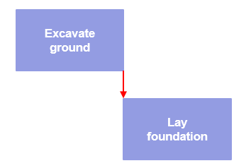
 | Finish-to-finish (FF) | The activity cannot finish before the preceding activity has finished. | 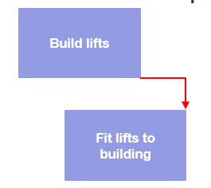
 | Start-to-start (SS) | The activity cannot start before the preceding activity starts. | 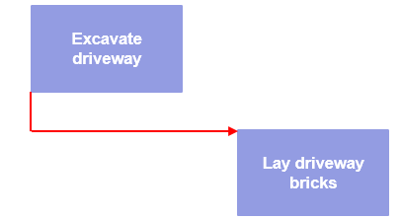
 | Start-to-finish (SF) | The activity cannot finish until the subsequent activity starts. | 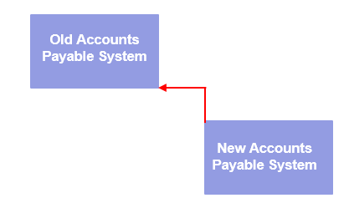

- Explain what is meant by a critical path in project management.

Answer | Critical path is the longest path in a schedule of project activities and represents the minimum time the schedule can take to complete.

- Which of the paths in the chart below is the critical path?
Tick your response. Note: The numbers shown below represent days.

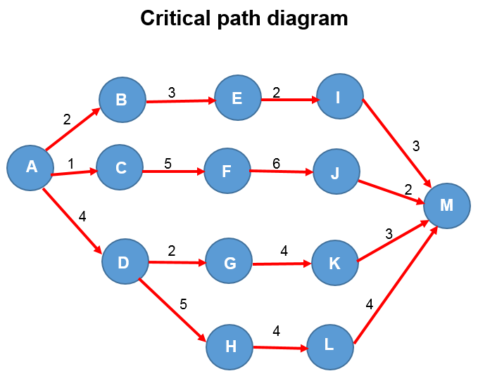

Answer | Choice | Possible Answers
 |  | A-B-E-I-M
 |  | A-C-F-J-M
 |  | A-D-G-K-M
 |  | A-D-H-L-M

- You are working on a project where you estimate the following:
- Your expected project duration is 8 days
- Your optimistic project duration is 7 days
- Your pessimistic project duration is 15 days
Calculate each of the following estimates to the nearest day.

Answer |  | Estimated duration
 | Three point estimate | 10 days
 | PERT estimate | 9 days

- When does the process of schedule control end for a project?
Tick your response.

Answer | Choice | Possible Answers
 |  | When the schedule baseline has been approved
 |  | When the project has ended
 |  | At the end of a major project milestone
 |  | When work on the project has started
 |  | When the project is forecast to finish on time

Please refer to the following information to respond to Q14. Q15. Q16. and Q17.

A project has the following activities with the following durations:

Activity Duration in days
A 1
B 2
C 4
D 2
E 1

The project also has the following activity dependencies:
    - A and B can be done in parallel
    - A must finish before C can start
    - B must finish before D can start
    - Both C and D must finish before E can start

- Draw a Gantt chart for the project. You may either use the template below, or insert an image on the following page.

Answer
  Day 10
  Day 9
  Day 8
  Day 7
  Day 6
  Day 5
  Day 4
  Day 3
  Day 2
  Day 1
  Task | A | B | C | D | E
Answer

- Detail activities on the critical path in the order in which they are performed.

Answer | A-C-E

- Will the project’s scope baseline be affected if Activity B is completed one day late but the other activities are completed on schedule?
Fully explain the reason for your answer.

Answer | If Activity B is completed one day late, Activity D will be pushed back by one day. This will not affect the scope baseline as these activities are not on the critical path.

- Will the project’s scope baseline be affected if Activity C is completed one day late but the other activities are completed on schedule?
Fully explain the reason for your answer.

Answer | If Activity C is completed one day late, the project’s scope baseline will be delayed by one day. This is because Activity C is on the critical path and any changes to this path will have a direct impact on project completion date.

- List five (5) advantages of a Gantt chart.

Answer | Advantage | Description
 | 1 | Easy to schedule tasks
 | 2 | Easy to understand
 | 3 | Dates are clear
 | 4 | Relationships are clear
 | 5 | Can be used for tracking performance against baseline

- List three (3) disadvantages of a Gantt chart.

Answer | Disadvantage | Description
 | 1 | Can take a lot of time if regular updates are required.
 | 2 | Can become very complex on large projects.
 | 3 | Each bar shows the time required for an activity but not how much work is needed to complete the task.

- Explain the meaning of ‘variance analysis’.

Answer | Variance analysis is the comparison of actual schedule performance against the schedule baseline.

- In project schedule control, variance analysis measures which of the following? Tick your response.

Answer | Choice | Possible Answers
 |  | Scope performance with schedule baseline
 |  | Schedule performance with project baseline
 |  | Schedule performance with schedule baseline
 |  | Schedule performance with project schedule
 |  | Schedule performance with milestone performance

- Trend analysis is used for which of the following scheduling purposes? Tick your response.

Answer | Choice | Possible Answers
 |  | Measuring whether our project is on schedule or not
 |  | Forecasting the future project schedule performance
 |  | Determining which project activities are behind schedule
 |  | To determine if a project activity is outside of a variance threshold.

- A project schedule can only be changed by which of the following?
Tick your response.

Answer | Choice | Possible Answers
 |  | The project manager
 |  | The project foreman
 |  | By notifying the project sponsor
 |  | By raising a change request
 |  | By any member of the project team

- Explain the purpose of using schedule compression in project management.

Answer | Schedule compression allows a project which has experienced delays to bring the actual schedule performance back to the schedule baseline.

- Discuss what is meant by ‘fast tracking’ in project management.

Answer | Fast tracking is a strategy used to compress a schedule. It involves saving time by performing tasks in parallel which are normally performed in sequence.

- Draw a diagram that shows how fast tracking can save time on a project.

Answer | 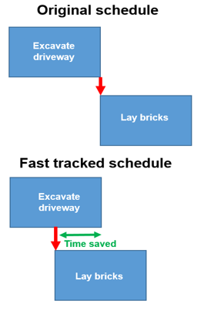

- Describe what is meant by ‘crashing’ in project management scheduling.

Answer | Crashing is a strategy used to compress project schedule. It involves adding resources to allow critical path activities to be completed quicker and therefore reduce the project duration.

BSBPMG512
Manage project time

PRACTICAL ASSESSMENT INSTRUCTIONS

- The following practical assessment will require the Participant to complete work related activities.
- The Assessor will conduct observations of the Participant’s work to determine whether they display sufficient practical skills and knowledge.
- Please fill in the details below – providing your name, signature and date of assessment.
  - The Participant’s signature acknowledges that the Assessor provided clear instructions and the Participant understood what was required to complete this assessment.
- The Assessor may substitute a Practical Task with an alternate task of equal value.
  - Alternate tasks must be fully documented by the assessor in the Assessor Comments area.

Participant name | Ben Dudman
Participant signature
Date | 16/04/2020

Assessor name
Assessor signature
Date | Click here to enter a date.

Task | Task outcome (Tick)
Task | Satisfactory | Not Yet Satisfactory
Task 1

Assessor Comments
BSBPMG512
Manage project time

Practical Task 1
Description of task:
A suitable observer is to verify the participant’s ability to manage time during projects, including:
- Determining the project schedule
- Assessing time management outcomes

The participant is to gather evidence of how they have completed each component of the Practical Task, which is to be submitted with this Practical Assessment sheet. Evidence to be submitted may include:
- Construction plan
- Gantt chart
- Short term and long term plans

The observer is to provide detailed comments on the tasks completed by the participant. The assessor is to verify the observer’s comments in the Assessor Comments section, and provide the Practical Assessment outcome on the front cover of this document.
Resources required:
Computer.
Assessment of task
Name of participant:
Name of observer:
Role of observer
(Confirm suitability to sign):
Email address of observer:
Signature of observer:
Date: | Click here to enter a date.
When completing the task, did the participant: |  | Tick if satisfactorily completed.  Provide comments if left unticked.
1 Determine project schedule
- Develop work breakdown structure with sufficient detail to enable effective planning and control.
- Estimate duration and effort to achieve project deliverables.
- Estimate sequence and dependencies of tasks to achieve project deliverables.
- Use project scheduling tools and techniques to identify schedule impact on:
- Project time management
- Resource requirements
- Costs
- Risks
- Contribute to achieving an agreed schedule baseline.
- Appropriately verbally communicate the schedule to stakeholders.
2 Implement project schedule
- Implement mechanisms to measure, record and report progress of activities according to agreed schedule.
- Conduct ongoing analysis to identify baseline variance.
- Analyse and forecast impact of changes to the schedule.
- Review progress throughout project life cycle and implement agreed schedule changes.
- Develop responses to potential or actual schedule changes and implement them to maintain project objectives.
3 Assess time management outcomes
- Review schedule performance records to determine effectiveness of time management activities.
- Identify and document time management issues and recommend improvements.
The Participant’s performance was: Satisfactory Not Satisfactory

observer Comments

