BSBLDR414
Lead team effectiveness

ASSESSMENT SUMMARY

The assessment activities for BSBLDR414 Lead team effectiveness cover all aspects of the unit of competency. For Apprentices/Trainees, this includes supervisor completion of the Apprentice/Trainee Record (ATR).

Participants must read all the information given before starting any assessment task. The assessment tasks are intended to be fair, flexible, valid and reliable. If a Participant has any questions or requires alternative arrangements to be made such requests should be directed to their Trainer/Assessor, who should note such arrangements in the ‘Assessor Comments’ on the affected assessment. If a Participant feels they are not yet ready to be assessed, they should discuss their options with their Trainer/Assessor.

To satisfactorily complete the assessment, the Participant is required to answer all questions correctly and demonstrate their skills to industry standards. If a Participant does not answer all questions or perform all tasks, they will be deemed ‘Not Satisfactory’ for the task and ‘Not Yet Competent’ for the unit of competency.

The Trainer/Assessor can provide the Participant with additional information on interpreting the assessment outcomes and guide the Participant’s options. If a Participant is still deemed ‘Not Satisfactory’ they will have the opportunity to undertake a supplementary assessment or appeal the result as per the process in the Student Handbook.

By signing below, the Participant acknowledges:
- They understand the assessment instructions and requirements, and consent to being assessed.
- The work submitted is to be their own work – with the work of/with others needing to be clearly acknowledged and documented.
- They consent to any photo/video recording of their work that occurs during assessment.

Participant name | Taylah Cubis
Participant signature | 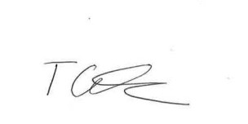

Pre-requisite unit(s) to be achieved and authenticated prior to undertaking assessment
Not applicable

Task | Date completed | Assessment Results
Theory Exam | Select Date. | Satisfactory | Not Satisfactory
Practical Assessment | Select Date. | Satisfactory | Not Satisfactory
Outcome for BSBLDR414 | Select Date. | Competent | Not Yet Competent

Evidence requirements checklist (ticked by assessor and evidence supplied to RTO)
Theory Exam | Practical Assessment  Team development plan

Assessor Name
Assessor Signature | 

BSBLDR414
Lead team effectiveness

THEORY EXAM

Participant name | Taylah Cubis

FOR THE PARTICIPANT
Instructions
- You will complete written questions as outlined on the following pages. You must attempt all questions and provide enough detail in your responses to demonstrate your knowledge.
- It is anticipated that you should complete this assessment within two (2) hours, but additional time may be allowed upon negotiation with the Assessor.
- You must complete all questions unassisted by the Assessor or other personnel but may refer to reference material as needed. All questions must be answered correctly for a ‘Satisfactory’ assessment outcome to be awarded.
  - An oral examination may be allowed under certain circumstances, whereby your answers will be documented by another party.
  - Any written questions that are incomplete, or not answered satisfactorily will need to be completed again after further training support.
    - If you answer a question incorrectly but modify your response, put your initials next to the written change (or the Assessor must initial a verbal change).
Resources required
Pen

FOR THE ASSESSOR
Instructions
- Where oral examination has occurred, ensure that this is acknowledged in writing (e.g. FT001 and Assessor Comments)
- All questions must be satisfactorily demonstrated by the Participant for a Satisfactory determination (indicated by an Assessor tick to the right of the question).
- Assessors are to complete marking in pen of a different colour to the Participant.
- If the Participant verbally modifies their response, write in the modified response verbatim and put your initials next to the written change.

ASSESSOR COMMENTS
As necessary, outline:
- Details on reattempts, alternative arrangements or reasonable adjustments made.
- Where a Participant is deemed ‘Not Satisfactory’, provide recommendations for future training.

- Identify a team that may exist in the workplace. Consider the purpose of the team, its goals and objectives. Name and describe the roles and responsibilities for at least three (3) team members. Finally, identify at least one (1) method that will assist with monitoring progress towards the team goals.

Answer | Point | Detail
 | Team purpose | To manage contractors to ensure project is complete in selected timeframe and by the client’s requests.
 | Goals and objectives | Short term | Construct the roof of the building
 | Goals and objectives | Long term | Achieve project completion
 | Team members | Role | Description | Responsibilities
 | Team members | 1 | Project Manager | Recommend and allocate sufficient resources within their various projects to successfully implement and maintain the Safety Management System and any site specific Safety Management Plan that may be developed.
 | Team members | 2 | Safety Officer | Plan, organise and carry out regular inspections of the Project to ensure compliance with the Health, Safety, Environment and Quality Management System
 | Team members | 3 | Site Foreman | Assist the Site Manager and/or WHS Officer to ensure subcontractors are assessed on their safety performance. Provide guidance, motivation and resources which are required to achieve the safety goals and initiatives outlined.
 | Progress monitoring | Weekly meetings with all team members to discuss progression and allocate jobs to each member for the week. Develop a program schedule that is updated each week and discussed.

- True or False (Tick your response): A team leader is more of a mentor than overseer who checks work.

Answer |  | True
 |  | False

- Match the leadership styles and definitions by writing the appropriate letter next to each number in the centre column.

Answer | Style |  |  | Definition
 | 1 | Authoritarian | 1 - B | A | Leaders who let the team function without much interference
 | 2 | Democratic | 2 - C | B | Leaders who fully control their team
 | 3 | Laissiz-Faire | 3 - A | C | Leaders who try to include everyone in the decision-making process

- Identify two (2) benefits and two (2) drawbacks of transactional leadership.

Answer | Benefits | Drawbacks
 | Clearly defined short- and long-term goals | Employees feel like followers rather than innovators or leaders
 | Clearly defined rewards and consequences for meeting or not meeting those goals | Personal initiative is not rewarded or valued

- Which of the following are characteristics of transformational leaderships? Tick all that apply.

Answer | Choice | Possible Answers
 |  | The leader acts as a role model to employees
 |  | Close, consistent focus on the company vision
 |  | A high value on interpersonal relationships
 |  | Inspiration as a tool to motivate employees

- Why is it important for team leaders to include team members in the planning process?

Answer | Having team members involved in the planning process ensures that a common goal is established, and all members can work toward the same goal. It also allows workers to be allocated work that is relevant to their own skills and experience, getting the most out of the team.

- For each of the listed activities in the table below, identify two (2) methods that team leaders can use to involve team members.

Answer | Activity | Method/s to involve team members
 | Goal setting | Agreed goals that are clearly defined and understood by all team members. There needs to be commitment to achieving something together
 | Decision making | The team should involve all members in the decision-making process. This ensures that team is working together as a unit
 | Work allocation | Ensure that work is allocated to team members based on their skills and abilities. Also ensuring that work is fairly delegated to avoid resentment between group members.

- True or False (Tick your response): Diverse teams produce more creative results than teams in which members are less diverse.

Answer |  | True
 |  | False

- Provide two (2) examples of how the knowledge, skills and background of team members can enhance team practices.

Answer | Involving people with different knowledge, skills and backgrounds can increase innovation and productivity by applying new and better solutions and by streamlining processes.

- Provide two (2) reasons that responsibilities must be carefully delegated within the work team.

Answer | To ensure that the role given to a team member aligns with their skills and abilities and to ensure that conflict doesn’t arise in the team.

- Describe what innovation brings to the workplace. Provide one (1) example of innovative practice.

Answer | Innovation allows practices to be streamlined and more effective. This improves productivity in the work place and allows more to be completed in a shorter amount of time. Continual improvement is a form of innovation. Practices are continually reviewed to ensure they are offering the most accurate and effective solution.

- Describe (3) methods that may be used to measure a team’s innovation.

Answer | - Number of new ideas proposed  - Speed to market  - Percentage of sales from new products

- Explain how encouraging team members to assist each other in undertaking their roles and responsibilities can improve productivity.

Answer | Encouraging team members to assist each other in undertaking their roles and responsibilities can improve productivity by allowing everyone to keep each other accountable for their work and to inspire new ideas.

- Describe (3) methods that may be used to measure a team’s productivity.

Answer | - Achievement of Objectives  - Measuring quantitative productivity  - Measuring profit

- Which of the following are likely outcomes from involving team members in all aspects of a job? Tick all that apply.

Answer | Choice | Possible Answers
 |  | Causes members to resent the team
 |  | Makes the work more meaningful
 |  | Improves self-esteem of team members
 |  | Improves team morale
 |  | Team members take more responsibility for their individual work

- Explain how providing feedback to team members can encourage and motivate team members – building trust and positive working relationships.

Answer | Providing constructive feedback shows team members how they can improve. It can show to workers that you are committed to seeing them thrive in the workplace.

- Identify one (1) issue, concern or problem that may be identified by team members. Describe the signs that you would recognise to identify the issue and how the matter could be resolved by internal team negotiation.

Answer |  | Response
 | Issue, problem, or concern | Underperformance
 | Signs | Goals and deadlines not being met, no new ideas being proposed, low quantitative productivity.
 | Solution via negotiation | Refocus team members on goals, closer management to ensure deadlines are met.

- Identify one (1) issue, concern or problem that would need to be resolved by an external party. Describe the signs that you would recognise to identify the issue and who the matter should be referred to.

Answer |  | Response
 | Issue, problem, or concern | Workplace Bullying
 | Signs | Arguments within team members, low morale, lack of confidence.
 | Solution via negotiation | Counselling can be offered both internally and externally.

- Identify three (3) ways that the team leader can serve as a role model to, and motivate, the team.

Answer | By modelling the characteristics and behaviours they wish to see in the team. This will show they team what is expected and shows that the goal is common between all levels of management.

- For each of the following areas, provide one (1) example of how the team leader’s contributions to the work team can enhance the organisation’s image:
- Internally, within the work team and the organisation
- Externally, with clients/customers

Answer | Question | Response
 | Within the work team and organisation | Builds trust and respect between all levels of the team, allowing the team to work together flawlessly.
 | With clients and customers | Shows a strong team with a leader who will ensure that the needs of the client or customer is met.

- Provide three (3) communication methods that a team leader may encourage the team to use, and situations that each communication method would be suitable for.

Answer | Method | Suitability
 | Email | To document important conversations such as deadlines and decisions being made.
 | Meetings | To allow team members to make a collective decision and plan on how to achieve aspects of a goal.
 | One-on-one conversations | When a message needs to sink in, one-on-one communication can be used. This allows the person to better understand the message.

- Identify two (2) ways that the team leader can establish open communication with management.

Answer | Having regular meetings with management where good news and bad news is reported and to communicate training and resource needs from the team to management to ensure the success of the team.

- Identify two (2) issues, concerns and problems that may be raised by the team to management.

Answer | Additional training needs and any ongoing workplace arguments and disputes.

- Identify two (2) issues, concerns and problems related to the team that may be raised by management back to the team.

Answer | To provide assistance where the team is having difficulties and cant resolve matters themselves and when underperformance has been flagged and needs to be monitored by management closer.

- Describe one (1) situation where the team leader may have to negotiate with management on behalf of the team.

Answer | If the performance level that is expected of the team is too high, the team leader may negotiate on behalf of the team.

Refer to the extract below from an Escalation Policy and Procedure to respond to Q26. to Q28.

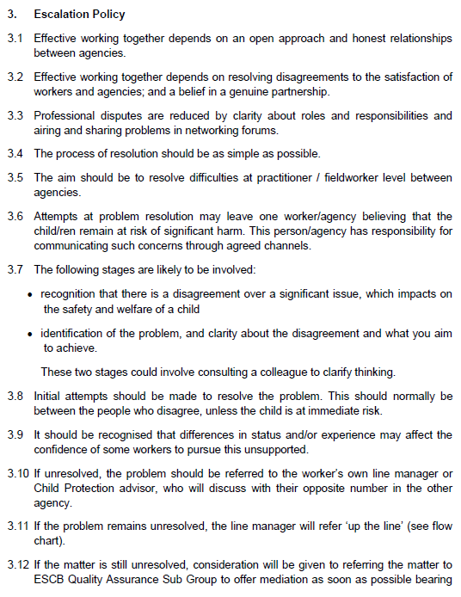
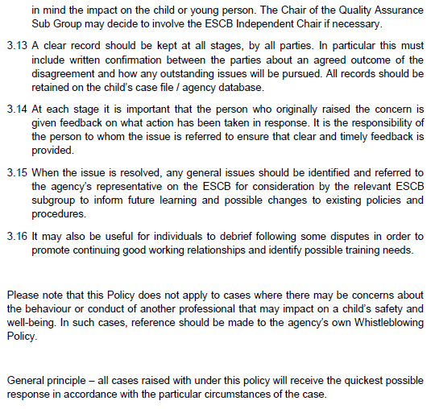
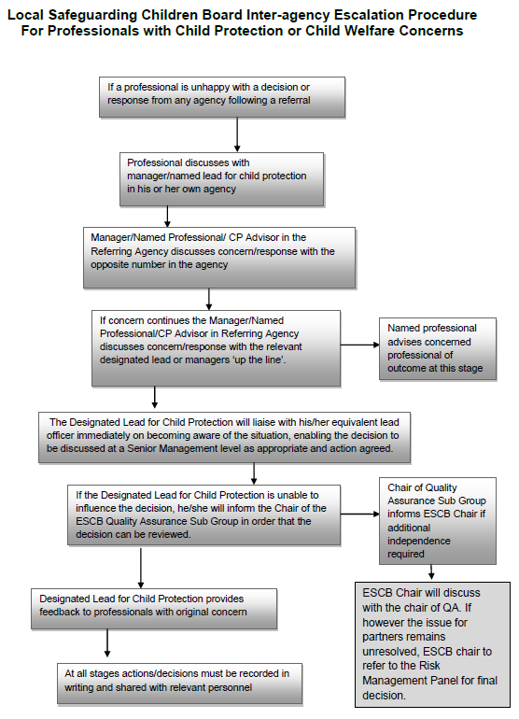

- Order the following steps from 1 to 5 to identify the correct order of issue escalation where a problem is unresolved.

Answer | Step Number | Steps
 | 1 | The people who disagree should make the initial attempts to resolve the problem
 | 5 | When the issue is resolved, any general issues should be identified and referred back to the agency’s representative to inform future learning and possible changes to existing policies and procedures
 | 3 | If the problem remains unresolved, line manager will refer ‘up the line’
 | 4 | If the matter is still unresolved, the matter may be referred to the Quality Assurance Sub Group to offer mediation
 | 2 | If unresolved, the problem should be referred to the worker’s own line manager

- True or False (Tick your response): It is the goal for all cases raised under this policy to receive the quickest possible response.

Answer |  | True
 |  | False

- If the ESCB Chair cannot resolve the issue, which body can make the final decision?

Answer | The Risk Management Panel can make the final decision.

BSBLDR414
Lead team effectiveness

PRACTICAL ASSESSMENT

Participant name | Taylah Cubis

FOR THE PARTICIPANT
Instructions
- The tasks outlined on the following pages will require performance of normal workplace activities, as a result of a structured activity set by an Observer in the workplace or a simulated activity set by your Assessor/Observer.
- The timeframe for these tasks will be established by your Assessor/Observer, in consideration of location conditions and industry requirements.
- You must complete all tasks unassisted by the Assessor or other personnel, unless the steps note this assistance.
- You must attempt all tasks (and itemised steps) for a ‘Satisfactory’ assessment outcome to be awarded.
  - For any observation conducted that is incomplete, or without satisfactory performance, the observation will need to be completed again after further training support.

FOR THE ASSESSOR/OBSERVER
Instructions
- The following observation record should be used to judge and record your observations of the Participant as they complete the task(s) set. You must record your observations of the Participant’s performance.
  - For each occasion, indicate the task performed and whether it was a simulation or workplace-based task.
    - Any simulated assessment must ensure the Participant still performs under workplace conditions which reflect industry standards.
  - In the comments, provide clear detail regarding the task that the Participant was required to do (e.g. PPE used, materials handled, attachments connected, plant types).
- All steps must be satisfactorily demonstrated by the Participant for a ‘Satisfactory’ determination (indicated by an Assessor tick to the right of each itemised step, or an Observer tick to the right of each itemised step, and confirmation by an Assessor in the Assessor Comments).
  - Where you have determined that one or more task steps have not been satisfactorily demonstrated, provide the Participant with additional support and outline details of such assistance in the Assessor/Observer Comments. Allow the Participant two (2) further opportunities to demonstrate the task again to allow an opportunity for a ‘Satisfactory’ assessment outcome to be achieved.
  - If after three (3) attempts the Assessor determines that the Participant cannot demonstrate the required steps, a ‘Not Satisfactory’ outcome is to be determined.

TASK OUTCOME
Task | Date | Task Type (Tick) | Location | Task outcome (Tick)
 |  |  |  | Satisfactory | Not Satisfactory
Task 1 | Select Date. | Workplace  Simulation

ASSESSOR COMMENTS
As necessary, outline:
- Details on reattempts, alternative arrangements or reasonable adjustments made.
- Where a Participant is deemed ‘Not Satisfactory’, provide recommendations for future training.

ASSESSOR COMMENTS: PRACTICAL TASK 1
Individual student (as named on cover page)
Multiple students [ All from Attendance Report, Specific students involved – identify students]
Task | Provide detail
1.B. | Feedback provided to team members:
1.C. | Support offered to identify and resolve problems, issues and concerns:
1.D. | Issues passed from management to the team and vice versa:

BSBLDR414
Lead team effectiveness

Practical Task 1
Description of task:
A suitable observer is to verify the participant’s ability to lead team effectiveness, including:
- Leading and consulting with the team to develop a team development plan that addresses –
  - Team cohesion
  - Innovation and productivity measures
  - Issues management and actions
- Communicating with team members and management to –
  - Consult, encourage, support and provide feedback to the team
  - Model team leadership behaviours and approaches
  - Resolve problems

The Observer is to provide detailed comments on the tasks completed by the Participant (on the Observer Comments, overleaf). The Assessor is to verify the Observer’s comments, noting their findings in the Assessor Comments (on the back of the Practical Assessment cover page) and provide the assessment outcome.
Resources required:
Team Development Plan Template
Observer details
Name of observer: | Lee Townsend
Role of observer  (Confirm suitability to sign) | Site Safety Officer
Email address of observer | Lee.townsend@paynters.com.au
Signature of observer:
Date: | 10/02/2023

When completing the task, did the Participant: | Tick if satisfactorily completed.  Provide comments if left unticked.
- Lead and consult with the team to establish and document a team development plan, incorporating:
- Team purpose, roles, responsibilities, goals, objectives and plans
- Consideration of organisational goals, objectives and plans
- Team cohesion
- Innovation and productivity measures
- Issues management and actions
- Lead team to develop cohesion, including:
- Providing opportunities for input of team members into planning, decision making and operational aspects
- Encouraging and supporting team members to take responsibility for own work and to assist each other
- Providing feedback to team members to encourage, value and reward individual and team efforts and contributions
- Participate in and facilitate work team, including:
- Leading and supporting team members in meeting expected outcomes
- Actively encouraging team members to participate in and take responsibility for team activities and communication processes
- Giving the team support to identify and resolve problems, issues and concerns
- Acting as a role model to enhance the organisation’s image for work team, clients and customers
- In line with organisational escalation policies and procedures, maintain open communication by passing information from management to the team and vice versa (including issues, concerns and problems).

OBSERVER COMMENTS
The participant showed evidence to:
• Maintain the HSEQ Management Plan and reporting requirements during construction.
• Assist the Project Manager and Site Manager / Foreman with compliance to Health, Safety, Environment and Quality Legislation, Australian Standards and Codes of Practices
• Assist internal staff and subcontractors by ensuring they are familiar
with the HSEQ Management System and other relevant requirements
• Proactively manage the effectiveness of the health, safety, environment, and quality measures on site
• Assist in the preparation of Safe Work Method Statements to ensure that all legislative requirements are met where required
• Carry out daily site inspections to ensure compliance with legislative requirements and documented Safe Work Procedures
• Assist with preparation of Toolbox Talk material and facilitation when required.
• Establish and maintain clear lines of communication with internal
staff, subcontractors, and their personnel
• Assist in the preparation and implementation of Health, Safety and Environmental Management Plan
• Maintain a working knowledge of the current WHS legislation and Codes of Practice
• Assist the Site Manager/Foreman with other duties when required

TEAM DEVELOPMENT PLAN

DATE OF EFFECT
Start | 1/03/2022 |  | End |  | 31/01/2023
GOALS, PLANS AND OBJECTIVES
Outline the team’s purpose, goals, and objectives. Identify how this fits within the organisation’s goals, objectives and plans.
Ensure all hazardous chemicals used or stored on site are captured via a hazardous chemical register and evidence of a SDS created in the last five years is provided for records and made available for workers.
OBJECTIVES FOR TEAM
Objective |  | Work process |  | Responsible employee |  | Start date | End date
Team cohesion |  | Plan, organise and carry out regular inspections of the Project to ensure compliance with the Health, Safety, Environment and Quality Management System |  | Lee Townsend  Taylah Cubis |  | 4/03/2022 | 31/01/2023
Innovation |  | Update hazardous chemical register to be linked to electronic format via QR code. |  | Lee Townsend  Taylah Cubis |  | 1/10/2022 | 31/01/2023
Productivity |  | Conduct informal daily site inspections to identify any hazardous chemicals to maintain current records. |  | Lee Townsend  Taylah Cubis |  | 1/03/2022 | 31/01/2023
Issues management |  | Conduct toolbox talks to address issues and non-conformances with workers and ensure they understand system requirements regarding hazardous chemicals. |  | Lee Townsend  Taylah Cubis |  | 29/09/2022 | 31/01/2023
REVIEWING AND ASSESSMENT METHODS
How will you track the plan’s implementation, the team’s progress (e.g. through team meetings, reports)?
Monitoring and reviewing of hazardous chemical register - informal daily site inspection to identify hazardous chemicals and identify gaps in documentation.
ADDITIONAL SUPPORT
Is there any additional support needed to reach the desired goals (e.g. courses, classes, resources).
Communication and support from HSEQ Management team with a development opportunity. Assistance provided with the development of QR Code.
EXPECTED OUTCOME
Team leader’s expectations on the outcome based on the data.
To streamline procedures including allowing contractors to verify hazardous chemicals on site and meet their requirements in providing evidence of SDS for hazardous chemicals.
OUTCOME IF GOALS AND OBJECTIVES ARE NOT MET
Identify the consequences and further steps if the team fails to satisfy the standards set by the plan.
Receive feedback from contractors to identify if QR Code assists in identifying if hazardous chemicals on site have the relevant documentation to meet legislative requirements or if alternative solutions are required.

