Jeremy Tydd
CPCCBC4017 Arrange resources and prepare for the building and construction
Project

Human Resources:
- Identify and Allocate Personnel: Determine the specific skills and roles needed for the project, and assign personnel accordingly.
- Address Industrial Relations: Manage potential issues related to labor relations and ensure a safe and fair work environment.
- Engage/Appoint Supervisors: Ensure proper supervision and leadership on site.
- Employee/Contractor Selection: Choose the right personnel based on project requirements and expertise.
2. Non-Human Resources:
- Materials: Procure all necessary building materials, including concrete, steel, wood, etc.
- Equipment: Obtain and maintain all necessary machinery and tools, such as bulldozers, cranes, and drills.
- Facilities: Set up temporary site facilities like offices, storage areas, and worker accommodations.
- Finances: Secure adequate funding to cover project costs.
- Time: Accurately plan and manage the project timeline.
3. Logistical Planning:
- Site Access and Egress:
Arrange temporary access routes and ensure they meet local authority requirements.
- Waste Management:
Establish waste disposal and removal procedures.
- Delivery Scheduling:
Plan and coordinate the delivery of materials and equipment to meet deadlines.
- Secure and Protect Resources:
Ensure the safety and protection of materials, equipment, and personnel on site.
4. Effective Resource Management:
- Planning and Scheduling: Develop a detailed schedule for resource allocation and utilization.
- Inventory Management: Track and manage materials and equipment to avoid shortages or overstocking.
- Cost Control: Monitor and manage project costs to stay within budget.
- Risk Management: Identify and address potential risks that could impact resource availability or project timelines.

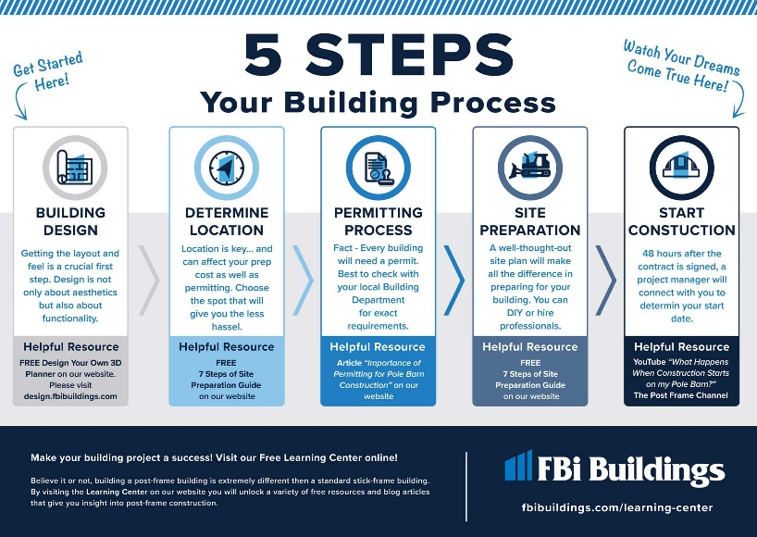

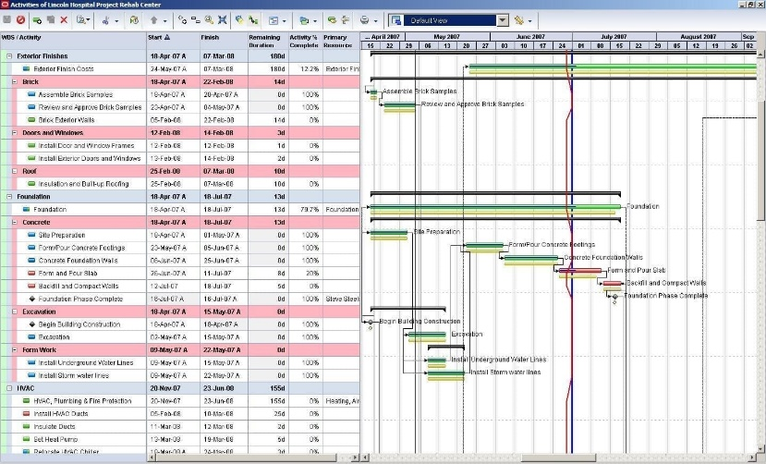
Common types of documentation associated with a building project:
- Permits and Approvals:
These are required before construction can begin and may include building permits, council approvals, and other necessary authorizations.
- Plans and Drawings:
These include architectural plans, structural plans, and other detailed drawings that outline the project design and construction details.
- Specifications:
These documents provide detailed information about the materials, methods, and standards to be used in the construction process.
- Contracts:
These agreements define the responsibilities and obligations of all parties involved in the project, including the owner, contractor, and subcontractors.
- Schedules:
These documents outline the project timeline, including key milestones and deadlines.

