
AHCLSC302
Construct landscape features using concrete

Copyright © 2021 CSTC Pty Ltd

All rights reserved. No part of the contents of this publication may be reproduced or used in any form or by any means – graphic, electronic, or mechanical including photocopying, digitising, recording, or information storage-and-retrieval systems – without the written permission of CSTC Pty Ltd.
ASSESSMENT FOR AHCLSC302

Student name | Kelly Thorpe
Date of assessment submission | 19/05/2021

Trainer/Assessor’s name
Date of assessment marking | Click here to enter a date.
Outcome for unit | ☐ Competent  ☐ Not Yet Competent

TASK INSTRUCTIONS

- As part of the assessment for this unit of competency, you are required to complete a series of activities.
  - Some of these activities will require you to provide a response within this document, others will require you to gather evidence to demonstrate your knowledge and skills.
- At all times, the responses in your assessment must reference Australian (Queensland or Federal) documentation, including legislation, regulations, codes of practice, standards and guidance publications.

ACTIVITIES

Identify/list the scope of the work to be carried out from the concept plan shown.

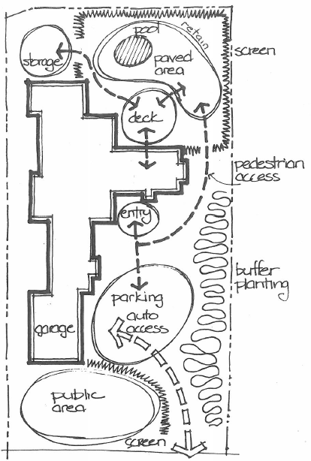

Response
Screening/Planting of trees shrubs etc
Path ways
Parking areas, decks, storage.

Outcome for Activity 1 | ☐ Satisfactory  ☐ Not satisfactory
Trainer/Assessor comments

Identify/list the detail on the landscape plan shown.

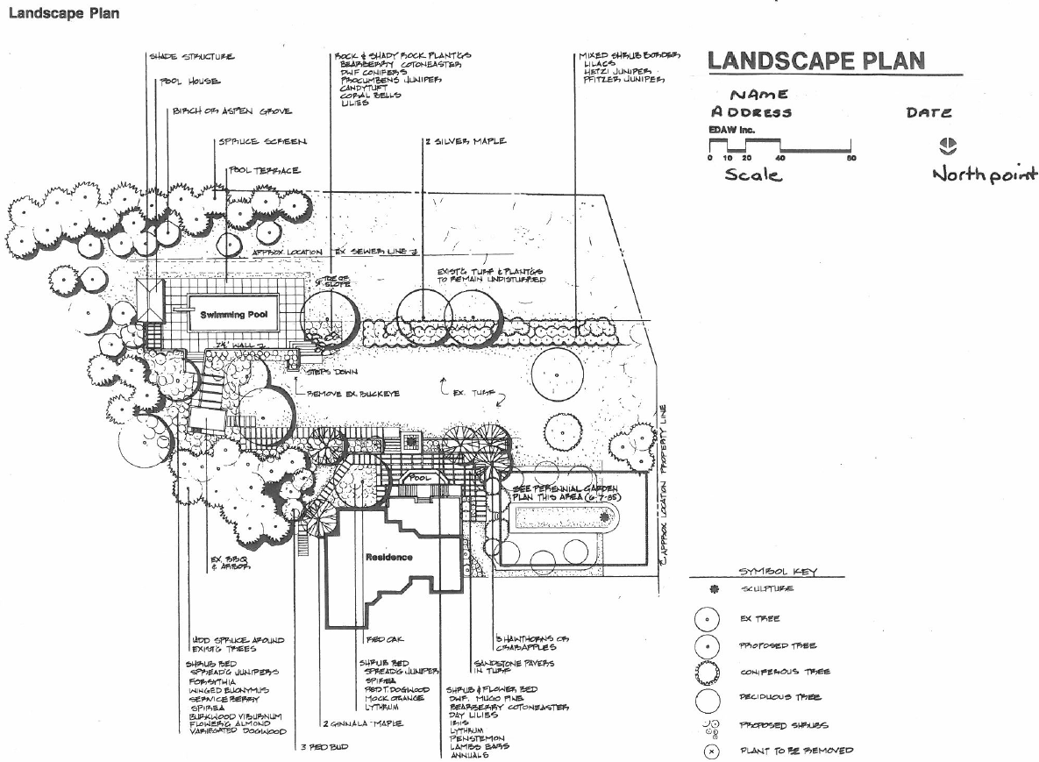

Response
Legend – Shows plants by type/function
Scale (scale bar) and direction (north point)
Title block, which includes plan/drawing number, date of preparation and version and plan/drawing author.
Existing Vegetation and proposed planting works
Proposed works
Streetscape works – including anything that may go over the boundary line.

Outcome for Activity 2 | ☐ Satisfactory  ☐ Not satisfactory
Trainer/Assessor comments

List the materials required to complete the water feature, by using the wall and water feature construction plan shown.

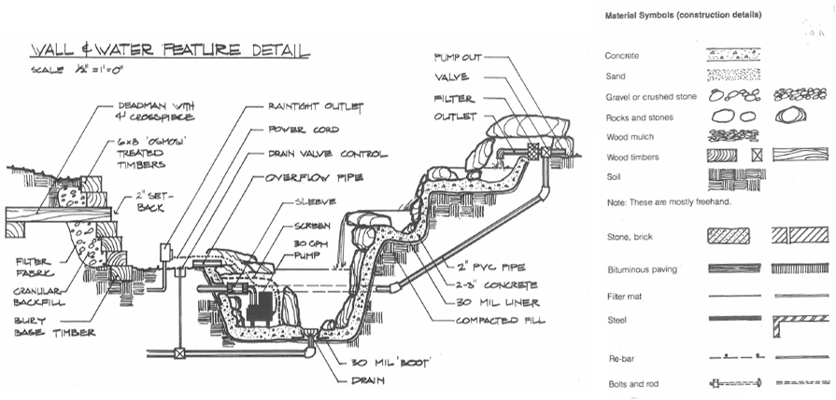

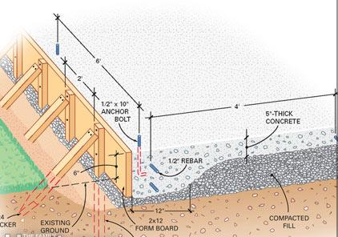

Response
Wall - Concrete, Rocks and stones, wood timbers, soil,
Pump – Powercord, valve, filter, Pipes,

Outcome for Activity 3 | ☐ Satisfactory  ☐ Not satisfactory
Trainer/Assessor comments

Research and list relevant laws and standards relating to concreting works
(e.g. Building Codes, Australian Standards, Codes of Practice)

 | Name of document
- Laws | Building Act 1975  Building Regulation 2006
- Standards | AS 2870-2011 Residential Slabs & Footings  AS3600-2009 Reinforced Concrete Design  AS 3600-2018 Concrete Structures  AS1012: Methods of testing concrete series  AS1379: Specification and supply of concrete issues  AS1478: Chemical admixtures for concrete, mortar and grout series  AS3600 Concrete structure series  AS3610: Formwork for concrete series  AS3972-2010 General purpose and blended cements
- Codes | National Construction code Series 2013 Volume two Building Code of Australia  Plumbing Code of Australia  QBCC Standards and Tolerances Guide

Outcome for Activity 4 | ☐ Satisfactory  ☐ Not satisfactory
Trainer/Assessor comments

List the components for four (4) common surface drainage systems used in landscape construction.

System | Components
- Spoon | Is a concrete drain formed in line with the ground surface and used to collect rainwater, generally 1 metre wide and 80-120mm deep.
- Channel and grate | Plastic, usually rectangular bases with grate on the top to stop blockages, comes in a variety of sizes and shapes, used to collect water and direct away.
- Pit | Is a rectangular box with a grate on top used to collect rainwater or excess water
- Contour | Contour banks are used to slow/break overland water flow on slopes, by reducing the slope of the land, one can reduce problems such as erosion and water speed.

Outcome for Activity 5 | ☐ Satisfactory  ☐ Not satisfactory
Trainer/Assessor comments

List the advantages and disadvantages of drainage behind and through the build wall (as shown).

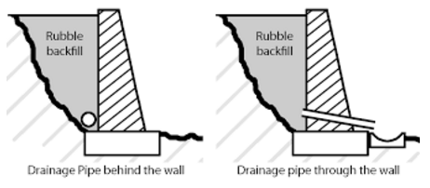

Drainage pipe behind the wall
Advantages
Relieves hydrostatic pressure preventing the wall from falling over and/or moving.
Disadvantages
Water seeping through can cause the soil behind the wall to stain the colour of the blocks.

Drainage pipe through the wall
Advantages
Relieves hydrostatic pressure preventing the wall from falling over and/or moving.
Disadvantages
Pests such as rats and mice can enter through weep holes/ end of pipe..
Blockages can occur

Outcome for Activity 6 | ☐ Satisfactory  ☐ Not satisfactory
Trainer/Assessor comments

Explain the purpose of a slump test. Describe the process of how such a test is conducted.

Response
The slump test measures the consistency of fresh concrete before it sets.
The test is carried out using an Abrams cone usually 3.9inch (top) x 7.9inch (bottom) x 12 inch (high).This is then filled in three stages, after the third stage the concrete is smoothed and the mould (cone) is lifted.
If the concrete collapses or slips sideways it is considered to wet or a high workability mix, which is considered inappropriate. A true slump or when the concrete keeps its shape but slides down is considered an appropriate mix.

Outcome for Activity 7 | ☐ Satisfactory  ☐ Not satisfactory
Trainer/Assessor comments

Research and list a range of curing compounds and the advantages of using each type

Curing compound | Advantages
- PVS Based | Form a film over the surface retaining water to prevent cracking and shrinking
- Plastic or hessian | Keeps moisture in concrete
- Water | Stronger and more durable
- Hydrocarbon | Will break down and leave the surface  For all compounds: To ensure water tight concrete, concrete should be cured for at least 7 days but up to 28 days. Concrete should be kept we and at as close to 23 degrees Celsius as possible

Outcome for Activity 8 | ☐ Satisfactory  ☐ Not satisfactory
Trainer/Assessor comments

List environmentally safe products for cleaning.

Response
Use a broom to brush concrete
Use a mix of liquid detergent and water
Use a mix of Vinegar, baking soda and water
Use a pressure water if concrete is heavily mildewed

Outcome for Activity 9 | ☐ Satisfactory  ☐ Not satisfactory
Trainer/Assessor comments

Have team members take photos and videos of your involvement with concrete features.

Identify each photo / video with a letter label and describe each photo / video in the table below. Submit the photo / video files along with this workbook.

Advantages
A | 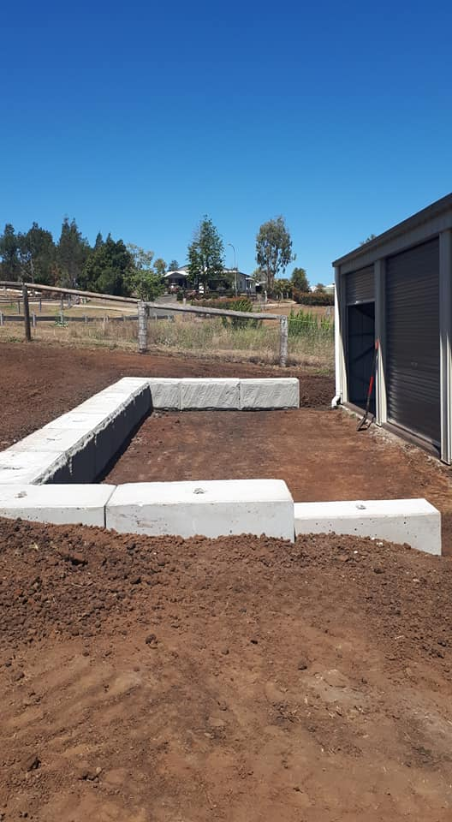  Retaining wall / seating for an outdoor entertainment area.
B | 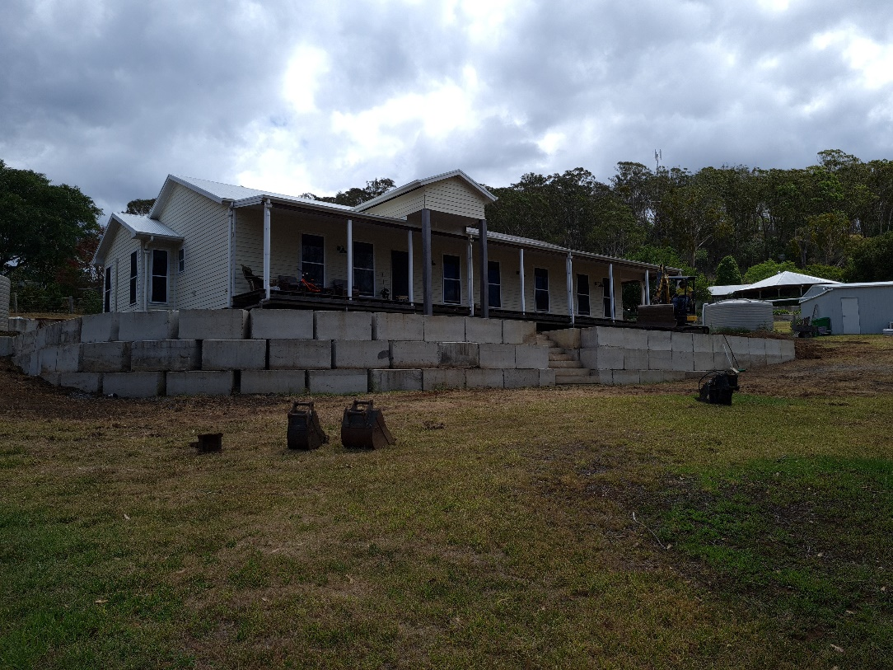  Retaining wall
C | 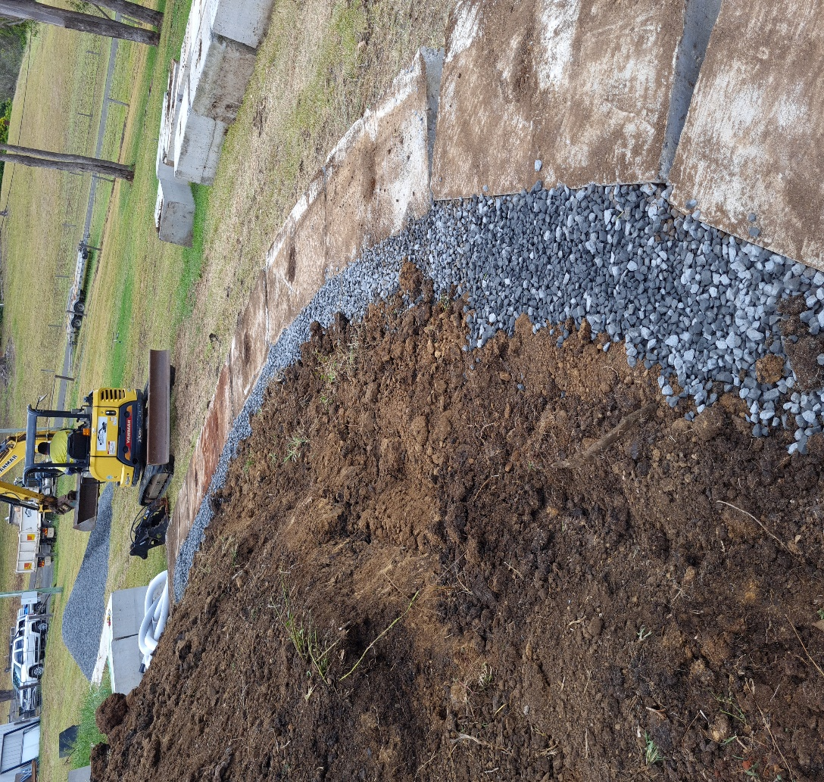  Drainage rock – for retaining wall in B
D | 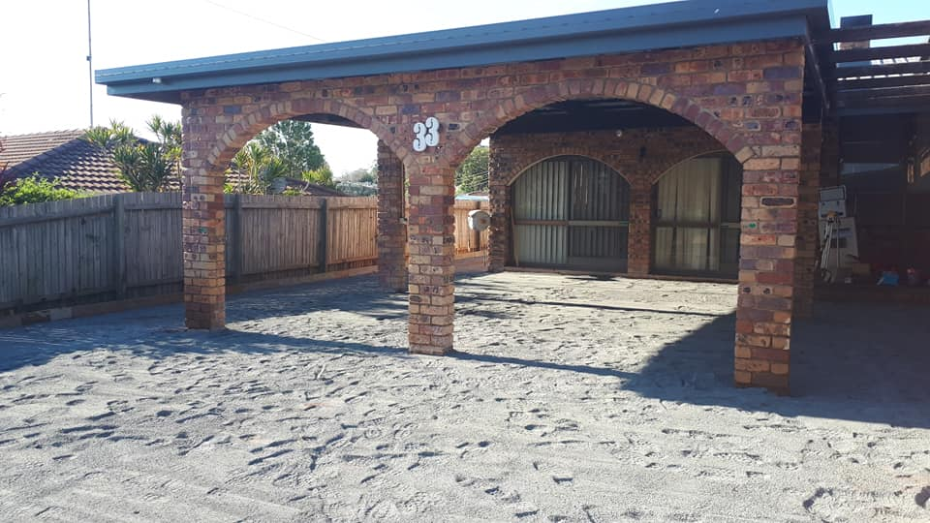  Installation of crusher dust for concreting of driveway
E
F
G
H
I
J
K
L
M
N
O
P
Q
R
S
T
U
V
W
X
Y
Z

Outcome for Activity 10 | ☐ Satisfactory  ☐ Not satisfactory
Trainer/Assessor comments

