Activity 1D:

Polka Dot
Telephone: 707707

Miss Smith
12 Parrot Parade
Tree Lane
The Forest

19th March 2018
Dear Miss Smith
It was great to speak to you earlier at Polka Dot. I would like to take this opportunity to welcome you on behalf of everyone at Polka Dot insurance. Here at Polka Dot, we know how important it is to have a friendly, helpful voice at the end of the phone.
To show you how much we value your custom, we are giving you $100 when you refer a friend.
See you soon,
Claire Bird

Activity 2B:

Meeting Minutes

Date: [Space for text]

Attendees:
[Space for text]

Agenda:
- [Space for text]
- [Space for text]
- [Space for text]
- [Space for text]
- [Space for text]

Action Items | Owner | Deadline
- [Space for text] | - [Space for text] | - [Space for text]
- [Space for text] | - [Space for text] | - [Space for text]
- [Space for text] | - [Space for text] | - [Space for text]

Activity 2D:

Staff Name | Department | Start Date
Sharon Wise
Daniel Parker
Graham Pat
Tyler Rust

Activity 2E:
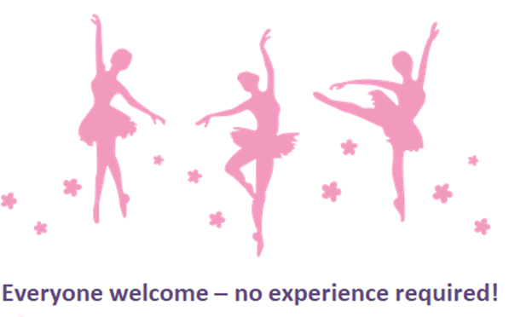
Every Tuesday evening
17:30- 18-30pm
DANCE CLASS

Activity 3A:



Activity skills and knowledge:
Section A:

Totem Pole Productions
A new set of policies and rules are being introduced which govern when and where employees have lunch.

This has become a problem due to extras wanting to talk and have lunch with A-list film stars, who have now communicated their wish to be undisturbed during lunch hours.

- Extras must eat their lunch in the main restaurant between 12:00 and 14:00
- The Lobster Café is exclusively for actors, directors, and producers
- Extras must not disturb actors when they are having lunch
- Selfies with actors are not permitted on set
- Extras must not pursue autographs, unless the actor has given their permission at the beginning of filming.

Managers have also clearly stated that extras will not be used again if they break these rules.

