
BSBMGT401
Show leadership in the workplace

Copyright © 2018 CSTC Pty Ltd

All rights reserved. No part of the contents of this publication may be reproduced or used in any form or by any means – graphic, electronic, or mechanical including photocopying, digitising, recording, or information storage-and-retrieval systems – without the written permission of CSTC Pty Ltd.
ASSESSMENT FOR BSBMGT401

Student name
Date of assessment submission | Click here to enter a date.

Trainer/Assessor’s name
Date of assessment marking | Click here to enter a date.
Outcome for task | ☐ Satisfactory  ☐ Not Satisfactory
Trainer/Assessor’s comments

Students must complete all tasks as outlined in the following pages.

Hints: - The following hints will assist when preparing reports for submission
Report format:
Executive summary
An executive summary is a very useful tool in communicating your information to busy people. It is essentially a short summary (often no more than a page) of the report objectives, findings, and conclusions.
Contents
Any report over three pages in length should have a list of contents. A list of contents not only helps people find their way around the report but it also gives an indication of what is in the report and the structure.
Introduction
The introduction should set the scene for the report by concisely describing the reason for the report and the background or history relevant to the report.

Body
The body should address the main information including:
• objectives of the review;
• how the review was conducted, who was consulted, etc.; and
• results of the review and key issues identified.

Summary/Conclusions/Recommendations
Your conclusions should be clearly justified with reference to the results of the review. Your recommendations should be made twice, briefly in the opening summary or Executive Summary and then in more detail in the recommendations section.
Useful links to assist with assigned tasks.

This information is to be handed to each student to outline the assessment requirements.
Assessment due date: This will be aligned to Session Plan

Instructions
CA City Scenario: CA City Department Store
The CA City Department Store is a one-stop shop for style and fashion. Our wide range includes Womenswear, Menswear, Childrenswear, Beauty, Footwear, Handbags, Accessories, Fragrance, and Home and Food.
We also create homes that inspire. Our modern Australian-made homewares and competitively priced electrical goods are hard to leave the store without. Great deals can be found both in store and online. Our strong brand is built on our great customer service and ability to provide quality products at low prices. Making happy customers is what we do.
You are Joan Brown, Sales Manager at CA City Department Store, you are responsible to provide first level of leadership to others for their work and performance within your organisation. You are required to follow and implement appropriate organisational values and standards to meet organisational goals and objectives effectively. You report to Hans Konig and manage your team of ten department managers. Your main responsibilities based on your job description and the CA City Retail Group Operational Plan are:
- to increase revenue through targeted marketing campaigns to achieve this you will be working with the marketing department to produce the advertisements and plan the campaigns
- maintain superior product
- maintain excellence in service quality standards.
An excerpt of the CA City Retail Group Operational Plan as it applies to the Department Store follows.
Operational objective | Activity/ Strategy | Approved Resources | Responsibility | Timelines | Performance Measures
Strategic direction as per the business plan - Increase revenue through targeted marketing campaigns
Marketing objectives  - To position CA City Retail Group as a provider of a superior product and customer service provider  - Increase foot traffic across all stores from 3000 customers to 7000 customers per day | Marketing plan completion | Budget  $3,000 | Marketing department | By end of financial year | Numbers of customers  Percentage brand recognition  Percentage of market recognition of ethical and environmental responsibility
 | Television advertising | Budget pa  $200,000 | Marketing department | AM and PM primetime spots
 | Monthly Direct Mail (DM) | Budget pa  $50,000 | Marketing department | First Sunday of each month
 | Website maintenance | Budget pa  $10,000 | Marketing department | Weekly
 | Social Media campaign 1 | Budget  $20,000 | Marketing department | First half of financial year
 | Customer surveys and analysis | Budget  $7,000 | Marketing department | Bi-annually
 | Sales analysis | Budget  $75,000 | Guaranteed Results Marketing Research Co. GRMRC | Quarterly
Strategic direction as per the business plan - Maintain superior product and service quality standards
Objectives  - Maintain superior product quality  - Maintain superior service standards | Conduct product satisfaction survey | Budget pa  $7,000 | Joan Brown and purchasing department | Quarterly | Score satisfaction survey on parameters of product  Score on mystery shopper checklist  Individual employee scorecard ratings (linked to company strategic directions)
 | Conduct spot checks on quality of products and service | Mystery shopper program  Budget  $5,000 pa | Joan Brown and GRMRC | Monthly
 | Conduct spot checks on environmental practices at stores |  | Store Manager | Bi-weekly
The risk of not achieving these objectives will vary but for the purposes of this assessment we can consider the risks to be financial and reputation based.
Not maintaining superior product and service standards for example will result in financial and other targets affected and loss of sales and reputation. Other issues could include faulty goods leading to compliance issues and loss of sales or expensive warranty claims.
Standards that fall under your direct responsibility include:
- teamwork
- honesty
- excellence
- commitment
- recognition
- customer service
- professionalism
- accountability
- personal development.
You may follow the scenario through the assignment questions, or alternatively, if you would like to use your own organisational example, answer questions in relation to your own workplace.

Task 1
Question 1
1a Each organisation has standards, values and requirements especially with regard to performance and behaviour? Where could you expect to find the standards in your organisation? Complete the following table providing at least five examples include at least two examples that could be implied.
Source of information | How does this inform your team? | Is this implied or stated? How would you know this? How does this impact on the organisation?
Example  Vision/mission. | Short statement explaining the main vision for the organisation. Helps keep the focus. | Stated. This is a statement to motivate and communicate main focus to the team.
1b How would you be sure you and your team’s management style including behaviour and performance meets the requirements of the organisation? Explain at least three skills you must use.
1c How could you evaluate your own behaviour and make necessary changes to achieve the standards expected? Provide two examples and explain how they could apply.
Question 2

2a What do you understand by being a positive role model in an organisational context?

2b How would you make sure you and your team demonstrate positive role model behaviour? Suggest at least three ways you would implement this practice in your team. Explain your answer.
Question 3
3a How would you determine the goals and objectives of your organisation? Explain a minimum of two sources of information and provide two examples of goals and objectives that would be suitable for your role.
Hint: Joan’s responsibilities have been outlined in the scenario.
3b What is a performance plan and why are they necessary for successful business? Minimum 50 words.
Question 4
4a You need to establish Key Performance Indicators for your team in order to be able to evaluate the results. Why this is so important and what steps could you take to ensure they are meaningful and realistic? Provide four steps and a brief explanation of why these are important.
4b Complete the following table to prepare a performance plan in accordance with the identified strategic objectives for the Department Store (or your own organisation).
Example Performance Plan CA City Department Store
Strategic Goal:
Increase revenue through targeted marketing campaigns
Operational Objective:
To position CA City Retail Group as a provider of a superior product and customer service provider
Task/Activity | Date | Responsibility | Resources | Risks | Key performance indicator (evaluation method)
Marketing plan completion | By end of financial year | Marketing department | Budget $3,000 | The marketing plan informs the rest of the process if it is not completed then there may be financial implications and lack of direction for the rest of the team. | Numbers of customers to increase by 5000/week by end of May 20XX

Performance Plan CA City Department Store
Strategic Goal:
Operational Objective:
Task/Activity | Date | Responsibility | Resources | Risks | Key performance indicator (evaluation method)

Task 2
An important part of showing leadership is to continually enhance the image of your organisation. Joan is aware of the importance of her and the team presenting the best face to customers and to other members of the Department Store team. Answer the following questions regarding enhancing the image of your business.
Question 1
As a leader how would you use the standards and values of your organisation when operating your business?
Question 2

2a One of the standards in place for your team is causing problems for you and the organisation. You are concerned about the negative impact of such a standard. How could you question the standard within the organisation? Explain seven steps you could take.
Hint: Consider established communication channels and appropriate communication methods in your response.
2b Identify two examples for behaviours and performances that can cause damage to an organisation?
Question 3

Your team member Mandy Panitz has been having some trouble with her team and is struggling to deal with her issues. Explain the concepts of integrity and credibility and provide her with two strategies to help her with her own performance and that of her team?

Task 3
Scenario:
It is six months later and your objective of maintaining service quality standards is not reaching the KPIs you indicated in your performance plan. The results of the Mystery Shopper from the external contractor GRMRC have been variable over the past 6 months (one set of results per month are available mystery shopper results) and there have been poor comments provided to Joan Brown by department staff from customers.
Question 1

Explain methods of relevant information collection and organisation for the problem under consideration. What information would you need to analyse this particular situation? Provide three sources and explain how this information would be useful. Complete the table.
Information source | Explanation of usefulness | How could you organise this information?
Example  Formal staff interviews | Why are there issues with service? The staff will have insight from dealing with the customers directly. | Order of Importance  Comparison and Contrast
Question 2

2a How will you involve your team in decision making processes? Explain at least two ways to facilitate their involvement and why this is important.
2b Explain Tuckman’s theory on group behaviour and describe why it is important to take it into consideration. Minimum 100 words.
Scenario
Hanz Konig, your immediate manager has advised that there is only a very small budget at this stage for your project. He urges you to try low cost solutions first until the next budget cycle when the budget can be increased if needed. Something must be done immediately but the budget is not negotiable at this time.
You have discussed the poor results from the GRMRC with your team noting their ideas and analysing the information gained via the Mystery Shopper results. The following suggestions have been generated by you, your team and management:

Issue | Possible solution/objective | Advantages | Disadvantages
Lack of product knowledge | Increase training for all floor staff. | Allow for improved performance.  Overdue and needed especially for new staff and trainees. | Expensive and time scheduling issues.
Poor customer recognition on first entry. 25% of customers leave without seeing any staff members. | Change visibility within the store to avoid customers being ignored | Easy to achieve and can return immediate results. Low cost. Staff have been lazy and need to be motivated to approach customers to provide service. | None
Poor morale and lack of understanding of the job in the team. | Hold regular meetings/team building activities. | Easy to achieve and can return immediate results. Low cost. | None.
Poor morale and lack of understanding of the job within the team. | Increased supervisor presence and on job training. | Easy to achieve and can return immediate results. Low cost. | None.

Question 3

Now it is important to look at the options and assess the risks that may affect your ideas.
3a What steps could you take in assessing the options and risks?
3b Which of the suggestions would be the least suitable option at this time? Explain your answer. Minimum 25 words.
Question 4
4a You have assessed all relevant information and made decisions regarding the poor performance. What must you do now?
Hint: How you would communicate with your team and the timeliness of your decisions must factor into your answer.
4b Draft an email to your team explaining the results, your decisions (including feedback on their suggestions) and what you propose to do about this at this time.
Question 5

Based on the above decisions and the urgency of this issue, complete the following plan and make sure all relevant individuals and teams are in agreement.
Hint: You have permission to work with the external contractor GRMRC to test the success of your suggestions. Month one results could be tailored to assess the success. The improved results could form the Measures of performance.

Implementation plan
Plan type |  | (Insert what plan is for here)
Time frame |  | (insert month and year here)
Issues | Comments
1 | Insert into this section the current situation and issues which you would like to resolve (Eg. The business has relocated, is well resourced but at an awkward phase in its development – risks need to be taken for growth to be achieved – need additional staff to grow the business further)
Future
No. | Objectives |  |  | Measures of performance
1 | Insert the objectives you aim to achieve based on issues listed above. |  |  | Insert measurements used to assess whether the objectives have been successfully achieved.
2 | Insert the objectives you aim to achieve based on issues listed above. |  |  | Insert measurements used to assess whether the objectives have been successfully achieved.
Agreement |  |  | I, agree with the plan as written.  Date:
Question 6

You have completed the first month with your new initiatives in place. What feedback processes can you use to assess the success of your implementation and decisions? Provide examples of three feedback systems or ideas you could use and how these would demonstrate effective leadership. Complete the following table.
Feedback processes | Benefits | Monitoring methods possible
Question 7
7a Briefly discuss three different leadership styles and concepts which could be useful in this situation.
7b What leadership style would you prefer and why?

Appendix A – CA City Department Store Organisational Chart
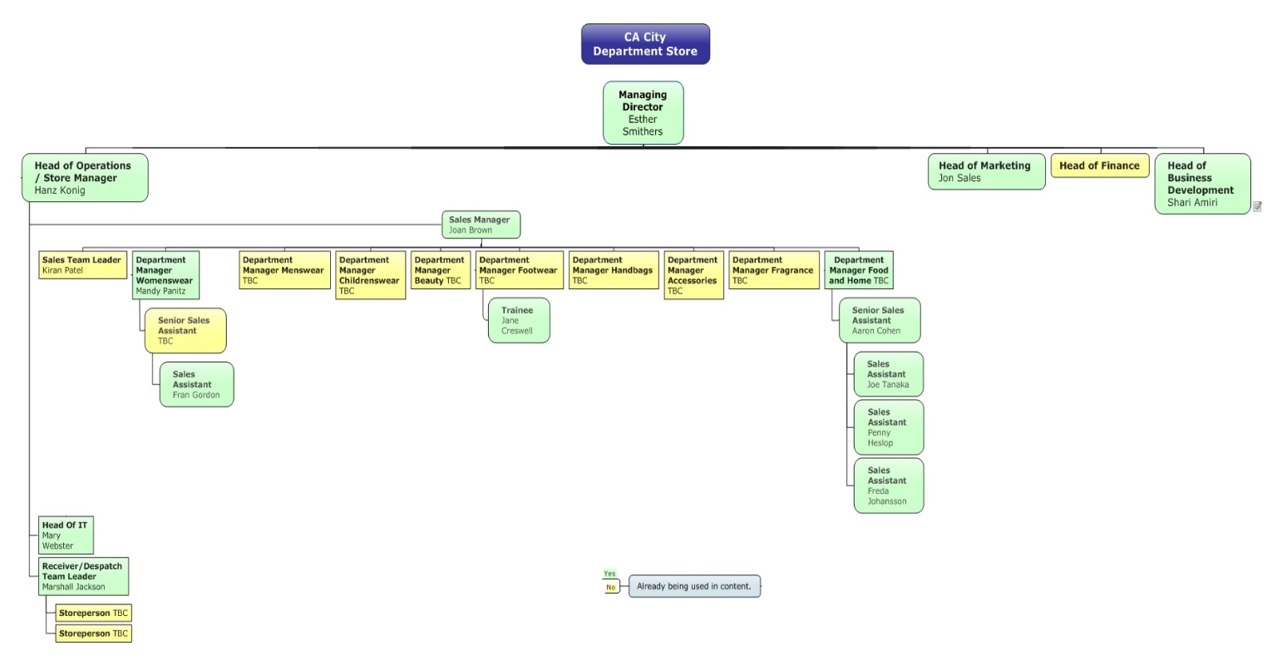
Appendix B risk management
Risk Rating Matrix
Risk Rating  E: Extreme  M: Medium  H: High  L: Low |  | Likelihood
 |  | Rare | Unlikely | Possible | Likely | Almost Certain
Consequence (Impact) | Severe | Medium | High | High | Extreme | Extreme
Consequence (Impact) | Major | Medium | Medium | High | High | Extreme
Consequence (Impact) | Moderate | Low | Medium | Medium | High | High
Consequence (Impact) | Minor | Low | Low | Medium | Medium | High
Consequence (Impact) | Insignificant | Low | Low | Low | Medium | Medium

Standard risk likelihood scale
RATING | DEFINITION | SCALE
Almost certain | Will definitely occur or will occur on an annual cycle | 5
Likely | Similar events have been experienced several times | 4
Possible | May occur once | 3
Unlikely | Occurs from time to time | 2
Rare | Occurrence is possible but highly unlikely | 1
Standard risk consequences scale
Consequences represent the possible impact of the risk on project outcomes, if it does occur.
RATING | DEFINITION | SCALE
Severe | Most objectives cannot be met | 5
Major | Some important objectives cannot be met | 4
Moderate | Some objectives impacted but may still be met | 3
Minor | Minor effects that can be remedied | 2
Insignificant | Almost no impact on objectives | 1

