Work Method Statement - [Incorporating Health, Safety and Environmental Risks]
WMS No.: |  | 4249 - 006 |  | Activity: | Excavation and Trenching
Risk Register Reference: |  | 001 ,002, 003, 004, 005, 006,007,008,009,010,011, 012,013,015,016,019,022, 023,024,025,026,027,028, 029,030,031,032,033,035, 037,038 |  | Commencement Date: | May 22 |  | Completion Date: |  | May 2023
BMD Project No.: |  | 141 - 4249 |  |  | WMS Review Date: |  | 17/05/2022
Project: |  | 141 - 4249 - Mount Crosby Bridge |  |  | To be Reviewed By: |  | Project Team
Site Address: |  | Allawah Road intersecting Alan Donovan Lane |  |  | Personnel Responsible for Monitoring this Activity: |  | Project Manager or Delegate
Employer: |  | BMD Constructions |  |  | Monitoring and Review Timeframe:  Maximum of 6 monthly |  | Every 6 months or change of works or any incident or change management, whichever comes first.
ABN: |  | 59 010 126 100
Legislative High-Risk Activity? ☒ Yes ☐ No
WMS involves: (cross ☒ any applicable below)
1. A High-Risk Construction Activity being a Prescribed Activity: 2. An Earthmoving, Particular Crane Operation or Elevated Work Platform ☐
- Asbestos Removal ☐ Demolition ☐ Other:
3. High Risk Construction Work
- Work at 2m or more fall height ☒ Close proximity to services ☐ Work involving tilt-up or pre-cast concrete
- Using a hazardous substance (Part 7.1) ☒ Work on or near energised electrical installation ☒ Work on/near gas distribution main or consumer piping
- Work that could cause disturbance to Asbestos ☒ Work adjacent to a Road or Railway ☐ Work in artificial extreme temperatures
- Work in contaminated / flammable atmosphere ☐ Work in or near water or other liquids where there is a ☐ Structural alterations requiring support
risk of drowning
☒ Movement of powered mobile plant ☐ Work in tunnel ☐ Demolition of a load bearing element of a structure
☒ Work in or near a confined space ☐ Work on telecommunication tower ☐ Work on / near chemical / fuel / refrigerant line
☒ Work in or near trench / shaft > 1.5m deep ☐ Using explosives ☐ Work involving Diving
- Scaffolding > 4 metres ☐ Forklift Truck Operation ☐ Dogging & Rigging
Project Approval | Site Safety / Environmental Representative(s): |  | Name: Peter Douglas |  |  | Signature(s): |  | Date:
Project Approval | BMD Site/Project Manager: |  | Name: Nicholas Maher |  |  | Signature: |  | Date:


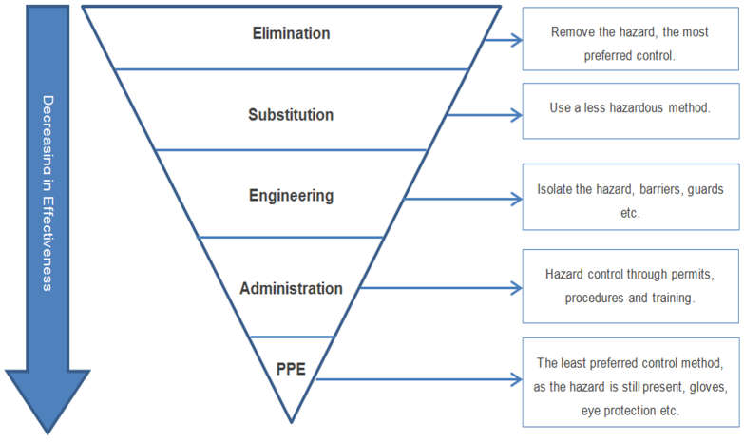
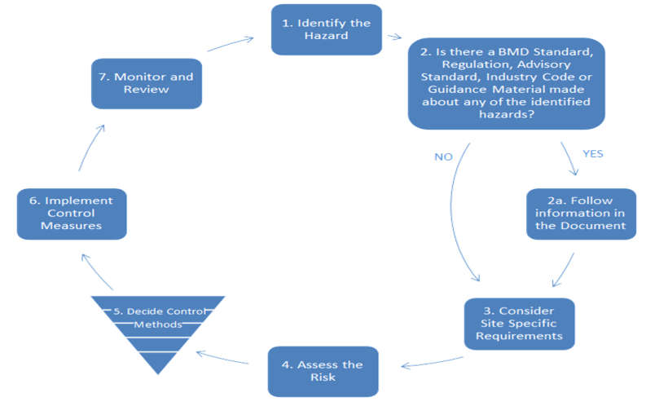

 | Consequence
Probability | Negligible (1) | Minor (2) | Moderate (3) | Major (4) | Substantial (5)
Rare (1) | 1 (L) | 2 (L) | 3 (L) | 4 (L) | 5 (M)
Unlikely (2) | 2 (L) | 4 (L) | 6 (M) | 8 (M) | 10 (H)
Possible (3) | 3 (L) | 6 (M) | 9 (M) | 12 (H) | 15 (H)
Likely (4) | 4 (L) | 8 (M) | 12 (H) | 16 (E) | 20 (E)
Almost Certain (5) | 5 (M) | 10 (H) | 15 (H) | 20 (E) | 25 (E)
Extreme | Further planning and notification to the next level of management is required to analyse control measure(s) and reduce this risk score. Work associated around this risk can only proceed with written authorisation at a General Manager level. (Refer sect. 10.2 Risk Standard)
High | Work can only proceed with written approval & reviewed by the Project Manager. (Refer sect. 10.4 Risk Standard)
Moderate | Managed by specific monitoring or response procedures.
Low | Manage by routine procedure, no formal approval required.

Recurring Hazard/Aspect  (Applies to all tasks) | Impact  (What can go wrong) | RISK SCORE  without Controls |  |  | Management Controls (controls to be in place to manage Health, Safety and Environmental Risks) | RISK SCORE  with Controls |  |  | Person Responsible (to ensure controls are applied)
Recurring Hazard/Aspect  (Applies to all tasks) | Impact  (What can go wrong) | Cons | Prob | Risk |  | Cons | Prob | Risk | Person Responsible (to ensure controls are applied)
Construction Site Entry | Refer to WMS 001 Pre-Planning and Arrival to Site
Manual Handling | Refer to WMS 002 General Labouring and Manual Handling
Working Near Services | Refer to WMS 003 Working Near Services

Recurring Hazard/Aspect  (Applies to all tasks) | Impact  (What can go wrong) | RISK SCORE  without Controls |  |  | Management Controls  (Controls to be in place in order to manage Health, Safety and Environmental Risks) | RISK SCORE  with Controls |  |  | Person Responsible  (To ensure controls are applied)
Recurring Hazard/Aspect  (Applies to all tasks) | Impact  (What can go wrong) | Cons | Prob | Risk |  | Cons | Prob | Risk | Person Responsible  (To ensure controls are applied)
Working in hot conditions – Heat stress | Health of workers - illness | 4 | 4 | 16 | - Start the day Hydrated.  - Regular Shade Rest Breaks.  - Have water available and regular water breaks.  - Monitor your mates and yourself.  - Avoid energy drinks.  - Monitor Urine for colour changes. | 3 | 2 | 6 | All Work Group
Exposure to the sun – UV radiation | Sunburn and skin cancer | 4 | 4 | 16 | - Correct PPE. Gloves/ Hard hat with sun protection.  - Regularly apply Sunscreen.  - Shade breaks.  - If possible, move work into shaded areas. | 3 | 2 | 6 | All Work Group
Working long hours - fatigue | Illness and injury  Accident involving plant and equipment | 4 | 4 | 16 | - Monitor work hours.  - Maintain good sleep patterns.  - Rotate Driving duties.  - Let your supervisor know if feeling fatigued. | 3 | 2 | 6 | All Work Group
Plant and equipment mechanical issues | Oil spill pollution of ground and water | 4 | 4 | 16 | - Make sure spill kits are available and operator are trained in the use of them.  - Know containment steps and act if needed.  - Prestart walk arounds and maintenance help avoid spills and pollution.  - Follow Operators manual. | 3 | 2 | 6 | All Work Group
Site Environment conditions.  Dust generation. | Impact through poor visibility.  Eye injury or damage. | 4 | 4 | 16 | - Drive to conditions.  - Slow down around work groups  - Follow site rules.  - Let supervisor know if condition start to change and water truck is needed.  - Correct PPE Glasses when working a site. | 3 | 2 | 6 | All Work Group
Poor Ground Conditions and trip hazards. | Injury through trip fall impact.  Cuts or breaks or muscle strains. | 4 | 4 | 16 | - Clear area of any obstacles  - Check path to be used.  - Mark objects if they can’t be moved.  - Use spotters | 3 | 2 | 6 | All Work Group

Task | Hazard/Aspect  (Procedure Step) | Impact  (What can go wrong) | RISK SCORE  without Controls |  |  | Management Controls (Controls to be in place in order to manage Health, Safety and Environmental Risks) | RISK SCORE  with Controls |  |  | Person Responsible (to ensure controls are applied)
Task | Hazard/Aspect  (Procedure Step) | Impact  (What can go wrong) | Cons | Prob | Risk |  | Cons | Prob | Risk | Person Responsible (to ensure controls are applied)
Plant Operations  Pre-Operational Procedures | - Incompetent operator  - Faulty plant  - Unidentified services in the area | Personnel Injury  Plant or Property Damage | 3 | 4 | 12 | - Trained and competent Operators  - Operators to be OSA for the plant or equipment.  - Ensure that the Permit to Work, (PTW) is available, read, understood, and signed on  - Service locations are identified and understood. NO PTW – NO WORK!  - Ensure the machine is isolated for the pre- start inspection, (can be re-energized for pre-operational checks)  - Any waste associated with pre-start inspection / maintenance is to be disposed appropriately.  - Establish exclusion zone for the machine operations and utilise controller (spotter) as required. | 3 | 2 | 6 | Operators Supervisor
Plant Operations  Pre-Operational Procedures | Damage outside approved project limits or to sensitive areas | Impact to protected items including flora or heritage items | 4 | 4 | 16 | - Delineate the extent of work area to clearly define the limits of disturbance. Areas outside the approved limits of disturbance to be marked and signed as No Go Zones.  - All materials and equipment are to be stored and located within the approved limits of disturbance.  - No vegetation or ground disturbance is permitted outside the approved limits. | 3 | 3 | 9 | BMD Foreman
 | Heavy rain/storm events | Environmental:  - Failure of erosion and sediment controls  - Pollution of waterways  - Flooding | 4 | 4 | 16 | - Ensure rain, storms, poor weather will not impact work areas or facilities.  - Review forecast prior to starting works. Consider delaying if adverse weather conditions are issued by the BOM.  - Ensure weather predictions are monitored and correct ESCP in place. If heavy rain or flooding warnings issued at site cease works.  - Ensure equipment/materials are always secured. | 3 | 3 | 9 | BMD Foreman
 | Storage of hazardous or dangerous goods | - Contamination of land and water | 4 | 4 | 16 | - Store, handle and use chemicals, fuels, and lubes to minimize potential impacts.  - All hazardous products are to be stored in adequately bunded areas. Containers are at the compounds.  - The quantity of oils/hazardous substances to be minimized during the works  - Undertake daily inspections of bunded areas to ensure adequate capacity to contain spills.  - Temporary bunding is to be used onsite for day use of chemicals. All chemicals are to be returned to the bunded containers at the end of the shift.  - SDS and Risk assessments to be available at the storage locations. Store in accordance with the SDS. | 3 | 3 | 9 | BMD Foreman
General Onsite Operation Excavator Backhoe  Bob Cat | - Plant Operations  - Interaction of plant/personnel  - Collision/interaction of plant  - Collision with structures  - Uncontrolled movement of plant  - Working in confined and restricted areas  - Rollover | - Personal Injury  - Plant or Property Damage | 4 | 4 | 16 | - Machine to be competent operate as per plant OSA and SOP’s.  - Positive communication to be always maintained.  - Stereo to be at low volume or not to be used.  - Do not work in areas where there is existing hazards or active work unless adequate controls are implemented, positive communication, VMP’s and delineation etc.  - Sounding of horn for identified movements, 1 start-up, 2 forward movement, 3 for reversing with initial movements  - Operators to be always aware of plant blind spots and shadow areas  - Where required, adopt controller (spotter). | 4 | 2 | 8 | Operators Personnel
General Onsite Operation Excavator Backhoe  Bob Cat | - Plant and equipment spills and leaks to the environment.  - Hydraulic hose failure.  - Refueling | - Impact to land or water /  contamination | 4 | 4 | 16 | - Spill kits are to be available on high-risk plant carrying hydrocarbons and in each work area.  - Know where the spill kits are and the spill response procedures.  - Servicing should occur offsite where possible. Only minor repairs onsite. Use drip trays and spill kits when conducting repairs.  - Ensure all plant has been serviced in accordance with manufactures requirements. Maintain and operate all plant/equipment in a proper and efficient manner.  - Undertake daily pre-start checks and ensure the plant is working correctly / no leaks etc.  - Drip trays / bunded areas are to be used under large standing machinery i.e. Generators, compressors if they are not self-bunded.  - If refueling onsite:  - Maximise distance from any waterways, you must be a minimum of 50m from waterways.  - A spill kit is to be in close proximity.  - The driver is to supervise and monitor refueling at all times.  - If a spill occurs works are to stop immediately and implement the spill response procedures. Clean up all spill immediately and report to the Enviro Rep and Supervisor. Restock spill kits when material is used. | 3 | 3 | 9 | BMD Foreman
General Onsite Operation Excavator Backhoe  Bob Cat | - Erosion and sediment control | - Waterway pollution | 4 | 4 | 16 | - Protect waterways, stormwater pits from sediment laden runoff by implementing the area Erosion and Sediment Control Plan.  - Ensure controls are put in prior to rain events and undertake immediate maintenance after rain events.  - Ensure all stockpiles are compacted and stabilized prior to rain.  - Obtain a BMD Dewatering Permit every time you need to dewater. | 3 | 3 | 9 | BMD Foreman  Operators Personnel
General Onsite Operation Excavator Backhoe  Bob Cat | - Noise, Vibration, Dust | - Impacts to residents or structures | 3 | 4 | 12 | - Minimize noise and vibration as much as possible.  - Work within standard construction hours. Works outside of standard hours requires an Out of Hours Work Permit.  - Switch off plant when not in use.  - Minimize drop heights into trucks.  - Vibration monitoring required if vibrating near any structures or services. Inform Enviro Rep.  - Visually monitor dust emissions and apply appropriate controls.  Eg:  - Limit speed of vehicles  - Use water cart when necessary  - Stabilise work areas and stockpiles  - Cover loads if on public roads  - Stop works if excessive dust is impacting properties or traffic. | 2 | 3 | 6 | BMD Foreman  Operators Personnel
General Onsite Operation Excavator Backhoe  Bob Cat | - Weeds | - Transportation of pest flora | 3 | 4 | 12 | - Ensure all plant brought to site is clean and free of all soil and vegetative matter prior to arriving.  - If working in a weed infested area onsite or working with our topsoil, ensure your plant is clean of weeds before leaving site.  - A BMD Equipment Clean Down Form must be completed and given to Enviro Rep. | 3 | 2 | 6 | BMD Foreman  Operators Personnel
General Onsite Operation Excavator Backhoe  Bob Cat | - Unexpected Contamination Finds | - Land and waterway pollution | 4 | 3 | 12 | - Should any unexpected, contaminated material including asbestos, be found STOP WORK immediately and notify the Enviro Rep and Supervisor. | 3 | 3 | 9 | BMD Foreman  Operators Personnel
General Onsite Operation Excavator Backhoe  Bob Cat | - Unexpected Heritage Finds | Damage to Heritage Items | 4 | 4 | 16 | - Should any unexpected heritage items or human remains be found, STOP WORK immediately and notify the Enviro Rep and Supervisor. | 3 | 3 | 9 | BMD Foreman  Operators Personnel
 | - Flora and Fauna | Impacts to flora and fauna | 4 | 4 | 16 | - Ensure no vegetation is removed, pruned, or impacted without Enviro Rep approval.  - Ensure no parking or storage of materials under tree driplines.  - Ensure no digging in tree driplines for retained trees.  - Ensure no entry or works beyond the approved clearing limits.  - Ensure fauna do not become trapped in your excavation - provide a ramp or similar for them to escape.  - Report any fauna requiring relocation or any injured wildlife to the Enviro Rep. | 3 | 3 | 9 | BMD Foreman  Operators Personnel
Working near services (overhead and underground) | - Electrical services / service strike  Environmental:  - Water and electrical services / Service strike | Serious Bodily Injury, Damage to property & Plant  Environmental harm: Fire from electrical service strike  Flooding from water service strike, failure of erosion and sediment controls, | 4 | 4 | 16 | - PTW to be available in all work areas prior to working near services and to be communicated and signed onto  - Controller, (spotters) to be utilised for works near services no spotter no work  - No mechanical excavation within 500 mm of a known service, unless an approved Risk assessment is completed and signed off  - Permit to Work Near Services to be available in all tasks if services exist within 10 metres and the permit to be available in the work area (Refer to WMS 003, Working Near Services)  - PTW to be communicated and signed onto  - No tooth buckets to be utilised when working around services  - Service providers authority to be obtained and available if required to work within exclusion zones.  - All services to be potholed, picked up by survey and put on PTW prior to commencement.  All services marked with BMD service markers including depth, alignment, and service type. | 4 | 2 | 8 | Supervisor Operator Controller
Excavating of trenches, pits, or material | - Moving Plant  - Working within exclusion zones  - Falling objects  - Collapse of excavation  - Plant or vehicle interaction  - Trenching over 1.5 metres  - Unstable ground  - Access/egress  - Fit for purpose plant  Environmental:  - Water and electrical services / Service strike | Property and Property Damage  Personnel Injury  Environmental harm: Fire from electrical service strike  Flooding from water service strike, failure of erosion and sediment controls, | 4 | 4 | 16 | - Positive Communication including acknowledge to be made between ground personnel and operators.  - Persons on foot must never approach plant from the operator’s blind spots.  - An exclusion zone of the slew radius + 5m for all slewing or static plant unless adequate controls are identified.  - Excavations of any depth are to be delineated.  - If excavations left unattended, barricading of a minimum of 900 mm high to be erected minimum of 1 m from edge.  - All excavations with risk of collapse or 1.5-meter deep are to be shored, battered, benched unless approved by a  Geotechnical Engineer.  - Ensure adequate access is made to the trench/excavation e.g., ladder or ramps, at every 9 meters  - Delineation of safe distances/exclusion zones for adjacent worksites or traffic flows  - Plant or materials to be stockpiled at a minimum of 1:1 from the bottom of the excavation plus 1 meter, (below).  - Spoil to be placed 1 meter from the 45º off the excavation crest +1meter  - Plant to be fit for purpose and not to be operated outside its capabilities  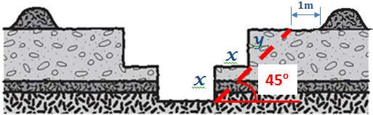 | 4 | 2 | 8 | Supervisor Operator Controller.

Identifying and establishing required levels | - Plant, people interaction  - Slip and trips  - Access and falls | Personal injury | 4 | 3 | 12 | - Machine to cease works and lower ground implements prior to personnel entering excavations/trench  - Personnel entering excavation to enter via provided/designated access.  - Personnel not authorised to be in the area to maintain adequate clearances (5-meter rule) whilst plant is placing or leveling required base materials  - Personnel authorised for the area to maintain clear distances from the operations of plant and extension of the plant with positive communications maintained  - Spotter to manage personnel and plant interaction.  - NO jumping into excavations from any height. | 2 | 3 | 6 | Spotter Operator Personnel
Installation of Temporation works (shoring boxes, sheet piling or PUP | - Incorrect set up of the equipment  - Access and egress  - System failure | - Property damage  - Personnel injury  - Ground collapse | 4 | 4 | 16 | - The selection of equipment is detailed in the Geotech report and per the ground surcharge and KPA ratings describe by the geo tech  - All equipment is to be built as per the equipment manufactures installation guide  - The box is to be driven into the bottom of the excavation  - Appropriate access/egress methods are to use, entry platform, ladder and entry ramp if required  - A minimum of 225mm is to be protruding as a kick board and handrails installed as per the manufactures recommendations  - Ensure the temp works report is completed and available on site  - Any action taken outside of the report, work must stop, and the geo techs consulted  - In an emergency there must be a rescue plan and a means to rescue the worker from inside the box. A davit arm is to be installed and the worker to be wearing a harness or have a rescue stretcher for rescue purposes  - All lifting is to be undertaken by a competent dogmen / rigger | 4 | 2 | 8 | Supervisor /controller/ Pipe Layer
Placement of bedding and overlay | Plant/people interactions\Personal injury  Sun/heat | - Over exertion due to in correct techniques  - Heat stress and fatigue  - Hit by debris/aggregate | 3 | 4 | 12 | - Correct manual handling and shoveling techniques are to be used  - Workers are to rotate their tasks and take regular breaks to manage fatigue and heat stress  - Workers are to be clear of the excavator when aggregate is being installed into the trench  - Controller is to direct the excavator when in use  - Pos comms is to be maintained at all times and when hand signals are used, they are to be agreed before ethe task commences. | 3 | 2 | 6
Lifting and Laying of Pipes | Plant/People/Vehicle Interactions | - Personal injury  - Plant/property damage or interactions  - Equipment damage  - Equipment failure | 4 | 4 | 16 | - All lifting to be undertaken by a competent dogman/rigger  - All equipment to be tested & tagged  - The work area is to be delineated where possible  - The use of a controller/dogman to be used when the excavator is moving or craning pipes  - The controller/dogman is to be easily identifiable by wearing the pink helmet  - The dogman is to undertake a training course to use the pipe lifting finger and pin  - The pipe layer is to use the crowbar to push the pipes home. Any pipe above 600mm diameter is to be installed by mechanical means.  - The pipe layer is to stand clear of the load until it is 300mm above the ground and then moving in to lay it.  - Pos comms is to be used when communicating between the dogman, pipelayer and the operator. Any hand signals are to be agreed before lifting activities commence  - When joining the 2 pipes at installation all hands are to be kept away from pinch points | 4 | 1 | 4

Excavation compacted to required levels | - Vibration of plant  - Sprains and strains  - Failure of equipment  - Fire | Personal Injury Plant & Property Damage | 3 | 3 | 9 | - Prestart inspection to be completed on all equipment prior to use  - Equipment to be turned off and funnel utilised when re-fueling equipment  - Team lifting and mechanical aids to be used for handling of all Wacker packers and vibrating plates  - Correct lifting manual handling techniques to be always used  - Rotation of personnel with the equipment  - Regular breaks to be taken during the task to reduce fatigue and risk of injury.  - Vibration gloves used if required. | 2 | 3 | 6 | Supervisor Personnel
Completion of works | General Shutdown of plant  - Plant left operating without operator present  - Plant not left in secure area  - Uncontrolled movement of plant | Plant damage Vandalism Theft | 3 | 3 | 9 | - Shut down the machine as per OM and SOP.  - Park in designated areas or go line.  - Check and ensure all environmental controls are in place. | 3 | 2 | 6 | Operator Supervisor
Completion of works | - Waste and spoil | Inappropriate disposal | 4 | 3 | 12 | - Work areas are to be kept clean and tidy.  - All rubbish and construction material to be removed from work areas and disposed of appropriately.  - Do not dispose of any material in waterways  - Chemical containers and surface preparation or coating by-products are to be disposed as per the SDS.  - Any spoil going offsite to a place other than landfill requires a BMD Fill Agreement to be in place.  - Any regulated waste must be appropriately transported and disposed of by licenced operators. Waste Tracking Certificates are required to be provided to the Enviro Rep. | 3 | 2 | 6 | All personnel
Emergency | Emergency response on site | Injury Fire Spills  Environmental Harm | 4 | 3 | 12 | - In event of an emergency raise the alarm, “emergency, emergency, emergency” on the nominated UHF channel  - Identify name, location, and incident  - Provide assistance if required and safe to do so.  - First aiders and first aid equipment to be available for all site in all LV’s  - SDS to be available at work locations or plant and vehicles as required  - Spill kit to be available in all service vehicles, chemical storage area, and nominated locations across the works  - All vehicles to be fitted with adequate fire extinguisher | 4 | 2 | 8 | All personnel

Consultation and Review

CONSULTATION - Personnel Consulted during the initial development of this WMS
Position |  |  | Name |  |  |  | Signature |  |  |  | Date
Site Engineer:
Site Supervision:
Site Worker’s Representative:
Site Subcontractor’s Representative:
REVIEW
Review No. | 1 | 2 |  | 3 | 4 | 5 |  | 6 | 7 | 8 |  | 9
Name
Date
Review Comments
WORKERS REVIEW SECTION: Please add in any new work activities that you may require, or any new control measures you may wish to add and contact site Safety / Environmental Representative before commencing this new work activity.
-

Date | Name | Employer | Signature

Date | Name | Employer | Signature

Date | Name | Employer | Signature

Date | Name | Employer | Signature

