BSBITU309
Produce desktop published documents
Learner Workbook



Table of Contents

Table of Contents 1
Candidate Details 2
Assessment – BSBITU309: Produce desktop published documents 2
Competency Record to be completed by Assessor 3
Activities 5
Activity 1A 5
Activity 1B 6
Activity 1C 7
Activity 1D 8
Activity 2A 9
Activity 2B 10
Activity 2C 11
Activity 3A 12
Activity 3B 13
Activity 3C 14
Activity 3D 15
Activity 4A 16
Activity 4B 17
Activity 4C 18
Activity 4D 19
Activity 4E 20
Activity 4F 21
Skills and Knowledge Activity 22
Major Activity 23

Candidate Details

Assessment – BSBITU309: Produce desktop published documents
Please complete the following activities and hand in to your trainer for marking. This forms part of your assessment for BSBITU309: Produce desktop published documents.
Name: Zoe Lwin
Address: 79 Waterview Avenue, Wynnum, 4178
Email: zoejade_98@hotmail.com
Employer: Lwins Cleaning
Declaration
I declare that no part of this assessment has been copied from another person’s work with the exception of where I have listed or referenced documents or work and that no part of this assessment has been written for me by another person.
Signed: ____________________________________________________________
Date: 25/4/2017
If activities have been completed as part of a small group or in pairs, details of the learners involved should be provided below:
This activity workbook has been completed by the following persons and we acknowledge that it was a fair team effort where everyone contributed equally to the work completed. We declare that no part of this assessment has been copied from another person’s work with the exception of where we have listed or referenced documents or work and that no part of this assessment has been written for us by another person.
Learner 1: ____________________________________________________________
Signed: ____________________________________________________________
Learner 2: ____________________________________________________________
Signed: ____________________________________________________________
Learner 3: ____________________________________________________________
Signed: ____________________________________________________________

Competency Record to be completed by Assessor
Learner Name: _______________________________________________________
Date of Assessment: _______________________________________________________
The learner has been assessed as competent in the elements and performance criteria and the evidence has been presented as:
Assessor Initials
Authentic
Valid
Reliable
Current
Sufficient

Learner is deemed: COMPETENT NOT YET COMPETENT (Please circle)

If not yet competent, date for re-assessment: ____________________________________

Comments from Trainer / Assessor:
__________________________________________________________________________________________________________________________________________________________________________________________________________________________________________________________________________________________________________________________________________________________________________________________________________________________
Assessor Signature: ________________________________________________________
Observation/Demonstration

Throughout this unit, you will be expected to show your competency of the elements through observations or demonstrations. Your instructor will have a list of demonstrations you must complete or tasks to be observed. The observations and demonstrations will be completed as well as the activities found in this workbook. An explanation of demonstrations and observations:
Demonstration is off-the-job
A demonstration will require:
- Performing a skill or task that is asked of you
- Undertaking a simulation exercise
Observation is on-the-job
The observation will usually require:
- Performing a work based skill or task
- Interaction with colleagues and/or customers
Your instructor will inform you of which one of the above they would like you to do. The demonstration/observation will cover one of the unit’s elements.
The observation/demonstration will take place either in the workplace or the training environment, depending on the task to be undertaken and whether it is an observation or demonstration. Your instructor will ensure you are provided with the correct equipment and/or materials to complete the task. They will also inform you of how long you have to complete the task.
You should be able to demonstrate you can:
- Prepare to produce desktop published documents
- Set up desktop published document
- Create desktop published document
- Finalise desktop published document.
You will also need to show:
- . Reading
- Writing
- Oral Communication
- Navigate the world of work
- Interact with others
- Get the work done
Activities

Activity 1A
Estimated Time | 15 Minutes
Objective | To provide you with an opportunity to use safe work practices including addressing ergonomic requirements and using work organisation strategies.
Activity | Give examples of the injuries related to computer use.  Regardless of the nature of your job, it is always important to ensure that you carry out work tasks safely. Some common injuries that can be sustained from using computers for an extended period include;  - Repetitive strain injury  - Eye strain and discomfort  - Back problems  Give examples of the ergonomic requirements that may apply to you.  Considering ergonomic requirements can allow for increased efficiency and comfort in the working environment. Some of these which relate to computer use include;  - Avoiding radiation from computer screens  - Chair adjustment  - Footrest  - Lighting  - Posture  - Keyboard, mouse and screen position  How can you minimise your chances of being affected by the radiation coming from your computer screen?  Some ways to decrease exposure to the radiation from your computer screen include;  - Reducing the time spent working at the computer  - Using an LED monitor  - Keeping a safe distance from the monitor  - Using radiation protection on the screen  - Taking regular breaks

Activity 1B
Estimated Time | 15 Minutes
Objective | To provide you with an opportunity to use energy and resource conservation techniques.
Activity | When producing desktop published documents, what energy and resource conservation techniques can you use?  Using energy conservation techniques in the workplace can assist in protecting non-renewable resources avoiding unnecessary waste. In an office, it is beneficial to employ such practices as printing double-sided, recycling/reusing paper for rough drafts and utilising power-saving and energy efficient equipment.  Explain which energy and resource conservation techniques you currently use.  As well as those mentioned above, some other conservation techniques that are encouraged in my workplace include turning off lights and shutting down and unplugging devices when not in use.  How could you improve this?  Wastage of resources is often a result of disorganisation and lack of planning or forethought on a task. Increasing overall efficiency in the workplace can assist in conserving resources. It may also be helpful to track improvement by monitoring usage of energy, water, office supplies etc.

Activity 1C
Estimated Time | 20 Minutes
Objective | To provide you with an opportunity to identify document purpose, audience and presentation requirements, and clarify with relevant personnel as required.
Activity | What documents do you produce within your own organisation?  Some of the documents that are produced within my organisation include calendars, forms, memos, letters, reports, schedules and tables.  Choose one example from your previous answer.  What is the purpose of this document?  Schedules can be used in various formats to present and record information. Within my organisation, weekly work schedules are created to outline and communicate work requirements to employees. Another type of schedule is used to track accounts payable, showing upcoming and paid bills. Business schedules are an important method of maintaining accurate records, and keeping the workplace organised.  Who is the audience?  Desktop published documents such as the schedules previously mentioned contain internal workplace information. Therefore, the intended audience includes employees, and directors. Some of these documents may also have confidentiality requirements.  What presentation requirements should be considered?  Information presented through workplace documents needs to be clear and understandable. As mentioned, weekly work schedules are used to outline work that needs to be completed. A miscommunication through this schedule could mean that important work doesn’t get done properly. Some presentation requirements which could increase clarity would be stating contact details, the use of fonts and sizing and having important points in bold.  Who are the relevant personnel you should clarify these issues with?  Information presented on workplace documents should be clarified with team leaders and directors.

Activity 1D
Estimated Time | 10 Minutes
Objective | To provide you with an opportunity to identify organisational and task requirements for desktop published documents to ensure consistency of style and image.
Activity | Give examples of organisational and task requirements.  When producing documents, organisation guidelines ensure that each document appears professional and provides a clear and positive representation of your company. Some of these task requirements may include;  - Company colour scheme  - Company logo  - Content restrictions  - Templates  - Vital business details such as organisation name, date, time, title, etc.  In relation to the documents you create within your organisation, outline how you ensure consistency.  A way in which consistency is maintained when producing documents is by creating a template that is reused for each similar document created. This means every document has the same properties; styles, layouts, spacing, fonts etc.

Activity 2A
Estimated Time | 15 Minutes
Objective | To provide you with an opportunity to design content structure and layout to ensure information and graphics are arranged according to related topics and in logical sequences.
Activity | What may the process of designing include?  The structure and layout of a document must be designed so that the information and graphics provide a logical presentation of relevant topics.  Well-designed documents may include;  - Balance  - Diversity  - Relative positioning of graphics/headings  - Simplicity  - Text flow  - Typography  Which of these aspects have you used before? Explain how you used it.  When producing documents, I have tried to consider the balance of the layout and the relative positioning of information and graphics. Depending on the type of document, balance may help you achieve symmetry/asymmetry to engage the audience and the positioning of articles on a document can contribute to whether it is logical and easy to understand.  Choose an example of a desktop published document.  What elements within the structure and layout should you consider?  Flyers and other advertising material must catch the eye of the reader and draw their attention to specific points. Therefore, it would be important to consider balance, diversity, and graphic layout.

Activity 2B
Estimated Time | 15 Minutes
Objective | To provide you with an opportunity to select appropriate formatting and create templates or master pages to ensure consistency of design and layout.
Activity | What aspects of a document can ensure consistency within design and layout?  The use of templates can help to ensure consistency in the design and layout of documents. Formatting of a template may include;  - Annotated references  - Borders  - Bulleted and numbered lists  - Captions  - Footnotes  - Indentations  - Page numbers  - Spacings  - Font styles  Using similar formatting layouts may also allow for consistency across other types of business documents.  What elements would you include in a master page?  Effective use of a master page also helps to achieve consistency since objects on other pages always match with the formatting of the master page. Elements to include on this page might be logos, empty text frames, headers, footers, graphic frames or page numbers.  Choose a type of document.  What are the aspects of formatting you should consider?  Letters: When producing business letter, there are various aspects of formatting to consider. To ensure consistency is maintained, you may be required to use organisational task guidelines such as a company colour scheme, company logo, templates and business details such as organisation name, date, time, title etc. Important aspects of formatting might also include  - Footnotes  - Indentations  - Page numbers  - Spacings  - Font styles  When producing a business letter, simplicity, text flow and typography would be important features of structure and layout to consider.

Activity 2C
Estimated Time | 10 Minutes
Objective | To provide you with an opportunity to confirm layout with appropriate person.
Activity | Within your organisation, who do you have to confirm any layouts with?  Depending on the type and purpose of the document, the layout may need to be confirmed with a supervisor, fellow team members, manager, or even a customer.  When confirming the layout with the appropriate person, what communication techniques should you remember?  When consulting with others to confirm a document layout, it is important that the medium used to communicate and the experiences of the listener/speaker do not distort the message. Rather than assuming that the listener knows what you mean, effective communication allows the listener to clearly understand the message. They must feel as though they can provide helpful feedback.

Activity 3A
Estimated Time | 20 Minutes
Objective | To provide you with an opportunity to prepare, format and enter required text.
Activity | Where may your text come from?  Depending on the context of your document, it’s content and the text used may come from a variety of places. It might be supplied by a client, supplied by your supervisor, or created by you.  What is text acquisition?  The method used to create text or import it into a document is known as text acquisition. You have the option of either typing text directly into the document, or creating it else ware and importing it across.  What is text composition?  Text composition relates to how text is arranged on the page. When formatting text, it is important to consider placement, spacing, embellishment and style.  For an example of a type of desktop published document, explain how you might prepare, format and enter the required text.  Document: Promotional material such as advertising flyers.  To produce this document, you would first need to consult with a supervisor or manager to obtain the necessary information. You might discuss details such what is being promoted or how it should be laid out to catch the audience’s attention. After gaining information and text from external sources, some text would need to be composed yourself. Depending on the program used to create the document, the text might then be copied and pasted or transferred into the document. The software would then allow you to manipulate the formatting of the text, and the placement and spacing could be adjusted.

Activity 3B
Estimated Time | 15 Minutes
Objective | To provide you with an opportunity to import text from other applications and resolve any formatting issues.
Activity | What are the two ways that you can import text from other files?  Text can be imported into a document by either copying and pasting the needed text or loading the text file into your desktop publisher.  Describe the steps of importing text from another file.  After text stories have been created in word processor, the following steps are involved when importing a text file.  - Select an empty frame  - Click ‘Insert’ tab and choose ‘text file’/right click the frame and click ‘insert text file’  - Locate and select the desired import file  - Check the ‘retain format’ box to keep the file’s formatting styles  - Click ‘open’  If your imported text doesn’t look right, what should you do?  To resolve formatting issues, you can re-try the importing process using your own converter. If the document still doesn’t look as you expected, you may need to revert to the original word processor document and save it in a different file format.

Activity 3C
Estimated Time | 20 Minutes
Objective | To provide you with an opportunity to scan or import graphics from other applications and resolve any formatting issues.
Activity | What are graphics?  Graphics include anything on the page that is not text, and can also be copied and pasted into a document or loaded into a desktop publisher.  Give examples.  Document graphics include photographs, basic shapes, word art, charts and graphs, artwork, line drawings and clip art.  How can you use a scanner to import images?  To import images using a scanner involves the following steps  - Connect the scanner to your computer and turn on  - Place image face down inside scanner  - Select the ‘scan’ button  - Preview the image  - Locate scanned documents in your software  - Set your scan options  - Scan and save the image  What aspects of your graphics may need reformatting?  If the document doesn’t look as desired, or could be improved, you may need to reformat the size, thickness, position, alignment, dimensions, shadowing, colours, transparency and rotation of your graphics.

Activity 3D
Estimated Time | 25 Minutes
Objective | To provide you with an opportunity to arrange text and graphics according to organisational and task requirements.
Activity | What should a good page layout do?  Effective layout and formatting will create an attractive document which is pleasing to look at and successfully conveys your message to the intended audience.  Give examples of tips that you consider when arranging the text and graphics in your documents.  While there are many things to consider when formatting a document, it is helpful to keep these tips in mind;  - Ensure that all the elements on the page have a visual connection to each other  - Have one strong visual element which draws the main attention  - Maintain balance  - Make use of templates and styles  It is also important to carefully consider the simplicity, text flow, typography, diversity and relative positioning of all formatted elements within the document.  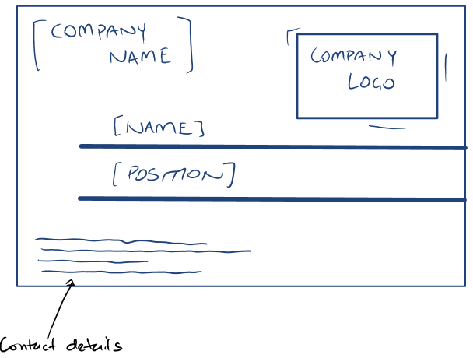  Choose a type of desktop published document.  Use this example to draw a sketch of how you would arrange the text and graphics. List the specific things you have considered.  - Business Card  For this type of document, there may be a template used within an organisation to maintain consistency as well as create familiarity for the audience, allowing them to quickly associate the document with your company. As part of this template, organisational task requirements would include the use of the company name, company logo as well as company colours. For a business card, as seen above, the required text would also include the name of the person, their position within the organisation and contact details. Specific consideration has been given to the design elements of balance, simplicity and relative positioning of objects.

Activity 4A
Estimated Time | 30 Minutes
Objective | To provide you with an opportunity to review text for possible errors and omissions, and resolve any issues.
Activity | Prepare and create a simple desktop published document.  Review the text you have used and identify any errors. How will you resolve these issues?  - Business Letterhead  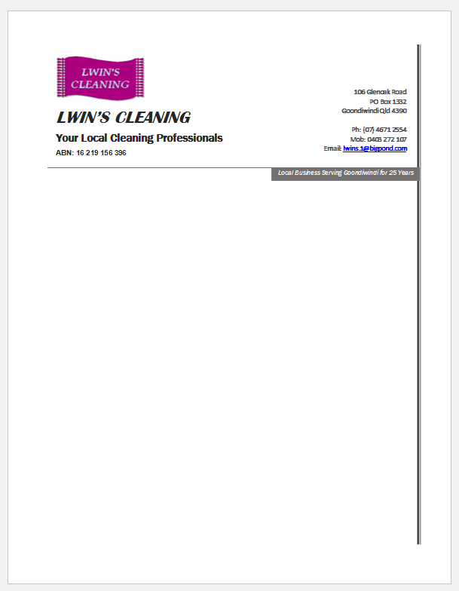  Proofreading text before producing or printing a document is a good way to detect errors in spelling, grammar, language, punctuation, style and layout features. Some ways to improve proofreading are to know what you are looking for, read out load and work in a way that suits you.

Activity 4B
Estimated Time | 15 Minutes
Objective | To provide you with an opportunity to check page order, structure and linkages.
Activity | Use the document you created in Activity 4A. Check the page order, structure and linkages. Describe this process and how you resolved any issues.  After proofreading, it is important to check the page order, structure and linkages within the document. While the document from question 4A is only 1 page in length, it is important when creating a document to ensure pages are in a logical order, so that they are easy to follow. Reviewing the structure involves making sure that all the elements are connected and work together to create stability and form. Linkages must also be checked to ensure that interconnected elements demonstrate a flow of information.

Activity 4C
Estimated Time | 10 Minutes
Objective | To provide you with an opportunity to produce completed document in required format.
Activity | How will you produce your completed document (from Activity 4A) in its required format?  The business letterhead produced in question 4A would be saved as a template so that it could be used for future business correspondence. The contents of each letter would differ depending on the topic and intended audience. The format of the document would need to use company colours, and be printed on an A4 sheet of paper.

Activity 4D
Estimated Time | 25 Minutes
Objective | To provide you with an opportunity to name and store text documents, in accordance with organisational requirements and exit application without information loss/damage.
Activity | Why should you name your document appropriately?  Naming documents appropriately is important as it allows others to relocate the document easily. Document names need to be logically ordered, possibly using the creation date within the document name. An organisation system may be in place for naming documents.  What tips do you keep in mind when naming your documents?  Some tips to keep in mind when naming documents include the use of;  - Keywords  - Name  - Date  - Alphabetical codes  - Version numbers  When naming documents, it is also helpful to be detailed and consistent.  How do you usually store your documents?  Electronical documents and templates are stored in ordered file locations on the computer; a system of folders and subfolders which allow all similar documents to be grouped and sorted. Hard copies of documents are located in a physical filing cabinet.  How can you improve your method?  Some ways to improve storage methods would be to incorporate an authorised access system where security and password protection is employed. Having an organisational policy in place for backing up files would also be useful.  What issues may you face when naming and storing your documents?  Some problems that arise when naming and storing documents may include the use of too many characters, restricted characters, or compatibility issues.

Activity 4E
Estimated Time | 10 Minutes
Objective | To provide you with an opportunity to prepare text documents within designated timelines and organisational requirements for speed and accuracy.
Activity | What is a time line?  Time lines show a sequence of occurrence of key events and tasks. When producing documents, it is important to ensure that they are completed within a designated time period.  What may your designated time line be?  Timelines might be agreed upon between a client, a supervisor or another person requiring the document. Organisational timelines such as deadline requirements may also need to be met.  Give examples of good time management.  Some ways to demonstrate good time management include recording your deadlines and carefully planning your activities as the deadline approaches, prioritising your tasks, tracking your progress, and knowing how to overcome potential problems.

Activity 4F
Estimated Time | 10 Minutes
Objective | To provide you with an opportunity to use manuals, user documentation and online help to overcome problems with document design and production.
Activity | How can manuals help you to overcome problems?  Manuals are designed to give assistance when using a particular system. When produce documents, they may be help the user to understand features of various computer software. Manuals are useful in overcoming problems as they are written in a way which the user can easily understand and often use accompanying mages or diagrams.  How can user documentation help you to overcome problems?  User documentation is provided to assist with a specific program or system. The information provided is often split into 3 categories;  - Installation  - Reference  - Tutorial  How can you find online help to help you overcome any problems?  The internet can be an extremely valuable resource as there is a wealth of information available. Just searching a topic can often provide you with the required instruction to overcome a problem.

Skills and Knowledge Activity
Estimated Time | 45 Minutes
Objective | To provide you with an opportunity to demonstrate your knowledge of the foundation skills, knowledge evidence and performance evidence.
Activity | Complete the following individually and attach your completed work to your workbook.  The answers to the following questions will enable you to demonstrate your knowledge of:  - Reading  - Writing  - Oral Communication  - Navigate the world of work  - Interact with others  - Get the work done  - Identify energy and resource conservation techniques  - Outline organisational requirements for ergonomics, work periods and breaks  - Describe contents and purpose of organisational style guides  - Explain purposes, uses and functions of desktop publishing software  - Outline various formatting styles and their effect on formatting, readability and appearance of documents  Answer each question in as much detail as possible, considering your organisational requirements for each one.  Choose a simple document using desktop publishing.  - Outline the design and layout principles for your chosen document.  Advertisement Flyer:  - Usually a single A4 sheet of paper  - Purpose is to promote business services/products by offering a small amount of information  - Presentation should be relative to the intended audience  - Consider a layout that will catch the eye of the viewer and emphasis important details.  - Produce this document using your keyboarding and literacy skills.  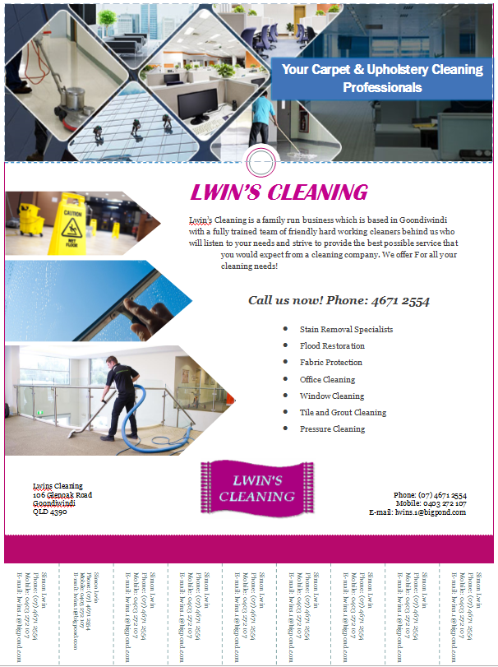  - Clarify the requirements with the relevant person.  Within my organisation, requirements such as the use of business information, and contact details, as well as business colours, logo, fonts, slogans and images needs to be clarified with an office supervisor.  - Proofread your document and edit it accordingly, solving any problems that you have identified.  After reviewing the text by proofreading, issues such as spelling, grammatical and content errors have been resolved. Proofreading also allowed me to consider structure and linkages within the document.  - What energy and resource conservation techniques have you considered whilst developing your document?  While developing this document, I have considered how resources could be conserved by running computers on low power settings, avoiding printing multiple paper drafts and using rough paper to draft designs.  - What are the organisational requirements in place for ergonomics, work periods and breaks?  Within my organisation, office staff using computers for an extended period are required to take short breaks every few hours to avoid injury.  - Are there any organisational style guides that you had to think about? Did they have an effect on your document?  When created my document, I had to consider organisation style guides such as the use of company colours, logos, and fonts. These help the document to portray a professional image and remain consistent with other organisational documentation.

Major Activity
Estimated Time | 1 Hour
Objective | To provide you with an opportunity to demonstrate your knowledge of the entire unit.
Activity | This is a major activity – your instructor will let you know whether you will complete it during class or in your own time.  Attach your completed answers to the workbook.  You must individually, answer the following questions in full to show your competency of each element:  - Prepare to produce desktop published documents  - Set up desktop published document  - Create desktop published document  - Finalise desktop published document.  Prepare, set up, create and finalise a desktop published document.  - Outline how you will use safe work practices when producing your document.  When producing desktop published documents, it is important that your work practices allow you to perform tasks safely. Some safe work practices that help to avoid computer related injuries such as repetitive strain injury, eye strain, and back problems include taking regular breaks, adjusting your seat, desk and computer position to improve comfort, and minimising noise around you. These are actions I will take when producing documents.  - List the energy and resource conservation techniques that you will consider.  Considering how you use non-renewable resources in the workplace will allow you to improve conservation techniques. When producing my desktop published document, some techniques that I will consider include printing double sided, re-using paper for rough draft and selecting power saving options on equipment such as laptops and printers.  - What is the purpose and audience of your document? Outline the presentation requirements.  Depending on the type of document you produce, its purpose may be to give instruction, persuade the reader, provide information or prohibit something. In the instance of a flyer, this would attempt to persuade your audience as well as provide some information about your services and products. My document would need to include presentation requirements such as the use of company colours, various font sizes and backgrounds, a company logo and contact details.  - Identify the organisational and task requirements for your document.  As a business document represents your company, it is important that it conveys the right ‘feel’ and is presented in a professional way. Some tasks requirements that are in place to ensure each document achieves this include the use of a company colour scheme, a company logo, content restrictions, organisational information and design templates.  - How will you design the structure and layout of your content to ensure the information and graphics are arranged according to related topics and logical sequences?  To ensure the information and graphics are arranged logically according to related topics, designs will need to give consideration to balance, diversity, positioning of graphics, simplicity, text flow and typography.  - Explain how you would develop templates or master pages to ensure consistency.  The use of templates and master pages are an excellent way to maintain consistency across a range of documents. If consistency of design is achieved, these templates can become familiar to clients and business contacts, allowing them to associate documents with your company. When developing templates and master pages, designs and layouts might include annotated references, borders, bulleted and numbered lists, captions, footnotes, indentations, spacings, font styles, logos and page numbers.  - Who will you confirm your layout with?  Layouts, designs and content of a document should be confirmed with team leaders, supervisors and directors.  - Describe the process you will through to prepare, format and enter the text you require.  To obtain and prepare the required text, consultation with a client or supervisor may be required. At times, text and document content may be created by the document author. Text can then be created and or imported into the document by using text acquisition techniques; either typing the text directly into a document, or by transferring it across. Formatting your text within a document or text composition, which is where placement, spacing, embellishment and style must be considered.  - How will you import text from other applications?  In most cases, text can be imported by copying and pasting the text into the document, which is method I will use. Another method is to import the text from a word processor file.  - How will you import the graphics that you need?  To import text graphics such as pictures, shapes and charts, you can simply copy and paste your graphics or use a scanner to insert them.  - How will you arrange the text and graphics according to organisational and task requirements?  Text and graphics need to be arranged in a way that created an attractive and effective document; one which is aesthetically pleasing and conveys the intended message to the audience. It is important that the elements within my document arranged so that they are balance, having a visual connection to each other with one central element that draws the focus. According to organisational guidelines, a template may also be required.  - What are your methods for reviewing the text within your document?  Reviewing the text by proofreading allows you to resolve any issues before printing or publishing the document. Some methods that I will use to assist proofreading include reading aloud, knowing what I am looking for, and working systematically.  - What will you check your page order, structure and linkages for?  While proofreading, it is important to check the page order, structure and linkages within a document. The pages need to be in a logical order which is easy to follow and allows the document to flow. When checking the structure, consider whether the elements are connected throughout the document. Finally, linkages or interconnected elements of the document need to demonstrate a flow of ideas and information, leading to a common goal.  - How will you produce your document in the required format?  Depending on the type of document, the intended audience, the topic of discussion as well as organisational requirements, it is important to make various considerations before producing a document. Think about whether it needs to be in colour, on a certain type of paper, if it should be laminated and what size paper should be used.  - Explain how you will name and store your document.  Documents need to be named and stored so that they can be easily located later on. When choosing an appropriate name, consider the use of keywords, names, date, alphabetical codes and version numbers. It is important to ensure that document names are detailed and consistent. A systematic filing system also needs to be in place.  - How will you ensure that you prepare your text documents within the designated time lines?  Some ways I will ensure that timelines are met when producing documents include recording deadlines, prioritising tasks, tracking progress and preparing for problems.  - What will you do if any problems arise?  The best way to approach a problem that arises is to deal with it right away to ensure you stay on track toward deadlines. If you personally don’t feel equipped to address the issue, refer it to someone who will know what to do.

