BSBSMB406A
Manage small business finances

THEORY EXAM INSTRUCTIONS

- This exam will occur under standard assessment conditions.
  - An oral examination may be allowed under certain circumstances.
Answers will be documented and FT003 (Oral examination declaration form) must be completed.
- Participants must provide enough detail in their responses to demonstrate their knowledge and skills.
- Please fill in the details below, providing your name, signature and date of assessment.
  - Your signature acknowledges that this is your own work.
- If a participant initially answers a question incorrectly but modifies their response, they must follow the instructions below:
  - If a participant changes their response in writing, they must put their initials next to the written change.
  - If a participant changes their response verbally, this must be noted on the exam paper by the assessor.

Participant name | Shane Palmer
Participant signature | 

Assessor name
Assessor signature

Date | Click here to enter a date.

Number of questions | Number of questions answered correctly | Satisfactory?
45 |  | Yes | No
ASSESSOR Comments
- What does a financial plan enable you to do in your business?

Answer | A financial plan will enable you to measure your business’s success, control the finances, evaluate the profit and loss and predict the profitability, financial needs and viability.

- List five (5) types of financial information you might need to profitably operate and extend your business in accordance with the business plan.

Answer | Asset registers, bookkeeping/ accounting/ stock/job costing records, business activity statements, cash flow forecasts and financial budgets

- Match the following specialists and the services they can provide to a business by writing the appropriate letter next to each number in the centre column.

Answer | Specialist |  | Answers | Services
 | 1 | Accountant | 1 - D | A | Provides assistance and direction across a variety of business areas, working closely with management.
 | 2 | Broker | 2 - B | B | Works with clients to determine their borrowing needs and ability, selects a loan suited to their circumstances.
 | 3 | Financial advisor | 3 - C | C | Provides advice and services in the form of investment and capital raising advice, insurance and income protection.
 | 4 | Legal advisor | 4 - E | D | Keeps financial records for a business, traditionally in the form of ledgers and journals.
 | 5 | Mentor | 5 - A | E | Can draft contract, provide advice of regulatory issues or protection of intellectual property.

- Briefly explain how personal net worth calculated. Give an example.

Answer | Personal net worth is calculated by working out the difference between what you own and what you owe. An example of this is if you had a house worth $600,000 (asset) and a mortgage of $500,000 (liability), then your personal net worth is $100,000.

- Identify the information required when calculating a budget.

Answer | The information required when calculating a budget are the time frame, fixed costs, variable costs and expected income.

- Explain the process for preparing a cash flow forecast.

Answer | The process for preparing a cash flow forecast is gathering information from your starting cash, cash in and cash out to get your ending cash.

- True or False (Tick your response): Cash flow forecasts are usually carried out at least once during a twelve month period.

Answer |  | True
 |  | False

- Refer to the anticipated figures in the table below to calculate the break even sales amount. Determine whether this business is viable.

Total sales | $180,000
Fixed costs | $ 64,800
Variable costs | $ 78,300
Total costs | $143,100

Answer | The anticipated sales of $180,000 will by far exceed the break even sales of $114,690. The business is viable.

- Refer to the anticipated figures in the table below to calculate the break even sales amount. Determine whether this business is viable.

Total sales | $ 800,000
Fixed costs | $ 559,800
Variable costs | $ 243,300
Total costs | $ 803,100

Answer | The anticipated sales amount of $800,000 will not exceed the break even sales of $804,310. The business is not viable.

- The cost of goods sold (COGS) is the total expense associated with the goods sold in a reporting period.
James has a business selling books on eBay. An inventory count at the beginning of November shows that he has $50,000 worth of inventory on hand. Over the month, he purchases another $14,000 worth of books. His inventory count at the end of November shows that he has $22,000 of inventory on hand.
Using the calculation for COGS (Beginning Inventory + Purchases - Ending Inventory = Cost of Goods Sold) determine the cost of goods sold for James’ business.

Answer | 50,000+14,000 = 64,000  64,000-22000 = 42,000  The COGS for James’s business is $42,000

- Identify the three (3) main methods of pricing products/services by writing the appropriate letter next to each number in the centre column.

Answer | Structure |  | Answers | Taxation requirements
 | 1 | Competition-based pricing | 1 - C | A | Adding together direct costs, indirect costs, profit margin and market price.
 | 2 | Cost-based pricing | 2 - A | B | Consider how much customers are prepared to pay.
 | 3 | Demand-based pricing | 3 - B | C | Charging a price as per market price.

- Name three (3) individuals/parties who should receive financial budgets/projections.
Answer | Banks, creditors, and investors.

- Provide three (3) reasons why you may need to raise business capital.
Answer | To be able to negotiate, secure and manage business capital.

- Which of the following could be a potential financial backer?
Tick all that apply.

Answer | Choice | Possible Answers
 |  | Banks
 |  | Family and friends
 |  | Private investors
 |  | Shareholders

- Which of the following are relevant when negotiating, securing and managing business capital? Tick all that apply.

Answer | Choice | Possible Answers
 |  | Contingency plans
 |  | Necessary experience
 |  | Tested business model
 |  | Tested marketing approach

- True or False (Tick your response): Tax obligations will differ depending on your business structure.

Answer |  | True
 |  | False

- Identify two (2) strategies that could be implemented to make sure your taxation liabilities are met when they are due.
Answer | Regular and accurate accounting procedures and payg instalments.

- Tax obligations will differ, depending on the business’s structure. Match the structures and their taxation requirements by writing the appropriate letter next to each number in the centre column.

Answer | Structure |  | Answers | Taxation requirements
 | 1 | Company | 1 - B | A | Declare business income (or loss) in their personal income tax return and pay tax at individual tax rates.
 | 2 | Partnership | 2 - C | B | A separate legal entity with its own income tax liability. No tax-free threshold.
 | 3 | Sole Trader | 3 - A | C | Must lodge a tax return, but doesn’t pay tax. Those involved pay tax on their share of the income according to individual tax rates.
 | 4 | Trust | 4 - D | D | Holds income for the benefit of others. Generally has no tax liability where the whole of the net income is distributed to adult resident beneficiaries. Each beneficiary pays tax on their share of the income according to individual tax rates.

- What is a credit policy? Identify three (3) points that may be included in a credit policy.
Answer | A credit policy is a set of terms and conditions in a company that is used to determine who can be credited money for goods and services. Three points that may be included are credit limits, collateral and payment options.

- Explain how a credit policy can maximise cash flow.
Answer | By encouraging customers to speed up or increase the amount they’re spending.

- Describe one (1) method you may use to address debtors in default.
Answer | Engage a debt collector to take reasonable steps to secure the payment.

- What purpose do Key Performance Indicators (KPIs) play in managing and monitoring a business?
Answer | Establishing a way to monitor the performance of the business, analyse its stability and determine its viability.

- True or False (Tick your response): Financial plans, strategies and objectives develop over time, so it is inappropriate to continue reporting on the same KPIs as in previous periods.

Answer |  | True
 |  | False

- Explain the seven (7) general characteristics of an effective KPI.
Answer | Characteristic | Explanation
 | Non-Financial | Non-financial measures, not expressed in dollars
 | Timely | Measured frequently
 | Management Focus | Acted upon by management
 | Simplicity | All staff understand the KPI and what corrective action is required
 | Team Orientated | Responsibility can be assigned to a team who work closely together
 | Significant Impact | Has noteworthy effect on the business’s outcomes
 | Encourage Appropriate Action | Has been tested to ensure it has a positive impact on performance

- Why should you consult with relevant stakeholders when developing financial procedures?
Answer | To ensure all the procedures are relevant and understood.

- Explain how you should communicate financial procedures to facilitate implementation of the business plan.
Answer | By putting them in writing and having them readily available to all. Developing training programs for these procedures will also help to communicate.

- True or False (Tick your response): The best way to maintain control of your business is to continuously monitor its financial performance targets.

Answer |  | True
 |  | False

- Identify four (4) points that a financial report should be able to address.
Answer | Is the business making a profit, suffering a loss, and how much?  How do assets stack up against liabilities?  Did the business reinvest all its profit?  Does the business have enough capital for future growth?

Refer to the following financial report to respond to Q29. to Q31.

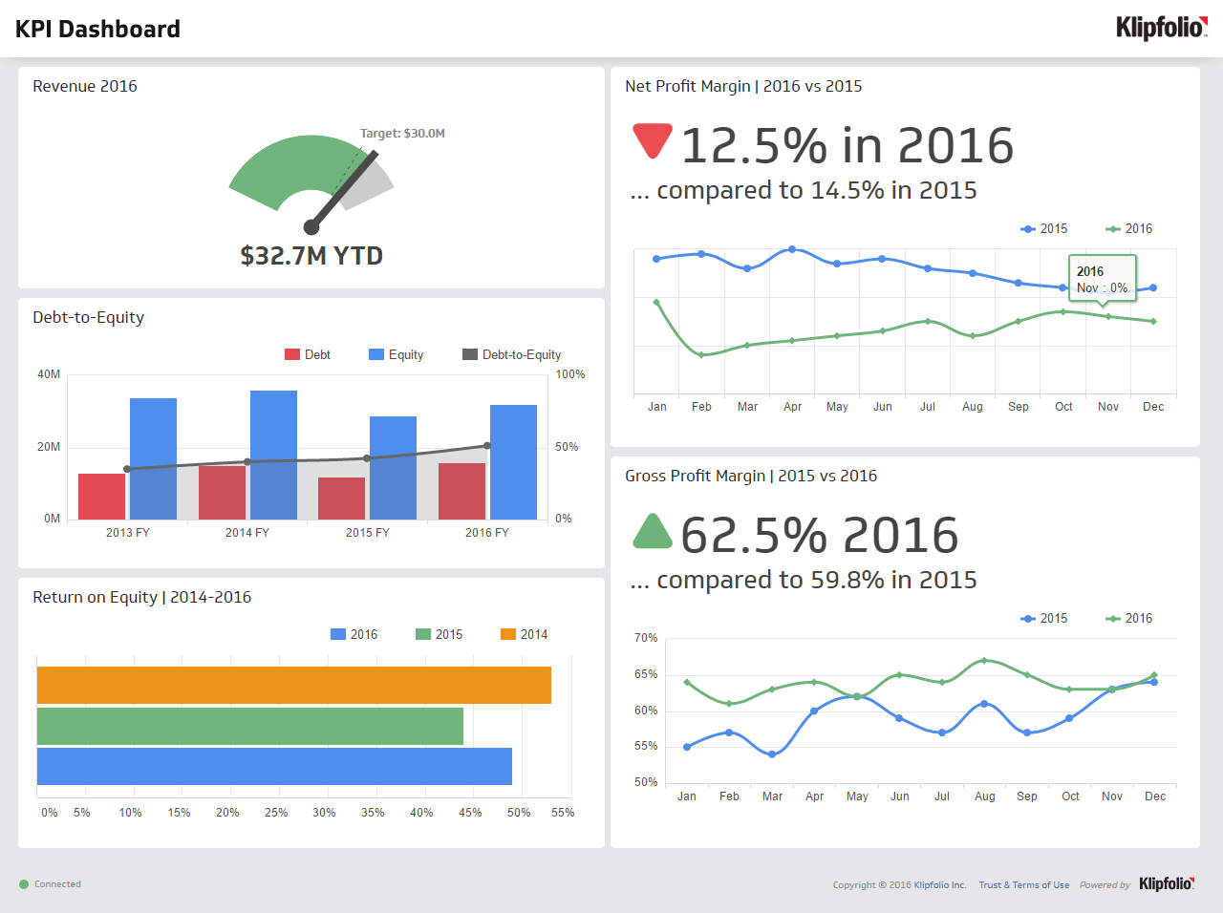
Source: https://www.klipfolio.com/resources/dashboard-examples/executive/kpi-dashboard

- True or False (Tick your response): The target revenue in 2016 was met.
Answer |  | True
 |  | False

- True or False (Tick your response): The gross profit margin for 2016 is better than 2015.
Answer |  | True
 |  | False

- True or False (Tick your response): The net profit margin for 2016 is better than 2015.
Answer |  | True
 |  | False

- How is gross profit determined for a profit and loss statement?
Answer | Total sales minus cost of goods sold

- Name six (6) expenses considered in a profit and loss statement.
Answer | Accountant fees, insurance, superannuation, income tax, wages, and bank interest.

- How is net profit calculated on a profit and loss statement?
Answer | Gross profit minus total expenses.

- Name two (2) current assets and two (2) fixed assets that would be considered when compiling a balance sheet.
Answer | Asset | Examples
 | Current | Cash and inventory
 | Fixed | Leasehold and vehicles

- Name two (2) long-term liabilities and two (2) short-term liabilities that would be considered when compiling a balance sheet.
Answer | Liability | Examples
 | Long-term | Loans and hire-purchase liabilities
 | Short-term | Income tax and accrued wages

- How are net assets calculated on a balance sheet?
Answer | Total assets minus total liabilities

- True or False (Tick your response): You may be legally obligated to perform an annual stocktake based on the stock and size of your business.
Answer |  | True
 |  | False

- You should be able to track in item in your stock by which of the following details? Tick all that apply.

Answer | Choice | Possible Answers
 |  | Applicable tax
 |  | Cost
 |  | Point-of-sale details
 |  | Quantity
 |  | Selling price
 |  | Source of supply
 |  | Stock number
 |  | Stored location
 |  | Unique item number

- Describe the effects that marketing strategies can have on the financial plan.
Answer | they will help your customers understand why your product and services are better than the competitors, reach your target audience, boost customer base, and increase your bottom line.

- Describe the effects that operational strategies can have on the financial plan.
Answer | They will enable you to optimise the use of resources, people, processes, and technology.

- There are some common financial ratios used which allow the financial position of a business to be compared over time. Three (3) of these are working capital, current ratio and quick ratio (or acid test ratio).
The equations and explanations for these follow in the table below:
Financial ratio | How to calculate It | What it tells you
Working Capital | = Current Assets - Current Liabilities | An indicator of whether the company will be able to meet its current obligations (i.e. pay its bills & meet its payroll, make a loan, etc.) If a company has current assets exactly equal to current liabilities. The greater the amount of working capital the more likely it will be able to make its payment on time
Current Asset Ratio | = Current Assets ÷ Current Liabilities | This tells you the relationship of current assets to current liabilities. A ratio of 3:1 is better than 2:1. A 1:1 ratio means there is no working capital
Quick Asset Ratio  (Acid Test) | = (Cash + Temp. Investments + Accounts Receivable) ÷ Current Liabilities : 1 | This ratio is similar to the Current Asset Ratio except that Inventory, Supplies and Prepaid Expenses are excluded. This indicates the relationship between the amount of assets that can be quickly turned to cash versus the amount of liabilities
Using the example company balance sheet on the following page, determine:
- Working Capital
- Current Asset Ratio
- Quick Asset Ratio (Acid Test)

Answer | Item | Calculations
 | Working Capital | 89,000 – 61,000 = $28,000
 | Current Asset Ratio | 89,000 / 61,000 = 1.45
 | Acid Test | (2,100 + 10,000 + 40,500) / 61,000 = 0.862

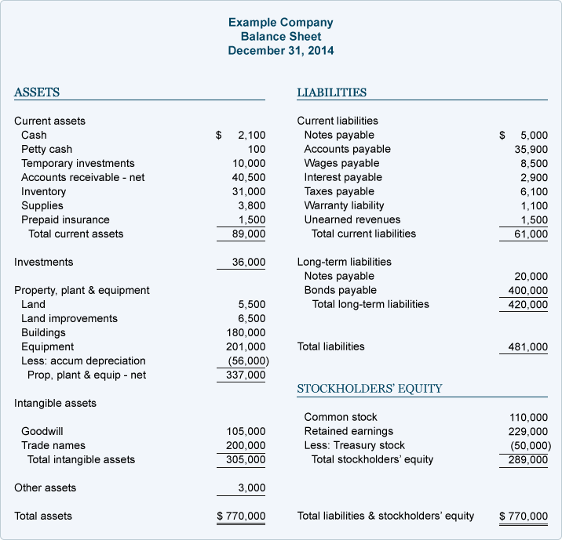

- Name and describe the two (2) types of benchmarks provided by the Australian Tax Office.
Answer | Benchmark | Explanation
 | Performance benchmarks | Financial ranges for your industry to help you work out how you compare to other businesses in your industry and if you need to improve.
 | Input benchmarks | Show an expected range of income for tradespeople based on the labour and materials they use to undertake domestic projects.

- True or False (Tick your response): Comparing your ratios to the benchmark will give you a better idea of how your business is tracking and whether change might be required.

Answer |  | True
 |  | False

- Provide two (2) reasons that might cause you to alter your financial plan.
Answer | Change in market and change in customers

