CPCCBC4012B
Read and interpret plans and specifications

THEORY EXAM INSTRUCTIONS

- This exam will occur under standard assessment conditions.
  - An oral examination may be allowed under certain circumstances.
Answers will be documented and FT003 (Oral examination declaration form) must be completed.
- Participants must provide enough detail in their responses to demonstrate their knowledge and skills.
- Please fill in the details below, providing your name, signature and date of assessment.
  - Your signature acknowledges that this is your own work.
- If a participant initially answers a question incorrectly but modifies their response, they must follow the instructions below:
  - If a participant changes their response in writing, they must put their initials next to the written change.
  - If a participant changes their response verbally, this must be noted on the exam paper by the assessor.

Participant name | Everett Putney
Participant signature | 

Assessor name
Assessor signature

Date | 24/06/2018

Number of questions | Number of questions answered correctly | Satisfactory?
77 |  | Yes | No
Assessor Comments
- What does the term ‘plan’ mean when referencing plans and drawings for construction purposes?

Answer | All of the drawings for a proposed house are known as “plans”. More accurately, a plan is a view which shows the layout or arrangement of rooms and other parts of the interior of a house .

- Name the people and organisations who will have an interest in plans and drawings for a construction project.

Answer | - the client and lending body  - local council  - supply authorities, (water, sewerage, drainage)  - Electrical, gas and cable supply companies  - builders and sub-contractors wanting to quote  - engineers  - Sub-contractors (carpenters, bricklayers, concreters, painters, plasterers)  - real estate agents  - neighbours  - kitchen manufacturers  - landscapers  - various material or product suppliers  - environmental agencies  - mechanical service installers, e.g. air conditioning, fire alarms

- What will plans show to the interested parties?

Answer | - ceiling heights and variations  - doors  - light fittings and power supplies  - services  - wall penetrations  walls

- What types of plans is it necessary to be familiar with for building and construction projects?

Answer | - Block plans  - Site plans  - Floor plans  - Basic floor plan  - General arrangement plans  - Elevations  - Estate road layout

- All plans and drawings give a compass direction.
Which compass direction is always shown and on which drawings is it likely to be found?

Answer | North points indicate the position of north relative to the site or building and are shown on:  - Key plans  - Site plans  - Block plans  - Floor plans

- What does a location plan contain?

Answer | A location plan details the:  - lot number/s  - deposit plan numbers  - north point  - Scale (usually 1:5,000)

- What does a site or block plan contain?

Answer | is usually drawn at 1:500 and gives the following information:  - A datum - reference height to other site levels  - Building orientation to north point  - Outline of site boundaries showing location of proposed building and existing dwellings  - Plan page number, client name, project address, scale, reference numbers and dates  - Major geological and topographical features (trees and vegetation)  - Contours and slopes – 500mm intervals  - Depths where they may occur  - Distance from the boundaries to the building foot print  - Driveways, stormwater drainage, easements and right of carriage  - Soil and surface water drains, pipe sizes  - Service runs from the house to mains - utility services location (sewer, water, gas, electricity)  - New levels on the site in connection with the new house  - Paving  - Retaining walls

- What features would you expect to look for and find on plans and drawings for a construction project?

Answer | Plans generally show:  - the location of various features on the site and illustrate details about the building e.g. construction details for specific trades people  - the height, position and bulk of the building so that council can determine compliance to its codes.  - allow builders and trades people to prepare written quotations. Remember written quotations (quotes) or contracts should only relate to approved building plans. An estimate should be given prior to council approval.  - provide the surveyor with the details ‘to set out’  - illustrate to trades people the structure to be built

- What do floor plans identify?

Answer | The typical layout of a basement, ground or higher floor including flooring, wall types, layout of fixtures and fittings etc

- What are elevation views? What do they provide to the plan reader?

Answer | An elevation is a view you see when standing in front of that wall. It may be multi-storey or single-storey, usually drawn to a scale of 1:100.  Most councils require an elevation from each side of the proposed development and the view is indicated by north, south, east or west - e.g. If the wall is on the west side of the house, it is the west elevation.  Elevations indicate:  - finish to external walls and  - size of windows, doors and balconies

- What is a section?

Answer | A section is a vertical view (slice) through the building. The direction of section lines or arrows is usually shown on the plan to help interpret the sectional view.

- What are detailed drawings?

Answer | There may be times when you need to provide further details of roads, pathways, parking areas, boundaries and landscaping, for example:  - A traffic and parking assessment report provided for all residential, commercial and industrial developments that seek to vary Council’s traffic and parking requirements and other developments involving a change to traffic  - A site plan (a bird’s-eye view of the site) showing the critical adjoining parts of surrounding properties and the locality  - If your application includes the proposal to provide for car parking then you will need to provide detailed plans  - Stormwater Drainage Concept Plan required to show how stormwater will be managed on the site and at a minimum show how it will be collected, conveyed and disposed from the site

- What are specifications?

Answer | Specifications set out the minimum standards or codes necessary to obtain relevant sizes for all structural components and provide details of building materials and fittings, such as:  - windows, frame material and type of glass  - doors, size, material and the swing on the door  - Finishes/colours to walls, floors and ceilings  - door types and models of locks, latches, hinges, push plates and pull handles

- What information will you find in a title block to a drawing?

Answer | Type of drawing  Ratio  Name of builder/architect/contractor  Name of client  Relevant contact details  Revision number

- What is the significance of the Australian Architectural Standards?

Answer | The Australian Architectural Standards details the symbols that must be used in drawings, including the following

- What will you find in the Waste Management Plans & Site Management plans?

Answer | Access & egress paths  Bin locations  Site shed locations  Delivery/laydown locations  Silt fences/boundary/site fences  Washout areas  Areas to be regrown/revegetated

- What is a landscape plan?

Answer | A plan for the site to show what is to be revegetated, planted, removed, irrigated, turfed etc.

- What is the purpose of a shadow diagram? Who primarily would seek one?

Answer | Used to show/calculate the amount of shadow cast by a development. Users would include architect, energy efficiency and acoustic engineers

- What is a bracing schedule?

Answer | Indicates where bracing is required on a development. For example where braces are required for a multi level development before formwork is removed

- What must we do with plans and drawings in our on-site environments? How often should plans and drawings be viewed on site?

Answer | Maintain them correctly and ensure they’re the most up-to-date revision. Should be viewed/referred to every day

- Explain the meaning of the abbreviations in the table below.

Answer | Abbreviation | Meaning
 | ACRYL | acrylic
 | AS | Australian standard
 | ASSD | Assumed datum
 | B | basin
 | BN | Bull nose
 | BTH | Bath
 | BWK | brickwork
 | CB | Concrete block
 | CF | Concrete floor
 | CG | Clear glass
 | CJ | Ceiling joist
 | CORR | corrugated
 | CWT | Cold water tank
 | DG | Double glazing
 | DH | Double hung
 | DPC | Damp proof course
 | DSB | Distribution switch board
 | DW | dishwasher
 | EJ | Expansion joint
 | FPBD | Fibrous plaster board
 | FFL | Finished floor level
 | FHR | Fire hose reel
 | GPO | General purpose outlet
 | HBD | hardboard
 | HTR | heater
 | HWD | hardwood

- Why and when would you use presentation drawings?

Answer | Presentation drawings are drawings used to convey basic design concepts from a design team to the client of other persons.  Presentation drawings are a very important part of public hearings and design reviews as a structure is studied by government and private agencies to determine its impact on the community.  In residential architecture, presentation drawings are frequently used to show compliance with review board standards and to help advertise existing stock plans

- Service drawings provide information about a variety of different components and equipment. In order to identify individual items, it is usual to give them a reference number on drawings such as services layout drawings and location plans.
What details might we expect to see from service drawings?

Answer | - hot and cold water supplies, above and below ground drainage,  - sanitary appliances  - refuse disposal  - Heating  - Ventilation  - air conditioning  electrical installations including lighting, telecommunications, gas installations, fire protection, mechanical conveyors and security systems

- What are working drawings? What do they record?

Answer | - record or explain the appearance and construction of an existing building or sketch  - are used as preliminary construction plans to clarify on-site details not made clear by other drawings

- What is an isometric view?

Answer | Isometric project is a method of showing three faces of an object on one drawing. ‘Isometric’ means equal measure - that is the three lines defining the three faces or planes produce three equal angles using vertical lines, and horizontal lines at 30 degrees to the horizontal

- Sketch a concrete block in isometric view.

Answer

- What is the purpose of perspective projection and representation in drawing of architectural buildings and edifices?

Answer | A perspective is a view that is normally seen by the eye or camera, and is the most realistic form of pictorial. All parallel lines converge at infinite vanishing points as they receded from the observer.

- What is a topographical survey?

Answer | including laser scanning or Lidar provides a robust method for surveying areas to set out the exact position of a proposed structure ensuring the construction is done within the legal boundary preventing any future disputes

- What is an ecological survey?

Answer | identify the habitats and/or species that exist within an area at the time of the survey

- What is significant to keep in mind when developing the Schedule of Quantities (also known as a Bill of Quantities)?

Answer | Where the bill of quantities does not form part of the lump sum contract, the Contractor's obligation to perform the works for a lump sum amount will disentitle it from claiming additional payment for increases in the quantities. However, contractual provisions expressly stating the status of a bill of quantities may or may not be enough to overcome the Principal's potential liability in tort and under statute

- What should be applied in consideration of stress, load and bearing calculations in the design, the drawings and the building of a structure?

Answer | Calculation pertinent to design shall be filed with the drawings and specifications when required.  All building code requirements and calculations for stress and load bearing need to be identified and complied with

- What is a prime cost (PC) item? Give an example.

Answer | A PC item is:  - an amount of money included in a contract sum to purchase a specified item such as tiles, taps, doors or bathroom fittings

- What is a provisional sum (PS) item? Give an example.

Answer | A provisional sum is:  - an amount of money included in contract sum to cover work and/or materials, not detailed when entering the contract  - typically builders will include a PS for site work costs

- Suggest when you would need to provide ‘additional’ plans.
Give some examples of such plans.

Answer | Usually when more detail is required  An example may be a more detailed structural section of a specific load bearing block wall indicating the required steel layout or a sectional drawings of a concrete beam fascia to a carpark level

- How do you identify and record customer variations?

Answer | - Put it in writing  - Client/subbies must agree to before work start  - Only exception for not putting it in writing is if it is not practical to produce a document before work commences (but it then MUST be done within 24 hours)  - All subsequent documentation must be completed by the client/subbies within 5 business days of when the variation was agreed to

- When reading and interpreting (or amending) variations project specifications, what documentation should you also refer to?

Answer | - Plans  - Contract doc  - Engineers details  - Building permits  - Other permits  - Forms the legal documentation for that building

- So you don’t end up in a dispute what strategies can you employ with your customer/client/home owners?

Answer | - It is their responsibility to put variations in writing to you (the builder) as early as possible on paper or by email  - Always put variations in writing  - Changes to any terms, including the cost, must be dated and signed by all the parties to the contract  - Submit an extension of time (for significant change, such as delays caused by owner increasing scope of works)  - Variation payments should be made in accordance with the time stated in the variation document  - Check out page 19 in the Smart Building and Renovating booklet to learn more www.qbcc.qld.gov.au

- Name each of the drawing symbol images shown in the table below.

Answer | Name | Image
 | Double brick construction | 
 | Brick veneer | 
 | Plasterboard wall | 
 | Double hung window | 
 | Single hung window | 
 | Single door opening 90degrees | 
 | Double door both opening 90degrees | 
 | Cavity slider | 
 | Wall hung sliding door | 
 | Electrical outlet | 

- Draw symbols for the following items.

Answer | Item | Drawing
 | Basin
 | Bidet
 | Bath
 | Drinking fountain
 | Sink: Single bowl
 | Sink: Double bowl
 | Tub: Double
 | Tub: Single
 | Drinking trough
 | Hotplates
 | Shower
 | Shower bath
 | Urinal stall
 | Vanity basin
 | Water Closet (Toilet)

- Draw the following window symbols in elevation.

Answer | Item | Drawing
 | Hinged at side
 | Hinged at top
 | Sliding horizontally
 | Fixed

- Draw symbols for the following items.

Answer | Item | Drawing
 | Brickwork
 | Blockwork
 | Concrete
 | Plaster/Render

- Provide a description of the residence shown in the plan drawing below.

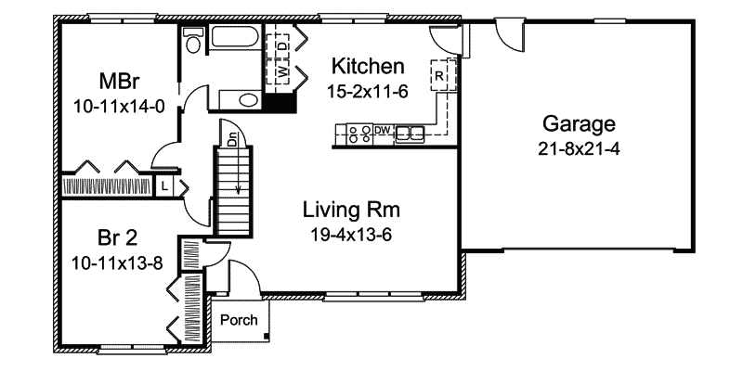

Answer | 2 bedroom brick veneer single level home with double lock up garage, living room and small external porch

Refer to the sectional drawing below to respond to Q43. to Q63.


- Give a brief description about the building from the detail available in the sectional drawing.

Answer | Double story cladded & brick veneer with ground floor living areas and surrounding verandas. Separating the upper level bedrooms

- Who is the client?

Answer | H&M Smith

- Where is this project to be built?

Answer | Lot 16 Glenvalley Road Richmond

- What are the contact details for the draftsman?

Answer | Joe Foreman  Ph: 03 9514 2311  Mob: 0413 113 113  18 Fairview Road, Richmond 3216

- What sheet number is this drawing?

Answer | 5 of 7

- What timber is required for loading and non-load bearing walls?

Answer | F5 45x90 load bearing  F5 35x90 non-load bearing

- What spacing is recommended for common studs?

Answer | 600 max

- What type of roof truss is to be installed?

Answer | Scissor truss

- What centres are the trusses positioned at?

Answer | at 900 spacing

- What size are the veranda posts?

Answer | 90x90

- What timber species are the veranda posts to come from?

Answer | Oregon

- What pitch is the roof?

Answer | 30 degrees

- What size are the noggings and at what spacing?

Answer | 35x70 @ 1350 max spacing

- What size are the ceiling joists?

Answer | intermediate

- What timber is used for roof battens and what spacing?

Answer | 35x70 FC Pine @ 900 spacing

- What thickness is the plasterboard sheeting?

Answer | 10mm

- What type of flooring is to be installed?

Answer | 15mm plywood

- What is the roof cladding material?

Answer | Colorbond corrugated metal roof

- Where will you find information about the footings?

Answer | Structural engineering drawings

- What do the letters DAR refer when timber ordering?

Answer | That the timber is dressed or planed smooth on all sides

- Explain 240 x 63 LVL. What does it refer to on the section?

Answer | 240 h by 63 wide laminated veneer lumber. A high strength engineered wood product usually used for structural beams.  On the section drawings it looks to be referring to a ‘starting joist’ or pole plate for the lower veranda roof

Refer to the drawing overleaf to respond to Q64. to Q75.

- What is the number of the drawing?

Answer | 2

- What is the Job Number?

Answer | OOR-112

- What is the scale of the drawing?

Answer | 1:100

- What does the drawing show?

Answer | Elevations of a single story, DLUG, tile roof dwelling

- Which view shows the front of the house?

Answer | East

- How many motor vehicles can be parked in the garage?

Answer | 2

- What are the window and doors made from?

Answer | Aluminium framed

- What is the size of the eaves?

Answer | 450mm

- What are the eaves lined with?

Answer | SOFFITS are lined with Hardiflex

- What type of roof structure is the roof built from?

Answer | Timber framed trusses at 600 centres

- What is the roof cladding materials made from?

Answer | concrete roof tiles

- What is the roof pitch?

Answer | 22.5



- You have spoken with a client on the phone and they are seeking to make amendments to some plans. They wish to add two more bedrooms to extend their home from the current four bedrooms to six bedrooms.
The two new bedrooms are to both have ensuites (including single shower in each, double bowl vanity unit and under cupboard and toilet) with walk in robes, including the extension of the existing hallway with built-ins for the existing Bed 1 and Bed 2. The Family Room is to be extended to the rear wall in line with kitchen rear wall.
The client has faxed through the image below. Re-sketch and redesign the drawing and add the two new bedrooms along with extended hallway, ensuites, walk-in robes and the Family Room extension for consideration by the client.
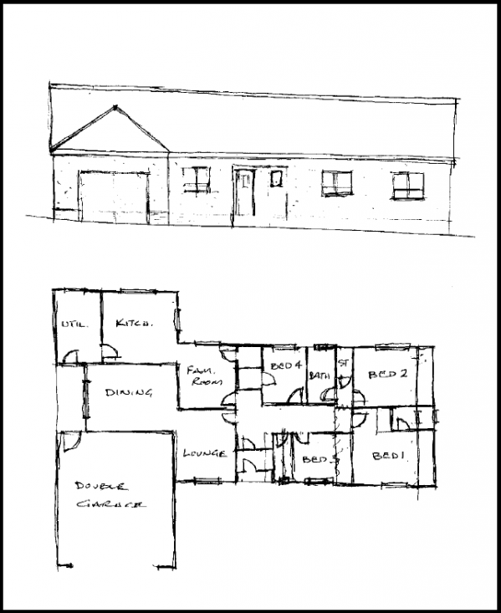
SKETCH

Answer

- Referring to Q76. compose an email to the client, providing an estimate of the additional labour hours/costs and material quantities/costs that have resulted from the their request.

Answer | Dear H & M Smith,  Regarding your recent request to alter your house plans to include the following:  - 2 x additional bedrooms consisting of Ensuites and walk in robes  - Extension of the family room to align with the kitchen rear wall  I have calculated an additional cost of $18,950.00 in materials and $2,440.00 in labour to complete the works.  Subtotal $21,390.00  GST $2,139.00  Total $23,529.00  Additional recommendations:  - Create an open plan of the kitchen, family room, dining and lounge to create an open feel upon entering the residence  - Structural load bearing concrete pillars throughout the open plan area  I have calculated a cost saving of $2,290.00 to remove the walls/frames from the original price and replace with structural concrete pillars. A further cost saving may apply should you wish to investigate block pillars or a light gauge structural steel depending on the requirements of the structural engineer.  This quote is valid for 30 days and subject to the QBBC and BCIPA Acts. Please do not hesitate to contact me if you have any questions.  Sincerely  EP DEEESIGNS

