CHCECE013
Use information about children to inform practice
Learner Workbook



Table of Contents

Table of Contents 2
Candidate Details 3
Assessment – CHCECE013 Use information about children to inform practice 3
Competency Record to be completed by Assessor 4
Activities 6
Activity 1A 6
Activity 2A 7
Activity 2B 8
Activity 3A 9
Activity 4A 10
Activity 4B 11
Skills and Knowledge Activity 12
Major Activity 15

Candidate Details

Assessment – CHCECE013 Use information about children to inform practice
Please complete the following activities and hand in to your trainer for marking. This forms part of your assessment for CHCECE013 Use information about children to inform practice.
Name: Jaide Miller
Address: _____________________________________________________________
_____________________________________________________________
Email: _____________________________________________________________
Employer: _____________________________________________________________
Declaration
I declare that no part of this assessment has been copied from another person’s work with the exception of where I have listed or referenced documents or work and that no part of this assessment has been written for me by another person.
Signed: ____________________________________________________________
Date: ____________________________________________________________
If activities have been completed as part of a small group or in pairs, details of the learners involved should be provided below;
This activity workbook has been completed by the following persons and we acknowledge that it was a fair team effort where everyone contributed equally to the work completed. We declare that no part of this assessment has been copied from another person’s work with the exception of where we have listed or referenced documents or work and that no part of this assessment has been written for us by another person.
Learner 1: ____________________________________________________________
Signed: ____________________________________________________________
Learner 2: ____________________________________________________________
Signed: ____________________________________________________________
Learner 3: ____________________________________________________________
Signed: ____________________________________________________________

Competency Record to be completed by Assessor
Learner Name: _______________________________________________________
Date of Assessment: _______________________________________________________
The learner has been assessed as competent in the elements and performance criteria and the evidence has been presented as;
Assessor Initials
Authentic
Valid
Reliable
Current
Sufficient

Learner is deemed: COMPETENT NOT YET COMPETENT (Please circle)

If not yet competent, date for re-assessment: ____________________________________

Comments from Trainer/Assessor:
__________________________________________________________________________________________________________________________________________________________________________________________________________________________________________________________________________________________________________________________________________________________________________________________________________________________
Assessor Signature: ________________________________________________________
Observation/Demonstration
Throughout this unit, you will be expected to show your competency of the elements through observations or demonstrations. Your instructor will have a list of demonstrations you must complete or tasks to be observed. The observations and demonstrations will be completed as well as the activities found in this workbook. An explanation of demonstrations and observations:
Demonstration is off-the-job
A demonstration will require:
- Performing a skill or task that is asked of you
- Undertaking a simulation exercise
Observation is on-the-job
The observation will usually require:
- Performing a work based skill or task
- Interaction with colleagues and/or customers
Your instructor will inform you of which one of the above they would like you to do. The demonstration/observation will cover one of the unit’s elements.
The observation/demonstration will take place either in the workplace or the training environment, depending on the task to be undertaken and whether it is an observation or demonstration. Your instructor will ensure you are provided with the correct equipment and/or materials to complete the task. They will also inform you of how long you have to complete the task.
The learner will need to demonstrate they can:
- Gather information about the child through observation
- Gather information about the child from secondary sources
- Record observations appropriately
- Use observations and information collected to contribute to program planning
The learner will also need to show their:
- Language skills
- Literacy skills
- Numeracy skills

Activities

Activity 1A
Estimated Time | 40 Minutes
Objective | To provide you with an opportunity to observe, listen and talk with children for sustained periods of time; pay close attention to what the child is saying and doing, and identify their interests, ideas, knowledge and skills.
Case Study and Activity | Individually, in pairs or in groups, complete the following:  You are the new educator in a room. Your lead educator has told you that 4-year-old Susan is struggling to make friends and has asked that you observe her for 1 week.  Outline your plan on how and when you will observe her for 1 week. Be sure to include ways you will pay close attention to what she is saying and doing in order to identify her interests, ideas, knowledge and skills as part of your observation.  - Drop offs and pick up’s  - Going outside  - Change of rotation  - Eating  - Playing with other people

Activity 2A
Estimated Time | 30 Minutes
Objective | To provide you with an opportunity to use child records to collect information about each child.
Activity | Individually, in pairs or in groups, complete the following:  Create a basic template you could use to record the lessons you conduct.  Consider including:  - Different categories of lessons  - Columns for language, mathematics, science, social studies, physical education and social skills.  - Tick boxes when a lesson is given, and make a note of how it went  - Space for comments or observations to reflect what you see in the child as an individual  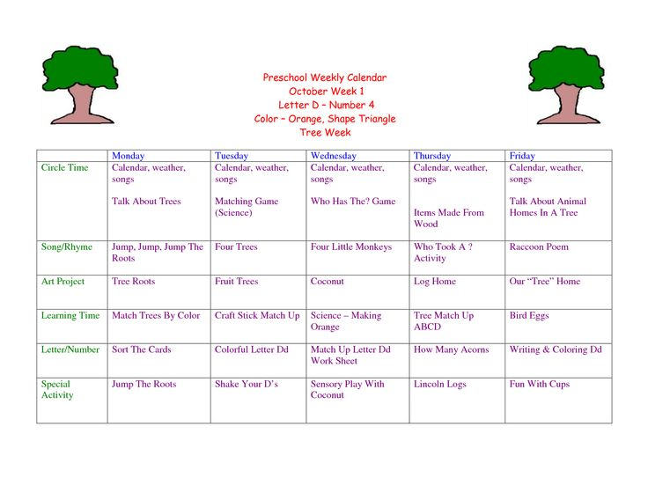

Activity 2B
Estimated Time | 20 Minutes
Objective | To provide you with an opportunity to collaborate with family and other educators to collect information about each child’s needs, interests, skills and cultural practices.
Activity | Individually, in pairs or in groups, complete the following;  Think about your setting and the issues or concerns you most frequently encounter. Develop a short questionnaire to give families in order to collect information about each child’s needs, interests, skills and cultural practices that will inform your program.  - How long do you expect to be needing child-care?  - Does your child have any known health issues?  - Does your child have any special needs (religious, food allergies, etc.)?  - Are you (or a designated person) able to pick up the child in case of accident or emergency?  - What is your child interested in?  - What type of eater is your child?  - What type of sleep schedule does the child have?  - Does your child have any behavioural problems?  - What are your expectations of a day-care provider?  - Do you have back-up care?  - Are you willing to sign a contract?

Activity 3A
Estimated Time | 30 Minutes
Objective | To provide you with an opportunity to ensure information collected through observation and secondary sources is discussed with relevant people and recorded accurately in accordance with service requirements, and ensure discussion and recording of information is free from biased comments and negative labelling of children.
Activity | Individually, in pairs or in groups, complete the following;  Your lead educator has given you a compilation of information about a specific child to review. You find the information to be biased and depict the child in a very negative way. You think back to your own casual observations of the child, and think there must be some mistake. What do you do? How would you go about rectifying the situation?  - Tell the lead educator that you want to observe the child for a few hours a day  - Ty and have an unbiased point of view on the child when observing them  - Write down notes on the child when they are being observed

Activity 4A
Estimated Time | 20 Minutes
Objective | To provide you with an opportunity to use information gathered about the child to contribute to the planning of programs that promote children’s learning and development.
Activity | Individually, in pairs or in groups, complete the following;  Come up with 2 of your own examples of how information about children contributes to planning. Provide details.  - A boy in my room called Richard has a lot of trouble with jumping. His previous educator who had him before he got moved up said they tried making activities to help him but was just not getting anywhere and he was starting to get scared when he jumped. I thought it would be good to keep trying different activities to build his courage to start jumping again and put most my focus on him and help him if he asks for it  - A few girls in my group likes to play with babies and pretend that they are going for walk when they cry, some of the other girls enjoy spending time with their friends and play babies with them but they don’t like the things they do and just sits there and watches them. I thought it would be good to encourage them to play with them or give them another thing to do with the baby such as changing nappies, putting them to sleep or feeding them a bottle

Activity 4B
Estimated Time | 20 Minutes
Objective | To provide you with an opportunity to use information gathered about the child to ensure interactions are responsive and respectful of the individual child.
Case Study and Activity | Individually, in pairs or in groups, complete the following;  You notice a child usually jumps around the room when he is excited and has a difficult time stopping. What can you do with this information to help him in a responsive and respectful way?  I could kindly ask him if he wanted to do a quiet activity and/or read him a book and have a conversation with him to calm him down  You notice a child is extremely shy whenever a new person enters the room, even if she has seen that person a number of times. What can you do with this information to help her in a responsive and respectful way?  I would hold Lachlan ‘s hand and calmly take him up to the person and introduce him to them but not get angry if she gets too scared.

Skills and Knowledge Activity
Estimated Time | 60 – 120 Minutes
Objective | To provide you with an opportunity to demonstrate your knowledge of the required skills, knowledge and critical aspects of the assessment.
Activity | This is a major activity – your trainer will let you know whether you will complete it during class or in your own time.  Complete the following individually and attach your completed work to your workbook.  Complete this activity individually, using a computer.  Successful completion of this activity will enable you to demonstrate your skills and knowledge of:  - How to access:  - The National Quality Framework  - The National Quality Standards  - The relevant approved learning framework  - How to navigate through standards and framework documents to find areas relevant to this unit of competency  - United Nations Convention on the Rights of the Child  - Code of ethics  - Reflective practice  - Child development, in order to analyse information and plan accordingly  - Observation techniques  - Report-writing standards and protocols relevant to the context of observation reports  - Organisational standards, policies and procedures  - Writing reports that record observations accurately and respectfully to the level of detail expected in the service  Answer each question in as much detail as possible, considering your organisational requirements for each one.  - National Framework and Standards  Locate and use the following documents:  - National Quality Framework  - National Quality Standards  - The relevant approved learning framework  - United Nations Convention on the Rights of the Child  - Your organisation’s standards, policies, procedures and guidelines  - Code of ethics  Outline what each of these standards specifically say about ensuring educators:  - Gather information about the child through observation  - Gather information about the child from secondary sources  - Record observations appropriately  - Use observations and information collected to contribute to program planning  - Research and summarise the following:  - Child development, in order to analyse information and plan accordingly  - Observation techniques  - Report-writing standards and protocols relevant to the context of observation reports  - Write a reflection about recording observations accurately and respectfully in reports. Why can this be challenging? Discuss any biases you have and how they could affect your reports.

Major Activity
Estimated Time | 120 Minutes
Objective | To provide you with an opportunity to revise the unit.
Activity | This is a major activity – you are required to complete part of this activity in your work placement. If this is not possible, discuss other options with your assessor.  You must individually, answer the following questions in full to show your competency of each element;  - Gather information about the child through observation  - Gather information about the child from secondary sources  - Record observations appropriately  - Use observations and information collected to contribute to program planning  Individually, complete the following and present it as a portfolio;  Use a computer to complete this report.  Observe, document and analyse information about a child in your setting. You will need to discuss this activity with your nominated supervisor. It is essential you keep all information confidential. Be sure you remove all child-identifying information.  - Gather and record information using:  - Observations  - Questioning  - Discussion with families  - Anecdotal information  - Learning stories  - Jottings  - Digital images  - Samples of children’s work  - Analyse observations of the child’s behaviour, including:  - Aspects of child’s development  - Knowledge, ideas, abilities and interests  - Social interactions  - Reactions to play environment  - How will you use this information to contribute to program planning?  - How would you share the information you have gathered with the child’s family as well as other educators?

