As part of our commitment to continual improvement across our HSEQ systems, we met with the project teams and the Systems Committee to review our current processes for the use, handling, and storage of hazardous substances.

After a thorough review of our hazardous substance processes, we have implemented a new software to improve how we manage and maintain our hazardous substances.

As such, all McIlwain workplaces will now have access to and shall use Chemwatch for:
- Creating and maintaining SDS Registers
- Conducting and managing Hazardous Chemical Risk Assessments

If you are required to use a hazardous substance at any of our workplaces, please ensure you have access to the relevant SDS via Chemwatch.
Access to Chemwatch is available via the QR Code or via the mobile phone app (on iOS and android).

To provide easy access to Chemwatch, the attached poster has been developed and shall be posted wherever chemicals are stored.


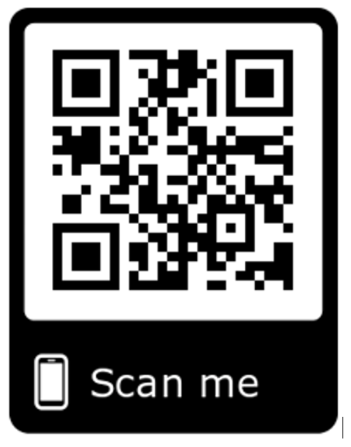
For more information on the updated hazardous substance processes, please speak to a project Safety Advisor.

