BSBPMG407A
Apply risk management techniques

THEORY EXAM INSTRUCTIONS

- This exam will occur under standard assessment conditions.
  - An oral examination may be allowed under certain circumstances.
Answers will be documented and FT003 (Oral examination declaration form) must be completed.
- Participants must provide enough detail in their responses to demonstrate their knowledge and skills.
- Please fill in the details below, providing your name, signature and date of assessment.
  - Your signature acknowledges that this is your own work.
- If a participant initially answers a question incorrectly but modifies their response, they must follow the instructions below:
  - If a participant changes their response in writing, they must put their initials next to the written change.
  - If a participant changes their response verbally, this must be noted on the exam paper by the assessor.

Participant name | Justin Sehan
Participant signature | 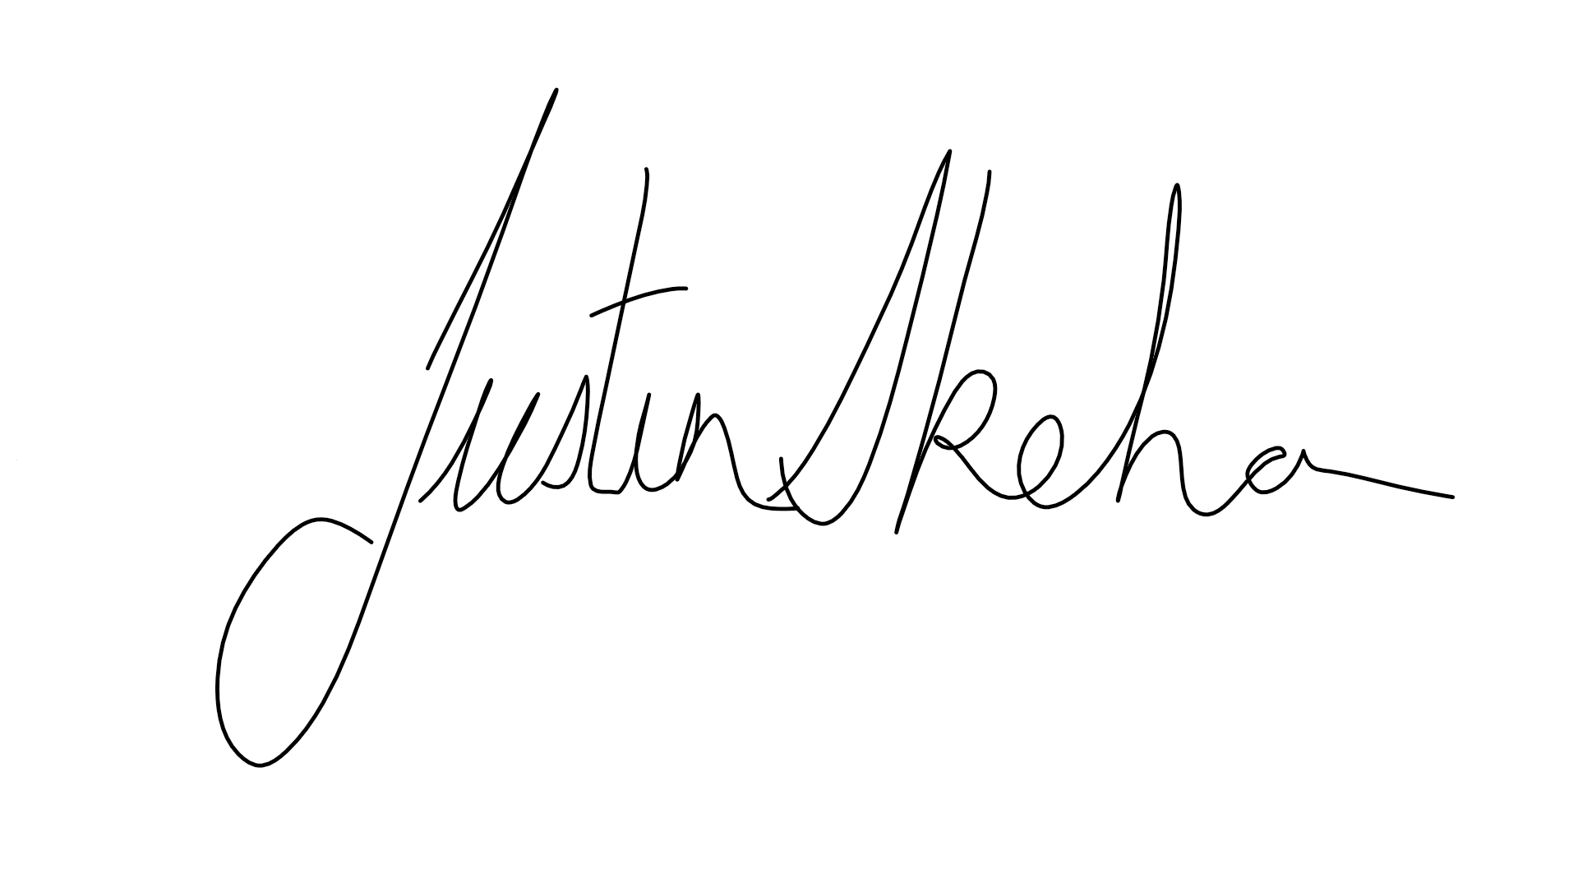

Assessor name
Assessor signature | 

Date | 25/09/2018

Number of questions | Number of questions answered correctly | Satisfactory?
16 |  | Yes | No
Assessor Comments
- Describe a project below. Conduct a SWOT analysis for the project. Identify at least two (2) points per area.

Project description | Construct a 3 Bedroom Lowset Rendered block home with Colorbond roof and landscaping in 20-week contract period

Answer | Area | Detail
 | S | Ideal type of construction  Suits Budget and cashflow capabilities
 | W | Busy Schedule  Distance from site
 | O | Complete project before deadline  Scheduling
 | T | Delays weather coming into rainy season  Variations

- Consider the project you identified in Q1. For each of the areas identified in the table below, identify one (1) risk that may arise.

Answer | Area | Project risk
 | Environmental | Time overruns due to inclement weather
 | Finance | Cashflow pressure
 | Human resources | Staff Turnover
 | Legal | Contract breach
 | Technology | Mobile phone service on site

- Using ticks, identify whether each of the risk analysis methods listed below is either ‘qualitative’ or ‘quantitative’.
Answer | Qualitative | Quantitative | Method
 |  |  | Analyses expected monetary value
 |  |  | Considers likelihood of occurrence and impact on projective objectives
 |  |  | Ranks risks

Refer to the Risk Matrix below when responding to Q4.

Matrix | A:  Catastrophic | B:  Major | C:  Moderate | D:  Minor | E:  Insignificant
1: Almost certain | E | E | H | H | M
2: Likely | E | H | H | M | M
3: Occasionally | H | H | M | M | L
4: Unlikely | H | M | M | L | L
5: Rare | M | M | L | L | L

E: Extreme | H: High | M: Medium | L: Low

- Referring to your responses in Q2. rate each of the risks you identified using the Risk Matrix shown above. Identify the Likelihood and Impact you have determined, plus the overall risk rating.
Prioritise each risk from 1 to 5 (1 = highest priority, 5 = lowest priority).

Answer | Area | Risk rating | Priority
 | Environmental | Likelihood: Almost certain  Impact: minor  Risk rating: high | 4
 | Finance | Likelihood: occasionally  Impact: major  Risk rating: high | 1
 | Human resources | Likelihood: Likely  Impact: minor  Risk rating: medium | 3
 | Legal | Likelihood: Rare  Impact: moderate  Risk rating: low | 5
 | Technology | Likelihood: likely  Impact: moderate  Risk rating: high | 2

- Order the elements of the hierarchy of control, from 1 to 6 (i.e. most effective to least effective).

Answer | Label (1 – 6) | Element
 | 3 | Isolate the hazard
 | 6 | Provide and use Personal Protective Equipment (PPE)
 | 1 | Eliminate the hazard
 | 4 | Control the hazard by engineering means
 | 5 | Control the hazard by administrative means
 | 2 | Substitute the hazard

- Referring to your responses in Q2. propose one (1) risk control for the risk identified in each of the areas listed below.

Answer | Area | Risk control
 | Environmental | Allowance in contract for weather
 | Finance | Accurate project schedule, overdraft in place
 | Human resources | Labour hire
 | Legal | Ensure specifications are met and inspections past
 | Technology | Arrange for set contact times if working out of range

- Which of the following parties should be consulted and agree to proposed risk managed strategies, plans and reporting mechanisms? Tick all that apply.

Answer | Choice | Possible Answers
 |  | Project manager
 |  | Project specialist
 |  | Team members

- True or False (Tick your response): Organisations all use the same risk analysis methods, techniques and tools.

Answer |  | True
 |  | False

- Identify the four (4) options that may be followed once you have established the revised risk level.

Answer | - Do nothing: If the initial risk level is acceptable  - Implement risk controls: If the controls bring the revised risk level to an acceptable level  - Reassess the risk: If the revised risk level is still too high, you need to determine better ways to mitigate the risk  - Accept the risk: If the initial risk is high, but the costs needed to reduce the risk exceeds the cost of the impact of the risk itself

- What is the name of the risk level measured after risk controls have been implemented? Tick all that apply.

Answer | Choice | Possible Answers
 |  | Initial risk
 |  | Revised risk
 |  | Residual risk
 |  | Updated risk

- On what document should incidents be recorded?

Answer | They should be reported on a issue register or incident report

- What is to be completed when a variation is to be made to the project?

Answer | You will need to complete a Change Request

- True or False (Tick your response): You should report opportunities for action in the same way as risks.

Answer |  | True
 |  | False

- Identify two (2) types of documents that may be referred to when conducting a review of a risk management plan.

Answer | Project files and records  Risk diaries, incident logs, occurrence reports

- Explain the relevance of evaluating project outcomes (e.g. agreed major milestones) as part of reviewing risk management activities.

Answer | It is important project outcomes and milestones are continuously reviewed to determine the effectiveness of risk management activities

- True or False (Tick your response): You may refer to past projects for lessons learned regarding risk management, even when the past projects are not identical to the current one.

Answer |  | True
 |  | False

