BSBWHS415
Contribute to implementing WHS management systems
ASSESSMENT SUMMARY

The assessment activities for BSBWHS415 Contribute to implementing WHS management systems cover all aspects of the unit of competency required. To demonstrate competence in this unit, a participant must undertake all tasks and complete them satisfactorily and consistently. For Apprentices and Trainees, this includes employer completion of the Employer Record Book (ERB).

Participants must read all the information given before starting any assessment task. The assessment tasks are intended to be equitable, fair and flexible. If a participant has any questions or requires alternative arrangements to be made such requests should be directed to their Trainer/Assessor, who should note such arrangements in the ‘Assessor Comments’ on the affected assessment. If a participant feels they are not yet ready to be assessed, they should discuss their options with their Trainer/Assessor.

To satisfactorily complete the assessment, the participant is required to answer all questions correctly and demonstrate their skills to industry standards. If a participant does not answer some questions or perform some tasks, they will be deemed ‘Not Satisfactory’ for the task and ‘Not Yet Competent’ for the unit of competency. The Trainer/Assessor is able to provide the participant with additional information on interpreting the assessment outcomes and provide guidance on the participant’s options. Should a participant still be deemed ‘Not Satisfactory’ they will have the opportunity to undertake a supplementary assessment or appeal the result.

By signing the cover page for each assessment item, the participant acknowledges they understand the assessment instructions and requirements and consent to being assessed. The participant also verifies and assures the RTO that the work submitted is their own work.

Participant Name | Brenton Judge

Task | Assessment Results
Workbook | Satisfactory | Not Yet Satisfactory
Quiz | Satisfactory | Not Yet Satisfactory
Practical Assessment | Satisfactory | Not Yet Satisfactory
Outcome for Unit of Competency | Competent | Not Yet Competent

Assessor Name
Assessor Signature | 
Unit Competence Determination Date | Click here to enter a date.

BSBWHS415
Contribute to implementing WHS management systems

WORKBOOK INSTRUCTIONS

- This workbook will occur under standard assessment conditions.
  - An oral assessment may be allowed under certain circumstances, whereby the Participant’s answers will be documented by a party other than the Participant. This must be acknowledged in writing (e.g. FT001 and Assessor Comments)
- Participants must provide enough detail in their responses to demonstrate their knowledge and skills.
- Please fill in the details below, providing your name, signature and date of assessment.
  - Your signature acknowledges that this is your own work.
- Assessors are to complete marking in pen of a different colour to the Participant.
- If a Participant initially answers a question incorrectly but modifies their response, they must follow the instructions below:
  - If a Participant changes their response in writing, they must put their initials next to the written change.
  - If a Participant changes their response verbally, this must be noted on the document by the assessor.

Participant name | Brenton Judge
Participant signature | 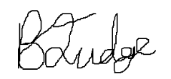
Date | 28/02/2024

Assessor name
Assessor signature
Date | Click here to enter a date.

Number of activities | Number of activities answered correctly | Task outcome (Tick)
3 |  | Satisfactory | Not Yet Satisfactory

ASSESSOR Comments
NOTE

At times, you will be provided with a specific business context to which you must respond, otherwise it is anticipated that you will use a workplace of your choosing (your own, or hypothetical) to provide the context to the task.

At all times, the responses in your assessment must reference Australian (Queensland or Federal) documentation, including legislation, regulations, codes of practice, standards and guidance publications.

For the following activities, you will assume the role of a workgroup supervisor in a workplace of your choosing (see example organisational chart below).

Name a workplace and workgroup that you are (or hypothetically are) the supervisor for:

Name of workplace | Central Highlands Regional Council
Workgroup | Construction Management Services

There are various legislative documents, standards and guidance documents to assist with the development and implementation of a WHSMS.

Summarise what the following documents address (e.g. duties) with respect to a WHSMS:
- Work Health and Safety Act 2011 (Cth)
- Work Health and Safety Act 2011 (Qld)
- Work Health and Safety Regulations 2011 (Qld)
- A code of practice relevant to your chosen workplace regarding risk assessment
- Australian Standard AS/NZS ISO 45001:2018
- The ‘Safety Management System Audit Report’ from the Queensland Regulator, Workplace Health and Safety Queensland (refer to Handout 1)
- Organisational policies regarding return-to-work and injury management
- Organisational procedures regarding return-to-work and injury management
- Organisational process regarding return-to-work and injury management

 | Summary of contents
- Work Health and Safety Act 2011 (Cth) | The Work Health and Safety Act 2011 (Cth) is a nationalised standardisation surrounding the WHS Act. This standardisation and overarching act ensures that the framework and requirements of a Work Health & Safety Management System are consistent and aligned across each state in Australia.  It addresses how the holistic process of how WHS should be managed, rather than dealing with the specifics of particular hazards and their control measures.
- Work Health and Safety Act 2011 (Qld) | The Work Health and Safety Act 2011 (QLD) provide a framework to ensure the health and safety of worker. The overall management system includes the organisational structure, planning activities, responsibilities, practices, procedures, processes and resources for developing, implementing, achieving, reviewing and maintain the WHS policy and so managing the WHS risks associated with the business of the organisation.
- Work Health and Safety Regulations 2011 (Qld) | The Work Health and Safety Regulation 2011 (QLD) identifies the requirements of what required to be incorporated into a management plan inclusive of:  *Name, position and whs responsibilities of all persons at the workplace whose position or roles involve specific whs responsibilities  * arrangement in place between any person conducting a business or undertaking at the workplace where the construction project is being undertaken  * arrangement in place for managing any work health and safety incidents that occur  * any site specific health and safety rules and the arrangement for ensuring that all persons at the workplace are informed of these rules  * arrangement for the collection and any assessment, monitoring and review of safe work method statements at the workplace  The regulation also identifies the need for managing and keeping the WHS management plan at hand
- Code of practice | The organisation is required to identify as part of its Management System the relevant Code of Practices it is required to adhere due to its day-to-day operations. These code of practices will need to be incorporated into the organsiation Safe Work Method Statements to ensure compliance.
- AS/NZS ISO 45001:2018 | The AS/NZS ISO 45001:2018 forms part of an International Organisation of Standardisation is part of Safety Management system that ensure international standardisation. The standard identifies the need for a framework for setting OH&S objectives, fulfilling legal requirements, eliminate hazards and reduce oH&S risk, continual improvement of OH&S and a commitment to consultation.  The standards identify the requirements for address risk and opportunities for improvement and continual review for compliance to legislative requirements.
- Guidance material | Guidance materials facilitate information on high risk industries, early intervention programs, dismissal protection and payment of compensation.  The guidance material provides practical information that must be incorporated into the Management System to ensure compliance with WHS obligations.
- Organisational policy | An organisational safety policy shows a commitment to safety and preventing work related injury and illness. It also sets the rules and standards you expect everyone to follow.
- Organisational procedure | An Organisational safe work procedure in the workplace will allow everyone to know the safe way to do their job. Safe work procedures should:  -clearly explain how to perform the task (step by step)  -point out any potential risks involved in the task  -tell you how to eliminate the risk to avoid injury or damage
- Organisational process | Organisational process are developed to help ensure a safe and healthy workplace. Processes are developed to effective inform and guide staff to be able eliminate or minimise health and safety risks arising from your business or undertaking.  In undertaking a risk assessment – the most common organisation process there will be guidance to:  -identify hazards  -assess risks if necessary  - control risks  -review control measures

Satisfactory Outcome

Explain your involvement, as a workgroup supervisor, with implementing the following elements of a WHSMS plan:
- Injury management
- Return-to-work

In particular:
- Use examples to explain how you would contribute to the planning, development and implementation of each elements, as relevant to your own workgroup
- Explain how you would seek the contribution and support of others in the planning, development and implementation of each element
- Communicate to workgroup members about the importance and application of each element in terms of meeting WHS policy

Injury management
Contributing to planning, development and implementation
Identifying chain of command lines for reporting of incident and realistic timeframes for reporting
Development of template for incident / hazard reporting and sign off
Developing procedure for incident investigation and close out

Seeking contribution and support in planning, development and implementation
Coordinating consultation with construction services team to identify whether the form was easily understandable, their perspective of timeframes and any general feedback.
Communicating about WHSMS element
As part of the communication process it is important to explain to staff as part of the consultation process why these injury management processes are necessary. The need to report to investigate and identify opportunities for improvement, procedures that were not correctly adhered too or gaps in procedures. It is also important to record incidents as different severity of incidents have different reporting requirements to the regulatory or for managing work cover claims.

Return-to-work
Contributing to planning, development and implementation
Developing a procedure to document the relationship management of an injured / recovering employee and the workplace.
Developing a procedure that identifies triggers and levels for recertifying peoples capability to return to work from limited to full duties.
A procedure that reports on the transition of return to work, ensuring touch in’s occur so the worker is facilitated the necessary support until they feel comfortable to return to business as usual.
Seeking contribution and support in planning, development and implementation
Undertake consultation with Human Resources team is critical surrounding the implementation of such procedure. There can be provisions in Enterprise Bargaining Agreement, Awards and Employment conditions that need to be considered surrounding the development of procedures for return to work.
Communicating about WHSMS element
It is important to communicate the elements that the organisation need to support return to work for injured employees and their medical professionals. Having clear correspondence and guidance of the procedure to effectively communicate to impacted employees is critical.

Satisfactory Outcome

You are required, as a workgroup supervisor, to contribute to reviewing the elements of the WHSMS plan addressed in Activity 2:
- Injury management
- Return-to-work

Explain how you would:
- Monitor each of these elements, to ensure they are effective and providing safe systems of work
- For each element, provide one (1) example of an implementation limitation that might be identified through the evaluation
- Propose two (2) adjustments to improve the WHSMS implementation plan to address each limitation, identifying the preferred option after considering time and resource constraints that may exist
- Explain how you would document and distribute the details of the adjusted plan, considering required training and induction requirements

Injury management
Monitoring effectiveness
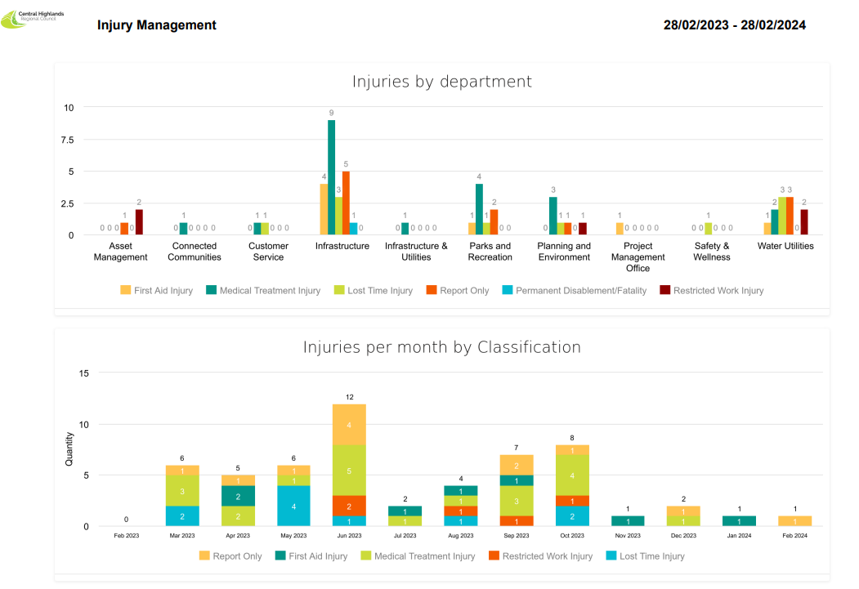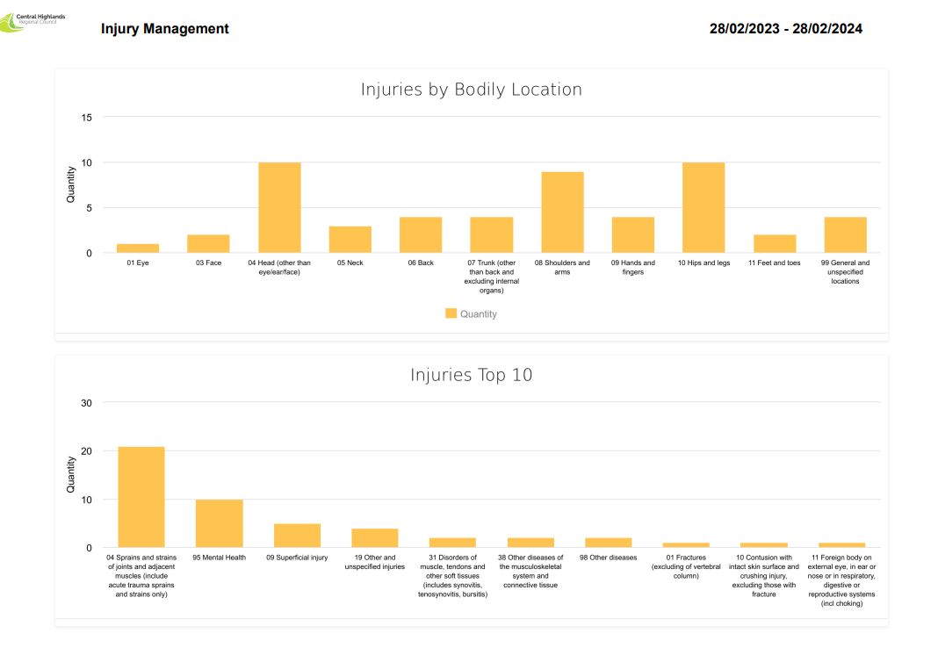
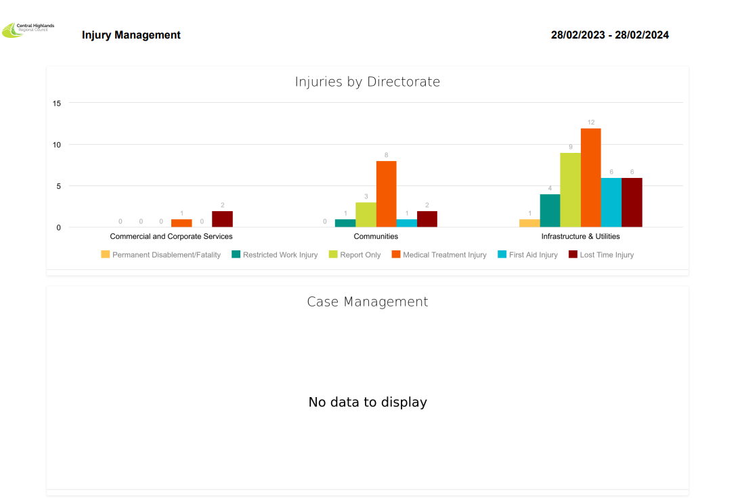
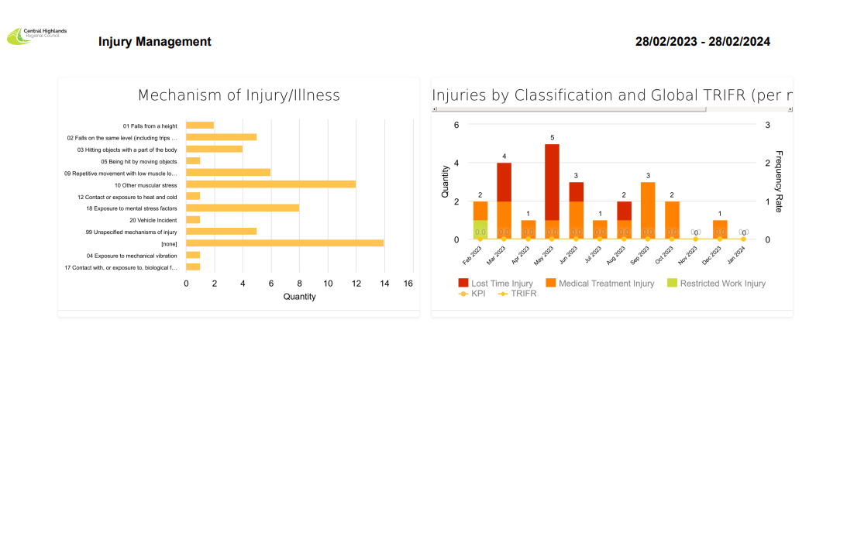
The effectiveness of council’s Injury Management system is reflected in the captured reporting. The safety system reflects that within the Infrastructure department their been 4 first aid injuries, 9 medical treatments, 3 lost time injuries, 5 report only and 1 permanent disability / fatality in the last 12 months.

Example limitation
An example of a limitation was the incident that resulted in a permanent disability where an operator was utilising plant and operating underneath the hydraulic lift equipment where it failed and landed on the person.
Adjustments
Adjustments were in relation to our safety system and the management of acquisition of our plant. A review lead to a revised minimum standard of features that the plant were required to have to risk mitigate any future occurrence from occurring.

A review into our operating procedures identified the need to incorporate provisions for not working under any plant which was hydraulically raised and a potential for hydraulic failure.
Communicating adjustments
The Organisation undertook a Safety Reset given the severity of the incident, conversation was had with staff about the contributing factors of the incident, the revised operating procedures and the new safety features being fitted to the plant.

Return-to-work
Monitoring effectiveness
Infrastructure is having limited effectiveness in transitioning staff on the return to work. It has been identifying that there is limited available scope for light duties with a large portion of our outdoor workforce due to limited literacy / numeracy skills, limited computer skills and limited outdoor works that can be light duties.
Example limitation
A worker has a back injury undertaking works, he went on claim and was identified to be suitable for light duties for a period of six months however was not able to return to work during this time due to the organisation being unable to facilitate light duties. The worker was in a remote crew that required camp and the manager was unable to facilitate work that did not have this requirement.
Adjustments
Organisation is undertaking holistic work force planning of functions and duties that can be suited to an employee who requires light duties and has limited literacy / numeracy skills, limited computer skills.

The Organisation is identifying ways to cross departmentally manage the return to work transition through exposure to works in different teams / departments.
Communicating adjustments
The Organisation through the adjustments are preparing several return to work specific position descriptions that will explain what council can facilitate as work while we manage their transition back to full duties.

Satisfactory Outcome

BSBWHS415
Contribute to implementing WHS management systems

QUIZ INSTRUCTIONS

- This quiz will occur under standard assessment conditions.
  - An oral assessment may be allowed under certain circumstances, whereby the Participant’s answers will be documented by a party other than the Participant. This must be acknowledged in writing (e.g. FT001 and Assessor Comments)
- Participants must provide enough detail in their responses to demonstrate their knowledge and skills.
- Please fill in the details below, providing your name, signature and date of assessment.
  - Your signature acknowledges that this is your own work.
- Assessors are to complete marking in pen of a different colour to the Participant.
- If a Participant initially answers a question incorrectly but modifies their response, they must follow the instructions below:
  - If a Participant changes their response in writing, they must put their initials next to the written change.
  - If a Participant changes their response verbally, this must be noted on the document by the assessor.

Participant name | Brenton Judge
Participant signature
Date | 28/02/2024

Assessor name
Assessor signature
Date | Click here to enter a date.

Number of questions | Number of questions answered correctly | Task outcome (Tick)
4 |  | Satisfactory | Not Yet Satisfactory

ASSESSOR Comments
- Which of the following are elements that may be included in a WHSMS? Tick all that apply.

Answer | Choice | Possible Answers
 |  | Duty holders and their responsibility
 |  | Injury management
 |  | Policies and procedures
 |  | Return-to-work procedures
 |  | Risk assessment
 |  | Training and induction

- Which of the following tools may be referred to when undertaking WHSMS planning, implementation and review? Tick all that apply.

Answer | Choice | Possible Answers
 |  | Audit checklists
 |  | Cost analysis
 |  | Return to work checklists
 |  | Risk registers

- True or False (Tick your response): It is best practice to communicate with others in the planning, implementation and review of a WHSMS.

Answer |  | True
 |  | False

- Which of the following are types of evaluation processes for monitoring WHS performance? Tick all that apply.

Answer | Choice | Possible Answers
 |  | Worker health surveillance
 |  | Writing policies and procedures
 |  | Monitoring effectiveness of risk controls
 |  | Auditing

BSBWHS415
Contribute to implementing WHS management systems

PRACTICAL ASSESSMENT INSTRUCTIONS

- The following practical assessment will require the Participant to complete work related activities.
- The Assessor will conduct observations of the Participant’s work to determine whether they display sufficient practical skills and knowledge.
- Please fill in the details below – providing your name, signature and date of assessment.
  - The Participant’s signature acknowledges that the Assessor provided clear instructions and the Participant understood what was required to complete this assessment.
- The Assessor may substitute a Practical Task with an alternate task of equal value.
  - Alternate tasks must be fully documented by the assessor in the Assessor Comments area.

Participant name | Brenton Judge
Participant signature
Date | 28/02/2024

Assessor name
Assessor signature
Date | Click here to enter a date.

Task | Task outcome (Tick)
Task | Satisfactory | Not Yet Satisfactory
Task 1

Assessor Comments
BSBWHS415
Contribute to implementing WHS management systems

Practical Task 1
Description of task:
The participant is to complete the Handout 2 template to plan the implementation of a work health and safety management system (WHSMS). As part of implementing the developed plan, the participant is required to:
- Develop and deliver a short presentation (e.g. PowerPoint presentation slides with accompanying face-to-face delivery or real-time video, as arranged with your assessor) for the PCBU regarding the WHSMS implementation plan
- Offer adjustments to the WHSMS implementation plan, in response to the PCBU’s (i.e. assessor’s) identified limitations for each WHSMS element

After the presentation, you are required to submit the following to the PCBU:
- The adjusted WHSMS implementation plan
- A WHSMS checklist to monitor and evaluate the WHSMS plan’s implementation

The participant is to submit the following evidence with this Practical Assessment sheet. There should be two (2) of each of the following documents submitted (i.e. one for each PCBU):
- Work Health and Safety (WHS) Management Plan (i.e. completed Handout 2)
- Presentation materials (e.g. PowerPoint) for PCBU
- WHSMS evaluation checklist

The assessor is to provide detailed comments on the tasks completed by the participant. Detail should be recorded in the Assessor’s Comments (e.g. Feedback on WHSMS plan, WHSMS limitations posed to participant and the participant’s suggested adjustments).
Resources required:
Computer, Handout 2.
Assessment of task
Name of participant: | Brenton Judge
Name of assessor:
Location:
Date: | Click here to enter a date.
When completing the task, did the participant: |  | Tick if satisfactorily completed.  Provide comments if left unticked.
1 Develop and implement WHSMS plan
- Complete WHSMS plan, after referring to WHS laws and organisational policies and procedures.
- Develop a presentation for the PCBU which:
- Identifies duties, rights and obligations, as per legal and organisational requirements
- Highlights key elements of the plan regarding return-to-work and injury management, plus another two (2) elements of their choice
- Deliver presentation (in person/via live stream video) and listen to PCBU to respond appropriately to any questions.
- Seek PCBU feedback about limitations to WHMS implementation plan.
- Offer adjustments to WHMS implementation plan in response to identified limitations.
2 Reviewing WHSMS implementation plan
- Distribute adjusted WHSMS plan to PCBU.
- Outline plan for monitoring and evaluate WHSMS implementation (i.e. using checklist).
The Participant’s performance was: Satisfactory Not Satisfactory

